Software Requirements Specification

for

E-Cycle
Version 1.0 approved
Prepared by
Ali Mourtadha bin Razman (U2322023K)
Gan Qing Rong (U2321908E)
Karen Lee Sze Suen (U2220129F)
Lim Zu Liang (U2322044H)
Sricharan Balasubramanian (U2322339L)
NTU SC2006 Group 61 (E-cycle)
Created 15 Nov 2024

Revision History ii
1. Introduction 1
1.1 Purpose 1
1.2 Document Conventions 1
1.3 Intended Audience and Reading Suggestions 1
1.4 Product Scope 2
1.5 References 2
2. Overall Description 3
2.1 Product Perspective 3
2.2 Product Functions 4
User Classes and Characteristics 4
2.3 Operating Environment 4
2.4 Design and Implementation Constraints 5
2.5 User Documentation 5
2.6 Assumptions and Dependencies 5
3. External Interface Requirements 6
3.1 User Interfaces 6
3.2 Hardware Interfaces 7
3.3 Communications Interfaces 7
4. System Features 9
4.1 Sign Up 9
4.2 System Feature 2 (and so on) 10
5. Other Nonfunctional Requirements 10
5.1 Performance Requirements 10
5.2 Safety Requirements 10
5.3 Security Requirements 10
5.4 Software Quality Attributes 10
5.5 Business Rules 10
6. Other Requirements 11
6.1 Data Dictionary 11
6.2 Use Case Diagram 13
6.3 Use Case Descriptions 13
6.4 Key Boundary Classes & Control Classes 30
6.5 Class Diagram 30
6.6 Sequence Diagrams 30
6.7 Dialogue Map 41
6.8 System Architecture 41
6.9 Testing 41
Appendix A: Glossary 50
Appendix B: Analysis Models 50
Appendix C: To Be Determined List 50

Revision History
Name | Date | Reason For Changes | Version

Introduction

1.1 Purpose
This document outlines the software requirements for "ECycle", our electronic waste webapp. This SRS serves as a reference for the functionalities, design, features, and constraints of the application, aiming to provide a comprehensive framework for development, focusing on key features of waste management, navigation, and forums for user interaction. The scope of this SRS encompasses the software aspects of Ecycle, including the frontend and backend programming, and database utilization.

1.2 Document Conventions
This SRS follows standard documentation conventions to ensure clarity and consistency. Key conventions include:
- Font Styles: 'Arial' for body text, 'Times New Roman' for headers.
- Highlighting: Bold for key terms, italics for emphasis.
- Requirement Prioritization: Higher-level requirements have inherited priority levels, cascading down to detailed requirements. Each requirement statement is explicitly labeled with a priority level (High, Medium, Low).
- Requirement Identification: Each requirement is uniquely identified for easy reference.
- Versioning: Changes in requirements through different versions are tracked for historical reference and future revisions.

1.3 Intended Audience and Reading Suggestions
This document is structured to cater to a wide array of stakeholders and should be read differently depending on the reader’s role:

- Project Managers and Stakeholders: Begin with the Introduction to understand the purpose and scope, then proceed to the Overall Description for a high-level overview of the system.
- Developers: After the introductory sections, delve into the System Features for detailed descriptions of the platform's functionalities, and the External Interface Requirements for integration specifics.
- Testers: Focus on the System Features for test case development, and refer to the Nonfunctional Requirements for performance and security testing guidelines.
- User Experience Designers: The User Interface sections within the External Interface Requirements will be of particular interest, providing details on the interaction between the system and its users.
- Technical Writers: The entire document is relevant, with emphasis on User Documentation and Assumptions and Dependencies to ensure accurate and comprehensive user guides and help documentation.
- Quality Assurance: Refer to the System Features for functionality, Other Nonfunctional Requirements for performance benchmarks, and the Other Requirements for additional specifications.

1.4 Product Scope
E-cycle is a web app designed to enable a circular economy for electronic waste. Its primary goal is to enable users to dispose of their waste, electronic or not, in the appropriate location to be recycled, disposed, or repaired, thereby reducing general waste generated and enhancing environmental benefits. The platform’s uniqueness is enabling users to navigate to the drop-off point or store within the application, and also allowing repair shops to communicate with users to check if their electronic waste can be repaired. This aligns with the broader objective of enabling all stakeholders to participate in Singapore’s circular economy.

1.5 References
JavaTPoint “Software Design Principles”:
https://www.javatpoint.com/software-engineering-software-design-principles
OOP Principles: https://www.digitalocean.com/community/conceptual-articles/s-o-l-i-d-the-first-five-principles-of-object-oriented-design

Overall Description

2.1 Product Perspective
This SRS specifies the requirements for E-Cycle, a new, self-contained product designed to enable more electronic waste recycling and circular economy participation. It is not a follow-on member of a product family nor a replacement for existing systems but is a pioneering effort to increase electronic waste recycling through a digital solution. The platform functions independently and also integrates with existing technologies via APIs. A system architecture diagram (as shown below) is provided to illustrate the interconnections and external interfaces.

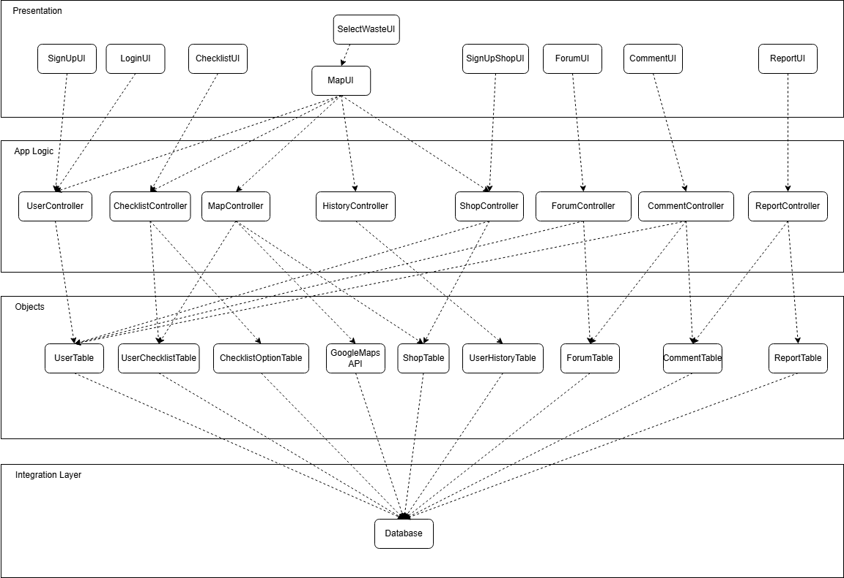

2.2 Product Functions
The following use case diagram depicts the key product functionalities that E-Cycle includes. There are 3 primary users of E-Cycle – Admin, User, and RepairShop. Each type of user interacts with E-Cycle to use their role-specific functions. In addition, E-Cycle gains inputs from 3 different APIs for the different functions.
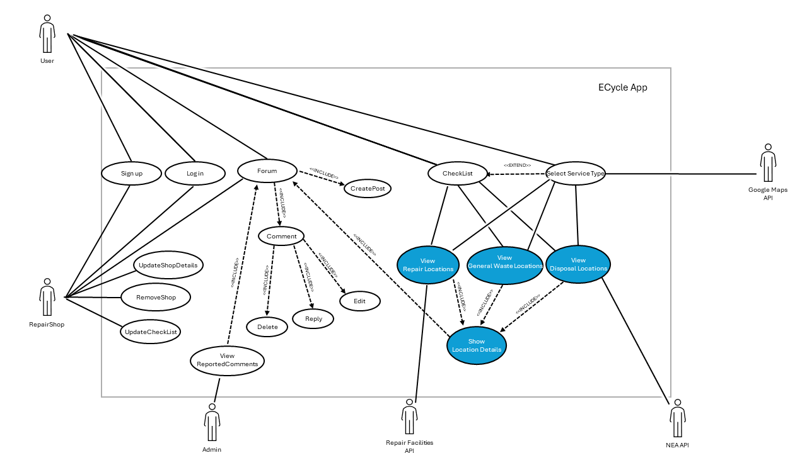
E-cycle will allow users to perform the following functions:
- Authentication
  - Sign up
  - Login
- RepairShop Functions
  - Update Shop Details
  - Remove Shop
  - Update checklist of items accepted
- User Functions
  - Map
    - Input current location
    - View nearby drop-off points
    - View nearby repair shops
    - View location viewing history
  - Forum
    - Add new forum posts
    - Edit old forum posts
    - Communicate with the repair shop
- Admin Functions
  - View reported comments
  - Edit shops

The following Class Diagram shows how different classes interact with each other, as well as the key functionalities that E-Cycle needs to perform

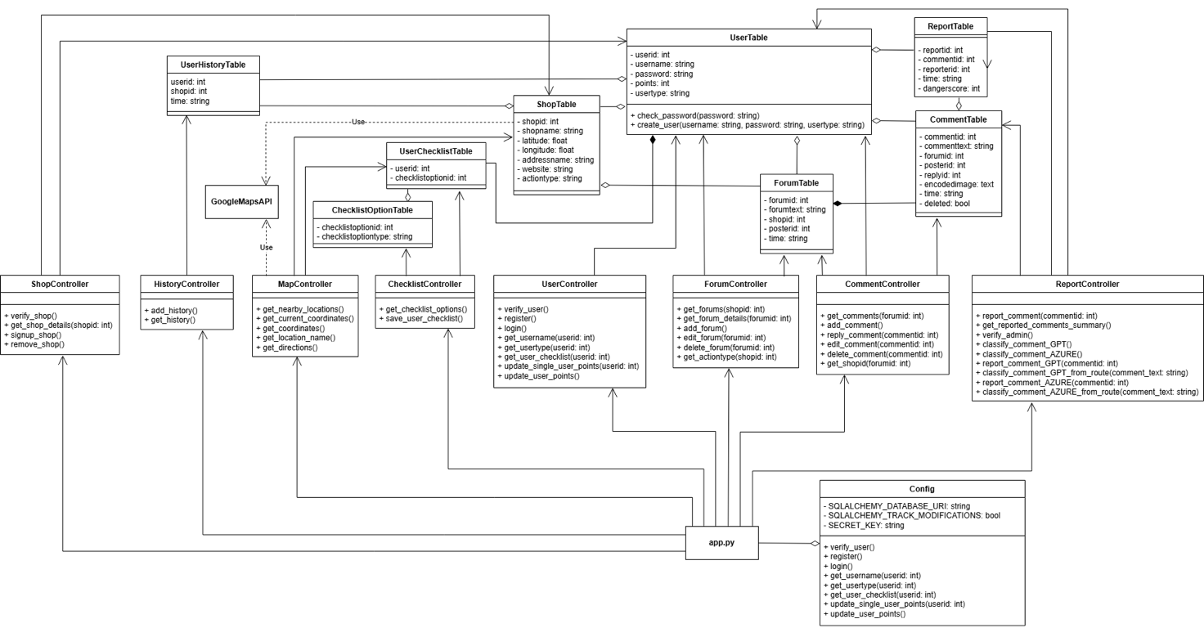

2.3 User Classes and Characteristics

Users of the platform are categorized into:

Users: An individual who wants to dispose of, or repair e-waste, and find collection points for recycling or repair.

RepairShop: A user who also runs a shop for repair and can interact with other users to accept items for repair.

Admins: Staff who oversee platform operations. They are technically skilled and need comprehensive tools for user management. They get privileged access to manage locations and user reports.

All three types of users are equally important for E-Cycle as they form a pipeline that makes the app functional and operational. E.g.: RepairShops add their shops to the app, Users attempt to find shops to repair their waste and Admins ensure that E-Cycle is fair and safe for its users.

2.4 Operating Environment
To use ECycle, permission for location services should be allowed. The development environment requires Python 3.9+ and Node 19+.
To start ECycle on localhost, type “npm start” under the frontend directory. Detailed information can be found in README.md

2.5 Design and Implementation Constraints
ECycle heavily depends on unpaid APIs, which could restrict its practicality. For example, although the Google Maps API offers free initial usage, credit limitations may arise once the trial period ends. With a larger financial budget, ECycle could fully realise its potential.
Additionally, ECycle is only available in the English language.

2.6 User Documentation
- Demo Video to guide users in using Ecycle
- User Manual (Appendix A)

2.7 Assumptions and Dependencies
It is assumed that all users are connected to a stable internet connection while using the website. If the user is not connected to the internet, the website may not be able to load and locate results.
It is also assumed that the information obtained from external APIs is accurate and up to date.

E-cycle depends on the following external services:
- NEA API
- Google Maps API
- Repair Facilities API
- Github Pages
- Azure and GPT APIs

External Interface Requirements

3.1 User Interfaces
The ECycle Application provides an intuitive interface designed to easily guide users through its features efficiently. Key interface features include:

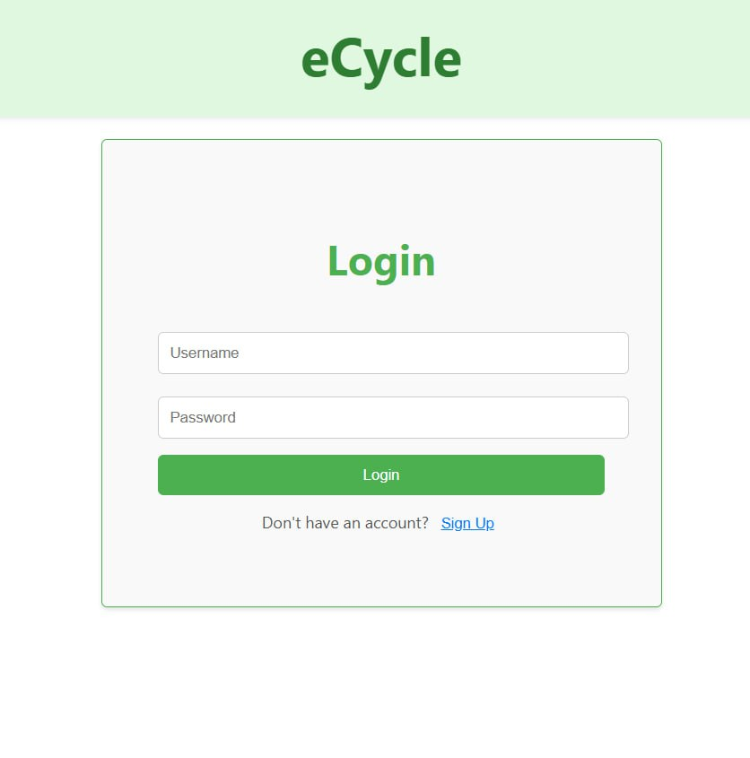

Login/Registration UI:
- Input fields space for username and password.
- Buttons for Login and Sign Up
- Error messages for invalid inputs.

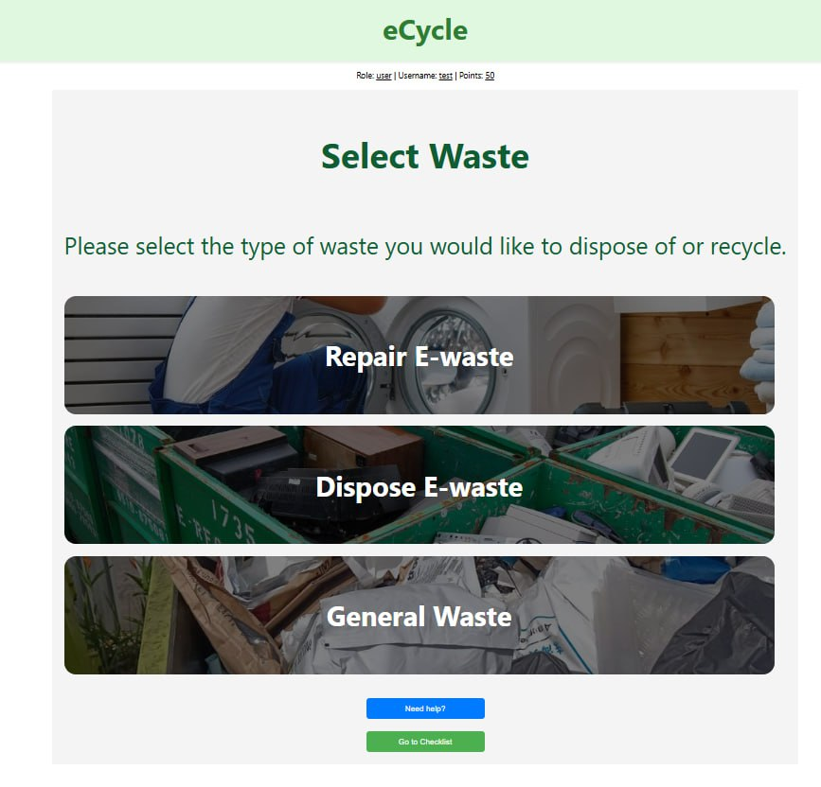

Select Waste UI:
- Interactive options for users to choose the type of waste they want to dispose of or recycle (repair, dispose, general waste).
- Filters shown locations based on action type, then redirects users to the Map UI with

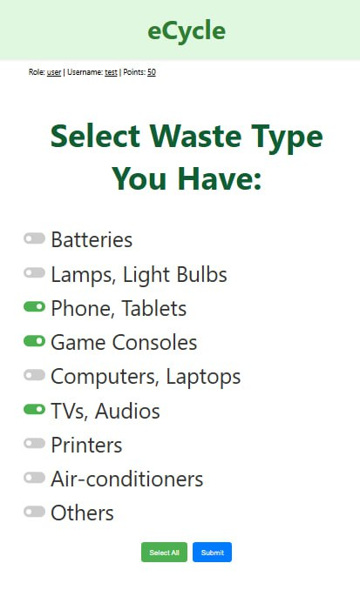

Checklist UI:

- Interactive options for users to customize their checklist to further filter their searches to a specific waste type
- Color coded indicators for user friendly interface
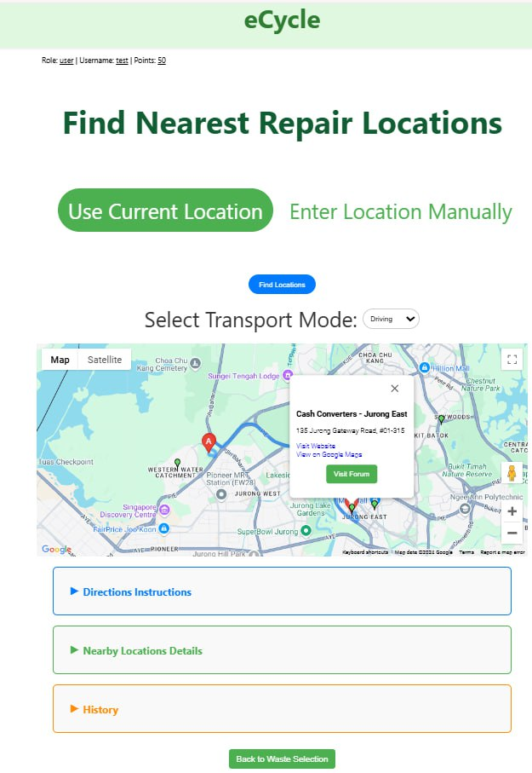

Map UI:

- Displays shops with green markers based on the user's checklist and action type.
- Interactive options for navigation. Contains directional navigation, nearby locations, and a search history
- Option to view details about each location.
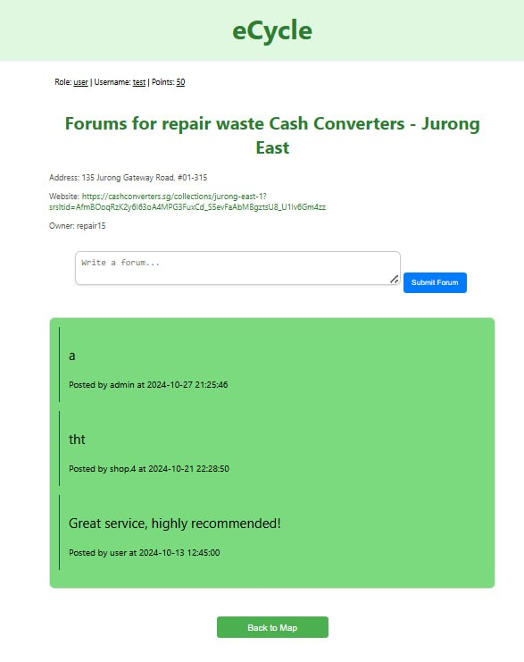

Comment and Forum UI:

- Users can view and post forums to any shop.
- Users can edit and delete their own forums.
- Users can post, reply to, or report comments in a forum.
- Users can edit and delete their own comments.
- Image attachments and rich text formatting are supported.

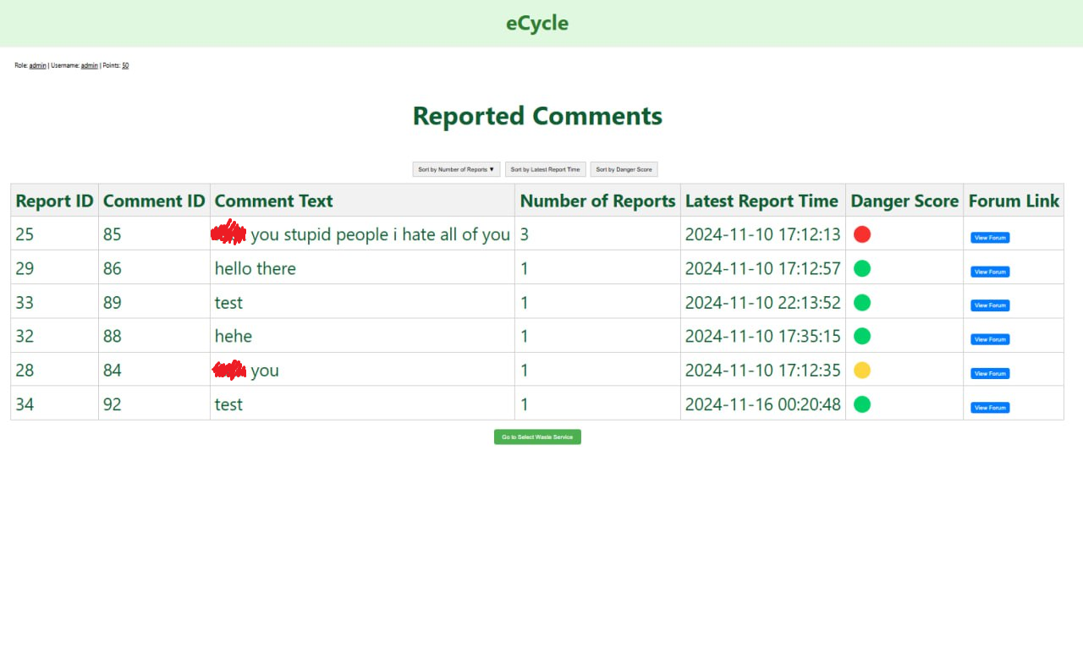
Admin Report Interface:

- Displays comments flagged with high danger scores and report counts.
- Sorting and filtering options for prioritizing review.
- Quick link for admins to view comments directly.

3.2 Hardware Interfaces
Our software can be used on webpages for both desktop and mobile. It can be implemented on both Android and IOS. WiFi is required for all functionalities of the application.

3.3 Software Interfaces
APIs:
- Google Maps API: Used for location and direction services.
- Azure OpenAI Language Learning Model API: For analyzing reported comments and determining danger scores.

Databases:
- PostgreSQL: Manages all data like user information, forums, comments, and shop information.

Libraries:
- React for Frontend functionality.
- Axios for API integration.
- Geopy for calculating distances.

External Tools:
- Admin moderation uses integrated GPT/AI-based classification services.

3.4 Communications Interfaces
HTTP/HTTPS Protocols: Communication between the frontend and backend uses REST APIs secured by HTTPS.

Authentication:
- OAuth2 for API security.
- JWT tokens for user login sessions.

Data Formats: JSON format for API requests and responses.

System Features

4.1 Sign Up
Description and Priority
Allows a new user to create an account by providing their username and password. This feature is of High priority as it is the initial step for any new user to access the system.

Stimulus/Response Sequences

The user selects the "Sign Up" option.
The user enters their username, password, and account type (user or shop).
The system checks if the username already exists.
If the username does not exist, the system creates a new account and logs the user in.
If the username already exists, the system displays an error message prompting the user to choose a different username.

Functional Requirements

REQ-1: The system shall provide a "Sign Up" option for new users.
REQ-2: The system shall accept input for the username, password, and account type.
REQ-3: The system shall verify whether the username already exists in the user database.
REQ-4: If the username is unique, the system shall create a new user account.
REQ-5: If the username already exists, the system shall display an error message.
REQ-6: The system shall display a success message upon account creation

4.2 Login
Description and Priority
Allows a user with an existing account to log into the system. This feature is of High priority as it is necessary for users to access any functionality that requires authentication.

Stimulus/Response Sequences

The user inputs their username and password into the login interface.
If the credentials are valid, the user is successfully logged in and gains access to the app.
If the credentials are invalid, the system displays an error message and prompts the user to try again.
If the user fails to log in more than 8 times, the system temporarily blocks further login attempts.

Functional Requirements
REQ-1: The system shall accept the user's username and password through the login interface.
REQ-2: The system shall verify the user's credentials against the user database.
REQ-3: If the credentials are valid, the system shall allow the user to log in.
REQ-4: If the credentials are invalid, the system shall display an error message prompting the user to retry.
REQ-5: If the user fails to log in more than 8 times, the system shall temporarily block further login attempts and display an account lock message

4.3 Create CheckList
Description and Priority
Allows users to indicate preferences on the checklist, which filters repair shops based on those preferences.
Priority: Medium

Stimulus/Response Sequences
The user selects various types of e-waste they wish to recycle by interacting with the checklist options in the system.
The user clicks on the "Submit" button.
The system processes these preferences and provides the available services based on the user’s selection.

Functional Requirements
REQ-1: The system shall allow users to select multiple types of e-waste items through a checklist.
REQ-2: The system shall provide a "Submit" button for users to confirm their selection.
REQ-3: Upon clicking "Submit", the system shall send the selected checklist preferences to the ChecklistOptionTable for storage.
REQ-4: The system shall take the user to the service type selection screen upon successful submission of preferences.

4.4 Update Checklist
Description and Priority
This feature allows shop owners to indicate the type of e-waste accepted. When users filter locations using the checklist, the shops' preferences will be displayed on the map. This feature is of high priority as it ensures shops display up-to-date information, facilitating effective e-waste disposal and recycling.

Stimulus/Response Sequences
The shop owner clicks on the "Update Checklist" button in the ForumUI.
The shop owner updates and submits the e-waste types they accept.
The system processes the updated checklist and stores the preferences in ChecklistOptionTable.
Confirmation is provided to the shop owner once the update is successfully processed.

Functional Requirements
REQ-1: The system must allow the shop owner to select and update the type of e-waste they accept through the ForumUI.
REQ-2: The system must save the updated preferences to the ChecklistOptionTable.
REQ-3: The system must notify the shop owner of the successful update or any errors encountered during the process.

4.5 Select Waste Type
Description and Priority
Allows the user to select the type of service they are interested in, such as Repair, Recycle, or Disposal. Based on the selected service, the system filters and displays nearby shop locations that match the selected type. This feature is of High priority, as it is a core functionality of the eCycle app.

Stimulus/Response Sequences
The user selects a type of service they want (repair, recycle, or dispose).
The system displays relevant shop locations that match the selected type of service.
The user selects a shop to view more details or directions.

Functional Requirements
REQ-1: The system must allow the user to select one of three waste service types: Repair, Recycle, or Disposal.
REQ-2: The system must display a filtered list of shop locations based on the user's selected service type.
REQ-3: The system must navigate to the Map UI after the user selects the desired service type.

4.6 Get Current Location
Description and Priority
Allows the user to find nearby shops based on their current location. This feature is of High priority as it provides a convenient and user-friendly way to find relevant recycling locations without manually entering an address.

Stimulus/Response Sequences
The user chooses to use their current location via the MapUI.
The system checks if the user has allowed location permissions.
If the location permission is granted, the system retrieves the user's latitude and longitude.
The system fetches relevant shop locations that match the user's checklist preferences.
The coordinates of nearby shops are returned to the MapUI and displayed on the user interface.

Functional Requirements
REQ-1: The system shall provide an option for the user to use their current location.
REQ-2: The system shall verify if location permission is granted by the user.
REQ-3: If the permission is granted, the system shall retrieve latitude and longitude of the user’s current location.
REQ-4: The system shall fetch shop locations that match the user's checklist preferences.
REQ-5: The system shall display the map with nearby shops on the user interface.

4.7 Get Coordinates
Description and Priority

This feature allows the user to find nearby shops based on manually entered location data. It is classified as High priority as it provides flexibility for users to manually input their desired address to locate nearby shops effectively.

Stimulus/Response Sequences

The user inputs an address through the manual entry feature on the UI.
The system sends this address for validation and geolocation processing.
If the address is valid, the corresponding geographical coordinates are retrieved.
The system returns the coordinates and displays nearby shops on the map view based on the user's input.
If the address is invalid, an error message prompts the user to enter a valid address.

Functional Requirements

REQ-1: The system shall allow the user to enter the desired address or postal code.
REQ-2: The system shall validate the user-provided address for correctness.
REQ-3: The system shall retrieve geographical coordinates from the entered address if it is valid.
REQ-4: The system shall prompt the user with an error message if the entered address is found to be invalid.
REQ-5: The system shall display a map view based on the manually entered coordinates along with nearby matching shops.

4.8 Get Directions
Description and Priority

Allows the user to retrieve and view directions to a selected shop. This feature is of High priority as it enables users to efficiently navigate to the selected repair or disposal location.

Stimulus/Response Sequences

The user requests directions to the selected shop via the interface.
The system retrieves the shop location details.
The system requests directions from Google Maps API, using the starting and selected shop location.
The system returns and formats the directions.
The system displays the formatted directions to the user.

Functional Requirements

REQ-1: The system shall accept a user's request to get directions to the selected shop.
REQ-2: The system shall retrieve the selected shop's location details.
REQ-3: The system shall send a request for directions using the starting and selected shop location.
REQ-4: The system shall receive and format the directions from the Google Maps API.
REQ-5: The system shall display the formatted directions to the user.

4.9 Show Nearby Locations
Description and Priority
Allows the user to see nearby repair or disposal locations. This feature is of High priority as it is essential for providing users with the ability to find suitable locations for their e-waste disposal or repair needs.

Stimulus/Response Sequences

The user initiates a request to view nearby shops using the map interface.
The system retrieves user checklist options and service type preferences.
The system calculates the distance between the user's location and shop locations.
The system displays the locations on the map based on the user's preferences.
If an error occurs during geocoding, the system displays an error message to the user.

Functional Requirements

REQ-1: The system shall allow users to request to view nearby shops for e-waste repair or disposal through the map interface.
REQ-2: The system shall retrieve the user's checklist options and service type preferences for shop selection.
REQ-3: The system shall use Google Maps API to calculate the distance between the user's location and shop locations.
REQ-4: The system shall display nearby shops on the map based on the user's preferences, including repair and disposal options.
REQ-5: If an error occurs during geocoding, the system shall display an appropriate error message to inform the user of the issue.

4.10 Store Location History
Description and Priority

Stores the user's recent location visits to a history table for easy reference. This feature is of Medium priority as it enables users to easily revisit their frequently accessed locations.

Stimulus/Response Sequences

The user clicks a marker on the map.
The system sends the clicked location details to the server.
The system stores the location data in the user history table.
The system displays the recent locations in the user's history.

Functional Requirements

REQ-1: The system shall accept the user's input (marker clicked) and send a request with location details.
REQ-2: The system shall store recent location data to a history table.
REQ-3: The system shall retrieve history data for the user.
REQ-4: The system shall display the recent locations in the user's history for easy access.
REQ-5: If system or network errors prevent history updates, the system shall notify the user.

4.11 Add shop
Description and Priority:

This feature allows shop users to register their shop details in the system, making the shop visible for users searching for repair, recycling, or disposal services. This feature is of High priority as it is necessary to keep the shop information current and ensure that users have accurate options when searching for e-waste services.

Stimulus/Response Sequences:

The shop user provides the shop details (e.g., shop name, address, waste service type).
If the provided shop details are valid, the system adds a new record.
If the shop already exists, the system updates the existing record.
The user is notified of the success or failure of the operation.

Functional Requirements:

REQ-1: The system shall accept the shop details through the registration interface.
REQ-2: The system shall validate the shop details provided by the user.
REQ-3: If the shop details are valid, the system shall add a new record to the shop database.
REQ-4: If the shop already exists, the system shall update the existing record.
REQ-5: The system shall provide a confirmation message to the shop user upon success or notify them of any errors.

4.12 Edit Shop
Description and Priority:

This feature allows a shop user to update their shop details in the system. This feature is of High priority as it ensures that shop information is accurate and up to date, which is crucial for visibility and service selection by users.

Stimulus/Response Sequences:

The shop user provides updated shop details through the user interface.
The system validates the updated details.
If validation is successful, the updated shop details are saved in the database.
If there is a database error, the user is notified to retry later.

Functional Requirements:

REQ-1: The system shall accept the updated shop details provided by the shop user.
REQ-2: The system shall validate the updated shop details for correctness and completeness.
REQ-3: If validation is successful, the system shall update the existing shop record in the database.
REQ-4: If a database error occurs, the system shall notify the shop user and suggest retrying later.

4.13 Add Forum
Description and Priority:

This feature allows a user or shop to post a new forum discussion for a specific shop. This feature is of High priority as it facilitates community engagement and communication.

Stimulus/Response Sequences:

The user writes a forum discussion text and clicks the "Add Forum" button in the forum interface.
The system responds with a confirmation message indicating that the forum post has been successfully added.
The forum interface updates the displayed forum list to include the newly added discussion.

Functional Requirements:

REQ-1: The system shall accept the user's forum text through the forum interface.
REQ-2: The system shall save the forum post and confirm the addition with a success message.
REQ-3: The system shall update the displayed list of forums immediately after a new forum is added.
REQ-4: The system shall display an error message if the forum submission fails due to a server issue, advising the user to try again.

4.14 Add comment
Description and Priority:
This feature allows a user, shop, or admin to add a comment to a forum post. This feature is of High priority as it enhances interaction within the platform and promotes active engagement.

Stimulus/Response Sequences:
The user clicks the "Add Comment" button on the comment interface and enters their comment text and optionally attaches an image.
The system displays a success message indicating that the comment has been successfully added.
The comment interface updates to include the newly added comment.

Functional Requirements:
REQ-1: The system shall accept the user's comment input and optional image attachment through the comment interface.
REQ-2: The system shall validate the input, ensuring it meets the minimum character requirement.
REQ-3: If the input is valid, the system shall save the comment in the database and confirm the addition with a success message.
REQ-4: The system shall update the displayed list of comments immediately after a new comment is added.
REQ-5: The system shall display an error message if the comment submission fails due to server issues, advising the user to try again.
REQ-6: If the user's session is invalid, the system shall redirect the user to the login page.

4.15 Report Comment
Description and Priority:

This feature allows a user or shop to report a comment for inappropriate or harmful content within a forum discussion. This feature is of Medium priority to ensure a safe and respectful user experience on the platform.

Stimulus/Response Sequences:

The user clicks the "Report" button for a specific comment in the comment interface.
The system logs the reported comment, including user and comment details, into the database.
The system displays a success notification to the user, confirming that the report has been submitted.

Functional Requirements

REQ-1: The system shall provide a "Report" button for each comment in the comment interface.
REQ-2: The system shall require the user to be logged in before reporting a comment.
REQ-3: The system shall log the reported comment in the database with details about the reporter and the reported content.
REQ-4: The system shall display a success notification to the user after the report is logged.
REQ-5: The system shall return an error response if the report fails due to server issues, and display an appropriate error message to the user.
REQ-6: Reports shall be reviewed by an admin for appropriate action.

Other Nonfunctional Requirements

5.1 Performance Requirements
5.1.1. The system must be usable by first-time users without assistance.
- 5.1.1.1 First-time users must be able to classify their e-waste easily.
  - 5.1.1.1.1 80% of first-time users must be able to classify their e-waste within 3 minutes of opening the app.
  - 5.1.1.1.2 Users must be able to classify their e-waste within 10 clicks upon opening the app.
5.1.1.2 Users must be able to view nearby repair / disposal locations easily.
5.1.1.2.1 80% of first-time users must be able to view nearby repair / disposal locations within 1 minute of opening the app.
5.1.1.2.2 Users must be able to view nearby repair / disposal locations within 3 clicks upon opening the app.
5.1.2. The app must display nearby repair/disposal locations within 5 seconds of receiving the user’s classification input.

5.1.3. The system must allow users to submit review within 10 seconds of confirmation of successful disposal.

5.2 Safety Requirements
5.2.1 The system must ensure all location data is handled securely.
- 5.2.1.1 Location data must be encrypted and not stored after use.

5.3 Security Requirements
5.3.1. Passwords must be hashed and securely stored to prevent exposure in case of a data breach.
- 5.3.1.1. Password should be masked when the user types it in.

5.3.2 User authentication must include username and password verification to prevent unauthorized access to admin or shop accounts.

5.3.3 All communications between the app and server must be encrypted using HTTPS to prevent interception of sensitive data.

5.4 Software Quality Attributes
5.4.1. The system must ensure 99.5% uptime for location detection and e-waste classification services during working hours.
- 5.4.1.1. The system must only be allowed to undergo maintenance from 1 a.m. to 4 a.m.
- 5.4.1.2. After a system reboot, the app must restore full functionality within 3 minutes.

5.4.2. The application must be able to integrate with third-party APIs for repair/disposal centers.
- 5.4.2.1. These APIs should be replaceable with other repair vendors.
- 5.4.2.2. These APIs should be replaceable with other disposal vendors.

5.5 Business Rules
5.5.1 Only authorized users can access and modify their profiles, checklists, and shop data.

5.5.2 Admin users can remove inappropriate comments that violate community guidelines.

Other Requirements

6.1 Data Dictionary
User roles
Term | Definition
User | An individual who wants to dispose of, or repair e-waste, and find collection points for recycling or repair.
RepairShop | A user who also runs a shop for repair and can interact with other users to accept items for repair.
Admin | A user with privileged access to manage locations and user reports.
API | Application programming interface (API) is a set of rules or protocols that enables software applications to communicate with each other to exchange data, features and functionality.
Repair Facilities API | The third-party API used by our system to retrieve the locations that repair malfunctional electronic products.
NEA API | The third-party API used by our system to retrieve the locations where users can drop off general or e-waste.
Google Maps API | The third-party API used by our system to retrieve the location of the user (either automatically or through manual input) and then provide directions from the user’s location to any chosen repair facility/drop off point.

Term | Definition
Username | A string used to identify unique users of the system.
Password | A hashed string of characters that is attached to the username and allows access to the system upon entry.
Sign Up | The process of registering a new user to the system by accepting a new unique username and password.
Login | The process of entering the system by an already registered user. The user needs to enter their username and password to enter the system.
Sign up Shop | The process of registering a new shop to the system by a RepairShop, by accepting relevant shop details.
Shop Details | A list of information on the shop. The information includes shop name, valid shop address, shop website, and a filled shop checklist.
Checklist | A list of items that is used by both users and RepairShops. The RepairShop uses this checklist to show what items they accept from users, and users use this checklist to check the items that they intend to repair/recycle/dispose.
Forum | A page of text posts by users to provide comments on the shop.
Locations | A point on the map that is returned by the APIs, where users can drop off items for repair/recycling/disposal.

E-waste and Classifications
Term | Definition
E-waste | Electronic waste, including items like batteries, smartphones, televisions, and other electronic devices and appliances.
General Waste | Other types of recyclable waste that are not electronic waste. (e.g. Clothes, bottles, cardboard, plastic bags)
Dispose | Throw away the waste in the appropriate bin, either for recycling or incineration in Singapore’s context. It is assumed that items that can be recycles will be recycled to their maximum potential.
Repair | Restore to working condition by bringing to a repair shop.
Repairable | E-waste that can be restored to working condition through repair or refurbishment, with minor issues like replaceable parts.
Disposable | E-waste that cannot be fixed due to severe damage or outdated technology, making it suitable for disposal or recycling.

Map and Location
Term | Definition
Location Access | A request sent to the user to allow the system access to their location to enable features like finding nearby e-waste collection points.
Postal Code | A series of 6 digits that are used to identify a specific mailing location. In Singapore, the first 3 digits indicate the locality, and the last 3 digits indicate the specific building or venue within the locality.
Address | A series of words that indicate the particulars of a specific venue. In Singapore, the words can include name of building, block number, unit number, street number and postal code.
Search results | A list of nearby e-waste repair or disposal locations displayed based on the user’s location and classification input.
Search filter | Criteria used by the user to refine their search for e-waste collection points, such as distance (using map), type of waste (using checklist), and condition (repairable/non-repairable).
History | A record of locations previously visited by the user on the map, shown to users as they browse the different locations.
Directions | A list of instructions on how to reach the chosen location on the map, from the user’s location. The user’s location is determined either automatically or manually via user input.
Mode of transport | The method in which the user intends to travel to the location. Options include walking, driving, public transport.
Shop details | A list of information about the shop, including address, opening hours, and website.
Repair Locations | A collection point that specialises in repairing usable/repairable e-waste.
Disposal Locations | A collection point that accepts unusable or spoilt e-waste for recycling

Shop and Forum
Term | Definition
Comment | A string of characters that are posted by users on the forum about the shop.
Reported Comments | Comments that have been flagged to have inappropriate or offensive contents and have been raised to the Admin for deletion.
Points | A number rating associated with users based on their past history of disposal/recycling/repairing by using the application.

6.2 Use Case Diagram

6.3 Use Case Descriptions
Use Case ID: | 1.1
Use Case Name: | Sign Up
Created By: | Lim Zu Liang | Last Updated By: | Lim Zu Liang
Date Created: | 10 Sep. 24 | Date Last Updated: | 15 Nov. 24

Actor: | User
Description: | Allows a new user to create an account by providing their username and password.
Preconditions: | The user must not already have an account.
Postconditions: | The user account is created, and the user is logged in to the system.
Priority: | High
Frequency of Use: | One-time per new user
Flow of Events: | - The user selects the "Sign Up" option.  - The user enters their username password, and account type (user or shop) into the SignUpUI.  - SignUpUI sends the sign-up request to the UserController.  - UserController checks if the username exists in the UserTable.  - If the username does not exist a new account is created.  - The system returns a success message to the SignUpUI, which displays the sign-up success to the user.
Alternative Flows: | -
Exceptions: | 1: If the username already exists, the SignUpUI displays an error message prompting the user to choose a different username.  2: If user inputs is empty, the system provides error messages.
Includes: | -
Special Requirements: | -
Assumptions: | The user has internet access during the sign-up process.
Notes and Issues: | -

Use Case ID: | 1.2
Use Case Name: | Log In
Created By: | Lim Zu Liang | Last Updated By: | Lim Zu Liang
Date Created: | 10 Sep. 24 | Date Last Updated: | 15 Nov. 24

Actor: | User
Description: | Allows a user with an existing account to log in to the system.
Preconditions: | The user must have an account.
Postconditions: | The user is logged in
Priority: | High
Frequency of Use: | Every time a user wants to access the app
Flow of Events: | - The user inputs their username and password into the LoginUI.  - LoginUI sends the credentials to the LoginController for processing.  - The LoginController verifies the credentials with the UserTable.  - If the credentials are valid, user is logged in.
Alternative Flows: | -
Exceptions: | - Invalid credentials: If the credentials are incorrect, LoginUI displays the LoginFailUI and prompts the user to try again.  - Multiple failed attempts: If the login attempt fails more than 8 times, LoginUI displays AccountLockUI, and the system temporarily blocks further attempts.
Includes: | -
Special Requirements: | -
Assumptions: | -
Notes and Issues: | -

Use Case ID: | 2.1
Use Case Name: | CreateChecklist
Created By: | Lim Zu Liang | Last Updated By: | Lim Zu Liang
Date Created: | 10 Sep. 24 | Date Last Updated: | 15 Nov. 24

Actor: | User
Description: | Allows users to indicate preferences on the checklist, which filters repair shops based on those preferences.
Preconditions: | The user must be logged in.
Postconditions: | Matching shops are displayed to the user based on preferences.
Priority: | Medium
Frequency of Use: | Always.
Flow of Events: | - The user indicates their checklist preferences through the CheckListUI  - The user clicks on the "Submit" button in the CheckListUI.  - The CheckListController sends the preferences to the ChecklistOptionTable to save.  - User brought to SelectWasteUi to select the service type.  - SelectWasteUI displays the available service type options for the user to proceed.
Alternative Flows: | -
Exceptions: | -
Includes: | -
Special Requirements: | -
Assumptions: | The user understands the basic condition of their item.
Notes and Issues: | -

Use Case ID: | 2.2
Use Case Name: | UpdateChecklist
Created By: | Lim Zu Liang | Last Updated By: | Lim Zu Liang
Date Created: | 10 Sep 2024 | Date Last Updated: | 15 Nov 2024

Actor: | Shop
Description: | Allows shop to indicate the type of E waste accepted such that it will be shown on map when user filters location using checklist.
Preconditions: | Shop must be registered
Postconditions: | Shop E-waste preferences saved
Priority: | High
Frequency of Use: | Occasionally, when Shop owner wants to update accepted E-waste
Flow of Events: | - The shop owner clicks on "Update Checklist" through the ForumUI.  - Shop Owner updates and submit the various E-Waste Type Accepted  - ForumUI sends a updated checklist to ChecklistController  - ChecklistController save the updated checklist options to ChecklistOptionTable for the shop.
Alternative Flows: | -
Exceptions: | -
Includes: | -
Special Requirements: | -
Assumptions: | -
Notes and Issues: | -

Use Case ID: | 3.1
Use Case Name: | SelectWaste
Created By: | Lim Zu Liang | Last Updated By: | Lim Zu Liang
Date Created: | 10 Sep 2024 | Date Last Updated: | 15 Nov 2024

Actor: | User
Description: | Allows the user to select the type of service (Repair, Recycle, or Disposal) they are interested in. The system then displays the filtered locations that match the selected service type
Preconditions: | User submitted Checklist
Postconditions: | System displays populated map based on users indicated preferences
Priority: | High
Frequency of Use: | Whenever user wants to view location
Flow of Events: | - The user selects the desired service type through the SelectWasteUI.  - SelectWasteUI navigates to MapUI to display filtered locations.  - MapUI sends a request to MapController for shop locations.  - MapController queries ShopTable for relevant locations.  - ShopTable returns the shop list to MapController.  - MapController provides the shop list back to MapUI.  - The user sees the filtered shop locations displayed on the map
Alternative Flows: | -
Exceptions: | -
Includes: | Checklist
Special Requirements: | -
Assumptions: | -
Notes and Issues: | -

Use Case ID: | 3.2
Use Case Name: | GetCurrentCoordinates
Created By: | Lim Zu Liang | Last Updated By: | Lim Zu Liang
Date Created: | 10 Sep 2024 | Date Last Updated: | 15 Nov 2024

Actor: | User
Description: | Find nearby shops based on user current location
Preconditions: | User submitted checklist and selected service type
Postconditions: | populated map of nearby locations based on user’s current location
Priority: | High
Frequency of Use: | Frequent
Flow of Events: | - The user chooses to use their current location via the MapUI.  - The system checks if user allowed Location Permission.  - If true,MApUI calls MapController to retrieve latitude and longitude.  - The MapController gets geocode data from ShopTable of shops that matches user’s checklist prefernces.  - The coordinates are returned to MapUI and displayed on the user interface.
Alternative Flows: | -
Exceptions: | If Location Permission is false, the system shows an error message: "Unable to fetch location".
Includes: | -
Special Requirements: | -
Assumptions: | The user is in an area where GPS or network-based location services are available.
Notes and Issues: | The accuracy of location data depends on the quality of the network or GPS signal.

Use Case ID: | 3.3
Use Case Name: | GetCoordinates
Created By: | Lim Zu Liang | Last Updated By: | Lim Zu Liang
Date Created: | 10 Sep 2024 | Date Last Updated: | 15 Nov 2024

Actor: | User
Description: | Find nearby shops based on manual input location
Preconditions: | User submitted checklist and select service type
Postconditions: | Show populated map based on user’s manual input location
Priority: | High
Frequency of Use: | Frequent
Flow of Events: | - User inputs address through MapUI.  - MapUI sends address to MapController.  - MapController checks if the address is valid  - If valid, MapController sends address to ShopTable.  - ShopTable returns coordinates to MapController.  - MapController returns coordinates to MapUI.  - MapUI displays map
Alternative Flows: | -
Exceptions: | If address is invalid, the system prompts the user to enter a valid address
Includes: | Address validation
Special Requirements: | -
Assumptions: | -
Notes and Issues: | -

Use Case ID: | 3.4
Use Case Name: | GetDirections
Created By: | Lim Zu Liang | Last Updated By: | Lim Zu Liang
Date Created: | 10 Sep 2024 | Date Last Updated: | 15 Nov 2024

Actor: | User
Description: | Retrieves and displays directions to the selected shop
Preconditions: | User has selected a shop to navigate to and specified a starting location.
Postconditions: | The system displays the formatted directions to the selected shop based on the user's specified location.
Priority: | High
Frequency of Use: | Frequent
Flow of Events: | - The user requests directions to the selected shop via MapUI.  - MapController retrieves the shop location from ShopTable.  - MapController sends a request for directions to GoogleMapAPI using the starting location and selected shop location.  - Directions are returned and formatted.  - MapUI displays the formatted directions to the user.
Alternative Flows: | -
Exceptions: | -
Includes: | Use of Google Maps API for fetching directions.
Special Requirements: | -
Assumptions: | -
Notes and Issues: | -

Use Case ID: | 3.5
Use Case Name: | ShowNearbyLocations
Created By: | Lim Zu Liang | Last Updated By: | Lim Zu Liang
Date Created: | 10 Sep 2024 | Date Last Updated: | 15 Nov 2024

Actor: | User
Description: | Allows the user to see nearby repair or disposal locations
Preconditions: | User submitted checklist and selected service type.
Postconditions: | Show populated map based on user’s preferences
Priority: | High
Frequency of Use: | Frequent
Flow of Events: | 1. Map UI request for Shops nearby.  2. MapController retrieves user checklist options  3. MapController retrieves shops based on service type.  4. GoogleMapsAPI calculates the distance between the user’s location and shop locations.  5. The system returns the calculated distance.  6. The system returns the nearby shops based on user indicated preferences.  7. Map UI displays nearby shops with markers on the map.
Alternative Flows: | -
Exceptions: | System error during geocoding; error message displayed to user.
Includes: | -
Special Requirements: | -
Assumptions: | -
Notes and Issues: | -

Use Case ID: | 3.6
Use Case Name: | StoreLocationHistory
Created By: | Lim Zu Liang | Last Updated By: | Lim Zu Liang
Date Created: | 1 Nov 2024 | Date Last Updated: | 15 Nov 2024

Actor: | User
Description: | Stores the user's recent location visits to a history table for easy reference.
Preconditions: | User must have successfully clicked a marker on the map.
Postconditions: | Recent location data is saved in the user's history, available for future retrieval.
Priority: | Medium
Frequency of Use: | Frequent for regular users who visit multiple locations.
Flow of Events: | 1. User clicks a marker on the map.  2. MapUI sends a POST request with userId and shopId to MapController.  3. MapController forwards the request to HistoryController.  4. HistoryController adds or updates history in UserHistoryTable.  5. HistoryController retrieves the history details from UserHistoryTable.  6. MapUI displays the recent locations.
Alternative Flows: | -
Exceptions: | System or network errors might prevent history updates.
Includes: | -
Special Requirements: | -
Assumptions: | -
Notes and Issues: | -

Use Case ID: | 3.7
Use Case Name: | ShowLocationDetails
Created By: | Sricharan Bala | Last Updated By: | Gan Qing Rong
Date Created: | 10 Sep. 24 | Date Last Updated: | 25 Sep. 24

Actor: | Repair Facilities API, NEA API
Description: | Extracts the details of the selected repair or disposal location from the NEA or Repair Facilities API and displays it to the user on the screen.
Preconditions: | - Performed a search & filter and selected a specific location to find our more details on.  - The system can access the API providing the address data.  - The system has access to the Google Maps API and the API geojson data.  - The system can access the API providing the website data.  - The system can access the API providing the waste type data.
Postconditions: | - The address data is correctly retrieved from the third-party API.  - The address of the drop off point is successfully displayed on the screen.  - The user is successfully redirected to Google Maps and can begin navigation to the selected location.  - The website of the selected location is successfully displayed on the screen.  - The website data is correctly extracted from the API.
Priority: | High
Frequency of Use: | High frequency
Flow of Events: | - The user performs a search & filter to find drop-off locations.  - The system sends a request to the Third-Party API for location data, including the address.  - The ShowLocationDetails use case extracts the address, coordinates, website, and waste type from the API response.  - The system displays the address of the selected drop-off point on the screen.  - The system displays the website of the selected drop-off point on the screen, allowing users to click on it.  - The system displays the information on the types of waste collected at the selected drop-off point on the screen.  - The user clicks on a button to navigate to the location using Google Maps.  - The system passes the coordinates to Google Maps and opens it.  - Google Maps starts navigation.  - The system can access the API providing the waste type data.
Alternative Flows: | - If no address data is available for a location, an error message is displayed to the user.  - The system may offer alternative drop-off location options if the address extraction fails.
Exceptions: | The API is unavailable or returns an error, causing the system to display an appropriate error message and prompting the user to try again later.
Includes: | -
Special Requirements: | -
Assumptions: | -
Notes and Issues: | -

Use Case ID: | 4.1
Use Case Name: | AddShop
Created By: | Ali Mourtadha | Last Updated By: | Ali Mourtadha
Date Created: | 16/11/2024 | Date Last Updated: | 16/11/2024

Actor: | Shop
Description: | This use case describes the process for a shop user to register their shop details in the system, enabling their shop to be visible for service selection by other users.
Preconditions: | - The user must be logged in as a shop user.  - The user must provide valid shop details.
Postconditions: | If successful, the shop is added or updated in the system and becomes visible to users.
Priority: | High
Frequency of Use: | Occasionally, when shop details are added.
Flow of Events: | - The shop user provides the shop details through the ShopUI.  - ShopController adds a new record in ShopTable.  - If the shop already exists, ShopController updates the existing record.  - ShopUI displays a success or error message to the user.
Alternative Flows: | If a database error occurs, the system notifies the user and suggests retrying later.
Exceptions: | -
Includes: | Validation of shop details in ShopUI.
Special Requirements: | -
Assumptions: | The user has a shop account.
Notes and Issues: | Ensure unique identification for each shop entry to prevent duplication.

Use Case ID: | 4.2
Use Case Name: | EditShop
Created By: | Ali Mourtadha | Last Updated By: | Ali Mourtadha
Date Created: | 16/11/2024 | Date Last Updated: | 16/11/2024

Actor: | Shop
Description: | This use case describes the process for a shop user to update their shop details in the system.
Preconditions: | - The user must be logged in as a shop user.  - The shop must already exist in the system.
Postconditions: | If successful, the shop details are updated in the system.
Priority: | High
Frequency of Use: | Occasionally, when shop details need to be updated.
Flow of Events: | - The shop user provides updated shop details through the ShopUI.  - ShopController updates the existing record in ShopTable.  - ShopUI displays a success or error message to the user.
Alternative Flows: | If a database error occurs, the system notifies the user and suggests retrying later.
Exceptions: | -
Includes: | Validation of updated shop details in ShopUI.
Special Requirements: | -
Assumptions: | The user has valid credentials to update the shop details.
Notes and Issues: | Ensure that the updates do not conflict with other data in the system.

Use Case ID: | 4.3
Use Case Name: | RemoveShop
Created By: | Ali Mourtadha | Last Updated By: | Ali Mourtadha
Date Created: | 16/11/2024 | Date Last Updated: | 16/11/2024

Actor: | Shop
Description: | This use case describes the process for a shop user to remove their shop and all associated data, such as forums and comments, from the system.
Preconditions: | - The user must be logged in as a shop user.  - The shop must exist in the system.
Postconditions: | If successful, the shop and all its associated data are deleted from the system.
Priority: | High
Frequency of Use: | Rare, used only when a shop needs to be permanently removed.
Flow of Events: | - The shop user initiates the removal process by clicking the "Remove Shop" button in ForumUI.  - Deletes all comments associated with the forums.  - Deletes the forums.  - Deletes the shop record.  - ForumUI displays a success message to the user if the deletion was successful.
Alternative Flows: | If there is a database or system error, the system notifies the user and suggests retrying later.
Exceptions: | -
Includes: | Validation of the shop's existence in database
Special Requirements: | Adequate permissions must be verified before deletion.
Assumptions: | The user is the owner of the shop they are attempting to delete.
Notes and Issues: | Ensure that associated data (forums and comments) is deleted in the correct order to maintain database integrity.

Use Case ID: | 5.1
Use Case Name: | ViewForum
Created By: | Ali Mourtadha | Last Updated By: | Ali Mourtadha
Date Created: | 16/11/2024 | Date Last Updated: | 16/11/2024

Actor: | User, Shop, Admin
Description: | This use case describes the process of a user viewing the forums associated with a specific shop.
Preconditions: | The user must be logged into the application.  The shop must exist in the database.
Postconditions: | The user successfully views the forum and its associated discussions.
Priority: | High
Frequency of Use: | On-demand by the user.
Flow of Events: | - The user clicks the "Visit Forum" button from the MapUI.  - MapUI sends a request to navigate to the forum page.  - The server responds with the forum data.  - ForumsUI renders the forum details and associated discussions for the user.
Alternative Flows: | -
Exceptions: | - If there is a server error, the system displays a message indicating that the forums cannot be loaded.
Includes: | Login Use Case (Precondition).
Special Requirements: | None.
Assumptions: | - The user has internet access.  - The forum data is available in the database.
Notes and Issues: | - The system must ensure that the forum data is up-to-date when fetched from the server.

Use Case ID: | 5.2
Use Case Name: | AddForum
Created By: | Ali Mourtadha | Last Updated By: | Ali Mourtadha
Date Created: | 16/11/2024 | Date Last Updated: | 16/11/2024

Actor: | User, Shop
Description: | This use case describes the process of a user posting a new forum discussion for a specific shop.
Preconditions: | - The user must be logged into the application.  - The user must navigate to the forum page of the shop.
Postconditions: | The new forum post is added to the shop's forum and is visible to other users.
Priority: | High
Frequency of Use: | On-demand by users who wish to initiate a discussion.
Flow of Events: | - The user writes a forum discussion text and clicks the "Add Forum" button in the ForumsUI.  - The system responds with a confirmation message that the forum post has been successfully added.  - ForumsUI updates the displayed forum list with the newly added forum discussion.
Alternative Flows: | -
Exceptions: | - If the server encounters an error while adding the forum discussion, the system displays an error message and advises the user to try again later.
Includes: | Login Use Case (Precondition).
Special Requirements: | -
Assumptions: | - The server and database are operational.
Notes and Issues: | The system should ensure that the forum discussions are immediately visible after being added.

Use Case ID: | 5.3
Use Case Name: | EditForum
Created By: | Ali Mourtadha | Last Updated By: | Ali Mourtadha
Date Created: | 16/11/2024 | Date Last Updated: | 16/11/2024

Actor: | User, Shop
Description: | This use case describes the process of a user editing an existing forum post.
Preconditions: | - The user must be logged in.  - The user must have previously posted a forum discussion that they wish to edit.
Postconditions: | The updated forum discussion is saved and displayed in the list of forum posts.
Priority: | Medium
Frequency of Use: | Occasionally, when users need to modify their forum posts.
Flow of Events: | - The user clicks the "Edit" button on an existing forum post in ForumUI.  - ForumUI displays a textbox containing the current forum content, along with "Save" and "Cancel" buttons.  - The user modifies the text and clicks the "Save" button.  - ForumUI updates the displayed forum list with the modified post.
Alternative Flows: | User Cancels Edit:  - The user clicks the "Cancel" button.  - ForumUI discards the changes and displays the original forum text.
Exceptions: | If the server encounters an error while updating the forum, ForumUI displays an error message and advises the user to try again later.
Includes: | Login Use Case (Precondition).
Special Requirements: | -
Assumptions: | - The user has permission to edit the forum post.  - The system ensures proper handling of concurrent edits to the same forum post.
Notes and Issues: | - The user must have authored the post to be able to edit it.  - Consider implementing an edit history for tracking changes.

Use Case ID: | 5.4
Use Case Name: | DeleteForum
Created By: | Ali Mourtadha | Last Updated By: | Ali Mourtadha
Date Created: | 16/11/2024 | Date Last Updated: | 16/11/2024

Actor: | User, Shop, Admin
Description: | This use case describes the process of a user deleting an existing forum post.
Preconditions: | - The user must be logged in.  - The user must have previously posted the forum discussion they wish to delete.
Postconditions: | The forum post is removed from the database and is no longer displayed in the forum list.
Priority: | Medium
Frequency of Use: | Rarely, when a user decides to delete their forum post.
Flow of Events: | - The user clicks the "Delete" button for an existing forum post in ForumUI.  - ForumUI sends a success response and removes the deleted forum post from the list displayed to the user.
Alternative Flows: | -
Exceptions: | If the server encounters an error while deleting the forum post, ForumUI displays an error message and advises the user to try again later.
Includes: | Login Use Case (Precondition).
Special Requirements: | Only the user who created the forum post or an admin can delete it.
Assumptions: | The system ensures proper handling of deletion to avoid accidental or malicious removal of forum posts.
Notes and Issues: | -

Use Case ID: | 6.1
Use Case Name: | AddComment
Created By: | Ali Mourtadha | Last Updated By: | Ali Mourtadha
Date Created: | 16/11/2024 | Date Last Updated: | 16/11/2024

Actor: | User, Shop, Admin
Description: | This use case describes the process of a user adding a comment to a forum post.
Preconditions: | - The user must be logged in.  - The user must navigate to the forum discussion where they want to post the comment.
Postconditions: | The new comment is saved in the database and displayed on the forum discussion page.
Priority: | High
Frequency of Use: | Frequently, as users interact with forum discussions.
Flow of Events: | - The user clicks the "Add Comment" button on the CommentUI and enters their comment text and optionally attaches an image.  - CommentUI displays a success message and updates the list of comments to include the newly added comment.
Alternative Flows: | Invalid Input:  - The user submits an empty comment or a comment with fewer than the required characters.  - CommentUI displays an error message and does not send a request to CommentController.
Exceptions: | - If the server encounters an error while saving the comment, CommentController returns an error response, and CommentUI displays an appropriate error message.  - If the user's session is invalid, the system redirects them to the login page.
Includes: | Login Use Case (Precondition).
Special Requirements: | -
Assumptions: | The system correctly handles encoding and decoding of optional image attachments.
Notes and Issues: | -

Use Case ID: | 6.2
Use Case Name: | ReplyToComment
Created By: | Ali Mourtadha | Last Updated By: | Ali Mourtadha
Date Created: | 16/11/2024 | Date Last Updated: | 16/11/2024

Actor: | User, Shop, Admin
Description: | This use case describes the process of a user replying to an existing comment within a forum discussion.
Preconditions: | - The user must be logged in.  - The user must navigate to the forum discussion containing the comment they want to reply to.
Postconditions: | The reply is saved in the database and displayed under the corresponding comment.
Priority: | High
Frequency of Use: | Frequently, as users interact with comments in forum discussions.
Flow of Events: | - The user clicks the "Reply" button for a specific comment in the CommentsUI.  - CommentsUI displays a textbox with submit and cancel buttons for the user to enter their reply.  - The user enters their reply and clicks "Submit".  - CommentsUI displays the newly added reply under the corresponding comment.
Alternative Flows: | User Cancels Reply  - The user clicks "Cancel" instead of "Submit".  - CommentsUI hides the reply input textbox without sending any data to the backend.
Exceptions: | - If the server encounters an error while saving the reply, CommentController returns an error response, and CommentsUI displays an appropriate error message.  - If the user's session is invalid, the system redirects them to the login page.
Includes: | Login Use Case (Precondition).
Special Requirements: | -
Assumptions: | -
Notes and Issues: | -

Use Case ID: | 6.3
Use Case Name: | EditComment
Created By: | Ali Mourtadha | Last Updated By: | Ali Mourtadha
Date Created: | 16/11/2024 | Date Last Updated: | 16/11/2024

Actor: | User, Shop
Description: | This use case describes the process of a user editing their existing comment in a forum discussion.
Preconditions: | - The user must be logged in.  - The user must navigate to the forum discussion containing the comment they want to edit.  - The user must have posted the comment they want to edit.
Postconditions: | The comment text is updated in the database and displayed with the updated content in the forum discussion.
Priority: | Medium
Frequency of Use: | Occasionally, when users need to correct or update their comments.
Flow of Events: | - The user clicks the "Edit" button for a specific comment in the CommentsUI.  - CommentsUI displays a textbox with save and cancel buttons for the user to edit their comment.  - The user edits the comment text and clicks "Save".  - CommentsUI displays the updated comment in the forum discussion.
Alternative Flows: | User Cancels Edit:  - The user clicks "Cancel" instead of "Save".  - CommentsUI hides the edit input textbox without sending any data to the backend.
Exceptions: | - If the server encounters an error while saving the edited comment, CommentController returns an error response, and CommentsUI displays an appropriate error message.
Includes: | Login Use Case (Precondition).
Special Requirements: | -
Assumptions: | The user has sufficient permissions to edit their comment.
Notes and Issues: | -

Use Case ID: | 6.4
Use Case Name: | DeleteComment
Created By: | Ali Mourtadha | Last Updated By: | Ali Mourtadha
Date Created: | 16/11/2024 | Date Last Updated: | 16/11/2024

Actor: | User, Shop, Admin
Description: | This use case describes the process of a user deleting their comment in a forum discussion.
Preconditions: | - The user must be logged in.  - The user must navigate to the forum discussion containing the comment they want to delete.  - The user must have posted the comment they want to delete.
Postconditions: | The comment is marked as deleted in the database, and it is displayed as "[deleted]" in the forum discussion.
Priority: | High
Frequency of Use: | Occasionally, when users want to remove their comments.
Flow of Events: | - The user clicks the "Delete" button for a specific comment in the CommentsUI.  - CommentsUI displays the comment as "[deleted]" in the forum discussion.
Alternative Flows: | -
Exceptions: | If the server encounters an error while processing the deletion, CommentController returns an error response, and CommentsUI displays an appropriate error message.
Includes: | Login Use Case (Precondition).
Special Requirements: | -
Assumptions: | The user has sufficient permissions to delete their comment.
Notes and Issues: | Ensure that associated reports or replies linked to the comment are handled appropriately when a comment is marked as deleted.

Use Case ID: | 6.5
Use Case Name: | ReportComment
Created By: | Ali Mourtadha | Last Updated By: | Ali Mourtadha
Date Created: | 16/11/2024 | Date Last Updated: | 16/11/2024

Actor: | User, Shop
Description: | This use case describes the process of a user reporting a comment for inappropriate or harmful content in a forum discussion.
Preconditions: | - The user must be logged in.  - The user must navigate to the forum discussion containing the comment they want to report.
Postconditions: | - The reported comment is logged in the database with the associated user and comment details.  - A success notification is displayed to the user.
Priority: | Medium
Frequency of Use: | Occasionally, when users encounter inappropriate or harmful content.
Flow of Events: | - The user clicks the "Report" button for a specific comment in the CommentsUI..  - CommentsUI displays a success notification to the user.
Alternative Flows: | -
Exceptions: | If the server encounters an error while processing the report, ReportController returns an error response, and CommentsUI displays an appropriate error message.
Includes: | Login Use Case (Precondition).
Special Requirements: | - Reports should be reviewed by an admin for appropriate action.  - Ensure the database efficiently handles multiple reports for the same comment.
Assumptions: | The user reports a comment in good faith and abides by the platform’s reporting guidelines.
Notes and Issues: | - Provide clear feedback to the user regarding the next steps after reporting (e.g., "Your report has been submitted for review.").  - Consider integrating AI tools for automated comment classification and flagging.

Use Case ID: | 7.1
Use Case Name: | GetReportedComments
Created By: | Ali Mourtadha | Last Updated By: | Ali Mourtadha
Date Created: | 16/11/2024 | Date Last Updated: | 16/11/2024

Actor: | Admin
Description: | This use case outlines the process for an admin to retrieve and review reported comments for potential action.
Preconditions: | - The admin must be logged into the system.  - The database contains reported comments.
Postconditions: | The reported comments are displayed to the admin in a table format, along with relevant metadata such as the number of reports, danger scores, and timestamps.
Priority: | High
Frequency of Use: | Regularly, depending on the volume of reported comments.
Flow of Events: | - Admin logs in:  - The admin accesses the ReportUI page.  - ReportUI organizes the data into a table format and displays it to the admin.  - Each row includes a View Forum button to navigate to the associated forum for context.
Alternative Flows: | No Reported Comments:  - If no comments are reported, the system displays a message indicating no data is available.
Exceptions: | Unauthorized Access:  - If the user is not an admin, the system redirects them to the login page or denies access.
Includes: | Login Use Case (Precondition).
Special Requirements: | -
Assumptions: | Admins will regularly monitor reported comments to maintain community standards.
Notes and Issues: | - Consider adding filtering options to allow admins to sort comments by danger score, number of reports, or timestamp.  - Future enhancements could include automated comment classification to prioritize review.

6.4 Key Boundary Classes & Control Classes
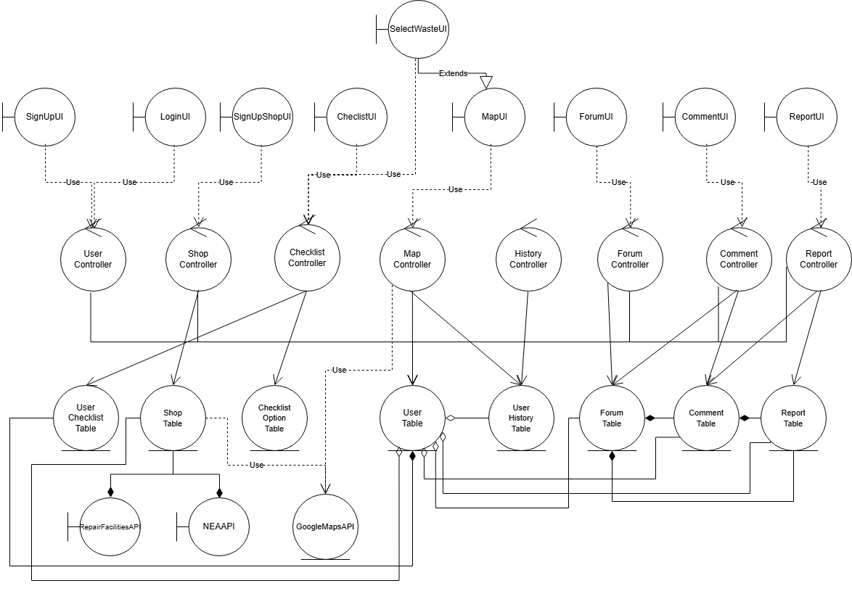

6.4 Class Diagram
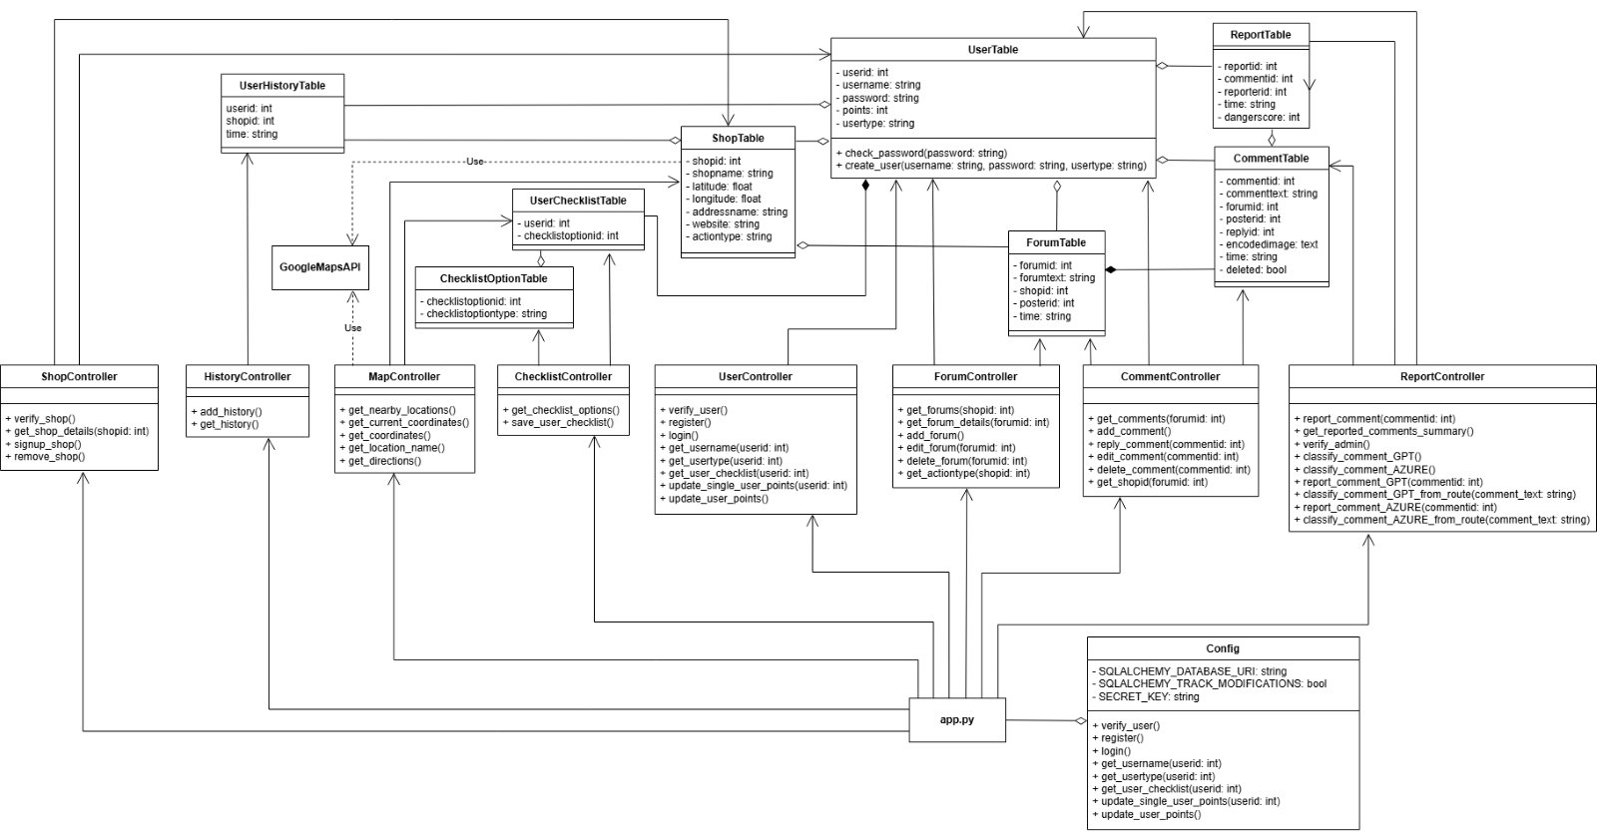

6.6 Sequence Diagrams

User Related
SignUp
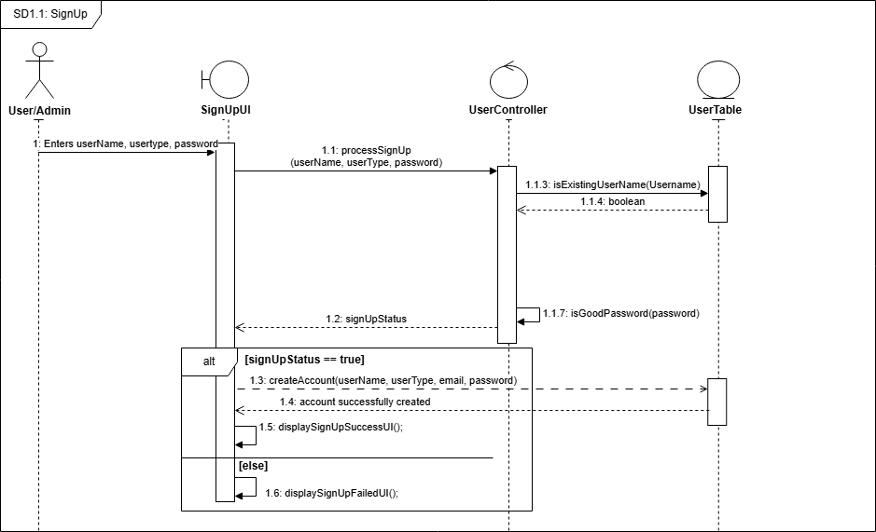

Login
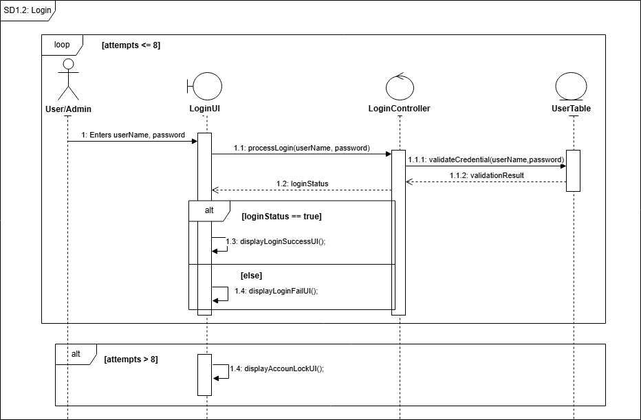

Checklist Management
CreateChecklist
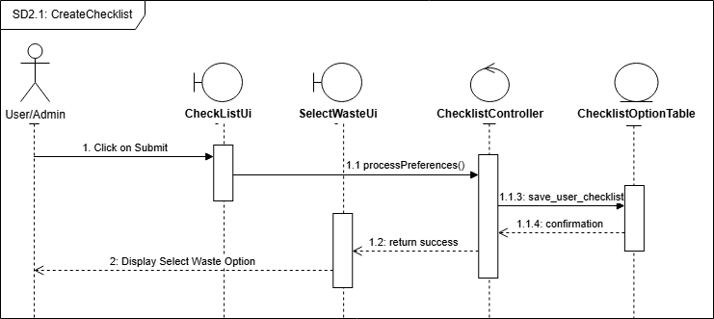

UpdateChecklist
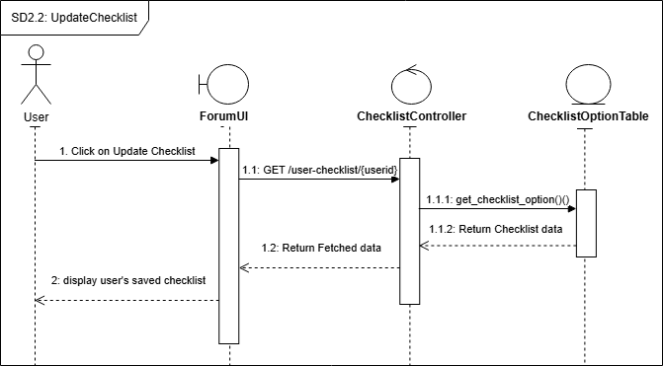

Map/Location Features
SelectWaste
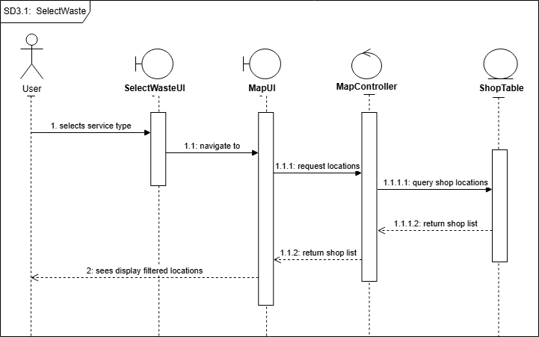

GetCurrentCoordinates
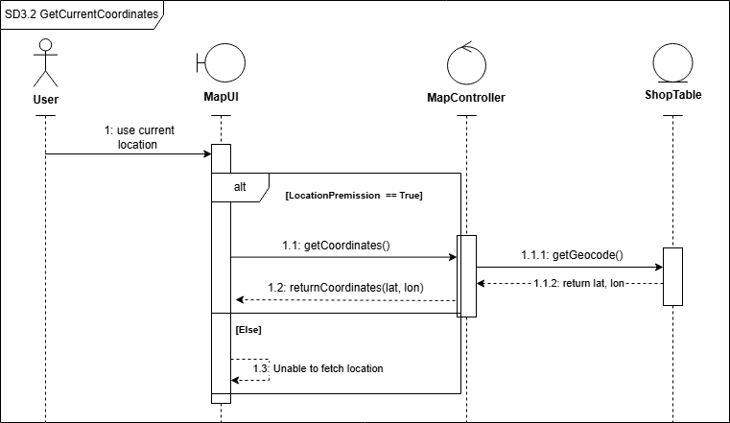

GetCoordinates
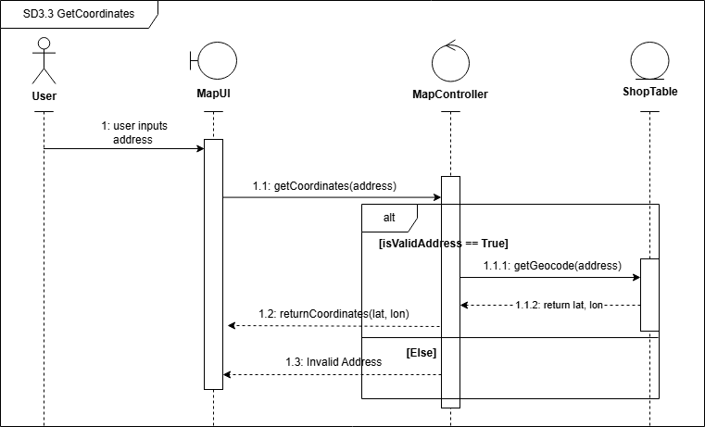

GetDirections
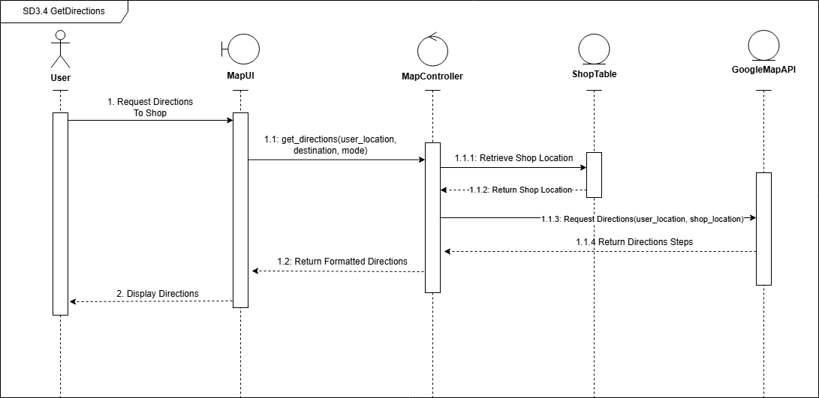

ShowNearbyLocations
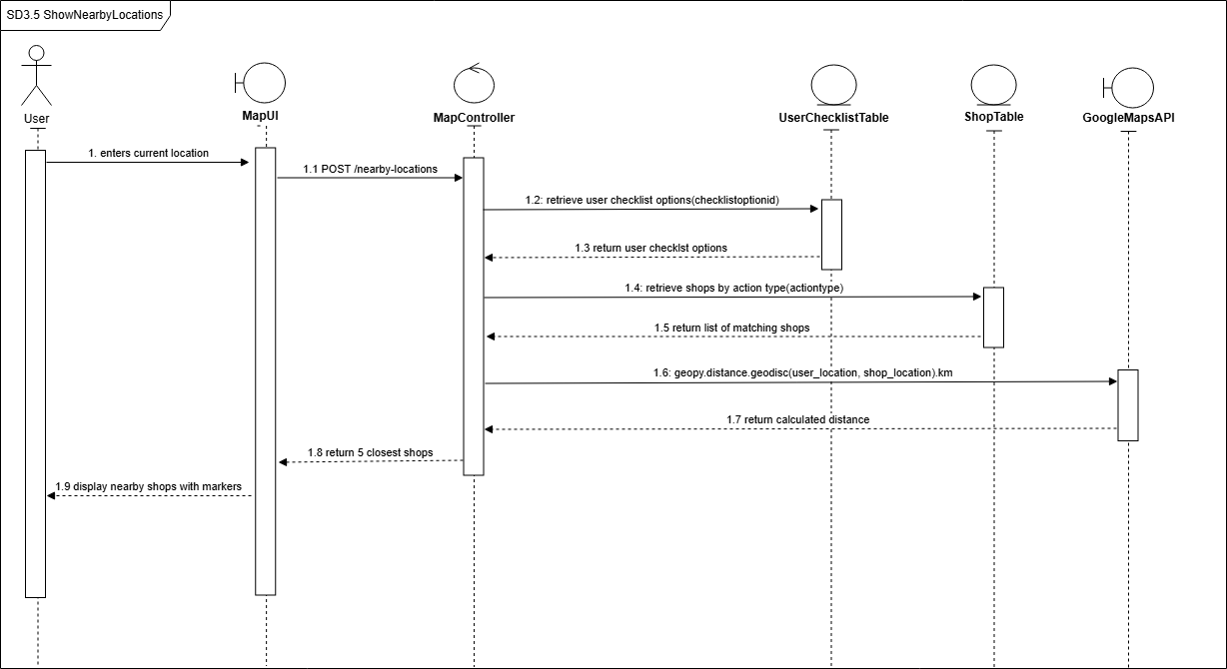

StoreLocationHistory
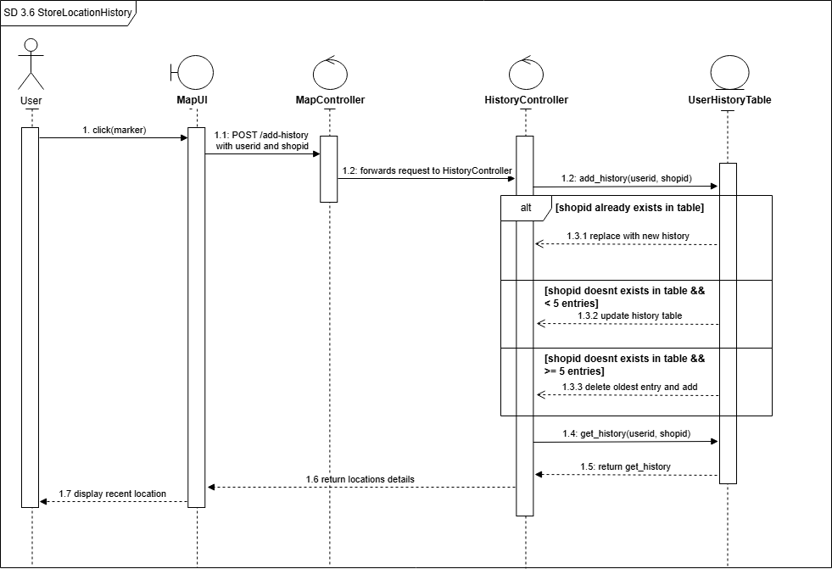

ShowLocationDetails
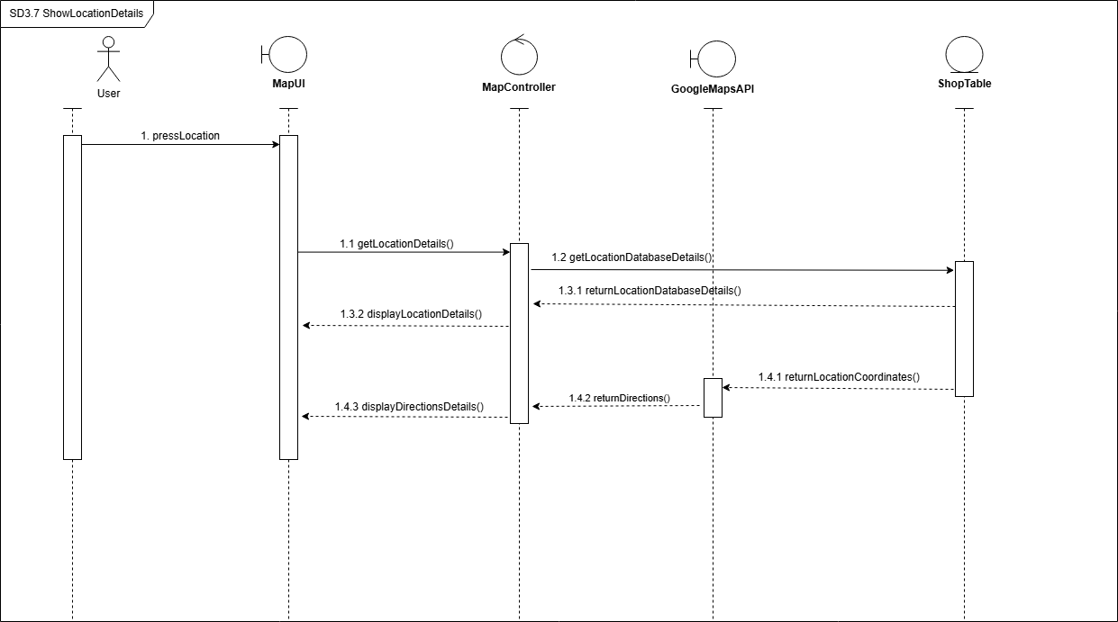

Shop Management
AddShop
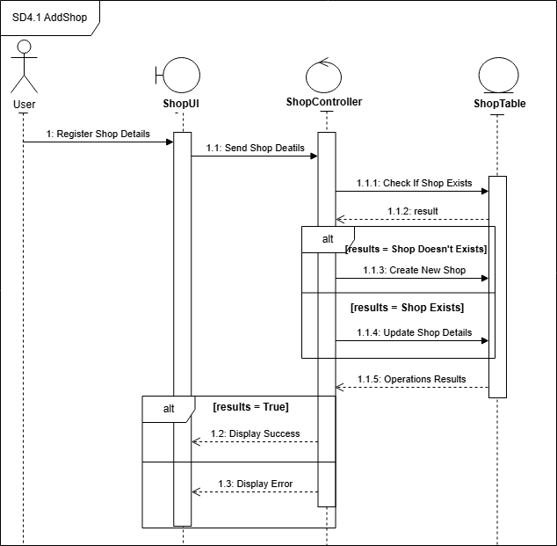

EditShop
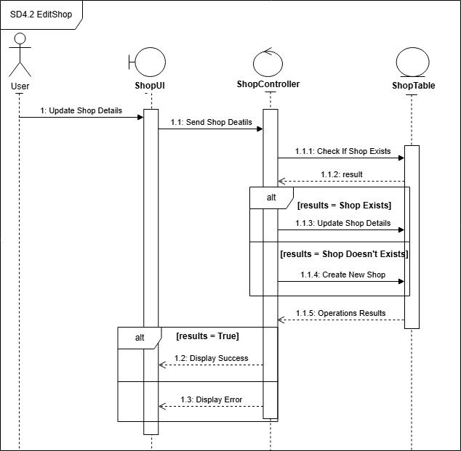

RemoveShop
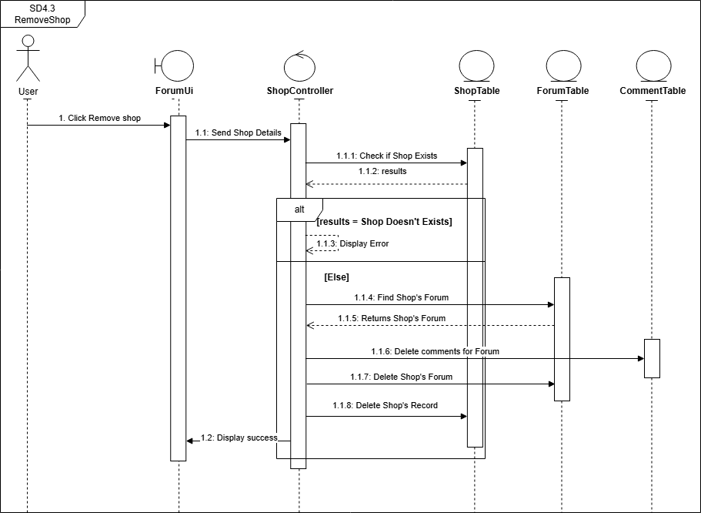

Forum Features
ViewForum
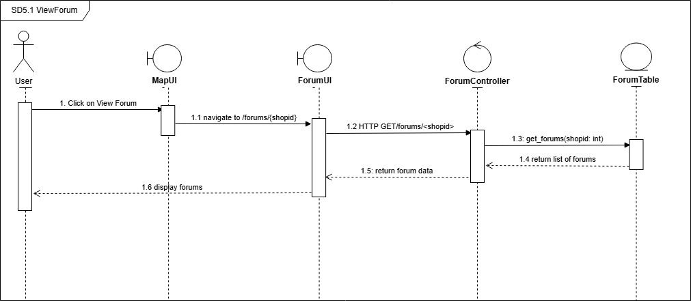

AddForum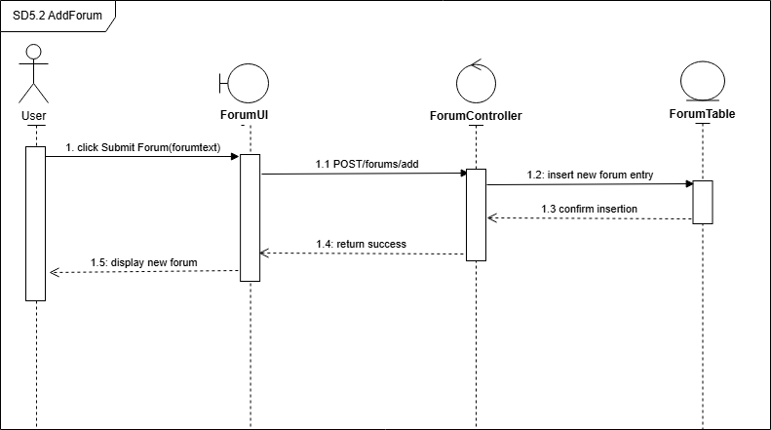

EditForum
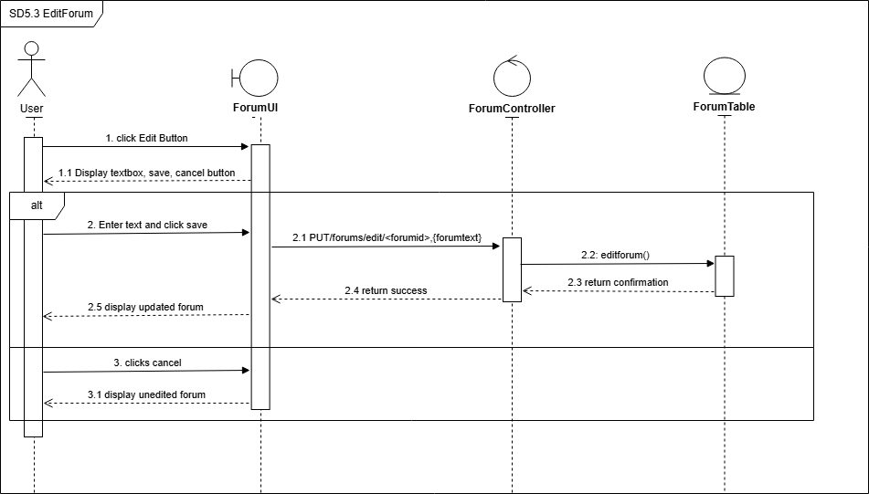

DeleteForum
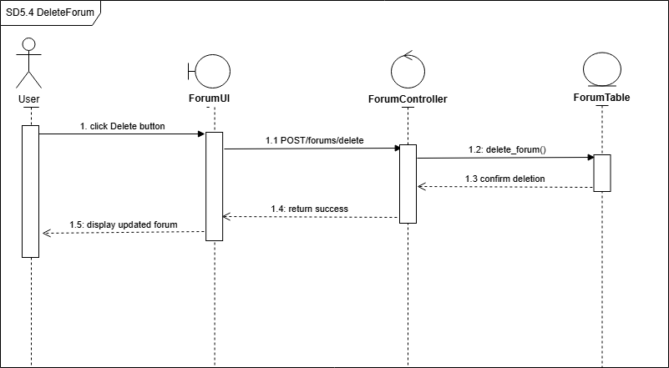

Comment Features
AddComment
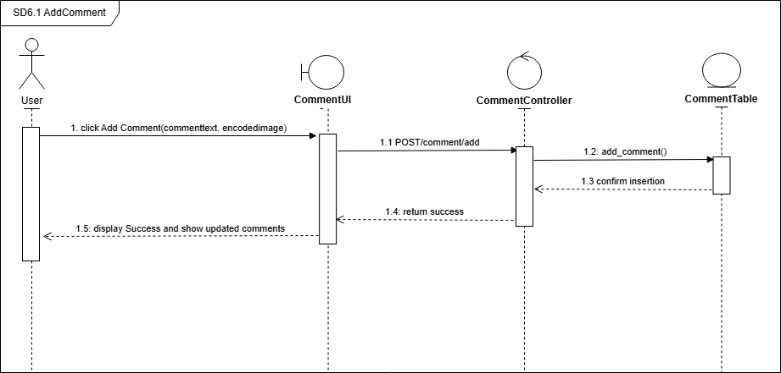

ReplyToComment
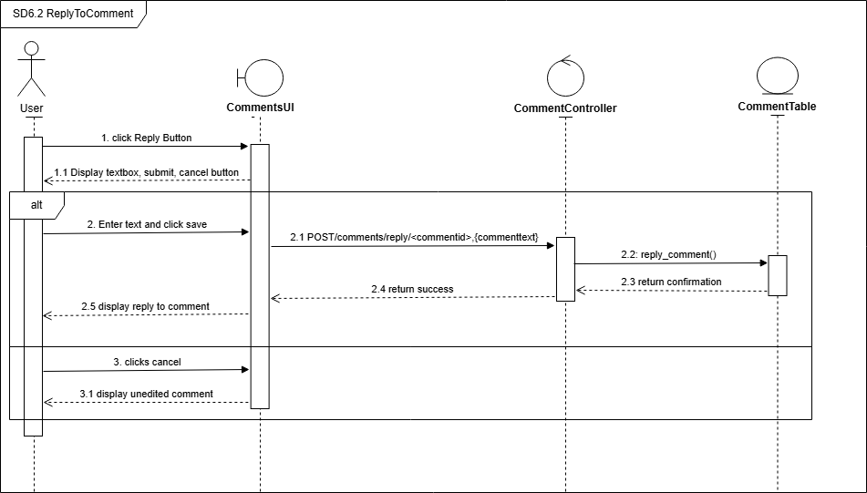

EditComment
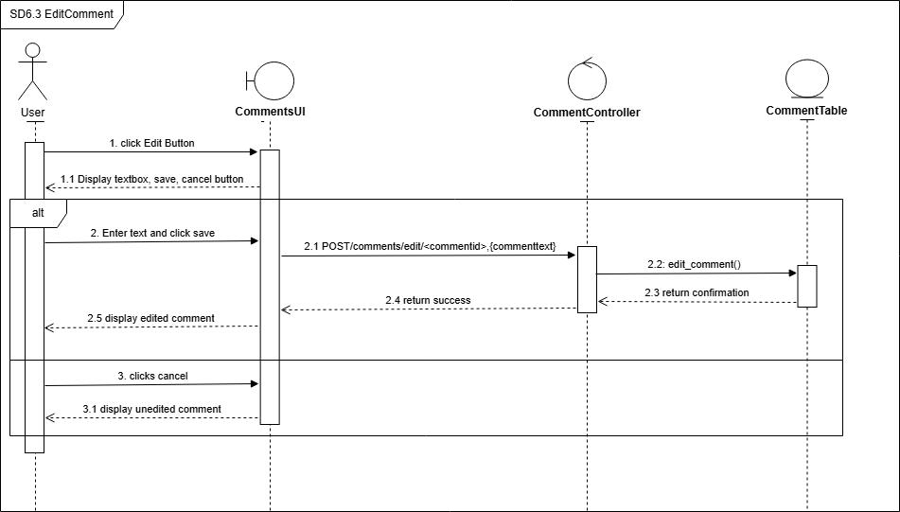

DeleteComment
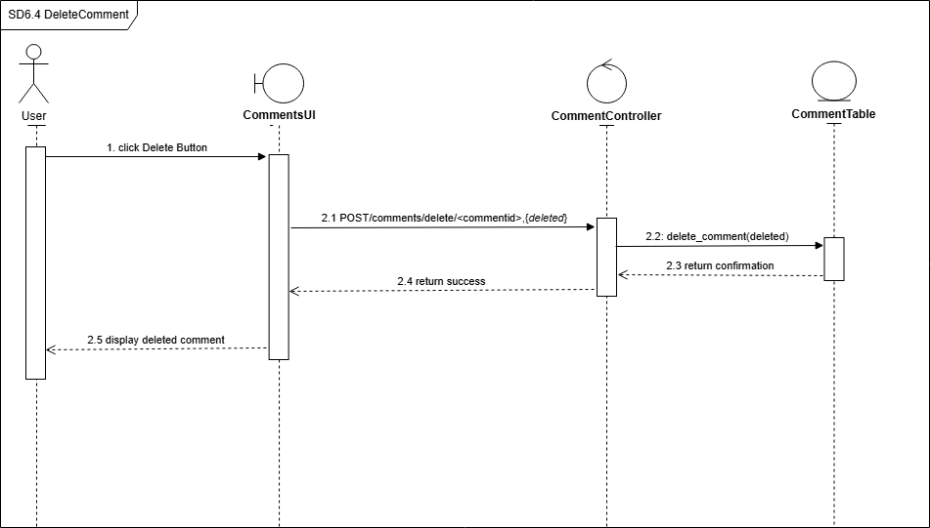

ReportComment
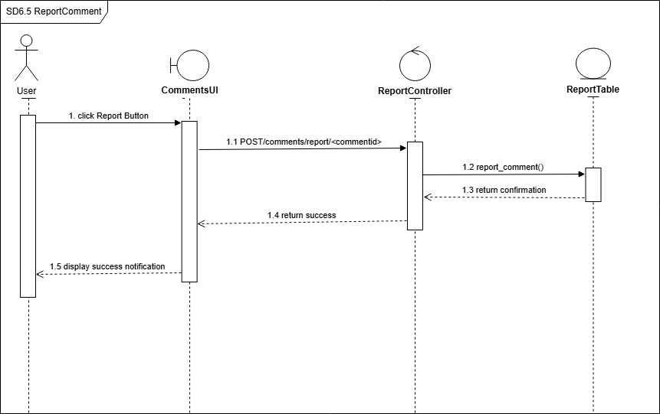

Reporting Management
GetReportedComments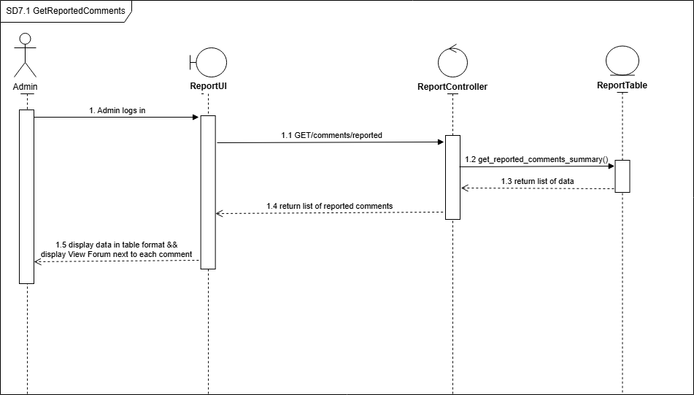

6.7 Dialogue Map
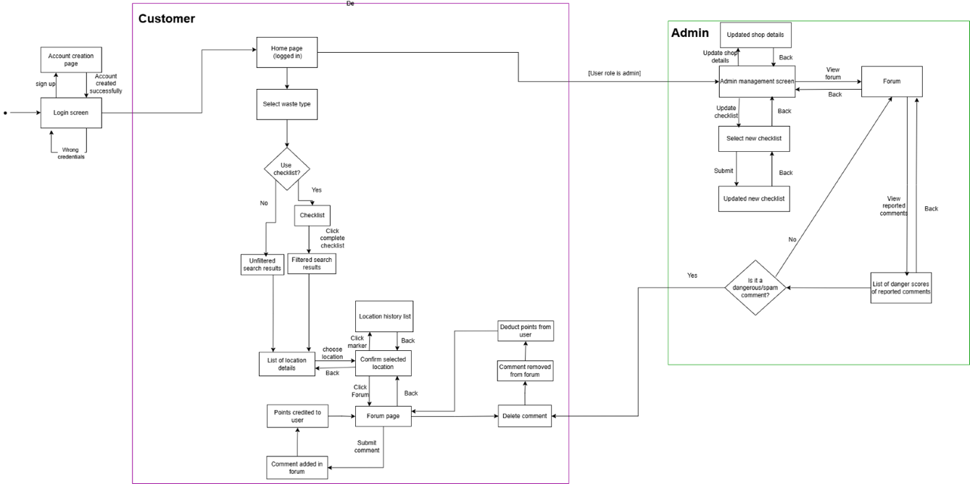
A clearer and enlarged image of the dialogue map can be found in Initial Dialogue Map.png

6.8 System Architecture

6.9 Testing
Our objective is to document the steps taken to test our system. The test cases below will be used to verify if our end-to-end system works properly. Both frontend and backend testing will be documented.

We have used both black box and white box testing based on the type of testing we wish to do. For the testing of integrations, we prioritised white box testing, as we wish to ensure that the different controllers interact properly. For the checking of interfaces, we prioritised black box testing, to ensure that from the user’s perspective, the given inputs results in the desired outputs, and all edge cases are handled appropriately.

6.9.1 Black Box Testing

Login
Inputs: Username (string), Password (string)
Test Case ID | Test Scenario | Test Input | Expected Output | Actual Output | Pass/Fail
TA001 | Valid username and password | Username: “test01”  Password: “Password” | Successful login | Successful login | Pass
TA002 | Valid username and empty password | Username: “test01”  Password: “” | System notify “Please fill in password field” | System notify “Please fill in password field” | Pass
TA003 | Valid username and invalid password | Username: “test01”  Password: “paword” | System notify “Invalid credentials. Please try again.” | System notify “Invalid credentials. Please try again.” | Pass
TA004 | Empty username and valid password | Username: “”  Password: “Password” | System notify “Please fill in username field” | System notify “Please fill in username field” | Pass
TA005 | Invalid username and valid password | Username: “test02”  Password: “Password” | System notify “Invalid credentials. Please try again.” | System notify “Invalid credentials. Please try again.” | Pass

Sign Up
Inputs: Username (string), Password (string)
Test Case ID | Test Scenario | Test Input | Expected Output | Actual Output | Pass/Fail
TB001 | Valid username and password | Username: “test02”  Password: “Password01” | System notify “Registration successful! Redirecting to login page.” | System notify “Registration successful! Redirecting to login page.” | Pass
TA002 | Valid username and empty password | Username: “test02”  Password: “” | System notify “Password cannot be empty.” | System notify “Password cannot be empty.” | Pass
TA003 | Empty username and valid password | Username: “”  Password: “Password01” | System notify “Username cannot be empty.” | System notify “Username cannot be empty.” | Pass

Location
Inputs: Address (words or postal code)
Test Case ID | Test Scenario | Test Input | Expected Output | Actual Output | Pass/Fail
TC001 | Valid address, complete wording | Address: ”Nanyang Technological University” | Shows location on map | Shows location on map | Pass
TC002 | Valid address, abbreviated wording | Address: “Nanyang tech u” | Shows location on map | Shows location on map | Pass
TC003 | Valid postal code | Address: ”570290” | Shows location on map | Shows location on map | Pass
TC004 | Case sensitivity | Address: ”nAnYaNg TeChNoLoGiCaL uNiVeRsItY” | Shows location on map | Shows location on map | Pass
TC005 | Invalid address wording | Address: ”Nanyang” | System notify ”Invalid Address” | System notify ”Invalid Address” | Pass
TC006 | Invalid postal code | Address: “570300” | System notify” Invalid Postal Code” | System notify ”Invalid Postal Code” | Pass
TC007 | Empty address | Address: “” | System notify ”Address cannot be empty” | System notify ”Address cannot be empty” | Pass

Forum Posting/Editing
Input: forum post (string)
Test Case ID | Test Scenario | Test Input | Expected Output | Actual Output | Pass/Fail
TD001 | Valid input | “Very amazing place, love it” | System notify “Forum posted successfully.” | System notify “Forum posted successfully.” | Pass
TD002 | Empty input | “” | System notify “Comment text cannot be empty.” | System notify “Comment text cannot be empty.” | Pass
TD003 | Invalid input, less than 10 characters | “boo” | System notify “Comment must be at least 10 characters.” | System notify “Comment must be at least 10 characters.” | Pass

Comment Posting/Editing
Input: comment post (string)
Test Case ID | Test Scenario | Test Input | Expected Output | Actual Output | Pass/Fail
TE001 | Valid input | “Great place with very kind people” | System notify “Forum posted successfully.” | System notify “Forum posted successfully.” | Pass
TE002 | Empty input | “” | System notify “Comment text cannot be empty.” | System notify “Comment text cannot be empty.” | Pass
TE003 | Invalid input, less than 10 characters | “blah” | System notify “Comment must be at least 10 characters.” | System notify “Comment must be at least 10 characters.” | Pass

6.9.2 White Box Testing

Register Shop
Control Flow Graph
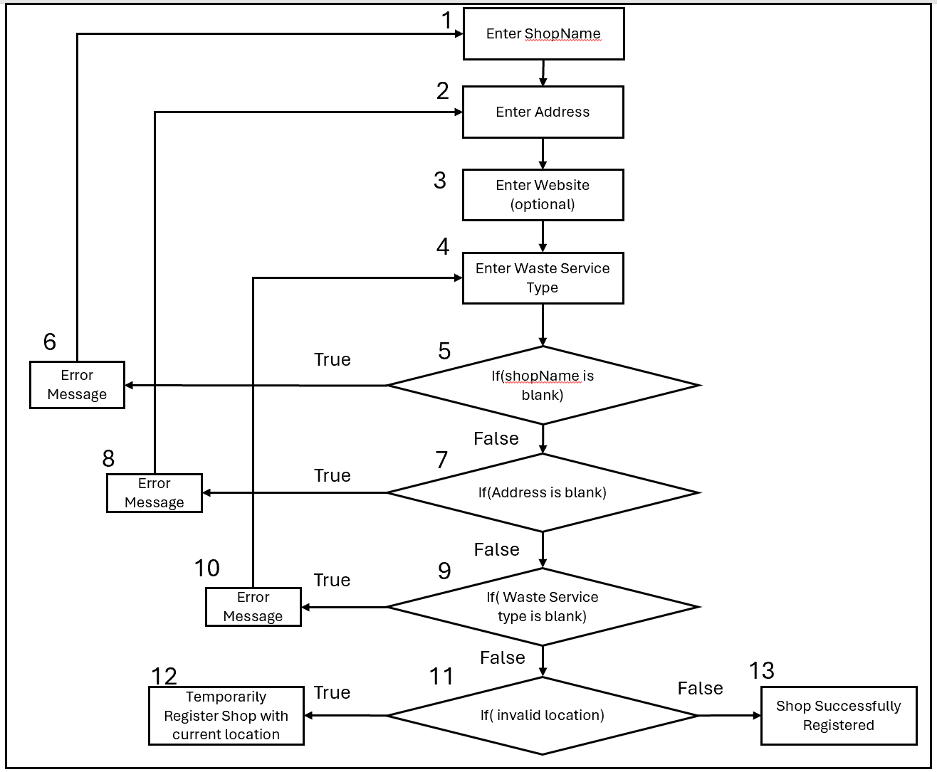

Basis Path Testing:

Cyclomatic Complexity = |Decision Points| + 1 = 4 + 1 = 5
Basis Paths:
- Baseline Path: 1,2,3,4,5,7,9,11,13
- Basis Path 2: 1,2,3,5,6
- Basis Path 3: 1,2,3,5,7,8
- Basis Path 4: 1,2,3,4,5,7,9,10
- Basis Path 5: 1,2,3,4,5,7,9,11,12

Test Cases & Results

Test scenario ID | Signup Shop | Test Case ID | Signup Shop 1-A
Test Case Description | Fill up details to register shop- Positive Test Case | Test priority | High
Prerequisite | Stable internet connection | Post requisite | NA

S. No | Action | Inputs | Expected Output | Actual Output | Test Result | Test Comments
1 | Enter Shop Name | “Test Shop” | Shop name field accepts valid text | Shop Name accepted | Pass | Valid Shop name provided
2 | Enter Address | “285C Toh Guan Rd, #01-92 Block 285C, Singapore 603285” | Address field accepts valid address | Address accepted | Pass | Valid address provided
3 | Enter Waste Service Type | "Electronics" | Waste service type field accepts valid input | Waste type accepted | Pass | All fields entered successfully
4 | Click Register | Click Register | Registration successful message displayed | Registration message | Pass | Shop successfully registered

Test scenario ID | Signup Shop | Test Case ID | Signup Shop 1-B
Test Case Description | Attempt registration with empty Shop Name- Negative Test Case | Test priority | High
Prerequisite | Stable internet connection | Post requisite | NA

S. No | Action | Inputs | Expected Output | Actual Output | Test Result | Test Comments
1 | Leave Shop Name Blank | “” (Blank) | Error message | Error message displayed | Pass | Shop name validation working
2 | Enter Address | “285C Toh Guan Rd, #01-92 Block 285C, Singapore 603285” | NA | NA | NA | Blocked by error
3 | Enter Waste Service Type | "Electronics” | NA | NA | NA | Blocked by error

Test scenario ID | Signup Shop | Test Case ID | Signup Shop 1-C
Test Case Description | Attempt registration with empty Address - Negative Test Case | Test priority | High
Prerequisite | Stable internet connection | Post requisite | NA

S. No | Action | Inputs | Expected Output | Actual Output | Test Result | Test Comments
1 | Enter Shop Name | "Test Shop" | Shop name field accepts valid text | Shop name accepted | Pass | Valid shop name provided
2 | Leave Address blank | “” (Blank) | Error message displayed | Error message displayed | Pass | Address validation working
3 | Enter Waste Service Type | "Electronics” | NA | NA | NA | Blocked by error

Test scenario ID | Signup Shop | Test Case ID | Signup Shop 1-D
Test Case Description | Attempt registration with empty Waste Service Type - Negative Test Case | Test priority | High
Prerequisite | Stable internet connection | Post requisite | NA

S. No | Action | Inputs | Expected Output | Actual Output | Test Result | Test Comments
1 | Leave Shop Name Blank | "Test Shop" | Shop name field accepts valid text | Shop name accepted | Pass | Valid shop name provided
2 | Leave Address blank | “285C Toh Guan Rd, #01-92 Block 285C, Singapore 603285” | Address field accepts valid address | Address accepted | Pass | Valid address provided
3 | Leave Waste Service Type blank | "” (Blank) | Error message | Error message | Pass | Waste service validation working

Test scenario ID | Signup Shop | Test Case ID | Signup Shop 1-E
Test Case Description | Attempt registration with invalid location - Negative Test Case | Test priority | High
Prerequisite | Stable internet connection | Post requisite | NA

S. No | Action | Inputs | Expected Output | Actual Output | Test Result | Test Comments
1 | Enter Shop Name | “Test Shop” | Shope name field accepts valid text | Shop Name accepted | Pass | Valid Shop name provided
2 | Enter Address | “123 main Street” | Address field accepts valid address | Address accepted | Pass | Invalid address provided
3 | Enter Waste Service Type | "Electronics" | Waste service type field accepts valid input | Waste type accepted | Pass | All fields entered successfully
4 | Click Register | Click Register | Registered Shop with Current Location | Registration message | Pass | Shop successfully registered

Map
Control Flow Graph
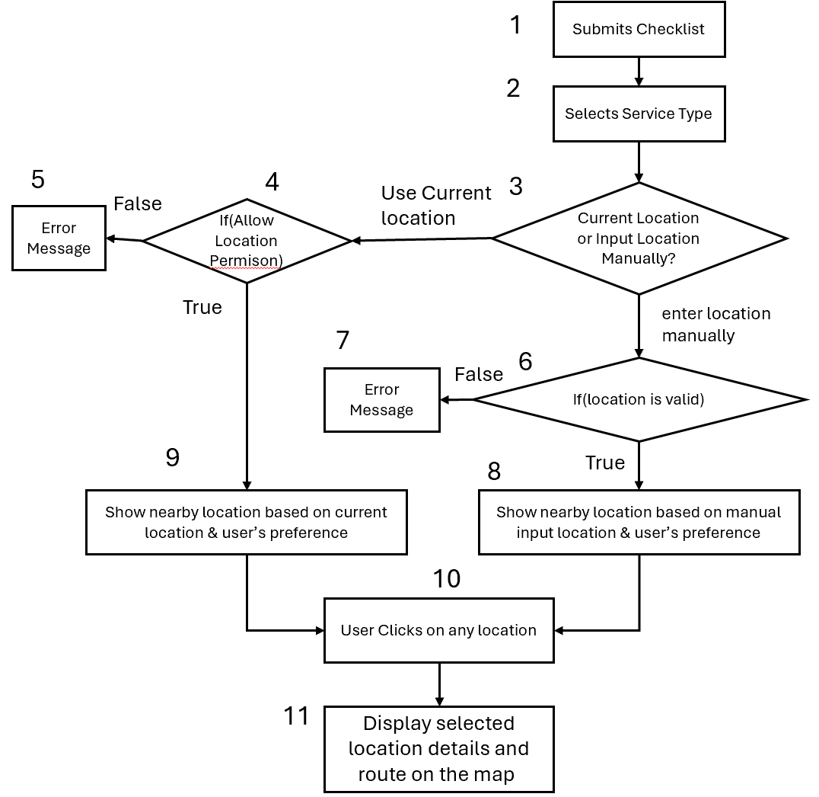
Basis Path testing

Cyclomatic Complexity = ∣Decision Points∣+1=3+1=4
Basis Paths:
- Baseline Path: 1, 2, 3, 4, 9, 10, 11
- Basis Path 2: 1, 2, 3, 6, 8, 10, 11
- Basis Path 3: 1, 2, 3, 4, 5
- Basis Path 4: 1, 2, 3, 6, 7
Test cases & Results
Test scenario ID | Map-1 | Test Case ID | Map-1A
Test Case Description | Find nearby locations using current location – Positive Test Case | Test priority | High
Pre requisite | Stable Internet Connection and logged in | Post requisite | NA

S. No | Action | Inputs | Expected Output | Actual Output | Test Result | Test Comment
1 | User submits checklist | Waste Type | Location type menu:  1. E-waste repair  2. E-waste disposal  3. General Waste | Location type menu:  1. E-waste repair  2. E-waste disposal  3. General Waste | Pass | User successfully sees the waste type options
2 | User selects Service type | Service Type | Map View | Map view | Pass | -
3 | User allows location access | User location | Populated map of nearby locations matching user’s waste preference | Populated map of nearby locations matching user’s waste preference | Pass | Nearby locations are displayed correctly
4 | User Clicks on any location | - | Display selected location details and route on the map | Display selected location details and route on the map | Pass | Location details are displayed

Test scenario ID | Map-1 | Test Case ID | Map-1B
Test Case Description | Find nearby locations using current location – Negative Test Case | Test priority | High
Pre requisite | Stable Internet Connection and logged in | Post requisite | NA

S. No | Action | Inputs | Expected Output | Actual Output | Test Result | Test Comment
1 | User submits checklist | Waste Type | Location type menu:  1. E-waste repair  2. E-waste disposal  3. General Waste | Location type menu:  1. E-waste repair  2. E-waste disposal  3. General Waste | pass | User successfully sees the waste type options
2 | User selects Service type | Service Type | Map View | Map view | Pass | -
3 | User Denies  location access | - | Error Message | Error Message | Pass | -

Test scenario ID | Map-2 | Test Case ID | Map-2A
Test Case Description | Find nearby locations using manual location input – Positive Test Case | Test priority | High
Pre requisite | Stable Internet Connection and logged in | Post requisite | NA

S. No | Action | Inputs | Expected Output | Actual Output | Test Result | Test Comment
1 | User submits checklist | Waste Type | Location type menu:  1. E-waste repair  2. E-waste disposal  3. General Waste | Location type menu:  1. E-waste repair  2. E-waste disposal  3. General Waste | Pass | User successfully sees the waste type options
2 | User selects location type | Location type | Populated map of nearby locations matching user’s waste preference | Populated map of nearby locations matching user’s waste preference | Pass | Nearby locations are displayed correctly
3 | User Clicks “Enter Location Manually” | - | Text field to type in address | Text field to type in address | Pass | Works as expected
4 | User inputs location | 531219 | Updated map of nearby locations matching user’s waste preference  based on input location | Updated map of nearby locations matching user’s waste preference based on input location | Pass | Works as expected
5 | User Clicks on any location | - | Display selected location details and route on the map | Display selected location details and route on the map | Pass | Works as expected

Test scenario ID | Map-2 | Test Case ID | Map-2B
Test Case Description | Find nearby locations using manual location input – Negative Test Case | Test priority | High
Pre requisite | Stable Internet Connection and logged in | Post requisite | NA

S. No | Action | Inputs | Expected Output | Actual Output | Test Result | Test Comment
1 | User submits checklist | Waste Type | Location type menu:  1. E-waste repair  2. E-waste disposal  3. General Waste | Location type menu:  1. E-waste repair  2. E-waste disposal  3. General Waste | Pass | User successfully sees the waste type options
2 | User selects location type | Location type | Populated map of nearby locations matching user’s waste preference | Populated map of nearby locations matching user’s waste preference | Pass | Nearby locations are displayed correctly
3 | User Clicks “Enter Location Manually” | - | Text field to type in address | Text field to type in address | Pass | Works as expected
4 | User inputs invalid location | 894432 | Error Message: “Failed to fetch coordinates for the given address” | Error Message: “Failed to fetch coordinates for the given address” | Pass | Invalid location validation works correctly

Appendix A: User Manual
Step 1: Accessing eCycle
Visit the eCycle website at using your preferred web browser on your computer or mobile device.

Step 2: Account Creation/Login
Existing User: Click "Login" and enter your registered email address and password.
New User: Click "Sign Up" to create a new account. You will need to provide a valid username abd create a password.
Step 3: Finding Disposal/Repair Locations
Search: Enter your location (address or use your device's geolocation) and the type of e-waste you want to dispose of or repair. You can select from a list of e-waste categories.
View Results: eCycle will display a list of nearby facilities that accept your e-waste, along with their details. You can view these as a list and on a map.
Select a Location: Click on a facility to view more details, including address, website, contact information, user reviews, and photos of previously accepted e-waste (if available).

