1. What are the various elements of the Excel interface? Describe how they're used.

**Ans**: Various Elements of the Excel Interface:

**Ribbon**: Located at the top, it contains tabs (Home, Insert, etc.) with groups of related commands for various tasks.

**Formula** **Bar**: Displays the contents of the active cell and allows input or editing.

**Cells**: The grid where you input data, perform calculations, and create visualizations.

**Sheet** **Tabs**: At the bottom, they allow navigation between different sheets within a workbook.

**Name** **Box**: Shows the address of the selected cell or range.

**Column** **and** **Row** **Headers**: Identify columns by letters (A, B, ...) and rows by numbers (1, 2, ...).

**Status** **Bar**: Displays information about the current operation or the status of selected cells.

1. Write down the various applications of Excel in the industry.

**Ans**: Applications of Excel in the industry:

* Data Analysis and Reporting
* Financial Modeling and Analysis
* Project Management
* Inventory Management
* Budgeting and Forecasting
* HR and Payroll Management
* Customer Relationship Management (CRM)
* Data Visualization

1. On the ribbon, make a new tab. Add some different groups, insert commands in the groups and name them according to their commands added. Copy and paste the screenshot of the steps you followed.

**Ans**:

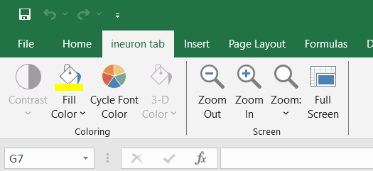

1. Make a list of different shortcut keys that are only connected to formatting with their functions.

**Ans**: Below are the shortcut keys that are only connected to formatting with their functions:

* Ctrl + B: Bold
* Ctrl + I: Italic
* Ctrl + U: Underline
* Ctrl + 1: Format Cells dialog
* Ctrl + Shift + $: Currency format
* Ctrl + Shift + %: Percentage format
* Ctrl + Shift + #: Date format
* Ctrl + Shift + @: Time format

1. What distinguishes Excel from other analytical tools?

**Ans**: Below are the aspects that distinguishes Excel from other analytical tools:

Versatility: Excel is adaptable for various tasks beyond analysis.

Integration: Seamlessly integrates with other Microsoft Office applications.

Formula Language (Excel Functions): Powerful functions for complex calculations.

PivotTables and Charts: Efficient tools for data analysis and visualization.

Data Validation and Protection: Ensures data accuracy and security.

1. Create a table and add a custom header and footer to your table.

**Ans**:

