1. Using Insert Function, give examples of any function available in the different dropdowns present in the function library. For example, AutoSum, Recently Used, Text, Date & Time, etc.

**Ans**: Using Insert Function:

* AutoSum:

Click on a cell where you want the sum. Go to the "Formulas" tab, click "AutoSum" in the "Function Library" group.

* Recently Used:

In the "Formulas" tab, click "Insert Function."

In the "Insert Function" dialog, check the "Recently Used" category.

* Text:

In the "Formulas" tab, click "Insert Function."

In the "Insert Function" dialog, select the "Text" category.

* Date & Time:

In the "Formulas" tab, click "Insert Function."

In the "Insert Function" dialog, choose the "Date & Time" category.

1. What are the different ways you can select columns and rows?

**Ans**: Below are the different ways to select columns and rows:

* Click and Drag: Select the column/row header and drag to select multiple.
* Ctrl + Space: Select the entire column of the active cell.
* Shift + Space: Select the entire row of the active cell.
* Ctrl + Shift + Arrow Keys: Extend the selection in the direction of the arrow key.

1. What is AutoFit and why do we use it?

**Ans**: AutoFit adjusts the column width or row height to fit the contents. We use it because it ensures all content is visible without unnecessary empty space or truncation.

1. How can you insert new rows and columns into the existing table?

**Ans**: This is the way:

**Rows**: Right-click on the row below where you want to insert -> Select "Insert."

**Columns**: Right-click on the column to the right of where you want to insert -> Select "Insert."

1. How do you hide and unhide columns in excel?

**Ans**: Below are the steps:

**Hide**: Select the column(s) you want to hide -> Right-click and choose "Hide."

**Unhide**: Select the columns adjacent to the hidden ones -> Right-click and choose "Unhide."

1. Create an appropriate table within the worksheet and use different functions available in the AutoSum command.

Ans: Below are the auto sum used

**Sum**: **Average**:

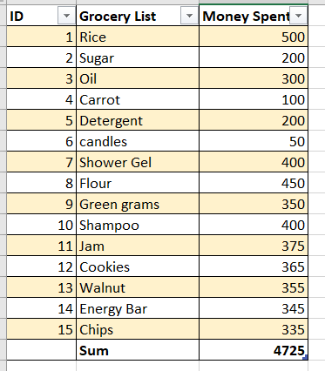 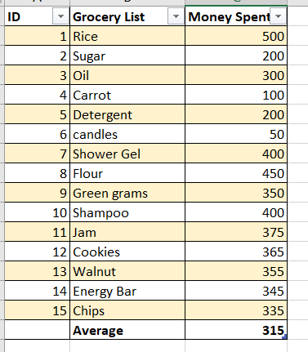

**Count**: **Max**:

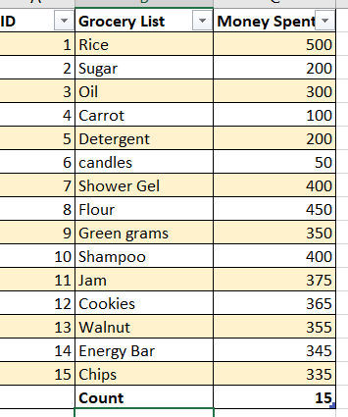 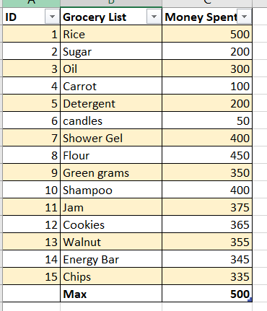

**Min**:

