1. What do you mean by AutoComplete feature in Excel and what are the benefits of using this feature?

**Ans**: Meaning: AutoComplete predicts the remaining characters of a word or phrase based on the input, making data entry faster.

Benefits: Saves time by reducing the need to type repetitive entries, enhances accuracy, and minimizes errors.

1. Explain working with workbooks and working with cells.

**Ans**: Workbooks: Excel files containing one or more worksheets. Manage them with tasks like creating, opening, saving, and organizing.

Cells: Basic units where data is entered. Perform operations like data entry, formatting, and applying formulas.

1. What is fill handle in Excel and why do we use it?

**Ans**: A small square at the bottom-right corner of a selected cell. Used to fill cells with data or extend a series. We use it because efficient for copying formulas, numbers, dates, or text patterns across cells or columns.

1. Give some examples of using the fill handle.

**Ans**: AutoFill Numbers: Enter a number in a cell, grab the fill handle, and drag to fill a series.

AutoFill Formulas: Create a formula, use the fill handle to extend it to adjacent cells.

AutoFill Dates: Enter a date, use the fill handle to create a series of dates.

1. Describe flash fill and what the different ways to access the flash fill are.

**Ans**: A feature that automatically fills values in a column based on patterns it recognizes.

Ways to Access Flash Fill:

Home tab: In the "Editing" group, click "Fill," and then choose "Flash Fill."

Shortcut: Press Ctrl + E after entering data in a column.

1. Extract first name and last name from the mail id and then from the address column, extract the city, state, and pin code using the flash fill. Given below is an example of the columns you have to create. Paste the screenshot of what you have created using the flash fill command. Example: Mail Id, Address, First name, Last name, State, City, Pincode

**Ans**:

Before Flash Fill:

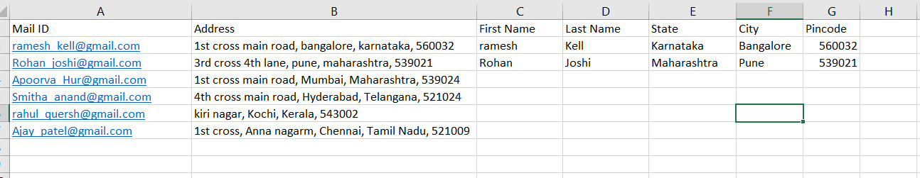

During Flash Fill

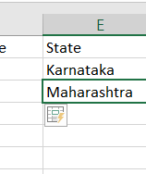

After Flash Fill + table formatting:

