1. What are the different margins options and do we adjust the margins of the excel worksheet?

**Ans**: Margins Options:

**Top**: Space between the top of the page and the worksheet.

**Bottom**: Space between the bottom of the page and the worksheet.

**Left**: Space between the left of the page and the worksheet.

**Right**: Space between the right of the page and the worksheet.

**Header**: Space between the header and the top of the page.

**Footer**: Space between the footer and the bottom of the page.

**Adjusting** Margins: Margins are adjusted in Page Layout tab > Margins. It helps control the layout and appearance when printing.

1. Set a background for your table created.

**Ans**: 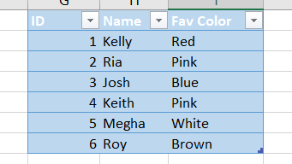

1. What is freeze panes and why do we use freeze panes? Give examples.

**Ans**: Freeze Panes allows you to lock specific rows or columns in place while scrolling. We use it for keeping headers visible while scrolling through large datasets.

Example: To freeze the top row, go to the "View" tab, click "Freeze Panes," and choose "Freeze Top Row."

1. What are the different features available within the Freeze Panes command?

**Ans**: Freeze Panes: Locks the selected rows and columns.

Freeze Top Row: Keeps the top row visible.

Freeze First Column: Keeps the leftmost column visible.

Unfreeze Panes: Unlocks frozen rows and columns.

1. Explain what the different sheet options present in excel are and what they do

**Ans**: **Insert Worksheet**: Adds a new worksheet to the workbook.

**Delete Worksheet**: Removes the selected worksheet.

**Rename**: Changes the name of the selected worksheet.

**Move or Copy**: Allows moving or copying the worksheet within the workbook.

**Protect Sheet**: Secures the worksheet with a password.

**Tab Color**: Changes the color of the worksheet tab for easy identification.