Name Adam Cobb Mark _____________________/50

## Brief introduction __/3

**Where’s My Spaceship** is a 2D action-adventure game featuring multi-era exploration, platforming, and dynamic combat. As part of the development team, I am responsible for designing and implementing key game interface elements including the **Inventory, HUD Main Menu, and Pause Menu**. These features are essential for enhancing the player’s experience by providing unique features for the HUD in the different respective era’s.

The **Inventory system** allows players to manage collected items, era-specific artifacts, and upgrades. The **HUD** provides real-time gameplay information such as health, abilities, collected ship parts, and current objectives. The **Main Menu** offers essential navigation for starting a new game, loading progress, or adjusting game settings, while the **Pause Menu** ensures players can take breaks, access controls, or modify settings without losing progress.

These interface components are integral to creating an immersive and user-friendly experience as players guide **Dr. Tempus Rift** through prehistoric landscapes, medieval castles/fields, and cyberpunk cities in search of his lost spaceship.

## Use case diagram with scenario __14

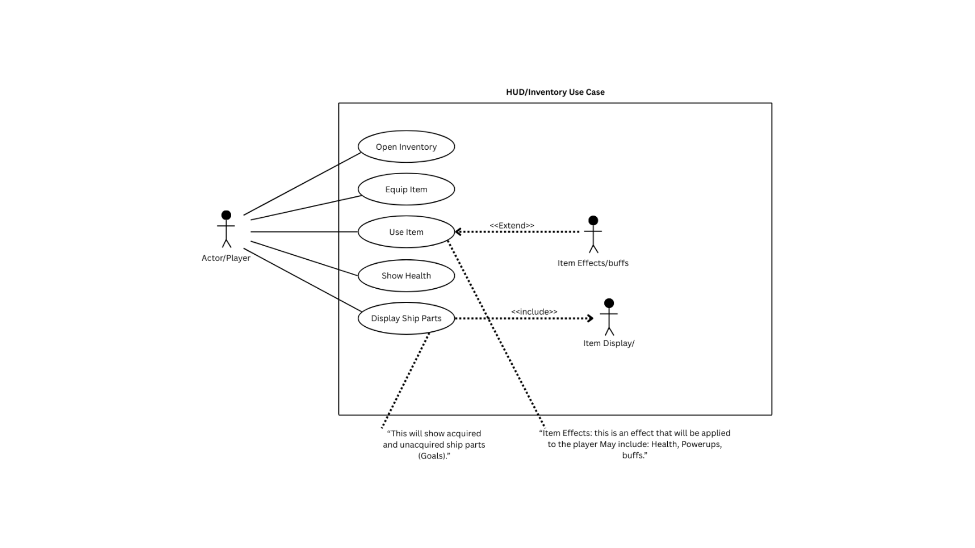

### Scenarios

**Name:** HUD/Inventory Use Case Diagram

**Summary: HUD Diagram: Shows the player as an external actor interacting with the HUD system. The system contains functions that display real-time game information, such as health, collected items, abilities, objectives, and timers. The diagram emphasizes monitoring and feedback, not direct gameplay actions.**

**Actors:**

**Actor (Outside the Box):**

* Player – needs real-time information during gameplay.

**System (Inside the Box):**

* Display Health
* Show Collected/Uncollected Ship Parts
* Show Equip Item
* Shows Inventory

**Preconditions:**

**HUD:**

* The game is running.
* Player character exists and has initialized stats (health, abilities, inventory).
* Level or mission data is loaded.
* HUD system is initialized and ready to display information.

**Basic sequence:**

**Step 1: Initialize and display HUD elements (health, abilities, score, timer).  
Step 2: Continuously update HUD based on player actions and game events.  
Step 3: Reflect changes immediately (e.g., health drops, items collected, objectives updated).  
Step 4: Maintain display until game ends or HUD is turned off.Exceptions:**

**Post conditions:**

All relevant game information (health, score, abilities, collected items, timer) is **accurately displayed** to the player.

Player has **up-to-date feedback** for decision-making during gameplay.

HUD remains active and responsive throughout gameplay until the game ends or the HUD is disabled.

**Priority:** 2*

**ID:** UC01 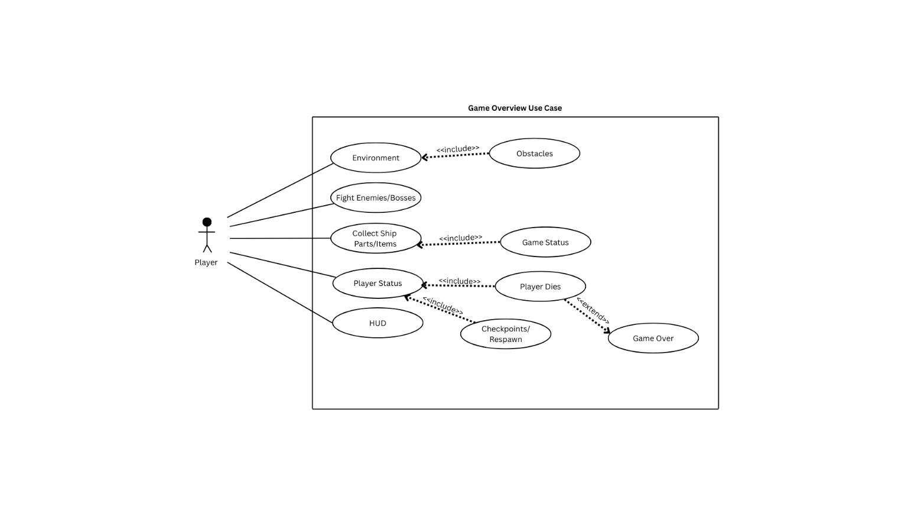

**Name:** Game Overview Use Case Diagram

**Summary: Game Overview / Main Loop Diagram: Shows the player as an external actor interacting with the main game system. The system encapsulates the core gameplay mechanics, including exploration, combat, puzzle-solving, item collection, inventory updates, and status checks. It also includes sub-processes like Game Over and Victory, demonstrating the game’s response to the player’s state.**

**Actors:**

**Actor (Outside the Box):**

* Player – explores, fights, collects items, solves puzzles.

**System (Inside the Box):**

* Explore Environment (🡨 Obstacles)
* Fight Enemies / Bosses
* Collect Ship Parts / Items ( 🡨 Game Status)
* Check Player Status (Alive / Dead) (🡨 Player dies 🡨 Game Over ) and (🡨 Checkpoints and Respawn)

**Preconditions:**

**Game Overview / Main Game Loop:**

* Game engine has started.
* Player has control of the character.
* Environment, enemies, and items are loaded.
* Necessary systems (HUD, inventory, combat, puzzles) are initialized.

**Basic sequence:**

* **Step 1: Load game environment, player character, enemies, items, and systems.**
* **Step 2: Accept player actions (movement, attacks, interactions).**
* **Step 3: Update game state based on player actions (combat outcomes, puzzle completion, inventory changes).**
* **Step 4: Check player status (alive/dead) and game conditions (victory/mission complete).**
* **Step 5: Trigger feedback through HUD, sounds, animations, or Game Over / Victory screens.**
* **Step 6: Repeat loop until game ends or player quits. Post conditions:** Calculated value is displayed.

**Priority:** 1*

**ID:** UC02

## Data Flow diagram(s) from Level 0 to process description for your feature _______14

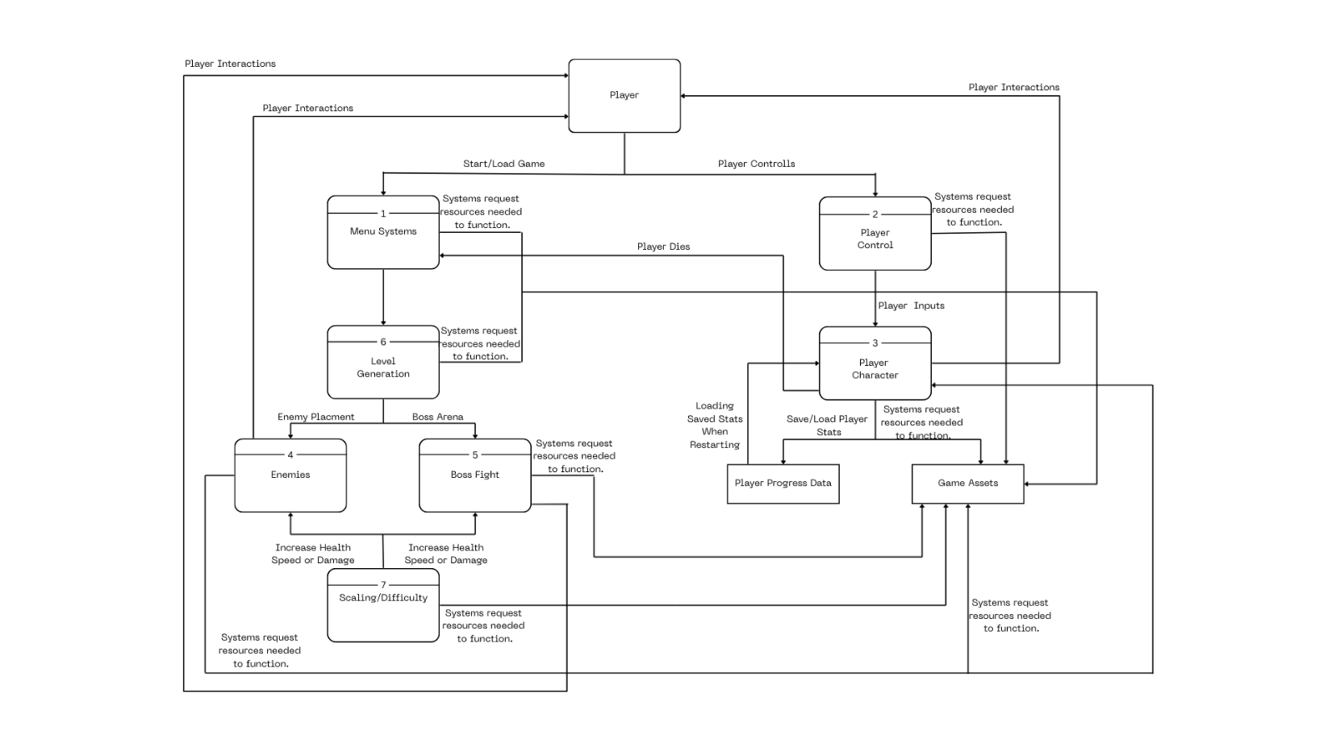

* 1. **Player Interactions**
* The player is the primary actor who initiates interactions such as starting the game, controlling the character, and providing inputs.
  1. **Menu Systems (1)**
* Handles starting or loading a game.
* Requests necessary resources to function (menus, UI assets).
* Passes control to **Level Generation (6)** to prepare the game world.
  1. **Player Control (2)**
* Receives player inputs (movement, actions).
* Requests required system resources for smooth gameplay.
* Sends inputs to **Player Character (3)** for execution.
  1. **Player Character (3)**
* Represents the in-game avatar controlled by the player.
* Receives inputs from **Player Control** and updates the game state.
* Communicates with **Player Progress Data** to save/load stats.
* Uses **Game Assets** (models, animations, sounds) as needed.
  1. **Enemies (4) & Boss Fight (5)**
* Enemies are spawned according to **Level Generation (6)**.
* Boss Fight represents special encounters (Boss Arena).
* Both receive adjustments from **Scaling/Difficulty (7)**, which can modify health, speed, or damage.
  1. **Level Generation (6)**
* Responsible for creating the game environment, placing enemies, and setting up boss arenas.
* Requests system resources to function properly.
  1. **Scaling / Difficulty (7)**
* Dynamically adjusts gameplay difficulty, modifying stats for **Enemies** and **Bosses** based on progression or settings.
* Ensures the game remains challenging but balanced.
  1. **Player Progress Data**
* Saves and loads player stats, inventory, and progress.
* Provides information to **Player Character** when restarting or continuing the game.
  1. **Game Assets**
* Provides required resources such as models, sounds, textures, and animations to all systems that need them.
  1. **Game Flow**
* Player starts the game via **Menu Systems** → Level is generated → Enemies and bosses are placed → Player interacts via controls → Game state updates dynamically → Progress is saved → Difficulty is scaled as needed → Feedback loops back to player via character, HUD, and gameplay results.

## Acceptance Tests ________9

**Example: HUD Feature Test**

**Input:** Simulated gameplay session where player takes damage, collects items, gains abilities, and completes objectives.

**Output (HUD display):**

* **Health: Never below 0, never above maximum set value.**
* **Items/Parts Collected: Count updates correctly each time an item is picked up.**
* **Objectives/Score: Updates consistently with game progress.**

**Boundary Cases:**

* player health starts at full → decrements correctly to 0.
* Player collects 0 items → HUD shows empty inventory.
* Player pauses game → HUD freezes but does not reset.

**Example: Game Overview / Main Loop Test**

**Input:** Simulated playthrough with exploration, combat, puzzle solving, and boss fight.  
**Output (Game System behavior):**

* **Environment:** Generated correctly at start; no missing assets.
* **Enemies:** Spawn in valid locations; never overlap incorrectly.
* **Boss Fight:** Triggers only once per level.
* **Game Over / Victory:** Triggers exactly once when conditions met.

**Boundary Cases:**

* Player starts with no saved data → new game initializes correctly.
* Player health = 0 at spawn → immediate Game Over triggered.
* Player collects all items → triggers Victory state.

**HUD Feature Test Cases**

|  |  |  |  |  |
| --- | --- | --- | --- | --- |
| Test ID | Description | Input | Expected Output | Boundary Case |
| HUD-01 | Health display | |  | | --- | |  |  |  | | --- | | Player takes damage | | Health decreases but never below 0 | Health starts full, decrements correctly to 0 |
| HUD-02 | Health max cap | Player collects healing items | Health increases but never above max | Healing at full health → stays max |
| HUD-03 | Item collection | Player picks up item | Item count increases | Player collects 0 items → HUD shows empty inventory |
| HUD-04 | Objective/score update | Player completes objective | Score/Objective progress updates | Completing final objective → triggers win condition |
| HUD-05 | HUD freeze on pause | Player pauses game | HUD display freezes (does not reset) | Game paused → HUD state unchanged |

**Game Overview / Main Loop Test Cases**

|  |  |  |  |  |
| --- | --- | --- | --- | --- |
| Test ID | Description | Input | Expected Output | Boundary Case |
| GOV-01 | Environment generation | |  | | --- | |  |  |  | | --- | | Start new game | | Level generates fully, no missing assets | Player starts with no saved data → new game initializes correctly |
| GOV-02 | Enemy spawning | Enter combat area | Enemies spawn in valid locations, no overlap | Edge of map spawning → still valid placement |
| GOV-03 | Boss fight trigger | Player reaches boss room | Boss spawns and triggers fight once | Boss triggers only once per level |
| GOV-04 | |  | | --- | | Game over condition |  |  | | --- | |  | | Player health reaches 0 | |  | | --- | |  |  |  | | --- | | Game Over screen shown exactly once | | Player health = 0 at spawn → immediate Game Over |
| GOV-05 | Victory condition | Player collects all items | Victory state triggered exactly once | Collecting all items triggers win sequence |

## Timeline _________/10

### Work items

|  |  |  |  |  |  |  |
| --- | --- | --- | --- | --- | --- | --- |
| Task | Duration (PWks) | Predecessor Task(s) | Early Start | Early Finish | Late Start | Slack Time |
| 1. Requirements Collection | 5 | - | 0 | 5 | 0 | 0 |
| 2. Screen Design | 6 | 1 | 5 | 11 | 5 | 0 |
| 3. Report Design | 6 | 1 | 5 | 11 | 5 | 0 |
| 4. Database Construction | 2 | 2,3 | 11 | 13 | 11 | 0 |
| 5. User Documentation | 6 | 4 | 13 | 19 | 15 | 2 |
| 6. Programming | 5 | 4 | 18 | 21 | 18 | 0 |
| 7. Testing | 3 | 6 | 18 | 21 | 18 | 0 |
| 8. Installation | 1 | 5, 7 | 21 | 22 | 21 | 0 |

### Pert diagram

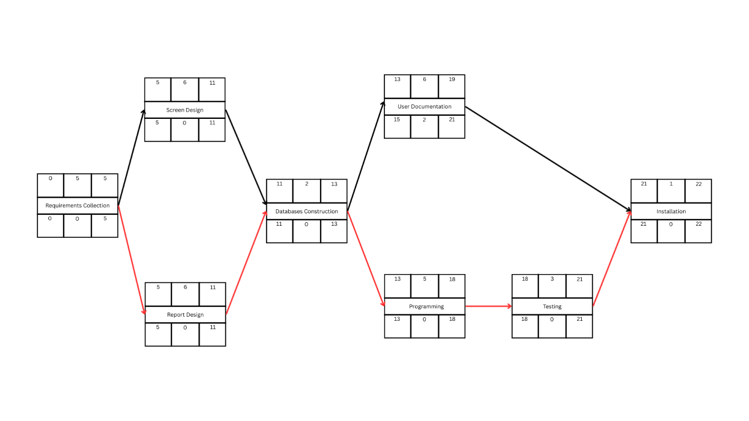

### Gantt timeline

|  |  |  |  |  |  |  |  |  |  |  |  |  |  |  |  |  |  |  |  |  |  |  |  |  |
| --- | --- | --- | --- | --- | --- | --- | --- | --- | --- | --- | --- | --- | --- | --- | --- | --- | --- | --- | --- | --- | --- | --- | --- | --- |
| 1 |  |  |  |  |  |  |  |  |  |  |  |  |  |  |  |  |  |  |  |  |  |  |  |  |
| 2 |  |  |  |  |  | 1 |  |  |  |  |  |  |  |  |  |  |  |  |  |  |  |  |  |  |
| 3 |  |  |  |  |  | 1 |  |  |  |  |  |  |  |  |  |  |  |  |  |  |  |  |  |  |
| 4 |  |  |  |  |  |  |  |  |  |  |  | 3 |  |  |  |  |  |  |  |  |  |  |  |  |
| 5 |  |  |  |  |  |  |  |  |  |  |  |  |  |  |  | 4 |  |  |  |  |  | S | S |  |
| 6 |  |  |  |  |  |  |  |  |  |  |  |  |  |  |  | 4 |  |  |  |  |  |  |  |  |
| 7 |  |  |  |  |  |  |  |  |  |  |  |  |  |  |  |  |  |  |  |  | 6 |  |  |  |
| 8 |  |  |  |  |  |  |  |  |  |  |  |  |  |  |  |  |  |  |  |  |  |  |  | 7 |
|  | 1 | 2 | 3 | 4 | 5 | 6 | 7 | 8 | 9 | 10 | 11 | 12 | 13 | 14 | 15 | 16 | 17 | 18 | 19 | 20 | 21 | 22 | 23 | 24 |