Name___Qiwei Liang_________________ Mark _____________________/50

## Brief introduction __/3

# Brief introduction

I am responsible for **designing and implementing the Boss Fight experience**. This work delivers climactic, fair, and memorable encounters that punctuate each era and advance progression.

The Boss Fight feature covers multi-phase encounters with **clear telegraphs**, **readable punish windows**, and **era-themed mechanics**. My scope includes **arena layout & hazards**, **AI state machines and behavior trees**, **stagger/phase transitions**, and **difficulty scaling** that tunes HP, damage, cooldowns, and projectile speeds across modes.

Each encounter **integrates with core systems**: Save/Load for checkpoints and fast retry, Player Progress for rewards and unlocks, Game Assets for animations/SFX/VFX, and the HUD to surface health, phase state, and objectives. **Victory** grants era-specific artifacts and ship parts that move the narrative forward; **defeat** triggers a quick reload with the option to skip intros, preserving flow and minimizing frustration.

These boss encounters are integral to creating an immersive and skill-rewarding experience as players guide **Dr. Tempus Rift** through prehistoric landscapes, medieval castles and fields, and cyberpunk cities in search of his lost spaceship.

## Use case diagram with scenario __14U

Use Case Diagrams

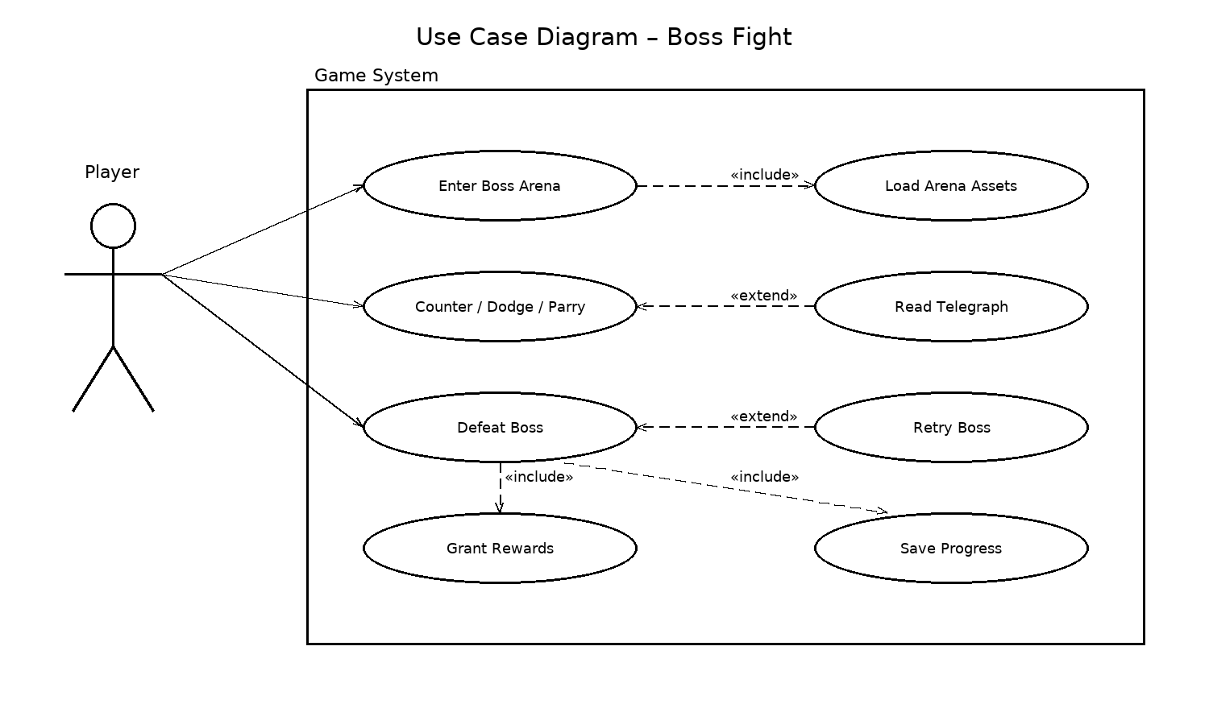

### Scenarios

Name: Enter Boss Arena  
Summary: The player enters the boss arena and the fight is initialized.  
Actors: Player, Game System.  
Preconditions: Player has reached the arena gate trigger; save data/context available.  
Basic sequence:  
 Step 1: Detect player crossing the arena trigger.  
 Step 2: Lock arena doors and (optionally) play the intro cut-in.  
 Step 3: Load and instantiate boss/arena resources (<> Load Arena Assets).  
 Step 4: Enable HUD elements; activate Boss AI in Phase 1.  
Exceptions:  
 Step 2: Intro is skipped by player → jump to Step 4 (fight starts immediately).  
 Step 3: High-quality assets unavailable → dynamically fall back to low-quality set and continue (dynamic binding of Load Arena Assets).

Post conditions: Boss fight begins; checkpoint set at arena entrance.  
Priority: 1  
ID: BF-UC01

Name: Counter / Dodge / Parry  
Summary: The player reads attack telegraphs and responds within the timing window.  
Actors: Player.  
Preconditions: Boss is executing an attack that has a readable telegraph; input system active.  
Basic sequence:  
 Step 1: Show telegraph (VFX/SFX and 0.8–1.2s windup in Phase 1).  
 Step 2: Player performs dodge/parry/counter within the valid window.  
 Step 3: System resolves: on success, avoid damage or apply stagger; on failure, apply damage/effects.  
Exceptions:  
 Step 1: Telegraph clarity insufficient or assist enabled → trigger <> Read Telegraph to enhance cues, then return to Step 2.  
 Step 2: Input late or incorrect → proceed to Step 3 failure branch (chip damage/guard break).  
Post conditions: Player/Boss states updated; potential punish window created.  
Priority: 1  
ID: BF-UC02

Name: Defeat Boss  
Summary: The player reduces the boss HP to zero and the game resolves rewards and progression.  
Actors: Player, Game System.  
Preconditions: Boss HP > 0; the fight is in any phase.  
Basic sequence:  
 Step 1: Player delivers the final blow (Boss HP ≤ 0).  
 Step 2: Play death animation and unlock arena exits.  
 Step 3: Grant rewards (<> Grant Rewards).  
 Step 4: Save progression and unlock next area (<> Save Progress).  
Exceptions:  
 Step 2: Player dies before death animation completes → trigger <> Retry Boss (see BF-UC04).  
 Step 3: Inventory full → route rewards to mailbox/stash, then continue with Step 4.  
Post conditions: Rewards granted and progress saved; next era/area unlocked.  
Priority: 1  
ID: BF-UC03

Name: Retry Boss  
Summary: On failure, the player quickly restarts the boss encounter.  
Actors: Player, Game System.  
Preconditions: Player died during the boss fight; a recent checkpoint exists.  
Basic sequence:  
 Step 1: Load the most recent checkpoint and reload the scene in ≤5 seconds.  
 Step 2: Offer “skip intro” option to the player.  
 Step 3: Return to Enter Boss Arena flow (may jump directly to Step 4 there).  
Exceptions:  
Step 1: Save/checkpoint corrupted or missing → load a safe fallback checkpoint and use degraded assets, then continue with Step 2 (dynamic binding of Load Arena Assets).  
Post conditions: Fight restarts; player can attempt the boss again.  
Priority: 2  
ID: BF-UC04

*The priorities are 1 = must have, 2 = essential, 3 = nice to have.*

## Data Flow diagram(s) from Level 0 to process description for your feature _______14

### Data Flow Diagrams

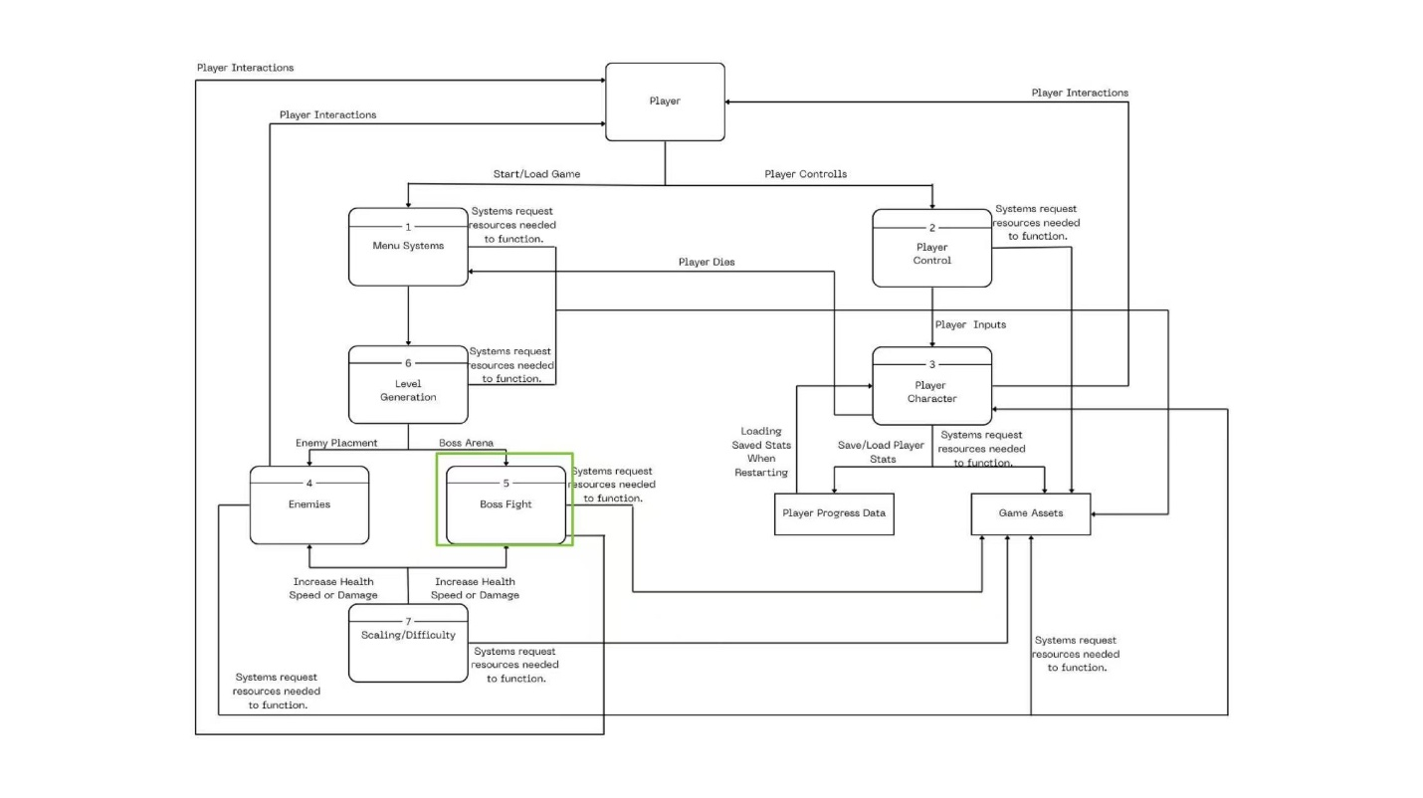

### Process Descriptions

1. **Player**

* **Role:** The primary agent driving gameplay and the boss encounter experience.
* **Inputs:** Controller/keyboard/mouse actions; menu choices.
* **Outputs:** Triggers character actions, starts/retries boss fights, and advances progression.

1. **Menu Systems (1)**

* **Role:** Start/continue the game; set difficulty and accessibility.
* **Inputs:** Player menu selections.
* **Outputs:** Triggers Start/Load; passes difficulty/settings to systems (incl. Boss Fight).

1. **Player Control (2)**

* **Role:** Map raw input to game commands (move, attack, dodge, interact).
* **Inputs:** Raw input events.
* **Outputs:** Normalized control commands to Player Character.

1. **Player Character (3)**

* **Role:** Avatar stats & state machine (HP, stamina, i-frames, etc.).
* **Inputs:** Control commands; collision/damage events.
* **Outputs:** Movement/animation; hit/damage results; death event (for retry flow).

1. **Enemies (4)**

* **Role:** Non-boss enemies used before/around the boss arena.
* **Inputs:** Level rules and difficulty parameters.
* **Outputs:** Combat interactions and drops (separate from the boss encounter).

1. **Boss Fight (5)**

* **Role:** Boss AI/phases/mechanics and resolution.
* **Inputs:** Player actions, difficulty multipliers, arena hazards, assets (animations/VFX/SFX).
* **Outputs:** Victory/defeat events, rewards, progress updates, retry trigger.

1. **Level Generation (6)**

* **Role:** Build/assemble the level and **Boss Arena** (doors, spawn points, blockers).
* **Inputs:** Level seed/era theme/difficulty.
* **Outputs:** Navigable scene + triggers that host the Boss Fight.

1. **Scaling / Difficulty (7)**

* **Role:** Central multipliers for HP, damage, cooldowns, projectile speed, etc.
* **Inputs:** Difficulty chosen in menus/saves; level progression.
* **Outputs:** Applied multipliers to Player/Enemies/Boss, shaping encounter intensity and forgiveness.

1. **Player Progress Data**

* **Role:** Track collected ship parts, era artifacts, and unlock states.
* **Inputs:** Rewards/flags granted after boss victory.
* **Outputs:** Unlocks the next area/era; updates HUD objectives.

1. **Game Assets**

* **Role:** On-demand loading/management of models, animations, SFX, VFX, and UI.
* **Inputs:** Resource requests from level/combat modules (with graceful degradation).
* **Outputs:** Assets that ensure readable telegraphs and stable performance during the boss fight.

## Acceptance Tests ________9

**Boss Fight Feature Test (overview format)**

Input: Simulated encounter covering arena entry, P1→P2→P3 transitions, dodge/parry timing, defeat & retry, and victory flow.

Output: Arena locks once; boss spawns once; telegraphs readable; transitions at 70%/40%; retry ≤5s with Skip Intro; victory grants rewards and saves progress.

Boundary Cases: Exact HP thresholds (70%/40%); asset fallback when high set unavailable; inventory full routes rewards to mailbox/stash.

|  |  |  |  |  |
| --- | --- | --- | --- | --- |
| **Test ID** | **Description** | **Input** | **Expected Output** | **Boundary Case** |
| BF-AT01 | Arena entry spawns boss once | Enter the arena trigger exactly once in a fresh session | Doors lock; intro plays once; exactly one boss instance | Re-enter trigger after defeat → no duplicate spawn |
| BF-AT02 | Dynamic binding of arena assets | Make the “high” asset group unavailable at load | Falls back to medium/low assets; fight proceeds | Asset swap during streaming → no hitch >200ms |
| BF-AT03 | Telegraph readability metric | Trigger 20 attacks in Phase 1 | ≥90% attacks readable; windup in [0.8s, 1.2s]; cues play | Exactly 0.8s / 1.2s valid; <0.8s flagged |
| BF-AT04 | Dodge/parry timing window | Attempt at (t−50ms, t, t+50ms) across 30 trials | Success at t; near misses per design; success → i-frames/stagger | Inject +60ms latency → window compensates/fails by spec |
| BF-AT05 | Exception → Read Telegraph extend | Enable assist/low-visibility, then trigger attacks | <<extend>> Read Telegraph activates; cues stronger; return to normal flow | Assist toggled mid-fight → adapts within 1 attack cycle |
| BF-AT06 | Phase transitions P1→P2→P3 | Reduce boss HP to exactly 70% and 40% | Transition anims & new hazards activate once | 69.9%/39.9% do not re-trigger; leaving/returning preserves phase |
|  |  |  |  |  |
|  |  |  |  |  |
| **Test ID** | **Description** | **Input** | **Expected Output** | **Boundary Case** |
| BF-AT07 | Fast retry loop & Skip Intro | Die in arena; choose retry | Reload latest checkpoint ≤5s; Skip Intro works | 5 consecutive retries → ≤5s each |
| BF-AT08 | Rewards with full inventory | Defeat boss (normal inventory, then full) | Normal: pick up; Full: mailbox/stash; both continue to save | Mailbox near capacity → graceful overflow handling |
| BF-AT09 | Save progress & unlock next area | After victory, go to next gate; reload game | Progress saved; next area/era unlocked; checkpoint beyond boss gate | Multiple reloads → never regress to pre-boss state |
| BF-AT10 | Difficulty scaling & winnability | Play on min and max difficulty | Multipliers clamp to ranges; fight remains winnable | Record effective HP/DMG/CD/projectile speed; out-of-range clamps logged |
| BF-AT11 | Performance budget (stress) | Run effect-heavy sequences 3 mins baseline HW | Avg frametime ≤16.6ms; 99th ≤28ms; no thrash or >200ms hitches | Particle burst + post-FX overlap stays within budget |

## Timeline _________/10

### Work items

|  |  |  |
| --- | --- | --- |
| Task | Duration (PWks) | Predecessor Task(s) |
| 1. Requirements Collection | 3 | - |
| 2. Screen Design | 3 | 1 |
| 3. Report Design | 3 | 1 |
| 4. Database Construction | 1 | 2, 3 |
| 5. User Documentation | 3 | 4 |
| 6. Programming | 2 | 4 |
| 7. Testing | 2 | 6 |
| 8. Installation | 1 | 5, 7 |

### Pert diagram

|  |  |  |
| --- | --- | --- |
| 3 | 3 | 6 |
| 2 | | |
| 3 | 0 | 6 |

|  |  |  |
| --- | --- | --- |
| 7 | 3 | 10 |
| 5 | | |
| 8 | 1 | 11 |

|  |  |  |
| --- | --- | --- |
| 0 | 3 | 3 |
| 1 | | |
| 0 | 0 | 3 |

|  |  |  |
| --- | --- | --- |
| 11 | 1 | 12 |
| 8 | | |
| 11 | 0 | 12 |

|  |  |  |
| --- | --- | --- |
| 6 | 1 | 7 |
| 4 | | |
| 6 | 0 | 7 |

|  |  |  |
| --- | --- | --- |
| 3 | 3 | 6 |
| 3 | | |
| 3 | 0 | 6 |

|  |  |  |
| --- | --- | --- |
| 7 | 2 | 9 |
| 6 | | |
| 7 | 0 | 9 |

|  |  |  |
| --- | --- | --- |
| 9 | 2 | 11 |
| 7 | | |
| 9 | 0 | 11 |

### Gantt timeline

Gantt Chart—Qiwei Liang

|  |  |  |  |  |  |  |  |  |  |  |  |  |
| --- | --- | --- | --- | --- | --- | --- | --- | --- | --- | --- | --- | --- |
| 1 |  |  |  |  |  |  |  |  |  |  |  |  |
| 2 |  |  |  |  |  |  |  |  |  |  |  |  |
| 3 |  |  |  |  |  |  |  |  |  |  |  |  |
| 4 |  |  |  |  |  |  |  |  |  |  |  |  |
| 5 |  |  |  |  |  |  |  |  |  |  |  |  |
| 6 |  |  |  |  |  |  |  |  |  |  |  |  |
| 7 |  |  |  |  |  |  |  |  |  |  |  |  |
| 8 |  |  |  |  |  |  |  |  |  |  |  |  |
|  | 1 | 2 | 3 | 4 | 5 | 6 | 7 | 8 | 9 | 10 | 11 | 12 |