# Clock Configuration

Configure the clock as external with 72MHz

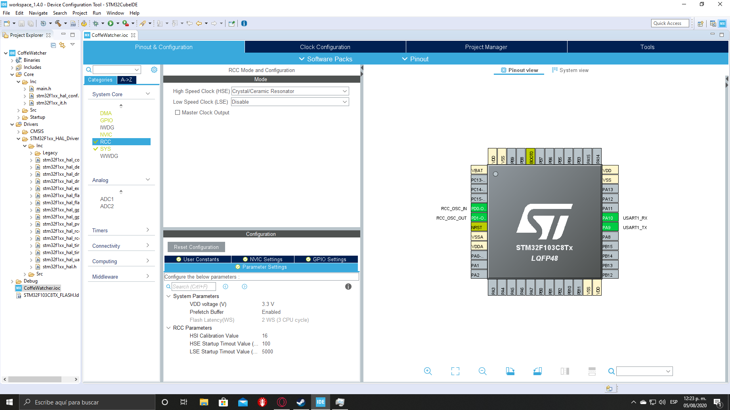

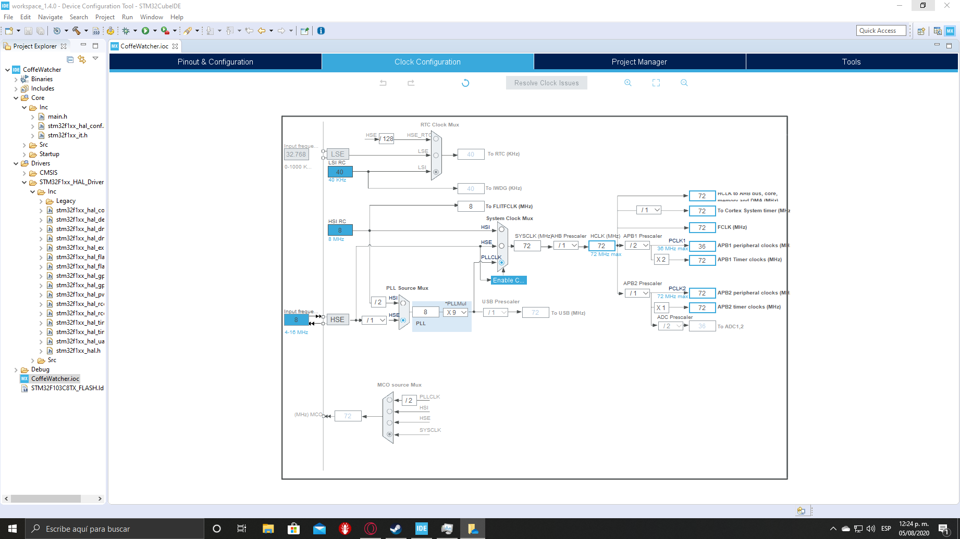

# USART Configuration

Configure in Asynchronous mode and enable global interruptions

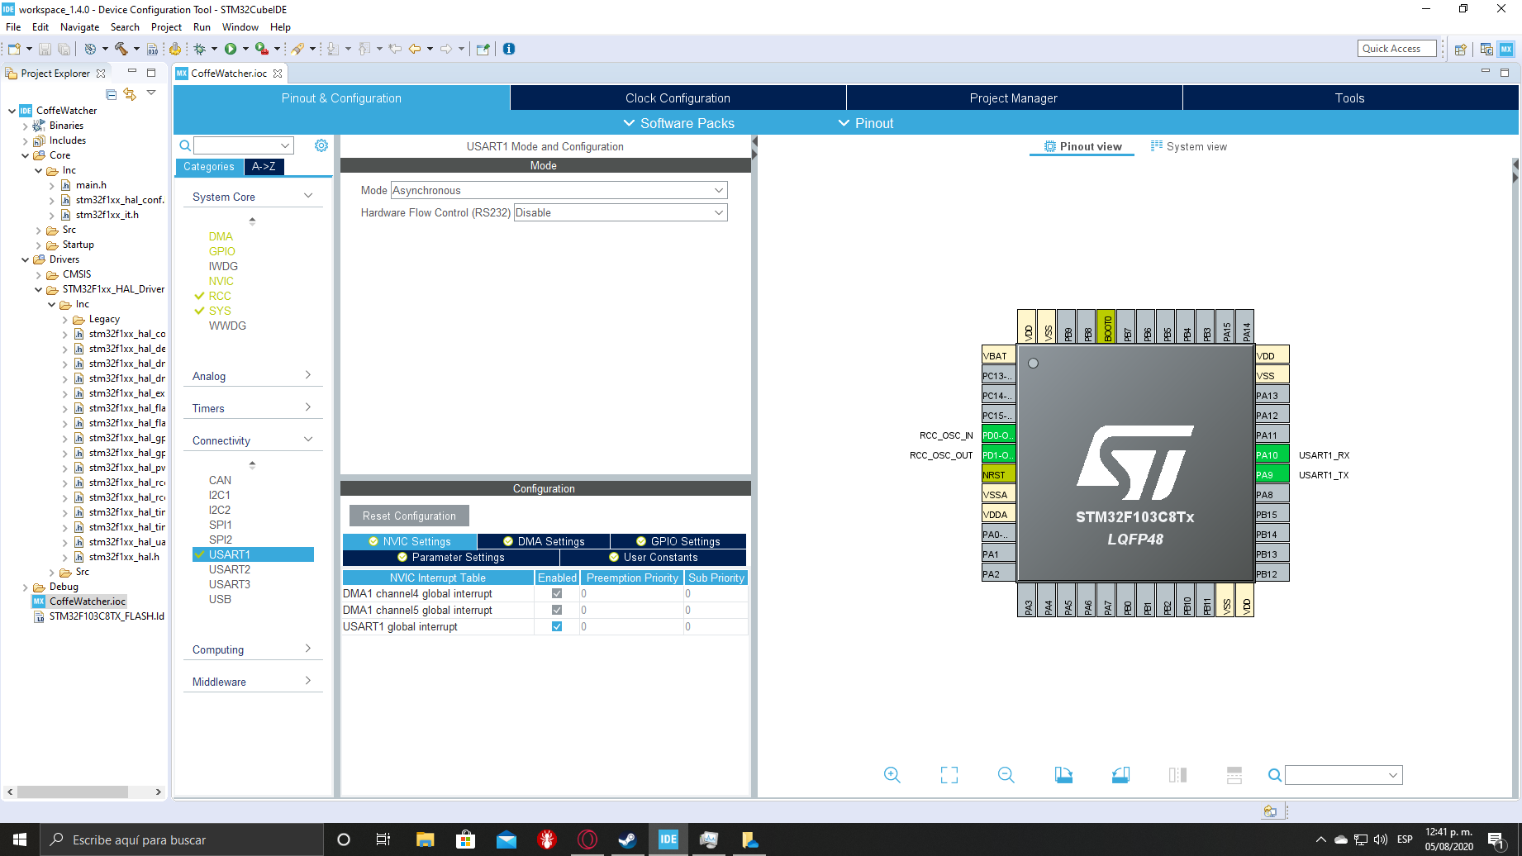

Configure parameters as you need, in this case it is used 115200 baudrate with 8 bits and no parity, configure data direction to receive and transmit.

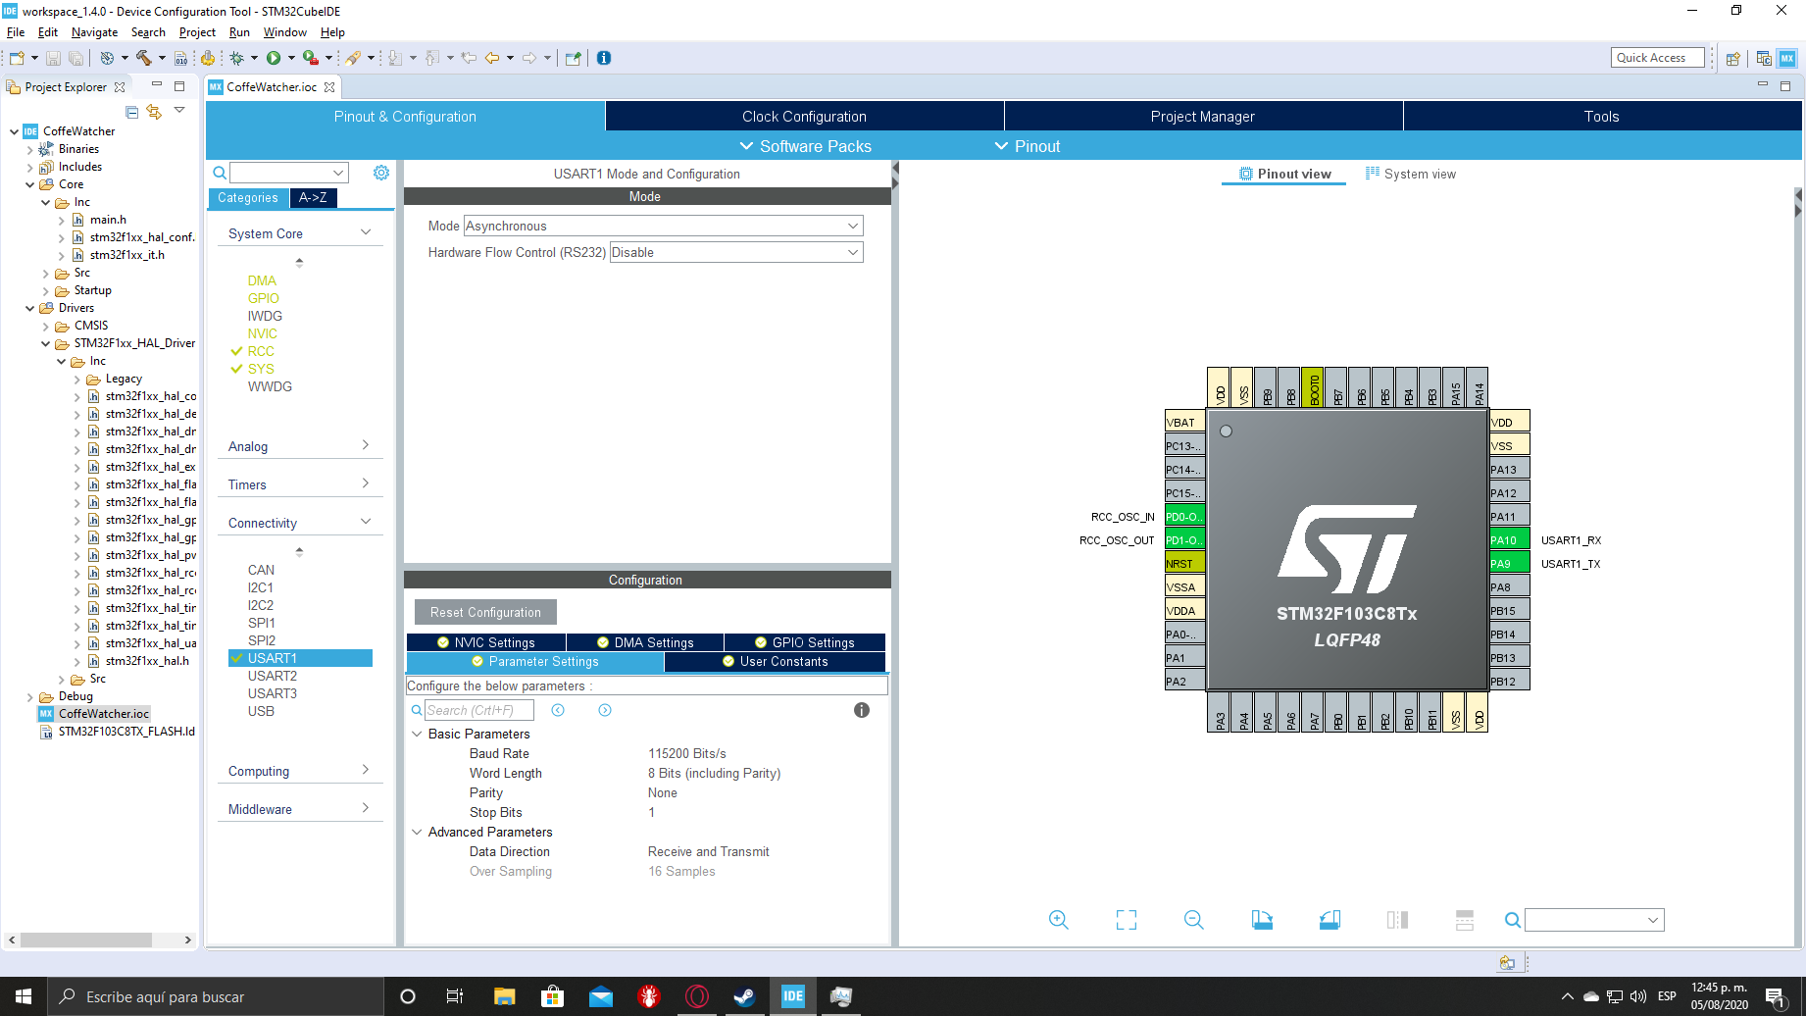

Configure RX DMA in circular mode, TX DMA in normal mode, increment memory address with peripheral and memory data width as byte in both.

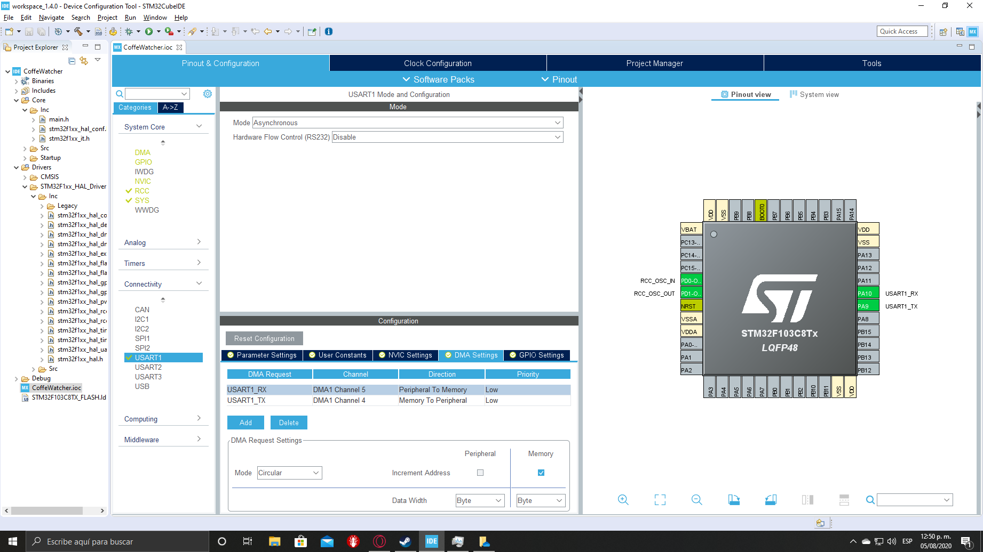

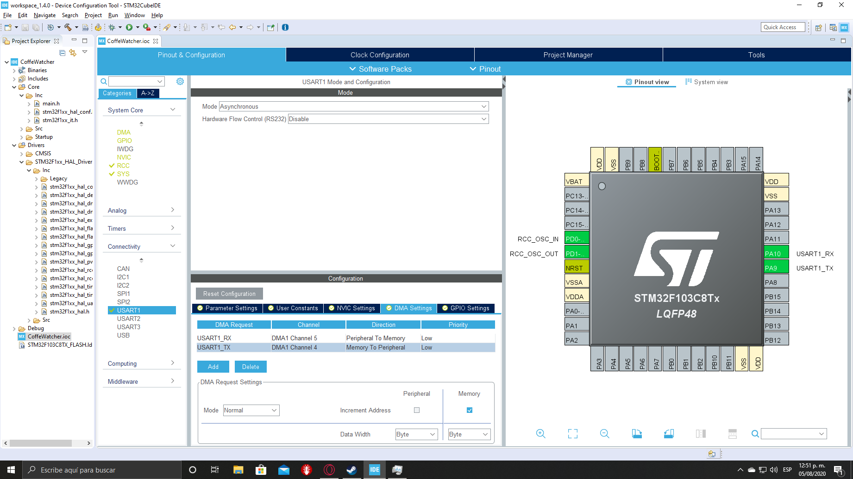

Finally save the file to generate code.

# Add library to project

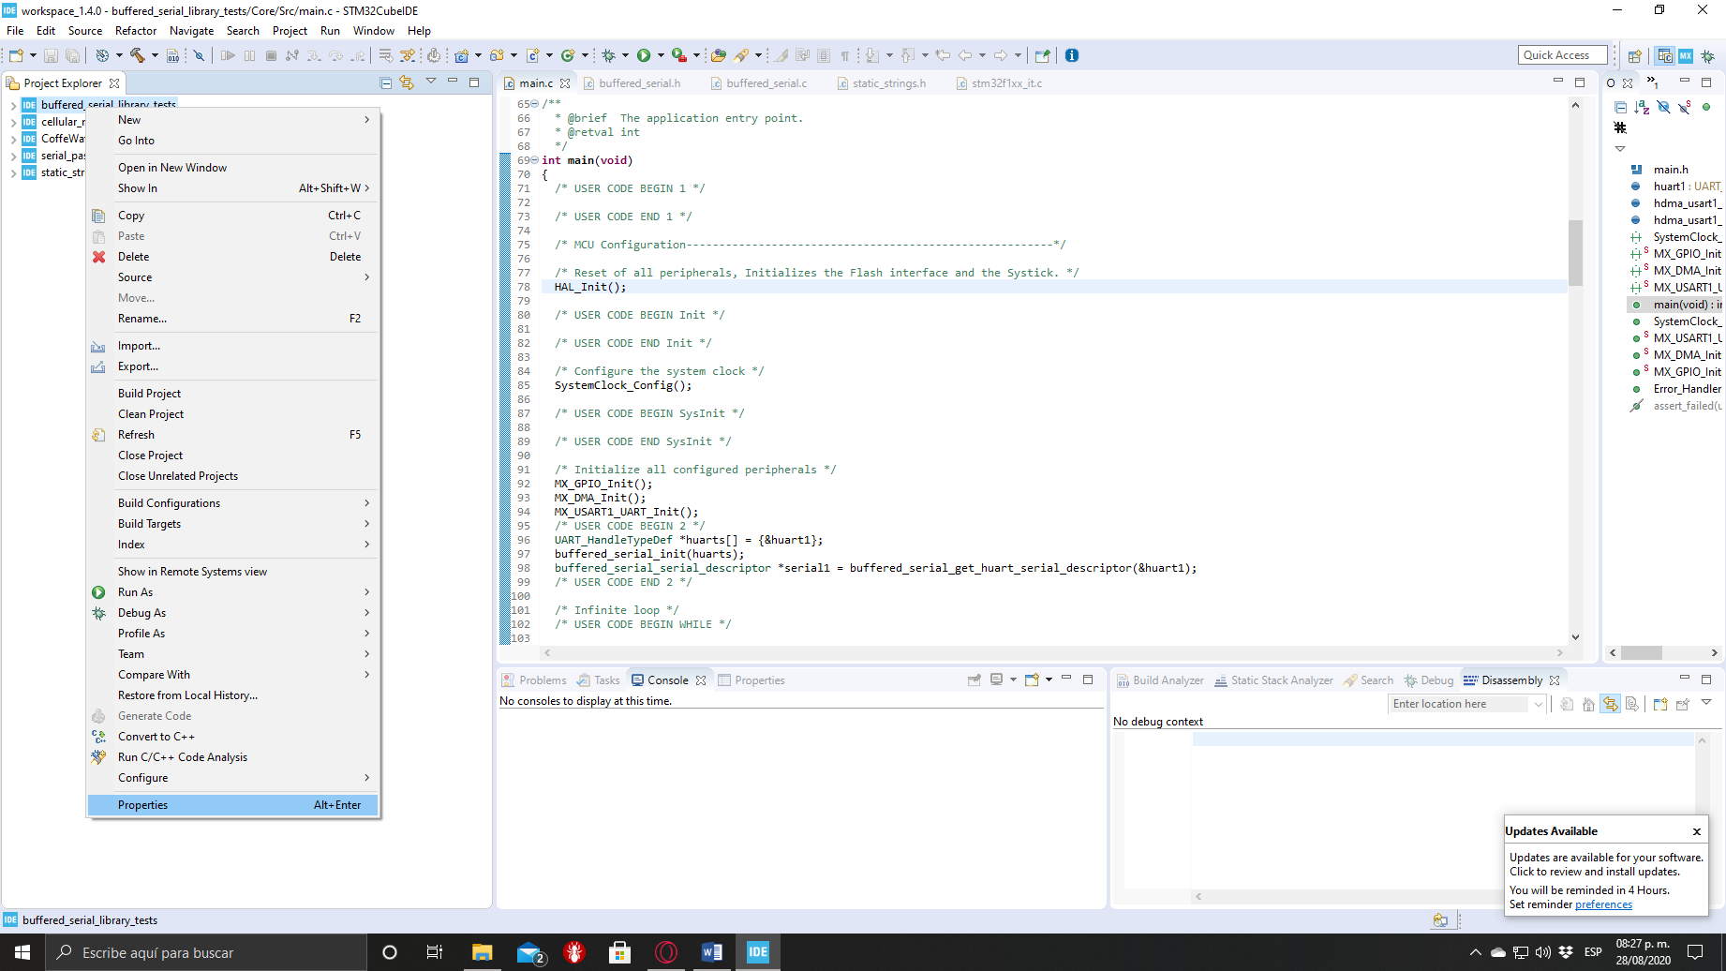Right click on project and select properties

Go to C/C++ General and select Paths and Symbols

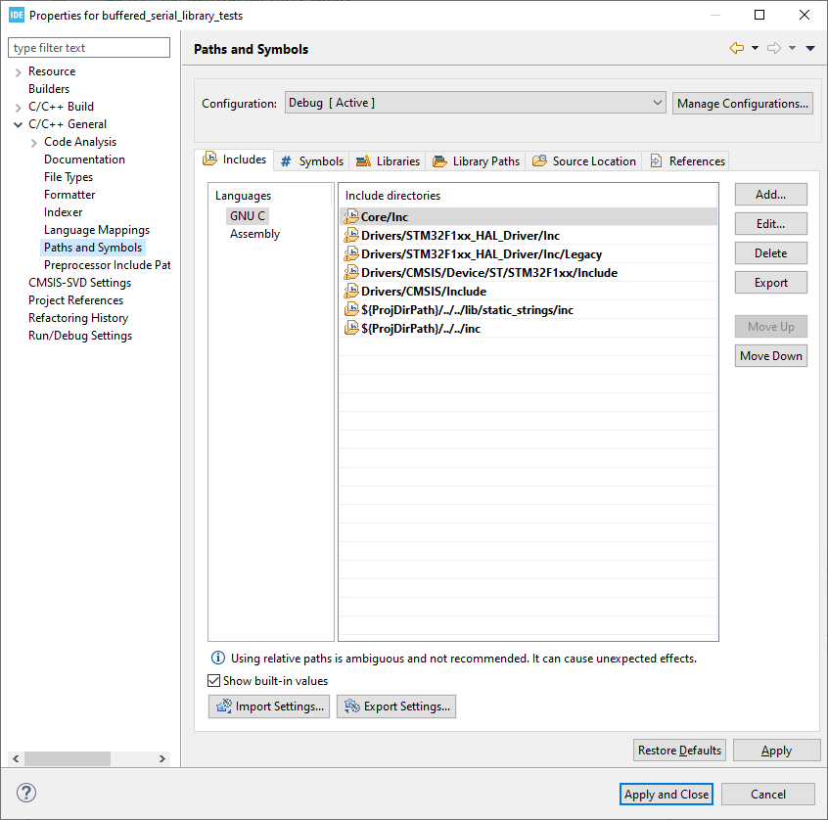

In includes click Add.

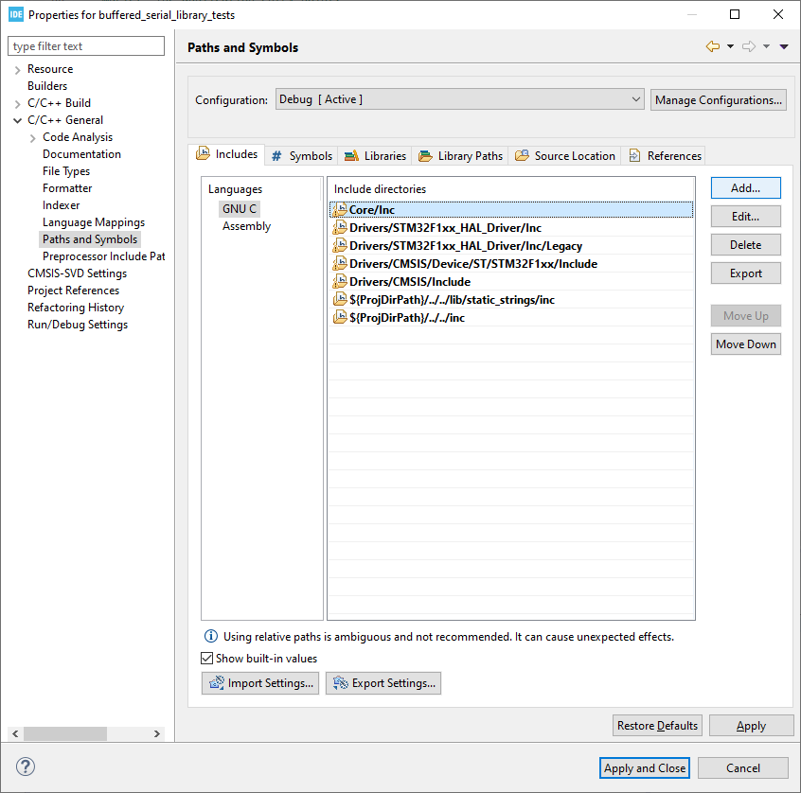

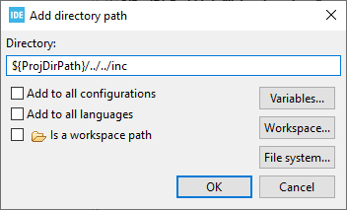Add the path of the folder with the header files and click OK. I use a relative path with the environment variable ProjDirPath, the variable can be placed with the Variables… button. I suggest to use relative paths and create a parent project folder with a lib folder and a the STM32CubeIDE project.

Go to Sources Location and select Link Folder.

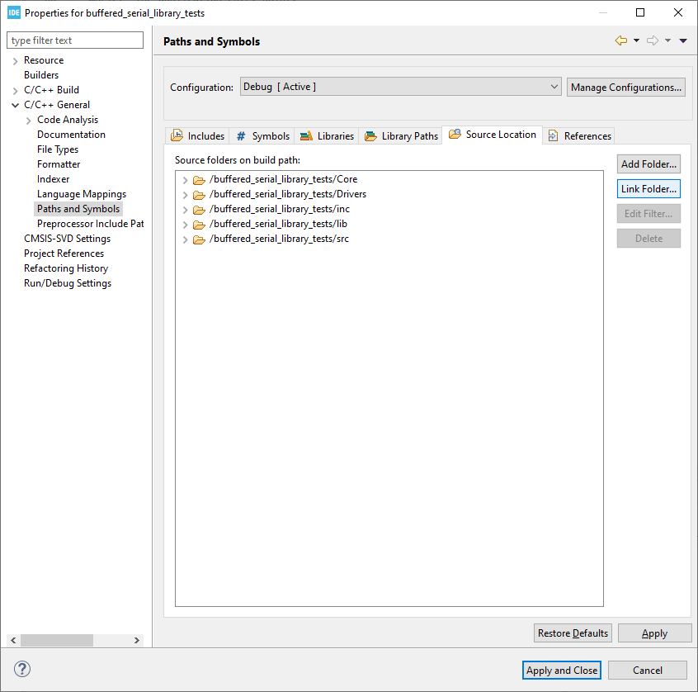

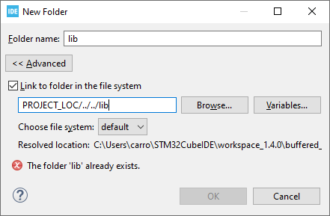Check “Link to folder in the file system” and select the folder where the library is and click OK. In my project I add the lib folder mentioned in the previous step, since I placed there all the libraries and it add the child folders and files, the sources and headers needed to run the project are added to the compiler and linker paths. You have to link all the folders with the sources and headers required.

Click Apply and Close button and rebuild.