COMP9331 Lab2

Name: Jiachen Li

Student ID: z5184142

**Exercise3:**

Q1: What is the status code and phrase returned from the server to the client browser?

The status code returned from the server to the client browser is 200 and the phrase is OK.

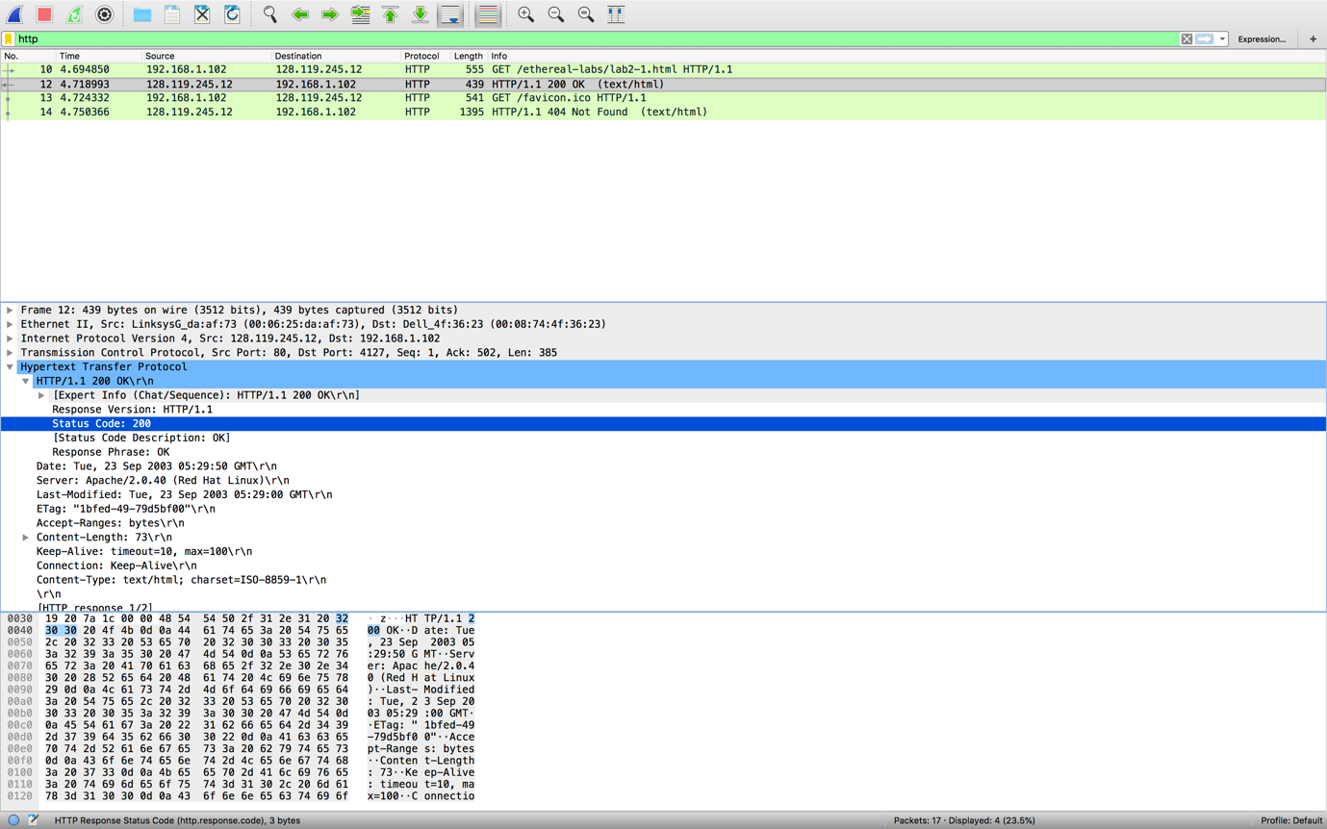

Q2: When was the HTML file that the browser is retrieving last modified at the server? Does the response also contain a DATE header? How are these two fields different?

The last-modified time is Tue, 23 Sep 2003 05:29:00 GMT. The response also contains a DATE header, and it’s Tue, 23 Sep 2003 05:29:50 GMT. Date field means the date and time that the message was originated while Last-modified means that the last time that the resources on the server was modified.

Q3: Is the connection established between the browser and the server persistent or non-persistent? How can you infer this?

The connection established between the browser and the server is persistent because the connection is keeping alive.

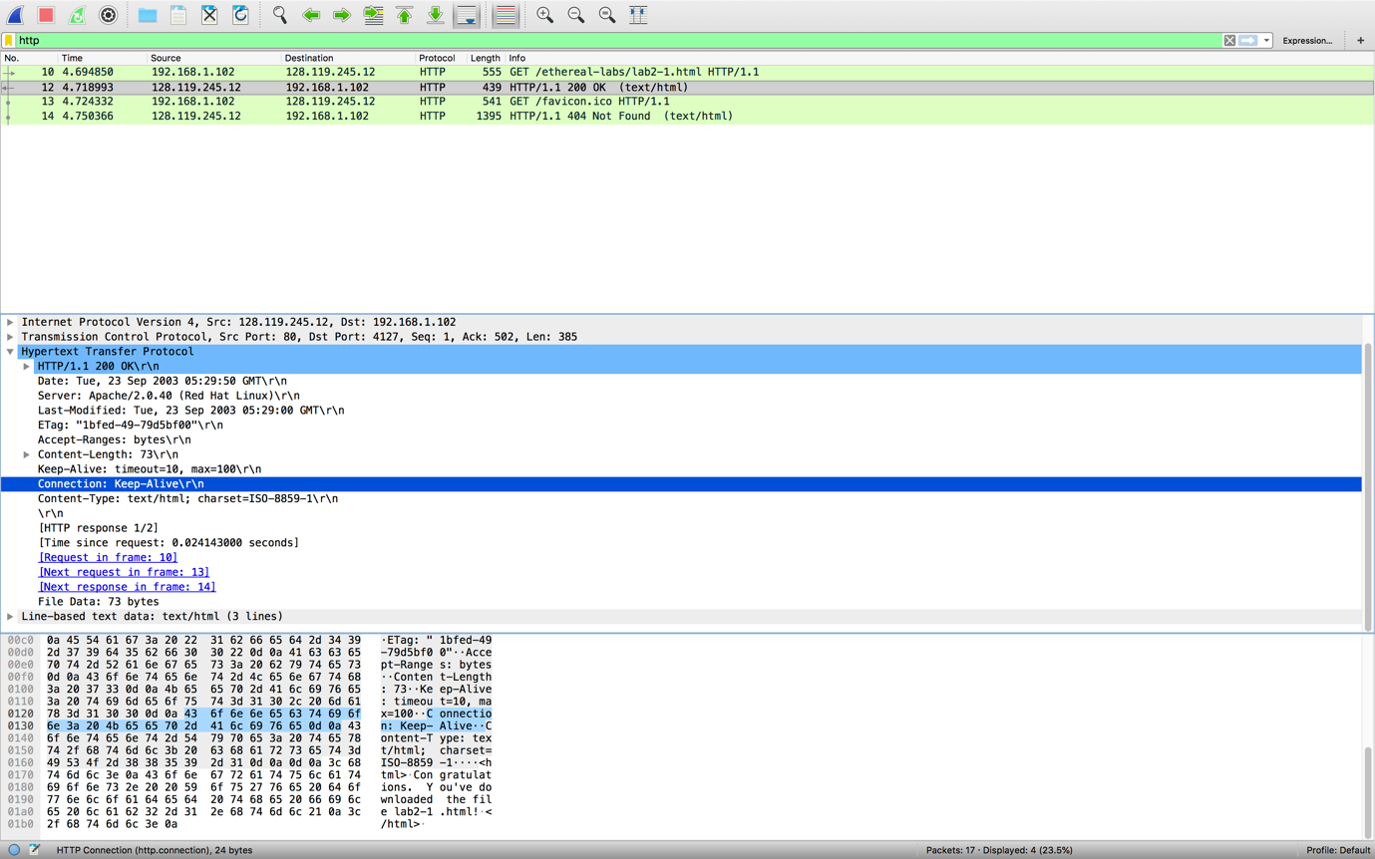

Q4: How many bytes of content are being returned to the browser?

73 bytes of content are being returned to the brower.

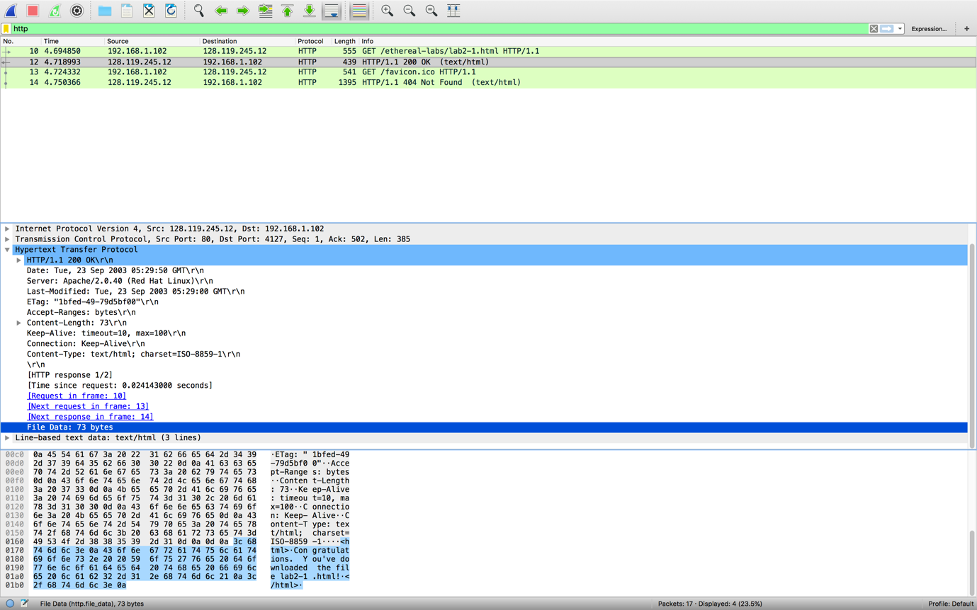

Q5: What is the data contained inside the HTTP response packet?

<html>\n

Congratulations. You've downloaded the file lab2-1.html!\n

<html>\n

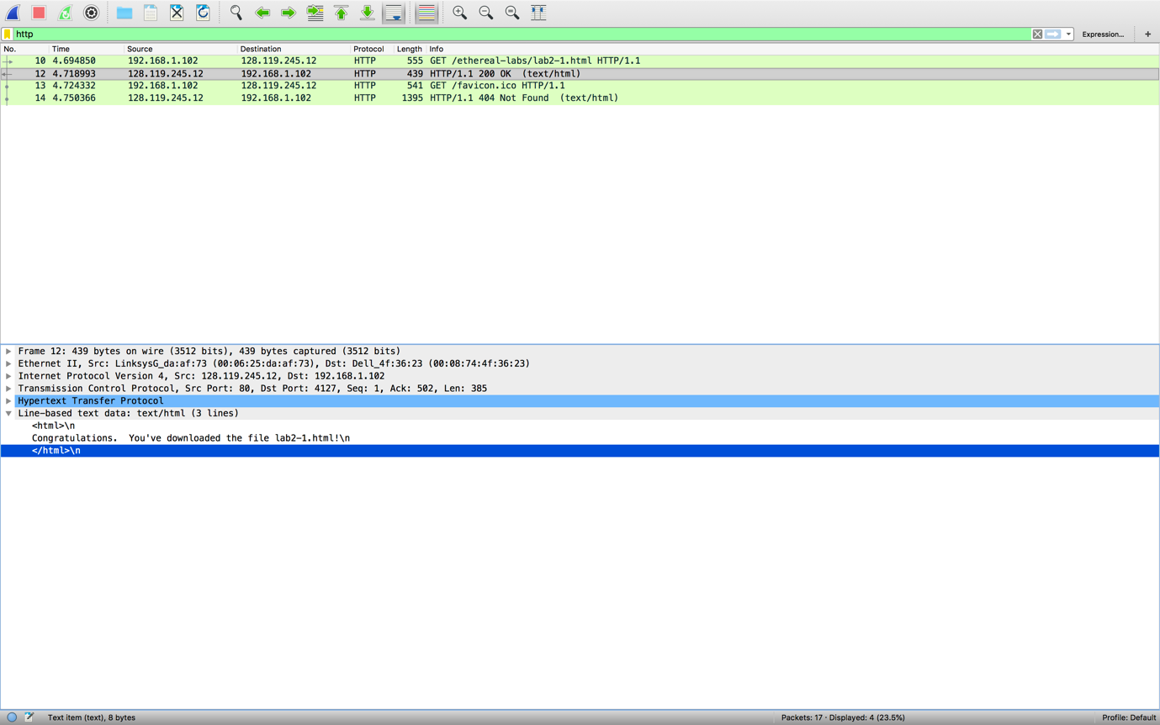

**Exercise4:**

Q1: Inspect the contents of the first HTTP GET request from the browser to the server. Do you see an “IF-MODIFIED-SINCE” line in the HTTP GET?

No, there is no “IF-MODIFIED-SINCE” line in the HTTP GET.

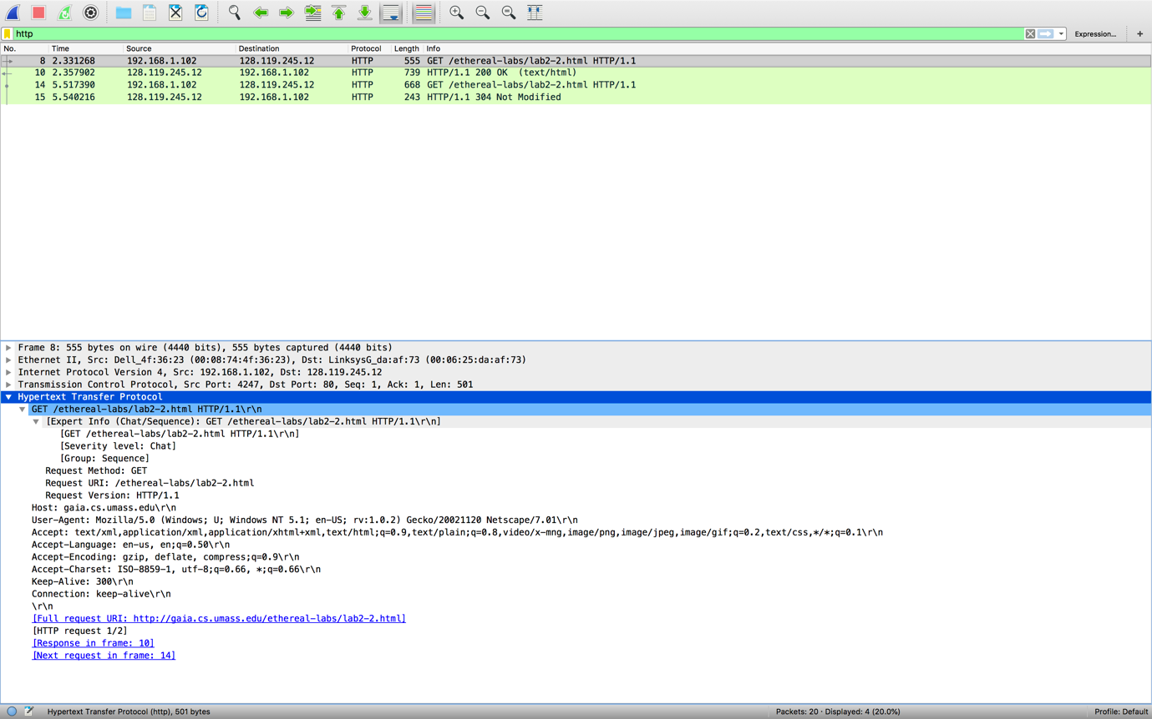

Q2: Does the response indicate the last time that the requested file was modified?

Yes, the last modified time of the requested file is Tue, 23 Sep 2003 05:35:00 GMT.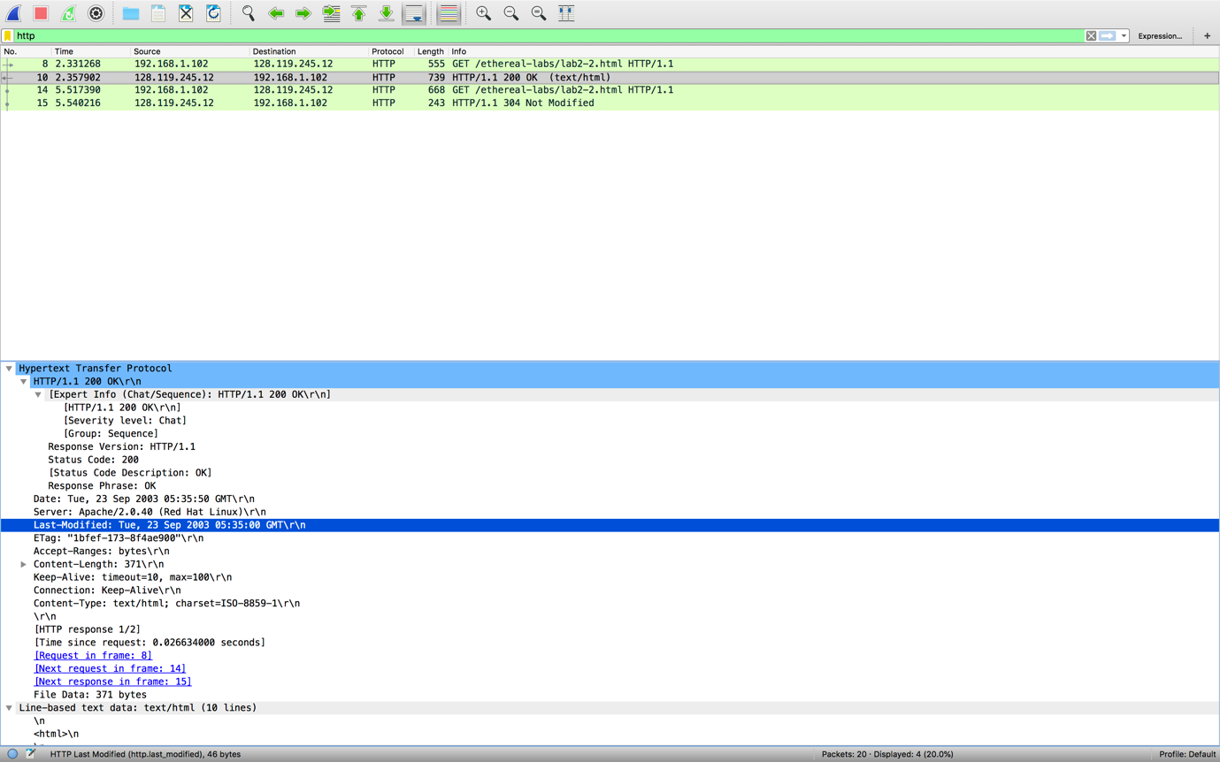

Q3: Now inspect the contents of the second HTTP GET request from the browser to the server. Do you see an “IF-MODIFIED-SINCE:” and “IF-NONE-MATCH” lines in the HTTP GET? If so, what information is contained in these header lines?

Yes. The information contained in If-Modified-Since header is Tue, 23 Sep 2003 05:35:00, which is the last modified time that the server sent to the browser. The If-None-Match header contains the text “1bfef-173-8f4ae900”, which is the ETag.

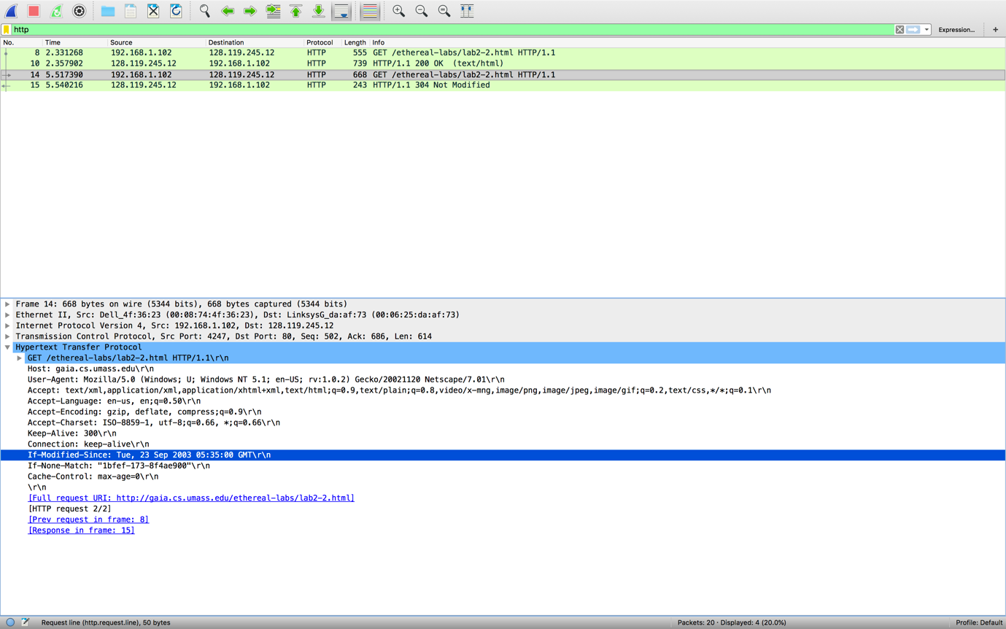

Q4: What is the HTTP status code and phrase returned from the server in response to this second HTTP GET? Did the server explicitly return the contents of the file? Explain.

The HTTP status code returned from the server in response to this second HTTP GET is 304, and the Phrase is Not Modified. The server did not explicitly return the contents of the file because the cache has up-to-date cashed version.

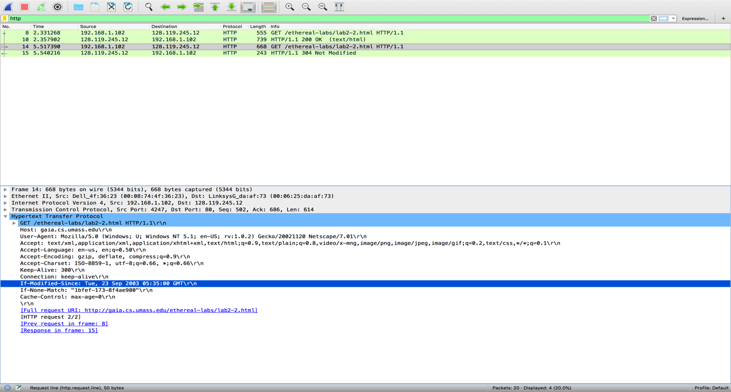

Q5: What is the value of the Etag field in the 2nd response message and how it is used? Has this value changed since the 1st response message was received?

The value of the Etag field in the 2nd response message is “1bfef-173-8f4ae900”, the browser will receive Etag in the first response packet from the Server, when the browser sends the next same request to the server, the value of the Etag will be take into IF-NONE-MATCH field, then the server will check the file that the browser request and calculates the Etag again. If the value of the Etag matches with the Etag from the browser’s request, then the server will send 304 status code to browser to tell the browser that the file that it requested has not been modified since the last time it requested, which means that the file in the browser is up-to-date.

This value didn’t change since the 1st response message was received.

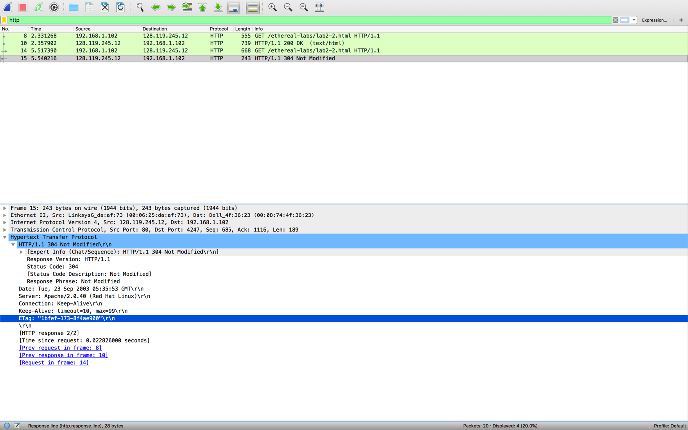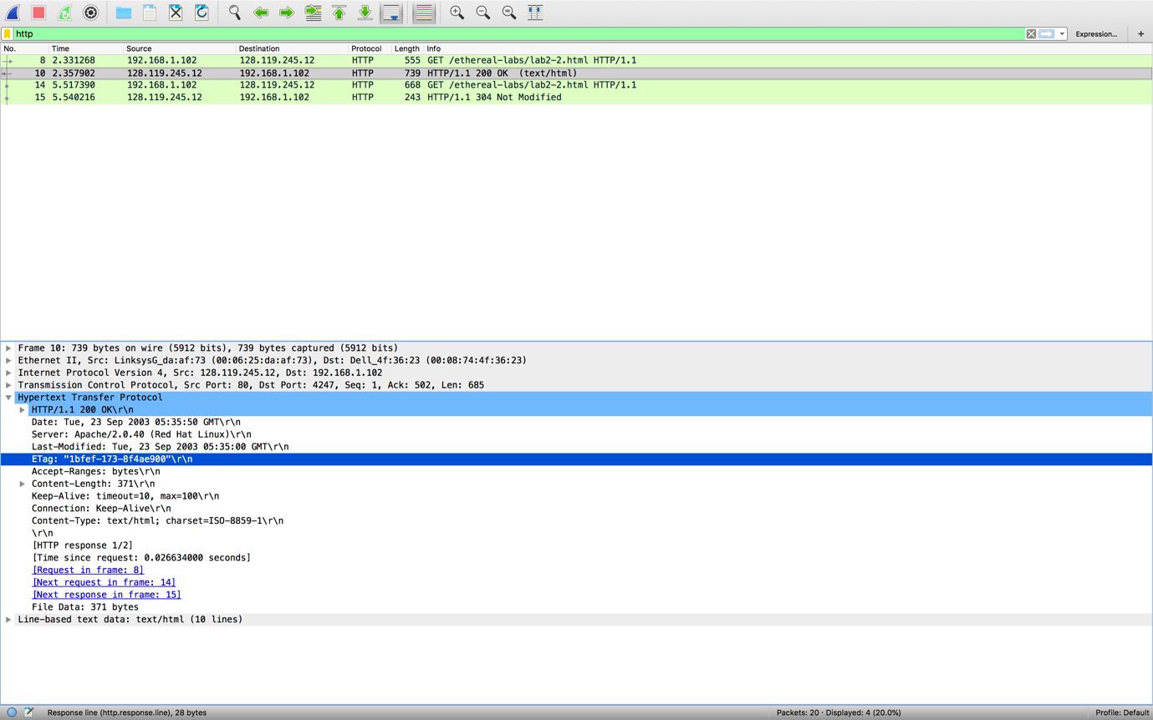

**Exercise 5:**

Result:

