COMP9331 Lab3

Name: Jiachen Li

Student ID: z5184142

**Exercise3:**

Q1: What is the IP address of www.cecs.anu.edu.au . What type of DNS query is sent to get this answer?

**The IP address of** [**www.cecs.aun.edu.au**](http://www.cecs.aun.edu.au) **is 150.203.161.98. A type of DNS query is sent to get this answer.**

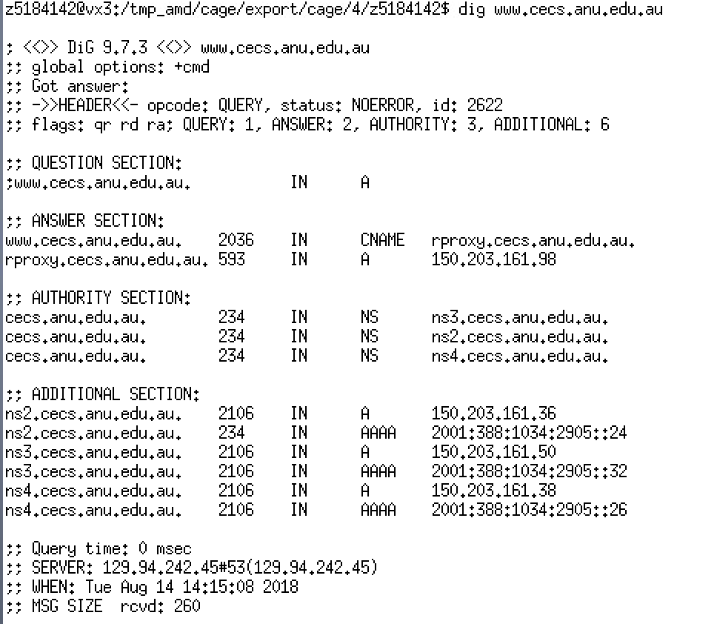

Q2: What is the canonical name for the CECS ANU web server? What is its IP address? Suggest a reason for having an alias for this server.

**The canonical name for the CECS ANU web server is rproxy.cecs.anu.edu.au and its IP address is 150.203.161.98.**

**Reason: The reason why having an alias is that alias hostnames are typically more mnemonic than canonical names and DNS can be invoked by an application to obtain the canonical hostname for a supplied alias hostname as well as the IP address of the host.**

Q3: What can you make of the rest of the response (i.e. the details available in the Authority and Additional sections)?

**Authority sections contains the host name of the authoritative servers and the time to live is 234s on DNS Cache, and additional sections contains the IPV4 and IPV6 addresses of these authoritative servers.**

Q4: What is the IP address of the local nameserver for your machine?

**The IP address of the local nameserver for my machine is 129.94.242.45.**



Q5: What are the DNS nameservers for the “cecs.anu.edu.au” domain (note: the domain name is cecs.anu.edu.au and not[www.cecs.anu.edu.au](http://www.cse.unsw.edu.au))? Find out their IP addresses? What type of DNS query is sent to obtain this information?

**DNS nameservers: ns3.cecs.anu.edu.au, ns4.cecs.anu.edu.au, ns2.cecs.anu.edu.au.**

**IPV4 address: 150.203.161.50 150.203.161.38. 150.203.161.36.**

**IPV6 address: 2001:388:1034:2905::32 2001:388:1034:2905::26 2001:388:1034:2905::24**

**The type of DNS query is NS type.**

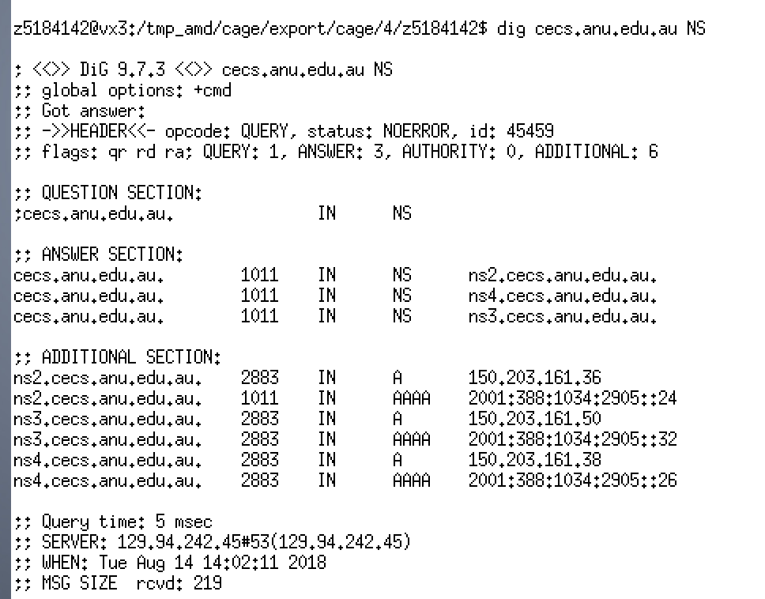

Q6: What is the DNS name associated with the IP address 149.171.158.109? What type of DNS query is sent to obtain this information?

**The DNS name associated with the IP address 149.171.158.109 is engplws008.eng.unsw.edu.au,** [**www.engineering.unsw.edu.au**](http://www.engineering.unsw.edu.au)**, engplws008.ad.unsw.edu.au.**

**PTR type query is sent to obtain this information.**

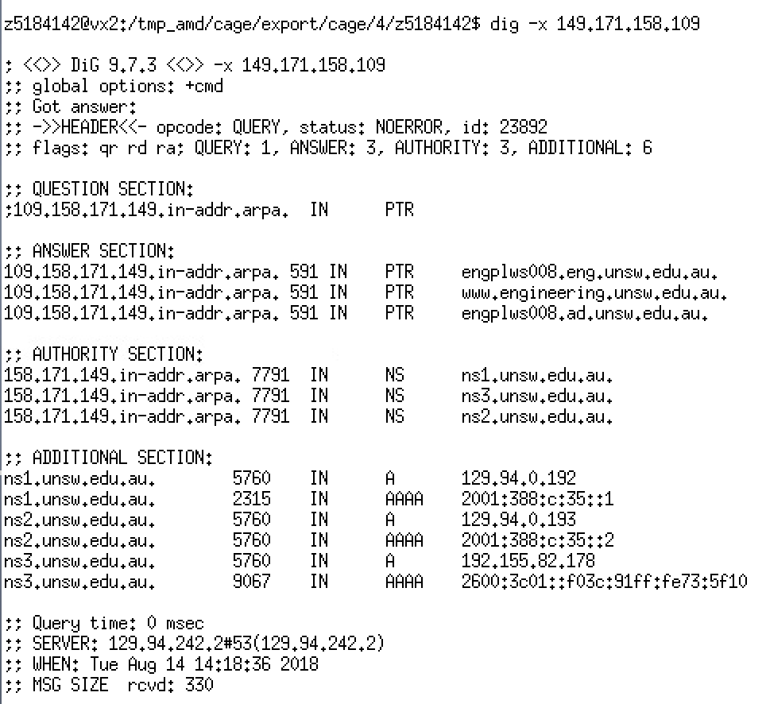

Q7: Run dig and query the CSE nameserver (129.94.242.33) for the mail servers for Yahoo! Mail (again the domain name is yahoo.com, not [www.yahoo.com](http://www.yahoo.com)). Did you get an authoritative answer? Why?

**I did not get an authoritative answer because there is no AA in flags of the header. The reason why I did not get the authoritative answer is that the dig command is sent from CSE nameserver to yahoo.com DNS server, and CSE nameserver is not the authoritative DNS server of yahoo, so yahoo’s server do not give the authoritative answer to CSE nameserver.**

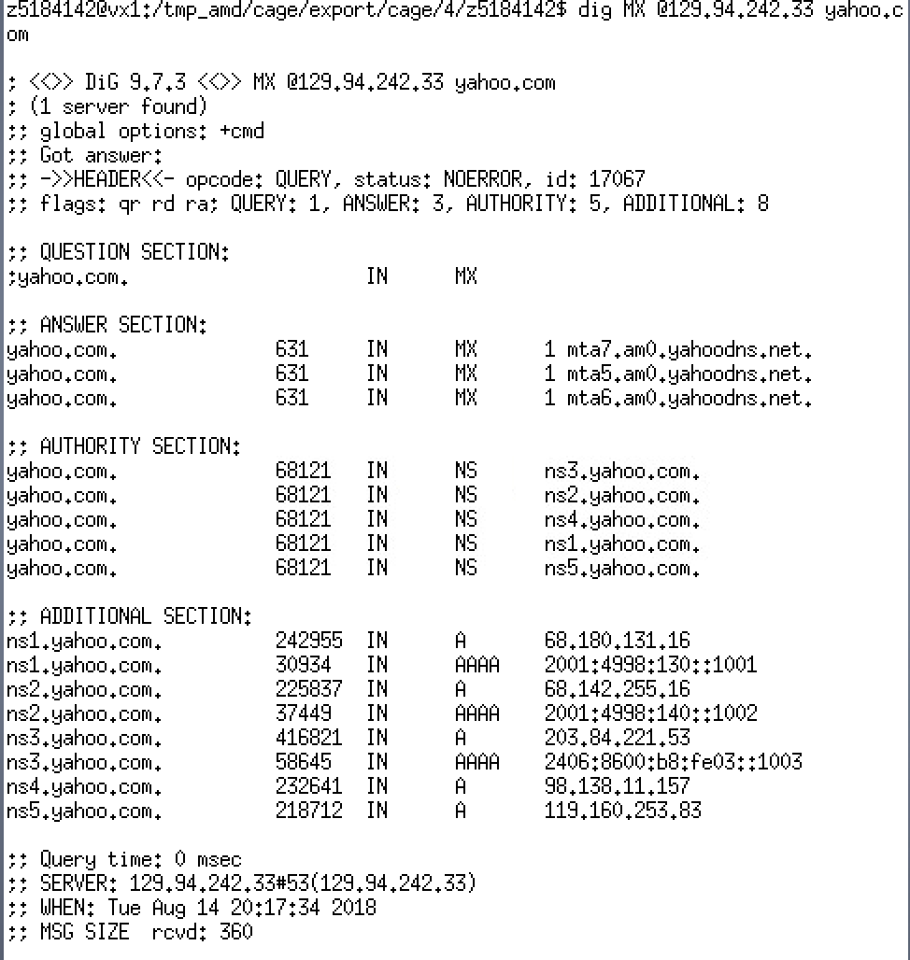

Q8: Repeat the above (i.e. Question 7) but use one of the nameservers obtained in Question 5. What is the result?

**The result is that I was refused to do dig command.**

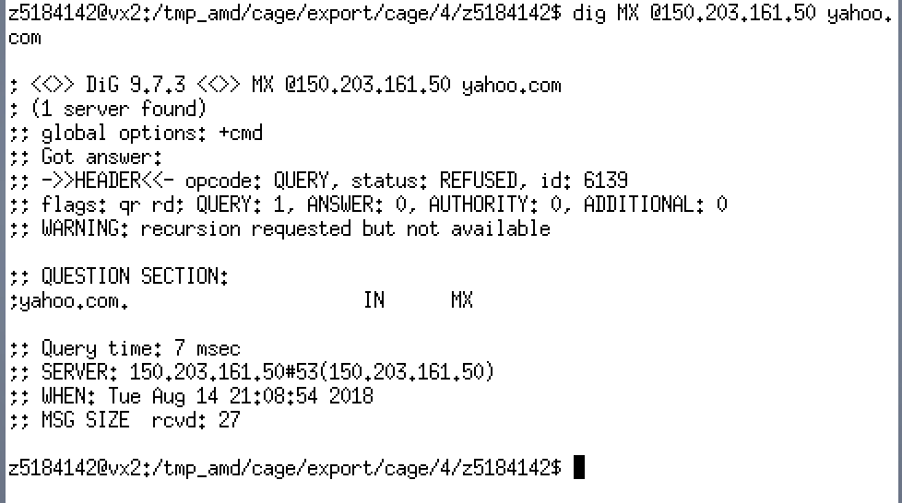

Q9: Obtain the authoritative answer for the mail servers for Yahoo! mail. What type of DNS query is sent to obtain this information?

**MX DNS query is sent to obtain this information.**

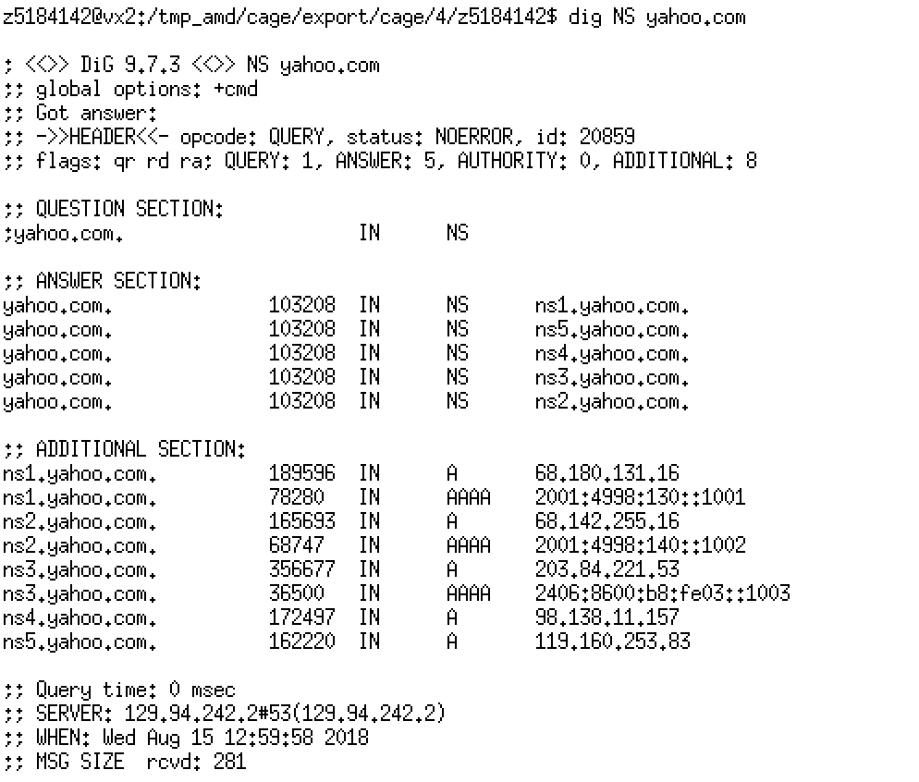

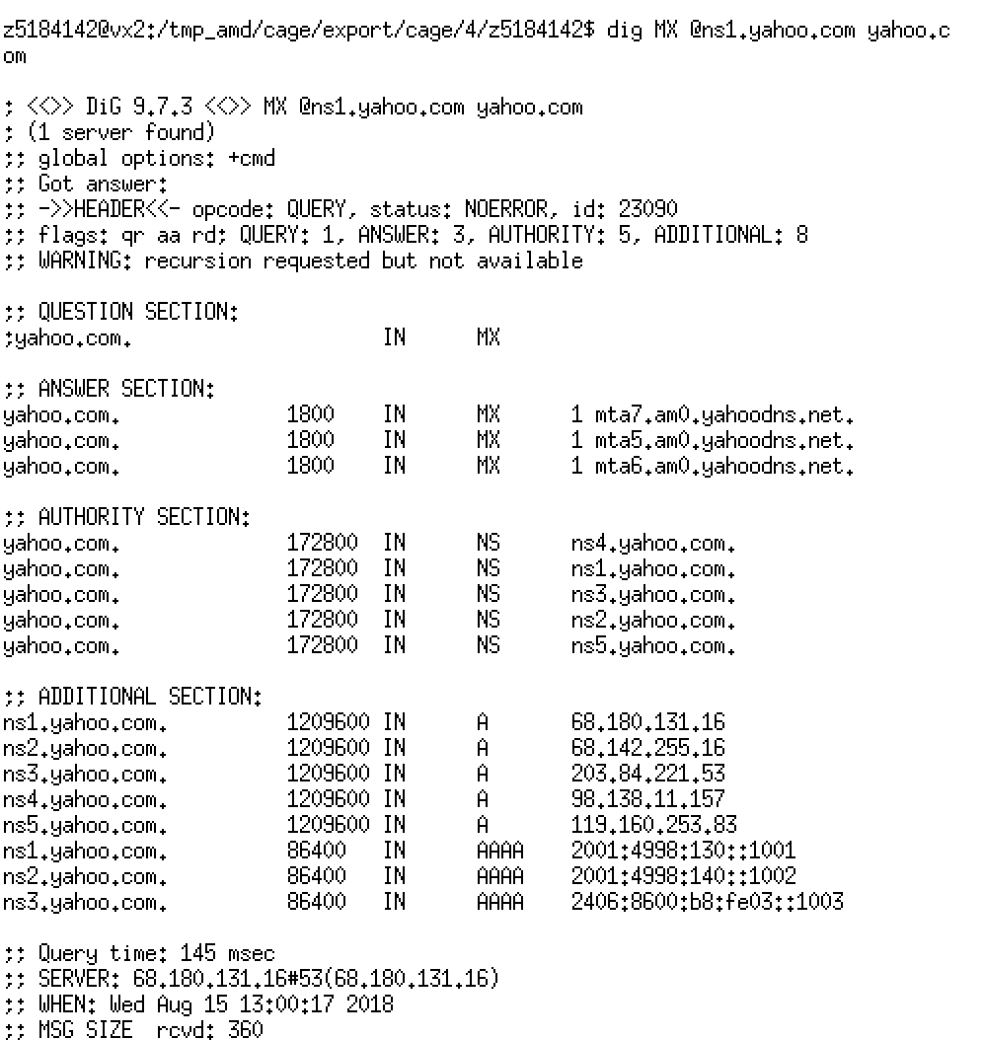

Q10: In this exercise you simulate the iterative DNS query process to find the IP address of your machine (e.g. lyre00.cse.unsw.edu.au). First, find the name server (query type NS) of the "." domain (root domain). Query this nameserver to find the authoritative name server for the "au." domain. Query this second server to find the authoritative nameserver for the "edu.au." domain. Now query this nameserver to find the authoritative nameserver for "unsw.edu.au". Next query the nameserver of unsw.edu.au to find the authoritative name server of cse.unsw.edu.au. Now query the nameserver of cse.unsw.edu.au to find the IP address of your host. How many DNS servers do you have to query to get the authoritative answer?

**Six DNS Servers.**

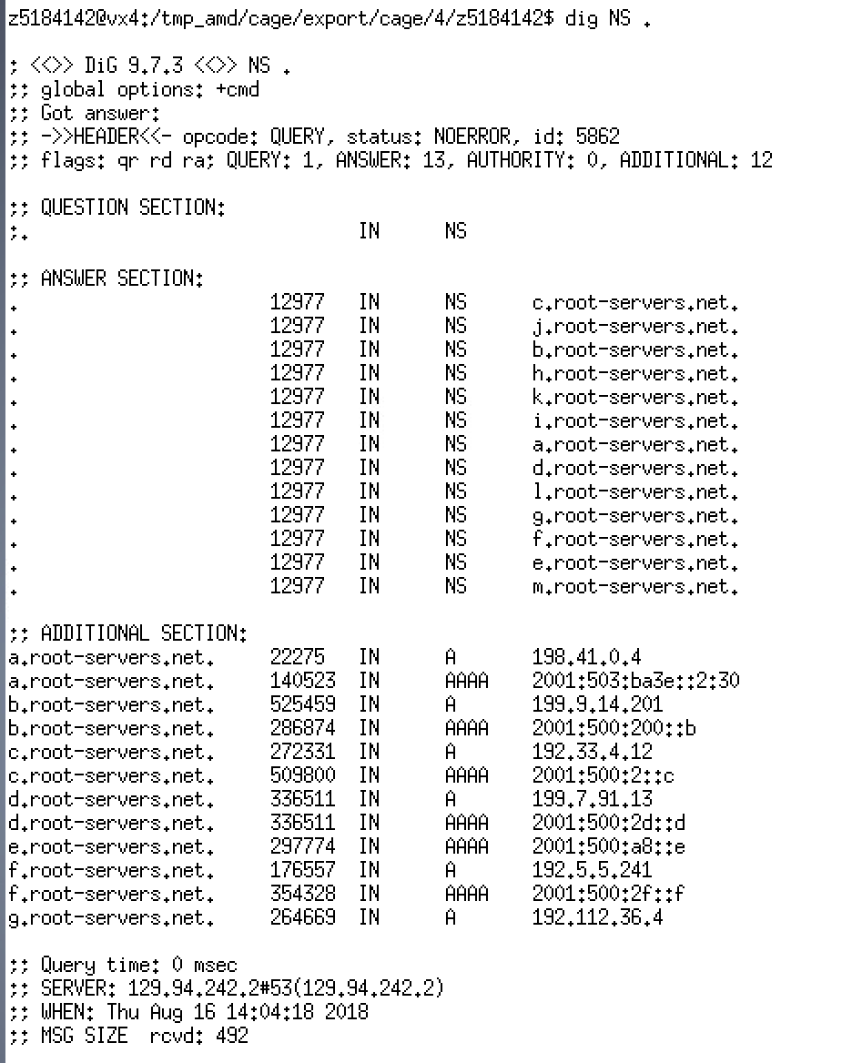

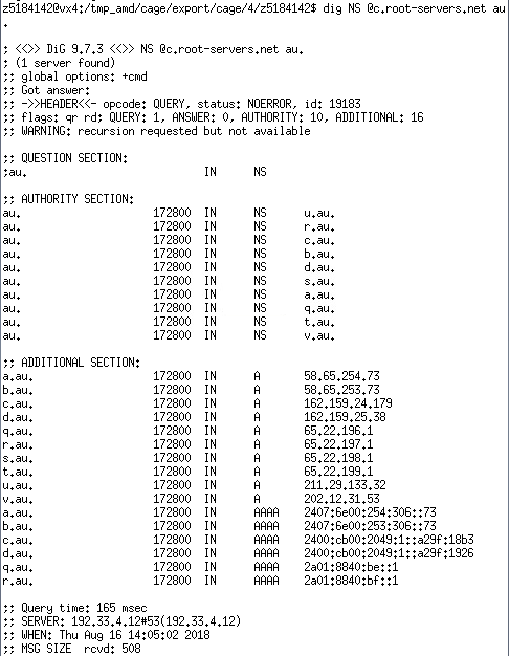

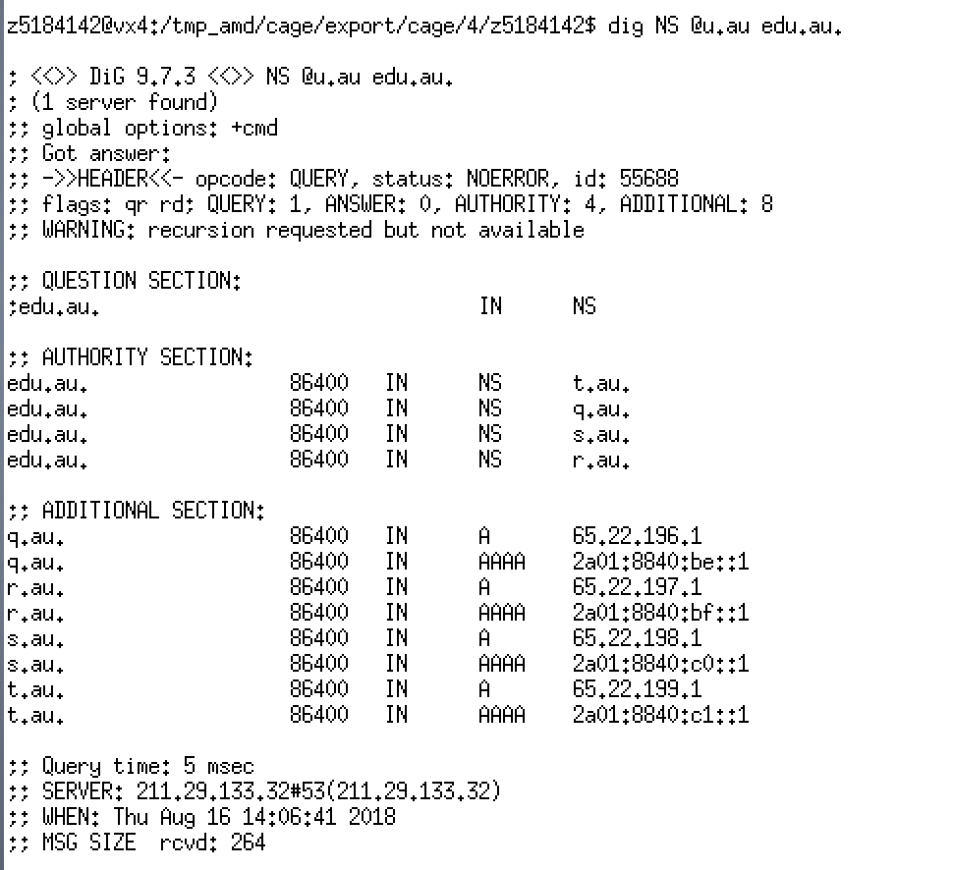

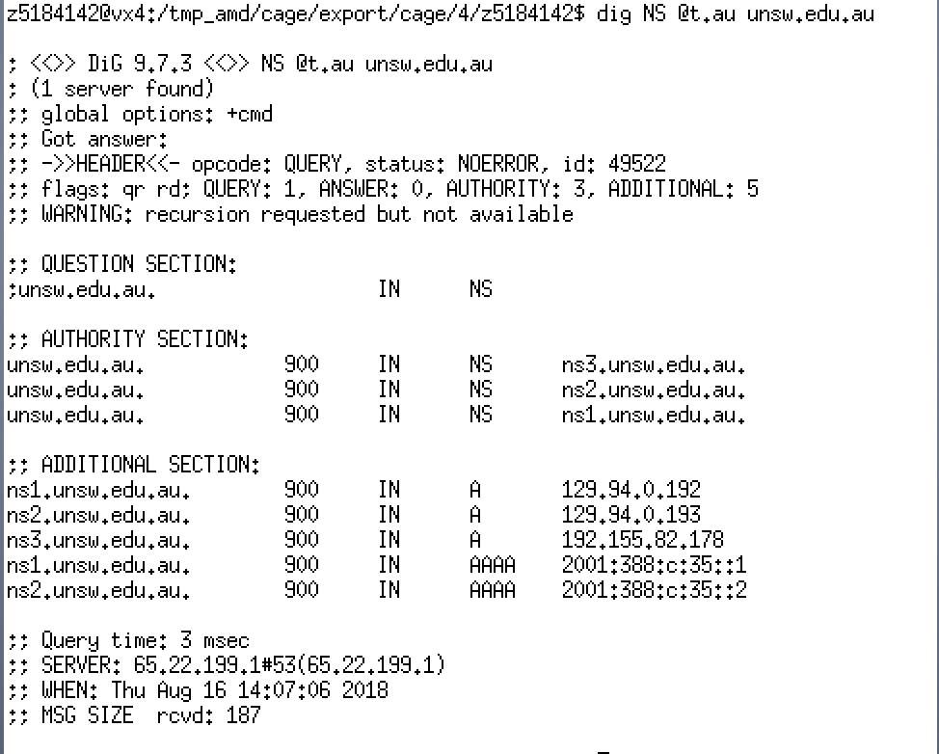

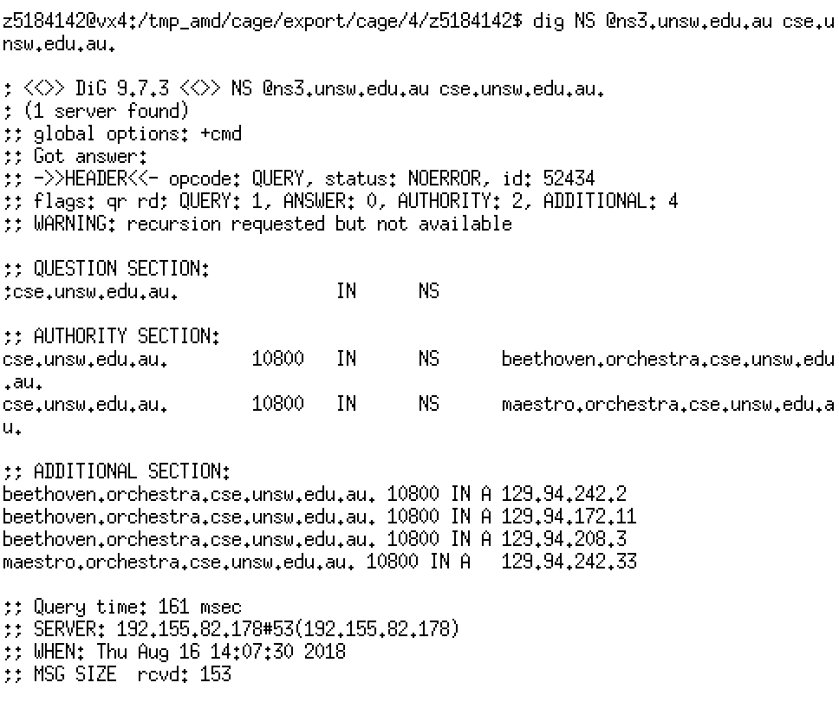

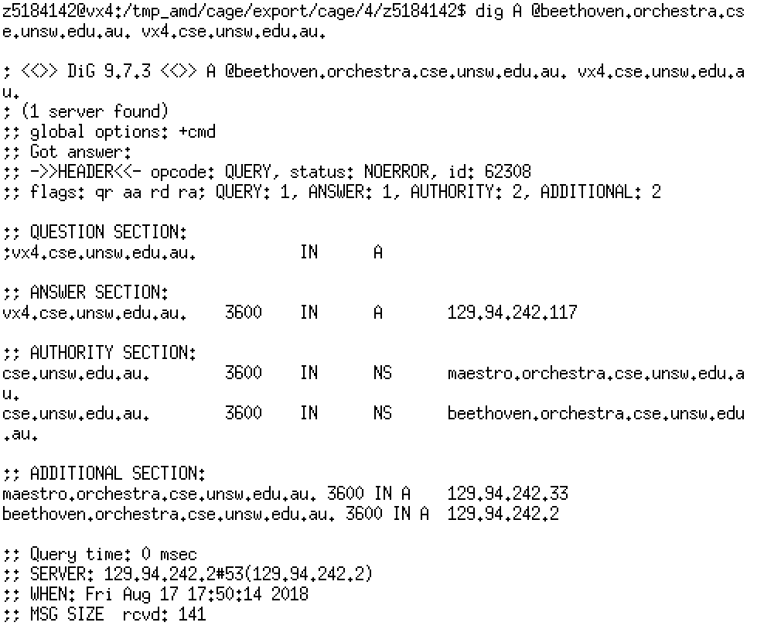

Q11: Can one physical machine have several names and/or IP addresses associated with it?

**Yes, because one physical machine can have multiple Network Interface Cards, so one physical machine can have several IP addresses, and several domain names can point to one IP address, which means that one physical machine can also have several names.**