What is Clonezilla?
Clonezilla, it is a free (Linux based) disk cloning utility that will let you image hard drives via a SATA, IDE, USB or Network connection. Note that it is also possible to clone flash drives, but only under rare circumstances would you ever want to.
Clonezilla is not the only freebie clone/imager. They all do about the same thing. Also, for about $20 you can buy a hardware replicator that will copy hard drives sector to sector. This method has limitations too.
For example, Acronis True Image has freebie versions for Windows and Linux.
This presentation will focus on Clonezilla and how to use it.
Clonezilla has 2 modes (Beginner and Expert). It will clone or image a hard drive or partition. Cloning vs. Imaging will be explained later in the presentation.

Potential uses?
- Your PC’s hard drive is getting bad sectors, and you need to replace it NOW!
- Someone has done something potentially illegal and/or malicious on your computer, and you want to preserve your hard drive, while searching for evidence of the illegal activity on a copy of the hard drive. This is called a “forensic” clone and generally involves a sector to sector copy, even if the file system thinks the sector is unallocated or unused.
- You want to try some “risky or experimental” software and want to test it on a copy of your hard drive, in case it does something malicious to your hard drive. If it blows up in your face, wipe the trial hard drive with DBAN, insert your original hard drive and reboot back to your original status.
- Your disk drive has developed major problems and you would like to try some data recovery software packages in an attempt to salvage whatever data you can. This assumes you have valuable data on the drive and you want to make multiple copies (via imaging; explained later in this presentation). Then try each data recovery package on a fresh copy of your original hard drive.
- You have a large number of PC’s that you want to load an image on the hard drive. For example a school might want to image a bunch of computers for the students with an identical image via the network.
- Many other scenarios, too numerous to mention in this presentation; generally, hardware problems, data loss, trying experimental SW, backup, forensic analysis, file system corruption.
- Backup an entire hard drive, so that the copy is bootable, and ready to insert in a system.

NOTE:
Because Cloning/Imaging can be destructive, it is highly recommended that you “practice” first on a couple of spare hard drives. See recommendations later in this presentation.

Limitations
Most of the limitations are applicable to the Beginner mode. Expert mode has ways around them.
- The Source and Target hard drives must not contain bad sectors in data areas.
- Cloning and Imaging do not copy unallocated or unused sectors.
- The destination partition must be equal or larger than the source one. Also, if cloning entire disk, the destination disk must be equal or larger than the source one
How to get it
Go to the source
https://clonezilla.org/
What’s the Difference: Disk Cloning vs Disk Imaging
Interesting reading for those who want more info.
https://davescomputertips.com/whats-the-difference-disk-cloning-vs-disk-imaging/

Which to use; imaging or cloning?
This question crops up quite a lot and the answer has more to do with procedure than the end result. Both disk cloning and disk imaging will copy the entire contents of one hard drive to another, including all data required for booting to the operating system. However, there are subtle differences which make each method suitable for differing purposes.
Disk cloning is a direct disk-to-disk method for creating an exact copy. There is no intermediary process, simply connect both drives and clone the contents from the source drive to the destination drive. Once completed, the two drives will be interchangeable, both will hold the identical data (at time of cloning) and both will boot to the identical system.
Disk imaging, on the other hand, is NOT a direct disk-to-disk method and requires an intermediary process. One cannot create a copy of a hard drive simply by placing a disk image file on it; the image needs to be opened and installed (restored) on the drive via the same imaging software that was used to create it. THIS IS VERY CONVENIENT IF YOU ANTICIPATE MAKING MANY COPIES OF A DRIVE. For example if you have several software packages you don't fully trust, and you want to experiment to see what effects it has.
Create a disk image and save to external media
Restore that image from external media to selected drive
Disk Cloning vs Disk Imaging – Key Differences
Disk Cloning creates a verbatim copy of the entire disk contents on a second hard drive
Disk Imaging copies the entire contents of a hard drive into a single compressed file, generally of a proprietary format.
Disk Cloning takes immediate effect, once the cloning process has been completed, the new drive (or destination drive) can be used to boot to the system immediately.
Disk Imaging is not immediate, the image created by the imaging software needs to be restored (opened and installed) to a drive before it can be used to boot to the system.
Disk Cloning requires a good, working system – not much point in cloning a broken system, and not much use with a failed hard drive.
Disk Imaging allows users to restore an image created previously, when the system was in a known good state, either to the same (original) hard drive or to a different hard drive.
The end result with both methods is pretty much identical, only the path differs. If you create and save an image of a hard drive and then immediately restore that image to a second hard drive, you have, in essence, created a ‘clone’ of the original drive. Note that unused space on a partition is not copied with imaging. If you want that, you must clone the entire disk directly to another disk.
More on when to use cloning vs imaging
Disk cloning is primary utilized to transfer entire disk content onto a new hard drive. For example; if you upgrade a hard drive to a new one with larger capacity, disk cloning is the preferred method. It’s direct, convenient, and immediate.
On the other hand, while disk imaging can certainly be used to clone a hard drive, it is primarily utilized for backup purposes. Disk imaging is eminently suitable for creating full system backups. Because the images consist of a single compressed file, multiple images can be stored on a single external hard drive ready for restoration. For example; an O.S. that occupies 90GB of space on the hard drive, will have a system image that is a little over 33GB.
While disk cloning can also be used for backup purposes via creating a clone and then tucking the cloned drive safely away, you’d need to be frequently re-cloning at regular intervals in order to maintain an up-to-date backup. Or utilize multiple hard drives to progressively create clones at various stages as you went along: disk cloning = a single copy per drive ~~ disk imaging = multiple copies per drive.
Bottom Line
It all comes down to a matter of convenience really. Disk cloning is the most convenient method for transfering an entire system over to a new hard drive for immediate use. Disk imaging is the most convenient method for creating full system backups, or for mass imaging of many PC’s.
Recommendations
Because Cloning/Imaging can be destructive, it is highly recommended that you “practice” first on a couple of spare hard drives. Load an operating system (only one, not dual boot) on the smaller of the two drives. Then use Clonezilla to clone the (source) hard drive with the OS to the other (target) hard drive. Remove the source hard drive from the PC, and try to boot the target hard drive.

IMPORTANT NOTES:
- Not all clones are created equal (at least as far as booting is concerned). It makes a difference if your target drive is in a SATA slot or USB caddy. If you clone a laptop, you have only one SATA slot and any other drives will have to be USB. If your target drive is USB, it will be bootable ONLY as USB. If your target drive is SATA. It will be bootable only as SATA. So, BEFORE YOU START Clonezilla, be sure to position your source and target drives appropriately.
- Clonezilla has two modes, Beginner and Expert. If you want to do things like copy from a large drive to a small drive, or make a forensic copy (sector by sector, regardless of whether or not the sector contains data), you need to use expert mode. It should be obvious that you cannot copy more data than there is space available on the target hard drive regardless of what mode or switches you select in Clonezilla.
- If you want to make an exact copy (forensic), there is a switch in Clonezilla (expert mode) that will copy all sectors regardless of whether or not they are allocated or used.
- If you have a drive that has bad sectors (dying!), there is a switch in Clonezilla (expert mode) that will keep on copying even if it encounters bad sectors.
- If you are working on a PC with only one or two USB ports, then when Clonezilla starts up, choose boot to RAM. Then the usb stick can be removed later, freeing up a USB port for another disk drive.

Useful switches in Clonezilla Expert mode
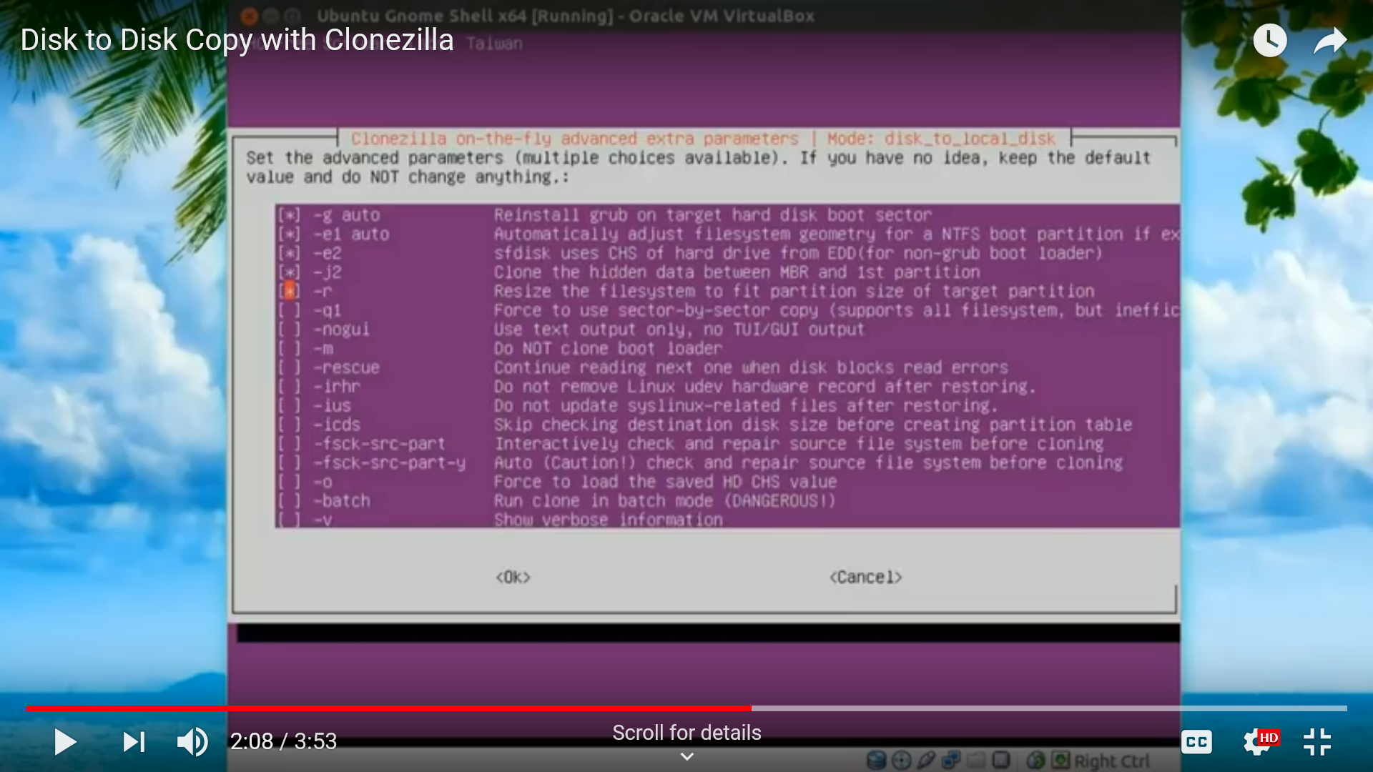
-r resize file system
-q1 force sector by sector copy (for forensic copy)
-rescue ignore read errors
-icds skip checking destination drive size
How to use it : Tutorials
Here are tutorials that you can watch it at your leisure.
Hard drive to hard drive clone
https://clonezilla.org/show-live-doc-content.php?topic=clonezilla-live/doc/03_Disk_to_disk_clone
Hard drive to image
https://www.youtube.com/watch?v=LS6VhLDw-io
More Hard drive to image videos
https://www.geekyprojects.com/cloning/how-to-use-clonezilla-tutorial/
https://www.youtube.com/watch?v=LS6VhLDw-io

