Objective: Learn how to take input from the keyboard using the Scanner class and perform basic operations in Java.

Question 1: Sum of Two Numbers
Write a Java program to:
Accept two integer numbers from the user.
Calculate their sum.
Display the result.
Enter First Number: 25
Enter Second Number: 35
Sum = 60
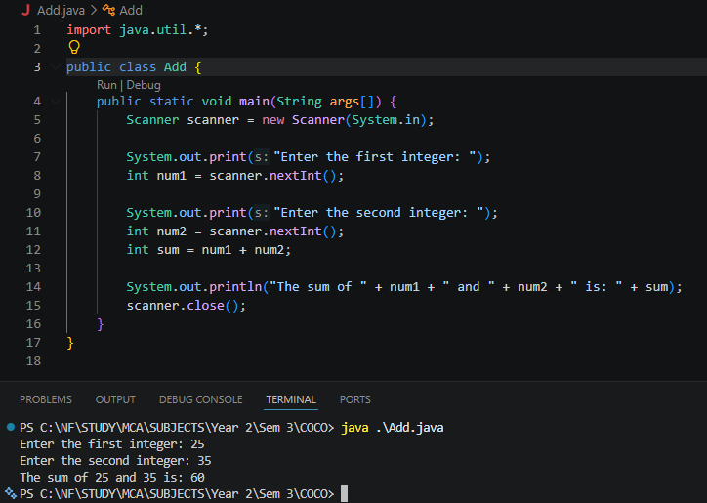

Question 2: Email Address Input
Write a Java program to:
Accept the user's full name.
Accept the user's email address.
Display both values in a formatted manner.

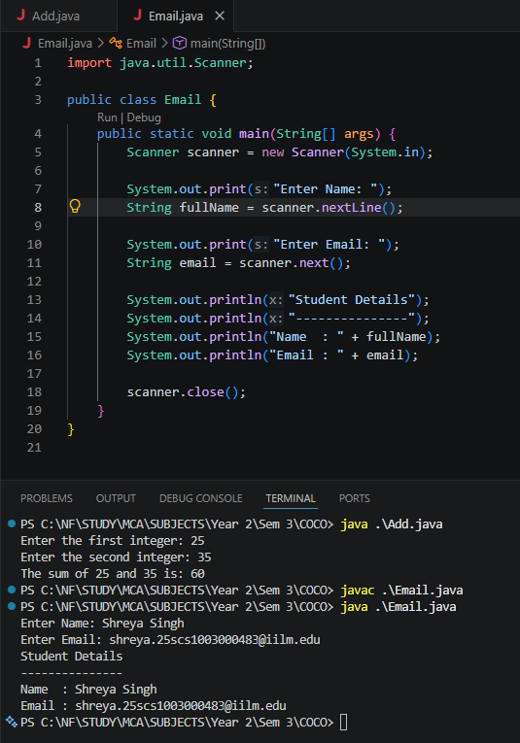
Question 3: Simple Interest Calculator Write a Java program to calculate using the formula:SI = (P × R × T) / 100 Where: = Principal Amount = Rate of Interest = Time (in years)

