SECTION - A
Create a Java class named Student with the following requirements:Declare the following instance variables:
- Student ID
- Student Name
- Course
- Age
Implement:
- A default constructor that initializes default values.
- A parameterized constructor that accepts all four values.
- A method displayDetails() to display student information.
- Create a Main class and demonstrate both constructors.
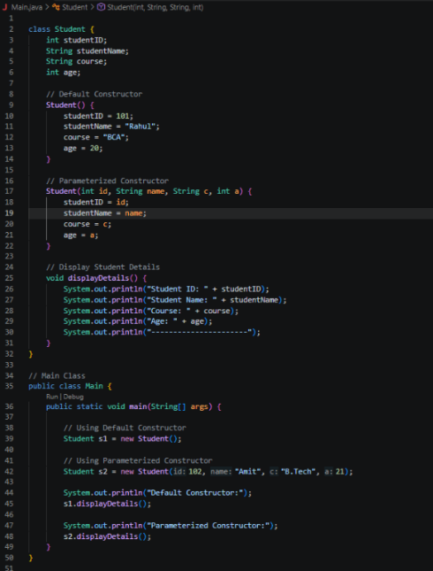
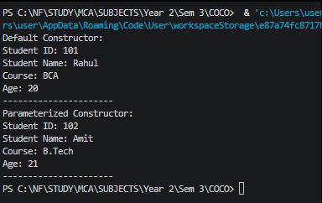
Create a class named Employee with the following requirements:Declare employee ID, name, designation, and salary.Create a default constructor.Create a parameterized constructor.Create a copy constructor that initializes an object using another Employee object.Display the details of all three employee objects.
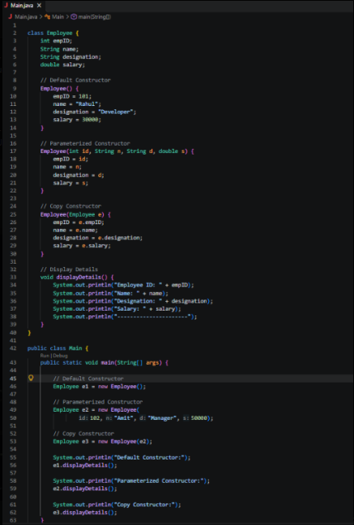
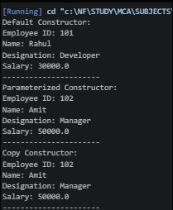
SECTION - B
Create the following inheritance structure:
- Parent Class: Person
- Name
- Age
- Email
- Method: displayPersonDetails()
Child Class: Student
- Student ID
- Course
- Method: displayStudentDetails()
Requirements:Implement single inheritance.Use the super keyword to call the parent class constructor.Create a Student object.Display both personal and academic details.
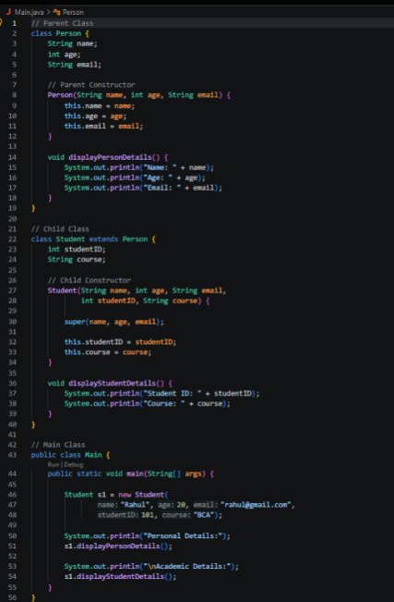
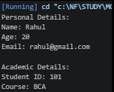
Create a Java program demonstrating multilevel inheritance.
Implement the following structure:
Employee
|
Manager
|
ProjectManager
Requirements:
- Employee ID
- Employee Name
- Basic Salary
- Department
- Team Size
- Project Name
- Project Duration
Create constructors in all three classes and use super() to invoke parent constructors.
Display complete project manager details.


