1-Check Even/Odd and Positive/Negative Take a number and determine whether it is positive/negative/zero and, if applicable, whether it is even or odd.

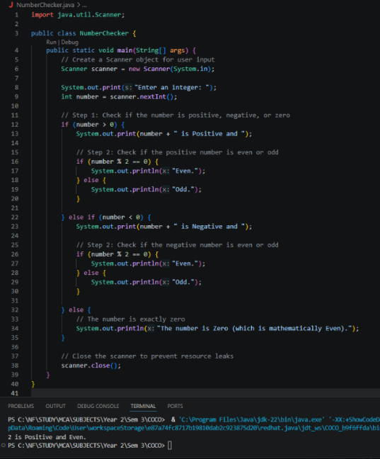

2-Largest of Three Numbers Take three numbers and find the largest using if-else.

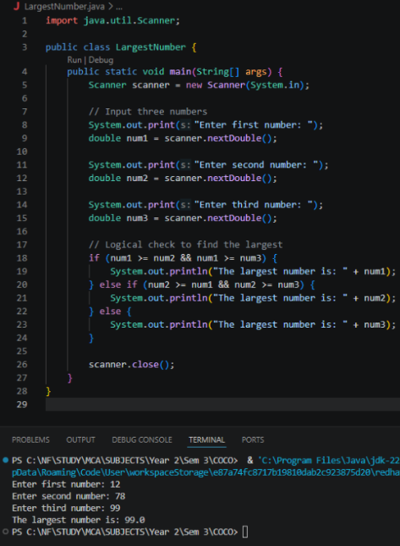

3-Number Divisibility Checker Take a number and check whether it is divisible by 5. If yes, further check whether it is also divisible by 10

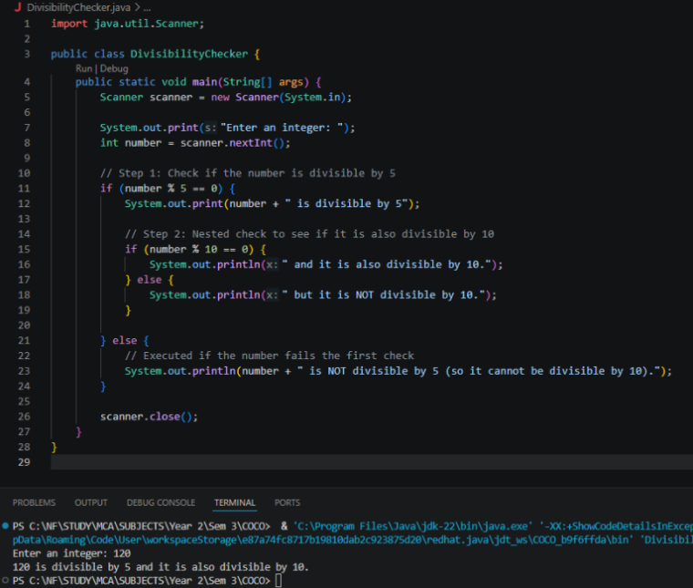

4-Check Working Day Take a day number (1–7) and determine whether it is a working day or weekend.

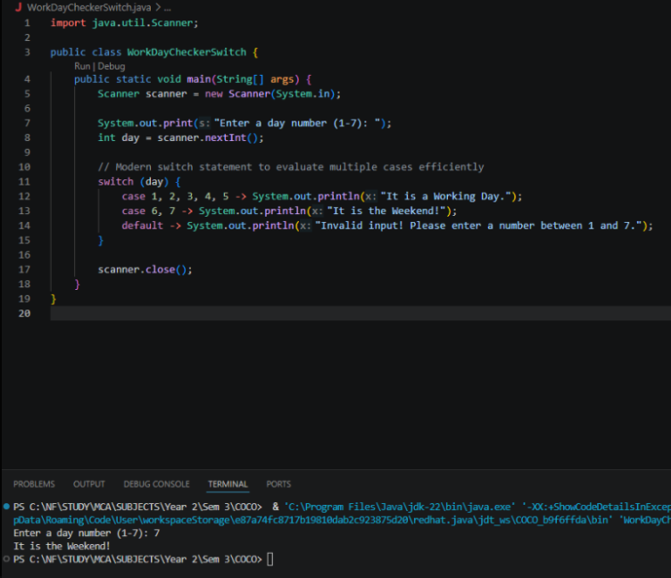

5-Password Length Checker Check whether a password is less than 8 characters, acceptable, or strong based on its length

