- Find the sum of numbers from 1 to N

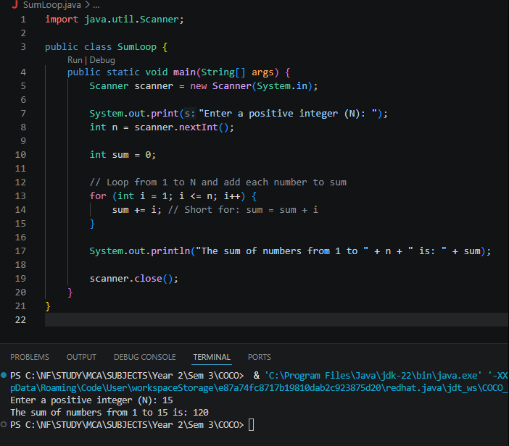

2. Print multiples of 5 from 1 to 100
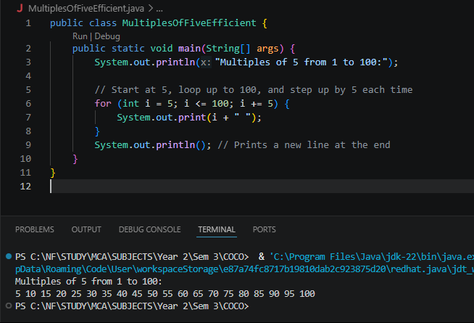

3. Count how many numbers are divisible by 3 between 1 and N

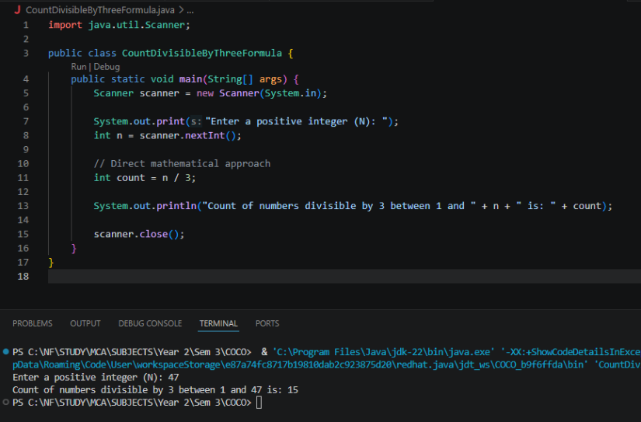

4. Check whether a number is prime or Not
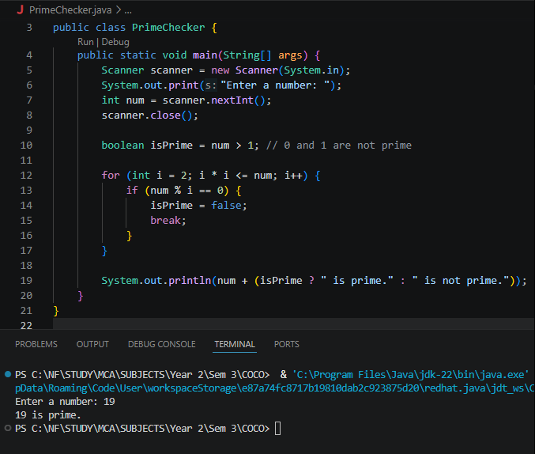

5. Reverse of a Given number.

