Assignment-8: Polymorphism and Method Overloading

Part A: Understanding of Theory Concept

1. Explain Polymorphism in Java. Write the definition of Polymorphism and explain why it is important in Object-Oriented Programming.
Definition:
Polymorphism is an important concept of Object-Oriented Programming (OOP) in which one name can have many forms. In Java, polymorphism allows the same method, object, or interface to behave differently depending on the situation.
The word polymorphism comes from two Greek words:
- Poly → Many
- Morphism → Forms
Thus, polymorphism means “many forms.”
Importance of Polymorphism in OOP
Polymorphism is important because:
- Code Reusability: The same method name can be used for different purposes.
- Flexibility: A program can work with different objects using a common interface or superclass.
- Maintainability: Code becomes easier to modify and maintain.
- Extensibility: New classes can be added without changing much existing code.
- Supports OOP: It helps achieve abstraction and loose coupling.
Example:
class Animal {
void sound() {
System.out.println("Animal makes a sound");
}
}

class Dog extends Animal {
void sound() {
System.out.println("Dog barks");
}
}
Here, the sound() method behaves differently for Animal and Dog. This demonstrates polymorphic behavior.
2. Explain the Types of Polymorphism.
Explain the following types of Polymorphism with suitable examples: Compile-Time Polymorphism (Static Polymorphism) Run-Time Polymorphism (Dynamic Polymorphism)

1. Compile-Time Polymorphism (Static Polymorphism)
Compile-time polymorphism is achieved through Method Overloading. In method overloading, multiple methods have the same name but different parameters.
The compiler decides which method should be executed at compile time.

Example:
class Calculator {

int add(int a, int b) {
return a + b;
}

int add(int a, int b, int c) {
return a + b + c;
}

double add(double a, double b) {
return a + b;
}
}

class Main {
public static void main(String[] args) {
Calculator c = new Calculator();

System.out.println(c.add(10, 20));
System.out.println(c.add(10, 20, 30));
System.out.println(c.add(10.5, 20.5));
}
}

Output:
30
60
31.0
Here, all methods have the same name add(), but their parameter lists are different. The compiler determines which add() method to call.
Therefore, method overloading is an example of compile-time polymorphism.

2. Run-Time Polymorphism (Dynamic Polymorphism)
Run-time polymorphism is achieved through Method Overriding.
In method overriding, a subclass provides its own implementation of a method that is already defined in its superclass.
The method that will execute is determined at run time, based on the actual object.

Example:
class Animal {
void sound() {
System.out.println("Animal makes a sound");
}
}

class Dog extends Animal {
@Override
void sound() {
System.out.println("Dog barks");
}
}

class Cat extends Animal {
@Override
void sound() {
System.out.println("Cat meows");
}
}

class Main {
public static void main(String[] args) {

Animal a;

a = new Dog();
a.sound();

a = new Cat();
a.sound();
}
}

Output:
Dog barks
Cat meows

3. Explain Method Overloading.
Your explanation should include: Definition of Method Overloading Rules of Method Overloading Different ways to overload a method Why changing only the return type is not considered Method Overloading Difference between Method Overloading and Method Overriding.

Definition of Method Overloading:
Method Overloading is a feature of Java in which a class contains multiple methods having the same name but different parameter lists.
The methods may differ in:
- Number of parameters
- Order of parameters
Method overloading is also known as Compile-Time Polymorphism or Static Polymorphism.

Example:
class Display {

void show(int a) {
System.out.println(a);
}

void show(String a) {
System.out.println(a);
}

void show(int a, int b) {
System.out.println(a + b);
}
}
All methods are named show(), but their parameters are different.

Rules of Method Overloading
The important rules are:
- The overloaded methods must have the same method name.
- Their parameter list must be different.
- Parameters can differ in their number.
- Parameters can differ in their data type.
- Parameters can differ in their order, provided the types are different.
- The return type alone cannot be used to overload a method.

Different Ways to Overload a Method

1. By Changing the Number of Parameters
class Test {

void display(int a) {
System.out.println(a);
}

void display(int a, int b) {
System.out.println(a + " " + b);
}
}
Here, the number of parameters is different.

2. By Changing the Data Type of Parameters
class Test {

void display(int a) {
System.out.println(a);
}

void display(double a) {
System.out.println(a);
}
}
Here, the parameter data type is different.

3. By Changing the Order of Parameters
class Test {

void display(int a, String b) {
System.out.println(a + " " + b);
}

void display(String a, int b) {
System.out.println(a + " " + b);
}
}
Here, the order of int and String parameters is different.

Why Changing Only the Return Type Is Not Method Overloading?
Changing only the return type does not constitute method overloading.

Example:
class Test {

int add(int a, int b) {
return a + b;
}

// Error
double add(int a, int b) {
return a + b;
}
}
The compiler cannot distinguish these methods only by their return type because both have the same:
- Method name: add
- Parameter types: int, int
Therefore, Java considers them duplicate methods.

Difference Between Method Overloading and Method Overriding

Method Overloading | Method Overriding
Occurs within the same class or through inherited methods with different parameter lists. | Occurs between a superclass and subclass.
Method name is the same. | Method name is the same.
Parameters must be different. | Parameters must be the same.
It is compile-time polymorphism. | It is run-time polymorphism.
Inheritance is not necessarily required. | Inheritance is required.
Return type may be different, but not as the only difference. | Return type must be compatible (covariant return types are allowed).
Compiler decides which method to call. | JVM determines the overridden method at run time.
Example: add(int,int) and add(int,int,int). | Example: Dog.sound() overriding Animal.sound().

Simple Example of Overloading
class Calculator {

int add(int a, int b) {
return a + b;
}

int add(int a, int b, int c) {
return a + b + c;
}
}

Simple Example of Overriding
class Animal {
void sound() {
System.out.println("Animal sound");
}
}

class Dog extends Animal {
@Override
void sound() {
System.out.println("Dog barks");
}
}

Part B: Programming Questions

- Calculator Addition
Create a class Calculator and overload the add() method to perform the following operations: Add two integers. Add three integers. Add two decimal numbers. Create an object of the class and call all overloaded methods.
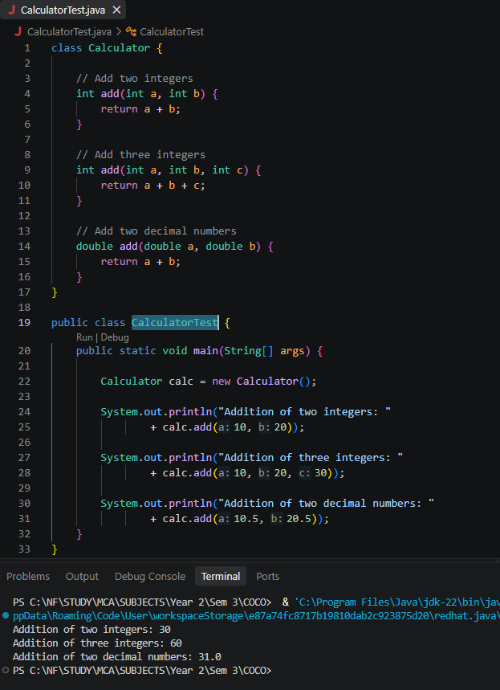

2. Display Method
Create a class Display and overload the show() method to display student information in different formats: Display only the student's name. Display the student's name and age. Display the student's name, age, and marks. Create an object and call all versions of the show() method.

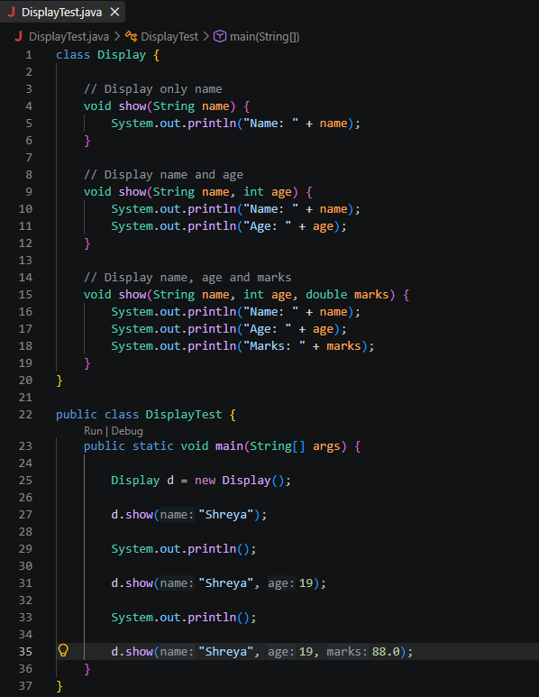

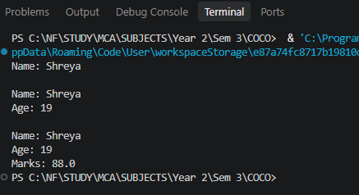

- Find Maximum
Create a class and overload the max() method to find: Maximum between two integers. Maximum between three integers. Maximum between two decimal numbers. Display the result for each method call.

