TP 3 – SNMP

Q1. SNMP on asrall-sw24 and asrall-sw48

1. (Command : snmpwalk -v 2c -c public asrall-sw24 SNMPv2-MIB::sysDescr.0) This is a HPE OfficeConnect Switch 1820 24G and for the asrall-sw48, this is a HPE OfficeConnect Switch 1820 48G.
2. (Command : snmpwalk -v 2c -c public asrall-sw24 sysUpTimeInstance) This switch is up since 34 days, 22 hours, 20 minutes and 15 seconds and for the asrall-sw48, it is up since 34 days, 23 hours, 28 minutes and 19 seconds.
3. As we can see on the main description of the switch, we have 24 Ethernet port and 48 Ethernet port for the asrall-sw48.
4. (Command : snmpwalk -v 2c -c public asrall-sw24 -m ALL ifInOctets and snmpwalk -v 2c -c public asrall-sw24 -m ALL ifOutOctets) The most traffic in usage is on port 24 : 2400423343 octets and the most traffic out usage is on port 18 : 3489900049 octets. The asrall-sw48’s most traffic in usage is on port 23 : 3262503640 octets and the most traffic out usage is on port 14 : 3810516063 octets.
5. (Command : snmpwalk -v 2c -c public asrall-sw24 -m ALL ifInError and snmpwalk -v 2c -c public asrall-sw24 -m ALL ifOutError) On the port 23, we have 1 error in and no out errors. For asrall-sw48, we have 1 error on 4 ports and no out errors.
6. (Command : snmpwalk -v 2c -c public asrall-sw24 -m ALL ifType) We have the ifType value which provides us the type of port we have on the switch (Ethernet or others types likes LAG ports or vlan. (Command : snmpwalk -v 2c -c public asrall-sw24 -m ALL ifOperStatus) See all the port and their status (if their up or down for example). (Command : snmpwalk -v 2c -c public asrall-sw24 -m ALL ifPhysAddress) To see each MAC address of each interfaces.
7. On the system description, we can see this sentence : HP ETHERNET MULTI-ENVIRONMENT,ROM G.08.08,JETDIRECT,JD33,EEPROM G.08.40 which provide all the informations about the printer’s name.
8. (Command : snmpwalk -v 1 -c public printer -m ALL -C c prtGeneralSerialNumber) The serial number of this printer is : NL7R079615.
9. This printer is up since 1 hour, 36 minutes and 12 seconds.
10. (Command : snmpwalk -v 1 -c public printer -m ALL -C c prtMarkerSuppliesLevel) This cartridge contain 7 % of ink (corresponding to 350/4600).
11. (Command : snmpwalk -v 1 -c public printer -m ALL -C c prtInputCurrent) There is no paper on this printer (no paper at all on each tray).
12. (Command : snmpwalk -v 1 -c public printer -m ALL -C c ipAdEntAddr) To show the IP address. (Command : snmpwalk -v 1 -c public printer -m ALL -C c prtGeneralCurrentOperator) See the printer’s status of work (idle or processing).

Q2. Intégration Munin et SNMP

1. Adding switches and printer monitoring on Munin :

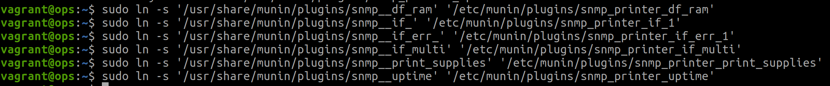

* 1. Add the printer into the munin.conf file on the munin-node (ops) :

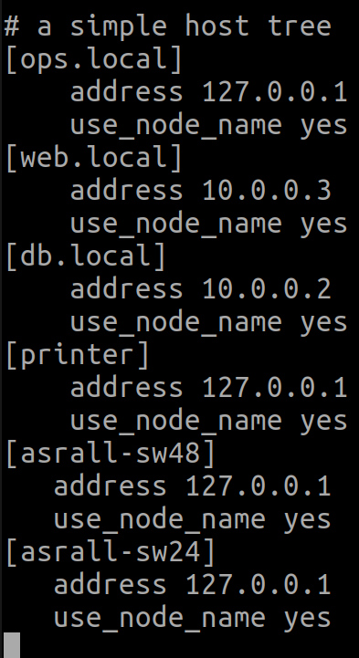

* 1. Same thing with switches to have the symbolic link to add : “munin-node-configure --shell --snmp asrall-sw24 --snmpversion 2c --snmpcommunity public“ and “munin-node-configure --shell --snmp asrall-sw48 --snmpversion 2c --snmpcommunity public“
  2. Screen of the three new machines on Munin :

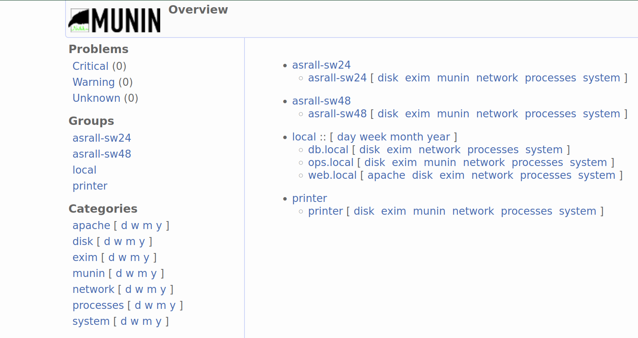

Q3. Intégration Icinga et SNMP

1. Adding printer toner level on Icinga :
   1. In the new configuration file on icinga conf directory “objects/printer.cfg” :

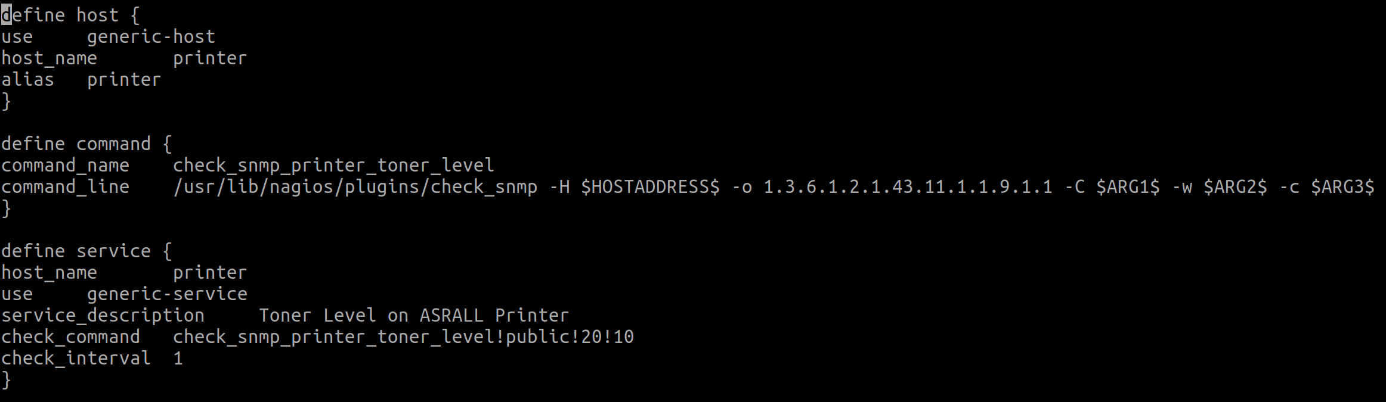

* 1. Screen of the result in Icinga web administration page :

