CocoMake7 - A jugaad and low-cost educational tool for digital interactivity

The difference between the meaning of „understanding“ and „grasping“ is more nicely described in the German language, where „begreifen“ is involving a more deeper use of the mind and the body to interpret an object of interest and create a conception of the world around us, as Gerd Folkers describes in his article on „Der Sinn des Begreifens“:
„Fälschlicherweise werden “verstehen” und “begreifen” heute synonym verwendet. Zusästzlich zum Betrachten lege ich Hand an und begreife das Objekt im wahrsten Sinne des Worts. Diese zusätzlichen Informationen helfen dem Gehirn, viel tiefer in die Bedeutung des Objekts einzudringen und es so tatsächlich zu verstehen. Begreifen heisst demnach, Geist und Körper zu benutzen, um ein Objekt zu deuten. Und genau dies ist notwendig um uns als körperliche Wesen eine Vorstellung von der Welt, die uns umgibt, zu machen.“
- Gerd Folkers, Abstrakt, N°8 Machen ist Macht

Digital and Interactive Hardware/Software Learning Tools for Low-Resource Settings

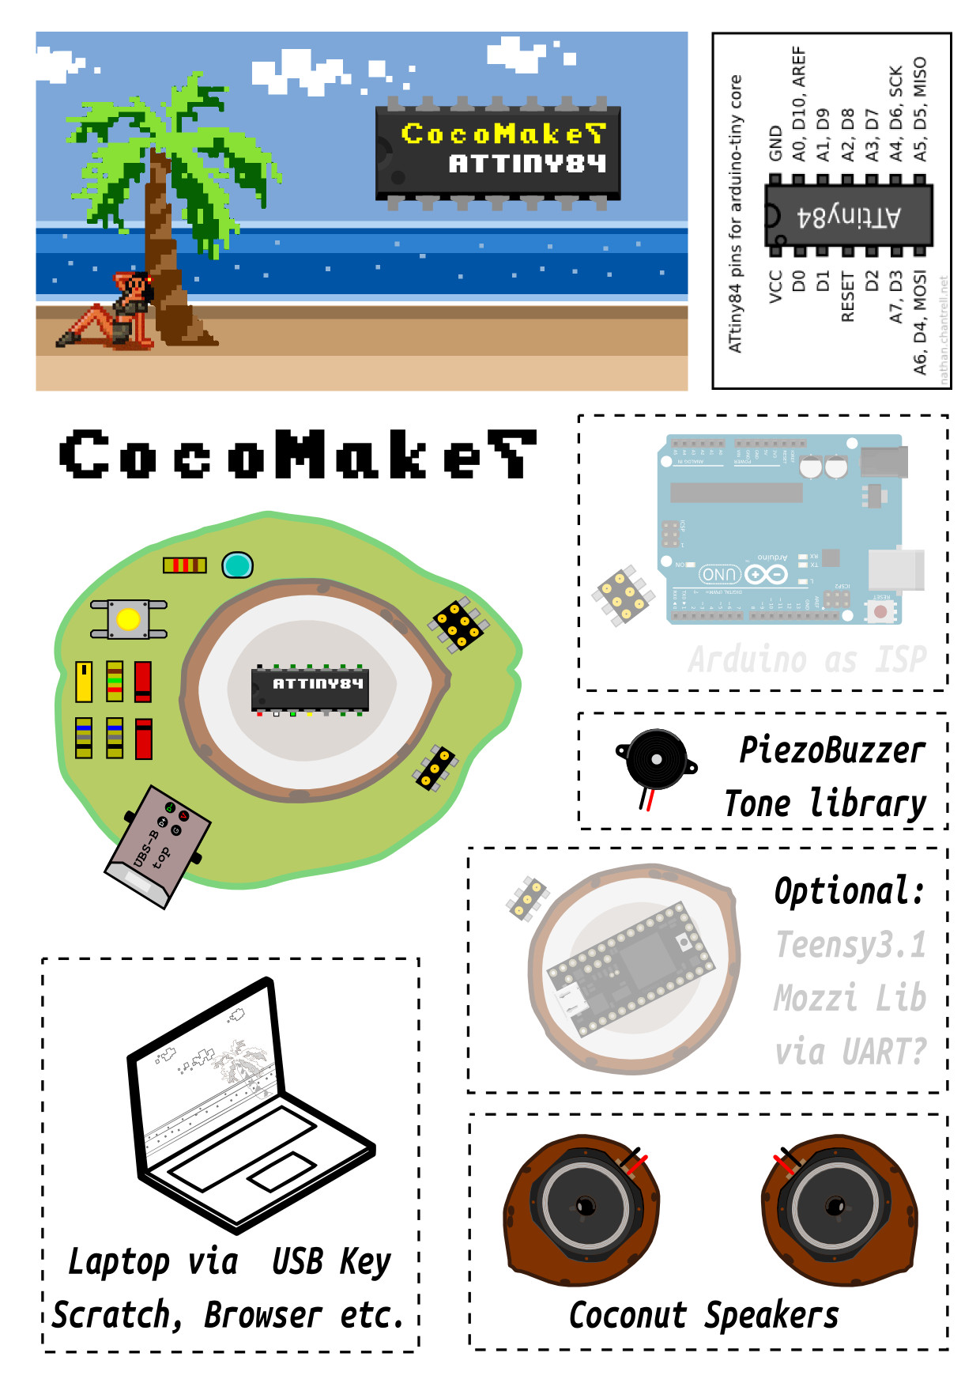
Background
Through our activities in doing workshops in low-resource settings, eg. the Drisha School in Bangalore or various schools in Indonesia or Nepal, we have seen excellent educators using the most up-to date pedagogic concepts. It seemed to us that the free access and open source resources to educational materials, especially for teaching programming and digital storytelling, such as Scratch, can have a fundamental impact in digital literacy, both in industrialized nations, aswell as in the global south. Similar platforms, developed by interdisciplinary teams of hackers, designers and educators, have now been developed to include dedicated hardware for physical computing, environmental sensing and digital interactivity, eg. the arduino platform, the smart citizen toolkit or the Makey Makey. But the prize of these tools are still a limiting factor for their implementation (besides the general limit of access to computers). While in Europe a 30$ hardware platform is considered „low-cost“, it can be a limiting factor in another environment and will not be implemented at all. We have initiated several projects with a team of international hardware developers, educators and designers to tackle that issue, such as the BabyGnusbuino, an arduino-compatible educational platform that can be locally produced for approximately 2€ or very recently the CocoMake7, which could replace a MakeyMakey for 1/10th of the cost of the original.
http://hackteria.org/projects/cocomake7/
http://wiki.sgmk-ssam.ch/index.php/Babygnusbuino-v2
We are very interested to continue some of these appraoches in collaboration with other groups across the world, as well as organizing international events in Switzerland (or across the Italian border), aswell as in the tropical regions where coconuts are growing freely. We are using collabroative methodologies such hackathons and co-production labs, to enable temporary and immersive production and research environments in the „Real World“.

Methodologies
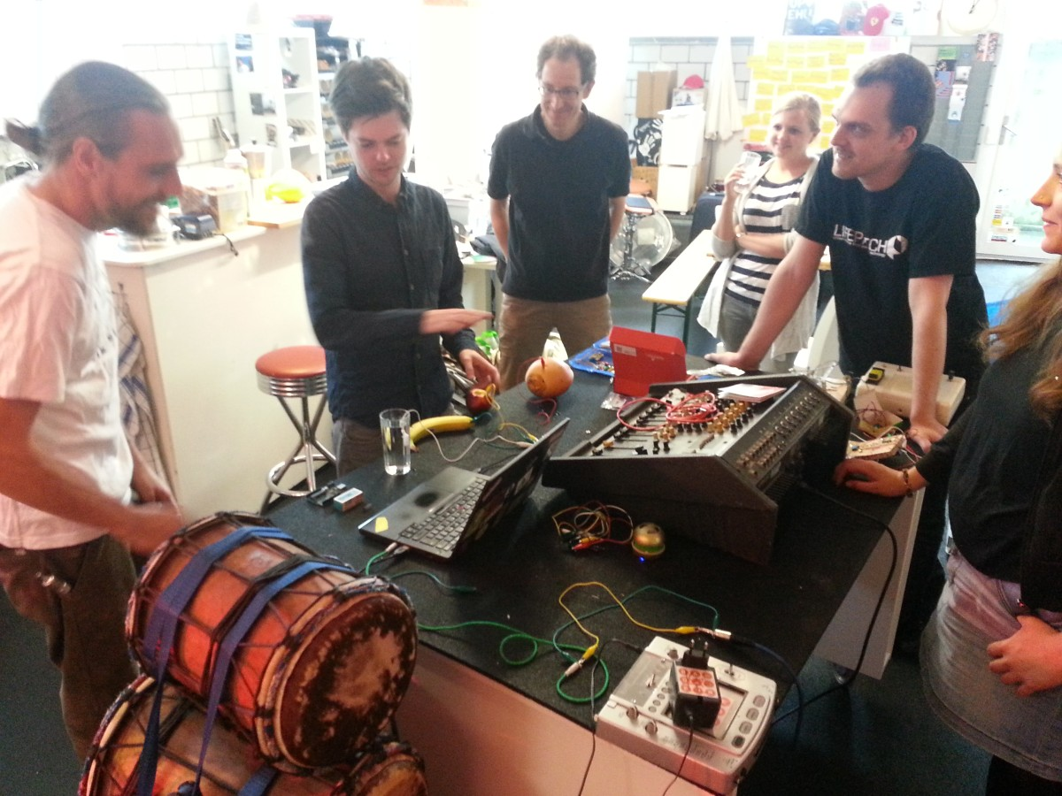

http://hackteria.org/wiki/CocoMake7-Hackathon

International Workshopology Symposium
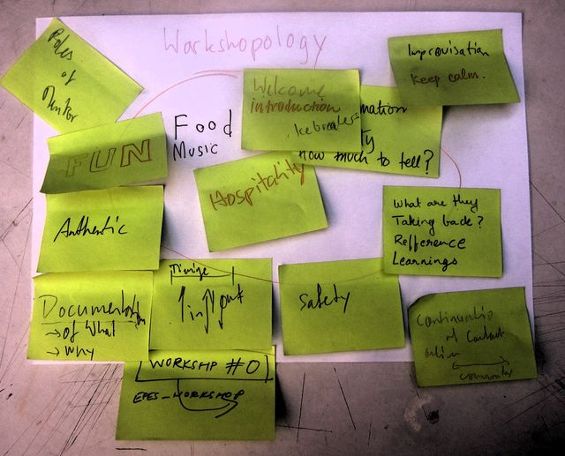
The field of media arts has always been very interdisciplinary and many practitioners have a non-linear professional background, engineers bridging from computer science into sculpture or performance, landscape painters learning to program for digital interactivity. So to keep up with the fast developments in technology at many festivals and other events workshops are extremely important both as a learning enviroment for their own professional development, as well as a stable and regular income for the artist/hackers/mentors giving the workshops. Not many of those workshopologists do have a formal education in pedagogy or in-depth exposure to an educational environment. After discussions at the pikselache festival in Helsiniki in 2011, we started a small discussion group on that issue, inviting „workshopologists“ and other practitioners to share their best (and worst) practices, and trying to put forward these meta-level discussion on workshops at various festivals instead of just executing them. During following events labelled as „Workshopology Symposium“ in Maribor, Zurich, Ljubljana and Yogyakarta, we have brought together enthusiastic self-tought workopologists with science communicators, artists and designers, social activists, art educators and hackers. We believe in the cross-fertilization from these informal educational settings with other pedagogic enviromnents and we have now started a more local network around workshopology, who meets regularly in Switzerland.
I hope to continue with that idea during my time at, organizing both local and international gatherings, in Helsinki, aswell as in other parts of the world, with the goal to analyze and document more in-depth these practices and share them widely through open online channels.
http://wiki.sgmk-ssam.ch/index.php?title=Workshopology
http://www.workshopology.org/ (reserved, but not used)

References
(Unsorted references used in framing the above research plan)
Csikszentmihalyi, Mihaly. 2013. Creativity: The Psychology of Discovery and Invention. Reprint edition. Harper Perennial.
Cybulski, James, James Clements, and Manu Prakash. 2014. “Foldscope: Origami-Based Paper Microscope.”arXiv:1403.1211 [physics], March.http://arxiv.org/abs/1403.1211.
Harris, Eva. 1998. A Low-Cost Approach to PCR : Appropriate Transfer of Biomolecular Techniques: Appropriate Transfer of Biomolecular Techniques. Oxford University Press, USA.
Gabrielson, Curt. 2013.Tinkering: Kids Learn by Making Stuff. 1 edition. Sebastopol, CA: Maker Media, Inc.
Gregory L. Charvat. 2015. “Hacking Education; Project-Based Learning Trumps the Ivory Tower.”Hackaday. Accessed January 4.http://hackaday.com/2014/12/31/hacking-education-project-based-learning-trumps-the-ivory-tower/.
Griffiths, Amber. 2015. “DIY Labs Are an Exciting Alternative to University Science Research.” The Guardian. Accessed March 17.http://www.theguardian.com/higher-education-network/blog/2014/jun/16/diy-labs-exciting-alternative-university-science-research.
Kera, Denisa. 2012. “Nano{Š}mano Lab in Ljubljana: Disruptive Prototypes and Experimental Governance of Nanotechnologies in the Hackerspaces.” JCOM11: 4.
Kera, Denisa. 2014. “Innovation Regimes Based on Collaborative and Global Tinkering: Synthetic Biology and Nanotechnology in the Hackerspaces.”Technology in Society, Nanotech traveling abroad: The international dimension of nanotechnology as a changing concept, 37 (May): 28–37. doi:10.1016/j.techsoc.2013.07.004.
Papanek, Victor. 1985.Design for the Real World: Human Ecology and Social Change. 2nd edition. Chicago, Ill: Academy Chicago Publishers.
Resnick, Mitchel, Robbie Berg, and Michael Eisenberg. 2000. “Beyond Black Boxes: Bringing Transparency and Aesthetics back to Scientific Investigation.”JOURNAL OF THE LEARNING SCIENCES 9: 7–30.
UNESCO, various. 1973. Low Cost Equipment for Science and Technology Education. UNESCO.http://otp.unesco-ci.org/training-resource/learning-materials/low-cost-equipment-science-and-technology-education.

Biograhien

Dr. Marc Dusseiller (CH)
Dr. Marc R. Dusseiller is a transdisciplinary scholar, lecturer for micro- and nanotechnology, cultural facilitator and artist. He works in an integral way to combine science, art and education. He performs DIY (do-it-yourself) workshops in lo-fi electronics and synths, hardware hacking for citizen science and DIY microscopy. He was co-organizing Dock18, Room for Mediacultures, diy* festival (Zürich, Switzerland), KIBLIX 2011 (Maribor, Slovenia), workshops for artists, schools and children as the former president (2008-12) of the Swiss Mechatronic Art Society, SGMK. In collaboration with Kapelica Gallery, he has started the BioTehna Lab in Ljubljana (2012 - 2013), an open platform for interdisciplinary and artistic research on life sciences. Currently, he is developing means to perform bio- and nanotechnology research and dissemination, Hackteria | Open Source Biological Art, in a DIY / DIWO fashion in kitchens, ateliers and in developing countries. He was the co-organizer of the different editions of HackteriaLab 2010 - 2014 Zürich, Romainmotier, Bangalore and Yogyakarta.
http://www.dusseiller.ch/labs/
http://hackteria.org/
http://www.randelab.ch/

Christoph Stähli (CH)
Christoph Stähli is working as freelance artist, hacker and programmer. He studied New Media (BA) and Fine Arts (MA) at the Universitiy of the Arts Zurich, ZHdK. His interest lies in the broad scientific field of media technologies and their applications in artist based practices. He developed content and software for the 3d LED display NOVA of ETH Zurich. As a member of the Swiss Mechatronic Art Society SGMK he's giving workshops and is co-organizer of the diy*-festival. 2010 he founded ZAAK (Zentrum für angewandte Automation und Kunst). At the momement Christoph Stähli is working as research associate at the Institute for Computer Music and Sound Technology ICST at ZHdK.
http://www.stahlnow.com

Michael Egger (CH)
Michael Egger (*1974) is a video artist, tinkerer, programmer, musician and pedagogue. He develops musical instruments that produce video instead of sound, instruments that let you manipulate images in real time and give them a musical expression. Together with Maïté Colin they put their research for a musical approach to visual language to test at regular intervals at concerts in different contexts – from rock to contemporary improvised music. His inventions, like the synkie, videobass, udmx or the gnusb, are published under open source licenses.
He is a founding member of [ a n y m a ] and a member of the Swiss Mechatronic Art Society. Michael Egger develops interactive multimedia installations (eg for the Museum of Ethnology at the University of Zurich), and imparts regularly his knowledge of sensor technology, programming (especially microcontrollers and MaxMSP) and electronics in workshops, lectures or as a guest lecturer at various universities. And sometimes he just grabs his guitar again, and you can encounter him busking in a subway somewhere…
http://www.anyma.ch/

International Collaborators

Gurinder Singh Gill (India)
Guri is an independent researcher, programmer and hardware developer, who has been very actively creating a community of makers and DIY electronics enthusiasts in Bangalore. He has done a series of workshops in Arduino programming and IoT introductions. He has developed various experimental musical interfaces using the most simple tools available on the local electronics markets and has already produced various small batch prototypes using local manufacturing suppliers from India.

Yashas Shetty and the team from (Art)Science Bangalore and CERTAD, Bangalore (India)
Yashas Shetty's practice is situated in the intersection between art, science and pedagogy, creating situations of dialogue between artists, scientists and the larger community. Working between various disciplines including installation, sound, software and biotechnology, Shetty often creates assemblages/collages of various life forms using techniques borrowed from genetic engineering and synthetic biology. In the work Teenage Gene Poems he isolates a sequence of DNA that produces an enzyme responsible for the smell of wet earth when it begins to rain, which is subsequently injected into the DNA of E.Coli bacteria. By doing so he transfoms the bacteria into 'living machines' that produce the smell of rain. The mystique surrounding the aroma of the Indian monsoon is encoded as a genetic sequence, continuing a line of enquiry in his work, the use of scientific techiniques to explore sensitive, emotive and often nostalgic subjects.
http://hackteria.org/network/artscienceblr/
CERTAD is a design collective currently comprising of people from diverse backgrounds: dancers, artists, literary and cultural critics, architects, storytellers, filmmakers, new media designers, environmentalists, technologists, mathematicians and science enthusiasts.
This collective together constructively and collaboratively creates tools, platforms and environments that reclaim formal and informal learning as intimate, personal, transformative and enabling.
http://srishti.ac.in/centers-and-labs/center-for-education-research-training-and-development

Roshan Battha and team from Karkhana - Make Break Innovate, Kathmandu (Nepal)
„I am a teacher at Karkhana. I have been involved in designing and teaching project based classes since last two years. Prior to becoming a teacher, I was an engineer. I love programming hardwares especially Atmel(AVR) microcontrollers and have spent decent amount of time working on different hardware projects. I love to animate and vfx as a hobby. During my free time, I like cycling around kathmandu with my friends.“
Karkhana is an education company and makerspace with a unique approach to learning. Our teachers – engineers, designers, artists, scientists – turn the classroom into a lab for discovery. We want our students to gain one key insight: the world is malleable. We work directly with learners between ages 8 and 14 through an integrated cross-disciplinary co-curricular after-school program. We also work directly with schools through a teacher professional development program for Science, Math and Computer teachers.
http://www.karkhana.asia/

Yair Reshef and the team from TAMI, Tel Aviv (Israel)
TAMI (our hackerspace) is a group of people with similar interests (more or less) that like to think, teach and create. We are interested not only in computers and electronics - there are amateur carpenters, cookers, people interested in do it yourself biology, and more.
http://telavivmakers.org/

Alex Giordano and the team from Rural Hub, Calvanico, Salerno (Italy)
Rural Hub is the rhizome of a network of researchers, activists, scholars, and managers interested in identifying new models of economic development. All those people are motivated to find new solutions to the needs (both social and market-related) of the new rural enterprises.
Rural Hub is the first Italian hacker space allowing connection and sharing among people, ideas, technologies and projects concerning social innovation projects applied to the rural world.
http://www.ruralhub.it/

