# Post-Fundamentals Drift in Stock Prices—— A Machine-Learning Approach

**Avramov_, Kaplanski , Subrahmanyam 2020 May， working paper**

## Introduction

### Background

* **A growing body of literature shows that trading rules based on moving averages of prices predict returns.**
* **While there are many factors based on fundamentals to predict stock returns in cross-section, moving averages of fundamentals are rarely used**
* **There are a fast-growing body of literature on machine learning (ML) as applied to asset pricing**

### Related literature

* **moving averages of prices : momentum (Jegadeesh and Titman, 1993), 52-week highs (George and Hwang, 2004), price trends (Han, Zhou, and Zhu, 2016), earnings momentum (Ball and Brown, 1968)**
* **based on fundamentals: termed BG (Bartram and Grinblatt, 2018) , The F-score (Piotroski, 2000) , The G-score (Mohanram, 2005) …all factors in group three of the FM regression control variables comes from literature**
* **ML applied in asset pricing: Gu, Kelly, and Xiu (2020), Avramov, Cheng, and Metzker (2019), Chen, Pelger, and Zhu (2019), and Feng, Polson, and Xu (2019), Chinco, Clark-Joseph, and Ye (2019), Jia, Wu, and Yan (2019)**

### Motivation/ Research Problem

* **Exploring the viability of return predictability from moving averages of financial statement items**
* **Trying to explain why the FDI yield positive abnormal profits**

### Contribution

* **The first to show that rules based on fundamentals’ deviations from past moving averages are profitable, provide a different context in which moving-average-based rules are applicable.**
* **contribute to the fast-growing literature on machine learning (ML) as applied to asset pricing**
* **related to the notion developed in recent years that investors’ expectations are slow-moving relative to a Bayesian**

### Outline

## Research Design

### FDI construction

* **Fundamental Deviation Index (FDI) is prediction of stock returns based on deviations for all Compustat Unrestated quarterly accounting variables.**
* **Deviation: the difference between the most recent quarterly release and the average over the preceding three quarters, scaled by total assets. Each deviation is then assigned a percentile relative to all stocks’ deviations in that month as an input of ML regression.**
* **For each month J, We run a LASSO (also replaced with ridge regressions and elastic net, index name as FDIRdg and FDIEn) panel regression (without intercept) of monthly stock returns realized up to month J on previous-months’ deviations. FDI is computed as the fitted value of the panel regression using time J realizations of deviation variables.**

### Data

* **Database: Computstat**
* **Sample: all U.S. firms listed on the NYSE, AMEX, and NASDAQ with share codes 10 and 11, with positive equity book values in Compustat for the previous year, an end-of-month price above $5, trading during the month, and having return or earnings at least one observations for the previous 12 months. 1987 through December 2017, 1,089,518 firm-month observations per 12,024 firms**

### Control variables (factors)

* **usual style characteristics variables**
* **variables associated with past prices**
* **fundamental related variables**
* **variables capture limits to arbitrage**

## Empirical Result

### Deviation Variables selection

**Starting with a universe of 105 deviation variables, about 93 are retained at least once in constructing FDI. Only 11 deviations are retained at least 180 times and additional 22 deviations are retained at least 120 times. Deviations in cash, accounts payable, capital surplus (negative weight), debt reduction, assets (negative weight), earnings per share, inventories (negative weight), and cash dividends are the most frequently selected. (see Appendix B)**

### The ability of FDI to predict future stock returns

#### Cross-Sectional Regression

**For each month, we regress monthly stock returns on FDI (replaced by FDIRdg and FDIEn) and other selected predictive characteristics as control variables. We only notice the statistical significance here.**

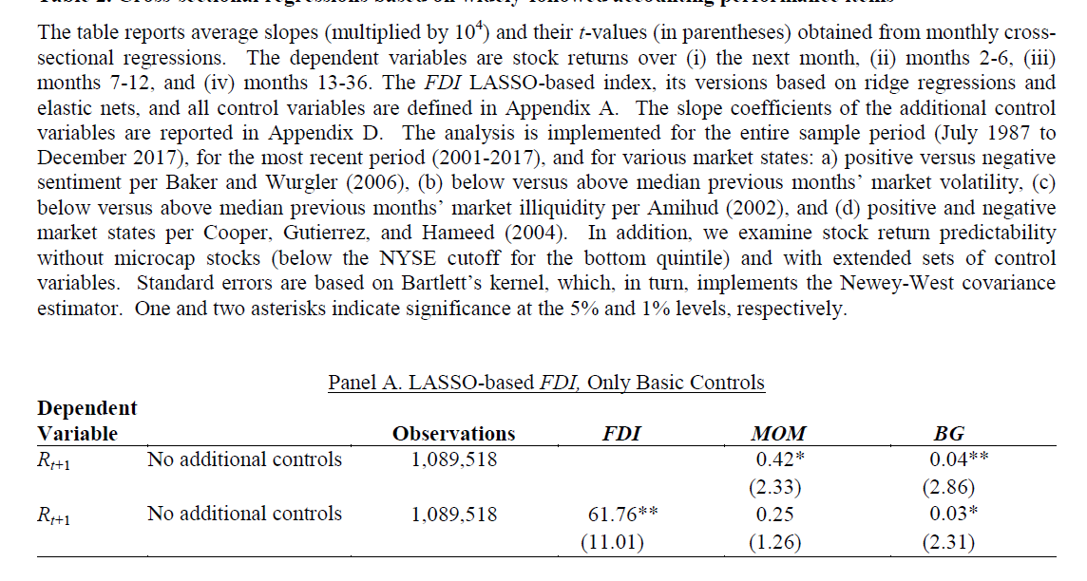

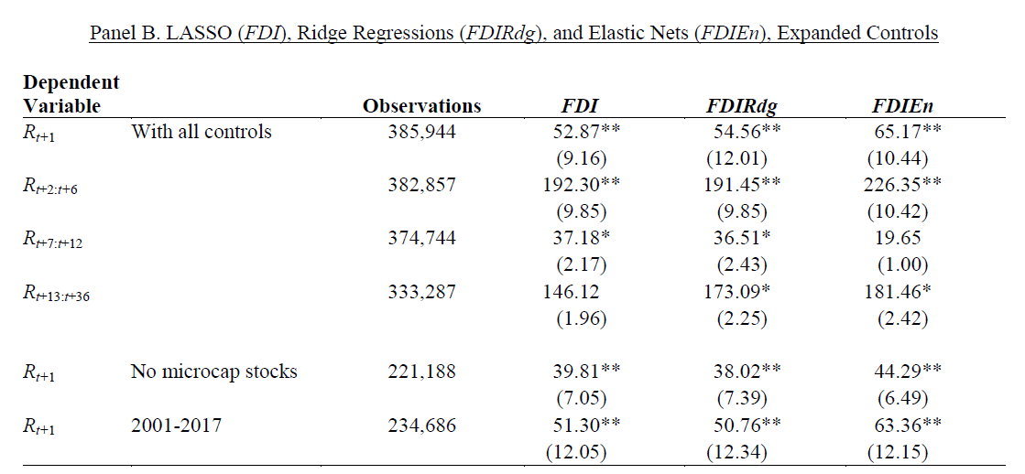

hly

hly

hly

* **FDI coefficient is highly significant, even with all other control variables**
* **FDI coefficient is significant, in longer and further investment horizon**
* **FDI coefficient is highly significant, excludes microcaps and remain significant in recent years**

**We then analyze the predictive power of FDI across different market states:**

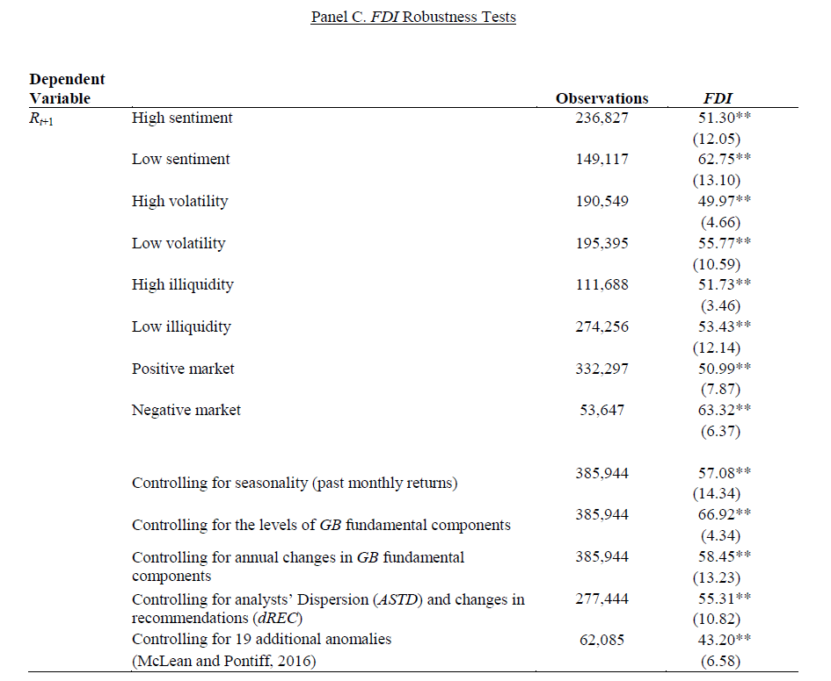

* **FDI coefficient’s high significance survives all the robustness tests and remains significance in all the scenario**
* **FDI survives BG(consist of 28 of the most common firm-level accounting variables) related tests indicates that it is the deviations of performance components from preceding means, rather than the components themselves that drive return predictability.**

#### Portfolio Analysis

**We next assess profitability of decile-based hedge portfolio strategies that employ FDI. The FDI strategy takes long (short) positions in top (bottom) FDI deciles.**

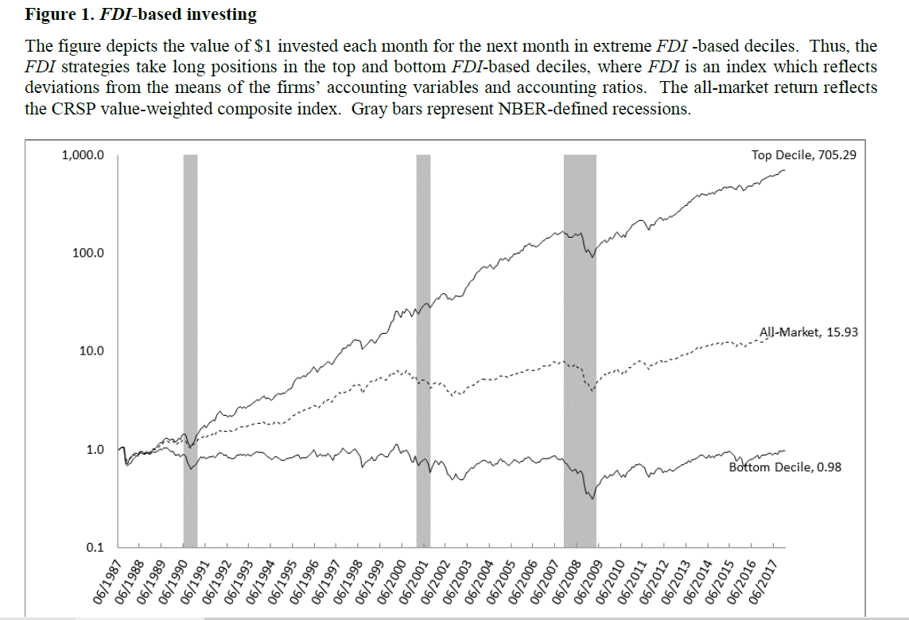

**We summarize annual alphas from the long-short extreme-decile-based FDI strategy and their significance for holding periods ranging from one to 12 months.**

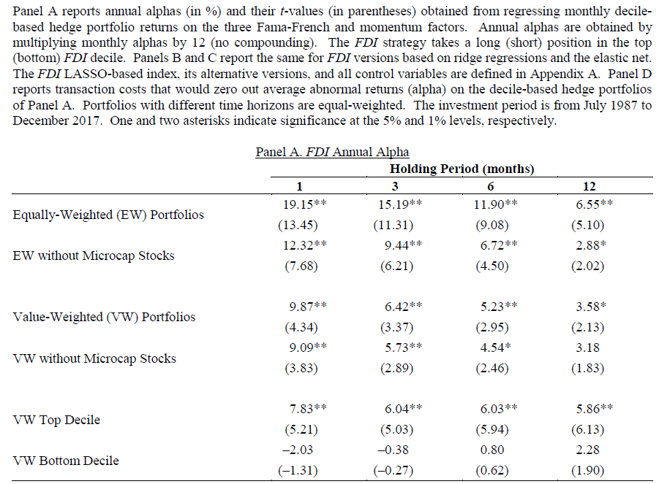

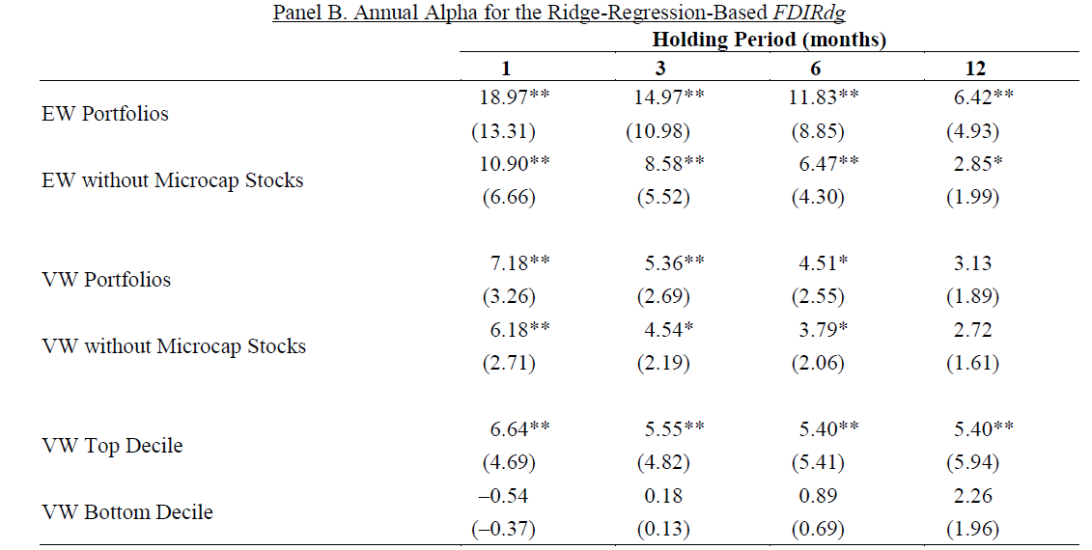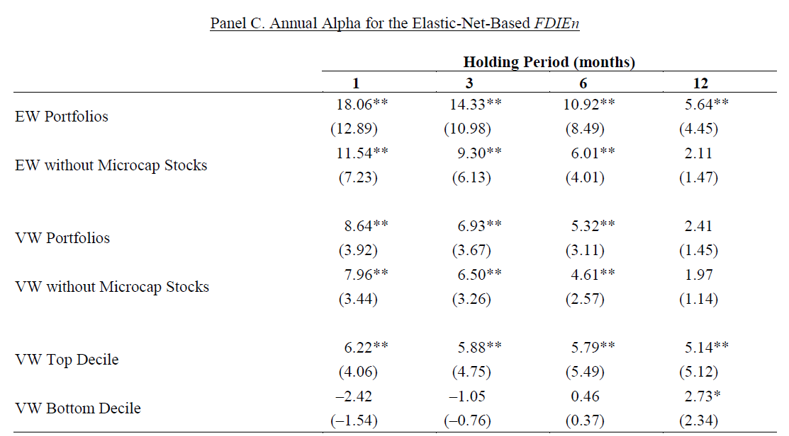

* **The alphas are positive and significant for all horizons**
* **Result of three regression models are similar**
* **The FDI effect is the asymmetry between top and bottom sides, which indicates that unlike many other anomalies, the FDI effect is more pronounced on the long leg.**

**The transaction costs are considered to test the profitability of FDI Strategies by calculating the break-even transaction as follow:**

**Let Rlt and Rst denote the returns on the long and short FDI deciles in month t. Let TOlt and TOst respectively denote the long- and short-side turnover in month t.**

**The return after transaction cost will be:**

**[Rlt − TOlt × TC] − [Rst + TOst × TC]**

**We calculate the TC that yields an alpha of zero when the quantity is regressed on the relevant factors.**

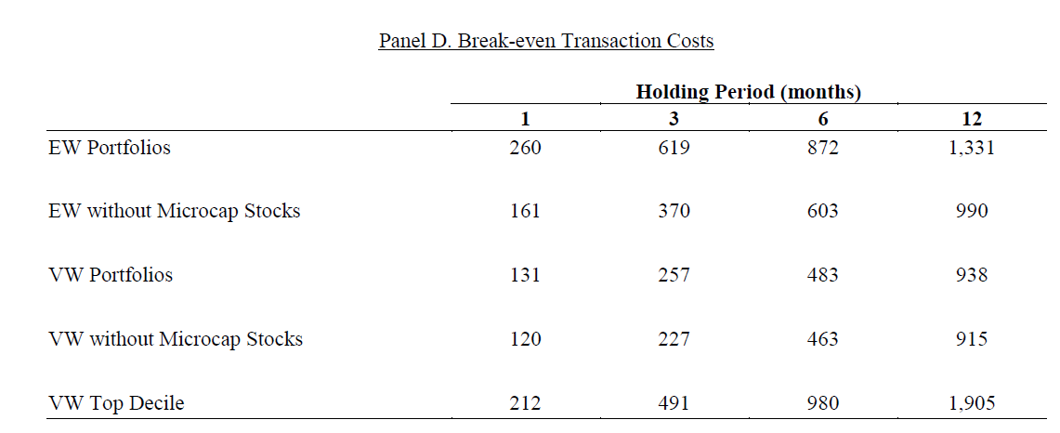

* **The results show that break-even costs increase with the holding period because longer holding periods imply lower turnover and thus lower transaction costs.**
* **The break-even Transaction is far larger than the actual transaction costs estimated by former researches (10 to 40 bps, 5.59 bps)**

### Properties of FDI portfolios

**We report the mean standard deviation based on the past 200 days of daily returns, intercept and loadings from regressing FDI-based portfolio returns on the five Fama and French (2015) factors and UMD**

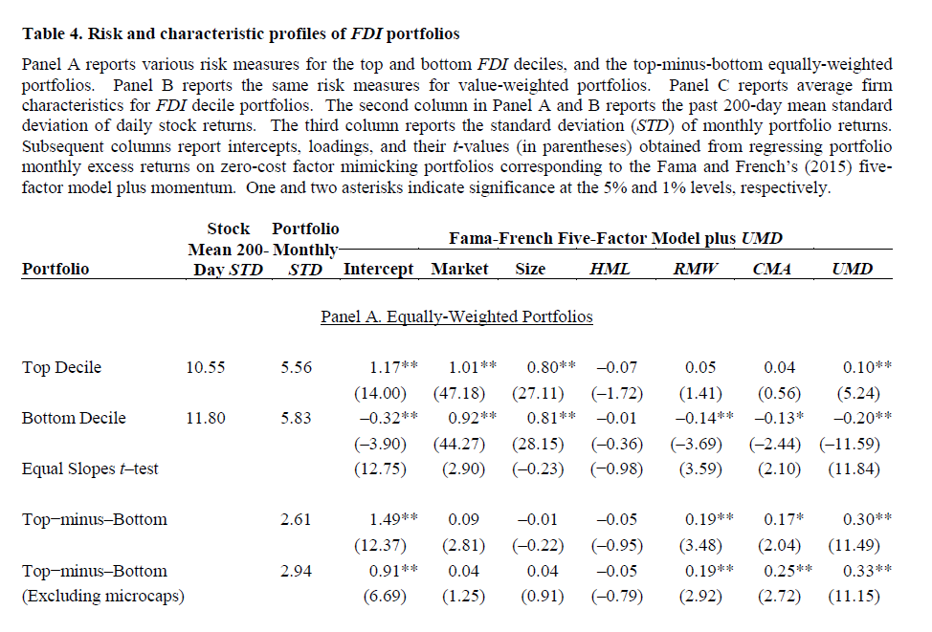

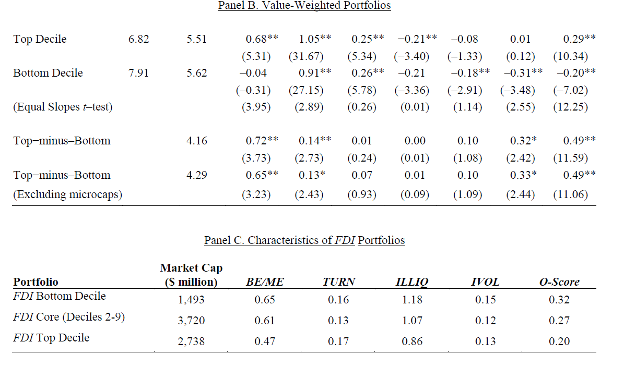

* **Market, RMW, CMA, UMD loading is slightly larger for the FDI top versus the bottom portfolios, and the differences are significant.**
* **Top-Decile return is not driven by small market capital stocks (former research shows past return effects is driven by less visible, smaller cap, more volatile, and more illiquid stocks).**
* **The O-score for top FDI stocks is not markedly different from that for others, suggesting that the FDI effect is not driven by credit risk.**

### Unique-component FDI

**UFDI is constructed similar to FDI except that it does not include deviations from accounting items of assets, earnings, inventories, income, revenue and capital expendi ture, which are known in the literature to be associated with future stock returns.**

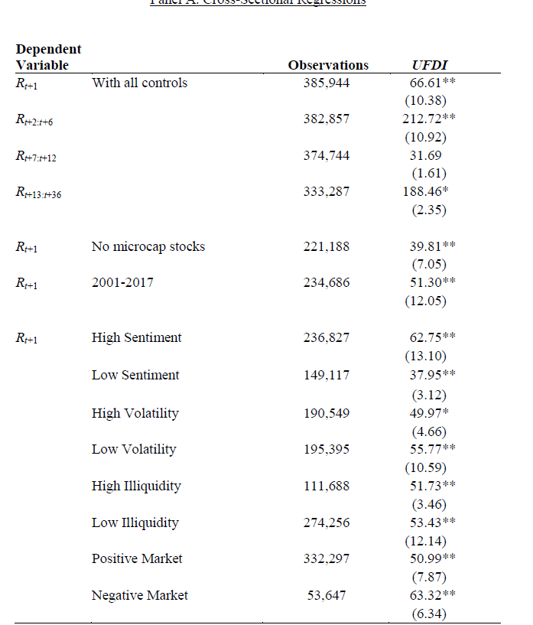

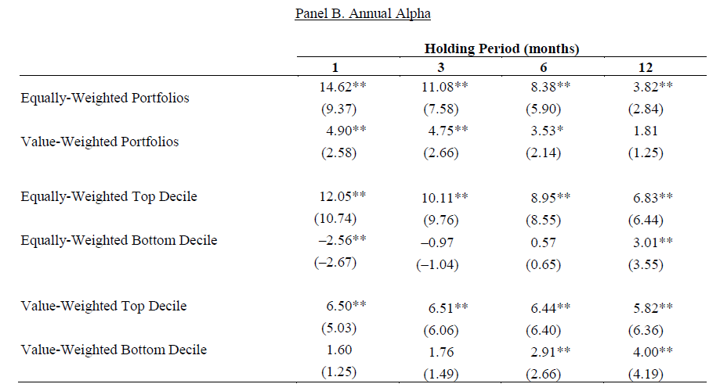

**Overall, the evidence shows that deviation-based under-reaction to fundamentals is a broader phenomenon that is not confined only to deviations for variables which are previously known to be associated with future stock returns.**

### The Anchoring Rationale

#### Why is FDI so robust in predicting future returns?

* **investors exhibit a continuing overreaction to public fundamental signals that deviate from the historical average**

**(×) no long-run reversals are observed**

* **cognitive dissonance (CD) . CD emerges when news contradicts investors’ sentiment, thereby slowing the diffusion of signals that oppose the direction of sentiment.**

**(×) FDI effect delivers statistically indistinguishable payoffs across high and low sentiment states and results are not fully explainable via slow diffusion of news and frictions (table4).**

* **anchoring bias:(√)**

#### Reasonable anchors

* **market prices: past market performance, the 52-week high price, aggregate capital gains measured by a volume weighting of past returns…**
* **fundamental analysts**

**Investors anchor on historical rolling averages of fundamentals.**

**This explanation implies that investors process small amounts of information, which generate small deviations, better than large amounts of information that cause sudden large deviations from the anchor and, in turn, a significant price under-reaction.**

**To verify this assertion, we repeat the FM regression analyses in Tables 2 with two additional explanatory variables represent the interaction of the deviation index with the level of suddenness: SUDDENUP and SUDDENDOWN.**

**For maximum positive monthly change in individual stocks’ FDI values in the last four quarters.**

**SUDDENUP is equal to one if this level is above the top decile monthly median level and zero otherwise.**

**SUDDENDOWN is calculated the same way but with minimum negative changes and bottom decile.**

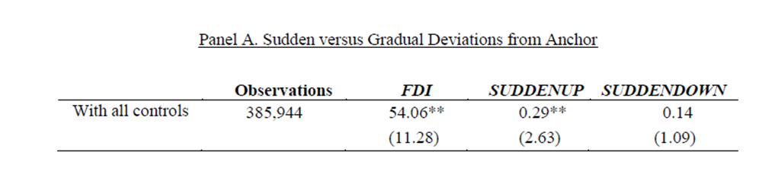

* **This result is consistent with the notion that sudden changes in FDI result in stronger return predictability than gradual changes, consistent with the anchoring rationale.**

**Same phenomena occurs in area besides fundamentals. An analogous effect exists also in deviations from analysts’ forecasts, which is in line with the hypothesis that different investors anchor on different types of information salient to stock valuation.**

### FDI-Based Factor

**We first split all stocks into two groups by the median market capitalization of NYSE stocks. We next consider two groups of stocks based on the deviation index. The first (second) group consists of stocks with an FDI above the 80th (below the 20th) percentile of NYSE FDIs.**

**We then form a value-weighted portfolio that is long stocks with above-median market capitalization and in top FDI group, short stocks with above-median market capitalization and in bottom FDI group. Another counterpart is formed in similar way but with below-median market capitalization.**

**The FDF factor is the average return of this two long-short portfolios.**

**To assess the performance of the newly proposed factor, we run time-series regressions of FDF on comprehensive sets of factors.**

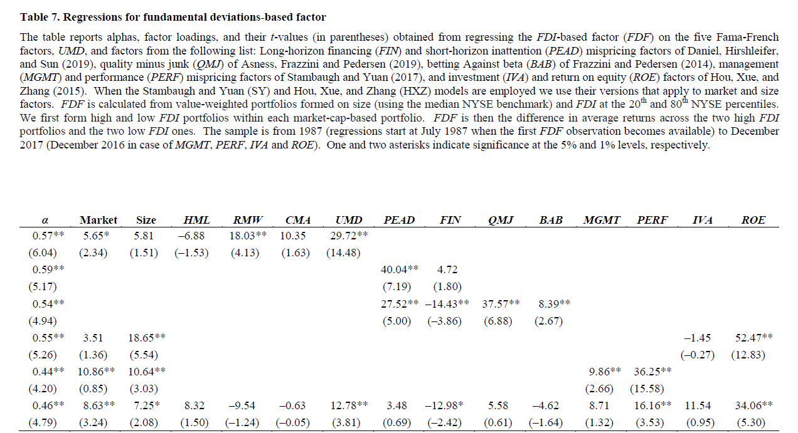

**Then, we plot the five-year trailing averages of Sharpe ratios for UMD and FDF for our sample period (starting in 1991).** 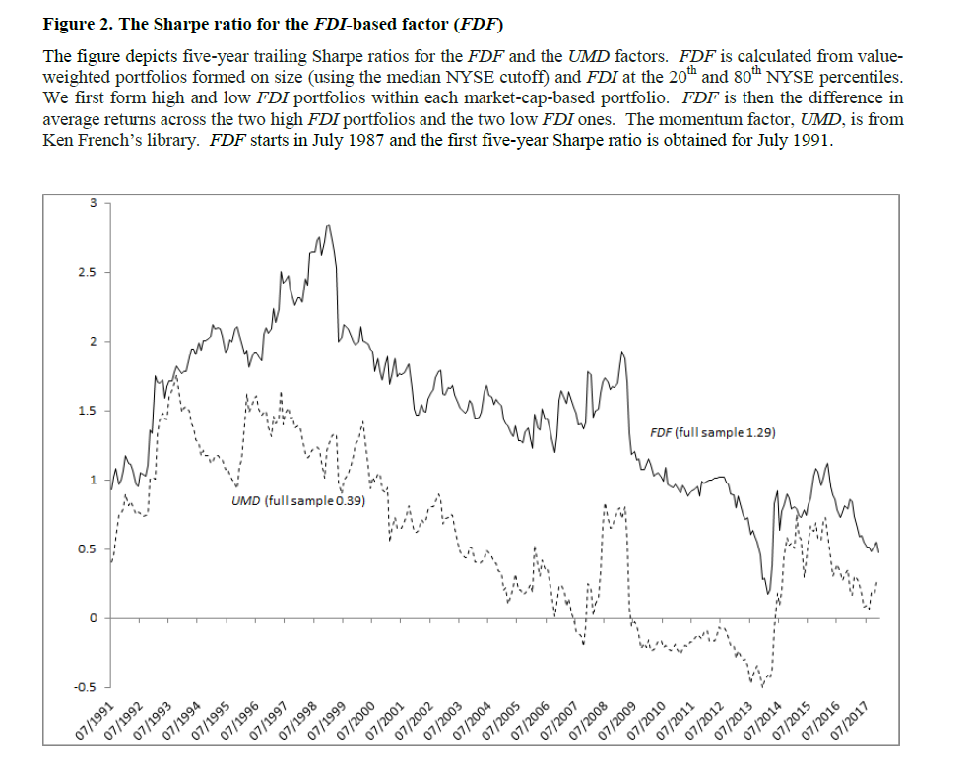

* **FDF retains a high Sharpe ratio in the most recent year relative to UMD.**

## Reflection

**疑问：文章行文逻辑不够流畅，suddenup和down指标构建有点仓促且不够有说服力**

**收获：文章中很多关于新因子提出的检验，有参考意义**

**延伸与启发：文章运用会计数据的偏移集成为一个因子，除了完全照搬中国市场外，可以考虑换机器学习方法进行聚合，还可以换聚合的数据类型**