# Variance risk in aggregate stock returns and time-varying return predictability

2019_JFE_Sungjune Pyun

## Introduction

### Background

* Bollerslev et al.(2009) variance risk premium(VRP)

VRP = Option-implied variance – Expected realized variance

Option prices reflects expectations about future variance. The expectations are always higher than realized. The overpricing is VRP.

→A proxy of price of variance risk; time-varying aggregate risk aversion

* Related literature
  1. Time-varying return predictability: business cycle-dependent → Rapach (2010) predict at longer horizons. This paper predicts over shorter horizons
  2. The role of the price of variance risk across various asset classes(Martin and Wagner, 2016) ……
  3. Downside risk (Kelly and Jiang, 2014)

### Motivation

* Challenges in risk premium prediction:

1. Predictive relationships change over time
2. Predictors that perform well in sample can fail out of sample
3. Predictions perform poorly at shorter horizons

* Why VRP?
  1. It’s actually a price of risk, rather than a variable that merely encodes information about risk prices in an unknown manner
  2. Variance innovations can be observed
  3. Market has substantial exposure to variance risk
* Market risk premium should be related to the VRP by the market’s exposure to variance risk. → intuitively from beta representation
* The return predictability of the VRP strongly depends on the size of “leverage effect”(the negative relationship between price and variance innovation).
* Time-varying prediction can be solved by estimating the risk exposure contemporaneously using high frequency data.

### Research Problem

* Whether this new approach can predict monthly market return precisely?
* How does the predictability vary over time?

### Contribution

* Propose a better approach for monthly market return prediction
* Investigate the relationship between return predictability & leverage effect

## Research Design

* **Model construction:**

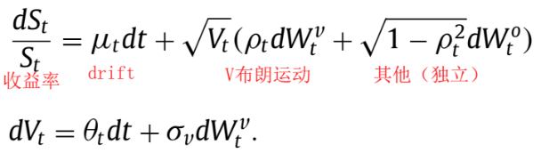

correlation (*ρt*) between market returns and changes in market variance is assumed to be time-varying.

→ 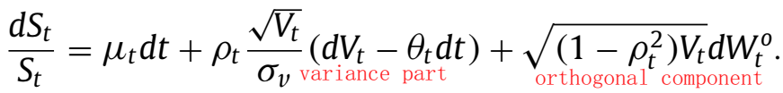

→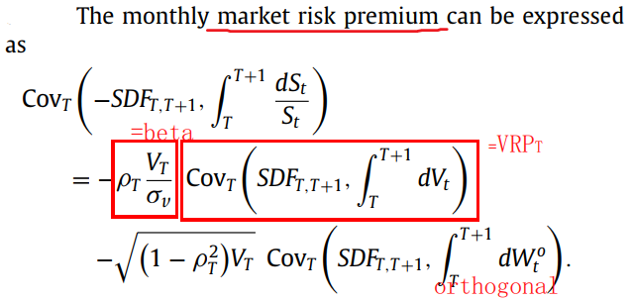

Part① The market risk premium due to variance

Part② The market risk premium related to the orthogonal part

Traditional predictive regression methods suffer from parameter instability

Premise: the close relation between predictive beta and contemporaneous beta

→ Contemporaneous beta approach is better:

1. The contemporaneous beta might be a much more accurate estimate
2. Using daily high frequency data can be more flexible over time

Why orthogonal risk is largely unrelated to the VRP:

1. The predictive power decreases as the forecast horizon increases, while the opposite is true for other predictors (Rapach, 2010)
2. Other predictors tend to perform well during recession. These periods don’t coincide with VRP’s strong predictive periods.

Empirical implications:

1. The slope of market risk premium & market variance risk premium is largely determined by market variance
2. Market returns are more accurately predictable when $ρ_{T}$ is large.

* Data
  1. High-frequency intraday trading data for the S&P500 index: Tickdata
  2. 1990.1 ~ 2016.12
* Method
  1. Forecasting realized variance
     1. Squared log returns from the last tick of each 5-minute internal
     2. Rescale to the monthly level → RV series
     3. 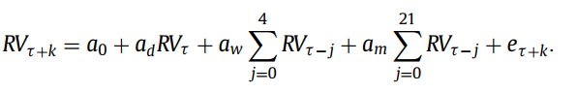
     4. The monthly variance is estimated by averaging the 22 daily forecasts
  2. Estimation of the VRP

Tradition: VRPt = VIX2t-1 – t

Problem: Timing mis-match(one with trend, the other no trend)

Solution: minimize any volatility trends affecting the VRP(both either average or last-trade-day estimation)

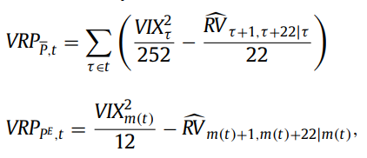

Nonparametric: VRPN = scaled VIX2 – historical RV, both averaged over the entire month

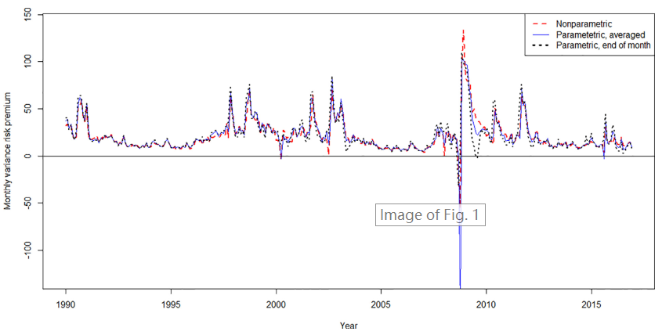

* 1. Estimation of the contemporaneous betas and correlations



OLS & WLS (in case of heteroscedasticity)

Window: One month & three months

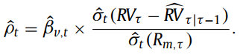One single month, non-overlapping

* 1. Out-of-sample prediction

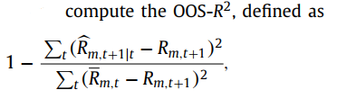

Wald stats: 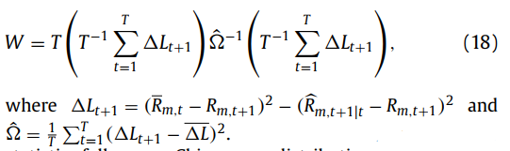

* + 1. VRP approach (traditional)



* + 1. Contemporaneous beta approach



* + 1. Hybrid approach



## Empirical Result

* Out-of-sample predictions

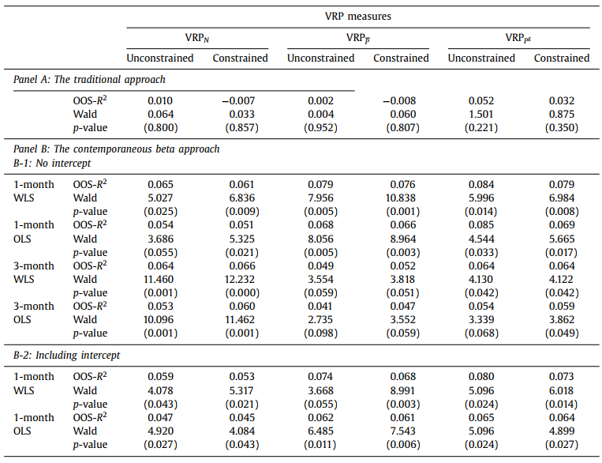

* Constrained: Campbell and Thompson(2008): impose a positivity constraint on the return forecast

→ The new approach effectively improved the return predictability.

* Time-varying prediction: contemporaneous correlation & predictive R2

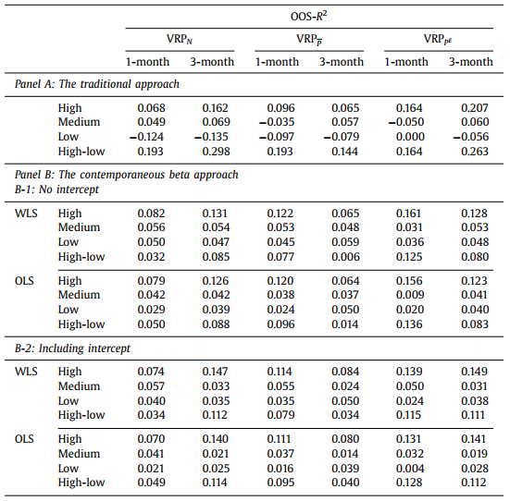

→ The return predictability is relatively high when contemporaneous correlation is higher.

* Explaining the orthogonal premium by other predictors

Why: they work in different horizons and periods(post-1993)

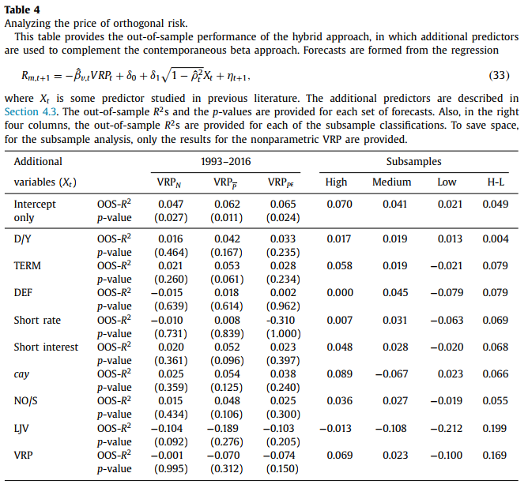

→ None of the other 8 predictors considerably improves the OOS-R2

* Evaluating economic significance- a trading strategy

Unconditional weight: 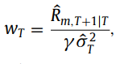

Conditional weight: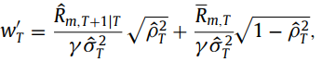

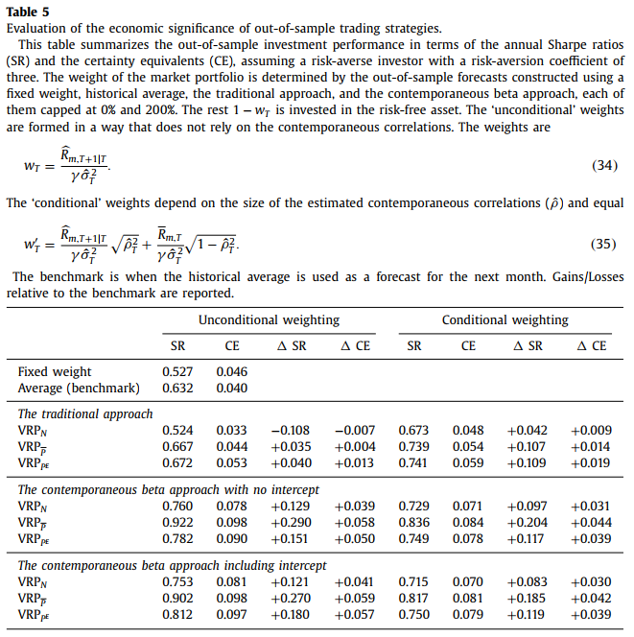

* In-sample predictions



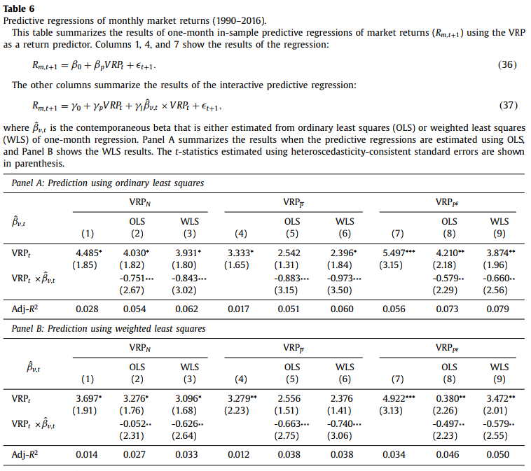

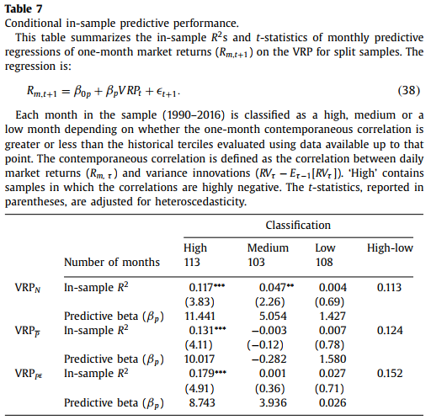

## Conclusion

* This method can effectively predict market risk premium.
* The slope that determines the contemporaneous relationship between market and variance risk resembles the relationship between the risk premium of the market and market variance.
* The predictive power strongly depends on the degree of the contemporaneous correlation between returns and variance innovations.
* Although the VRP is constructed from option prices on the index as well as index returns, its ability to predict future returns is not necessarily restricted to the equity index.

## Reflection

* Model + Empirical research
* Apply VRP to other assets
* Mixed data frequency
* Time-varying predictability explanation ho