Twin Momentum: Fundamental Trends Matter 2

Central idea 2

Literatures 2

Motivations 2

Questions: 2

Contributions 3

Data 3

Method 3

Results 4

Conclusions 9

# Twin Momentum: Fundamental Trends Matter

Dashan Huang, Huacheng Zhang, Guofu Zhou, Yingzi Zhu

Working paper, 2019.07

## Central idea

Make use of information on fundamental trends in constructing investment portfolios.

## Literatures

Daniel and Moskowitz (2016): price momentum tends to have crash risk;（某些月份出现极低的月度收益）

Lewellen (2015), Cosemans, Frehen, Schotman, and Bauer (2016), Stambaugh and Yuan (2017), Green, Hand, and Zhang (2017), Light, Maslov, and Rytchkov (2017): none of them exploits the use of fundamental trends.

Bouchaud, Krueger, Landier, and Thesmar (2018): investors’ **sticky expectations** can result in predictability by using fundamental variables.

Barberis, Greenwood, Jin, and Shleifer (2018): investors’ **extrapolative expectations** can yield fundamental predictability and can even lead potentially to bubbles.

外推预期：外推预期是指对未来的预期不仅依据经济变量的过去发展水平，而且还应建立在经济变量未来变化趋势的基础上。

Akbas, Jiang, and Kock (2017): the first to address explicitly the importance of profitability trend.

## Motivations

1. Cochrane (2011): “asset prices should equal expected discounted cashflows.” →expected fundamentals should be the most powerful predictors of future stock returns.
2. Prior studies find that the predictive power of fundamentals is usually eclipsed by that of price momentum, which is based on stock prices alone.
3. It is important to show that fundamentals matter in predicting the cross section of stock returns.

## Questions

1. Does the aggregated fundamental momentum have predictive power, which is stronger than its components?
2. Is there difference between price momentum and fundamental momentum?
3. Is the predictive power of the twin factor stronger than price momentum and fundamental momentum at the same time?

## Contributions

1. The results shows, for the first time, that fundamentals matter in asset pricing, in contrast with prior studies that find only weak results due to the insufficient use of fundamental information.
2. The article provides a twin momentum trading strategy, which offers a monthly average return more than twice of that from price momentum without taking any additional risk.
3. This paper has implications to the recent growing literature on the cross section of stock returns and multiple firm characteristics, it highlights the importance of using trend signals in a cross sectional forecasting framework.

## Data

Compustat: 197301~201508

CRSP: 197604~201509

Factors: ROE, return on assets (ROA), earnings per share (EARN), accrual-based operating profitability to equity (APE), cash-based operating profitability to assets (CPA), gross profitability to assets (GPA), and net payout ratio (NPY).

To remove the outlier effect, all of the variables are cross-sectionally winsorized at the 1% and 99% percentiles each quarter.

value-weighted; monthly rebalanced

## Method

**fundamental trends construction→multivariate regression→forecast combination**

decomposition of the expected stock return of firm i:



fi,t: the required return based on the current fundamental(e.g., a constant)

Et[Fi,t+1]: the required return based on future fundamental, often estimated by its current value: (works badly if Fi,t doesn’t follow a random walk or AR(1) process)

Revise:

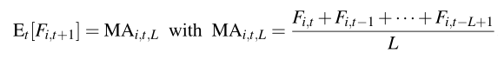

L = 1,2,4,8(By allowing L to vary, we let data determine the weights on how information in different time horizons affects the expected return.)

**Multivariate regression approach**

1. run a cross-sectional regression of each stock return Ri,t on all the predictors

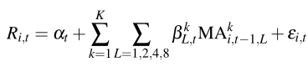(multicollinearity→over-fitting)

1. construct firm i’s fundamental implied return, FIR, in month t by using the forecasted return for month t +1

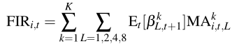(no intercept)



Revise: run univariate regressions(include intercepts, since they are different due to different factors)

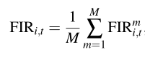

**Why do the authors obtain so much stronger results than existing studies?**

1. Existing studies often focus on one fundamental variable at a time. Vs. this article utilizes the information of seven major fundamentals jointly, in the spirit of “big-data”.
2. Not only fundamentals, but also their trends are used.

Loh and Warachka(2012): strong earnings in one quarter do not necessarily suggest that the firm’s fundamental is strong, but consistent strong earnings do.

## Results



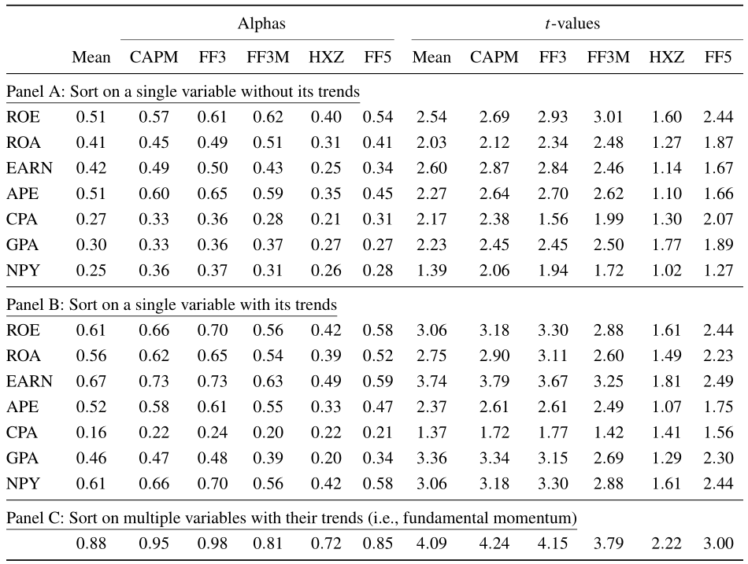

Panel B：run a cross-sectional regression (16), restricting it to a single fundamental variable (i.e., K = 1) to estimate FIR as (17)

Result:

1. the forecasting power of fundamental variables can be subsumed;
2. the average returns are higher than Panel A
3. by using multiple variables and their trends, we get the highest return



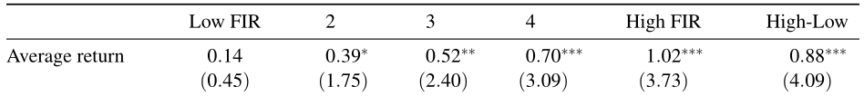

Result: FIR is aligned with expected returns in the cross section



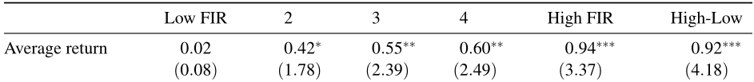

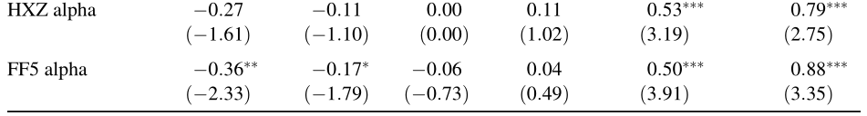

Result: The result of the alternative forecast combination is similar with the “multivariate regression” way.

**Is the fundamental momentum different from the price momentum?**

1. Independently bivariate portfolio analysis

past returns (11-month cumulative return from month t −12 to month t −2) and FIRs

1. Fama-MacBeth regression

stock return in month t on past return (i.e., 11-month cumulative return from month t−12 to month t−2) and FIR in month t−1

1. Campbell, Giglio, Polk, and Turley (2018) decomposition

unexpected returns on the market portfolio can be decomposed into 3 components: shocks relating to future cash flows、 shocks relating to discount rates and variance shocks

the single CAPM β can be decomposed into three betas: one reflecting the covariance with news about future cash flows/ discount rates/ variance.

run time-series regressions of price momentum and fundamental momentum returns on shocks about future cash flows (Ncf), discount rate (−Ndr), and variance (Nv) of the aggregate market





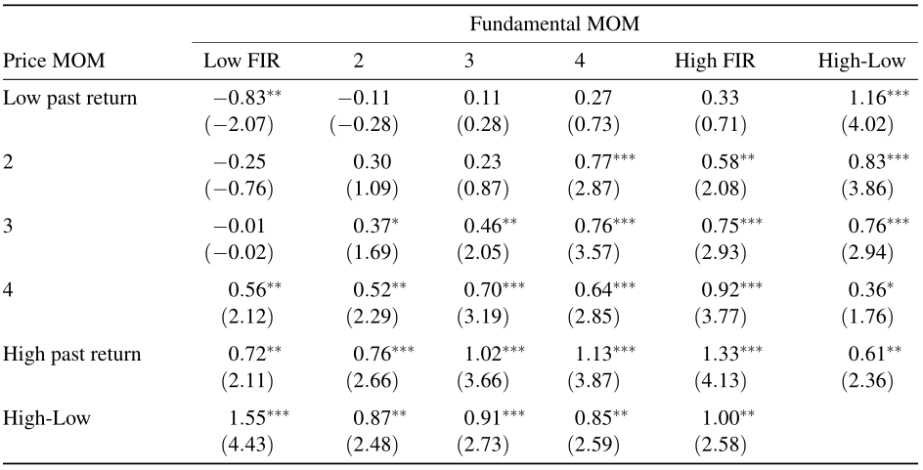

Result:

1. fundamental momentum exists in stock returns and is not simply a manifestation of price momentum.
2. fundamental momentum exists not only in the past winner stocks but also in the past loser stocks with even stronger performance



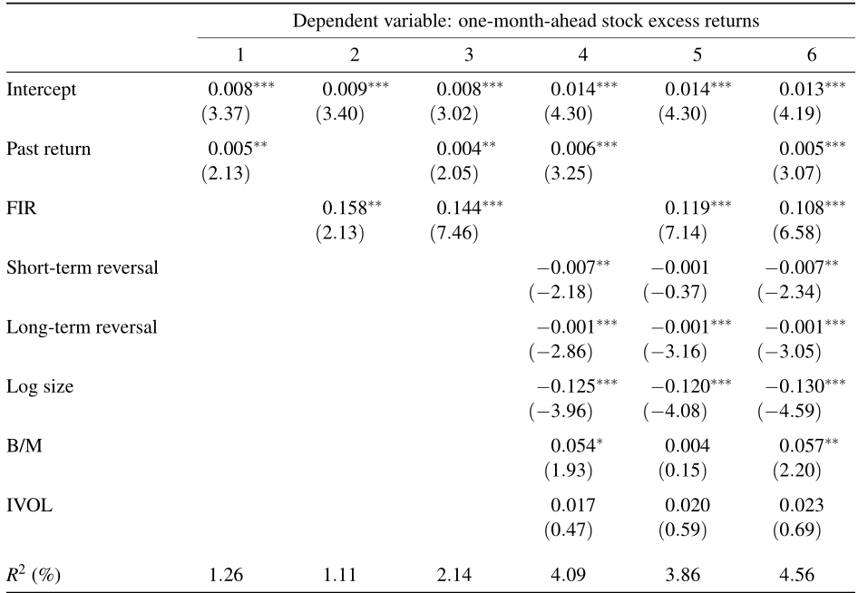

Result: fundamental momentum and price momentum coexist in the stock market and neither subsumes the other.



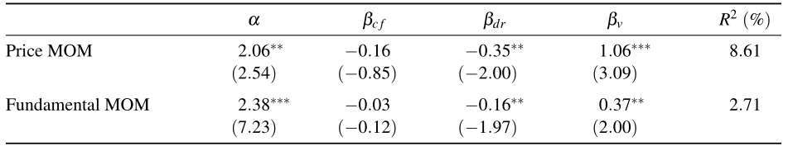

Result:

1. price momentum and fundamental momentum are related

coefficients have the same sign

same significant β

1. price momentum and fundamental momentum are different.

the impact of the shocks is different(the value of βs)

construct the twin momentum: buy stocks in the intersection of the top past return and FIR quintiles and sell stocks in the intersection of the bottom past return and FIR quintiles.

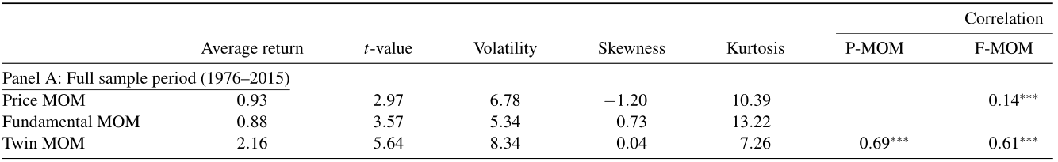

Result:

1. twin momentum has the highest return
2. according to the correlation, price momentum and fundamental momentum are equally important to twin momentum



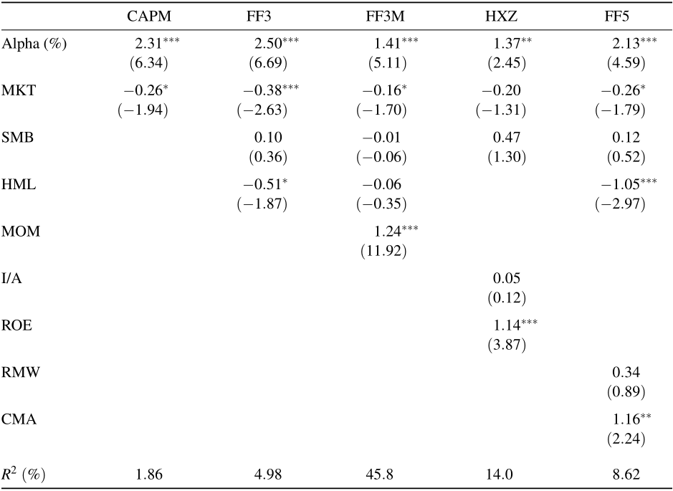

Mean-variance spanning tests

Whether twin momentum adds any investment value from the perspective of an investor who holds a well-diversified portfolio?

run a time-series regression of the twin momentum portfolio return on the factor returns in each asset pricing model

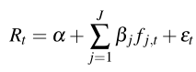 = 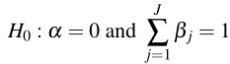



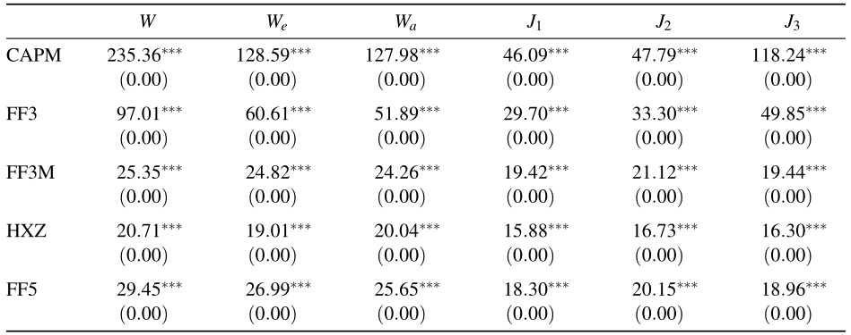

Result: H0 is rejected, and twin momentum provides incremental investing value

Due to the short-sale impediments, the returns are more likely to come from the short-leg. Is that still true among the momentums?



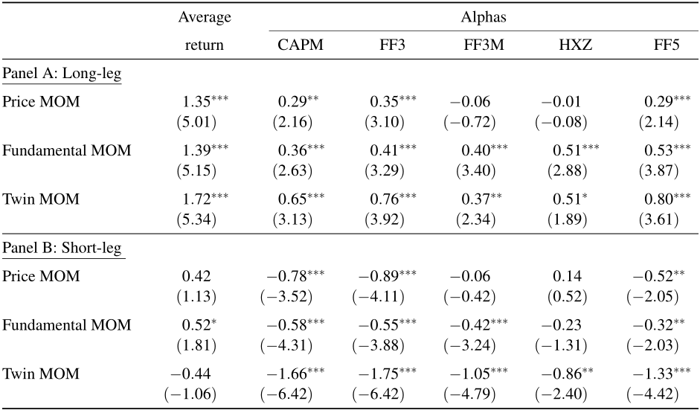

Result:

1. P-MOM: higher return in the long-leg, but becomes lower after risk adjusting;
2. F-MOM: higher return in the long-leg, but the risk-adjusted returns of the long- and short-legs are large and have the same magnitude.;
3. T-MOM: higher return than P-/F-MOM in the long-leg; the alpha is significant for all the five asset pricing models.→twin momentum is unlikely to be driven by short-selling constraints and other market frictions.

## Conclusions

1. The underperformance of fundamental analysis in existing studies is driven primarily by not making full use of the available fundamental information.

2.The fundamental momentum, which is constructed by 7 firm fundamentals, can indeed predict the future stock returns.

3. Fundamental momentum and price momentum are largely complimentary, rather than overlapping, according to the amazing performance of the twin momentum.