# Does earnings growth drive the quality premium？

Journal of Banking and Finance 2020

Georgi Kyosev, Matthias X. Hanauer, Joop Huij, Simon Lansdorp

## 1、Introduction

### Background

* More recently, a range of accounting-based factors (see, e.g., Haugen and Baker, 1996 ; Sloan, 1996 ; Cooper et al., 2008 ; Novy-Marx, 2013 ) have been documented to have predictive power for future stock returns and beyond their expected returns based on betas, market sizes, valuations, and momentum.
* Because these accounting-based variables are often seen as important determinants for investors’ perception of firm quality (see, e.g., McGuire et al., 1990 ; Asness et al., 2019 ; Trammell, 2014 ), they are also referred to as quality variables.

### Motivation

* A notable observation regarding these accounting-based (quality) factors is the lack of a common element (apart from all of them being derived from accounting statements).
* There is no study which explains why some quality measures systematically work better than others.

### Research question

* Why quality measures predict future stock returns ?
* Why some quality measures systematically work better than others ?
* Whether the quality premium can be observed in other markets than the U.S. stock market as well ?

### Related researches

* Sloan (1996) already shows that accruals are negatively related to future earnings and that higher accruals predict lower stock returns.
* Haugen and Baker (1996) assume that currently profitable firms have greater potential for future growth and document that ROE is positively correlated with future re-turns.
* Cooper et al. (2008) find that a general measure of investments (total asset growth) is negatively correlated with future returns.

### Research Contents

* We conduct a set of empirical tests to shed more light on the common quality indicators.
* First, we test which ones have predictive power for future earnings growth.
* Second, we create two competing quality strategies – the earnings predictive quality variables and the earnings non-predictive quality variables .
* Third, we test if there is a causal relation between the quality premium and distress risk.
* In addition, we conduct regional analyses to test if our global results are a manifestation of systematic regional allocation bets.

### Contribution

* The main contribution of our study is that we provide empirical evidence that the predictive power of quality variables for the cross-section of stock returns originates from the variables being good proxies for future earnings growth.

## 2、Research Design

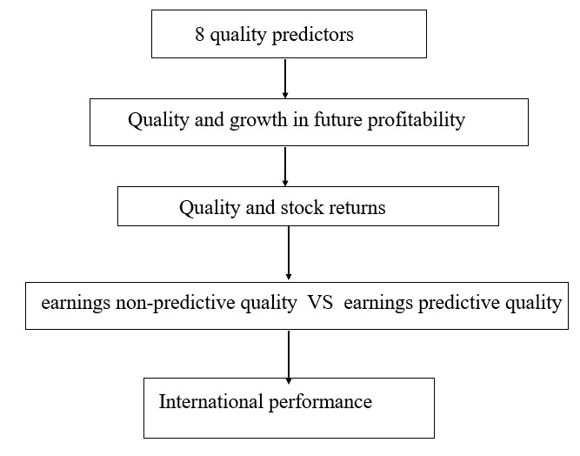

### Variable

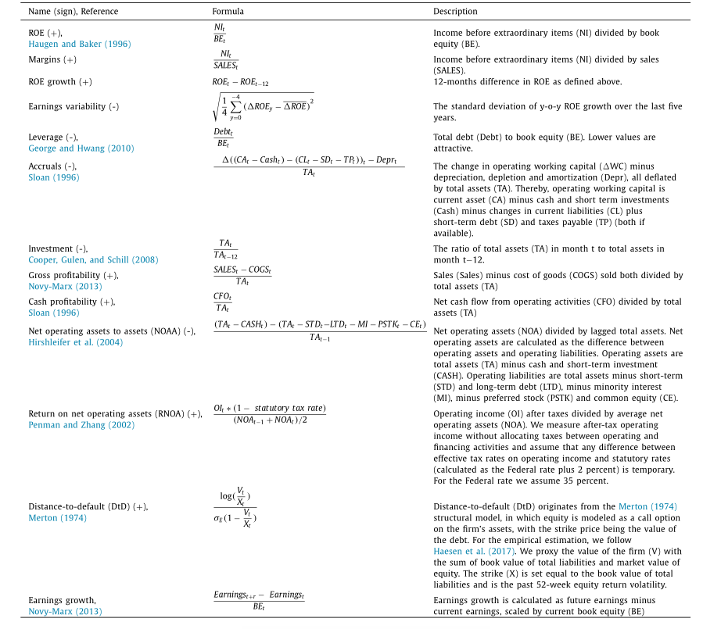

### Data

* Sample: all constituents of the FTSE World Developed Index and the S&P/IFC Investable Emerging Markets Index. excluding financial firms.
* Period：December 1985 to December 2015.
* data sources: Interactive Data Exshare, MSCI, Compustat, Worldscope

### Method

* Cross-sectional Fama and MacBeth regressions
* Sorting stocks into portfolios based on quality variables

## 3、Empirical Result

### Quality and growth in future profitability

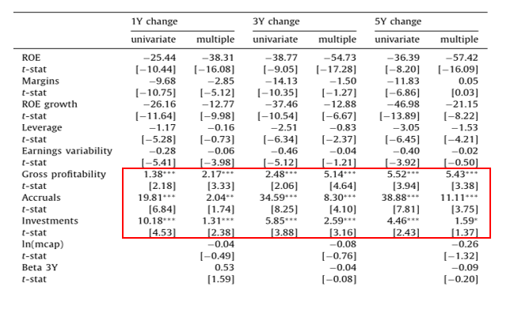

* High gross profitability, low accruals, and low investments positively predict future earnings growth, corrected for the expected sign, with coefficients 2.48 (t-stat 2.06), 34.59 (t-stat 8.25), and 5.85 (t-stat 3.88) respectively.
* In a multiple regression framework, gross profitability, accruals, and investments correctly predict earnings growth across all horizons.

### Quality and stock returns

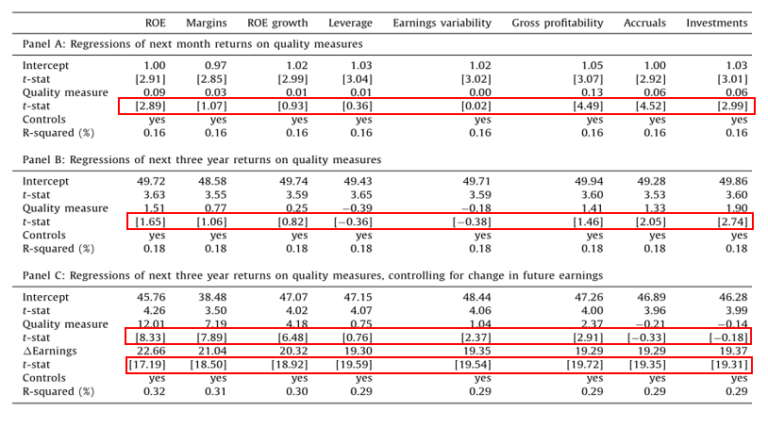

The earnings predictive variables (gross profitability, accruals, and investments) also have predictive power for stock returns

In Panel C we augment our regression specification and regress three-year returns on quality characteristics. They show that what is driving returns is future earnings growth and different measures used to define quality are effectively different ways to predict earnings growth.

It also shows that earnings information is highly relevant as all earnings-based characteristics are significantly related to stock returns after controlling for earnings mean reversion associated with them.

Performance of earnings non-predictive quality measures

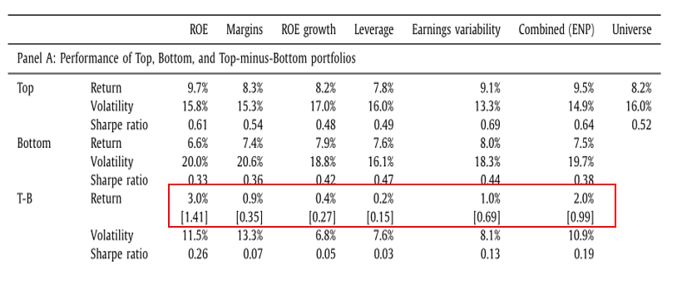

The combined quality strategy generates a T-B quintile return of 2.0%. However, none of the T-B return spreads are statistically different from zero.

Performance of earnings predictive quality measures

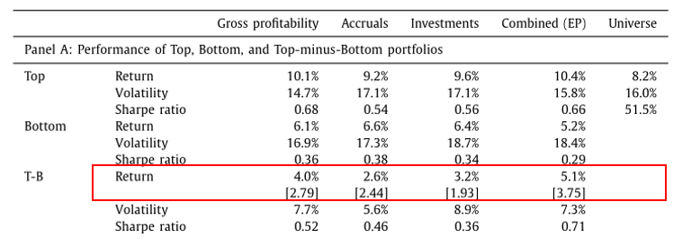

The T-B portfolios for all three characteristics have positive returns – 4.0% for gross profitability, 2.6% for accruals, and 3.2% for investments. Furthermore, all top quintile port-folios also outperform the total market portfolio.

### International performance of earnings predictive and earnings non-predictive quality factors

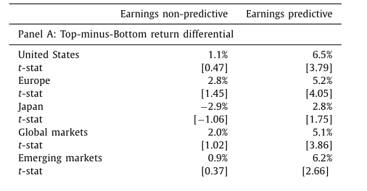

We therefore further split the Global universe into three main regions – United States, Europe, and Japan as well as add Emerging markets.

The main takeaway is that the combined ‘earnings predictive’ strategy consistently outperforms ‘earnings non-predictive’ one based on both T-B returns as well as alphas.

### Quality and distress-risk

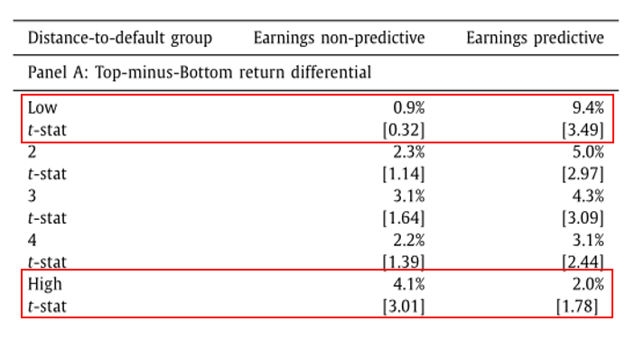

We apply a dependent double-sort in which we first sort all stocks into quintiles by distress risk, measured by distance-to-default (DtD).

The double sorts show that the top-minus-bottom returns and alphas of the earnings-predictive measure are positive and significant across distress risk groups suggesting that the return premium is not concentrated in the stocks with the highest levels of distress risk.

We conclude that mispricing is a more likely cause for the existence of the quality premium than distress risk is.

## Conclusion

* We find that the predictive power of quality factors originates from its measures being good proxies for future earnings growth.
* We find no relationship between the quality premium and distress risk and that mispricing is a more likely cause for the existence of the quality premium than distress risk is.