CP Capstone Project Proposal
ข้อเสนอโครงงานรวบยอดวิศวกรรมคอมพิวเตอร์ 1

เรื่อง
ระบบฐานข้อมูลจัดเก็บสำหรับห่วงโซ่อุปทานของโกโก้
Databank for Cocoa Supply Chain

โดย
6330080621 ชนาธิป กุลสิริลักษณ์
6532091021 ธนภัทร มโนอิ่ม
6532125821 เป็นเอก สิทธิมงคล
6633062121 ณรัช รัตนวิภานนท์

อาจารย์ที่ปรึกษา
รศ. ดร. ธนารัตน์ ชลิดาพงศ์
อาจารย์ ดร. สุดลพ รัตนเกื้อกังวาน
ผศ. ดร. ธัญศิภรณ์ ณ น่าน

รายงานนี้เป็นส่วนหนึ่งของวิชา 2110488 โครงงานรวบยอดวิศวกรรมคอมพิวเตอร์ 1
ภาควิชาวิศวกรรมคอมพิวเตอร์ คณะวิศวกรรมศาสตร์ จุฬาลงกรณ์มหาวิทยาลัย
ประจำปีการศึกษา 2568

บทคัดย่อ
โครงงานนี้มีชื่อว่า ระบบฐานข้อมูลจัดเก็บสำหรับห่วงโซ่อุปทานของโกโก้ มีวัตถุประสงค์เพื่อพัฒนาแนวทางในการจัดเก็บและบริหารข้อมูลที่เกี่ยวข้องกับกระบวนการผลิตโกโก้อย่างครบวงจร ตั้งแต่ขั้นตอนการปลูก การเก็บเกี่ยว ไปจนถึงการนำผลผลิตเข้าสู่กระบวนการแปรรูป
ทั้งนี้ CUSAR ได้รับทราบถึงปัญหาที่เกิดขึ้นจากเกษตรกรผู้ปลูกโกโก้และนักวิจัย ซึ่งส่วนใหญ่ประสบปัญหาในการจัดเก็บและเข้าถึงข้อมูลการผลิตที่ไม่เป็นระบบ ส่งผลให้การวิเคราะห์ การวางแผน และการพัฒนาคุณภาพผลผลิตทำได้ยาก โครงงานจึงมุ่งเน้นการนำเทคโนโลยีสมัยใหม่มาประยุกต์ใช้เพื่อแก้ไขปัญหาดังกล่าว ให้การจัดเก็บข้อมูลมีความเป็นระบบ มีความถูกต้อง และสามารถนำไปใช้ประโยชน์ได้อย่างต่อเนื่องและยั่งยืน
คำสำคัญ: โกโก้, ฐานข้อมูล, ห่วงโซ่อุปทาน, เทคโนโลยีการจัดเก็บข้อมูล, เกษตรกร

Abstract
The project titled “Databank for Cocoa Supply Chain” aims to develop an effective approach for collecting and managing data related to the entire cocoa production process from cultivation and harvesting to post-harvest processing.
CUSAR has identified significant challenges faced by cocoa farmers and researchers in maintaining and accessing production data, as traditional record-keeping methods are often unstructured and prone to data loss. To address these issues, this project focuses on applying modern technology to improve data collection and management systems, ensuring accuracy, reliability, and accessibility. Ultimately, the project seeks to enhance efficiency within the cocoa industry, support research and innovation, and contribute to the sustainable development of cocoa farming communities.
Keywords: Cocoa, Databank, Supply Chain, Databank Technology, Farmer

Table of Contents
บทคัดย่อ 2
Abstract 2
Table of Contents 3
1. Introduction & Problem Definition 4
1.1 Background & Motivation 4
1.2 Problem Statement 4
1.3 Objectives 4
1.4 Scope & Limitations 4
1.5 Expected Benefits 5
2. Problem Solving & Related Work 6
2.1 Review of Existing Knowledge 6
2.2 Comparison with Existing Systems 9
2.3 Gap Analysis 10
2.4 Linkage to Project 10
3. Proposed Solution / Design Concept 11
3.1 System Overview 11
3.2 Components 12
3.3 Constraints Considered 13
3.4 Diagrams 14
4. Teamwork Plan 17
4.1 Roles and Responsibilities 17
4.2 Collaborative Plan 17
4.3 Task Coverage 17
4.4 Workload Balance 18
5. Timeline (Semester 1) 18
6. Planned Work (Semester 2) 18
7. Ethics, Privacy, and Professional Considerations 19
7.1 Plagiarism Check 19
7.2 Credibility of Information 19
7.3 Intellectual Property & Law 19
References 20
Appendix A: Use Case Diagram 21
Appendix B: Complete ER Diagram (Google Drive) 44
Appendix C: Prototype Design (Figma) 44

Table of Figures

Figure 2.1 From Cacao Tree to Cocoa Product 7
Figure 2.2 Environment and Sustainable Development 8
Figure 2.3 modelling approaches for simulating cocoa production 8
Figure 2.4 Logistics management system based on IoT from investigated the application of IoT (Internet of Things) technologies, such as 3G networks, RFID, and GPS, in supply chain risk management (SCRM) 9
Figure 2.5 Tools for Mobile Application Development 10
Figure 3.1 Farmer Screen 12
Figure 3.2 Processor Screen 13
Figure 3.3 Researcher Screen 13
Figure 3.4 Architecture Diagram 16
Figure 3.5 Use Case Diagram 17
Figure 3.6 ER Diagram 18
Figure 3.7 Deployment Diagram 19
Figure 5.1 Semester 1 Gantt Chart 21
Figure 6.1 Semester 2 Gantt Chart 22
Figure 7.1 Result from Turnitin 23

Table of Tables

Table 2.1 Gap Analysis between current situation and identified gap 11
Table 5.1 Timeline (Semester 1) 21
Table 6.1 Planned Work (Semester 2) 22

1. Introduction & Problem Definition

1.1 Background & Motivation
This project originated from issues identified by The Innovation Center for Research and Development of Sustainable Cocoa Thailand (ISTC) and the School of Agricultural Resources, Chulalongkorn University (CUSAR), based on feedback from local cacao farmers who face multiple challenges throughout the production process including cultivation, harvesting, and post-harvest handling. These challenges highlighted the need for a digital solution to streamline data collection and management. Consequently, the idea for this project emerged from the desire of researchers and academics to create a centralized platform that collects, compiles, organizes, and presents cocoa-related data, allowing it to be further utilized for research and development in the future.

1.2 Problem Statement
The cocoa market in Thailand has been rapidly expanding, supported by a growing number of farmers who are adopting cocoa cultivation and improving their production quality. However, current data collection methods still rely heavily on traditional practices, such as recording information on paper. This approach often leads to inefficiencies, including delays, data mismanagement, and human errors.
Recognizing these issues, educators and researchers have agreed on the importance of introducing modern technology to improve data storage and management processes. By developing a digital application, the project aims to modernize Thailand’s cocoa industry, making it more efficient, accessible, and data-driven. The proposed application will serve as a key tool in promoting sustainable growth and technological advancement within the cocoa supply chain.

1.3 Objectives
The main objective of this project is to develop a fully functional application that acts as a Cocoa Databank: a centralized digital repository of cocoa-related information covering all stages, from cultivation and harvesting to processing.
The application is designed to be user-friendly, informative, and technologically up-to-date. It will enable data collection, storage, and presentation in a clear and accessible format. Moreover, it will support data utilization for research purposes, allowing both farmers and researchers to access and benefit from the information, thereby strengthening the connection between agricultural production and academic development.

1.4 Scope & Limitations
In its initial phase, the project will prioritize development for farmers and processors with a cocoa hub, ensuring that the system functions effectively in real-world agricultural operations. Future expansions will include additional features for researchers and other user groups, further enhancing the platform’s long-term impact and utility.

1.5 Expected Benefits
The Databank for Cocoa Supply Chain project is expected to generate benefits across academic, industrial, and social domains
Academic Benefits
Provides researchers with reliable, organized, and up-to-date cocoa production data, enabling advanced analysis and the development of new methodologies. Supports knowledge sharing between farmers and academics, fostering research-driven improvements in cocoa cultivation and processing.
Industrial Benefits
Enhances operational efficiency in the cocoa industry by streamlining data collection and management. Reduces time and costs associated with manual record-keeping, while minimizing errors in production tracking. Facilitates data-driven decision-making for production planning, quality control, and supply chain optimization.
Social Benefits
Improves the quality of life for cocoa farmers by providing easy access to practical information, workshops, and guidance for better crop management. Promotes sustainable agricultural practices and strengthens the connection between local communities and market development. Supports long-term growth of the Thai cocoa sector, benefiting both producers and consumers through higher-quality, well-managed products.

2. Problem Solving & Related Work

2.1 Review of Existing Knowledge
From Cacao Tree to Cocoa Product
The cocoa supply chain initiates with the harvest of Cacao pods from the Cacao tree, yielding Cacao seeds which are then subjected to essential post-harvest processing. This begins with an intensive Fermentation phase lasting 7-8 days to develop flavor precursors, followed by Drying for 7-10 days to preserve the resulting Cocoa beans. These dried beans are then prepared for consumption or further processing through Roasting, which intensifies flavor and aroma, before undergoing Breaking shells and Winnowing to separate the shells and produce the final product shown, Cocoa nibs.
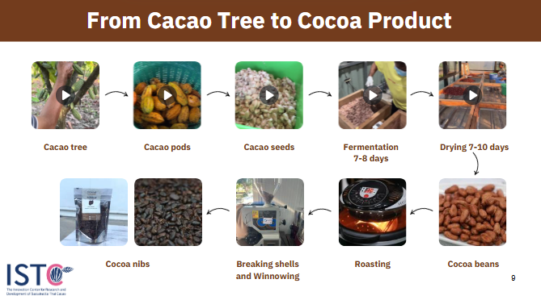

Figure 2.1 From Cacao Tree to Cocoa Product
A Comparative Study of the Sustainable Efficiency and Technical Efficiency of Upstream Sector Cacao Production in Thailand
In Thailand, improving upstream cacao production efficiency has been emphasized for sustainable development. Nan, T. N., & Ratanakuakangwan, S. [1] conducted a comparative study between technical efficiency, which considers only economic aspects, and sustainable efficiency, which integrates economic, environmental, and social factors. Using a slacks-based measure method, they evaluated inputs such as total costs, agricultural non-point source pollution, and land use, and outputs including total cacao production, carbon captured, and employment promotion. Their findings indicate that plant age positively influences efficiency, while farm size and farming experience have negligible effects. This study provides quantitative evidence for policymakers aiming to implement a sustainable cacao production strategy.

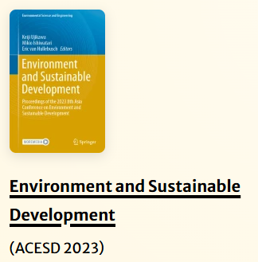

Figure 2.2 Environment and Sustainable Development
An analysis of factors that affecting cocoa yield gap .
Recent studies have increasingly utilized supply chain data to analyze cocoa production and yield variability. Tosto et al. [2] reviewed various modelling approaches for simulating cocoa production, highlighting existing gaps in linking production outcomes with supply chain factors. Asante et al. [3] quantified the cocoa yield gap in Ghana and analyzed key factors such as farm management practices and environmental conditions that could help narrow this gap. Similarly, Asante et al. [4] investigated the high variability of on-farm cocoa yields across environmental gradients, emphasizing how supply chain-related factors, including inputs, farm characteristics, and local management practices, influence production outcomes. Together, these studies demonstrate the importance of leveraging supply chain data to understand and optimize cocoa production systems.
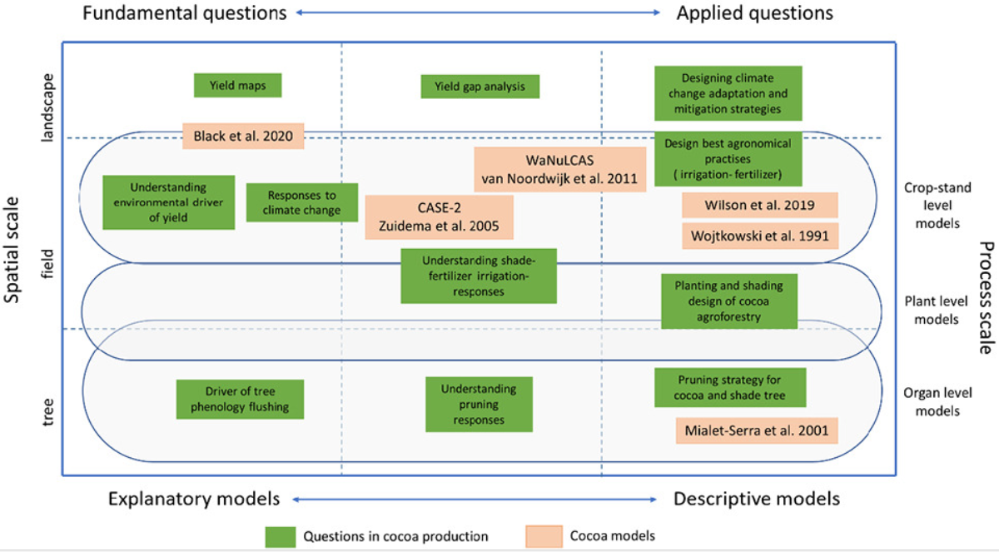

Figure 2.3 modelling approaches for simulating cocoa production
IoT and cloud based Supply Chain Management and Risk Mitigation
Recent studies have increasingly explored the use of advanced information technologies to enhance supply chain management and risk mitigation. Gao et al. [5] investigated the application of IoT (Internet of Things) technologies, such as 3G networks, RFID, and GPS, in supply chain risk management (SCRM). The study identified internal and external sources of risk, described risk management strategies in detail, and used case reasoning to simulate and improve risk mitigation, demonstrating how IoT contributes to the informatization and operational efficiency of supply chains. Similarly, Wu et al. [6] examined the adoption of cloud computing technologies to support supply chain operations, highlighting organizational factors such as business process complexity, entrepreneurial culture, and the compatibility and functionality of existing information systems. Their empirical study, grounded in innovation diffusion theory and the information processing view, showed that these factors significantly influence a firm’s intention to adopt cloud-based solutions, providing insights for both researchers and practitioners on effective technology adoption in supply chains. Together, these studies underscore the importance of integrating IoT and cloud computing to optimize supply chain operations, improve risk management, and facilitate informed decision-making.
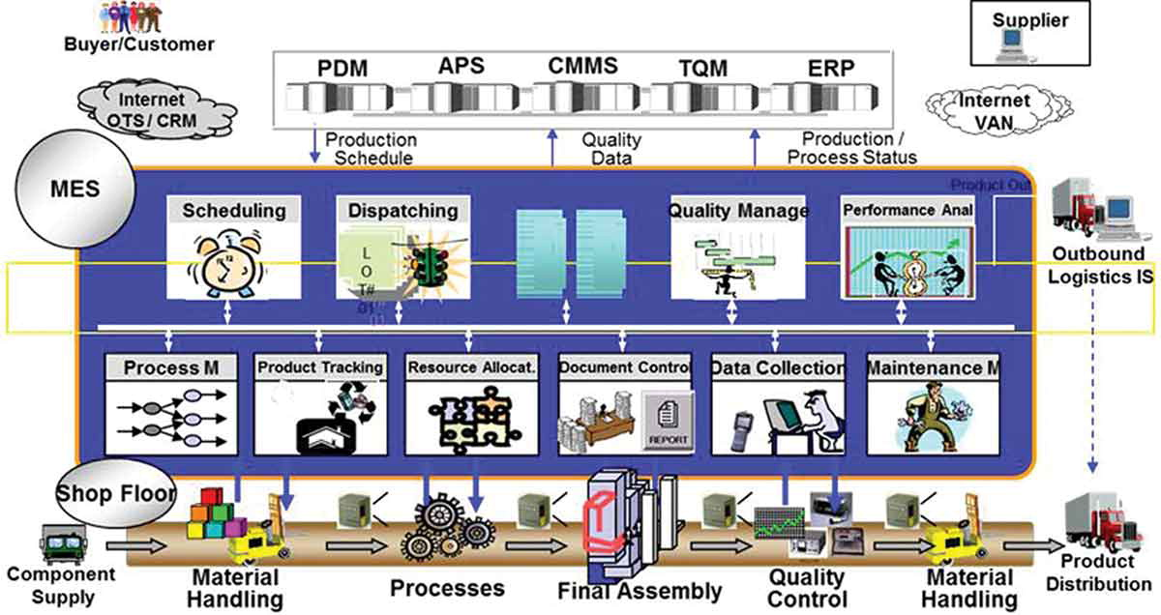

Figure 2.4 Logistics management system based on IoT from investigated the application of IoT (Internet of Things) technologies, such as 3G networks, RFID, and GPS, in supply chain risk management (SCRM)
Tools for Mobile Application Development
Recent studies and practices in mobile application development have highlighted several widely-used tools and platforms:
- Flutter: A cross-platform UI toolkit developed by Google for building natively compiled applications for mobile, web, and desktop from a single codebase. Flutter enables fast development, expressive UIs, and high performance [7].
- Spring Boot (Java): A Java-based framework for creating stand-alone, production-grade web servers and RESTful APIs, simplifying backend development and integration with databases [8].
- Next.js: A React-based framework for building server-side rendered (SSR) and static web applications, often used for creating admin dashboards and web portals integrated with backend services [9].
- PostgreSQL: An open-source relational database system known for robustness, scalability, and support for complex queries, widely used in both mobile and web application backends [10].
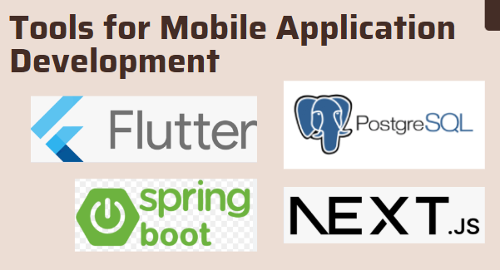

Figure 2.5 Tools for Mobile Application Development

2.2 Comparison with Existing Systems
The existing system is still at a basic level, relying heavily on manual, paper-based data collection through onsite surveys and interviews. This traditional approach creates major challenges in coordination, resource utilization, and efficient data sharing particularly in the upstream segment of the cacao supply chain. The fragmented and unstructured nature of existing data makes it difficult to synchronize supply and demand, or to accurately track essential indicators such as production volumes, quality standards, and distribution logistics. As the cacao industry continues to expand geographically and involve more stakeholders, the task of managing and monitoring data at scale has become increasingly complex and inefficient.
The to-be system aims to secure funding for the development of a comprehensive centralized data bank for Thailand’s cacao supply chain. This system would enable stakeholders especially local farmers to systematically input, access, and analyze data through a unified digital platform. By capturing key information such as product quantity, type, production time, quality, and location, the proposed data bank would generate actionable insights into market trends and support evidence-based decision-making. Ultimately, this initiative seeks to improve coordination and create stronger alignment between production levels and consumer demand, contributing to a more efficient and sustainable cacao industry.

2.3 Gap Analysis
Area | Current Situation | Identified Gap
Data Management and Integration | Data is collected manually using paper-based methods from onsite surveys and interviews. Information is stored in fragmented formats across different stakeholders. | Lack of centralized, standardized, and digital data management system; difficulty in data sharing and integration.
Coordination and Communication | Communication among farmers, processors, and researchers is limited to manual reporting and irregular updates. | Poor coordination and delayed information flow across the supply chain.
Data Accessibility and Usability | Local farmers have limited access to production, quality, and market data. | Farmers and cooperatives cannot utilize data for production planning or market decisions.
Capacity Building and Adoption | Farmers in rural areas have limited digital literacy and technological infrastructure problems. | Low adoption rate of digital systems and lack of sustained engagement.

Table 2.1 Gap Analysis between current situation and identified gap

2.4 Linkage to Project
This research, Databank for Cocoa Supply Chain, is a one-year initiative (2025) jointly conducted by The Innovation Center for Research and Development of Sustainable Cocoa Thailand (ISTC) and the School of Agricultural Resources, Chulalongkorn University (CUSAR), funded by The Asahi Glass Foundation (AGF) [11]. The research focuses on the upstream sector, addressing the need for a modern, centralized, and scalable data management system that captures cocoa production information from farms across multiple regions.
Research Objective
- Improve supply chain efficiency through real-time data integration and analytics.
- Support scalability and flexibility, allowing data from diverse regions to be harmonized for national use.
- Empower local farmers by developing a user-friendly mobile application and conducting training workshops to enhance digital literacy.
- Foster collaboration between researchers, cooperatives, and farmers, strengthening Thailand’s sustainable cocoa ecosystem.
- Enable data-driven decision-making to better align production with market demand and improve farmers’ livelihoods.

Research Approach
- System and Database Design – including UX/UI development.
- Application Development and Beta Testing – ensuring usability and reliability.
- Training Workshops and Feedback Collection – engaging end users for refinement.
- Data Collection and Real-Time Analysis – evaluating how the system enhances supply chain efficiency and sustainability.

3. Proposed Solution / Design Concept

3.1 System Overview
The system is designed to allow farmers and processors to record cocoa cultivation and processing data through a mobile application. All data collected via the mobile app is transmitted to a backend service and stored in a centralized database for secure and convenient access.
Meanwhile, researchers use a separate web application that connects to its own backend service but also accesses the same main database, enabling real-time insights and data analysis for research purposes.
The system facilitates the secure, transparent, and comprehensive management of data across the cocoa supply chain, involving Farmers, Processors, and Researchers.
- Farmers utilize a mobile application to record detailed cultivation and harvesting activities, including farm/plot data, planting activities, fertilizer/chemical usage, harvest data, and economic evaluations.
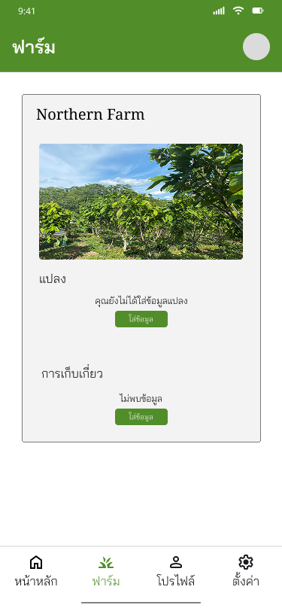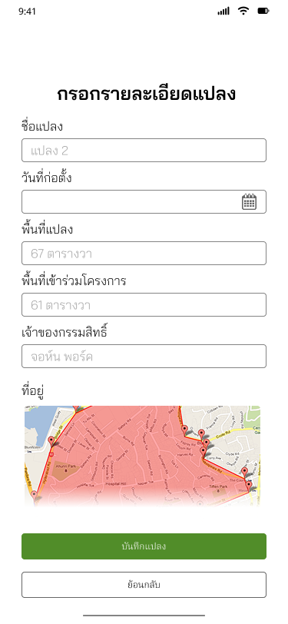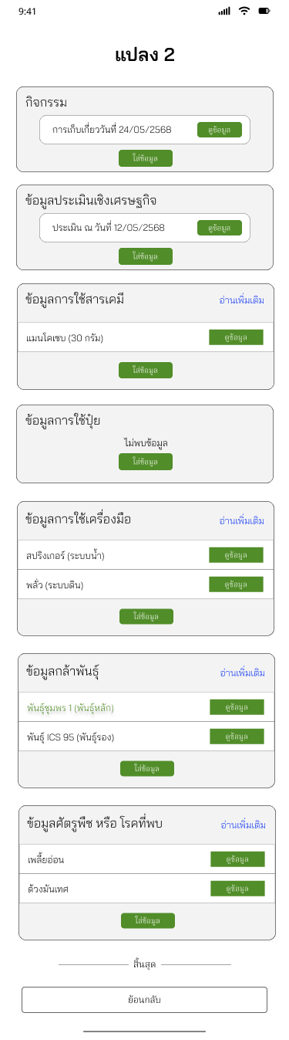

Figure 3.1 Farmer Screen

- Processors also use the mobile application to document all post-harvest processes, such as processor registration, batch data, processing records, cacao bean fermentation/drying, and final cocoa bean grading
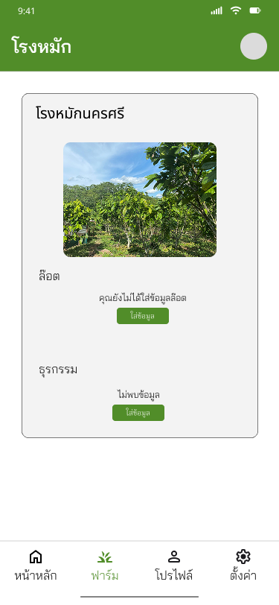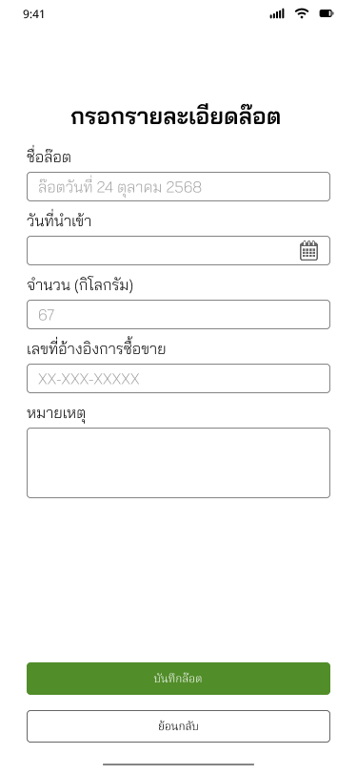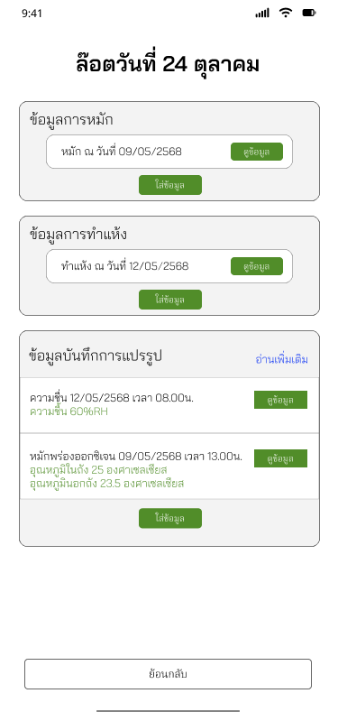

Figure 3.2 Processor Screen
- Researchers engage with a separate web application to access and analyze the collected data. They can View All Supply Chain Data, manage the cacao calendar, and track cacao transactions to gain real-time insights.
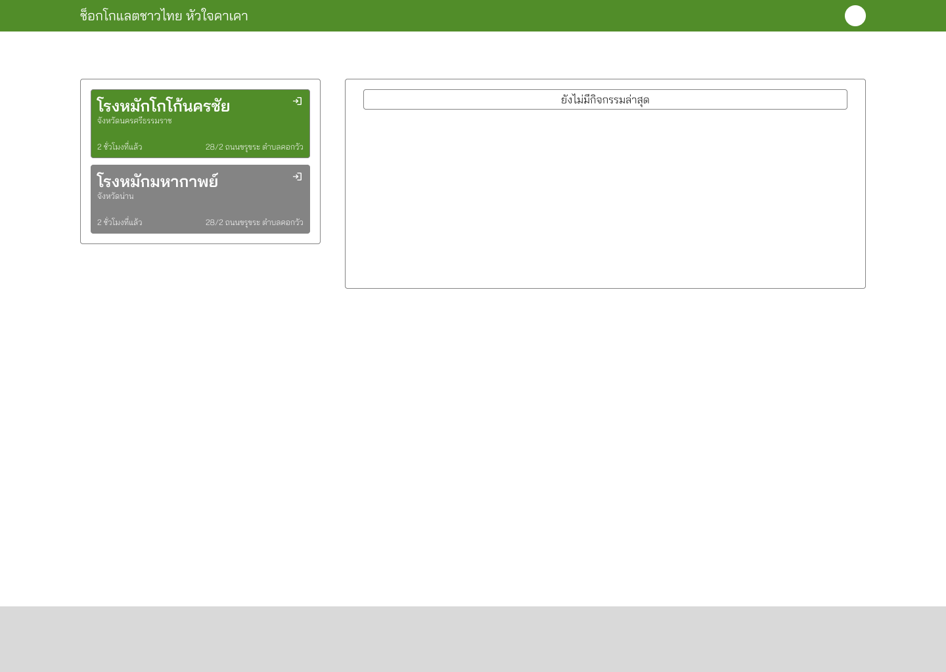

Figure 3.3 Researcher Screen

3.2 Components
The DataBank application consists of the following main components:
- Mobile Application (for farmers and processors workers): Allows easy recording of cocoa cultivation and initial processing data.
  - The mobile application serves as the primary tool for data input at the field level. It enables farmers and cocoa processing workers to easily record information related to cocoa cultivation, harvesting, fermentation, drying, and other early processing activities.
  - Offline capability: Users can record data even in areas with limited internet connectivity, with automatic synchronization once a connection is available.
  - User-friendly interface: Designed for simplicity to accommodate varying levels of digital literacy among farmers.
  - GPS and timestamp features: Enhance the traceability and authenticity of recorded data.
  - Photo and document uploads: Allow visual verification of crops, processing steps, or quality conditions.
- Web Application (for researchers): Displays real-time data and insights to support further research and analysis.
  - Dashboard and analytics: Displays real-time statistics, trends, and comparative analyses of cocoa production and processing.
  - User management: Ensures that only authorized personnel can view or modify sensitive information.
- Application-Side Server: Manages data transmission and processing between clients, handling requests and delivering data services to the web application.
  - Data validation and preprocessing: Ensures accuracy and consistency before storing data.
  - API management: Provides secure endpoints for data exchange between applications.
  - Business logic implementation: Executes processing rules, calculations, and data aggregation tasks.
  - Scalability and performance optimization: Supports multiple concurrent users and large datasets efficiently.
- Main Database: Stores all data from both farmers and researchers, ensuring systematic access and management.
  - Centralized storage: Consolidates all data from farmers, processors, and researchers.
  - Data integrity and backup: Includes mechanisms for data validation, versioning, and regular backups to prevent loss.
  - Structured schema design: Facilitates easy querying and integration with analytical tools.
  - Access control: Restricts data access based on user roles and privileges.

3.3 Constraints Considered
- Usability
  - The system shall provide a user-friendly interface that is easy to navigate and minimizes user errors.
  - The application shall ensure that data entry and navigation can be performed with minimal training by end-users such as farmers and processing workers.
- Reliability and Availability
  - The mobile application shall operate continuously with minimal downtime or interruptions.
  - The system shall automatically reconnect to the backend service when the network connection is restored.
- Performance
  - The application shall maintain a responsive user interface, with all user actions processed within an acceptable time.
  - The backend synchronization process shall complete efficiently without affecting the user experience.
- Integration
  - The system shall automatically integrate real-time weather data from the designated external API or service provider.
  - The Admin Dashboard shall provide real-time monitoring and analytics of data collected from the mobile application.
- Data Management
  - The system shall store all collected data in a centralized database to ensure consistency and easy retrieval.
  - Data synchronization between the mobile device and central database shall occur automatically when network connectivity is available.
- Security
  - The application shall include user authentication to prevent unauthorized access to sensitive data.
  - All data transmitted between the mobile application and backend service shall be encrypted using secure communication protocols (e.g., HTTPS/TLS).
- Offline Capability
  - The mobile application shall support offline mode, allowing users to record and store data locally when internet access is unavailable.
  - Data recorded offline shall automatically synchronize with the central database once connectivity is restored.

3.4 Diagrams
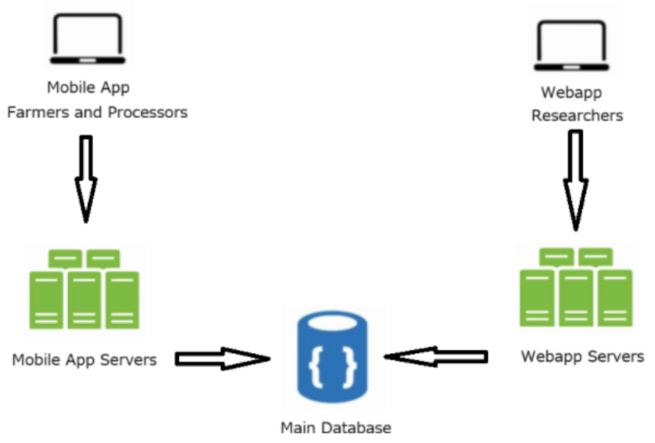

Figure 3.4 Architecture Diagram

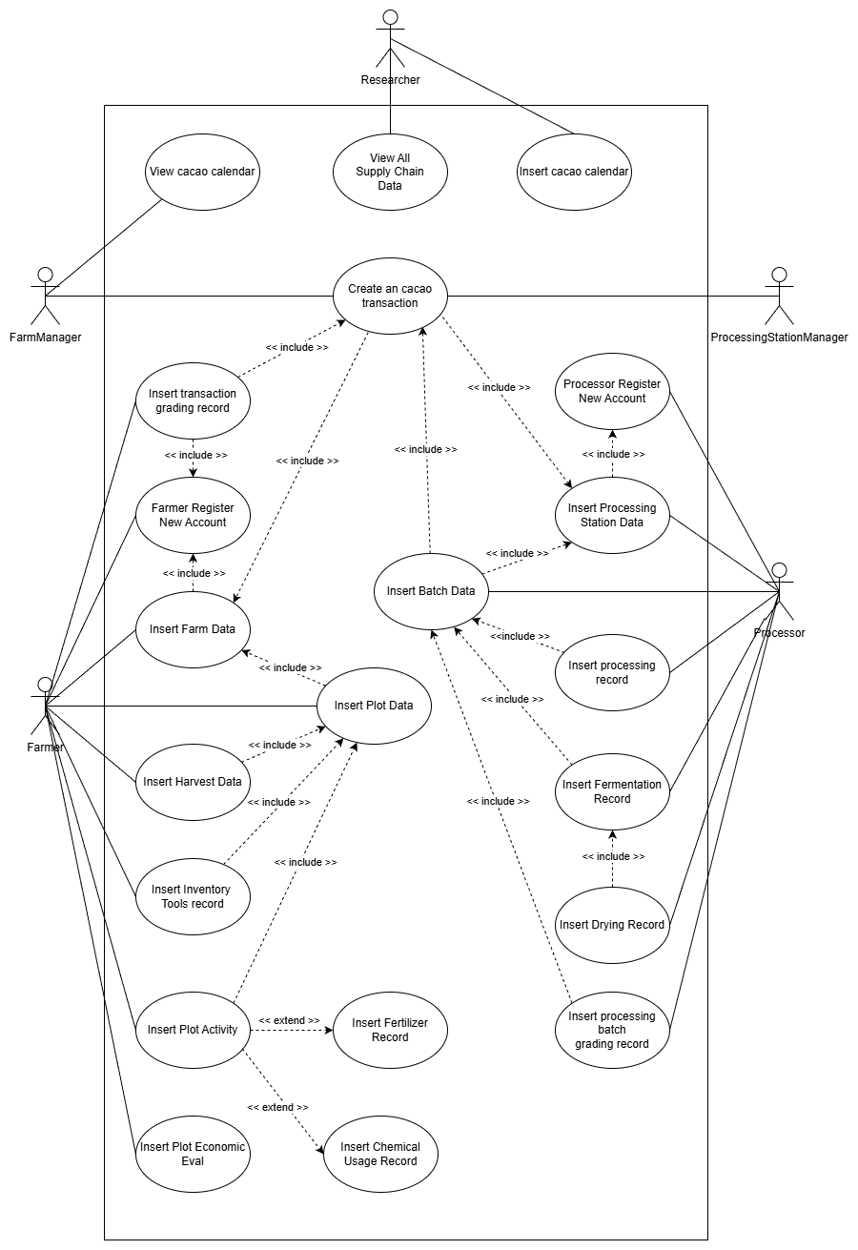

Figure 3.5 Use Case Diagram
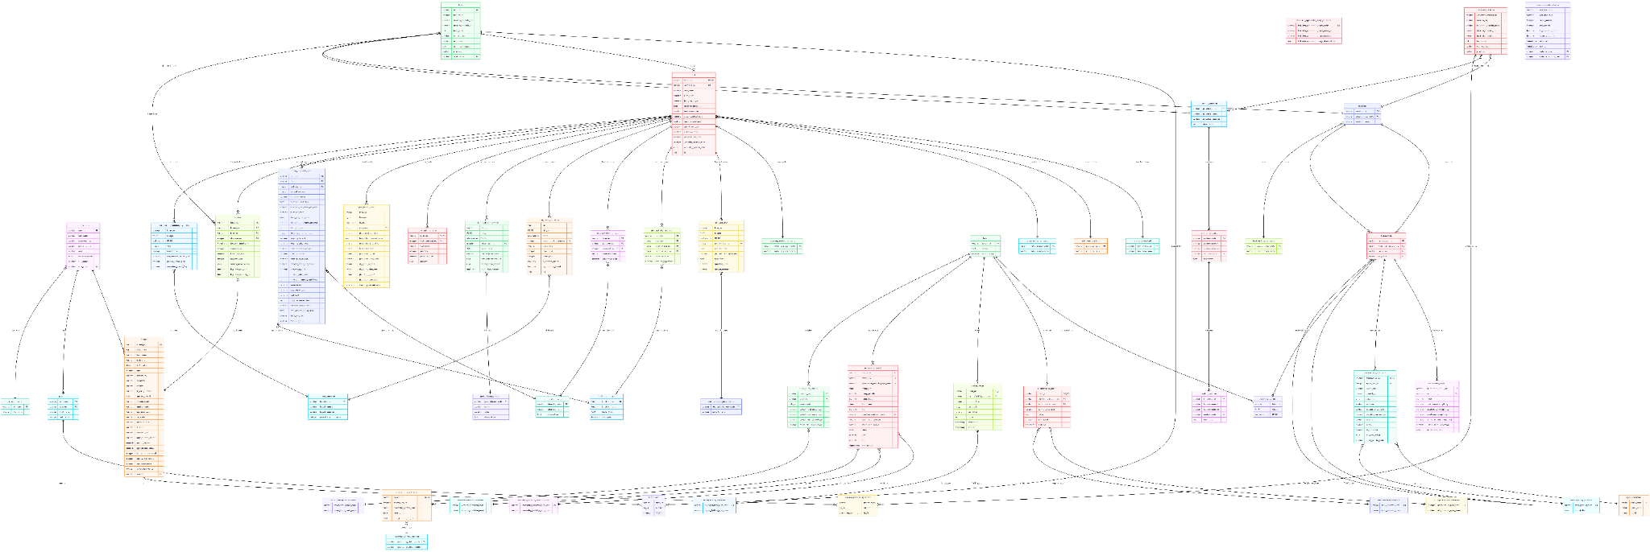

Figure 3.6 ER Diagram
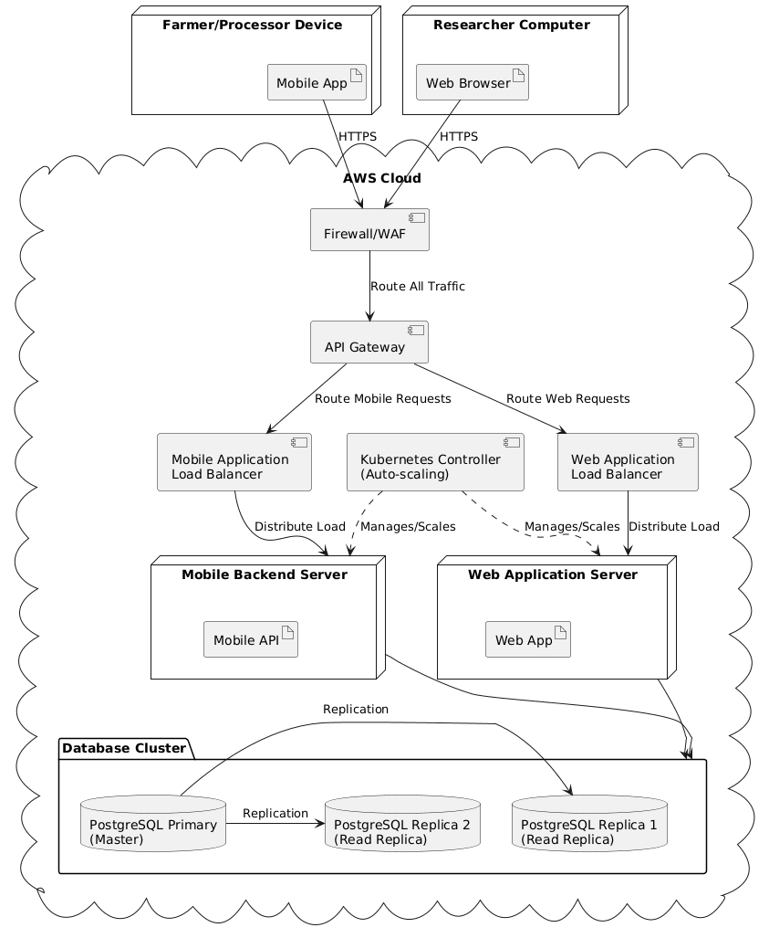

Figure 3.7 Deployment Diagram

4. Teamwork Plan

4.1 Roles and Responsibilities
The project team consists of four members, each with clearly defined roles to ensure efficient workflow and accountability:
- Chanathip Kulsirilak (6330080621) – Project Leader / UX/UI Designer / Front-end Developer
  - Responsible for overseeing the overall project progress, coordinating team activities, and designing the user interface of both mobile and web applications.
- Thanapat Manoim (6532091021) – System Analyst / Processor System Designer / Back-end Developer
  - Handles system analysis, requirements gathering, and back-end development for the processor side of the application.
- Peneik Sitthimongkol (6532125821) – Secretary / Coordinator / Farmer System Designer / Back-end Developer
  - Manages communication and coordination among team members, designs the system of the farmer side, and contributes to back-end development.
- Narat Rattanawiphanon (6633062121) – UX/UI Designer / Business Analyst
  - Supports interface design and gathers business requirements to ensure the application meets user needs and usability standards.

4.2 Collaborative Plan
The team will work collaboratively using a combination of regular meetings, shared documentation, and online project management tools. Tasks will be tracked through a central document, allowing members to update progress, report issues, and provide feedback. Close coordination between front-end and back-end developers ensures smooth integration of the mobile and web applications, while continuous input from the UX/UI designers and business analyst ensures usability and alignment with user needs.

4.3 Task Coverage
All major areas of the project are assigned as follows:
- Project management and coordination: Chanathip (Leader) & Peneik (Coordinator)
- UX/UI Design: Chanathip & Narat
- Front-end Development: Chanathip
- Back-end Development: Thanapat (Cocoa Hub system) & Peneik (Farm system)
- Business Analysis and Requirement Gathering: Narat
- Documentation and Reporting: Peneik & Narat
This ensures that all critical tasks, from design and development to coordination and analysis, are covered without overlap or gaps.

4.4 Workload Balance
Responsibilities are assigned based on each member’s expertise and role. Chanathip serves as the project leader and oversees front-end development, while Thanapat and Peneik handle different components of the back-end. Narat contributes to both design and analysis, effectively bridging the gap between technical implementation and user requirements. By clearly defining roles and maintaining consistent communication, the team ensures a balanced and fair workload and promotes overall efficiency.

5. Timeline (Semester 1)
Week | Task / Milestone | Deliverable
Week 1–2 | Literature review & background study | Draft background & problem statement
Week 3–4 | Problem definition & objectives | Problem statement & objectives
Week 5–7 | System-level design & tool selection | Draft design diagram & tool list
Week 8–10 | Proposal writing | Draft report
Week 11–12 | Proposal revision (advisor feedback) | Revised report
Week 13–14 | Proposal presentation preparation | Slides
Week 15 | Proposal presentation | Final report & slides

Table 5.1 Timeline (Semester 1)

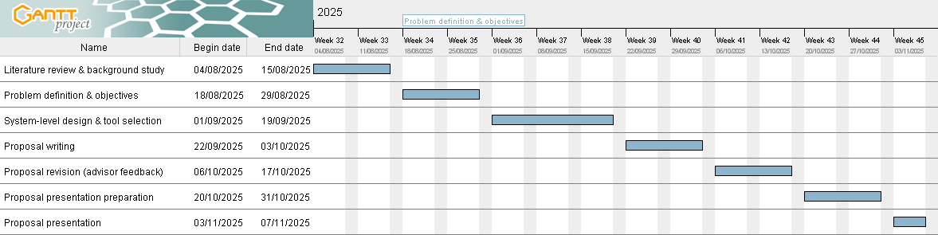

Figure 5.1 Semester 1 Gantt Chart

6. Planned Work (Semester 2)
Week | Task / Milestone | Deliverable
Week 1 | Develop and Test prototype software | Prototype Software and feedback
Week 2-3 | Develop and Test database and software | Cocoa Supply Chain Database
Week 4–6 | Develop and Test mobile application | Mobile application and Data Storing
Week 7–8 | Conduct workshops to teach local farmers to use the application | Training Report for Local Farmers and Step-by-Step App Usage Guidebook
Week 9–10 | Conduct field testing of the application with local farmers and incorporate feedback to refine the application and database | Field testing and feedback report
Week 11–12 | Finalize the application and database | Final version of the application and database
Week 13–14 | Final Project revision and preparation | Revised report, Slides
Week 15 | Final Project presentation | Final report & slides

Table 6.1 Planned Work (Semester 2)

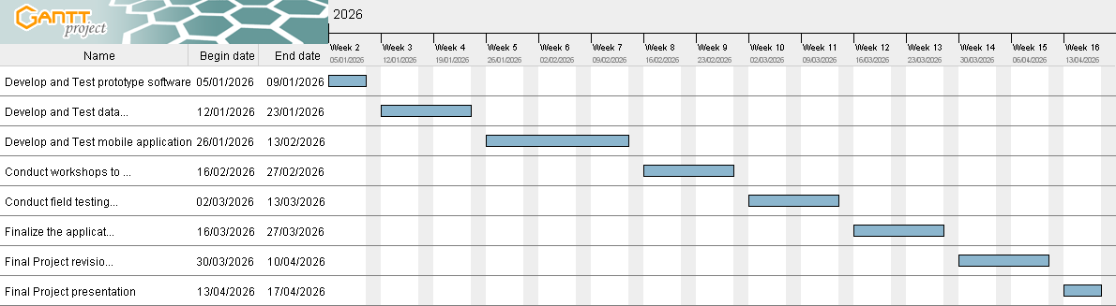

Figure 6.1 Semester 2 Gantt Chart

7. Ethics, Privacy, and Professional Considerations

7.1 Plagiarism Check
All project deliverables, including reports, presentations, and source code, will be submitted through Turnitin and the university Capstone account to ensure originality. Team members commit to proper citation of all external sources and adherence to academic integrity guidelines.
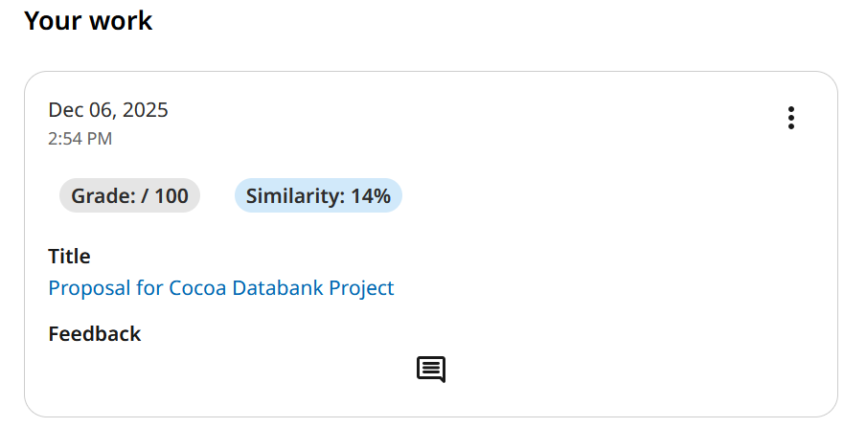

Figure 7.1 Result from Turnitin

7.2 Credibility of Information
The project relies exclusively on trustworthy and verifiable data from reliable sources such as academic publications, official agricultural reports, and validated user inputs from farmers and researchers. Any external references will be documented properly to maintain credibility and transparency.

7.3 Intellectual Property & Law
All software, designs, and documentation developed during the project will be considered intellectual property of the project team, while adhering to university policies. Any use of third-party libraries, frameworks, or datasets will comply with licensing agreements. Agreements or restrictions related to data access from farmers, processors, or CU SARs will be respected, ensuring lawful and ethical use of all project resources.

References
[1] Nan, T. N., & Ratanakuakangwan, S. (2024). A Comparative Study of the Sustainable Efficiency and Technical Efficiency of Upstream Cacao Production in Thailand. In Environmental science and engineering (pp. 441–451). https://doi.org/10.1007/978-981-97-3320-0_32
[2] Tosto, A., Morales, A., Rahn, E., Evers, J. B., Zuidema, P. A., & Anten, N. P. (2023). Simulating cocoa production: A review of modelling approaches and gaps. Agricultural Systems, 206, 103614. https://doi.org/10.1016/j.agsy.2023.103614
[3] Asante, P. A., Rahn, E., Zuidema, P. A., Rozendaal, D. M., Van Der Baan, M. E., Läderach, P., Asare, R., Cryer, N. C., & Anten, N. P. (2022). The cocoa yield gap in Ghana: A quantification and an analysis of factors that could narrow the gap. Agricultural Systems, 201, 103473. https://doi.org/10.1016/j.agsy.2022.103473
[4] Asante, P. A., Rozendaal, D. M., Rahn, E., Zuidema, P. A., Quaye, A. K., Asare, R., Läderach, P., & Anten, N. P. (2021). Unravelling drivers of high variability of on-farm cocoa yields across environmental gradients in Ghana. Agricultural Systems, 193, 103214. https://doi.org/10.1016/j.agsy.2021.103214
[5] Gao, Qian., Guo, Shanshan., Liu, Xiaofu., Manogaran, Gunasekaran., Chilamkurti, N.., & Kadry, Seifedine. (2019). Simulation analysis of supply chain risk management system based on IoT information platform. Enterprise Information Systems , 14 , 1354 - 1378 . http://doi.org/10.1080/17517575.2019.1644671.
[6] Wu, Yun., Cegielski, Casey G.., Hazen, Benjamin T.., & Hall, D.. (2013). Cloud Computing in Support of Supply Chain Information System Infrastructure: Understanding When to go to the Cloud. Journal of Supply Chain Management , 49 , 25-41 . http://doi.org/10.1111/J.1745-493X.2012.03287.X.
[7] F. B. Malek and A. Sharma, Flutter for Mobile Development: A Practical Guide, 1st ed. New York, NY, USA: Apress, 2021.
[8] P. Johnson, Spring Boot in Action, 2nd ed. Shelter Island, NY, USA: Manning Publications, 2018.
[9] V. Thakur, Mastering Next.js: Server-side Rendering and Static Web Development with React, 1st ed. Birmingham, UK: Packt Publishing, 2022.
[10] M. J. Hernandez, PostgreSQL: Up and Running, 3rd ed. Sebastopol, CA, USA: O’Reilly Media, 2020.
[11] Ratanakuakangwan, S., “Databank for Cocoa Supply Chain,” Project Proposal submitted to The Asahi Glass Foundation (AGF), The Innovation Center for Research and Development of Sustainable Cocoa Thailand (ISTC) and School of Agricultural Resources, Chulalongkorn University (CUSAR), 2025.

.

Appendix A: Use Case Diagram

Use Case Name: Farmer Registering New Account |  | ID: 001 | Importance Level:
Primary Actor: Farmers | Use Case Type:
Stakeholders and Interests:
Brief Description: Account registration for farmers
Trigger: Farmer opens the app for the first time and selects "Register New Account"
Type:
Relationships:
Association:
Include:
Extend:
Generalization:
Precondition: User has prepared necessary information to be used in the registration process
Postcondition: New “Farmer” account is registered
Involved Tables: farmer
Normal Flow of Events:
- Farmer opens the app
- Farmer clicks on “register new account”
- Farmer enters basic personal information such as FirstName, LastName, Experience in Cocoa Farming, A check for if the farmer doesn’t have that much experience, Contact Information etc.
- Farmer can tick the checkbox which will indicates whether they have some extent of experiences or not
- Farmer clicks on “register” button to submit the account registration form
- The information is registered into the database
- User account of farmer type will then created successfully created
SubFlows:
- At Stage 3, if information deemed not essential is left out, the system will still let the user register the data
Alternate/Exceptional Flows:
- At Stage 3, system won’t let the data register if the user forgot to enter some information deemed essential, or if the data type of input does not match the data type required
- At Stage 5, The system will not let user complete registration flow if there are some error in entered data

Use Case Name: Insert farm data |  | ID: 002 | Importance Level:
Primary Actor: Farmer | Use Case Type:
Stakeholders and Interests:
Brief Description: Farm data registration for farmer
Trigger:
Type:
Relationships:
Association:
Include:
Extend:
Generalization:
Precondition:
- User account exists with type of farmer
- User has prepared the information of the farm
Postcondition: Farm data is registered into the database
Involved Tables: farm, farmer_farm
Normal Flow of Events:
- Farmer opens the app
- Farmer login onto their own account
- Farmer clicks on “register new farm” button
- Farmer enters the information about their farm, such as Farm Name, Location (Using Centroid), Farm Area, Farm Map (URL to a map application)
- Farmers can tick various checkboxes which indicates whether the farm is still active etc.
- Farmer clicks on “register” button to submit a farm registration form
- The system registers the information given by the farmer in the farm table
- The system further registers the farmer’s farmer number and the newly created farm no into the farmer_farm table to record the ownership of the farm
SubFlows:
- At Stage 4, if information deemed not essential is left out, the system will still let the farmer register the data
Alternate/Exceptional Flows:
- At Stage 6, system won’t let the data register if the farmer forgot to enter some information deemed essential, or if the data type of input does not match the data type required
- At Stage 3, if the farmer is not logged in, the system won’t let the farmer enter their information

Use Case Name: Insert plot data |  | ID: 003 | Importance Level:
Primary Actor: Farmer | Use Case Type:
Stakeholders and Interests:
Brief Description: Plot data registration for farmer
Trigger:
Type:
Relationships:
Association:
Include:
Extend:
Generalization:
Precondition:
- User account exists with type of farmer
- User has prepared the information of the plot
- User already registered the information of the farm for this plot
Postcondition: Information about the plot is registered
Involved Tables: plot, farm_plot
Normal Flow of Events:
- Farmer opens the app
- Farmer selects the farm which the plot is in
- Farmer clicks on “register new plot” button
- Farmer enters information about their plot such as Location (Centroid), Cocoa Planted Area, A check on whether the plot has chemical use, Codes for water source, land type, soil type, watering system etc
- Farmer clicks on “register” button to submit a plot registration form
- Plot information is registered into the database with the no of the farmer and farm also registering

SubFlows:
- At Stage 4, if information deemed not essential is left out, the system will still let the farmer register the data
Alternate/Exceptional Flows:
- In Stage 3, if the farm the plot is in hasn’t been registered, it would not let the farmer click the button to register the plot
- At Stage 5, system won’t let the data register if the farmer forgot to enter some information deemed essential, or if the data type of input does not match the data type required

Use Case Name: Record Harvest data |  | ID: 004 | Importance Level:
Primary Actor: Farmer | Use Case Type:
Stakeholders and Interests:
Brief Description: Harvest data recording for farmers
Trigger:
Type:
Relationships:
Association:
Include:
Extend:
Generalization:
Precondition:
- User account exists with type of farmer
- The farm is already registered
- The plot is already registered
- The information for the harvest has been prepared
Postcondition: Information about the harvest is registered
Involved Tables: harvest
Normal Flow of Events:
- Farmer enters the app
- Farmer taps the farm the harvest is in, taps the register harvest button
- Farmer selects the farm and the plot that has been harvested
- Farmer clicks on “record harvest data” button
- Farmer enters information about their plot such as Harvest Time, plot (if any), The amount of pods, Check if the farmer would sell ugly pods etc
- Farmer clicks on “submit record” to submit the harvest record form
- Harvest information is registered into the database with the no of the farmer, farm and plot also registering
SubFlows:
- At Stage 4, if information deemed not essential is left out, the system will still let the farmer register the data
Alternate/Exceptional Flows:
- In Stage 3, if the plot the harvest is in hasn’t been registered, it would not let the farmer click the button to register the harvest information
- Additionally, if the farmer is logged out, the system won’t let the farmer register either
- At Stage 5, system won’t let the data register if the farmer forgot to enter some information deemed essential, or if the data type of input does not match the data type required

Use Case Name: Record plot activity
Primary Actor: Farmer |  |  | Use Case Type:
Stakeholders and Interests:
Brief Description: Plot activity recording for farmers
Trigger:
Type:
Relationships:
Association:
Include:
Extend: Insert chemical usage, Insert fertilizer record
Generalization:
Precondition:
- User account exists with type of farmer
- The farm is already registered
- The plot is already registered
- The information for the plot activity has been prepared
Postcondition: Information about the plot activity is recorded
Involved Tables: plot_activity, plot_activity_type_constant
Normal Flow of Events:
- Farmer enters the app
- Farmer selects the farm and plot to record the plot activity
- Farmer clicks on “records plot activity” button
- Farmer enters information about their plot such as Activity Date, Plot Activity Type (Ex: Use Fertilizer, Pruning, Use Chemicals, Watering etc.), Activity Description, Quantity Used, Measurement Unit etc.
- Farmer clicks on “submit record” button
- Plot Activity information is registered into the database with the no of the farm and plot also registering
- Additionally the Plot Activity will be registered in the plot_activity_type_constant with the activity type

SubFlows:
- At Stage 4, if information deemed not essential is left out, the system will still let the farmer register the data
- Additionally, farmers should fill in more information in each activity type form such as Chemical Usage, Fertilizer Usage etc.
Alternate/Exceptional Flows:
- In Stage 3, if the plot the activity is in hasn’t been registered, it would not let the farmer click the button to register the plot activity
- Additionally, if the farmer is logged out, the system won’t let the farmer register either
- At Stage 5, system won’t let the data register if the farmer forgot to enter some information deemed essential, or if the data type of input does not match the data type required

Use Case Name: Record plot economic evaluation
Primary Actor: Farmer | Use Case Type:
Stakeholders and Interests:
Brief Description: Plot economic data recording for farmers
Trigger:
Type:
Relationships:
Association:
Include:
Extend:
Generalization:
Precondition:
- User account exists with type of farmer
- The farm is already registered
- The plot is already registered
Postcondition: Information about the plot economic value is registered
Involved Tables: plot_economic_eval
Normal Flow of Events:
- Farmer open the app
- Farmer selects the farm and plot to record plot economics evaluation
- Farmer clicks on “record plot economics evaluation” button
- Farmer enters information about their plot's economic value such as Fertilizer cost/use time per year, Chemical cost/use time per year, Weeding cost/use time per year, Pruning cost/ use time per year etc
- Farmer clicks on “submit record” button
- Plot economic information is registered into the database with the no of the farm and plot also registering

SubFlows:
- At Stage 4, if information deemed not essential is left out, the system will still let the farmer register the data
Alternate/Exceptional Flows:
- In Stage 3, if the plot this is about hasn’t been registered, it would not let the farmer click the button to register the plot economic evaluation information
- Additionally, if the farmer is logged out, the system won’t let the farmer register either
- At Stage 5, system won’t let the data register if the farmer forgot to enter some information deemed essential, or if the data type of input does not match the data type required

Use Case Name: Record chemical usage
Primary Actor: Farmer | Use Case Type:
Stakeholders and Interests:
Brief Description: Chemical usage recording for farmers
Trigger:
Type:
Relationships:
Association:
Include:
Extend: Insert plot activity
Generalization:
Precondition:
- User account exists with type of farmer
- The farm is already registered
- The plot is already registered
Postcondition: Information about the plot chemical records is registered
Involved Tables: plot_activity_chemical
Normal Flow of Events:
- Farmer opens the app, taps the farm the plot is in, taps the plot the farmer wants to register the chemical records in and taps the register chemical records button
- Farmer selects the farm and plot to record chemical usage
- Farmer clicks on “record chemical usage” button
- Farmer enters information about their chemical usage such as Chemical Type, Amount of chemical used etc
- Farmer clicks on “submit record” button
- Plot chemical information is registered into the database with the no of the farm and plot also registering

SubFlows:
- At Stage 4, if information deemed not essential is left out, the system will still let the farmer register the data
Alternate/Exceptional Flows:
- In Stage 3, if the plot this chemical is used in hasn’t been registered, it would not let the farmer click the button to register the chemical record
- Additionally, if the farmer is logged out, the system won’t let the farmer register either
- At Stage 5, system won’t let the data register if the farmer forgot to enter some information deemed essential, or if the data type of input does not match the data type required

Use Case Name: Record fertilizer usage
Primary Actor: Farmer | Use Case Type:
Stakeholders and Interests:
Brief Description: Fertilizer usage recording for farmers
Trigger:
Type:
Relationships:
Association:
Include:
Extend:
Generalization:
Precondition:
- User account exists with type of farmer
- The farm is already registered
- The plot is already registered
Postcondition: Information about the plot fertilizer record is registered
Involved Tables: plot_activity_fertilizer
Normal Flow of Events:
- Farmer opens the app
- Farmer selects the farm and plot to record fertilizer usage
- Farmer clicks on “record fertilizer usage” button
- The farmer enters information about their fertilizer such as Fertilizer Type, Amount of fertilizer used etc.
- Farmer clicks on “submit record” button
- Plot fertilizer information is registered into the database with the no of the farm and plot also registering

SubFlows:
- At Stage 4, if information deemed not essential is left out, the system will still let the farmer register the data
Alternate/Exceptional Flows:
- In Stage 3, if the plot this fertilizer is used in hasn’t been registered, it would not let the farmer click the button to register the fertilizer
- Additionally, if the farmer is logged out, the system won’t let the farmer register either
- At Stage 5, system won’t let the data register if the farmer forgot to enter some information deemed essential, or if the data type of input does not match the data type required

Use Case Name: Register inventory tool record
Primary Actor: Farmer | Use Case Type:
Stakeholders and Interests:
Brief Description: Inventory tool registration by plot for farmers
Trigger:
Type:
Relationships:
Association:
Include:
Extend:
Generalization:
Precondition:
- User account exists with type of farmer
- The farm is already registered
- The plot is already registered
Postcondition: Information about the inventory tool usage is registered
Involved Tables: plot_tool_inventory
Normal Flow of Events:
- Farmer opens the app, taps the farm the farmer wants to register the inventory tool information in and taps the register inventory tool information button
- Farmer selects the farm and plot to register new inventory tools
- Farmer clicks on “register new inventory tools” button
- The farmer enters information about their tool such as Tool Name, Quantity, Price per unit etc.
- Farmer clicks on “submit” button
- Inventory tool information is registered into the database

SubFlows:
- At Stage 4, if information deemed not essential is left out, the system will still let the farmer register the data
Alternate/Exceptional Flows:
- In Stage 3, if the plot this tool is used in hasn’t been registered, it would not let the farmer click the button to register the tool
- Additionally, if the farmer is logged out, the system won’t let the farmer register either
- At Stage 5, system won’t let the data register if the farmer forgot to enter some information deemed essential, or if the data type of input does not match the data type required

Use Case Name: Add cacao calendar
Primary Actor: Researcher | Use Case Type:
Stakeholders and Interests:
Brief Description: Cacao calendar added by researchers
Trigger:
Type:
Relationships:
Association:
Include:
Extend:
Generalization:
Precondition:
- User account exists with type of researcher
Postcondition: Information about cacao calendar is registered
Involved Tables: cacao_calendar_activity
Normal Flow of Events:
- Researcher logging into the website
- Researcher navigate to “cacao calendar” page
- Researcher clicks on “add new cacao calendar” button
- Researcher enters information about the activity such as Start-end date, check if its flowering period or growth period, calendar year etc into the Calendar
- Researcher clicks on “add calendar” button
- Cacao Calendar is registered into the database
- The farmers involved with that activity receives a notification of this action

SubFlows:
- At Stage 2, if information deemed not essential is left out, the system will still let the researcher register the data

Alternate/Exceptional Flows:
- At Stage 5, system won’t let the data register if the researcher forgot to enter some information deemed essential, or if the data type of input does not match the data type required

Use Case Name: Record transaction grading details
Primary Actor: Processor | Use Case Type:
Stakeholders and Interests:
Brief Description: Transaction grading details recording for processor
Trigger:
Type:
Relationships:
Association:
Include:
Extend:
Generalization:
Precondition:
- User account exists with type of processor
- The transaction is already created
Postcondition: Information about the grading record is registered
Involved Tables: transaction_grade_detail
Normal Flow of Events:
- Processor opens the app
- Processor selects the transaction to record grading details
- Processor clicks on “record grading details” button
- Processor enters information about their grading record such as Defect mold percentage, defect color percentage, defect pest percentage etc
- Processor clicks on “submit record” button
- Processor grading record is registered into the database
SubFlows:
- At Stage 4, if information deemed not essential is left out, the system will still let the farmer register the data
Alternate/Exceptional Flows:
- In Stage 3, if the harvest involved hasn’t been registered, it would not let the farmer click the button to register the grading record
- Additionally, if the farmer is logged out, the system won’t let the farmer register either
- At Stage 5, system won’t let the data register if the farmer forgot to enter some information deemed essential, or if the data type of input does not match the data type required

Use Case Name: Processor Registering New Account
Primary Actor: Processor | Use Case Type:
Stakeholders and Interests:
Brief Description: Account registration for processor
Trigger:
Type:
Relationships:
Association:
Include:
Extend:
Generalization:
Precondition: User has prepared necessary information to used in registering process
Postcondition: New “Processor” account is registered
Involved Tables: processor
Normal Flow of Events:
- Processor opens the app
- Processor clicks on “register new account” button
- Processor enters personal information such as FirstName, LastName, etc
- Processor clicks on “register” button
- The information is registered into the database
- The processor’s account is successfully created
SubFlows:
- At Stage 3, if information deemed not essential is left out, the system will still let te user register the data
Alternate/Exceptional Flows:
- At Stage 4, system won’t let the data register if the user forgot to enter some information deemed essential, or if the data type of input does not match the data type required

Use Case Name: Register new processing station
Primary Actor: Processor | Use Case Type:
Stakeholders and Interests:
Brief Description: Processing station registration for processor
Trigger:
Type:
Relationships:
Association:
Include:
Extend:
Generalization:
Precondition:
- User account exists with type of processor
- User has prepared the information of the processing station
Postcondition: Processing_station data is registered into the database
Involved Tables: processing_station, processor_processing_station
Normal Flow of Events:
- Processor enters the app
- Processor clicks on “register processing station” button
- Processor enters the information about their station, such as Name, Location (Using Centroid), Area, Map(URL to a map application), A check on whether the station is active etc
- Processor clicks on “register” button
- The system registers the information given by the processor in the processing_station table
- The system further registers the processors’s station number and the newly created station no into the processor_processing_station table to record the ownership of the station
SubFlows:
- At Stage 3, if information deemed not essential is left out, the system will still let the processor register the data
Alternate/Exceptional Flows:
- At Stage 4, system won’t let the data register if the processor forgot to enter some information deemed essential, or if the data type of input does not match the data type required
- At Stage 2 if the processor is not logged in, the system won’t let the processor enter their information

Use Case Name: Create an Cacao transaction |  | ID: | Importance Level:
Primary Actor: Farm, Processing Station | Use Case Type:
Stakeholders and Interests:
Brief Description: Cacao transaction creation for farm and processing station
Trigger:
Type:
Relationships:
Association:
Include:
Extend:
Generalization:
Precondition:
- The farm is already registered
- The processing station is already registered
Postcondition:Transaction with detail is in the database.
Involved Tables: transaction and transaction_detail.
Normal Flow of Events:
- Farmer/Processor enters the app
- Farmer/Processor navigates to “transaction” page
- Farmer/Processor clicks on “create transaction” button
- Farmer/Processor fills in details including seller, weight, defect and usable seed percentage.
- Farmer/Processor clicks on “save transaction” button
- The transaction is successfully created
SubFlows:
- At Stage 4, The processing station can search for a farm in the system as a seller by processor.
Alternate/Exceptional Flows:
- At Stage 5, system won’t let the data register if the user forgot to enter some information deemed essential, or if the data type of input does not match the data type required

Use Case Name: Record batch data
Primary Actor: Processing Station | Use Case Type:
Stakeholders and Interests:
Brief Description: Batch data recording for processing station by processor
Trigger:
Type:
Relationships:
Association:
Include:
Extend:
Generalization:
Precondition:
- The processing station is already registered
- The cacao transaction is already created
Postcondition:Transaction with data is in the database.
Involved Tables: batch
Normal Flow of Events:
- Processor enters an app and go to “batch record”
- Processor navigates to “batch” page
- Processor clicks on “record batch data” button
- Processor divides fresh cacao into any batch and fills in information about the origin source
- Processor clicks on “save records” button
- The System will generate batch_no and insert batch data into the database.
SubFlows:

Alternate/Exceptional Flows:
- At Stage 5, system won’t let the data register if forgot to enter some information deemed essential, or if the data type of input does not match the data type required

Use Case Name: Record fermentation batch data
Primary Actor: Processor | Use Case Type:
Stakeholders and Interests:
Brief Description: Fermentation batch recording by dividing origin batch for processor
Trigger:
Type:
Relationships:
Association:
Include: Insert Batch Data
Extend:
Generalization:
Precondition:
- User account exists with type of processor
- The origin batch has been recorded
Postcondition: Information about the fermentation batch is recorded.
Involved Tables: fermentation_batch
Normal Flow of Events:
- The Processor opens the app
- Processor navigates to “batch” page
- Processor clicks on “record fermentation batch data” button
- The Processor selects a divided batch and fills in information about the fermentation process such as air exposure type, tank material, tank volume (liter), start and end time, and specific notes.
- Processor clicks on “save records” button
- The system references the main batch_no and fermentation batch data is successfully created.

SubFlows:

Alternate/Exceptional Flows:
- At Stage 5, system won’t let the data register if forgot to enter some information deemed essential, or if the data type of input does not match the data type required

Use Case Name: Record drying batch data
Primary Actor: Processor | Use Case Type:
Stakeholders and Interests:
Brief Description: Drying batch recording which derived from fermentation batch for processor
Trigger:
Type:
Relationships:
Association:
Include: Insert Batch Data
Extend:
Generalization:
Precondition:
- User account exists with type of processor
- The origin batch has been recorded
- The origin batch has its records on fermentation batch
- The origin batch has been fermented successfully
Postcondition: Information about the drying batch is recorded.
Involved Tables: drying_batch
Normal Flow of Events:
- After the fermentation is completed, the Processor opens the app
- Processor navigates to “batch” page
- Processor clicks on “record drying batch data” button
- The Processor selects the fermented batch and records drying details such as drying facility type, air flow system, fan count, fan power (watt), start and end time, and notes.
- Processor clicks on “save records” button
- The system references the main batch_no and drying batch data is successfully created.

SubFlows:

Alternate/Exceptional Flows:
- At Stage 5, system won’t let the data register if forgot to enter some information deemed essential, or if the data type of input does not match the data type required

Use Case Name: Record processing details
Primary Actor: Processor | Use Case Type:
Stakeholders and Interests:
Brief Description: Processing details’s activity log recording for processor
Trigger:
Type:
Relationships:
Association:
Include:
Extend: Insert Processing Defect Record
Generalization:
Precondition: Processor account exists, The batch is already registered
Postcondition: Information about the processing record is recorded.
Involved Tables: processing_record, processing_defect
Normal Flow of Events:
- During the fermentation and drying stages, a device called Logger automatically collects and sends data into the system at regular intervals.
- Processor can review and update each processing record including temperature, humidity, weather condition, bean color, smell, and location coordinates (lat/lng)
- The system generates a unique record_no for each entry linked to the related batch_no
SubFlows:
- At Stage 2, If any defects are observed during processing, the processor can enter processing defects by selecting the related processing record and specifying the defect type (e.g., mold, bubbling, etc.).
Alternate/Exceptional Flows:
- At Stage 2, system won’t let the data register if forgot to enter some information deemed essential, or if the data type of input does not match the data type required

Use Case Name: Record processing batch grading details
Primary Actor: Processor | Use Case Type:
Stakeholders and Interests:
Brief Description: Processing batch grading detail recording for processor
Trigger:
Type:
Relationships:
Association:
Include:
Extend:
Generalization:
Precondition:
- User account exists with type of processor
- The processing station is already registered
- The origin batch has been recorded
Postcondition: Information about the grading record is registered
Involved Tables: cocoa_bean_grade_constant, cocoa_bean_grading
Normal Flow of Events:
- Processor opens the app, taps the processing station, taps the bash the processor wants to record grading information of and taps the register cocoa grading record button
- Processor navigates to “processing station” page
- Processor selects desired batch in the station to record grading information
- Processor clicks on “record processing batch grading details” button
- Processor enters information about their grading record such as Defect mold percentage, defect color percentage, defect pest percentage etc
- Processor clicks on “save records” button
- Cocoa grading record is registered into the database
SubFlows:
- At Stage 5, if information deemed not essential is left out, the system will still let the farmer register the data
Alternate/Exceptional Flows:
- In Stage 4, if the harvest involved hasn’t been registered, it would not let the processor click the button to register the grading record
- Additionally, if the processor is logged out, the system won’t let the processor register either
- At Stage 6, system won’t let the data register if the processor forgot to enter some information deemed essential, or if the data type of input does not match the data type required

Appendix B: Complete ER Diagram (Google Drive)

https://drive.google.com/drive/u/0/folders/1XOwZAYuCyZSvpDLJv5uF_2WweaCSc9w5

Appendix C: Prototype Design (Figma)
UX/UI Semester 1 – Figma
