**Step 5.4 - Insert several records in each table, preserving all constraints. Put in enough data to demonstrate how the database will function.**

INSERT INTO InsurancePolicy VALUES(13452, ‘Blue Shield’ , ‘Carlos Flores’, ‘P’, 150.00, 75.00, 50.00, ‘01-JAN-2022’, ‘31-DEC-2022’);  
INSERT INTO InsurancePolicy VALUES(12342, ‘UnitedHealthCare’, ‘Christina Hyman’, ‘P’, 200.00, 50.00, 25.00, ‘01-MAR-2022’, ‘01-MAR-2023’);

INSERT INTO InsurancePolicy VALUES(12169, ‘Pace Health’, ‘Sagar Devkate’, ’S’, 10.00, 10.00, 10.00, ‘01-SEP-2022’, ‘01-SEP-2023’);  
INSERT INTO InsurancePolicy VALUES(21321,’Pace Health’, ‘Daulet Kapezov’, ’S’, 10.00, 10.00, 10.00, ‘07-SEP-2022’, ‘07-SEP-2023’);

INSERT INTO InsurancePolicy VALUES(17939, ’Empire Healthcare’, ‘Filippo Zallocco’, ’P’, 100.00, 50.00, 30.00, ‘01-SEP-2022’, ‘01-SEP-2023’);

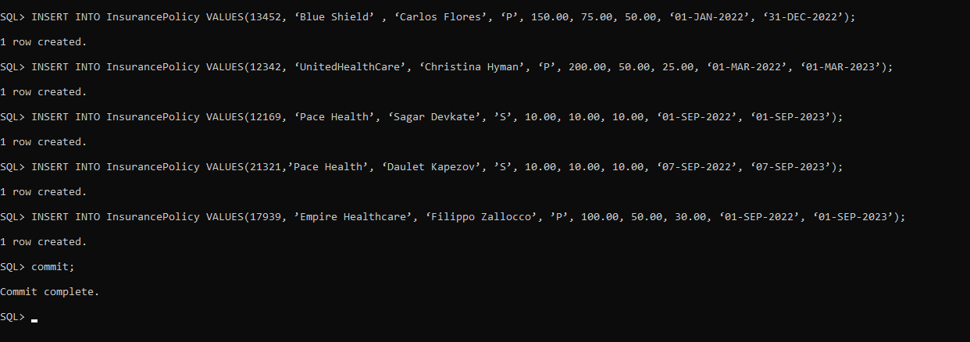

INSERT INTO Patient VALUES(1, ‘Carlos Flores’, ‘123 8th Ave, New York, NY 10018’, ‘2120101234’, ‘09-OCT-1995’, ‘M’, ‘Blue Shield’, 13452, ‘Self’);

INSERT INTO Patient VALUES(2, ‘Christina Hyman’, ‘101 6th Ave, New York, NY 10018’, ‘2121234543’, ‘02-FEB-1999’, ‘F’, ‘UnitedHealthcare’, 12342, ‘Parent’);

INSERT INTO Patient VALUES(3, ‘Daulet Kapezov’, ‘1 Pace Plaza, New York, NY 10018’,

‘3013217890’, ‘07-JUL-1998’, ‘M’, ‘Pace Health’, 12169, ‘Self’);

INSERT INTO Patient Values(4, ‘Sagar Devkate’, ‘21 Main St, Jersey City, NJ 10232’, ‘5313214567’, ‘04-MAR-1997’, ‘M’, ‘Pace Health’, ‘21321’, ‘Self’);

INSERT INTO Patient VALUES(5, ‘Filippo Zallocco’, ‘174 Broma St, Brooklyn, NY 10037’, ‘3909754327’, ‘05-OCT-1997’, ‘M’, ‘Empire Healthcare’, 17939, ‘Self’);

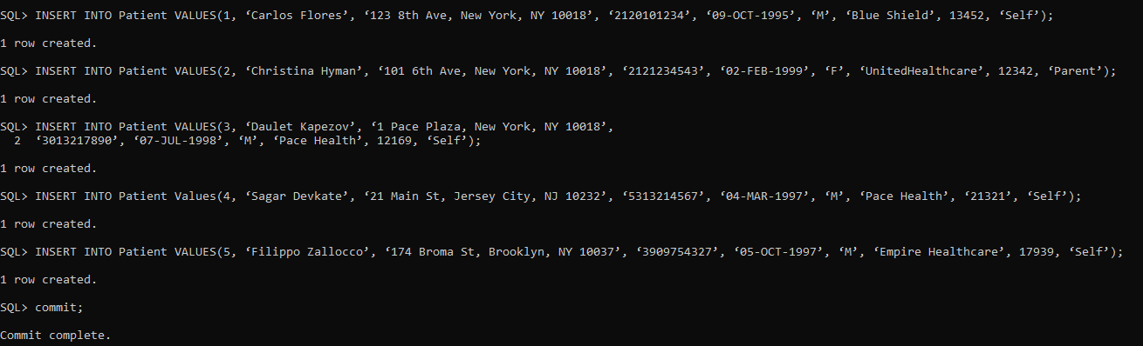

INSERT INTO Staff VALUES(1, ‘Dianna Kreppel’, ‘MD’, ‘Physician’, ‘25 Mulberry Ln, Yonkers, NY 10704’, ‘9145839293’);

INSERT INTO Staff VALUES(2, ‘Kevin Malone’, ‘MD’, ‘Surgeon’, ‘42 Holland Ave, Bronx, NY 10453’, ‘3473829384’);

INSERT INTO Staff VALUES(3, ‘Jade Nolan’, ‘RN’, ‘Registered Nurse’, ‘582 Grand St, Brooklyn, NY 11211’, ‘9172832958’);

INSERT INTO Staff VALUES(4, ‘Steven Leonard’, ‘CNM’, ‘Midwife’, ‘163 William St, New York, NY, 10038’, ‘2125849382’);

INSERT INTO Staff VALUES(5, ‘William Morris’, ‘Ms.’, ‘Receptionist’, ‘96-08 45th Ave, Queens, NY 11368’, ‘7188492839’);

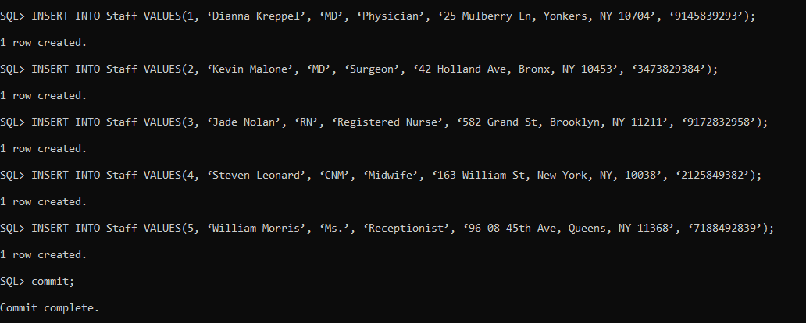

INSERT INTO Availability VALUES(1, ’05-OCT-2022’, ‘9:00’, ‘17:00’);  
INSERT INTO Availability VALUES(2, ’10-OCT-2022’, ‘9:30’, ‘17:30’);  
INSERT INTO Availability VALUES(3, ’15-OCT-2022’, ‘10:00’, ‘17:45’);  
INSERT INTO Availability VALUES(4, ’20-OCT-2022’, ‘10:30’, ‘18:00’);  
INSERT INTO Availability VALUES(5, ‘25-OCT-2022’, ‘10:45’, ‘18:15’);

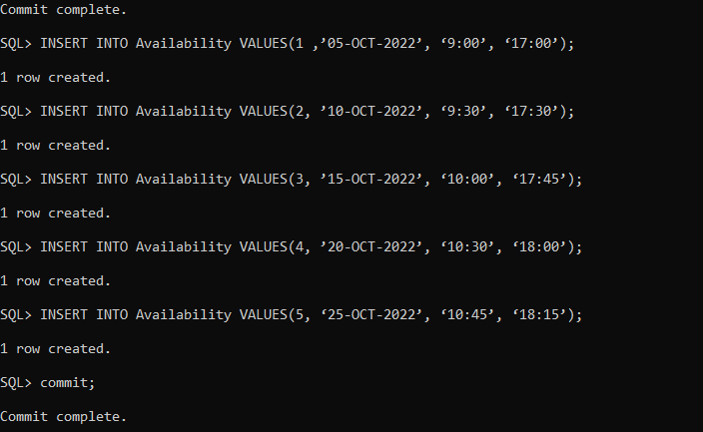

INSERT INTO Room VALUES(301, ‘R’ , ‘Acceptable’);  
INSERT INTO Room VALUES(302, ‘R’, ‘Not enough beds’);

INSERT INTO Room VALUES(303, ‘O’, ‘Acceptable’);  
INSERT INTO Room VALUES(304, ‘D’, ‘Acceptable’);  
INSERT INTO Room VALUES(305, ‘R’, ‘Acceptable’);

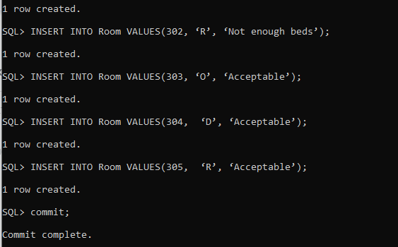

INSERT INTO Visit VALUES(1, 1, ‘01-OCT-2022’, ‘15:00’, 20, ‘Vaccination’, ‘Routine’, 69.99, 24219, 301);

INSERT INTO Visit VALUES(2,2, ‘21-SEP-2022’, ‘10:30’, 0, ‘Birthing’, ‘Routine’,130.24, 390293, 302);

INSERT INTO Visit VALUES(3, 3, ‘28-SEP-2022’, ‘13:00’, 50, ‘New Symptoms’, ‘Urgent’,359.99, 839283, 303);

INSERT INTO Visit VALUES(4, 4, ‘03-OCT-2022’, ‘14:15’, 50, ‘Chronic Ankle Pain’, ‘Routine’,129.99, 483927, 304);

INSERT INTO Visit VALUES(5, 5, ‘07-OCT-2022’, ‘15:00’, 45, ‘Chest Discomfort’, ‘Walk-in/Same day’,255.99, 83928, 305);

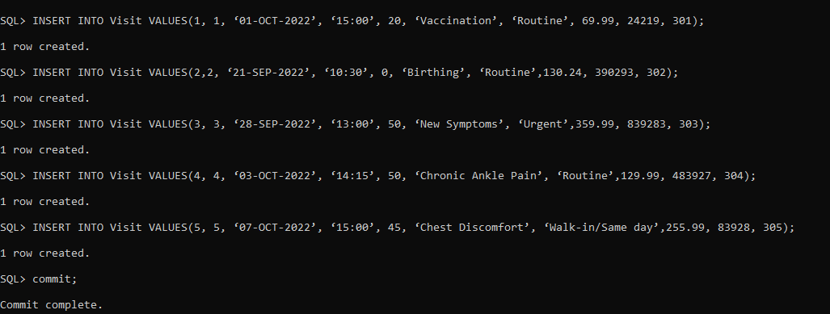

INSERT INTO Appointment VALUES(1, ‘01-OCT-2022’, ‘09:00’, ‘Flu Shot’, 1, 1);

INSERT INTO Appointment VALUES(2, ‘21-SEP-2022’, ‘10:30’, ‘Childbirth’, 2, 2);

INSERT INTO Appointment VALUES(3, ‘28-SEP-2022’, ‘13:00’, ‘Anemia’, 3, 3);

INSERT INTO Appointment VALUES(4, ‘03-OCT-2022’, ‘14:15’, ‘Ankle Pain’, 4, 4);

INSERT INTO Appointment VALUES(5, ‘07-OCT-2022’, ‘15:00’, ‘Chest Discomfort’, 5, 5);

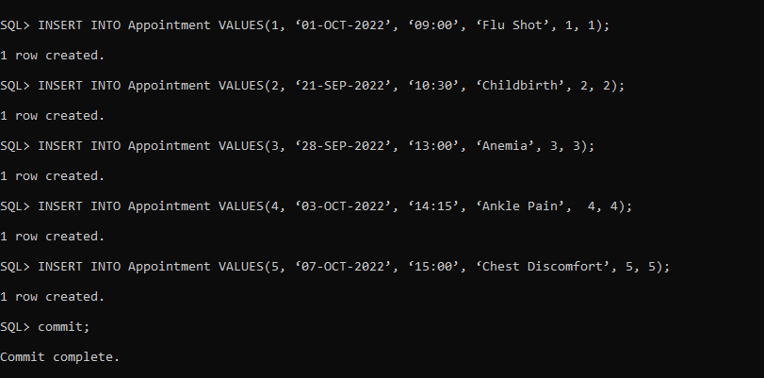

INSERT INTO Referral VALUES (100500, 1, ‘William Jones’, ‘Vaccination’);

INSERT INTO Referral VALUES (100501, 2, ‘Karl Gustaf’, ‘Birthing’);

INSERT INTO Referral VALUES (100503, 3, ‘James Alexander Monro’ , ’New Symptoms’);

INSERT INTO Referral VALUES (100504, 4, ‘Candy Pumpkin’, ’Chronic Ankle Pain’);

INSERT INTO Referral VALUES (100505, 5, ‘Hainz Eggplant’, ’Chest Discomfort’);

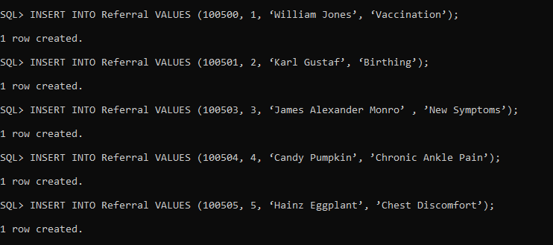

INSERT INTO Bill VALUES (67791, ‘07-NOV-2022’, 900.00, ‘30-NOV–2022’, 1, 800.50);

INSERT INTO Bill VALUES (67792, ‘09-NOV-2022’, 1000.35, ‘29-NOV–2022’, 2, 100.35);

INSERT INTO Bill VALUES (67793, ‘10-NOV-2022’, 20000.00, ‘28-NOV–2022’, 3, 500.00);

INSERT INTO Bill VALUES (67794, ‘01-NOV-2022’, 3000.00, ‘27-NOV–2022’, 3, 89.00);

INSERT INTO Bill VALUES (67795, ‘03-NOV-2022’, 100.00, ‘26-NOV–2022’, 3, 200.00);

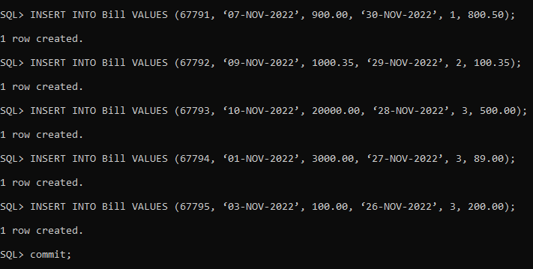

INSERT INTO Charge VALUES (67791, ‘Flu Symptoms occurred’, ‘07-NOV-2022’, 900.00);

INSERT INTO Charge VALUES (67792, ‘Childbirth begins’, ‘09-NOV-2022’, 1000.35);

INSERT INTO Charge VALUES (67793, ‘Anemia Symptoms’, ‘10-NOV-2022’, 2000.00);

INSERT INTO Charge VALUES (67794, ‘Ankle Symptoms’, ‘01-NOV-2022’, 3000.00);

INSERT INTO Charge VALUES (67795, ‘Injury of the chest’, ‘03-NOV-2022’, 100.00);

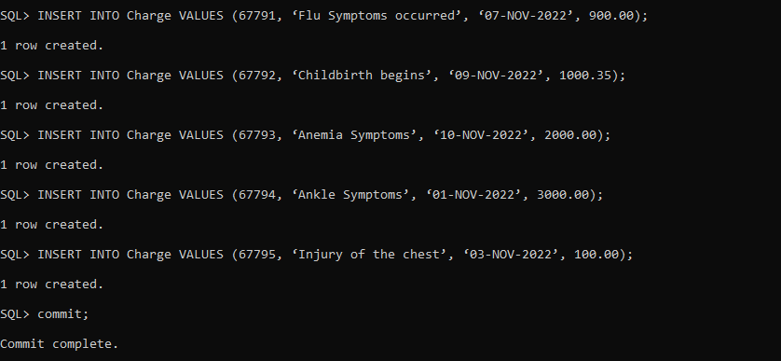

INSERT INTO Payment VALUES (67791, ‘30-NOV–2022’, 800.50, 1 , ‘Blue Shield’, 13452);

INSERT INTO Payment VALUES (67792, ‘29-NOV–2022’, 100.35, 2 , ‘UnitedHealthcare’, 12342);

INSERT INTO Payment VALUES (67793, ‘28-NOV–2022’, 500.00, 3 , ‘Pace Health’, 12169);

INSERT INTO Payment VALUES (67794, ‘27-NOV–2022’, 89.00, 4 , ‘Pace Health’, 21321);

INSERT INTO Payment VALUES (67795, ‘26-NOV–2022’, 200.00, 5 , ‘Empire Healthcare’, 17939);

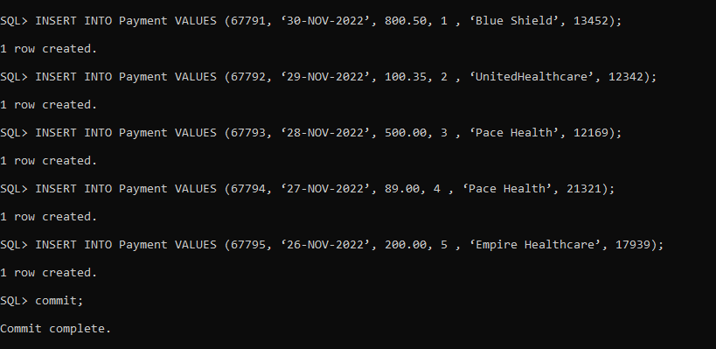

INSERT INTO DiagnosisMenu VALUES(‘A0112B’, ‘Sprain of ankle’);

INSERT INTO DiagnosisMenu VALUES(‘A152B1’, ‘Full-term uncomplicated delivery’);

INSERT INTO DiagnosisMenu VALUES(’A15253’, ‘Chest Pain, Unspecified’);

INSERT INTO DiagnosisMenu VALUES(‘A5601F’, ‘Flu Vaccination’);

INSERT INTO DiagnosisMenu VALUES(‘A253G1’, ‘Anemia, Unspecified’);

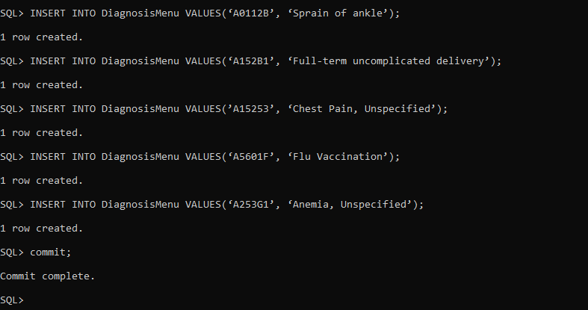

INSERT INTO ProcedureMenu VALUES(‘29540’, ‘Under Lower Extremity Application of Strapping-Any Age’, 129.99);

INSERT INTO ProcedureMenu VALUES(‘59400’, ‘Vaginal delivery’, 130.24);

INSERT INTO ProcedureMenu VALUES(‘99212’, ‘Established patient office visit, 10-19 minutes’, 249.99);

INSERT INTO ProcedureMenu VALUES(‘90688’, ‘Inactivated Influenza Vaccine’, 69.99);

INSERT INTO ProcedureMenu VALUES(‘99203’, ‘New patient office visit, 30-44 minutes’, 349.99);

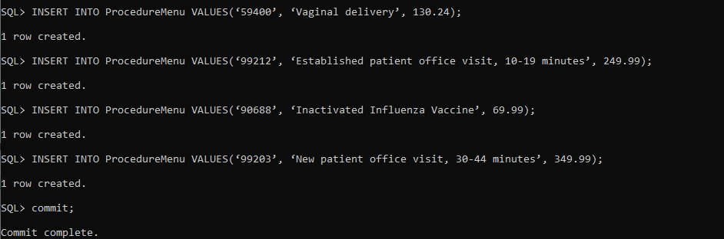

INSERT INTO PrescriptionScript VALUES(12302, 2, ‘01-OCT-2022’, ‘Paracetamol’, 2, ‘Take one before bed’, 4);  
INSERT INTO PrescriptionScript VALUES(12301, 2, ‘21-SEP-2022’, ‘Atorvastin’, 1, ‘Take once a day with food’ , 3);

INSERT INTO PrescriptionScript VALUES(12303, 3, ‘28-SEP-2022’, ‘Meloxicam’, 1, ‘Take once a every two days with food’, 4);  
INSERT INTO PrescriptionScript VALUES(12305, 4, ‘03-OCT-2022’, ‘Wellbutrin’, 3, ‘Take every morning with food’, 4);  
INSERT INTO PrescriptionScript VALUES(12307, 5, ‘07-OCT-2022’ ,’Hydrochlorothiazide’, 2 , ‘Apply to affected area as needed’, 6);

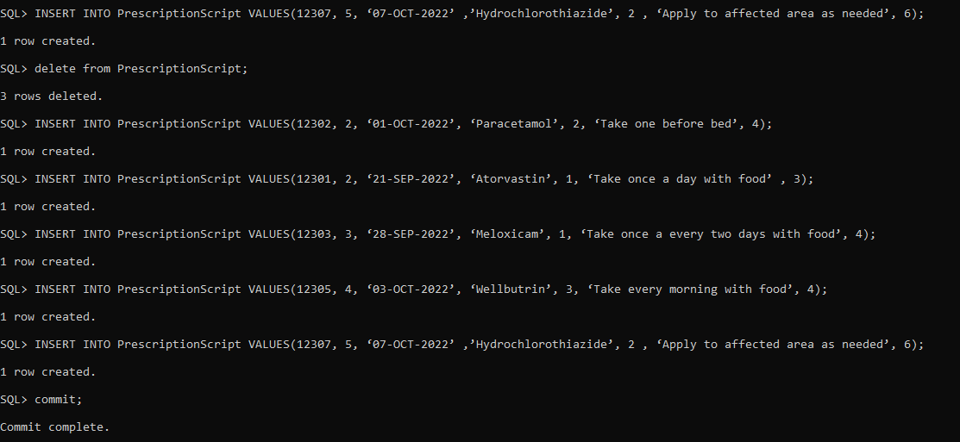

INSERT INTO PrescriptionMedication VALUES(1, 12302, ‘Paracetamol’, ‘02-OCT-2022’, 2, 4, 12.99);

INSERT INTO PrescriptionMedication VALUES(2, 12301, ‘Atorvastatin’, ‘22-SEP-2022’, 1, 3, 25.99);

INSERT INTO PrescriptionMedication VALUES(3, 12303, ‘Meloxicam’, ‘28-SEP-2022’, 1, 4, 10.29);

INSERT INTO PrescriptionMedication VALUES(4, 12305, ‘Wellbutrin’, ‘03-OCT-2022’, 3, 4, 199.99);

INSERT INTO PrescriptionMedication VALUES(5, 12307, ‘Hydrochlorothiazide’, ‘07-OCT-2022’, 2, 6, 15.99);

Commit;

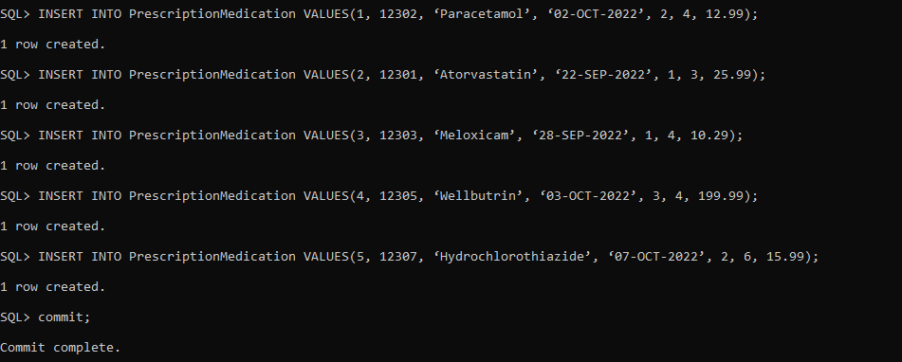

INSERT INTO LabTest VALUES(1, 1, ‘B’, ‘01-OCT-2022’, ‘20:00’, 19.99, ‘Negative’);  
INSERT INTO LabTest VALUES(2, 2, ‘R’, ‘21-SEP-2022’, ‘20:30’, 29.99, ‘Negative’);  
INSERT INTO LabTest VALUES(3, 3, ‘B’, ‘28-SEP-2022’, ‘20:00’, 19.99, ‘Negative’);  
INSERT INTO LabTest VALUES(4, 4, ‘R’, ‘03-OCT-2022’, ‘19:00’, 29.99, ‘Positive’);  
INSERT INTO LabTest VALUES(5, 5, ‘R’, ‘07-OCT-2022’, ‘19:30’, 29.99, ‘Negative’);

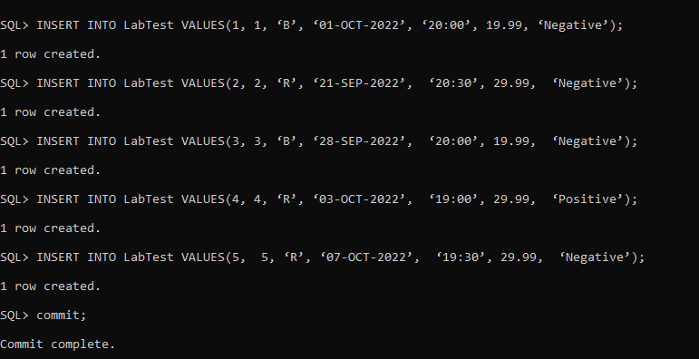

INSERT INTO ProcedurePerformed VALUES (1, ‘29540’, ‘The patient was vaccinated’);

INSERT INTO ProcedurePerformed VALUES (2, ‘59400’, ‘A healthy baby weighing 3.2 kilograms was born ’);

INSERT INTO ProcedurePerformed VALUES (3, ‘99212’, ‘ Visit with consultations happened ’);

INSERT INTO ProcedurePerformed VALUES (4, ‘90688’, ‘The patient limbs were treated.’);

INSERT INTO ProcedurePerformed VALUES (5, ‘99203’, ‘New patient was consulted’);

commit;

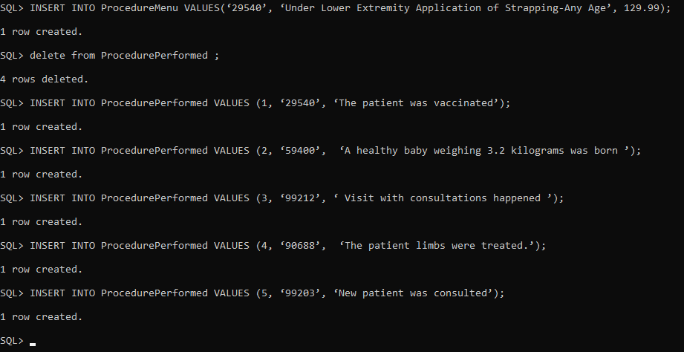

INSERT INTO Diagnosis VALUES(1, ‘A5601F’, ‘07-OCT-2022’, ‘Flu Symptoms occurred’, 2, ‘Vaccinated’);

INSERT INTO Diagnosis VALUES(2, ‘A152B1’, ‘21-SEP-2022’, ‘Childbirth begins’, 5, ‘Recovery’);

INSERT INTO Diagnosis VALUES(3, ‘A253G1’, ‘28-SEP-2022’, ‘Anemia Symptoms’, 7, ‘Under observation’);

INSERT INTO Diagnosis VALUES(4, ‘A0112B’, ‘03-OCT-2022’, ‘Ankle Symptoms ’, 6, ‘Recovery’);

INSERT INTO Diagnosis VALUES(5, ’A15253’, ‘07-OCT-2022’, ‘Injury of the chest’, 9, ‘Dead’);

commit;

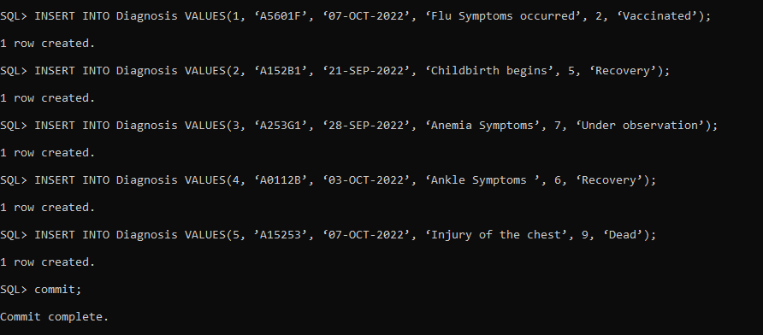

INSERT INTO Availability VALUES(1 ,’05-OCT-2022’, ‘9:00’, ‘17:00’);  
INSERT INTO Availability VALUES(2, ’10-OCT-2022’, ‘9:30’, ‘17:30’);  
INSERT INTO Availability VALUES(3, ’15-OCT-2022’, ‘10:00’, ‘17:45’);  
INSERT INTO Availability VALUES(4, ’20-OCT-2022’, ‘10:30’, ‘18:00’);  
INSERT INTO Availability VALUES(5, ‘25-OCT-2022’, ‘10:45’, ‘18:15’);

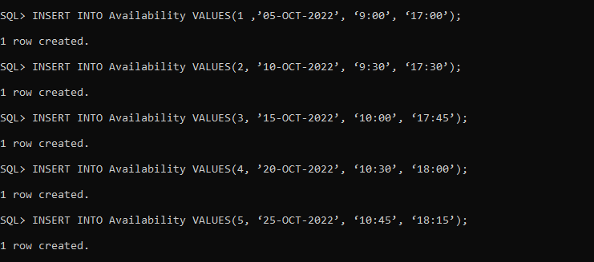

5.6

This SQL query finds the number of visits of the patient, whose names are Daulet Kapezov. There possibly could be several people with that name, but here we have only one.

SELECT p.patientNo, COUNT(v.VisitNo)

FROM Patient p, Visit v

WHERE upper(p.name) = ‘DAULET KAPEZOV’ and upper(p.patientNo) = upper(v.patientNo)

GROUP BY p.patientNo;

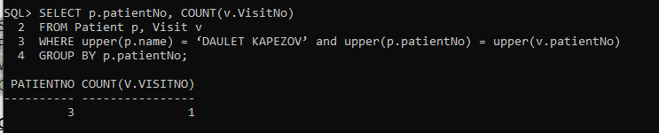

**Carlos’ Part**

This SQL query lists the appointments that Dr. Kevin Malone has conducted.

SELECT s.staffNo, s.name, s.title, a.apptdate

FROM Staff s, Appointment a

WHERE s.staffNo = a.staffNo and upper(s.name) = ‘KEVIN MALONE’;

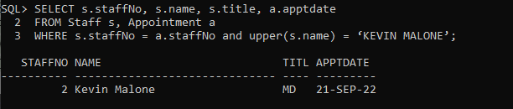

**Filippo’s part:**

This SQL query will show what the X-mount of dollar was for:

SELECT p.name , b.totalAmount, c.amountCharged

FROM Charge c, Bill b , patient p

WHERE b.totalAmount > 1000 and c.amountCharged > 1000 and b.patientNo = p.patientNo and c.invoiceNo = b.invoiceNo;

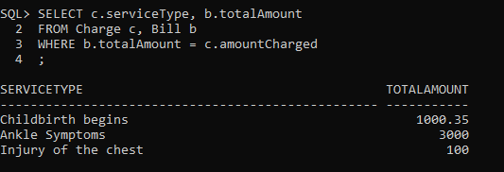

This SQL query will show the totalAmount which is greater than average totalAmount.:

SELECT p.name, b.totalAmount

FROM patient p,

Bill b

WHERE p.patientNo = b.patientNo and b.totalAmount > ( SELECT avg(b.totalAmount)

FROM Bill b);

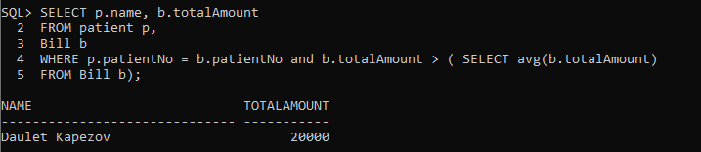

**Christina’s Part:**

This query will show the diagnosis name for each patient’s visit.

SELECT p.Name, dm.diagName

FROM patient p,

visit v,

diagnosis d,

diagnosisMenu dm

WHERE v.visitNo = d.visitNo and p.patientNo = v.patientNo and dm.diagCode = d.diagCode

ORDER BY p.name;

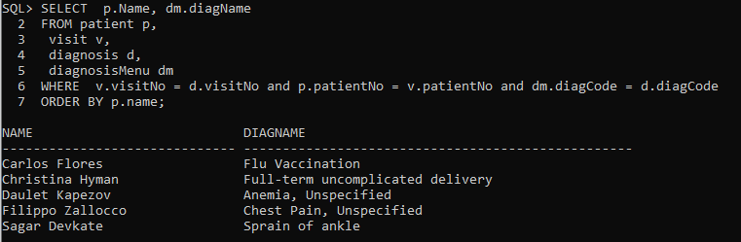

Query will show the avg patients pay for their insurance prescription co-pay

SELECT p.patientNo, p.patient, name,