CREATE TABLE PolicyType (

company VARCHAR2(50) NOT NULL,

policytype CHAR(1) NOT NULL,

medicalCoPay NUMBER(9, 2),

labCoPay NUMBER(9, 2),

pharmacyCoPay NUMBER(9, 2),

CONSTRAINT PolicyType_company_policyType_pk PRIMARY KEY (company, policyType)

);

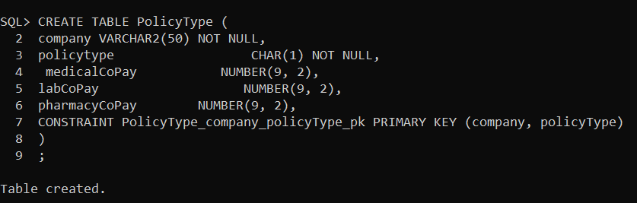

CREATE TABLE InsurancePolicy (

policyNo NUMBER(9) NOT NULL PRIMARY KEY,

company VARCHAR2(30),

policyType CHAR(1),

startDate DATE,

endDate DATE,

CONSTRAINT InsurancePolicy_company_policyType_fk FOREIGN KEY (company, policyType) REFERENCES PolicyType (company, policyType) ON DELETE CASCADE

);

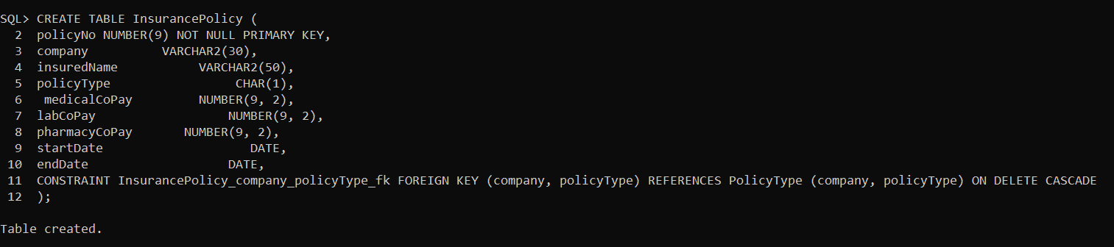

CREATE UNIQUE INDEX InsurancePolicy_company_policyType_i ON InsurancePolicy (company, policyType);



InsurancePolicy ( policyNo, *company*, insuredName, *policytype*, startDate, endingDate)

policyType(company, policytype, medicalCoPay, labCoPay, pharmacyCoPay)

CREATE TABLE Zip (

zipCode CHAR(5) NOT NULL PRIMARY KEY,

city VARCHAR2(20),

state CHAR(2)

);

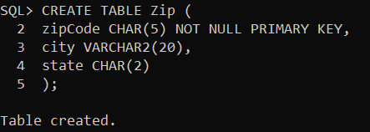

CREATE TABLE Patient (

patientNo NUMBER(9) NOT NULL PRIMARY KEY,

firstName VARCHAR2(30) NOT NULL,

lastName VARCHAR2(30) NOT NULL,

street VARCHAR2(20),

zipCode CHAR(5),

phone CHAR(10),

dateOfBirth DATE,

sex CHAR(1),

policyNo NUMBER(9),

CONSTRAINT Patient_policyNo_fk FOREIGN KEY (policyNo) REFERENCES InsurancePolicy (policyNo) ON DELETE CASCADE,

CONSTRAINT Patient_zipCode_fk FOREIGN KEY (zipCode) REFERENCES Zip (zipCode) ON DELETE CASCADE

);

CREATE UNIQUE INDEX Patient_policyNo_i ON Patient(policyNo);

CREATE UNIQUE INDEX Patient_zipCode_i ON Patient(zipCode);

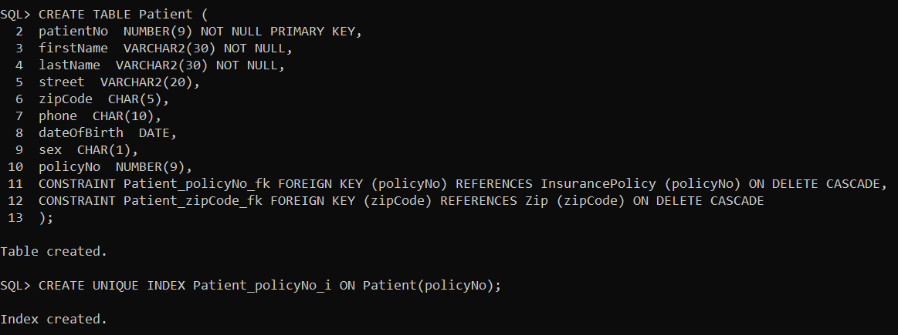

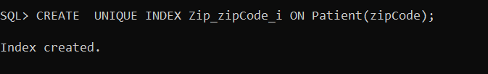

CREATE TABLE Staff(

staffNo NUMBER(9) NOT NULL PRIMARY KEY,

firstName VARCHAR2(30) NOT NULL,

lastName VARCHAR2(30) NOT NULL,

title VARCHAR2(4) NOT NULL,

specialty VARCHAR2(30),

Street VARCHAR2(25),

zipCode CHAR(5),

phone CHAR(10),

CONSTRAINT Staff_zipCode_fk FOREIGN KEY (zipCode) REFERENCES Zip (zipCode) ON DELETE CASCADE

);

CREATE UNIQUE INDEX Staff_zipCode_i ON Staff(zipCode);

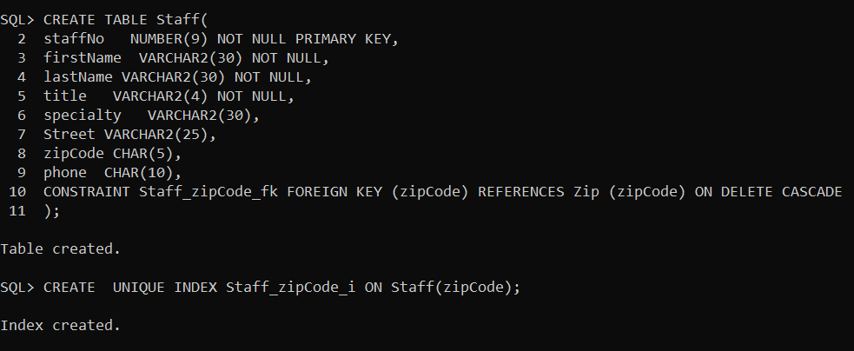

CREATE TABLE Availability(

staffNo NUMBER(9) NOT NULL,

availDate DATE NOT NULL,

startTime    VARCHAR2(8),

endTime      VARCHAR2(8),

CONSTRAINT Availability_staffNo_availDate_pk PRIMARY KEY (staffNo, availDate),

CONSTRAINT Availability_staffNo_fk FOREIGN KEY (staffNo) REFERENCES Staff (staffNo)

);

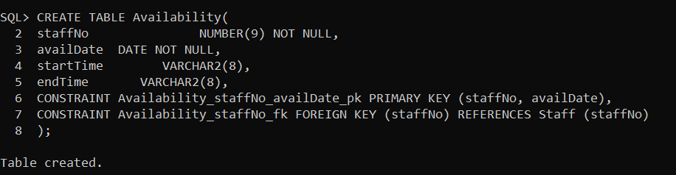

CREATE UNIQUE INDEX Availability_staffNo_i ON Availability(staffNo);

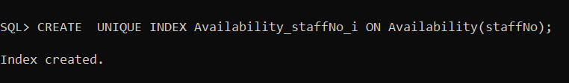

CREATE TABLE Room (

roomNo NUMBER(3) NOT NULL PRIMARY KEY,

roomType CHAR(1),

condition VARCHAR2(50)

);

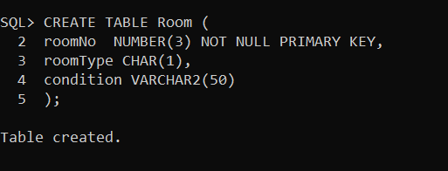

CREATE TABLE visitType(

visitType VARCHAR(30) NOT NULL PRIMARY KEY,

visitCost NUMBER(10,2)

);

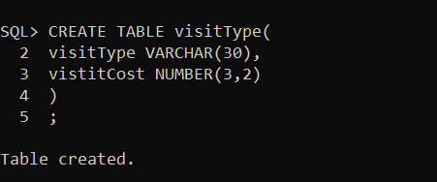

CREATE TABLE Visit(

visitNo NUMBER(9) NOT NULL,

patientNo NUMBER(9) NOT NULL,

visitdate DATE,

visittime VARCHAR2(30),

duration NUMBER(2),

reason VARCHAR2(100),

visitType VARCHAR(30) NOT NULL,

staffNo NUMBER(9) NOT NULL,

roomNo NUMBER(3) NOT NULL,

CONSTRAINT Visit_visitNo_pk PRIMARY KEY (visitNo),

CONSTRAINT Visit_patientNo_fk FOREIGN KEY (patientNo) REFERENCES Patient(patientNo) ON DELETE CASCADE,

CONSTRAINT Visit_roomNo_fk FOREIGN KEY (roomNo) REFERENCES Room(roomNo) ON DELETE CASCADE,

CONSTRAINT Visit_visitType_fk FOREIGN KEY (visitType) REFERENCES visitType(visitType) ON DELETE CASCADE

);

CREATE UNIQUE INDEX Visit_patientNo_i ON Visit(patientNo);

CREATE INDEX Visit_roomNo_i ON Visit(roomNo);

CREATE INDEX Visit_visitType_i ON Visit(visitType);

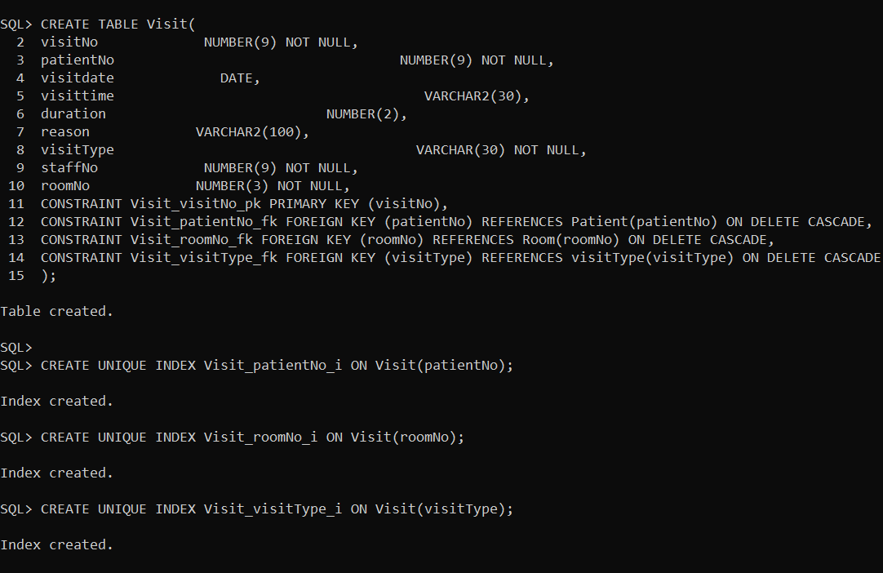

CREATE TABLE Appointment(

patientNo NUMBER(9) NOT NULL,

apptDate DATE NOT NULL,

apptTime VARCHAR(30) NOT NULL,

reason VARCHAR2(50),

staffNo NUMBER(9) NOT NULL,

visitNo NUMBER(9),

CONSTRAINT Appointment_patientNo_apptdate_pk PRIMARY KEY (patientNo, apptdate),

CONSTRAINT Appointment_patientNo_fk FOREIGN KEY (patientNo) REFERENCES Patient(patientNo) ON DELETE CASCADE,

CONSTRAINT Appointment_staffNo_fk FOREIGN KEY (staffNo) REFERENCES Staff(staffNo) ON DELETE CASCADE,

CONSTRAINT Appointment_visitNo_fk FOREIGN KEY (visitNo) REFERENCES Visit(visitNo) ON DELETE CASCADE

);

CREATE INDEX Appointment_patientNo_i ON Appointment(patientNo);

CREATE INDEX Appointment_staffNo_i ON Appointment(staffNo);

CREATE UNIQUE INDEX Appointment_visitNo_i ON Appointment(visitNo);

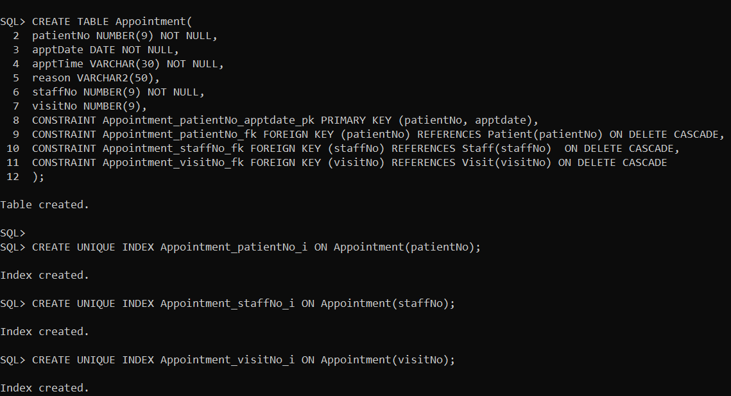

CREATE TABLE Referral (

refNo NUMBER(6) NOT NULL PRIMARY KEY,

visitNo NUMBER(6) NOT NULL,

refTo VARCHAR2(30),

Reason VARCHAR2(50),

CONSTRAINT Referral_visitNo_fk FOREIGN KEY (visitNo) REFERENCES Visit(visitNo) ON DELETE CASCADE

);

CREATE UNIQUE INDEX Referral_visitNo_i ON Referral(visitNo);

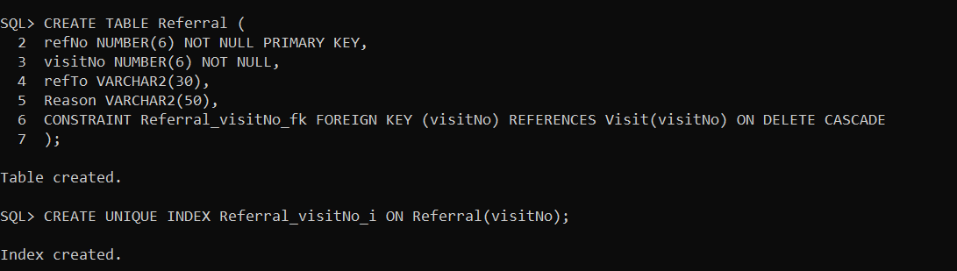

CREATE TABLE Bill (

invoiceNo NUMBER(9) NOT NULL PRIMARY KEY,

billDate DATE ,

totalAmount NUMBER(9, 2),

dueDate DATE,

patientNo NUMBER(9) NOT NULL,

CONSTRAINT Bill_patientNo_fk FOREIGN KEY (patientNo) REFERENCES Patient(patientNo) ON DELETE CASCADE

);

CREATE INDEX Bill_patientNo_i ON Bill(patientNo);

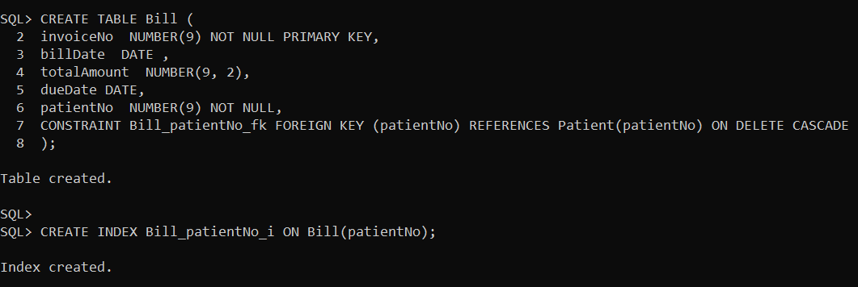

CREATE TABLE Charge(

invoiceNo NUMBER(9) NOT NULL,

serviceType VARCHAR2(75) NOT NULL,

serviceDate DATE NOT NULL,

amountCharged NUMBER(3,2),

CONSTRAINT Charge_invoice_serviceType_serviceDate_pk PRIMARY KEY (invoiceNo, serviceType, serviceDate)

);

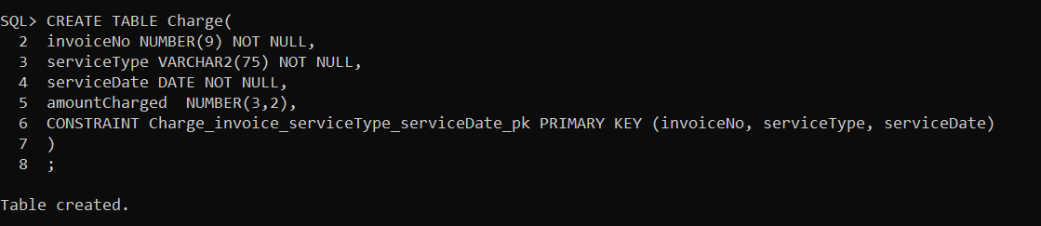  
  
  
CREATE TABLE Payment (

invoiceNo NUMBER(9) NOT NULL,  
datePaid DATE NOT NULL,   
amountPaid NUMBER(9,2),  
policyNo NUMBER(9),

CONSTRAINT Payment_invoiceNo_date_pk PRIMARY KEY(invoiceNo, datePaid),

CONSTRAINT Payment_invoiceNo_fk FOREIGN KEY(invoiceNo) REFERENCES Bill(invoiceNo),

CONSTRAINT Payment_insCo_polNo_fk FOREIGN KEY(policyNo) REFERENCES InsurancePolicy(policyNo)

);

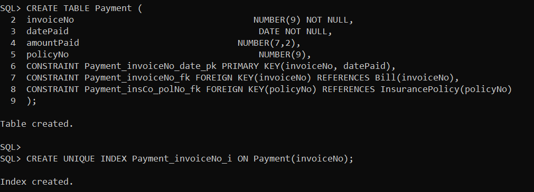

CREATE UNIQUE INDEX Payment_invoiceNo_i ON Payment(invoiceNo);

CREATE UNIQUE INDEX Payment_policyNo_i ON Payment(policyNo);

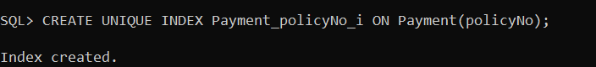

CREATE TABLE Drug(

drugDispensed VARCHAR2(30) Primary Key NOT NULL,

cost NUMBER(9,2)

);

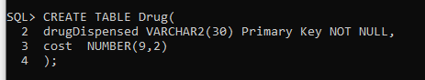

CREATE TABLE TestType(

testType CHAR(1) NOT NULL PRIMARY KEY,

Cost NUMBER(10,2)

);

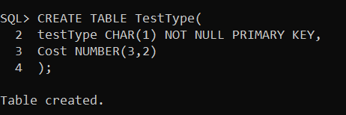

CREATE TABLE DiagnosisMenu (

diagCode CHAR(6),

diagName VARCHAR2(50),

CONSTRAINT DiagnosisMenu_diagCode_pk PRIMARY KEY (diagCode));

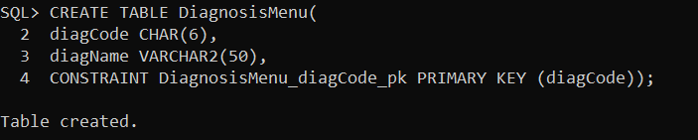

CREATE TABLE ProcedureMenu (

procCode CHAR(6) NOT NULL,

procName VARCHAR2(50),

cost NUMBER(10,2),

CONSTRAINT ProcedureMenu_procCode_pk PRIMARY KEY (procCode));

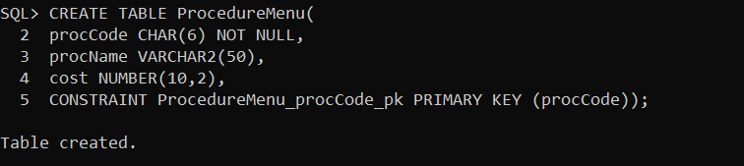

CREATE TABLE PrescriptionScript (

scriptNo NUMBER(9),

visitNo NUMBER(9),

dateWritten DATE,

Directions VARCHAR(50),

CONSTRAINT PrescriptionScript_scriptNo_pk PRIMARY KEY (scriptNo),

CONSTRAINT PrescriptionScript_visittNo_fk FOREIGN KEY (visitNo) REFERENCES Visit(visitNo)

);

CREATE INDEX PrescriptionScript_visitNo_i ON PrescriptionScript(visitNo);

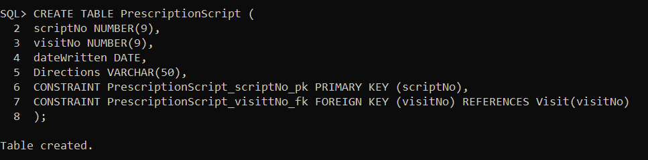

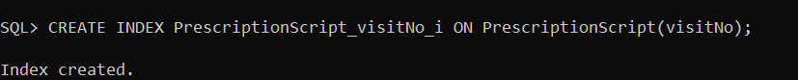

CREATE TABLE PrescriptionMedication (

RXNumber NUMBER(9) NOT NULL PRIMARY KEY,

scriptNo NUMBER(9),

drugDispensed VARCHAR2(30),

dateDnispensed DATE,

quantityPrescribed NUMBER(3),

quantityDispensed NUMBER(3),

refillsRemaining NUMBER(2),

CONSTRAINT PrescriptionMedication_scriptNo_fk FOREIGN KEY (scriptNo) REFERENCES PrescriptionScript(scriptNo)

);

CREATE INDEX PrescriptionMedication_scriptNo_i ON PrescriptionMedication(scriptNo);

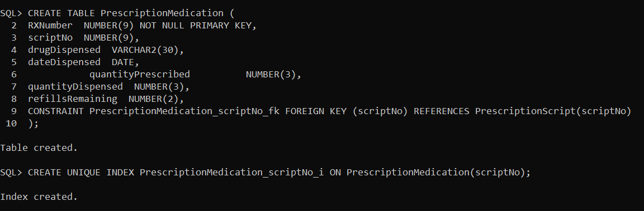

CREATE TABLE LabTest (

testNo NUMBER(9) NOT NULL,

RXNumber NUMBER(9) NOT NULL,

testType CHAR(1),

testDate DATE,

testTime VARCHAR2(30),

cost NUMBER(9,2),

result VARCHAR2(30),

CONSTRAINT LabTest_testNo_pk PRIMARY KEY (testNo),

CONSTRAINT LabTest_RXNumber_fk FOREIGN KEY (RXNumber) REFERENCES PrescriptionMedication(RXNumber) ON DELETE CASCADE,

CONSTRAINT LabTest_TestType_fk FOREIGN KEY (TestType) REFERENCES TestType(TestType) ON DELETE CASCADE

);

CREATE UNIQUE INDEX LabTest_RXNumber_i ON LabTest (RXNumber);

CREATE UNIQUE INDEX LabTest_testType_i ON LabTest (testType);

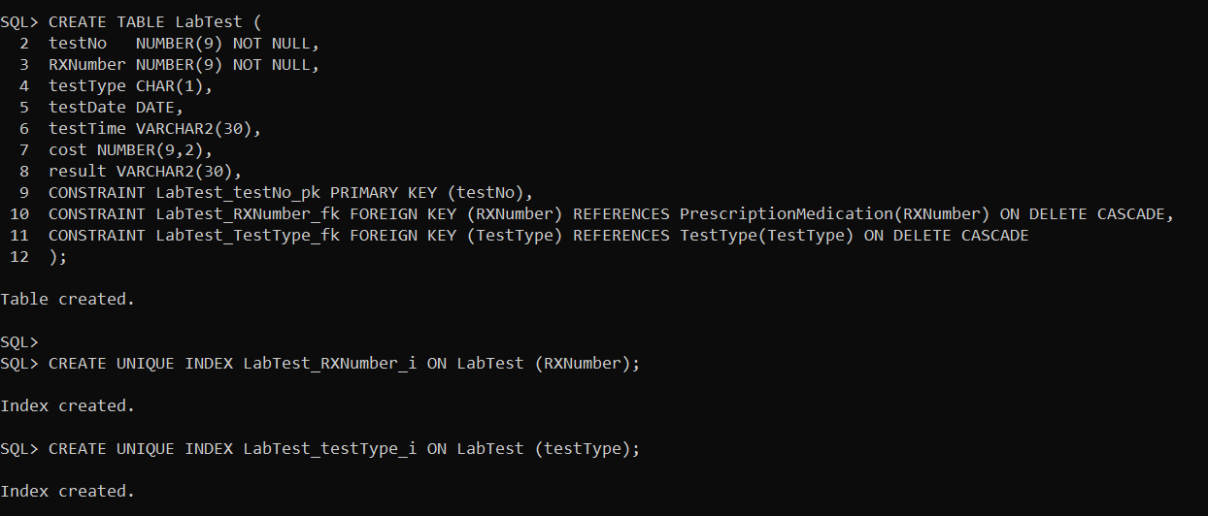

CREATE TABLE ProcedurePerformed (

visitNo NUMBER(6) NOT NULL,

procCode CHAR(6) NOT NULL,

result VARCHAR2(50),

CONSTRAINT ProcedurePerformed_visitNo_procCode_pk PRIMARY KEY (visitNo, procCode),

CONSTRAINT ProcedurePerformed_visitNo_fk FOREIGN KEY(visitNo) REFERENCES Visit(visitNo),

CONSTRAINT ProcedurePerformed_procCode_fk FOREIGN KEY(procCode) REFERENCES ProcedureMenu(procCode));

CREATE INDEX ProcedurePerformed_procCode_i ON ProcedurePerformed(procCode);

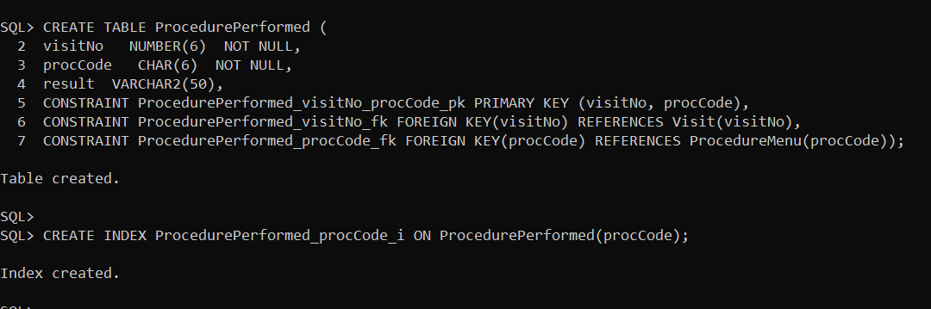

CREATE TABLE Diagnosis (

visitNo NUMBER(6) NOT NULL,

diagCode CHAR(6) NOT NULL,

dateOnset DATE,

symptoms VARCHAR2(50),

Severity NUMBER(2),

Prognosis VARCHAR(50),

CONSTRAINT Diagnosis_visitNo_diagCode_pk PRIMARY KEY(visitNo, diagCode),

CONSTRAINT Diagnosis_visitNo_fk FOREIGN KEY (visitNo) REFERENCES Visit (visitNo),

CONSTRAINT Diagnosis_diagCode_fk FOREIGN KEY (diagCode) REFERENCES DiagnosisMenu (diagCode));

CREATE UNIQUE INDEX Diagnosis_visitNo_i ON Diagnosis (visitNo);

CREATE UNIQUE INDEX Diagnosis_diagCode_i ON Diagnosis (diagCode);

