INSERT INTO PolicyType VALUES(‘Allstate’, ‘P’, 2340.90, 970.00, 500.00);

INSERT INTO PolicyType VALUES(‘Geico’, ‘P’, 3400.90, 790.00, 90.00);

INSERT INTO PolicyType VALUES(‘AIG’, ‘P’, 8760.00, 670.00, 100.00);

INSERT INTO PolicyType VALUES(‘NewYorkState’, ‘S’, 4012.09, 507.00, 225.00);

INSERT INTO PolicyType VALUES(‘StateOfMassachusetts’, ‘S’, 13402.91, 969.00, 130.00);

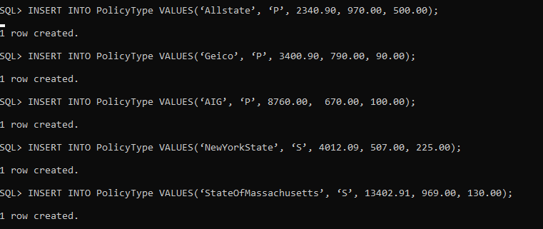

INSERT INTO InsurancePolicy VALUES(500000123, ‘Allstate’, ‘P’, ‘10-OCT-2022’, ‘09-OCT-2023’);

INSERT INTO InsurancePolicy VALUES(600000124, ‘Geico’, ‘P’, ‘11-NOV-2022’, ‘10-NOV-2023’);

INSERT INTO InsurancePolicy VALUES(700000125, ‘AIG’, ‘P’, ‘12-JAN-2022’, ‘11-JAN-2023’);

INSERT INTO InsurancePolicy VALUES(800000126, ‘NewYorkState’, ‘S’, ‘07-JUN-2022’, ‘06-JUN-2023’);

INSERT INTO InsurancePolicy VALUES(900000127, ‘StateOfMassachusetts’, ‘S’, ‘05-MAY-2022’, ‘04-MAY-2023’);

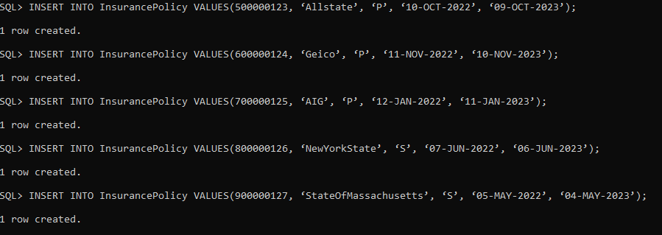

INSERT INTO Zip VALUES(10010, ‘NewYorkCity’, ‘NY’);

INSERT INTO Zip VALUES(10312, ‘NewYorkCity’, ‘NY’);

INSERT INTO Zip VALUES(10401, ‘NewYorkCity’, ‘NY’);

INSERT INTO Zip VALUES(10532, ‘NewYorkCity’, ‘NY’);

INSERT INTO Zip VALUES(10623, ‘NewYorkCity’, ‘NY’);

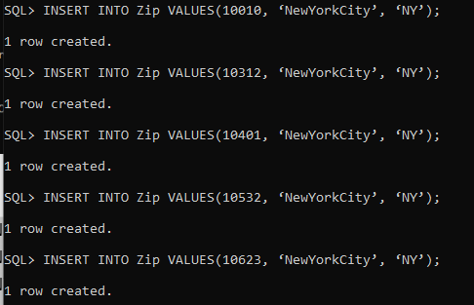

INSERT INTO Patient VALUES(789001, ‘Mitch’, ‘Chin’, ‘Bradford Road’, 10312, 678456098, ‘13-MAR-1993’, ‘M’, 600000124);

INSERT INTO Patient VALUES(789002, ‘Rossella’, ‘Ahmad’, ‘Ross Stress’, 10010, 3749754273, ‘12-FEB-1992’, ‘F’, 500000123);

INSERT INTO Patient VALUES(789003, ‘Karla’, ‘Rapezvkov’, ‘JFK Avenue’, 10401, 234546586, ‘14-MAR-1994’, ‘F’, 700000125);

INSERT INTO Patient VALUES(789004, ‘Joseph’, ‘Shoellerman’, ‘Vincelly Street’, 10532, 321345231, ‘15-APR-1995’, ‘M’, 800000126);

INSERT INTO Patient VALUES(789005, ‘Jesus’, ‘Muñoz’, ‘Wall Street’, 10623, 687904321, ‘16-MAY-1997’, ‘M’, 900000127);

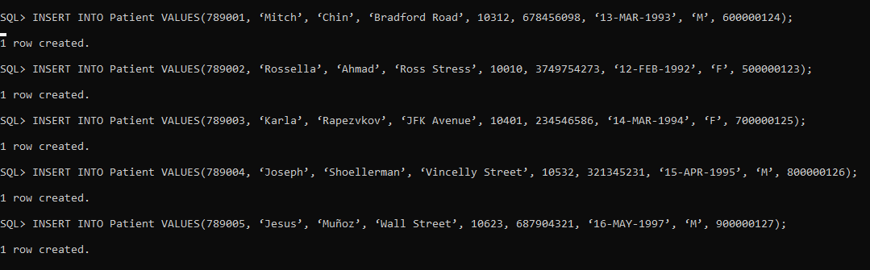

INSERT INTO Staff Values(100679, ‘Marla’, ‘Smith’, ‘CNM’, ‘Midwife’, ‘01 Broadway’, 10010, 890765342);

INSERT INTO Staff Values(100680, ‘Michael’, ‘Ross’, ‘Mr.’, ‘Receptionist’, ‘215 8th Ave’, 10312, 654987123);

INSERT INTO Staff Values(100681, ‘Abdhul’, ‘Sagar’, ‘MD’, ‘Surgeon’, ‘12 Allen St’, 10401, 687321456);

INSERT INTO Staff Values(100682, ‘Homer’, ‘Hardwood’, ‘MD’, ‘Physician’,’17 William Street’ ,10532, 098567432);

INSERT INTO Staff Values(100683, ‘Donna’, ‘Paulsen’, ‘RN’, ‘Registered Nurse’, ‘1 Pace Plaza’ ,10623, 798567345);

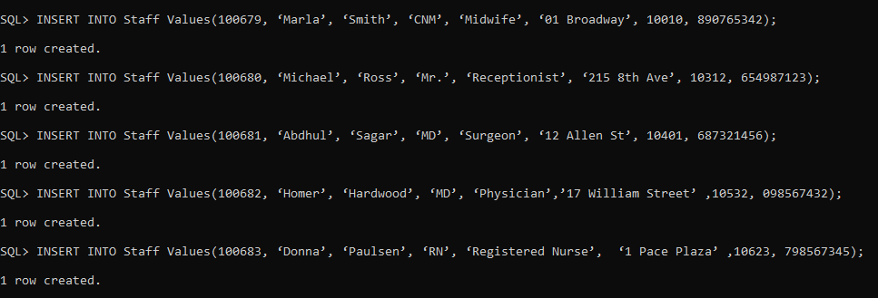

INSERT INTO Availability VALUES(100679, ‘16-NOV-2022’, ‘10:00’, ‘15:00’);

INSERT INTO Availability VALUES(100680, ‘15-NOV-2022’, ‘09:00’, ‘17:00’);

INSERT INTO Availability VALUES(100681, ‘20-NOV-2022’, ‘12:00’, ‘18:00’);

INSERT INTO Availability VALUES(100682, ‘18-NOV-2022’, ‘15:00’, ‘18:00’);

INSERT INTO Availability VALUES(100683, ‘17-NOV-2022’, ‘09:00’, ‘16:00’);

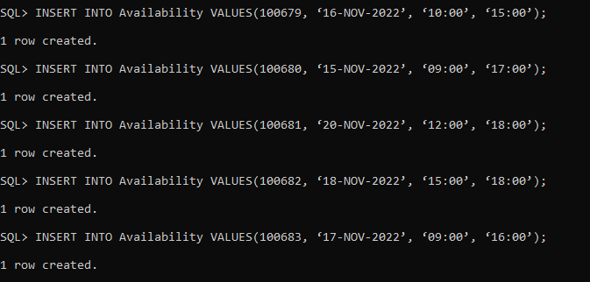

INSERT INTO Room VALUES(101, ‘R’ , ‘Acceptable’);  
INSERT INTO Room VALUES(102, ‘R’, ‘Not enough beds’);

INSERT INTO Room VALUES(103, ‘O’, ‘Acceptable’);  
INSERT INTO Room VALUES(104, ‘D’, ‘Not enough beds’);  
INSERT INTO Room VALUES(105, ‘R’, ‘Acceptable’);

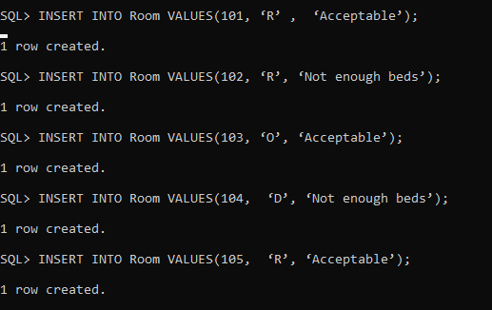

INSERT INTO VisitType VALUES(‘New Patient’, 300.00);

INSERT INTO VisitType VALUES(‘Follow-Up’, 250.00);

INSERT INTO VisitType VALUES(‘Walk-in/Same day’, 300.00);

INSERT INTO VisitType VALUES(‘Urgent’, 350.00);

INSERT INTO VisitType VALUES(‘Bloodwork/Vaccination’, 175.00);

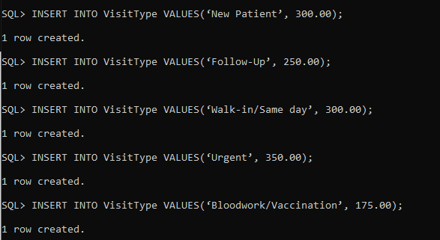

INSERT INTO Visit VALUES(1, 789001, ‘07-OCT-2022’, ‘13:15’, 15, ‘Flu symptoms’, ‘Walk-in/Same day’, 100682, 101);

INSERT INTO Visit VALUES(2, 789002, ‘21-SEP-2022’, ‘15:00’, 60, ‘Childbirth’, ‘Urgent’, 100679, 103);

INSERT INTO Visit VALUES(3, 789003, ‘28-SEP-2022’, ‘12:30’, 30, ‘Low energy levels’, ‘Bloodwork/Vaccination’, 100683, 103);

INSERT INTO Visit VALUES(4, 789004, ‘03-OCT-2022’, ‘16:45’, 15, ‘Injury to ankle’, ‘Walk-in/Same day’, 100682, 105);

INSERT INTO Visit VALUES(5, 789005, ‘07-OCT-2022’, ‘09:45’, 30, ‘Chest pain’, ‘New Patient’, 100682, 105);

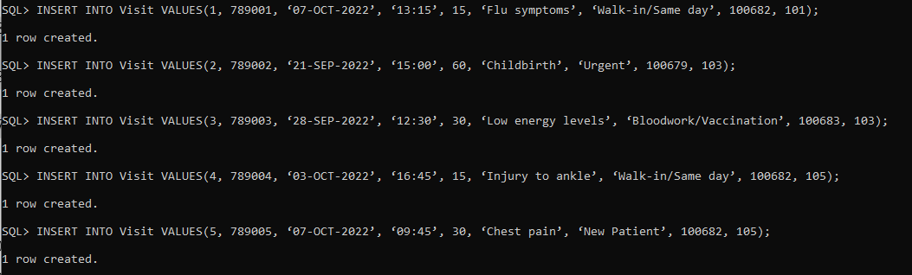

INSERT INTO Appointment VALUES(789001, ‘07-OCT-2022’, ‘13:15’, ‘Flu Shot’, 100682, 1);

INSERT INTO Appointment VALUES(789002, ‘21-SEP-2022’, ‘15:00’, ‘Childbirth’, 100679, 2);

INSERT INTO Appointment VALUES(789003, ‘28-SEP-2022’, ‘12:30’, ‘Anemia’, 100683, 3);

INSERT INTO Appointment VALUES(789004, ‘03-OCT-2022’, ‘16:45’, ‘Ankle Pain’, 100682, 4);

INSERT INTO Appointment VALUES(789005, ‘07-OCT-2022’, ‘09:45’, ‘Chest Discomfort’, 100682, 5);

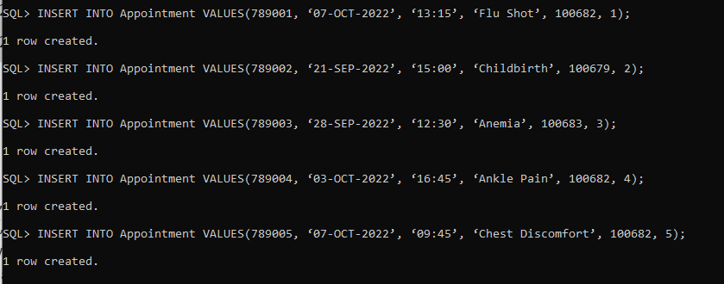

INSERT INTO Referral VALUES(135791, 1 , ‘Marla Smith’, ‘Flu symptoms’);

INSERT INTO Referral VALUES(135792, 2, ‘Micheal Ross’, ‘Childbirth’);

INSERT INTO Referral VALUES(135793, 3, ‘Sagar Abdhul’, ‘Low energy levels’);

INSERT INTO Referral VALUES(135794, 4, ‘Homer Hardwood’, ‘Injury to ankle’);

INSERT INTO Referral VALUES(135795, 5, ‘Paulsen Donna’, ‘Chest Pain’);

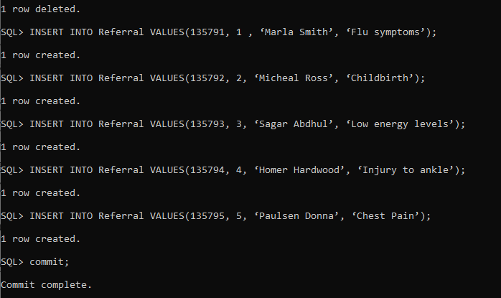

INSERT INTO Bill VALUES(111222333, ‘07-OCT-2022’, 250.00, ‘07-NOV-2022’, 789001);

INSERT INTO Bill VALUES(234567433, ‘21-SEP-2022’, 300.00, ‘21-OCT-2022’, 789002 );

INSERT INTO Bill VALUES(322546677, ‘28-SEP-2022’, 350.00, ‘28-OCT-2022’, 789003);

INSERT INTO Bill VALUES(789532345, ‘03-OCT-2022’, 175.00, ‘03-NOV-2022’, 789004);

INSERT INTO Bill VALUES(323412387, ‘07-OCT-2022’, 300.00, ‘07-NOV-2022’, 789005);

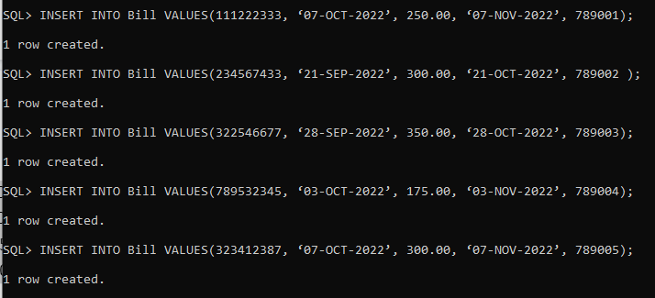

INSERT INTO Charge VALUES(111222333, ‘Routine’, ‘07-OCT-2022’, 69.99 );

INSERT INTO Charge VALUES(234567433, ‘Operation’, ‘21-SEP-2022’, 59.99)

INSERT INTO Charge VALUES(322546677, ‘Routine’, ‘28-SEP-2022’, 89.99);

INSERT INTO Charge VALUES(789532345, ‘Operation’, ‘03-OCT-2022’, 99.99);

INSERT INTO Charge VALUES(323412387, ‘Testing’, ‘07-OCT-2022’, 69.99);

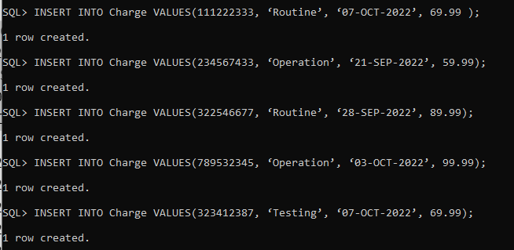

INSERT INTO Payment VALUES(111222333, ‘07-OCT-2022’, 69.99, 500000123);

INSERT INTO Payment VALUES(234567433, ‘15-OCT-2022’, 59.99, 600000124);

INSERT INTO Payment VALUES(322546677, ‘31-OCT-2022’, 89.99, 700000125);

INSERT INTO Payment VALUES(789532345, ‘21-OCT-2022’, 99.99, 800000126);

INSERT INTO Payment VALUES(323412387, ‘05-OCT-2022’, 69.99, 900000127);

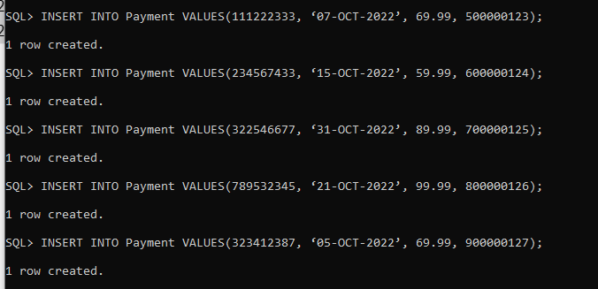

INSERT INTO Drug VALUES(‘Stanozolol’, 99.99);

INSERT INTO Drug VALUES(‘Methandienone’, 119.99);

INSERT INTO Drug VALUES(‘Trenbolone Acetate’, 149.99);

INSERT INTO Drug VALUES(‘Oxandrolone’, 99.99);

INSERT INTO Drug VALUES(‘Fluoxymesterone’, 129.99);

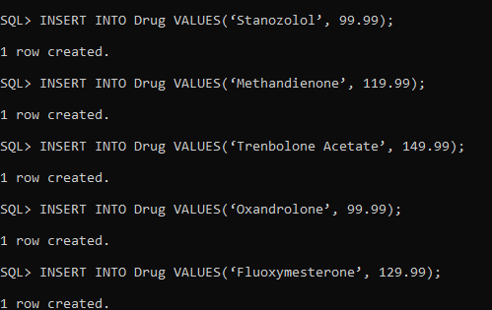

INSERT INTO TestType VALUES(‘A’, 29.99);

INSERT INTO TestType VALUES(‘B’, 27.99);

INSERT INTO TestType VALUES(‘C’, 25.99);

INSERT INTO TestType VALUES(‘D’, 99.99);

INSERT INTO TestType VALUES(‘E’, 19/99);

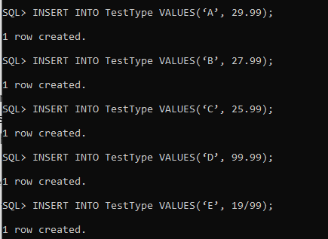

INSERT INTO DiagnosisMenu VALUES(‘A0112B’, ‘Septicemia’);

INSERT INTO DiagnosisMenu VALUES(‘A152B1’, ‘Depressive disorders’);

INSERT INTO DiagnosisMenu VALUES(’A15253’, ‘Schizophrenia spectrum’);

INSERT INTO DiagnosisMenu VALUES(‘A5601F’, ‘Diabetes mellitus with complication’);

INSERT INTO DiagnosisMenu VALUES(‘A253G1’, ‘Alcohol-related disorders’);

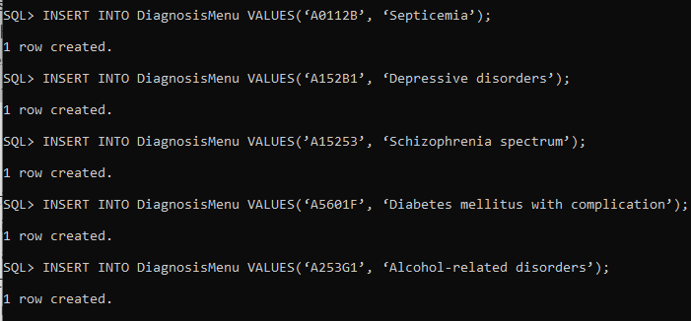

INSERT INTO ProcedureMenu VALUES(‘29540’, ‘Antibiotics’, 129.99);

INSERT INTO ProcedureMenu VALUES(‘59400’, ‘Depression Therapy’, 130.24);

INSERT INTO ProcedureMenu VALUES(‘99212’, ‘Individual therapy. Psychotherapy.’, 249.99);

INSERT INTO ProcedureMenu VALUES(‘90688’, ‘Medication for diabet’, 69.99);

INSERT INTO ProcedureMenu VALUES(‘99203’, ‘Behavioral treatment’, 349.99);

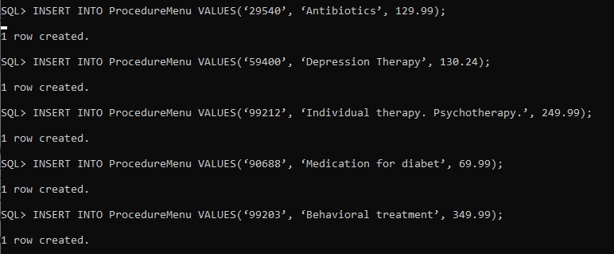

INSERT INTO PrescriptionScript VALUES(1, 1, ‘07-OCT-2022’, ‘Take two before bed’);  
INSERT INTO PrescriptionScript VALUES(2, 2, ‘27-NOV-2022’, ‘Take once after food’ );

INSERT INTO PrescriptionScript VALUES(3, 3, ‘25-SEP-2022’, ‘Twice a day’);  
INSERT INTO PrescriptionScript VALUES(4, 4, ‘05-OCT-2022’, ‘Once a week’);  
INSERT INTO PrescriptionScript VALUES(5, 5, ‘09-OCT-2022’ , ‘Take four every hour’);

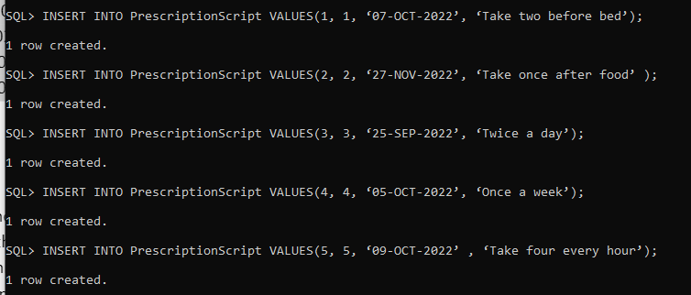

INSERT INTO PrescriptionMedication VALUES(1, 1, ‘Stanozolol’, ‘08-OCT-2022’, 2, 4, 2);

INSERT INTO PrescriptionMedication VALUES(2, 2, ‘Methandienone’, ‘28-NOV-2022’, 1, 3,2);

INSERT INTO PrescriptionMedication VALUES(3, 3, ‘Trenbolone Acetate’, ‘26-SEP-2022’, 1, 4, 3);

INSERT INTO PrescriptionMedication VALUES(4, 4, ‘Oxandrolone’, ‘06-OCT-2022’, 3, 4, 1);

INSERT INTO PrescriptionMedication VALUES(5, 5, ‘Fluoxymesterone’, ‘10-OCT-2022’, 2, 6, 4);

INSERT INTO PrescriptionMedication VALUES(6, 1, ‘Stanozolol’, ‘08-OCT-2022’, 4, 6, null);

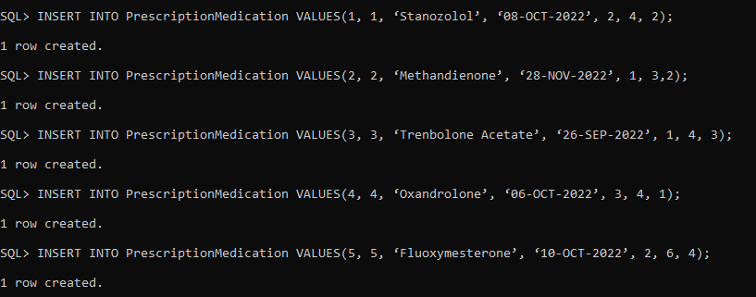

INSERT INTO LabTest VALUES(5, 1, ‘A’, ‘11-SEP-2022’, ‘15:00’, 18.99, ‘Positive’);

INSERT INTO LabTest VALUES(4, 2, ‘B’, ‘25-OCT-2022’, ‘14:30’, 28.99, ‘Positive’);

INSERT INTO LabTest VALUES(3, 3, ‘C’, ‘2-OCT-2022’, ‘12:00’, 18.99, ‘Positive’);

INSERT INTO LabTest VALUES(2, 4, ‘D’, ‘13-SEP-2022’, ‘13:00’, 25.99, ‘Negative’);

INSERT INTO LabTest VALUES(1, 5, ‘E’, ‘17-SEP-2022’, ‘11:30’, 30.99, ‘Positive’);

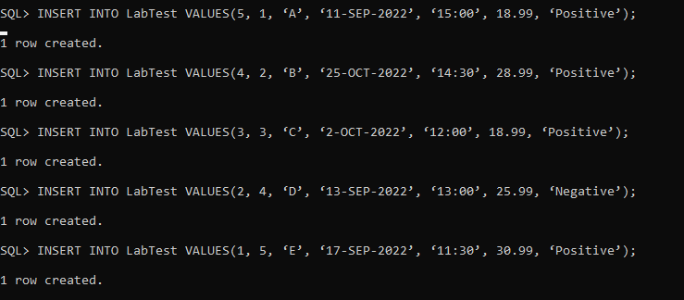

INSERT INTO ProcedurePerformed VALUES(1,‘29540’,’Positive’);

INSERT INTO ProcedurePerformed VALUES(2,‘59400’, ‘Positive’);

INSERT INTO ProcedurePerformed VALUES(3,‘99212’, ‘Positive’);

INSERT INTO ProcedurePerformed VALUES(4,‘90688’, ‘Negative’);

INSERT INTO ProcedurePerformed VALUES(5,‘99203’, ‘Positive’);

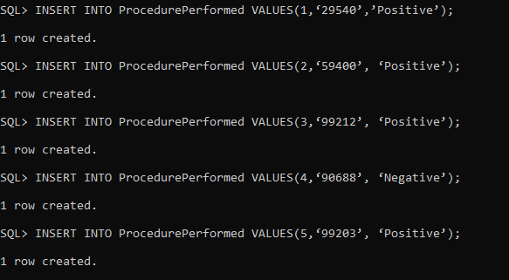

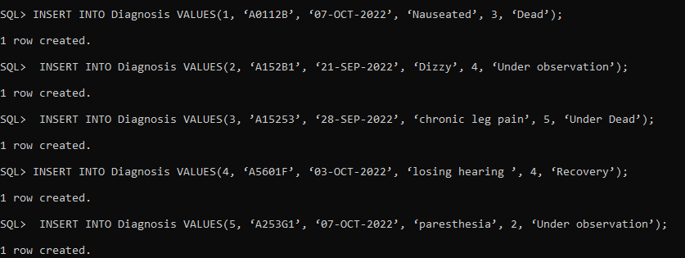

INSERT INTO Diagnosis VALUES(1, ‘A0112B’, ‘07-OCT-2022’, ‘Nauseated’, 3, ‘Dead’);  
 INSERT INTO Diagnosis VALUES(2, ‘A152B1’, ‘21-SEP-2022’, ‘Dizzy’, 4, ‘Under observation’);  
 INSERT INTO Diagnosis VALUES(3, ’A15253’, ‘28-SEP-2022’, ‘chronic leg pain’, 5, ‘Under Dead’);   
INSERT INTO Diagnosis VALUES(4, ‘A5601F’, ‘03-OCT-2022’, ‘losing hearing ’, 4, ‘Recovery’);

INSERT INTO Diagnosis VALUES(5, ‘A253G1’, ‘07-OCT-2022’, ‘paresthesia’, 2, ‘Under observation’);