This statement shows the number of drugs required to every patient.

SELECT p.firstName, p.lastName, COUNT(RXNumber) as Drugs

FROM PrescriptionMedication m, PrescriptionScript s, Visit v, Patient p

WHERE v.patientNo = p.patientNo and s.visitNo = v.visitNo and s.scriptNo = m.scriptNo

GROUP BY p.firstName, p.lastName;

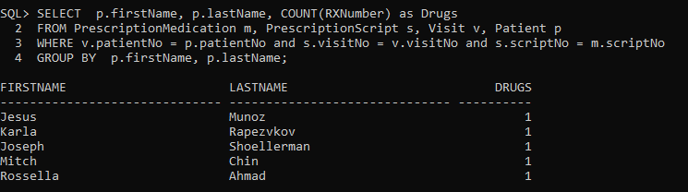

This statement will be used to find the quantity of drugs that are being dispensed by type.

SELECT m.drugDispensed, SUM(m.quantityDispensed)

FROM PrescriptionMedication m

GROUP BY drugDispensed

ORDER BY drugDispensed desc;

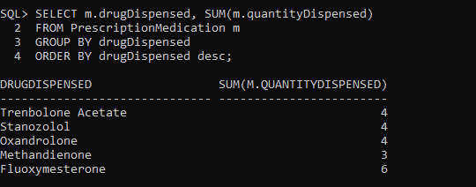

This statement will be used to show the different policy type payouts per insurance policy

SELECT i.company ,p.medicalCoPay, p.labCoPay, p.pharmacyCoPay

FROM PolicyType p, InsurancePolicy i

WHERE p.policytype=i.policytype ORDER BY p.company;

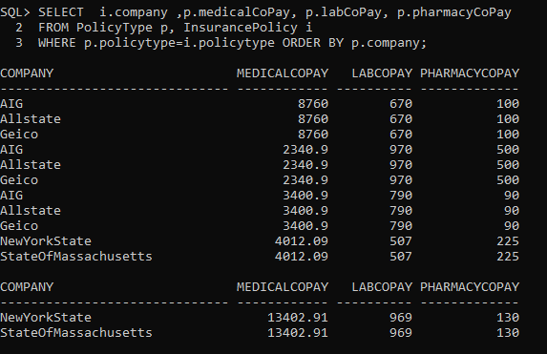

This statement will select patients who had visits on October 7th 2022 and the reason for the visit.

SELECT p.firstName, p.lastName, v.visitdate, v.reason

FROM Patient p,

Visit v

WHERE p.patientNo = v.patientNo and v.visitDate = ‘07-OCT-2022’

ORDER BY p.lastName;

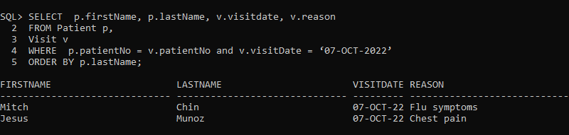

This statement will be used to show the diagnosis per Labtest

SELECT d.diagCode, d.symptoms, d.severity, d.prognosis, l.testNo, l.testType

FROM Diagnosis d, LabTest l

WHERE symptoms = ‘Dizzy ’

