**Step 6.8 - Create one trigger for The Art Gallery database.**

CREATE OR REPLACE TRIGGER refilRemainingCount

BEFORE INSERT OR UPDATE ON PrescriptionMedication

REFERENCING NEW AS NEW OLD AS OLD

FOR EACH ROW

BEGIN

:NEW.refillsRemaining := :NEW.quantityPrescribed - :NEW.quantityDispensed;

END;

/

Trigger created.

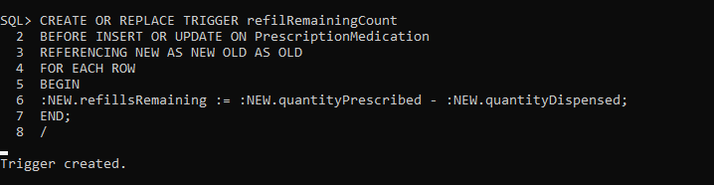

We insert a new value to check whether the trigger works or not. As we can see here, the value of refillsRemaining changed using quantityPrescribed and quantityDispensed to calculate it.

