* Receptionists or office admin can be the user we use; they have access to patient and doctor information.
  + DB privileges of receptionist/office admin:
* The other four users can be a practitioner, nurse, labtech, and pharmacist
  + Privileges:

8.1

CREATE VIEW PatientView1 AS

SELECT patientNo, firstName, lastName, phone, dateOfBirth, sex, policyNo

FROM Patient;

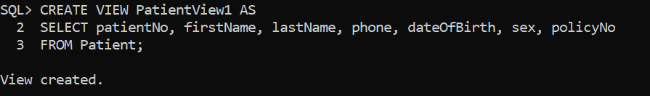

CREATE VIEW FindPhysicianView1 AS

SELECT staffNo, firstName, lastName, title , specialty , phone

FROM Staff

WHERE specialty= ‘physician’;

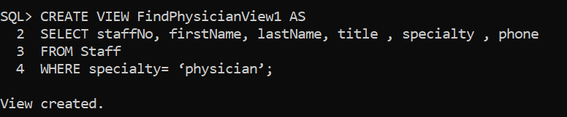

8.2

CREATE USER RECEPTIONIST1 IDENTIFIED BY 123;

GRANT CREATE SESSION to RECEPTIONIST1;

GRANT SELECT ON PatientView1 TO RECEPTIONIST1 ;

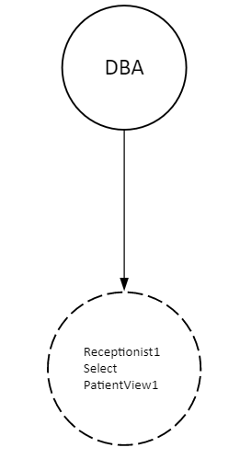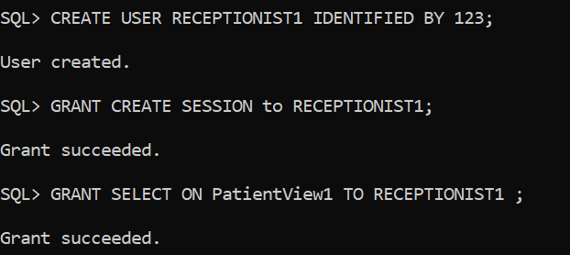

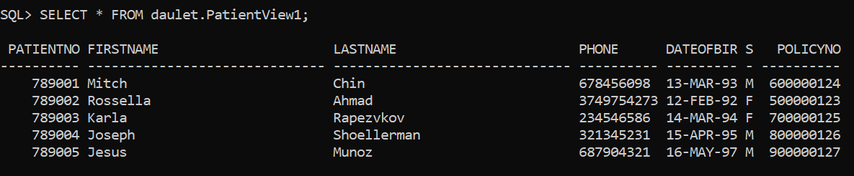

8.3.

CREATE USER PHYSICIAN1 IDENTIFIED BY 985;

GRANT CREATE SESSION to PHYSICIAN1 ;

GRANT CONNECT TO PHYSICIAN1;

GRANT SELECT ON Diagnosis to PHYSICIAN1 WITH GRANT OPTION;

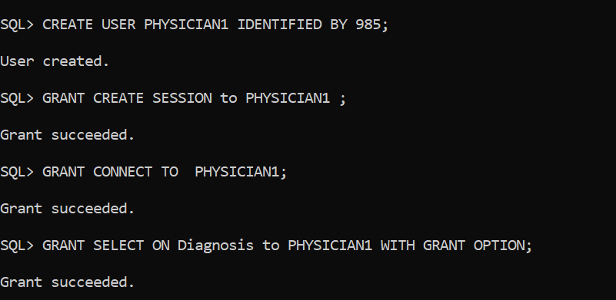

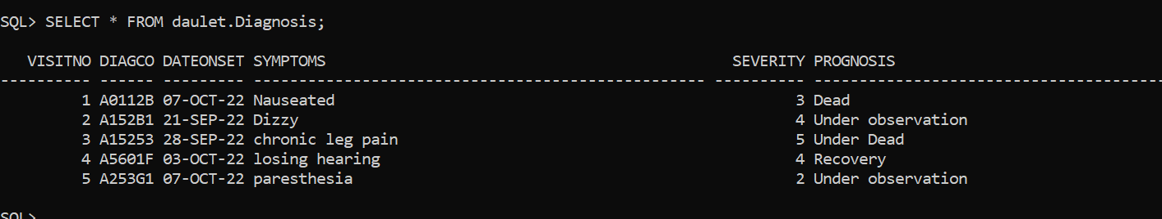

CREATE USER PHARMACIST1 IDENTIFIED BY 365;

GRANT CREATE SESSION to PHARMACIST1 ;

GRANT INSERT ON PrescriptionMedication TO PHARMACIST1;

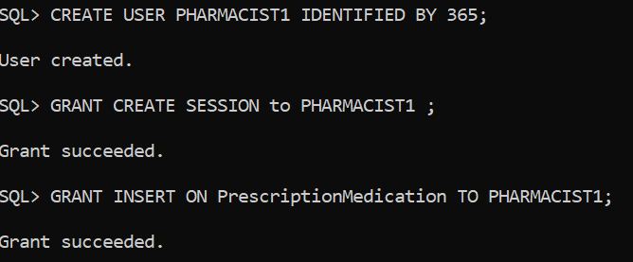

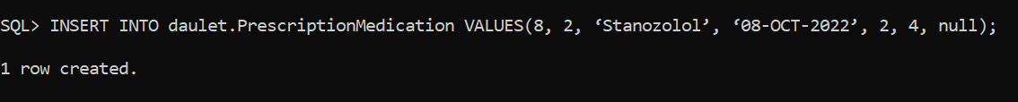

CREATE USER BOOKKEEPER1 IDENTIFIED BY 587;

GRANT CREATE SESSION to BOOKKEEPER1 ;

GRANT SELECT ON Bill TO BOOKKEEPER1;

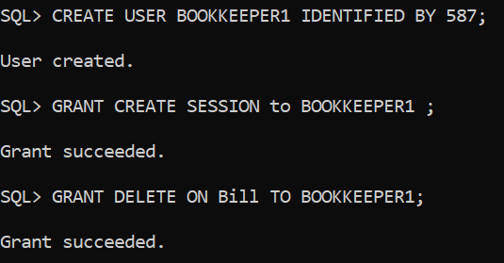

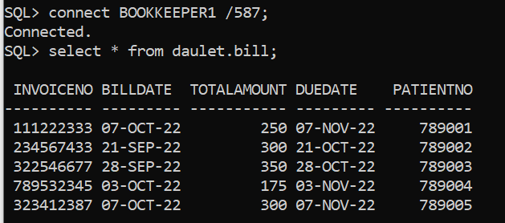

CREATE USER MEDICALTECHNICIAN1 IDENTIFIED BY 193;

GRANT CREATE SESSION to MEDICALTECHNICIAN1;

GRANT SELECT ON LabTest TO MEDICALTECHNICIAN1;

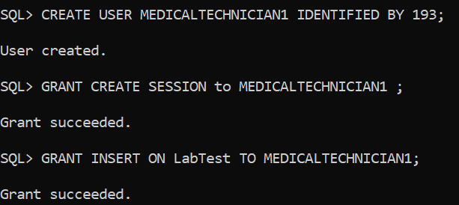

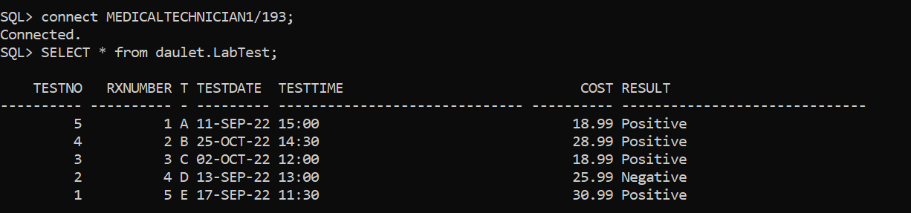

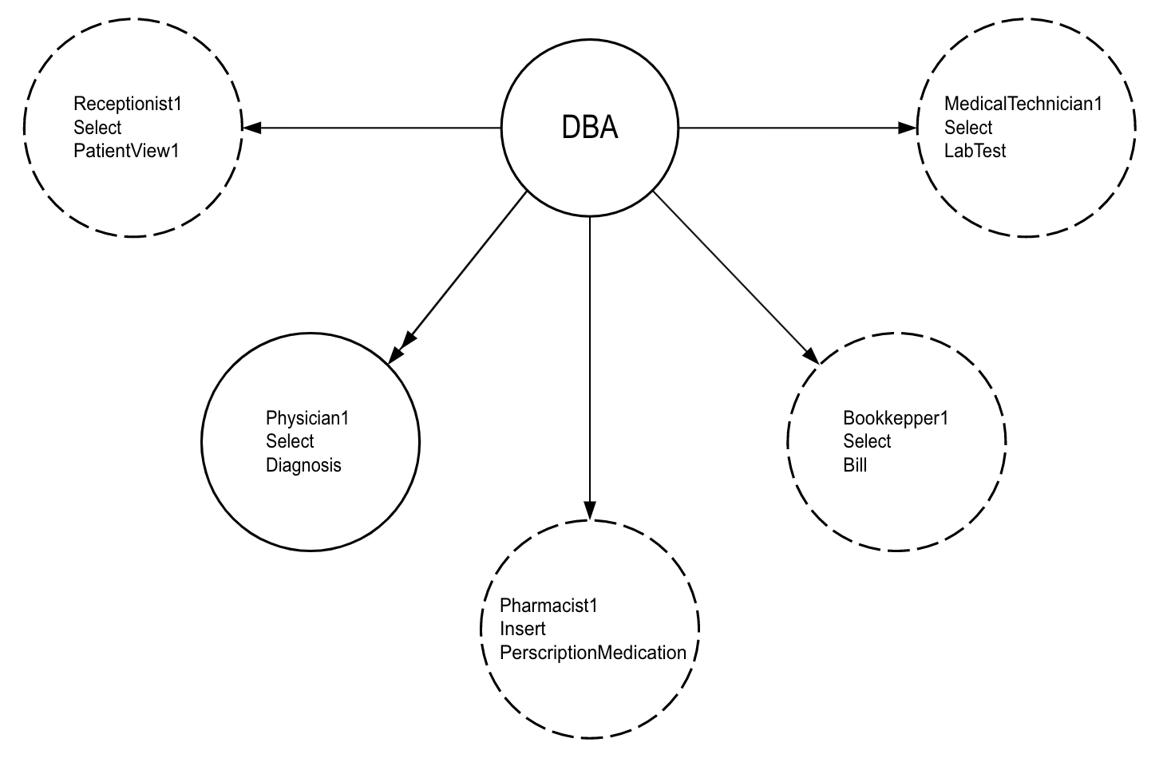

CREATE TABLE PrescriptionMedicationAuditTrail(

staffName VARCHAR2(30) NOT NULL,

drugdate DATE NOT NULL,

RXNumber NUMBER(9) NOT NULL,

CONSTRAINT PrescriptionMedicationAuditTrail_staffNo_drugdate_pk PRIMARY KEY (staffName, drugdate),

CONSTRAINT PrescriptionMedicationAuditTrail_RXNumber_fk FOREIGN KEY (RXNumber) REFERENCES PrescriptionMedication(RXNumber)

);

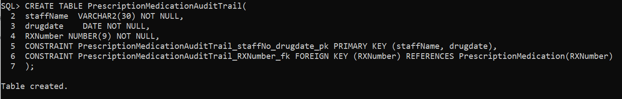

CREATE OR REPLACE TRIGGER PrescriptionMedicationAuditTrailTrigger

AFTER INSERT OR UPDATE ON daulet.PrescriptionMedication

REFERENCING NEW AS NEW OLD AS OLD

FOR EACH ROW

BEGIN

INSERT INTO daulet.PrescriptionMedicationAuditTrail VALUES(USER , SYSDATE, :NEW.RXNumber);

END;

/

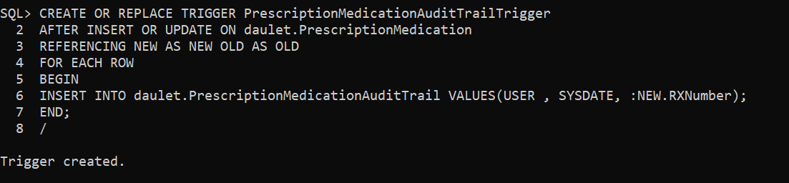

INSERT INTO daulet.PrescriptionMedication VALUES(13, 1, ‘Stanozolol’, ‘08-OCT-2022’, 2, 4, 2);



Connect as DBA and see who inserted the values into the table.

