1. 클래스들
   1. Bank
   2. Saving
   3. Deposit
   4. Simple
   5. Compound
   6. Driver

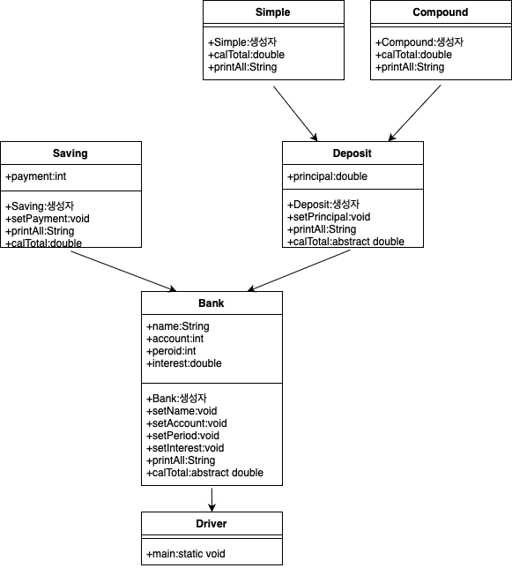

1. 각 클래스 구현
   1. Bank
      1. 변수
         1. name
         2. account
         3. period
         4. interest
      2. 메소드
         1. Bank
         2. setName
         3. setAccount
         4. setPeriod
         5. setInterest
         6. printAll
         7. calTotal
   2. Saving
      1. 변수
         1. patment
      2. 메소드
         1. Saving
         2. setPayment
         3. printAll
         4. calTotal
   3. Deposit
      1. 변수
         1. principal
      2. 메소드
         1. Deposit
         2. setPrincipal
         3. printAll
         4. calTotal
   4. Simple
      1. 변수
      2. 메소드
         1. Simple
         2. calTotal
         3. printAll
   5. Compound
      1. 변수
      2. 메소드
         1. Compound
         2. calTotal
         3. printAll
   6. Driver
      1. 변수
      2. 메소드
         1. main
            1. 변수

Ds

Dc

s

* + - * 1. 알고리즘

main

Simple Ds = new Simple("선남",100,12,0.05,10000000);

System.***out***.println("정기예금(단리)")

System.out.println(Ds.printAll())

Compound Dc = new Compound("선녀",200,12,0.05,10000000);

System.***out***.println("정기예금(복리)")

System.out.println(Dc.printAll())

Saving s = new Saving("길동",300,12,0.05,10000000);

System.***out***.println("정기적금")

System.out.println(s.printAll())

end