**End 2 End – a File Sharing Application**

*Created by Brent Thompson and JT Kawaski*

***Overview***

Providing a similar service to—the no-longer—Napster file sharing platform, End 2 End is a client-server network application modeled in relation to the concept of peer-to-peer (P2P) file sharing. To summarize, the basic architecture of the application exists in two parts: (1) a centralized server responsible for monitoring two lists: one tracking all of the current active users and one tracking all of the available files for sharing in the network; and (2) the remote client (which delegates as a server when hosting a file) responsible for establishing connections with file hosts in efforts of executing file transfer (this is based on basic FTP client and server interaction).

***Design***

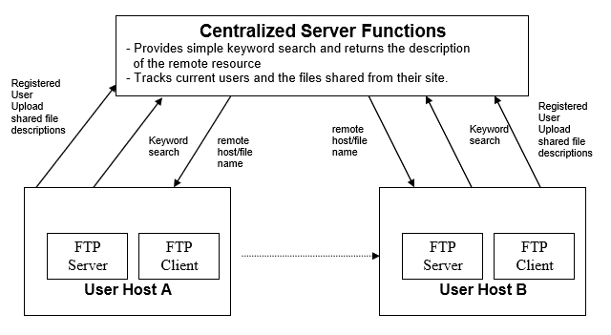

Figure 1: Concept of Architecture of the GVNapster application

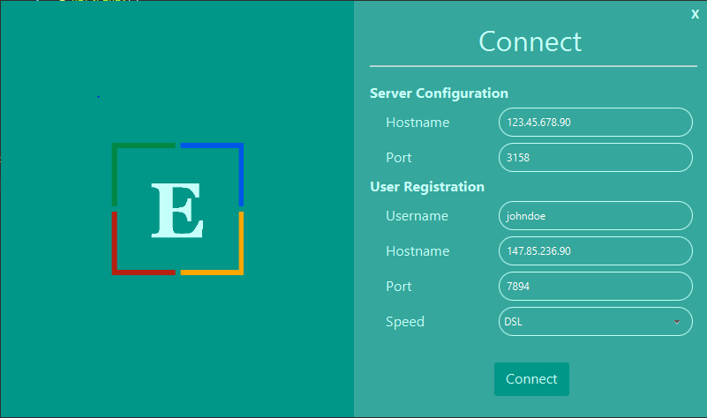

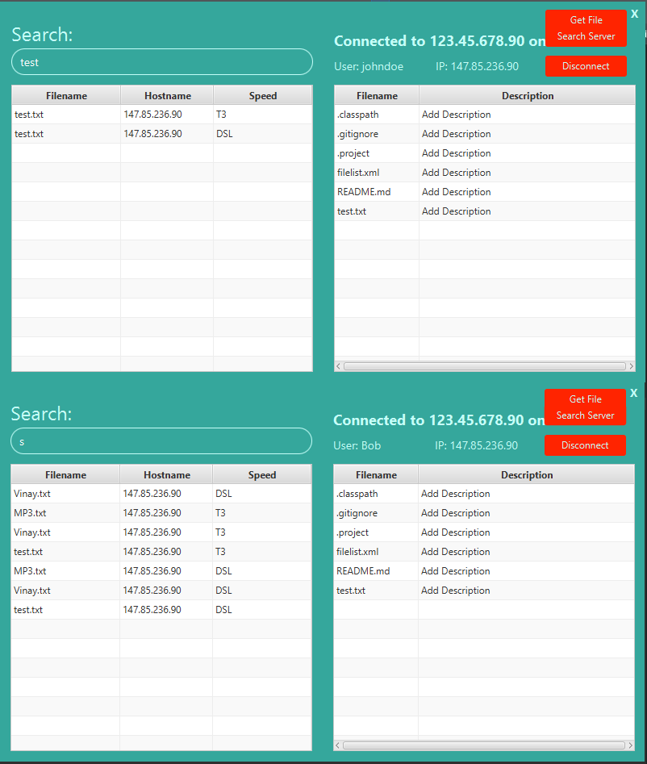

***\*Two different Client both using the search function***

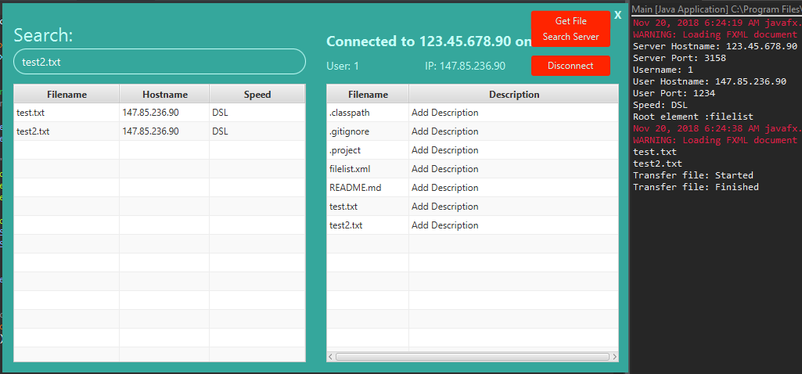

***\*Client using getfile***

***Features***

GVNapster features a GUI interface implemented with the JavaFX library. Some of the features of the interface include:

* Intuitive user-friendly interface
* Dynamically updated table of local and server-based file lists
* Dynamically updated search results
* Simple file description editor
* Safe & simple disconnection

***Problems***

Problems that arose in the GVNapster were mostly dealing with parsing the xml file and setting up the GUI. Time also became a factor in what we were able to add to the GUI, giving more time we would have made it so the descriptions of the files are editable, and so that the file list xml can be changed and reloaded to the server.

***Summary***

The GVNapster project was a long but rewarding project, in the end was not too complex but still required a good amount of thinking to plan everything out. We completed 100% of the requirements.