# Cocos2d-x: A cross-platform 2D game engine



## Abstract

Cocos2dx is an open source 2D game engine which support cross-platform and a wide range of languages like c++, javascript and lua. You can use cocos2dx to develop your game which can runs on windows, macOS, android, Linux and Web platform with only one set of code. It is supported by lots of people on github, you can easily download its source code and start building your application. The features of cocos are fast, free, easy to use. To find out how cocos achieves those features, we start looking at its architecture from the bottom. Below is the what we find about the architecture of cocos through different viewpoint and perspectives

## .Table of contents

1. Introduction
2. Stakeholder Analysis
3. Development View

## Introduction

Cocos2d-x is a cross-platform game engine. A game engine is a piece of software that provides common functionality that all games need. You might have heard this referred to as an API or framework but in this guide, we'll be calling it a **game engine**.

**Game engines** usually support multiple platforms thus making it easy to develop your game and then deploy it to multiple platforms without much overhead at all. Since **Cocos2d-x** is a **game engine**, it provides a simplified API for developing cross-platform mobile and desktop games. By encapsulating the power inside an easy to use API, you can focus on developing your games and worry less about the implementation of the technical underpinnings. Cocos2d-x will take care of as much or as little of the heavy lifting as you want.

The original version of Cocos2d was written in python, then use objectiveC, which was applied to iphone. After that, someone in China changed it to C++ version according to the design concept. This version can run on iphone, widnows and android platforms. The latest version of cocos is 1.0.0. The C++ version of the engine also introduces the lua scripting system. Cocos2d is a completely open source engine which is widely used including Zynga, Nangong Meng and other well-known game companies. Cocos2d is not only a 2D graphics engine library, but also provides some systems to support game logic. Cocos2d provides a simple sound engine that supports playing mp3, wave, ogg etc. cocos2d can be used together with the physics engine box2d to achieve physical effects such as collisions. The structure of the cocos2d engine is clear, and the documents and examples are rich which makes cocos very easy to learn.

This chapter,we discuss in details about the architecture about cocos from different stakeholders’ view. We divide the whole system into different components which have a specific function and look at how they work tighter. I believe that after reading our report, you will have a better understanding of cocos.

## Stakeholder Analysis

In the book *Software System Architecture* we learned how to analysis the stakeholders of a standard software system by identify the roles which are played by those people/group who are involved in the process of construction. For this section we are going to analysis and identify the significant roles that of great importance.

### Acquirers

Acquirers, or called as investors, is the first part of the chain which decides the survival of tech companies. Cocos2d-x was developed by @*Ricardo Quesada* who was born in Argentina, and later on established the @Los cocos which was the prototype of cocos2d-x. Now we would like to claim that the cocos2d-x is sponsored or invested by a Chinese company @Chukong Technologies, which is the role of sponsor. This company decides the business and technical decisions and provides funds to cocos2d-x.

### Assessors

Assessors are stakeholders that test bugs in the system which is game engine in Cocos case, and report or modify the bug-list to the developers. For cocos, the job is taken by the group inside the company rather than give out to other testers. In the test part, testers would test every detail in System, like Actions test, Billboard test, Box2D test, ClickandMove test, etc. Each part will be allocated to a tester or two to make sure the System goes well. @minggo(Zhang XiaoMing), @drelaptop are active bug-testers in Cocos2d-x github who donate significant number of bugs.

### Developers

As an open-source program on GitHub, dozens of developers would like to take part in this job. A few of them can join in the program at last, however. As developer of game engine, they need to master the framework, web service techs, androids programming, js language, 3d developing and other skills, so the number of core developers are 13 only. As for framework/web service support, each part gets no more than 2 individuals. For certain many individual developers also did a great job and made the cocos grow faster ever.

### Supports

We divide the support characters as tech support and platform support to identify the concrete role. Tech support grant developers deploy their program on different platforms that are supported, which makes cocos efficient and powerful.

ⅰtech support

①C++

②Lua

③JavaScript

④Cocos platform framework tools and IDEs

ⅱplatform support

①iOS

②Android

③Windows phone

④Windows

⑤Mac OSX

⑥Tizen

### Support Staff

Cocos has dedicated support staff spreading in several websites: [Facebook](https://www.facebook.com/cocos2dx/), [Twitter](https://twitter.com/cocos2dx), [Blog](http://blog.cocos2d-x.org/), and most accessed [community](https://github.com/CocosStructure/cocos2d-x-1#where-to-get-help). At these places, developers who ran into troubles that unable to solve can obtain the details of APIs and notes of program, and get help from other experienced developers. Or, they can have a look at the [guide](https://github.com/CocosStructure/cocos2d-x-1#learning-resources) on github to acquire the most knowledge/guide that he/she needs.

### Communicators

Communicators often play an important role on explaining the architecture of the system and the function of each part of system to those who may buy/use the product and those who may join in and contribute to the program. Usually they may also take the job which need them to create linkage between different classes. As an open-source program, the importance of communicators is inevitably lower than others. For the core developers, the structure is established by themselves, so they could be seen as the communicators in Cocos program.

### Users

Cocos in China is a perfect successful case in commercial, almost 70% of games in Chinese market is developed by Cocos rather that unity in foreign countries. Without considering the sponsor is a Chinese company, it would also be a marvelous great achievement for a game engine. The user is not only including individual developers and game lovers but great organizations like Zynga、Wooga、Gamevil、Glu、GREE、Konami、TinyCo、HandyGames、IGG and Disney Mobiles. Also for big enterprises the cocos is a great choice, engineers in these companies such as Google, Microsoft, ARM, Intel are active in cocos developing.

### Competitors

As a game engine, at no circumstances can Cocos take in charge of game developing market. For certain, the **unity,** **unreal,Frostbite,IW** are powerful competitors which are trying their best to grasp the market share.

## Power-Interest-Grid View





*power*



*Web structure developer*

*Core developers*





*C++*

*Ordinary developers*

*Sponsor*

*API programmers*



*competitors*



*individual contributors*



*Support service*

*users*

*Interest*

# Context View

Cocos2d-x is an open-source mobile 2D game framework released under the MIT license. This is a version of the cocos2d-iphone project.It's all written in C++. Cocos2d-x development focuses on the framework provided by Cocos2d cross-platform and cocos2d-x. Mobile games can be written in C++ or Lua, using an API that is fully compatible with the cocos2d-iphone version. The cocos2d-x project can easily be built and run on iOS, Android, Blackberry and other operating systems. Cocos2d-x also supports desktop operating systems like Windows, Mac and Linux.Therefore, the source code written by developers is easy to edit and debug in the desktop operating system.

Family members

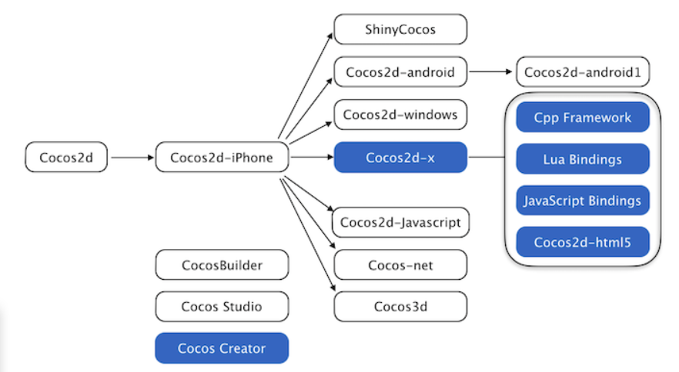

Branch engines and editors in the blue box are most active.

Cocos2d-x allows developers to use visual editor Cocos Creator for rapid prototyping, debugging packaging, and cross-platform deployment.

Features：

1.Easy to use: game developers can focus on the game without spending a lot of time learning the arcane OpenGL ES. Cocos2d-x offers plenty of specification.

2.Efficient: cocos2d-x performs graphics rendering based on OpenGL ES to maximize GPU performance of mobile devices.

3.Flexibility: easy to extend and integrate third-party libraries.

4.Free: the free open source framework based on the MIT protocol allows users to use without worrying about commercial licensing.

5.Community support: developers set up a community organizations, easy to access various technical problem.

version control and issue tracker: Git and Github.

Supported platforms: The core advantage of cocos2d-x is that it allows developers to leverage C++, Lua, and Javascript for cross-platform deployment, covering platforms include iOS、Android、Windows Phone、Windows, Mac OS、Tizen、Linux and so on.

Language of IDE: completely written in C++. the core engine has the smallest footprint, yet the fastest speed of any other game engine, and is optimized for running on all kinds of the devices including low-end Android systems.

Software project development language: C++、Lua and Javascript

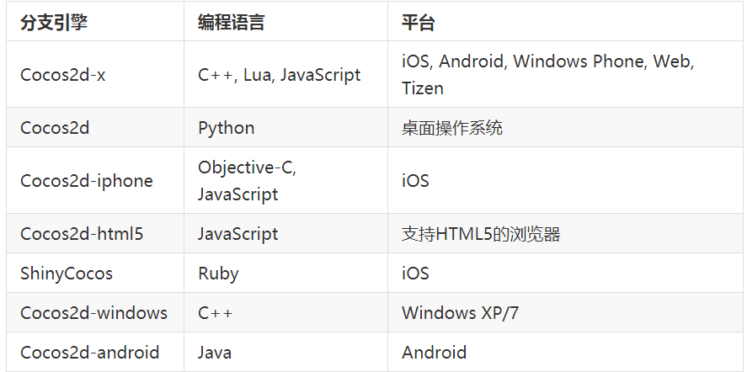

Users：Cocos2d-x users include not only individual developers and game development enthusiasts, but also many well-known large companies such as Zynga, Wooga, Glu, GREE, Konami, TinyCo and Disney Mobile.As of September 2013, more than 1.5 billion games were downloaded worldwide based on the cocos2d-x engine, many of which also dominated the apple AppStore and Google AppStore rankings.At the same time, many companies such as touch, Google, Microsoft, ARM, and Intel engineers are also very active in the cocos2d-x field.

Developers: Wang zhe and his team of Beijing touch technology co. LTD、open source community

Market position:cocos2d-x mainly occupies the high-end and low-end markets.In the development of 2D mobile games in China, the cocos2d-x engine accounts for more than 70%.There are 45 domestic monthly income over 10 million mobile game, 30 based on cocos2d-x.

License: Cocos2d-x is released under the MIT license.

Cocos-2dx 主要类的功能

|  |  |
| --- | --- |
| Stakeholder class | Description |
| Ref | *Ref* class is the base class for the Cocos-2dx project. It contains the related functions that the project uses for automatic memory management, and many classes inherit from it. It should be noted that the constructor of the Ref class is protected, so it can only be inherited and cannot be instantiated. |
| Director | *Director* class determines what is displayed on the screen, that is, through its related functions to achieve the display and hiding of certain nodes. |
| Node | *Node* class is the most basic element in the project scene graph [on the screen or the collection of elements that have been displayed or may be displayed], and most of the classes related to rendering come from Node. It mainly determines the position, size, angle, etc. of the element, and the *Node* class object can be used as a child node, using timers and performing actions. |
| Scene | *Scene* class is the basic unit of scene switching, and provides a rich switching effect. The unit that the project renders on the screen is the scene. There are three types: game content scenes; option class scenes; display class scenes. It should be noted that there can be multiple scenes in a project, but only one scene is active at the same time. |
| Layer | *Layer* class is the basic unit that makes up the scene. Multiple layers form a scene, which is convenient for layered processing to show different effects. The *Layer* class is a container for displaying content. It is usually used as a background for games, and can receive operations such as clicks from users and make corresponding changes. |
| Sprite | *Sprite* class is the most basic unit that players can see. |
| Renderer | *Renderer* class mainly implements the rendering function, and internally, it also needs to classify and sort the Render Command. |
| Event | *Event* class identifies the different types of events and records the specific data, which determines which *EventListener* to handle this event. |
| EventDispatcher/EventListener | *EventDispatcher* class performs like the control center of all events [equivalent to a relay], which manages the *EventListener*. When an Event arrives, it determines the calling sequence of CallBack. *EventListener* class establishes the mapping relationship from Event to CallBack, and the *EventDispatcher* calls the corresponding CallBack according to the relationship. |
| Scheduler | *Scheduler* class is similar to Timer in other languages and is used to implement delayed calls and timed calls. Its other sub-methods also enable control of timing operations, such as pauses, resumes, and so on. |

