Tech Test Scenario: As a part of this tech test you will be Given an API and an existing website, you will need to componentize and port a portion of the website to angular 4 framework.

Specifically, you will need to create an angular 4 component to display a panel containing a count of **completed audits** in a specified filtering time frame.

Filtering and grouping is done by category and department and shows a simple pass to fail ratio in a bar graph for each department.

Note:

Ignore all other panels, filtering options and graphs.

Please feel free to make assumptions and document them in the solution.

    Api

<http://incontrolpty.australiaeast.cloudapp.azure.com:7123/webservices>

**Swagger url :** <http://incontrolpty.australiaeast.cloudapp.azure.com:7123/webservices/swagger/ui/index>

**Website**

<http://incontrolpty.australiaeast.cloudapp.azure.com:7123/dashboard/index.html>

login : admin / topcat

This Api link should land on the Api help page, the help page has links to how to use the Api,

here is a screenshot of the Api help page:

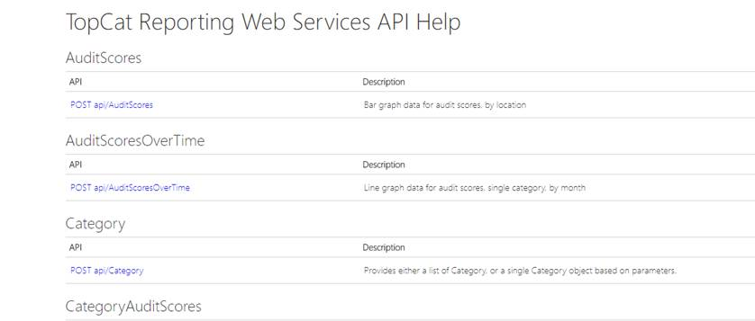

An example api call to get users for the application help page : <http://incontrolpty.australiaeast.cloudapp.azure.com:7123/WebServices/Help/Api/POST-api-Users>

Method : Post

Request URL : <http://incontrolpty.australiaeast.cloudapp.azure.com:7123/webservices/api/users>

Body : leave blank

You should get a response

[

    "admin",

    "Auditor",

    "Test User"

]

Another example is <http://incontrolpty.australiaeast.cloudapp.azure.com:7123/WebServices/Help/Api/POST-api-Category>

Method : Post

Request URL: <http://incontrolpty.australiaeast.cloudapp.azure.com:7123/WebServices/api/Category>

Body : {"UserId":"1","CategoryId":"1","LoadAttributes":true}

You should get a response

{

    "CategoryId": 1,

    "Name": "Environmental Cleaning Policy - NSW standards",

    "AttributeTypes": [

        {

            "TypeId": 3,

            "Name": "Risk Level",

            "DisplayOrder": 0

        },

        {

            "TypeId": 100,

            "Name": "Site",

            "DisplayOrder": 1

        },

        {

            "TypeId": 101,

            "Name": "Building",

            "DisplayOrder": 2

        },

        {

            "TypeId": 102,

            "Name": "Floor",

            "DisplayOrder": 3

        },

        {

            "TypeId": 105,

            "Name": "Department",

            "DisplayOrder": 4

        },

        {

            "TypeId": 104,

            "Name": "Room",

            "DisplayOrder": 5

        }

    ],

    "DemeritStartingScore": 0,

    "DefaultTypeId": 105

}

**website**

<http://incontrolpty.australiaeast.cloudapp.azure.com:7123/dashboard/index.html>

login : admin / topcat

There are multiple grouping options and filters, the task is to just implement

the **category** and **department** filters – ignore all other filters

cid:image003.png@01D32E0F.D3695880

**(Filters to be ignored – risk level, room , building , site , floor – etc.)**

* As mentioned in the question only implement the **completed audits**, ignore all other panels.

