i)

ISBN determines BookTitle, Publisher and Edition (Partial)

Author_Num determines LastName (Partial)

BookTitle determines Publisher (Transitive)

ii) + iii)

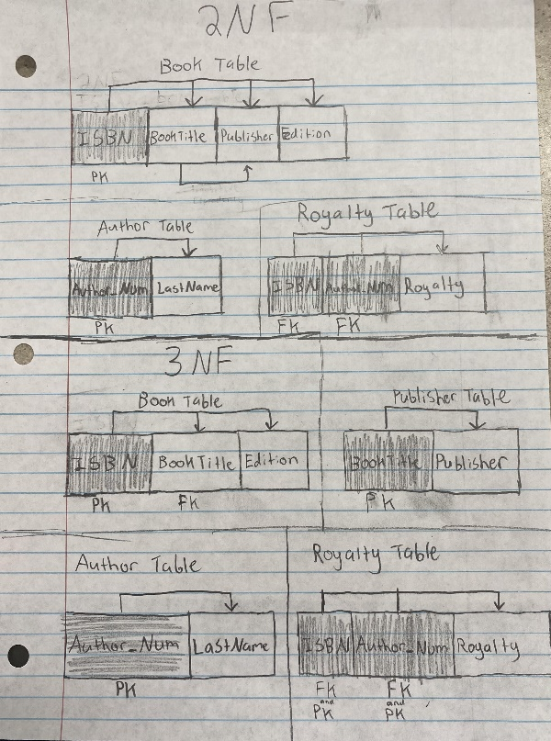

iv)

