Submitted to the 10th Conference on Robot Learning (CoRL 2026). Do not distribute.
When Reconstruction Passes:
Natural-Language Autoencoders on VLA Activations
Fail Grounding and Semantic Steering
Anonymous Author(s) | Anonymous Institution | anonymous@domain.com

Abstract. Natural-language autoencoders (NLAs) map neural activations to text and back, offering readable interfaces to model internals. We port the NLA recipe to the GR00T vision-language-action (VLA) backbone: extract per-token hidden states, train an activation verbalizer (AV) and reconstructor (AR), and inject AR outputs as live backbone steers in LIBERO simulation. Supervision uses a multimodal teacher (frames + instruction), not human descriptions of what h encodes—a confound inherited from the original LLM setting. We release nla-groot and a three-axis evaluation protocol: (1) offline reconstruction and retrieval, (2) vision-grounded caption judging, (3) closed-loop steer A/B (matched vs. mismatched language). On our main checkpoint, reconstruction metrics pass while grounding, anti-template specificity, and semantic steering fail; aggregate scores hide collapse on image_patch tokens, where retrieval margin is near zero. Claim: NL autoencoders on VLA activations are misleading without vision-grounded and behavioral checks stratified by token role—use this protocol before trusting captions or steering policies with language.
Keywords: vision-language-action models, interpretability, activation steering, robot learning

Contributions.
- Port & tooling: NLA (AV/AR) on GR00T layer-16 activations with live LIBERO steering hooks.
- Three-axis scorecard: reconstruction/retrieval, vision-grounded judge, closed-loop steer A/B (Δ_cw).
- Negative result: pooled metrics pass while image_patch margin ≈ 0.003, anti-template judge 8.3%, Δ_cw = 0.
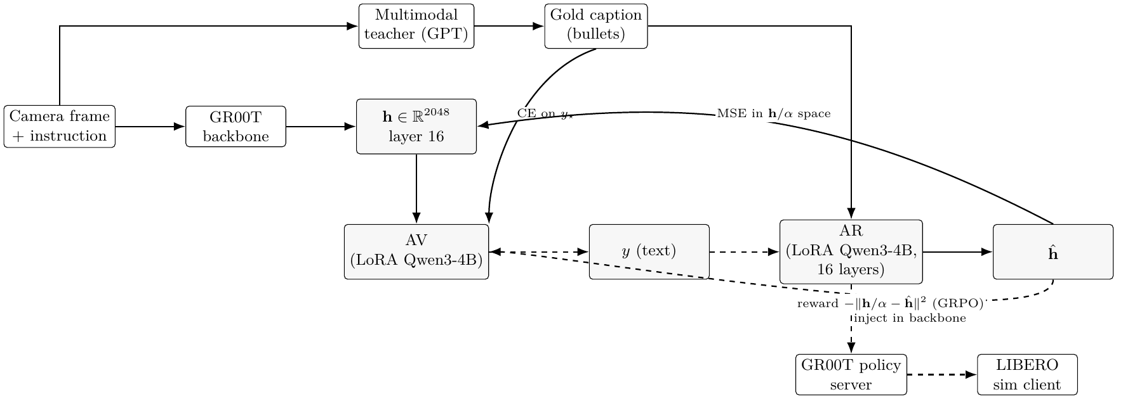
Metric | Value | Thr. | Verdict
retrieval_margin | 0.124 | 0.05 | PASS
judge_anti_template | 0.083 | 0.50 | FAIL
sim_correct_minus_wrong | 0.000 | 0.05 | WARN
image_patch margin | 0.003 | — | near chance

Takeaway. Reconstruction certifies a text–vector codec, not pixel grounding or semantic steering. Stratify by token role before deploying NL interfaces on VLAs.

