Submitted to the 10th Conference on Robot Learning (CoRL 2026). Do not distribute.
When Reconstruction Passes:
Natural-Language Autoencoders on VLA Activations
Fail Grounding and Semantic Steering
Anonymous Author(s)
Anonymous Institution
Anonymous City, Country
anonymous@domain.com

Abstract
Natural-language autoencoders (NLAs) map neural activations to text and back, offering readable interfaces to model internals. We port the NLA recipe to the GR00T vision-language-action (VLA) backbone: extract per-token hidden states, train an activation verbalizer (AV) and reconstructor (AR), and inject AR outputs as live backbone steers in LIBERO simulation. Supervision uses a multimodal teacher (frames + instruction), not human descriptions of what h encodes—a confound inherited from the original LLM setting. We release nla-groot and a three-axis evaluation protocol: (1) offline reconstruction and retrieval, (2) vision-grounded caption judging, (3) closed-loop steer A/B (matched vs. mismatched language). On our main checkpoint, reconstruction metrics pass while grounding, anti-template specificity, and semantic steering fail; aggregate scores hide collapse on image_patch tokens, where retrieval margin is near zero. Claim: NL autoencoders on VLA activations are misleading without vision-grounded and behavioral checks stratified by token role—use this protocol before trusting captions or steering policies with language.
Keywords: Vision-language-action models, interpretability, activation steering, robot learning

1 Introduction
Vision-language-action policies such as GR00T couple a multimodal backbone to a diffusion action head. The backbone hidden state h ∈ R^2048 at layer 16 is causally upstream of actions, yet there is no standard way to read or write h in natural language. Fraser-Taliente et al. propose natural-language autoencoders: AV(h) produces a caption and AR(y) reconstructs ĥ ≈ h, yielding both an interpretability artifact and a causal handle for activation steering.
We ask whether this recipe transfers to a VLA backbone, where (i) activations are multimodal and task-conditioned, (ii) downstream behavior is the right falsification test, and (iii) training labels are synthetic: a GPT-class teacher sees camera frames and token metadata, not raw h floats. The teacher may describe scene attributes only weakly present in h; supervised fine-tuning (SFT) therefore optimizes P(teacher text | h), not faithful “what h means.”
Contribution. We do not claim a strong AV or working semantic steer. We claim a negative, actionable result: autoencoder metrics can look successful while captions are vision-ungrounded and steering is behaviorally non-semantic. We release open tooling and a pre-registered three-axis scorecard so NLA ports on policies are not validated by reconstruction alone.
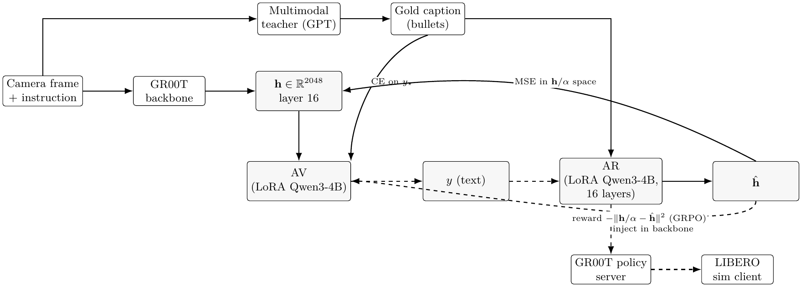
Figure 1. Pipeline. Solid: training (h from GR00T hook; gold captions from teacher). Dashed: inference (ĥ = AR(y) steers the live policy). Auditing uses AV(h); steering bypasses AV.

2 Setup (minimal)
Activations. A forward hook on GR00T backbone_features (Qwen3-VL, layer 16, pre-action-head LayerNorm) records h_i per token at three position types: last_text, image_patch, anchor. Corpus: LIBERO Goal/Spatial/Object/10 LeRobot trajectories; α ≈ P75||h||_2 for injection scaling.
AV and AR. Both are LoRA fine-tunes of Qwen3-4B-Instruct. AV injects α·normalize(W_p h) at a reserved slot token and is trained with CE on teacher bullets. AR reads “Summary of the following text:” and predicts ĥ/α; loss is MSE plus InfoNCE hard negatives. Joint SFT (libero_4suite_v3: 15k steps, batch 4).
Steering. At inference, user text y maps to ĥ = AR(y) and blends into backbone tokens (image_patch or image_patch_all) on every get_action call in the official LIBERO policy server.

3 Three-axis evaluation protocol
Each checkpoint is scored on independent axes; overall PASS requires required metrics (pre-registered in build_v3_scorecard.py).
Axis 1: Reconstruction & retrieval. Closed-loop cosine cos(h, AR(AV(h))) without teacher forcing; retrieval margin (matched vs. cross-pair). Report both aggregate and per-position_type slices.
Axis 2: Vision-grounded judge. llm_judge_av_captions.py scores captions against cached frames. We report gold (teacher) vs. AV greedy on identical rows.
Axis 3: Closed-loop steer A/B. On put_the_bowl_on_the_plate (LIBERO Goal, GR00T checkpoint, seeds {0,1,2}): baseline, correct steer text, wrong text. Primary metric: Δ_cw = succ_correct − succ_wrong (PASS if ≥ 5pp).

4 Results: metrics pass, semantics fail
Table 1. V3 scorecard (libero_4suite_v3). Required metrics gate overall verdict.
Metric | Value | Thr. | Verdict
retrieval_margin | 0.124 | 0.05 | PASS
judge_grounding_specific | 0.417 | 0.55 | WARN
judge_anti_template | 0.083 | 0.50 | FAIL
sim_correct_minus_wrong | 0.000 | 0.05 | WARN

Table 2. Stratified V3 metrics (libero_4suite_v3).
Position | n | CL cos | Margin | AV B%
image_patch | 85 | 0.338 | 0.003 | 0
last_text | 85 | 0.437 | 0.046 | 67
anchor | 8 | 0.367† | 0.139 | 75
pooled | 178 | 0.388 | 0.124 | 42

Table 3. Multimodal judge pass rates (24-row held-out sample).
Checkpoint | Source | Ground. | Anti-templ.
v3 (4-suite) | gold | 0.750 | 0.500
v3 (4-suite) | AV | 0.417 | 0.083

Symmetric steering (Axis 3). Baseline solves all seeds (succ = 1.0). Every steer arm fails (succ = 0) for both matching and contradictory prompts—Δ_cw = 0. Bowl displacement ≈ 0.145 m (baseline) vs. ≈ 0.07 m (all steers): intervention dampens motion uniformly rather than redirecting toward the prompted object. Steerability ≠ faithful interpretability.

5 Limitations
Scope and generalization. All experiments use a single VLA (GR00T-N1.7-LIBERO), one hook site (layer 16), and LIBERO simulation. We do not establish whether failures persist across layers, action heads, real robots, or other VLAs.
Teacher supervision confound. Gold captions are produced by a multimodal teacher that sees pixels and metadata, not h itself. Our negative result therefore bounds teacher-supervised NLAs under this protocol.
Evaluation coverage. Axis 3 steering is tested on one LIBERO Goal task with three seeds. Judge subsamples are small for per-position_type slices.

6 Use this before you trust or steer
For auditing. Do not treat AV(h) as ground truth without Axis 2 on held-out frames. Report gold-vs-AV gaps per position_type; image_patch is the vision-grounding slice.
For steering. Do not deploy AR(y) backbone steers because reconstruction is high. Require Δ_cw > 0 on held-out tasks and dose calibration.
Reproducibility. Anonymous code: https://anonymous.4open.science/ (placeholder—replace before submit). Scorecard: scripts/eval/build_v3_scorecard.py.
Broader impact. NL interfaces to policy internals could help safety auditing or harm if misread as faithful; our protocol is meant to reduce overclaim.

References
[1] NVIDIA. GR00T-N1: An open foundation model for generalist humanoid robots. arXiv preprint, 2025.
[2] Connor Fraser-Taliente et al. Natural language autoencoders produce unsupervised explanations of LLM activations. Transformer Circuits Thread, 2026.
[3] Alexander Matt Turner et al. Activation addition: Steering language models without optimization. arXiv:2308.10248, 2023.
[4] Andy Zou et al. Representation engineering: A top-down approach to AI transparency. arXiv:2310.01405, 2023.
[5] Edward J. Hu et al. LoRA: Low-rank adaptation of large language models. ICLR, 2022.
[6] Anthony Brohan et al. RT-2: Vision-language-action models transfer web knowledge to robotic control. CoRL, 2023.
[7] Moo Jin Kim et al. OpenVLA: An open-source vision-language-action model. CoRL, 2024.

