|  |
| --- |
| The DryadLINQ Job Browser |
| User Manual |
| March 30, 2011 |
| The DryadLINQ job browser is an interactive visualization tool which allows the user to explore the state of a distributed DryadLINQ job. |
| Contents  Introduction 2  Starting up 2  The Cluster browser 2  The “View” menu 3  The “Job” menu and the right-click context menu 4  Starting the job browser 4  Terminating jobs 4  Diagnosing job failures 4  The job browser 4  The job summary 6  The job plans 6  The job static plan 6  The Dynamic Job Plan 7  The execution schedule 8  Color coding 9  Hiding cancelled vertices 9  Stage summary 9  Stage Code 10  Stage Vertices 10  Table views 11  Vertex Statistics 12  Vertex-generated Information 13  Vertex-level operations 14  Automatic Failure Diagnosis 14  Local debugging 15  Local profiling 16 |

Mihai Budiu, [mbudiu@microsoft.com](mailto:mbudiu@microsoft.com), MSR SVC

# Introduction

DryadLINQ is a compiler and runtime designed to allow users to run .Net programs on large computer clusters. The input language of DryadLINQ is .Net 3.5 or later. DryadLINQ compiles some .Net LINQ constructs into distributed execution plans, and uses the Dryad distributed runtime to execute these plans on a computer cluster reliably. An introduction to Dryad, LINQ and DryadLINQ is not in the scope of this manual.

LINQ is essentially a language of operators that compute on *collections* of values, reminiscent of the relational algebra (SQL), and Lisp. A chain of LINQ operators is a LINQ *query.* Each LINQ query is translated by DryadLINQ into a Dryad job plan, which is then executed by Dryad on the cluster. A Dryad job is always a directed acyclic graph: the nodes of the graph (also called *vertices*) are processes that run independently on different machines. The edges of the graph (also called *channels*) are communication channels that move data between the vertices.

While conceptually the user writes a single program that operates on collections, at runtime the program is executed using multiple machines, and on collections that are partitioned and stored on multiple machines.

While DryadLINQ does a very good job of providing the illusion that the distributed computation occurs on a single machine, under some circumstances the single-machine abstraction breaks down. This happens especially when the application has (correctness or performance) bugs. The user of DryadLINQ is faced with the task of understanding the behavior of an application that spans multiple machines.

The DryadLINQ job browser is a graphical user interface which provides a unified view of a large part of the distributed state of a DryadLINQ job. In this document we provide a brief overview of the main capabilities of the DryadLINQ job browser.

# Starting up

To start the job/cluster browser the user has to invoke the provided executable.

While running the job browser a console window is present showing the detailed log messages generated by the job browser.

# The Cluster browser

The cluster browser is used to connect to a cluster and to retrieve the list of running, or recently run jobs. Once the user has connected to a cluster a display like the one in Figure 1 is shown.

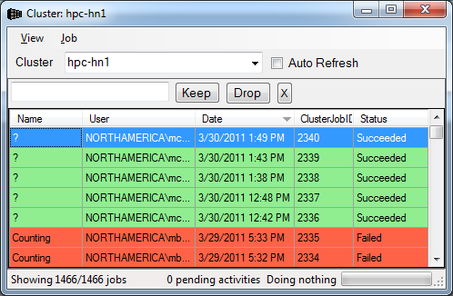

Figure : Cluster browser window

Each job is a displayed on a separate line. The jobs are color coded according to their status: red=failed, green=successful, cyan=running and yellow=cancelled. The cursor points to the currently selected job(s). Several operations can be applied to the selected jobs; some operations can be performed on a single job.

The jobs can be sorted on the displayed columns. They can also be filtered using the three buttons shown in Figure 2. The “Keep” button will only show jobs which match the filter, while the “Drop” button will only show jobs which do not match the filter. The “X” button removes all applied filters.



Figure : Filtering jobs

## The “View” menu



Figure : Functionality of the "View" cluster browser menu.

Figure 3 shows the operations offered by the “View” menu:

* “new window” (or hotkey control-N) opens a new cluster browser window
* “Refresh” (F5) refreshes the view of the cluster is refreshed.   
  If the “auto-refresh” checkbox is set, the view will automatically be refreshed every 30 seconds.
* Exit (control-Q) closes the cluster browser and saves some settings about the current view.

## The “Job” menu and the right-click context menu

The user can perform per-job operations either by selecting a job in the display and using the “Job” menu, or right-clicking in the job display window. The set of operations available is shown in Figure 4.

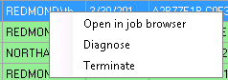

Figure contextual menu for job operations, invoked through right-click.

## Starting the job browser

By double-clicking on a job, or selecting Job/open in job browser the user invokes the job browser, which is described below. The user can start multiple browsers by selecting multiple jobs.

Note that, although a job may be displayed in this window, the state of the job may not be available on the cluster, or may be only partly available. This is because the cluster job management may garbage-collect information about old jobs, and garbage collection is not instantaneous on all cluster machines: only parts of old jobs may be available for inspection. The user may need to have permissions to start the job browser on a specific job.

## Terminating jobs

The menu item Job/Terminate can be used to terminate a (single) job executed on the cluster. The user may need to have adequate privileges to perform this operation.

## Diagnosing job failures

Failed jobs can be diagnosed by invoking the Job/Diagnose menu. Diagnosis is explained in more detail in Section “Automatic Failure Diagnosis”.

# The job browser

The job browser provides a hierarchical display of the DryadLINQ job information. The job browser shows a *snapshot* of the job state; the display has to be explicitly refreshed for a running job. There is an **auto-refresh** checkbox which causes the browser to automatically refresh the state periodically. A screen-shot of the job browser is shown in Figure 5.

Stage state

Vertex state

Job state

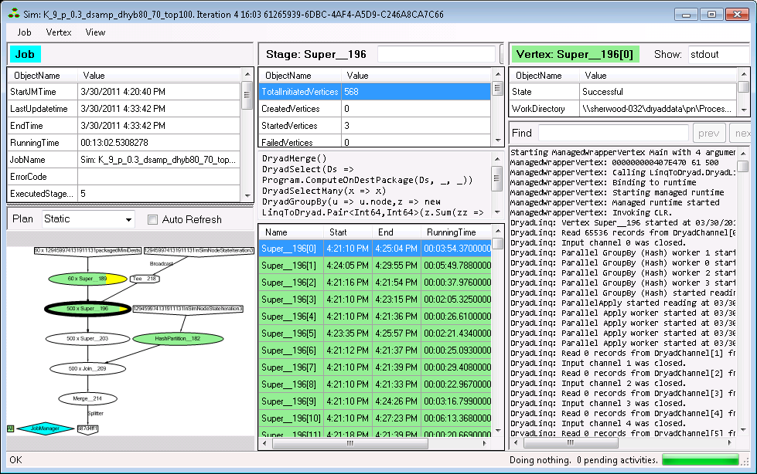

Figure : The job browser window.

The job browser has to collect information from a potentially large number of large files spread among many machines in the cluster. Since the job browser is an interactive application that runs on a single client machine, data collection could be slow for large jobs. Some information is collected only on-demand, when initiated by user requests.

The job browser is divided into three vertical panes, representing a hierarchy from left to right. The job state pane (left) shows global job information. The user can select one of the job stages by clicking on the job plan. (A stage is a set of vertices that all operate on the same data collection and perform the same computation.) The selected stage is displayed in the middle pane. The stage information includes the list of all vertices in the stage. The user can click on a vertex to select it. Information specific about the selected vertex is shown in the right (vertex) pane.

The panes can be resized; the position and sizes of the panes are saved when the application is quit normally (through the Job/Close menu), and restored on the next execution.

In the remaining of the document we describe briefly the functionality provided by the job browser.

## The job summary

The job summary is in the leftmost top pane, shown in Figure 6. Some of the fields have meaningful values only after the job has completed.

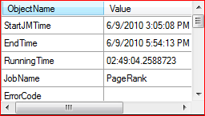

Figure : The job summary

## The job plans

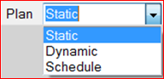

Figure : Selecting the job plan view

The bottom-left pane can display information about the global job plan. A combo box is used to select one of three different views: static, dynamic and schedule. Note that some views may be unavailable if the information could not be collected from the cluster. The plans displays can be zoomed in/out by using Ctrl + and Ctrl – (or the menu items View/Zoom in, View Zoom out). The menu item View/Zoom to fit (or Ctrl ~) will resize the plan view to fit in the window.

### The job static plan

The static plan is a picture of the plan as submitted by DryadLINQ to the cluster. Each stage is represented by an ellipse.

In Figure 8 we show a fragment of a job static plan. The pentagons are inputs and outputs. For example, the shown input contains 60 partitions. The first stage reading from that table is comprised of 60 vertices, numbered Super__230[0] to Super__230[59]. The coloring of the stages is explained below.

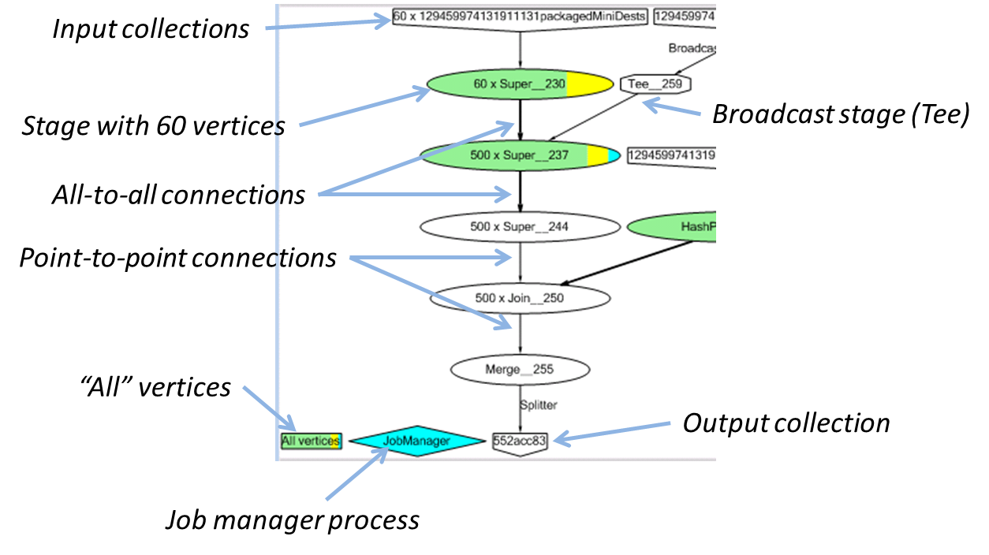

Figure : Static job plan fragment

The edges between ovals indicate channels. Only two types of channel connections are possible: point-to-point (or, more precisely, round-robin), and all-to-all. The thin edge indicates a point-to-point: each vertex in the top layer is connected to one vertex in the bottom layer. (If the number of vertices is not equal, the vertices in the smaller layer are used repeatedly, in round-robin manner.)

The thick edges indicate an all-to-all connection. In the example in Figure 8 the top thick edge represents 60x500 channels: one between each of the 60 vertices in the stage Super__230 and each of the 500 vertices in stage Super__237.

All Dryad edges are point-to-point, connecting one source vertex with one destination vertex.

The only way to broadcast the contents of a channel is by using a Tee vertex. In the figure the Tee__259 vertex indicates that the rightmost input is read by all 500 vertices in stage Super__237.

The user can click on any stage or edge to select it.

The user can also click on the job input and output stages to display information about the associated distributed collection.

### The Dynamic Job Plan

Figure 9 shows a fragment of a dynamic plan display. At run-time the Dryad job graph may dynamically change, so the set of stages displayed is not identical to the ones present in the static plan. In the dynamic display the horizontal axis is time; each box covers the execution time of all vertices belonging to the stage. From this picture we infer that most of the execution time of this job was spent in stage Super__237.

The user can also on the dynamic plan boxes to select a stage. The user can also zoom-in by dragging a box with the mouse.

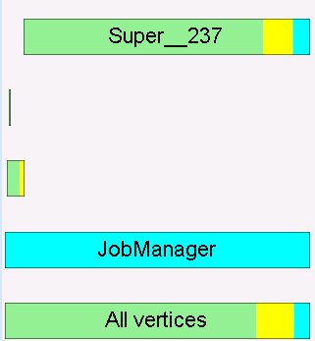

Figure : Dynamic plan

### The execution schedule

Figure 10 shows a display of a job schedule. The horizontal axis is time, while the vertical axis is machine. Each vertex executed corresponds to one line, showing the time spanned by the vertex execution. Clicking on a line will focus on the corresponding vertex.

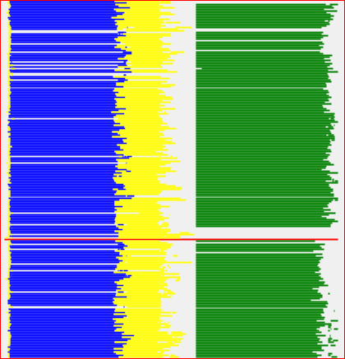

Figure : job schedule view. Each vertex is a different line.   
The vertical axis is the machine, the horizontal axis is time.

### Color coding

The plan views are color coded in one of two ways: by the status of each vertex, or by the stage of each vertex. The coloring can be toggled by using the menu “View/Color by stage” (status), or with hotkey Control-T.

* Coloring by state: each vertex is colored by its current state, which can be one of: successful=green, running=cyan, cancelled=yellow, failed=red, white=not yet started. Figure 8 and Figure 9 show coloring by state.
* Coloring by stage: each vertex is colored according to the stage it belongs to. Figure 10 shows coloring by stage.

### Hiding cancelled vertices

The user can toggle the display of cancelled vertices using the menu “Job/Hide cancelled vertices”.

## Stage summary

The top-middle pane displays basic statistics about the selected stage, as shown in Figure 11.

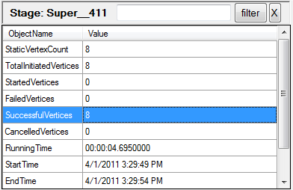

Figure : Stage statistics:   
filtering only succesful vertices.

Selecting some of the rows in this table will filter the data in the stage vertices pane (described below). For example, selecting the **SuccesfulVertices** row (as in Figure 11) will cause the only vertices that are in the **Successful** state to be displayed.

## Stage Code

The central pane of the display shows in an abbreviated form the code that is being executed in the selected stage. This code is generated by the DryadLINQ compiler starting from the user-supplied code.

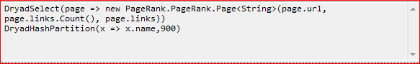

Figure : Stage code

## Stage Vertices

The bottom-middle pane displays information about the selected vertices in the selected stage, as shown in Figure 14. The filtering box at the top of the Stage panes can be used to filter vertices by typing a string, as shown in Figure 13.



Figure 13: Filtering stage contents

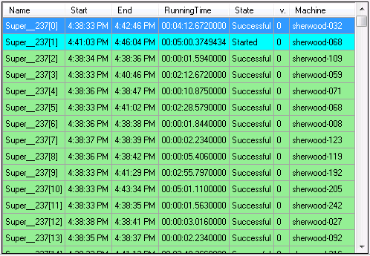

Figure : Stage vertices

Most fields of this table should be self-explanatory.

For fault-tolerance and scheduling reasons Dryad may execute each vertex multiple times. The **v** column displays vertex instance version. For a job to succeed, at least one version of each vertex must succeed. Note that there could be multiple successful versions of the same vertex (for example, when a vertex is re-executed because some of its outputs in a previous execution have been corrupted).

The cancelled vertices have been aborted by the runtime before completion. These do not signal failures. Some vertices may be cancelled before they even start running, and then they do not have an assigned machine.

The user can select a row in the stage vertices table to display further information about the corresponding vertex in the right pane.

## Table views

The user can click on a job input or output in the static job view to display summary information about the table. The information will be displayed in the stage panes, as shown in Figure 15.

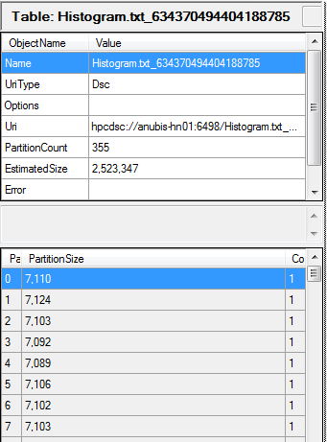

Figure : table view

## Vertex Statistics

The top-right pane displays statistics about the selected vertex.

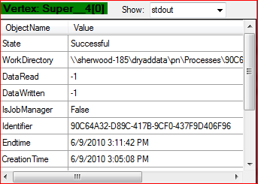

Figure : Vertex statistics

The user can use the combo-box on top next to the vertex name to select additional information to display about the selected vertex.

The options provided in the combo box are:

* Nothing
* Vertex standard output file (stdout). This file normally includes all messages printed on console by the user-level code executed by the vertex. (E.g., the programmer can insert Console.WriteLine() in C#, and their output would be routed to this file.) On some platforms this file may contain the vertex logs as well.
* Vertex standard error file (stderr). On some cluster platforms this file does not exist.
* The logs generated by the vertex runtime (logs). A description of the format of these logs is behind the scope of this paper.
* The work directory of the vertex. Normally this contains all the information necessary to run the vertex, and often the vertex output files as well.
* The set of inputs of the vertex (a brief description of each of the input channels).
* The set of outputs of the vertex (a brief description of each of the output channels).

## Vertex-generated Information

Finally, the bottom-right pane of the browser allows one to inspect some of the state generated by the vertex, as selected by the combo box described above (see Figure 18).



Figure : Filtering vertex-generated information

Figure 17 shows some tools that can be used to find information in the displayed files. The `Find’ box allows the user to quickly search for strings. The `Filter’ button restricts the view to lines that contain the found selection. “Prev” and “Next” navigate through the found matches. Unfortunately there is no `back’ button for this view.

A menu item View/Load file in editor allows the user to load the contents of the pane in an editor of their choice (as indicated by the EDITOR environment variable).

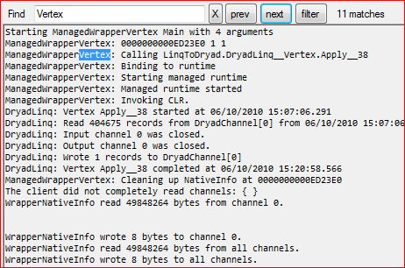

Figure : Inspecting vertex state

The display shown in Figure 18 can contain hyperlinks to additional files and folders:

* clicking on hyperlinks will load their contents in the window
* control-clicking on the hyperlinks will open the hyperlinks using Windows explorer

# Vertex-level operations

The list of vertices provides a set of operations through either the Vertex menu, or through a contextual menu accessible through right-click.

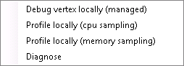

Figure : vertex-level operations.

## Automatic Failure Diagnosis

The job browser contains a module that can be used to attempt to diagnose the reason for the failure of a job. This is invoked from the menu item “Job/Diagnose”. The diagnosis is performed using a decision tree that attempts to find the root cause of a failure by checking various pieces of information in the distributed state.

Figure 20 shows an example output produced by the automatic diagnosis module.

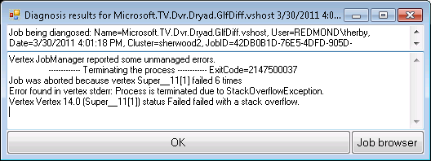

Figure : Output from the automatic diagnosis

## Local debugging

The user can select any vertex in a job that has been started debug it locally on the client workstation.

Local debugging works by copying the entire vertex environment from the cluster to a temporary directory on the local machine, finding the proper pdb (debug information) files on the local machine, and recreating the vertex environment before starting the vertex. At this point the vertex will be rerun by reading its original inputs from the cluster; in the future we may provide the option of also copying the inputs to the local machine for re-execution. Figure 21 shows a debugger attached to a local vertex execution.

The vertices contain a mix of user-written and machine-generated code. In local debugging managed code the vertex should stop hitting a breakpoint, as shown in Figure 21.

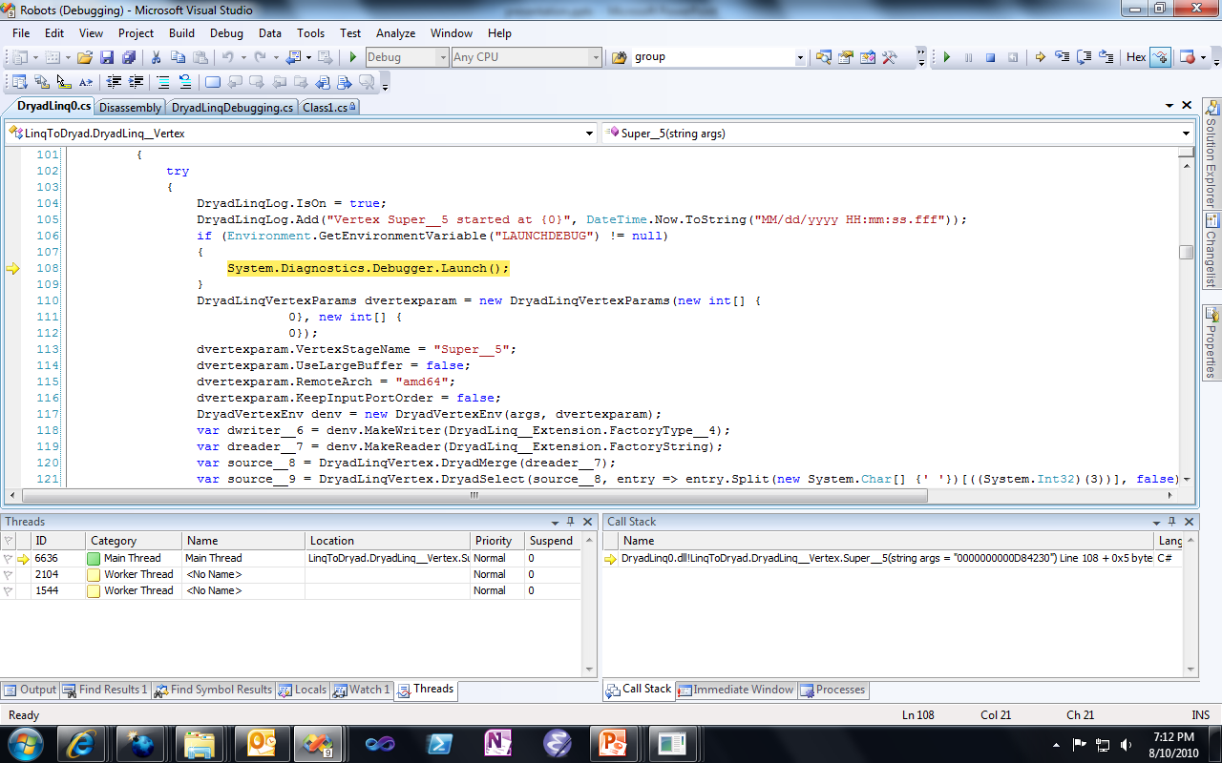

Figure : debugger attached to a locally debugged vertex.

For debugging to work properly the user should be running a debug build on the cluster.

## Local profiling

In order to enable the diagnosis of performance problems the job browser offers a profiling scenario for managed code. From the user point of view this scenario is very similar to local debugging: with one mouse click in the job browser (the menu in Figure 19) the user triggers an execution using the Visual studio profiler; after profiling the user is shown a report generated by Visual Studio, as in Figure 22.

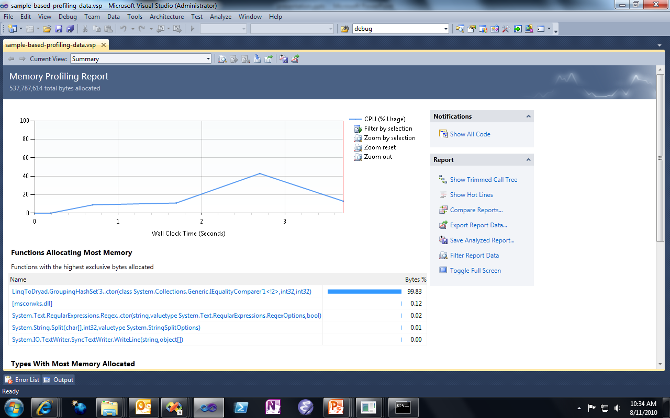

Figure : the result of performing local vertex profiling is a   
Visual Studio performance profile report.