**Analysis of Public Bike Sharing Ridership Data**

horizontal line

# Introduction

This report presents an analysis of public bike-sharing ridership data for the month of January 2022. The dataset contains detailed records of bike trips, including information on trip start and end times, stations, and user types. The objective of this analysis is to uncover patterns in ridership behavior, identify popular stations, and understand factors influencing bike usage.

## Data Overview

The dataset, 202201-divvy-tripdata.csv, includes the following key columns:

* ride_id: Unique identifier for each trip.
* started_at: The date and time when the trip started.
* ended_at: The date and time when the trip ended.
* start_station_name: Name of the station where the trip started.
* end_station_name: Name of the station where the trip ended.
* member_casual: Indicates whether the user is a member or a casual rider.

### Data Cleaning

Before performing any analysis, the dataset was cleaned to ensure accuracy and relevance:

1. **Datetime Conversion:** The started_at and ended_at columns were converted to datetime format for accurate time-based analysis.
2. **Duration Calculation:** The trip duration was calculated in minutes by subtracting started_at from ended_at.
3. **Filtering:** Trips with negative durations or excessively long durations (e.g., over 2 hours) were filtered out to remove potential data entry errors.

**Exploratory Data Analysis(EDA)**

**The following analyses were conducted to explore the data:**

1. **Ridership by Day of the Week:**
   * The number of trips was aggregated by day of the week.
   * Findings: The analysis revealed that ridership peaked on weekdays, with Monday through Friday showing higher usage, likely due to commuting patterns. Weekend ridership was comparatively lower.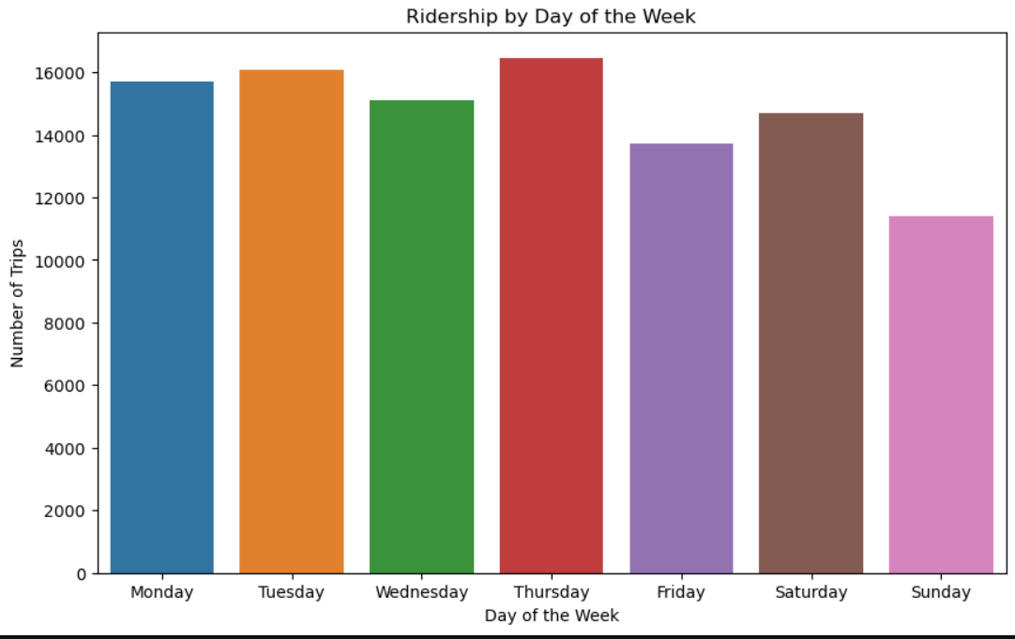

**2.Ridership by Hour of the Day:**

* Trips were aggregated by the hour of the day to identify peak usage times.
* **Findings:** Morning and evening rush hours (8-10 AM and 5-7 PM) showed the highest ridership, indicating that men rely on bike-sharing for commuting.
* 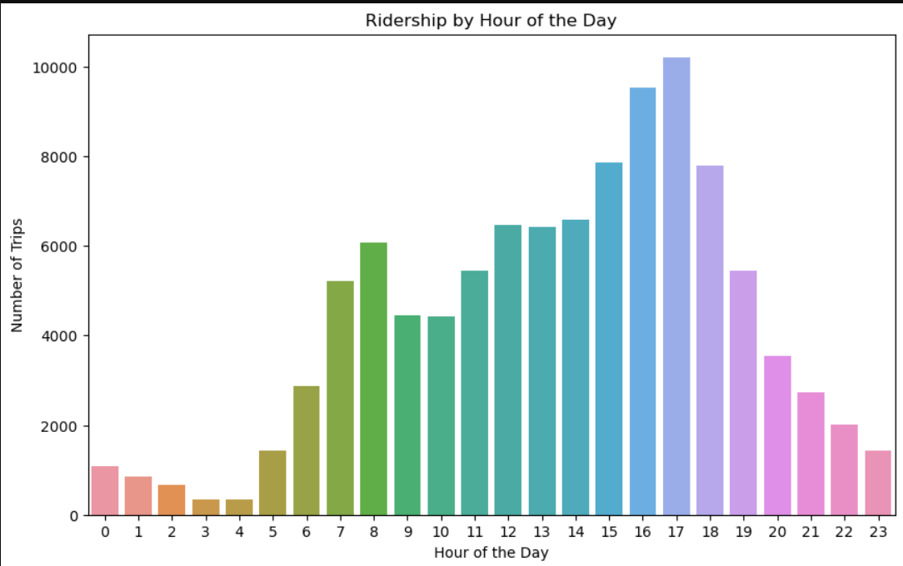

**3. Most Popular Start Stations:**

* The top 10 start stations were identified based on the number of trips originating from each station.
* **Findings:** Central city locations and stations near major transit hubs were among the most popular, highlighting the role of bike-sharing as a complement to public transportation.
* 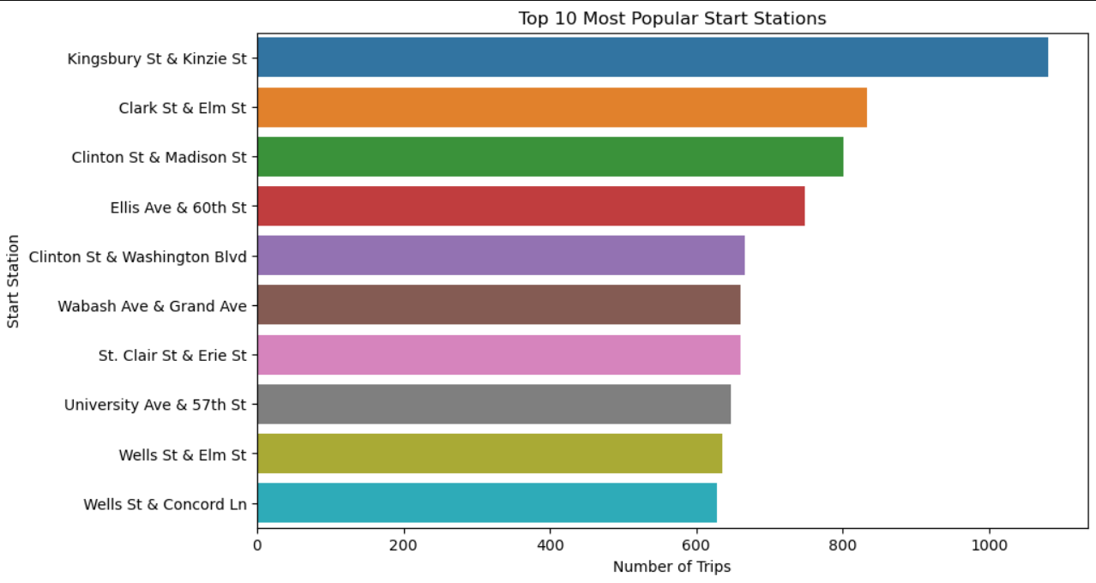

**4.Trip Duration Distribution:**

* A histogram was used to visualize the distribution of trip durations.
* **Findings:** Most trips were short, with durations under 30 minutes. This suggests that bike-sharing is primarily used for quick, short-distance travel.
* 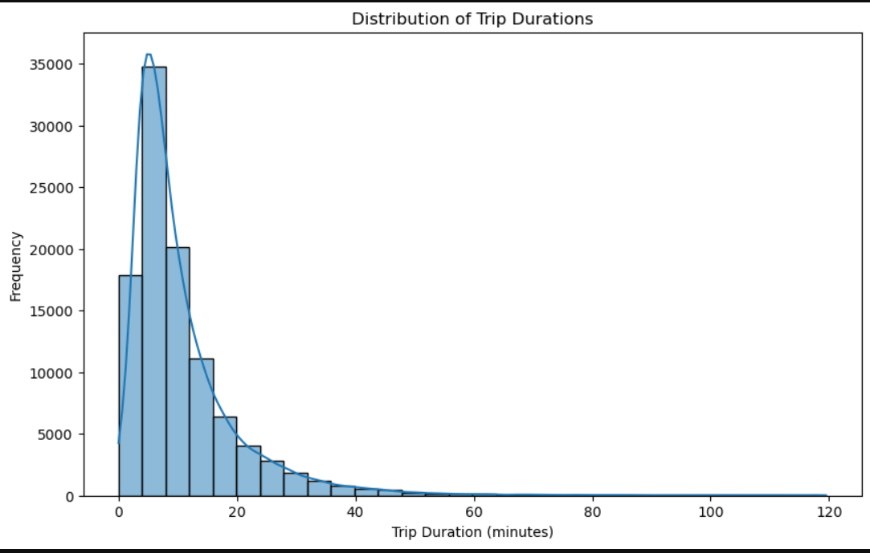

**5.User Type Distribution**

* The dataset was segmented by member_casual to compare usage between members and casual riders.
* **Findings:** Members accounted for a larger share of trips, indicating a strong base of regular users. Casual riders tended to take longer trips, likely for leisure rather than commuting.
* 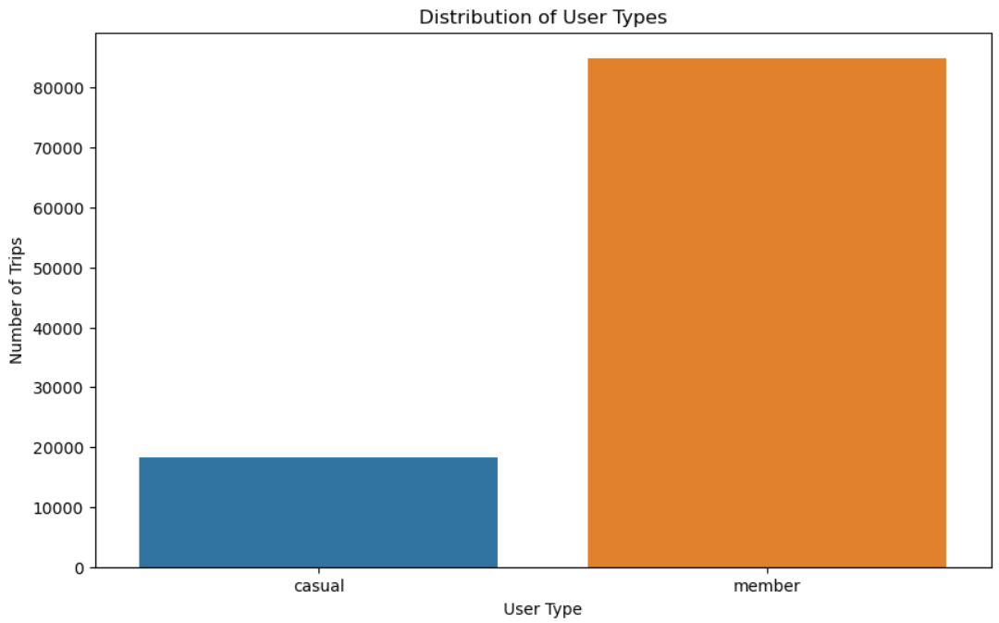

#### **Visualizations**

The analysis was supported by several visualizations:

* **Bar Charts:** For ridership by day of the week and hour of the day.
* **Heatmaps:** To visualize the geographic distribution of trips by station.
* **Histograms:** To show the distribution of trip durations.
* **Pie Charts:** To compare the proportion of member vs. casual riders.

#### **Conclusion**

The analysis of January 2022 bike-sharing data provides valuable insights into ridership patterns and user behavior. The data shows that bike-sharing is heavily utilized for commuting during weekday rush hours, particularly by regular members. Popular stations are often located near public transit hubs, reinforcing the integration of bike-sharing with the broader transportation network. Understanding these patterns can help in optimizing station locations, adjusting bike availability during peak times, and tailoring services to different user segments.

#### **Recommendations**

1. **Optimize Bike Availability:** Increase bike availability at popular stations during peak hours to meet demand.
2. **Promote Casual Usage:** Implement targeted promotions or pricing strategies to attract more casual users, especially on weekends.
3. **Expand Data Analysis:** Conduct further analysis with additional datasets (e.g., weather data) to explore other factors influencing bike-sharing usage.

By continuing to analyze ridership data, bike-sharing services can be better tailored to meet the needs of the community and encourage greater usage, contributing to more sustainable urban mobility.