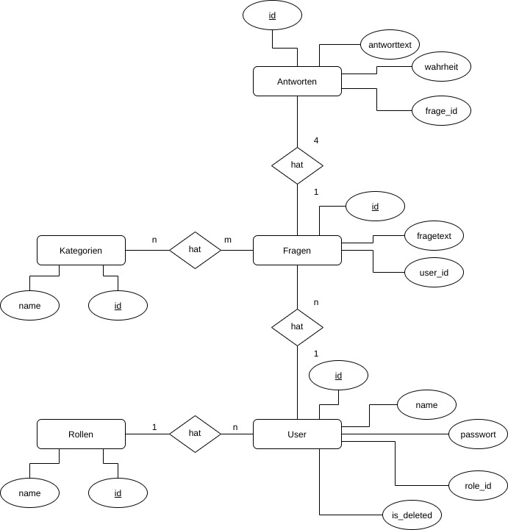

T_Antworten
p_id | antworttext | wahrheit | f_frage_id

T_Fragen
p_id | fragetext | f_user_id

T_Kategorien
p_id | name

T_User
p_id | name | passwort | is_deleted | f_role_id

T_Rollen
p_id | name

T_Frage_Kategorie
pf_frage_id | pf_kategorie_id

