THE UNIVERSITY OF ZAMBIA
School of Natural and Applied Sciences
Department of Computing and Informatics

FINAL YEAR PROJECT PROPOSAL

Academic Year 2026
PROPOSAL TITLE
Intelligent Identity Deduplication Framework for National Registration System
STUDENT DETAILS
First Name | Last Name | Computer No.
NATHAN | SACHITEMBE | 2022090446
SUBMISSION DETAILS
Supervisor | Mr. Martin Phiri
Department | Computer Science
Date of Submission | March 20, 2026

1 Introduction
National identity registration systems serve as the foundational infrastructure of modern governance, enabling states to deliver social services, administer electoral processes, manage taxation, and promote financial inclusion. In Zambia, the National Registration, Passport and Citizenship Authority (NRPCA) administers the National Registration Card (NRC) system, which assigns every citizen aged sixteen and above a unique identity number used across government, financial, and electoral systems [5]. The recent introduction of the Integrated National Registration Information System (INRIS) represents a significant step toward modernising citizen identity management by replacing legacy paper-based processes with digital biometric registration.
However, this digitalisation has surfaced a persistent and nationally consequential data quality problem — duplicate identity records — that existing systems are insufficiently equipped to detect, prevent, or correct. This project proposes an Intelligent Identity Deduplication Framework that directly addresses this problem through a combination of dual-channel AI-driven blocking, Zambian Bantu language phonetic normalisation, quality-adaptive biometric fusion, a post-issuance batch audit scanner, and an explainable administrator resolution interface.
Societal and Governance Stakes
The consequences of duplicate NRC records extend across all levels of Zambian society and government. At the individual level, duplicate records cause identity confusion, denial of social welfare payments, invalidation of voter registration, passport delays, and bank account suspensions. At the national level, duplicate records have been identified as a vector for electoral manipulation, social welfare fraud through ghost beneficiaries, and tax evasion using dual identities — directly threatening the integrity of the Electoral Commission of Zambia's voters' roll [5]. Under international Anti-Money Laundering and Combating the Financing of Terrorism (AML/CFT) frameworks governed by the Financial Action Task Force (FATF), Zambia is obligated to maintain a reliable Know-Your-Customer identity infrastructure; persistent duplicate records expose Zambia to the risk of FATF grey-listing, which would restrict correspondent banking relationships and increase the cost of international financial transactions [9]. At the international level, duplicate identities enable fraudulent passport issuance, undermine border security cooperation with SADC and INTERPOL, and compromise Zambia's standing within the African Union's Continental Identification Framework under Agenda 2063 [9].

1.1 Problem Statement
The integrity of Zambia's national identity infrastructure is being undermined by a specific and measurable problem: duplicate records in the NRC database. This project addresses five taxonomically distinct forms of duplication observed in national identity systems:
- A single citizen appears more than once in the national register — the same person accumulates multiple NRC numbers through re-registration, administrative error, or data entry mistakes.
- Two or more different citizens are assigned the same NRC number — an identity collision caused by system error, data migration failures, or corrupt officer conduct.
- A citizen re-registers with slightly different details at a different district office — producing near-duplicate records that standard exact-match systems fail to detect.
- A citizen presents false or altered identity documents to obtain a second NRC number under a different identity — deliberate biometric fraud that demographic-only systems cannot catch.
- Corrupt officers or system errors create entirely fictitious ghost identities — persons who do not exist registered in the system. Note: ghost identity detection requires anomaly detection on registration behaviour and is explicitly identified as future work. The present framework addresses the four preceding duplication types.

Studies of comparable African identity systems report duplicate rates of one to five percent in newly digitalised databases [5]. At just one percent, Zambia's population of approximately twenty million citizens yields two hundred thousand erroneous records — enough to compromise the Electoral Commission's voters' roll, misdirect social welfare payments, and expose the country to financial compliance risk under international AML/CFT frameworks.
The root causes are multifaceted. Weak biometric matching systems fail to detect the same person registered under different names or profiles [5]. Poor birth registration coverage across rural areas means many applicants lack documentary proof of identity, creating opportunities for fraudulent re-registration. Legacy paper records migrated into INRIS carry structural errors and missing fields that automated systems cannot match [1]. Corruption among registration officers enables deliberate bypassing of system controls. The lack of real-time synchronisation across geographically dispersed offline registration terminals allows duplicates to accumulate before a central cross-check can be performed. Finally, inadequate post-issuance audit and quality control means duplicates — including shared NRC number collisions already present in the database — are never systematically found or corrected.
Despite the deployment of INRIS, current deduplication approaches rely on simple exact-match or single-field rules that cannot detect typographic variants, re-registrations under different names, or deliberate fraud where the same person registers under a completely different identity [1]. Current systems also lack any post-issuance audit capability to identify shared NRC number collisions already resident in the database. A further gap specific to Zambia is that standard string similarity algorithms such as Jaro-Winkler were designed for English names and perform poorly on Zambian Bantu language names, where common variants such as Ng'andu versus Ngandu, or Mwamba versus Mvamba, are treated as different persons rather than the same individual [4].
This project therefore proposes an Intelligent Identity Deduplication Framework that combines dual-channel AI blocking — demographic and biometric — with a Zambian-specific name normalisation layer, quality-adaptive score fusion, a post-issuance batch audit scanner for shared NRC collision detection, and an explainable administrator resolution interface to detect, prevent, and correct duplicate NRC records in Zambia's national registration system.

1.2 Project Aim
Aim Statement: To design, implement, and evaluate a prototype Intelligent Identity Deduplication Framework that detects, prevents, and assists in correcting duplicate citizen identity records in Zambia's National Registration System — using a hybrid pipeline combining dual-channel blocking (LSH/MinHash demographic and FAISS ANN biometric), Zambian Bantu language phonetic normalisation, quality-adaptive score fusion, a post-issuance batch audit scanner for shared NRC number collision detection, and an Explainable AI administrator resolution interface — achieving an overall F1-score of at least 0.85 on a structured synthetic dataset of 1,000 Zambian citizen records containing 50 ground-truth duplicate pairs across five taxonomically distinct duplicate types, within a 17-week development timeline.

1.3 Objectives
The following objectives are structured in SMART format, each specifying a clear action, measurable outcome, timeframe, and validation method.

# | Objective (SMART) | Acceptance Criterion | Phase
01 | To construct a structured synthetic evaluation dataset of 1,000 Zambian citizen records, containing 50 ground-truth duplicate pairs distributed equally across five taxonomic duplicate types — (Type 1) typographic name variants, (Type 2) same face with different demographic identity, (Type 3) date of birth transposition errors, (Type 4) two different persons sharing the same NRC number, and (Type 5) same person submitted simultaneously from two offline terminals — by Week 5, verified using ground-truth label injection scripts and linguistic validation against Zambian census name frequency data. | Dataset generated and validated. Ground-truth labels confirmed against injection scripts. Name distribution validated against Zambian census linguistic data. All five duplicate types represented with 10 pairs each. | Wk 3–5
02 | To design and implement a distributed registration terminal prototype simulating at least three offline-capable district offices with SQLite local storage and cryptographic slot-ID duplicate prevention by Week 7, validated by three independently operating Docker containers each capturing demographics and facial images and syncing to a central server. Slot-ID conflicts arising from concurrent multi-terminal submissions are routed to the administrator review queue as Type 5 duplicate alerts rather than silently rejected. | Three Docker containers running independently, each capturing demographics and face image, storing locally, and syncing to central server. Slot ID prevents duplicate creation during offline window. Type 5 conflict alerts visible in admin dashboard. | Wk 6–7
03 | To implement a dual-channel blocking architecture combining LSH/MinHash demographic blocking with FAISS approximate nearest-neighbour biometric blocking by Week 9, achieving a combined union blocking recall of at least 97%, verified against ground-truth duplicate pairs from the synthetic evaluation dataset. | LSH channel achieves ≥95% blocking recall on Type 1 pairs. FAISS channel achieves ≥90% blocking recall on Type 2 (biometric fraud) pairs. Combined union achieves ≥97% recall. | Wk 8–9
04 | To develop a Zambian Bantu phonetic normalisation pre-processing module by Week 8, addressing apostrophe tonal markers, Bantu prefix variations (Wa-, Ka-, Chi-, Mu-), and consonant equivalence substitutions (Mv→Mw), verified by demonstrating that Jaro-Winkler similarity for Ng'andu versus Ngandu rises from ≤0.82 without normalisation to ≥0.95 after normalisation on a held-out test set of 50 known Bantu name variant pairs. | Jaro-Winkler score for Ng'andu vs Ngandu rises from ≤0.82 to ≥0.95 after normalisation. Module validated against 50 held-out Bantu name variant pairs. | Wk 8
05 | To implement a quality-adaptive score fusion module by Week 9 that dynamically adjusts biometric and demographic weights based on the OpenCV Laplacian variance quality score of the captured facial image, verified by unit tests confirming that the biometric weight w_bio ranges from 0.40 (quality = 0.0) to 0.70 (quality = 1.0) and that composite scores are computed correctly. | w_bio ranges from 0.40 (quality = 0.0) to 0.70 (quality = 1.0). Composite score: composite = w_demo × S_demo + w_bio × S_bio. Verified with unit tests. | Wk 9
06 | To develop a configurable decision module by Week 10 applying composite score thresholds (Clear < 0.55, Review 0.55–0.85, Block > 0.85) that routes records to automated write, human review queue, or fraud flag, verified by a unit test suite that confirms 100% of records are correctly routed and that thresholds are configurable at runtime without code changes. | Decision module correctly routes 100% of records in unit test suite. Thresholds are configurable at runtime without code changes. | Wk 9–10
07 | To build an administrator dashboard with an Explainable AI (XAI) layer by Week 11 that presents field-level Jaro-Winkler scores, cosine similarity score, quality flag, quality-adaptive weight breakdown, duplicate alert type label (Type 1–5), and a natural language system assessment for every duplicate alert, verified by confirming that all six XAI fields are displayed per alert and that merge, reject, and approve resolution actions generate a complete audit log entry. | Dashboard displays all six XAI fields per alert including duplicate type label. Natural language rationale generated for all three decision outcomes. Resolution actions (merge/reject/approve) are functional and generate audit log entries. | Wk 10–11
08 | [NEW] To design and implement a post-issuance batch audit scanner module by Week 11 that queries the master identity database for shared NRC number conflicts — records where the same NRC number is assigned to more than one citizen — runs the biometric scorer on each conflicting pair, and routes confirmed conflicts to the administrator dashboard as Type 4 duplicate alerts, triggered on demand via a manual dashboard control. | SQL query correctly identifies all injected Type 4 shared-NRC pairs in the synthetic dataset. Biometric scorer distinguishes same-person clerical duplicates from different-person identity collisions. Type 4 alerts routed to admin dashboard with full XAI breakdown. Manual trigger confirmed functional. | Wk 10–11
09 | To evaluate the full framework against two defined baseline systems by Week 14 — Baseline A (exact match only) and Baseline B (demographic Jaro-Winkler only) — and produce a comparative evaluation report demonstrating an overall F1-score of at least 0.85, an F1 improvement of at least +0.40 over Baseline A, and at least +0.15 over Baseline B, verified through confusion matrices and per-type F1 scores for all five duplicate types. | Evaluation report with confusion matrices, per-type F1 scores for Types 1–5, and baseline comparison table. Overall F1 ≥0.85 achieved. F1 gain ≥+0.40 over Baseline A and ≥+0.15 over Baseline B. Type 4 precision/recall reported independently. | Wk 12–14

1.4 Scope of the Project

1.4.1 In Scope
- Three simulated offline-capable registration terminals with SQLite storage and slot-ID offline duplicate prevention, with Type 5 conflict alerts routed to the administrator dashboard.
- Dual-channel blocking: LSH/MinHash demographic pipeline and FAISS ANN biometric index operating as independent parallel channels.
- Zambian Bantu phonetic normalisation module — apostrophe normalisation, prefix standardisation, consonant equivalence substitution.
- Jaro-Winkler demographic similarity scoring applied to phonetically normalised fields.
- Pre-trained FaceNet Siamese Neural Network for facial biometric cosine similarity scoring.
- Quality-adaptive weighted composite score fusion module.
- Decision module with three-tier threshold classification (Clear / Human Review / Block).
- Post-issuance batch audit scanner for shared NRC number collision detection (Type 4), triggered on demand via administrator dashboard. [NEW]
- Administrator dashboard with XAI field-level explanation layer, duplicate type label, resolution workflow, and manual batch audit scan trigger.
- Structured synthetic evaluation dataset (1,000 records, 50 duplicate pairs, five types — 10 pairs per type).
- Three-system comparative evaluation with two defined baselines; per-type F1 scores for all five duplicate types.
- Tier 3 Verification Gateway API stub demonstrating external system integration capability.

1.4.2 Out of Scope
- Deployment to live NRPCA or INRIS infrastructure — this is an academic prototype only.
- Fingerprint biometric matching — facial biometrics only in this prototype.
- Real citizen data — all records are synthetically generated using Faker.
- Production-grade security hardening, HSM key management, load balancing, or disaster recovery infrastructure.
- GRO birth register API integration — noted as future work.
- Full monthly automated model recalibration — demonstrated as a single manual run in the evaluation chapter.
- Ghost identity detection — fictitious person creation by corrupt officers requires anomaly detection on registration behaviour patterns rather than record collision detection, and is explicitly identified as future work building on this prototype.

2 Literature Review

2.1 Identity Management and Deduplication in National Systems
Large-scale national identity systems represent one of the most demanding applications of record linkage and deduplication technology. The challenge is characterised by high data volume, demographic name variability, inconsistent data quality across registration terminals, and the high cost of both false positives — wrongly merging distinct citizens — and false negatives — failing to detect true duplicates [1].
Oladipo et al. [5] present an empirical study of biometric deduplication in Nigeria's national data repository — the closest comparable context to Zambia's INRIS — demonstrating that biometric-assisted deduplication can achieve duplicate detection rates above 94 percent when combined with demographic cross-validation. Their findings underscore both the value and the practical limitations of relying solely on biometrics, particularly where capture quality varies across field registration environments. Surana et al. [8] advance this work by demonstrating the use of scalable vector databases for identity deduplication, showing that embedding-based similarity search can process millions of identity records with sub-second candidate retrieval latency. This study directly informs the architectural decision to implement a FAISS-based biometric blocking channel as the second independent candidate generation pathway.
A critical gap in the existing literature is the absence of multi-modal deduplication systems designed for developing-world registration environments, where network connectivity is intermittent, biometric capture quality is variable, and name corpora differ substantially from those used in Western benchmark datasets [5]. A further gap is the absence of post-issuance audit mechanisms for shared NRC number collisions — a form of duplication that cannot be detected at registration time but requires a separate database-scan approach. This project addresses both gaps directly by designing a system whose every component — from Bantu phonetic normalisation to quality-adaptive fusion to the batch audit scanner — is calibrated to the specific operational realities of Zambia's registration infrastructure.

2.2 Blocking and Candidate Generation
A fundamental challenge in large-scale record linkage is the quadratic growth in the number of record pairs requiring comparison. For a database of n records, exhaustive pairwise comparison requires O(n²) operations — computationally infeasible at national scale [2]. Indyk and Motwani [2] established the theoretical foundations for Locality Sensitive Hashing (LSH), a probabilistic blocking technique that maps similar records to the same hash bucket with high probability, reducing the effective comparison space to near-linear. Li and Wang [3] demonstrate that q-gram indexing approaches achieve blocking recall rates above 97 percent on identity databases with realistic name variation. However, demographic-only blocking has a critical limitation: it cannot identify duplicate records where a perpetrator uses an entirely different name and demographic profile while retaining the same biometric identity [5]. This project therefore implements a dual-channel blocking architecture in which a FAISS-based approximate nearest-neighbour search over FaceNet face embeddings [7] operates as an independent second blocking channel. The union of both candidate sets is passed to the ranking stage, ensuring that neither typographic variants nor deliberate identity fraud can evade candidate generation.

2.3 Zambian Bantu Name Normalisation — Original Contribution
Standard string similarity metrics, including Jaro-Winkler distance, were developed and validated primarily against English-language name corpora [10]. Three categories of Bantu name variation systematically degrade matching performance on Zambian demographic data. First, tonal markers expressed through apostrophes — Ng'andu versus Ngandu — are inconsistently recorded across registration terminals. Second, Bantu name prefixes — Wa-, Ka-, Chi-, Mu- — are applied inconsistently, producing variants such as Mwale versus Wale. Third, phonetic equivalences across Bemba, Nyanja, Tonga, and Luvale dialects — Mwamba versus Mvamba — are treated as distinct strings by standard algorithms. Mala and Chinnadurai [4] confirm that Jaro-Winkler outperforms edit distance and Soundex for personal name matching in noisy administrative datasets, but their evaluation is restricted to Latin-script European names. This project extends that work by implementing a Zambian-specific pre-processing layer applied before scoring.
Original Contribution: No published work has addressed phonetic normalisation specifically for Zambian Bantu language names in the context of identity deduplication. This represents a genuine gap in the academic literature that this project addresses as its primary original contribution.

2.4 Demographic Similarity Scoring
The Jaro-Winkler distance metric is widely favoured in identity matching applications due to its sensitivity to transpositions and its prefix-weighting property [10]. Mala and Chinnadurai [4] confirm its superiority over edit distance and Soundex for name matching in noisy administrative datasets, though their evaluation is restricted to European name corpora. The present project applies Jaro-Winkler to phonetically normalised name fields, independently scoring first name, surname, and date of birth before computing a weighted aggregate demographic similarity score S_demo. The prefix-weighting property of Jaro-Winkler is particularly appropriate here because Bantu name variants often differ at interior or terminal positions rather than at the prefix, meaning the algorithm's preference for prefix matches does not penalise legitimate Bantu name pairs.

2.5 Biometric Matching with Siamese Neural Networks
Siamese Neural Networks learn a similarity function over pairs of inputs, mapping facial images to a compact embedding space such that embeddings of the same individual are close while those of different individuals are distant [11]. FaceNet [7], trained using a triplet loss function, produces 128-dimensional embeddings that generalise well to new facial images without requiring fine-tuning on the target population. FaceNet was selected over alternative architectures such as ArcFace and DeepFace because of the wide availability of pre-trained weights, its established benchmark performance, and its compatibility with FAISS indexing for approximate nearest-neighbour search [8]. This project adopts a pre-trained FaceNet model whose embeddings also serve as the basis for the FAISS ANN biometric blocking index — a dual use that provides both candidate generation and precise similarity scoring from a single embedding computation. The same biometric scorer is reused by the batch audit scanner to assess shared NRC number conflicts (Type 4), allowing the system to distinguish same-person clerical duplicates from genuine identity collisions without duplicating the embedding infrastructure.

2.6 Decision Fusion and Threshold Calibration
The combination of demographic and biometric similarity scores into a final duplicate decision requires a fusion strategy. Weighted linear combination of normalised similarity scores is the most common approach in operational identity systems, with weights determined empirically through threshold calibration on labelled training pairs [1]. The duplicate decision boundary can be tuned to prioritise recall (minimising missed duplicates) or precision (minimising false alarms), depending on the operational context. In this prototype, weights and thresholds will be calibrated against a synthetic ground-truth dataset containing known duplicate pairs, using the F1-score as the primary optimisation metric to balance precision and recall [1].

2.7 Quality-Adaptive Score Fusion
A critical limitation of static fusion weights in field-deployed systems is insensitivity to biometric capture quality variation [1]. Mobile registration units operating in variable lighting conditions may capture low-quality facial images that produce artificially low similarity scores for genuine persons. OpenCV's Laplacian variance operator was selected as the quality metric because it directly measures image sharpness through second-order intensity gradients, is computationally efficient, and has been widely applied in biometric pre-processing pipelines [8]. This project implements a quality-adaptive fusion mechanism in which the biometric weight is dynamically scaled by the OpenCV Laplacian variance quality score, directly addressing the biometric capture failure root cause identified in the problem statement.

2.8 Post-Issuance Audit and Shared NRC Collision Detection
A form of duplication not addressed by registration-time pipelines is the shared NRC number collision, in which two or more different citizens have been assigned the same NRC number through system error, data migration failure, or corrupt officer conduct. Christen [1] identifies post-issuance audit as a necessary complement to real-time deduplication in operational identity systems, noting that legacy data migration processes routinely introduce collision-type errors that cannot be detected at the point of new record ingestion. This project addresses this gap through a dedicated batch audit scanner module that queries the master PostgreSQL database for NRC numbers appearing more than once, applies the existing biometric scorer to each conflicting pair, and routes confirmed identity collisions to the administrator dashboard as Type 4 duplicate alerts. This component closes the post-issuance audit gap identified in the problem statement without requiring any additional algorithmic infrastructure beyond what the registration-time pipeline already provides.

2.9 Explainable AI in High-Stakes Decision Systems
The deployment of AI systems in identity administration contexts raises requirements for transparency and explainability that go beyond technical performance metrics. Ribeiro et al. [6] introduce LIME as a general framework for explaining individual model predictions, demonstrating that end users make better decisions when provided with structured rationales alongside model outputs. In the deduplication context, explainability is achieved through structured field-level score decomposition — presenting administrators with individual Jaro-Winkler scores per demographic field, the cosine similarity score for the face embedding, the quality-adaptive weight applied, the duplicate type label, and a natural language system assessment. This approach directly realises the ethical transparency commitment described in Section 3.3 and ensures that every automated decision is auditable and contestable by a qualified human administrator.

3 Proposed Methodology
The Unified Process (UP) development methodology is adopted for this project. UP is an iterative, use-case-driven framework that structures development into repeated elaboration cycles, each producing a working increment of the system that can be evaluated and refined before the next cycle begins [1]. UP was selected over alternative methodologies such as Waterfall and Scrum for three reasons that are directly relevant to this project. First, its iterative and risk-driven nature allows algorithm parameters — particularly LSH band/row configuration, FAISS nprobe settings, and quality-adaptive fusion weights — to be tuned against evolving ground-truth data across successive iterations rather than being committed to in a single design phase. Second, its use-case-driven elaboration model maps naturally onto the modular architecture of this system, in which the registration terminal, deduplication engine, batch audit scanner, and XAI dashboard can be developed and tested independently before integration. Third, UP's explicit treatment of architectural risk in early iterations is appropriate for a project whose core technical risk — whether FAISS biometric blocking can achieve 90% recall on synthetic facial images — must be resolved before the full pipeline is committed to implementation.

3.1 System Architecture
The framework is structured as a three-tier distributed system designed to mirror the operational realities of national identity registration in Zambia: geographically dispersed registration points, intermittent network connectivity, and high-volume record ingestion during mass enrollment campaigns [5].

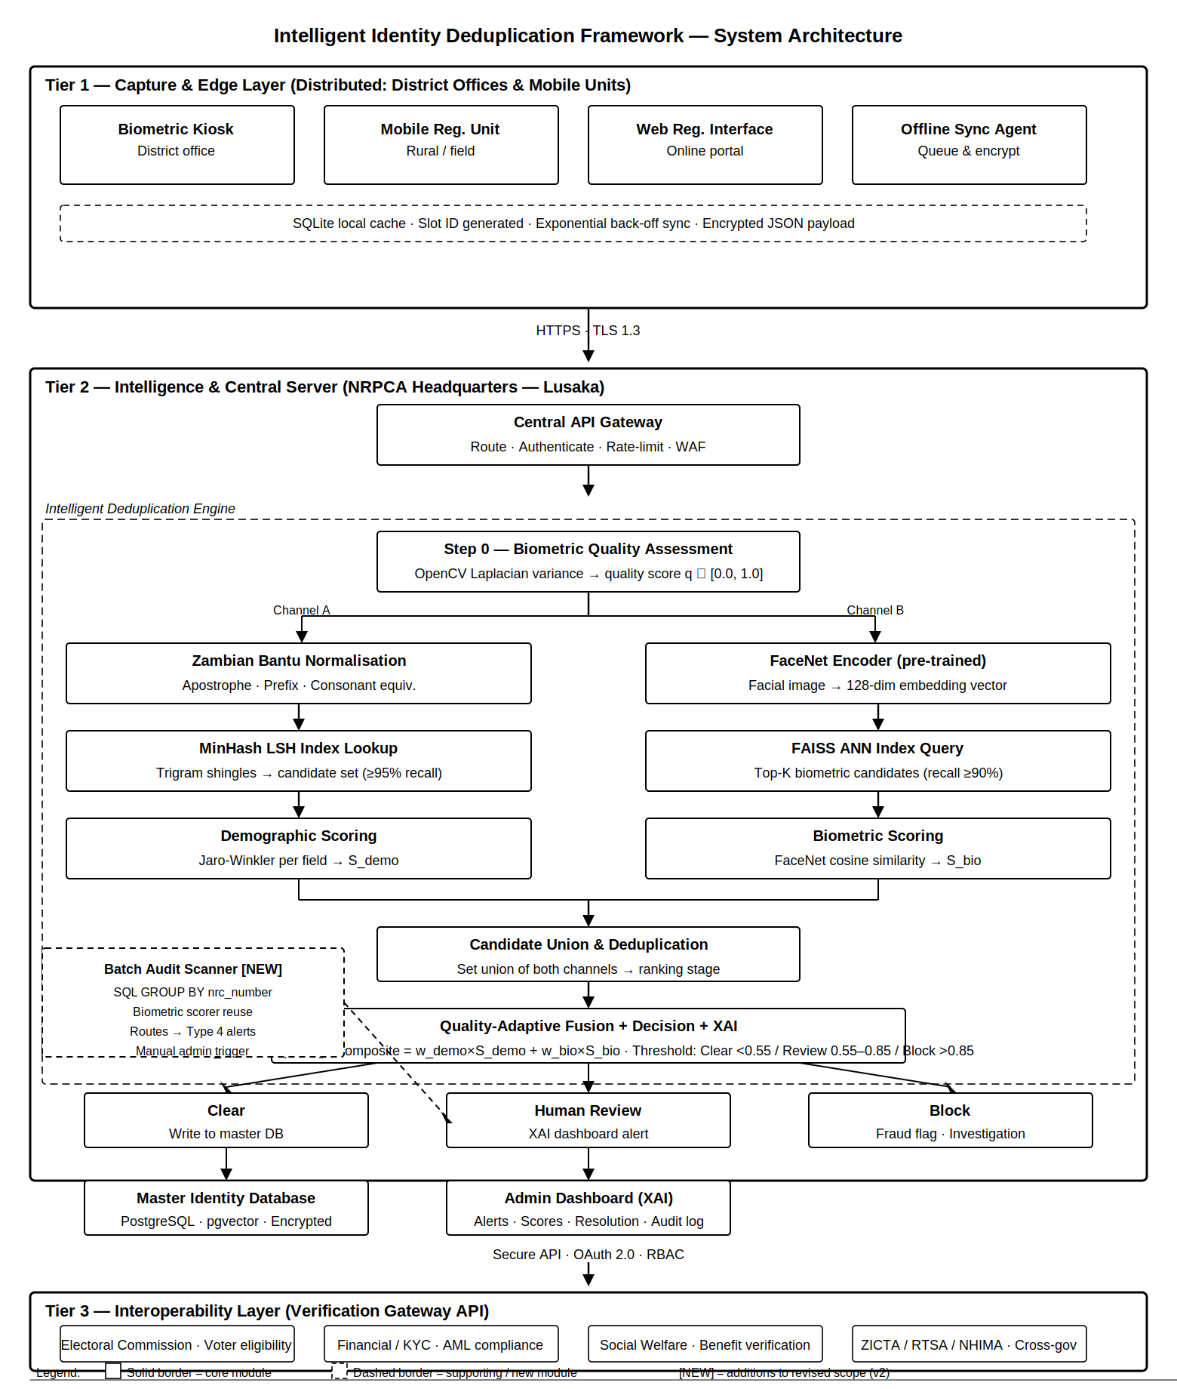Figure 1: system architecture overview

3.1.1 Tier 1: Registration Terminals
Registration terminals simulate district registration offices or mobile registration units. Each terminal operates in offline-first mode, persisting records to a local SQLite database until connectivity is available. On capturing a registration, the terminal generates a cryptographic slot identifier using Python's uuid and hashlib libraries. This slot ID is a globally unique reservation in the central database, ensuring that a citizen who visits two different terminals during an offline window cannot create two separate NRC records — the second terminal's slot submission will be flagged as a conflict upon synchronisation and routed to the administrator review queue as a Type 5 duplicate alert.
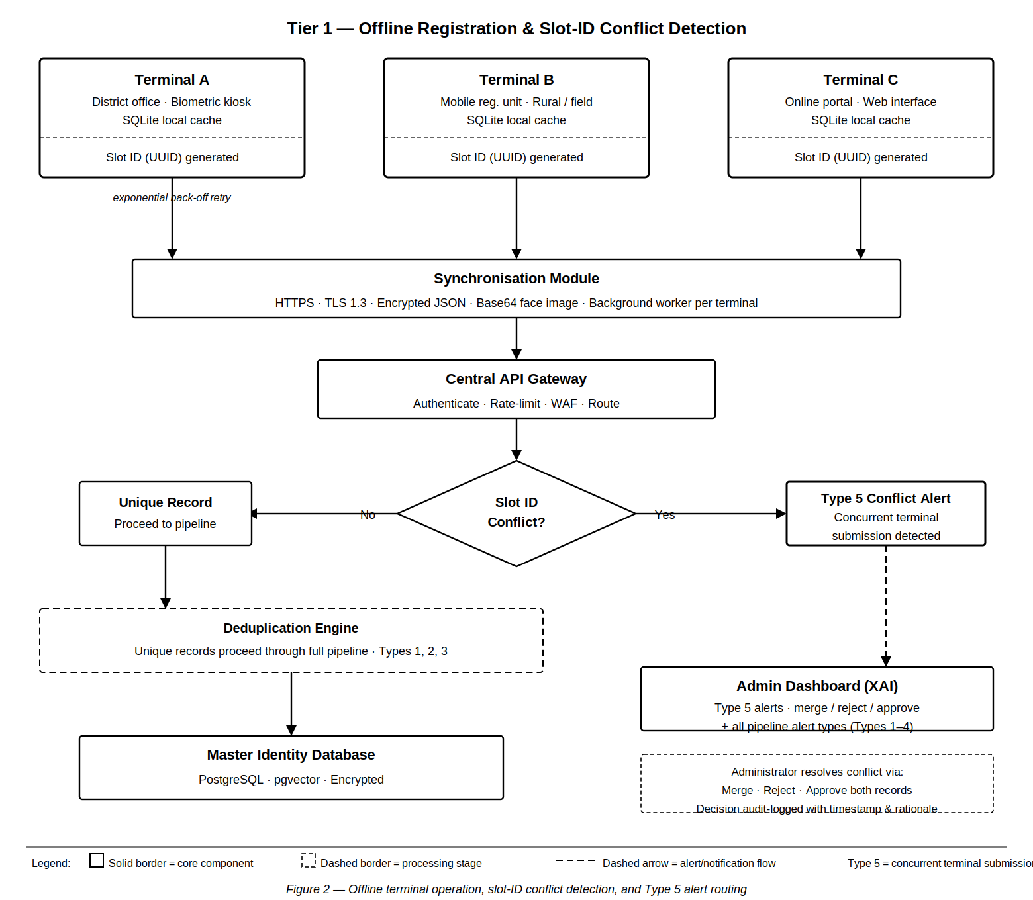Figure 2: Tier 1 overview

3.1.2 Synchronisation Module
A background worker on each terminal monitors connectivity and transmits queued records over HTTPS as JSON payloads with Base64-encoded facial images. An exponential back-off retry strategy handles intermittent connectivity. Slot ID conflicts received from multiple terminals for the same citizen are automatically routed to the administrator review queue as Type 5 alerts rather than silently creating a duplicate record, ensuring the administrator has full visibility of concurrent terminal submission events.

3.1.3 Tier 2: Central Server (Identity Intelligence Hub)
The central server hosts the primary PostgreSQL identity database and the Intelligent Deduplication Engine — the technical core of this project. On receipt of a synchronised record from a Tier 1 terminal, the Central API Gateway authenticates the request, applies rate limiting and Web Application Firewall (WAF) protection, and routes the record through the deduplication pipeline described below. In addition to the registration-time pipeline, the central server hosts the batch audit scanner module, which operates independently of incoming record processing and is triggered on demand by the administrator.
Step 0 — Biometric Quality Assessment
Before any matching is attempted, the incoming facial image is assessed for quality using OpenCV's Laplacian variance measure. This produces a quality score q between 0.0 and 1.0 that is stored alongside the record. A low-quality score does not reject the registration — it adjusts how much weight the biometric channel carries in the final fusion decision.
Step 1 — Dual-Channel Blocking
The pipeline runs two independent blocking channels in parallel. Channel A passes the incoming demographic fields through the Zambian Bantu phonetic normalisation module before computing a MinHash signature and querying the LSH index [2], returning a set of demographically similar candidate records with a target blocking recall of at least 95 percent. Channel B passes the facial image through the pre-trained FaceNet encoder [7] to produce a 128-dimensional embedding vector, which is queried against the FAISS approximate nearest-neighbour index [8] to return biometrically similar candidates with a target recall of at least 90 percent. The two candidate sets are merged into a single deduplicated union.
Step 2 — AI Ranking
Each candidate in the union is scored against the incoming record using two independent measures. The demographic scorer applies Jaro-Winkler similarity [10] to the phonetically normalised first name, surname, and date of birth fields, producing an aggregate demographic similarity score S_demo. The biometric scorer computes cosine similarity between the incoming FaceNet embedding and the stored embedding of each candidate, producing a biometric similarity score S_bio.
Step 3 — Quality-Adaptive Fusion
The two scores are combined using a quality-adaptive weighted formula [1]. The biometric weight is calculated as w_bio = 0.4 + (0.3 × q), giving it a range of 0.40 when image quality is poor to 0.70 when image quality is high. The demographic weight takes the remainder: w_demo = 1.0 − w_bio. The composite score is then computed as composite = (w_demo × S_demo) + (w_bio × S_bio).
Step 4 — Decision Module and XAI Dashboard
The composite score is evaluated against two calibrated thresholds. Records scoring below 0.55 are classified as unique and written directly to the Master Identity Database. Records scoring between 0.55 and 0.85 are flagged as probable duplicates and routed to the administrator review queue. Records scoring above 0.85 are blocked and flagged for fraud investigation. Every alert is accompanied by a structured Explainable AI payload presenting the individual field-level scores, the quality-adaptive weights applied, the duplicate type label (Type 1, 2, or 3 for registration-time detections), and a natural language system assessment [6].
Step 5 — Post-Issuance Batch Audit Scanner (Type 4 Detection) [NEW]
Operating independently of the registration-time pipeline, the batch audit scanner is triggered on demand by the administrator via a dashboard control. The scanner executes a SQL GROUP BY query on the nrc_number field of the master identity database, identifying all NRC numbers assigned to more than one citizen record. For each conflicting pair, the existing biometric scorer computes cosine similarity between the stored FaceNet embeddings. Pairs with low cosine similarity — indicating different individuals — are confirmed as Type 4 identity collisions and routed to the administrator dashboard with a full XAI breakdown. Pairs with high cosine similarity indicate same-person clerical duplicates and are routed accordingly. No new algorithmic infrastructure is required; the batch scanner reuses the biometric scorer already present in the deduplication engine.
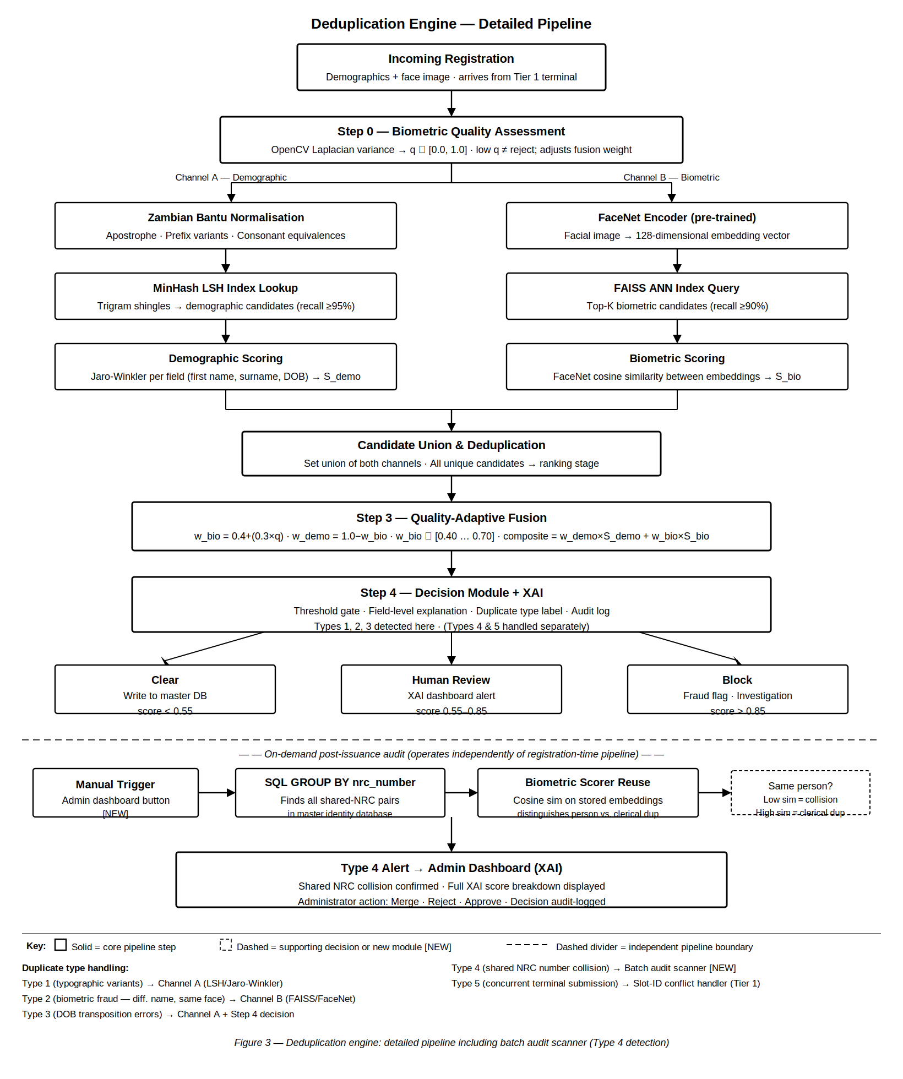Figure 3: AI pipeline Deduplication Engine

3.1.4 Duplicate Alert and Administrator Resolution Workflow
When a potential duplicate is flagged — whether by the registration-time pipeline (Types 1, 2, 3) or the batch audit scanner (Type 4) or the slot-ID conflict handler (Type 5) — the system generates a structured alert containing the two candidate records, their individual field-level similarity scores, the composite score, and the duplicate type label. The administrator may take one of three actions:
- Merge records — designating one as the canonical record and archiving the other.
- Reject the new record — if the incoming registration is determined to be fraudulent or erroneous.
- Approve both records — if sufficient evidence indicates they represent distinct individuals.
All decisions are audit-logged with the administrator's identity, timestamp, duplicate type, and resolution rationale.

3.1.5 Tier 3: Interoperability Layer
Tier 3 is the outward-facing interface of the framework — a Flask REST API that allows authorised external systems to verify the validity and uniqueness of an NRC number without requiring direct access to the Master Identity Database. Currently, institutions across Zambia — banks, the Electoral Commission, NHIMA, ZRA, and ZICTA — have no reliable way to verify whether an NRC presented to them is valid, active, or associated with a duplicate record. Tier 3 addresses this by exposing controlled endpoints over HTTPS, secured by OAuth 2.0 authentication and rate limiting. The API never exposes raw citizen data; it returns only verification status, validity flags, and duplicate risk scores. In the prototype, Tier 3 is implemented as a working stub demonstrating the integration capability.

3.2 Tools and Technologies

Category | Technology | Justification
Backend Language | Python 3.11 | Dominant language for ML/AI; rich ecosystem for all required libraries
Backend Framework | Flask | Lightweight; suitable for prototype REST API; easy integration with Python ML stack
Frontend | HTML5, CSS3, JavaScript | Standards-based; no framework dependency; suitable for terminal simulation UI
ML / Deep Learning | TensorFlow 2.x / Keras | Industry standard; pre-trained FaceNet weights available; GPU-optional
Face Embeddings | FaceNet (pre-trained) | 128-dim embeddings; proven generalisation; avoids training from scratch
ANN Biometric Index | FAISS (Facebook AI) | Production-quality ANN search; sub-second retrieval; biometric blocking channel
Demographic Similarity | jellyfish library | Jaro-Winkler implementation; well documented
LSH Blocking | datasketch (Python) | Production-quality MinHash LSH; configurable band/row parameters
Name Normalisation | Custom Python module | Zambian Bantu phonetic normalisation — original contribution; no library exists
Image Processing | OpenCV | Face detection, quality scoring, preprocessing before FaceNet embedding. Laplacian variance chosen for sensitivity to image blur and computational efficiency in resource-constrained environments
Primary Database | PostgreSQL 15 + pgvector | ACID compliance; pgvector extension for embedding vector storage and ANN search; nrc_number index supports batch audit scanner GROUP BY query
Edge Database | SQLite | Zero-configuration; embedded; offline terminal local storage
Development Env. | VS Code + Jupyter Notebook | Rapid prototyping in Jupyter; full system integration in VS Code
Containerisation | Docker / Docker Compose | Reproducible multi-terminal simulation environment
Synthetic Data | Faker + custom Zambian corpus | Generates realistic Zambian citizen records; configurable duplicate injection across all five types

3.3 Ethical and Legal Considerations
The project strictly adheres to the ethical requirements of academic research involving sensitive data domains. Key measures include:
- Synthetic data only — all citizen records are programmatically generated using Faker with a custom Zambian name corpus. No real citizen data is used at any stage.
- Biometric data ethics — synthetic facial images are generated using StyleGAN2-based face synthesis or sourced from permissively licensed synthetic face datasets. No real individual's facial data is used.
- Data minimisation — the prototype captures only the minimum demographic fields required to demonstrate deduplication: name, date of birth, gender, and district.
- Transparency in AI — the composite scoring formula, quality-adaptive weights, threshold values, batch audit scanner query logic, and Bantu normalisation rules are fully documented and presented through the XAI administrator dashboard [6].
- Responsible disclosure — findings regarding duplicate detection rates, algorithm performance, and limitations are reported honestly including failure modes and the explicit boundary around ghost identity detection, in accordance with academic integrity standards.
- Alignment with data protection principles — the system design adheres to data minimisation, purpose limitation, and transparency principles consistent with emerging African data protection frameworks [9].

4 Expected Outcomes
Successful completion of this project will produce the following deliverables and demonstrate the performance characteristics defined below. Each outcome is aligned with a specific objective from Section 1.3 and includes quantifiable success indicators.

4.1 Expected Deliverables

Deliverable | Description | SMART Criterion
D1 — Registration Prototype | Three simulated offline-capable registration terminals in Docker, with SQLite, slot-ID mechanism, sync module, and Central API Gateway. Slot-ID conflicts routed as Type 5 alerts to the admin dashboard. | Specific (O2), Achievable, Time-bound (Wk 6–7)
D2 — Deduplication Engine | Full dual-channel pipeline: LSH + FAISS blocking, Bantu normalisation, Jaro-Winkler scoring, FaceNet cosine similarity, quality-adaptive fusion, decision module. | Specific (O3–O6), Measurable (F1 ≥0.85), Time-bound (Wk 8–10)
D3 — XAI Admin Dashboard | Administrator interface with field-level scores, duplicate type label (Type 1–5), natural language XAI explanations, merge/reject/approve resolution, audit log, and manual batch audit scan trigger. | Specific (O7), Relevant (Governance transparency), Time-bound (Wk 10–11)
D4 — Bantu Normalisation Module | Standalone reusable Python module for Zambian Bantu name phonetic normalisation — documented as original contribution. | Specific (O4), Measurable (Score rise validated), Relevant (original academic work)
D5 — Synthetic Evaluation Dataset | 1,000 records with 50 ground-truth duplicate pairs across five types (10 pairs each): Type 1 typographic variants, Type 2 biometric fraud, Type 3 DOB transposition, Type 4 shared NRC collision, Type 5 concurrent terminal submission. | Specific (O1), Measurable (Ground-truth labels), Time-bound (Wk 3–5)
D6 — Evaluation Report | Precision, recall, F1 per type (Types 1–5); three-system baseline comparison; confusion matrices; Type 4 independently reported; performance analysis. | Measurable (O9), Specific, Time-bound (Wk 12–14)
D7 — Batch Audit Scanner | Post-issuance audit module that queries the master database for shared NRC conflicts (Type 4), runs biometric scoring on conflicting pairs, and routes results to the admin dashboard. Triggered manually via dashboard control. [NEW] | Specific (O8), Achievable, Time-bound (Wk 10–11)
D8 — Tier 3 API Stub | Flask endpoint demonstrating ECZ/KYC/NHIMA integration capability — demonstrative only. | Specific, Achievable, Time-bound (Wk 11)

4.2 Performance Targets
The following quantitative performance targets are set for the full framework. These metrics will be reported in the evaluation report (D6) using precision, recall, F1-score, and confusion matrices per duplicate type, providing a complete basis for validating each objective.

Metric | Target | Rationale
LSH blocking recall (Channel A) | ≥95% | Must not miss true duplicates at the filter stage
FAISS blocking recall (Channel B) | ≥90% | Must not miss biometric-only fraud at filter stage
Combined channel recall | ≥97% | Dual-channel union must exceed either channel alone
Post-ranking precision | ≥80% | Limits unnecessary administrator review burden
Post-ranking recall (overall) | ≥90% | Prioritises detection over false alarm rate
Type 2 recall (biometric fraud) | ≥85% | Specific target for cases only the FAISS channel catches
Type 4 precision (shared NRC — batch scanner) | ≥90% | High precision required: shared NRC collision is a serious integrity violation; false positives cause operational disruption [NEW]
Type 5 detection (concurrent terminal submission) | 100% | Slot-ID mechanism must catch all concurrent dual-terminal submissions deterministically [NEW]
Overall F1-score | ≥0.85 | Balanced effectiveness measure — primary SMART metric
F1 gain over Baseline A | ≥+0.40 | Quantifies contribution over rule-based legacy approach
F1 gain over Baseline B | ≥+0.15 | Quantifies value of biometric channel and Bantu normalisation
Bantu normalisation improvement | ≥+0.10 Jaro-Winkler gain | Validates original linguistic contribution on held-out variant pairs
Processing latency (registration-time pipeline) | < 2 seconds / record | Acceptable for live registration terminal workflow
Batch audit scanner latency | < 30 seconds for 1,000 records | Acceptable for on-demand post-issuance audit triggered by administrator [NEW]

5 Project Timeline

Phase | Weeks | Key Activities | Milestone
Proposal & Inception | 1–2 | Final proposal submission; architecture design; data model; tech stack confirmation. Update problem statement to explicitly include Type 4 (shared NRC collision) and Type 5 (concurrent terminal conflict) as addressed duplicate types. | Approved proposal
Literature Review & Design | 3–5 | Critical literature review; LSH and FAISS proof-of-concept; Bantu normalisation rules design; database schema including nrc_number index and audit_conflicts table for batch scanner; synthetic dataset generation with all five duplicate types (10 pairs each). | Schema finalised; PoCs validated; D5 complete — all five duplicate types represented
Implementation — Infrastructure | 6–7 | Registration terminal UI; SQLite cache; slot-ID mechanism; sync module with Type 5 conflict alert routing to admin queue; Central API Gateway skeleton; Docker Compose environment. | D1 complete — end-to-end data flow working; Type 5 alerts visible in dashboard
Deduplication Engine | 8–9 | LSH indexing pipeline; FAISS ANN index; Bantu normalisation module (D4); Jaro-Winkler scorer; FaceNet embedding integration; quality-adaptive fusion module; decision module. | D2 + D4 complete — full pipeline operational for Types 1, 2, 3
Batch Audit Scanner + Dashboard | 10–11 | Administrator alert dashboard; XAI explanation layer with duplicate type label; resolution workflow; audit logging; batch audit scanner module (D7) — SQL GROUP BY nrc_number, biometric scorer on conflicting pairs, Type 4 alert routing; manual trigger button in dashboard; Tier 3 API stub (D8). | D3 + D7 + D8 complete — all five alert types handled; batch scanner operational
Midway Evaluation | 11 | Supervisor demonstration including live batch scanner finding Type 4 conflicts; feedback collection; algorithm parameter tuning. | Midway sign-off — all objectives O1–O8 verified
Testing & Refinement | 12–13 | Unit and integration testing; per-type precision/recall benchmarking for all five types; three-system baseline comparison; Type 4 independently reported; performance optimisation; evaluation report generation (D6). | D6 complete — F1 ≥0.85 target verified or documented; all five types reported
Report Writing | 14–15 | Final project report; user guide; system demonstration recording. Ghost identity detection positioned explicitly as future work in conclusion. | Draft report submitted
Final Submission | 16 | Final corrections; submission package preparation. | Project submitted

6 Risk Analysis
The following risk register identifies potential project risks, assesses their likelihood and impact, and specifies mitigation strategies.

Risk | Likelihood | Impact | Mitigation Strategy
FaceNet produces poor accuracy on synthetic facial images | Medium | High | Use pre-trained weights; augment synthetic images with noise, blur, and lighting variation to simulate field conditions; fallback to demographic-only deduplication if biometric F1 < 0.70.
FAISS ANN index misses biometric duplicates at blocking stage | Low | High | Tune nprobe parameter on validation set; target ≥90% biometric blocking recall; validate specifically against Type 2 ground-truth pairs before proceeding to ranking stage.
LSH blocking misses typographic duplicates at blocking stage | Low | High | Tune band/row parameters on validation set; target ≥95% demographic blocking recall; validate against Type 1 ground-truth pairs.
Batch audit scanner produces false-positive Type 4 alerts | Low | Medium | Biometric scorer applied to all shared-NRC pairs to distinguish same-person clerical duplicates from genuine identity collisions; high precision target (≥90%) set for Type 4; all alerts reviewed by administrator before any action. [NEW]
Bantu normalisation rules introduce false positives | Medium | Medium | Validate all normalisation rules against a held-out test set of 50 known Zambian name variant pairs before integration; apply normalisation only as pre-processing; rules are configurable at runtime.
Implementation scope too large for 17-week timeline | Medium | Medium | Prioritise core dual-channel pipeline. Batch scanner is ~40 lines of Python reusing existing scoring logic. Tier 3 API is a documented stub (D8). Modular architecture allows partial completion while still producing a meaningful system.
Synthetic dataset does not reflect real Zambian name variation | Medium | Medium | Source Zambian name frequency data from public census reports and University of Zambia linguistic resources; configure Faker with custom name lists; introduce controlled spelling noise for all five duplicate types independently.
High computational cost of FAISS + FaceNet on laptop hardware | Medium | Low | Process embeddings in batch mode; cache computed embeddings to disk; FAISS CPU mode is efficient at prototype scale (~1,000 records); LSH blocking reduces candidate set before biometric comparison is invoked.
Offline sync conflicts between multiple terminals | Low | Medium | Slot-ID mechanism prevents silent duplicate creation; Type 5 conflicts routed to admin dashboard as alerts rather than silently rejected; test with concurrent Docker terminal simulation.
External system dependency failures (e.g. PostgreSQL, Docker networking) | Low | Medium | Use Docker Compose health checks and restart policies; implement graceful degradation to SQLite fallback where applicable; document dependency requirements and tested versions.
Computational resource limitations during FAISS index building | Medium | Low | Pre-compute and persist all FaceNet embeddings to disk before index construction; limit index rebuild frequency; profile memory usage on target hardware during Week 3 proof-of-concept phase.

7 References
[1] P. Christen, Data Matching: Concepts and Techniques for Record Linkage, Entity Resolution, and Duplicate Detection. Berlin: Springer, 2012.
[2] P. Indyk and R. Motwani, "Approximate nearest neighbors: Toward removing the curse of dimensionality," in Proc. 30th Annual ACM Symposium on Theory of Computing, 1998, pp. 604–613.
[3] J. Li and H. Wang, "Efficient identity matching using static pruning q-gram indexing approach," Decision Support Systems, vol. 70, pp. 1–12, 2015.
[4] K. Mala and S. Chinnadurai, "Efficient record de-duplication identifying using the FEBRL framework," IOSR Journal of Computer Engineering, vol. 10, no. 2, pp. 1–6, 2013.
[5] F. Oladipo et al., "Use of biometrics for records deduplication: Case study of the national data repository in Nigeria," Online Journal of Public Health Informatics, 2025.
[6] M. A. Ribeiro, S. Singh, and C. Guestrin, "'Why should I trust you?': Explaining the predictions of any classifier," in Proc. 22nd ACM SIGKDD International Conference on Knowledge Discovery and Data Mining, 2016, pp. 1135–1144.
[7] F. Schroff, D. Kalenichenko, and J. Philbin, "FaceNet: A unified embedding for face recognition and clustering," in Proc. IEEE Conference on Computer Vision and Pattern Recognition (CVPR), 2015, pp. 815–823.
[8] S. Surana et al., "Deduplication of identities using similarity search in scalable vector databases," arXiv Preprint, 2024.
[9] United Nations, "Transforming Our World: The 2030 Agenda for Sustainable Development," UN General Assembly Resolution A/RES/70/1, 2015.
[10] W. E. Winkler, "String comparator metrics and enhanced decision rules in the Fellegi-Sunter model of record linkage," in Proc. Section on Survey Research Methods, American Statistical Association, 1990, pp. 354–359.
[11] X. Zhang et al., "Siamese neural networks for privacy-preserving record linkage," Journal of Information Security and Applications, 2023.

Supervisor Approval
Name: ___________________________________________
Signature: ________________________________________
Date: ____________________________________________

