Arrays
___________________________________________________________________________________
Q. What is array?
________________________________________________________________________________
Array is a collection of similar type of data or it is used for store multiple values in single variable called as array.

How to declare array in JAVA
__________________________________________________________________________________
If we want to declare array in java we have two steps.
1. Declare array: if we want to declare array we have following syntax
Syntax: data type variablename[]; //declaration.
When we declare array in java then array not allocate its memory just create reference variable which is used for store the address of array or store base address of array and by default array reference variable is null.

2. Allocate memory of array: if we allocate memory array we need to use new keyword means when we use new keyword then array variable allocate memory and store 0th location address in reference variable.

Syntax: variablename = new datatype[size];
Example:
int a[]; //reference variable of array
a = new int[5];
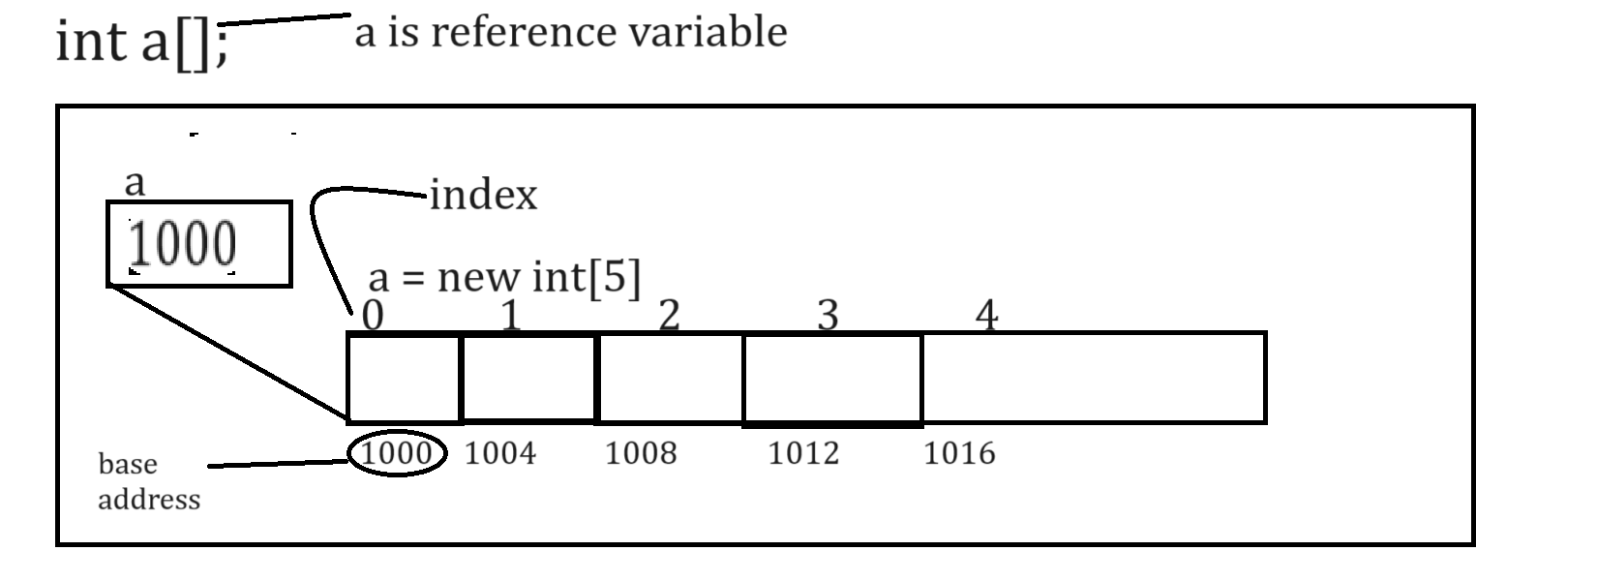
Note: if we think about above memory diagram we have assume or consider 1000 is our base address
and 0 ,1,2,3,4 these are indexes.

Q. What is base address?
_________________________________________________________________
0th index address called as base address.

Q. What is index and Why use index?
index is identity of block in array or value in array and it is used for insert data in array, delete data from array or update data in array or search data from array etc
Note: array index always start from 0th index.
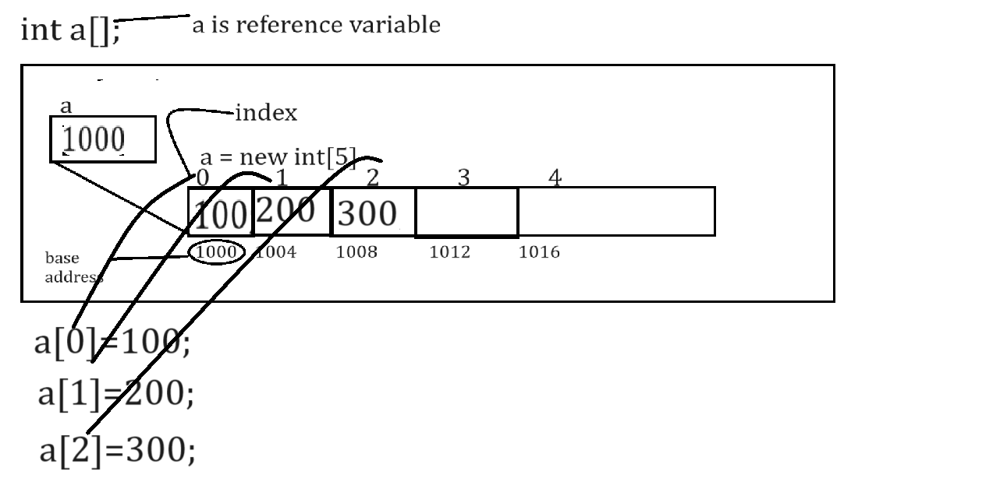
Note: if we think about above diagram we store manually on every index but if we have array size of 100 then we need to write 100 different individual lines of code and it is not possible in real time so better way you can use loop for store data in array or retrieve data from array or perform any other operation on array.
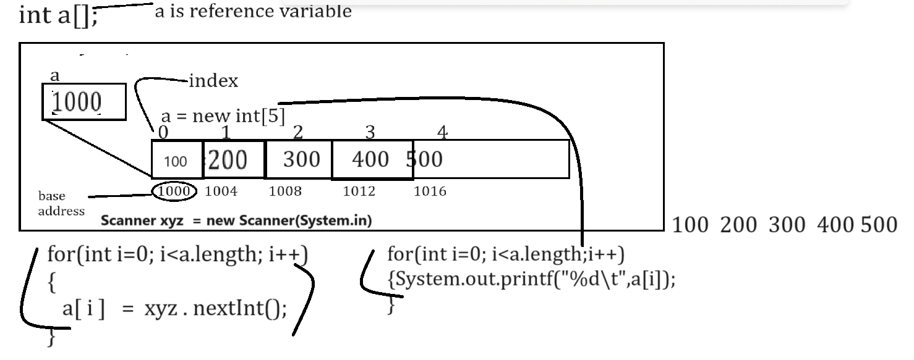
Note: length is constant of array in JAVA which help us to return the size of array
Example with source code
import java.util.*;
public class ArrayApp
{ public static void main(String x[])
{ int a[];//declaration or reference variable of array
a = new int[5];//allocated memory for array.
Scanner xyz = new Scanner(System.in);
System.out.println("Enter values in array");
for(int i=0; i<(a.length-1); i++)
{
a[i]=xyz.nextInt();//store values in array
}
System.out.println("Display array values");
for(int i=0;i<a.length;i++)
{ System.out.printf("%d\t",a[i]);
}
}
}
Note: if we think about above code we can say int a[] is reference variable means it contain address of 0th location
2. when we declare array variable then its default value is null
Q. Can we prove default value of array is null?
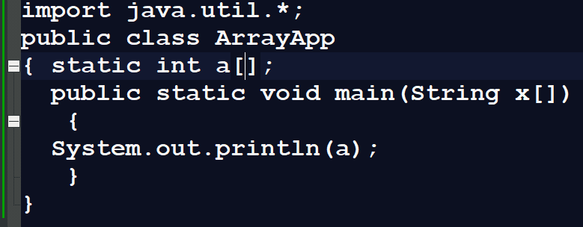
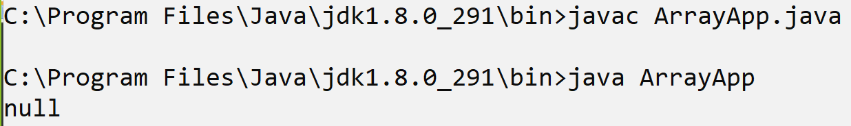
Note: if we think about above code we use array without new keyword then we get its default null
null means variable not points to address in memory.

Q. What happen if we use array without using new keyword?
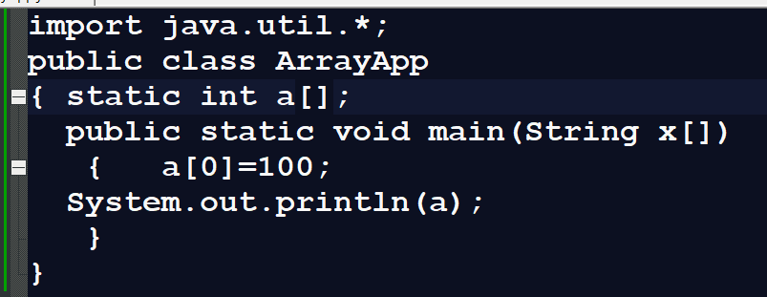
Note: if we use array without using new keyword then we get NullPointerException at program run time because if we want to store value in memory we must have some space or address but if we not use new keyword then there is no memory present so we cannot store values and if we try then we get run time error NullPointerException.

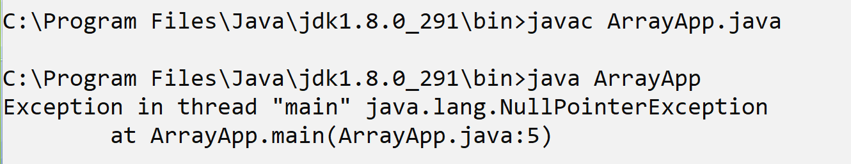
Q. Can we see the address present in reference variable or array variable?
______________________________________________________________________________
Yes we can see the address of reference variable and for that we have System.identitfyHashCode() method

import java.util.*;
public class ArrayApp
{ static int a[];
public static void main(String x[])
{
a= new int[5];
System.out.println("Base address of array is "+System.identityHashCode(a));
}
}
Output
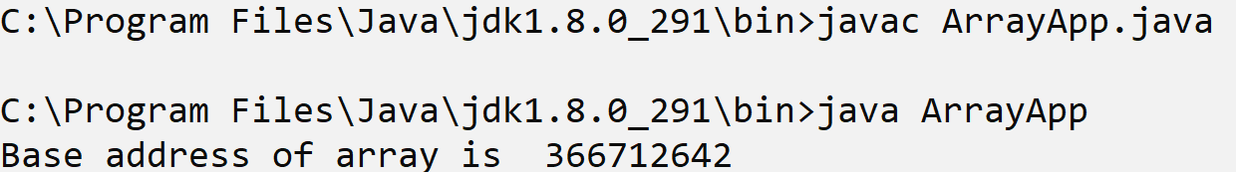

How to initialize array with fix values in JAVA?
_________________________________________________________________________________
If we want to initialize array with fix values in java we have following syntax

Syntax:
int a[]={value1,value2……value…n};
import java.util.*;
public class ArrayApp
{
public static void main(String x[])
{
int a[]={10,20,30,40,50};
System.out.println("Display array values");
for(int i=0;i<a.length;i++)
{ System.out.printf("%d\t",a[i]);
}
}
}
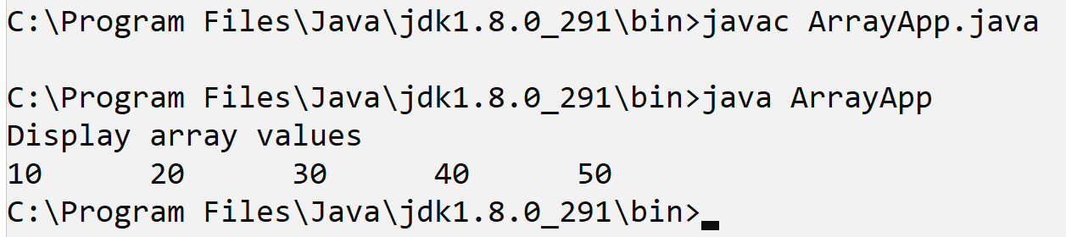

or
int a[]=new int[]{value1,value2…..value…n};

Example with source code
import java.util.*;
public class ArrayApp
{ public static void main(String x[])
{ int a[]=new int[]{10,20,30,40,50};
System.out.println("Display array values");
for(int i=0;i<a.length;i++)
{ System.out.printf("%d\t",a[i]);
}
}
}
Output
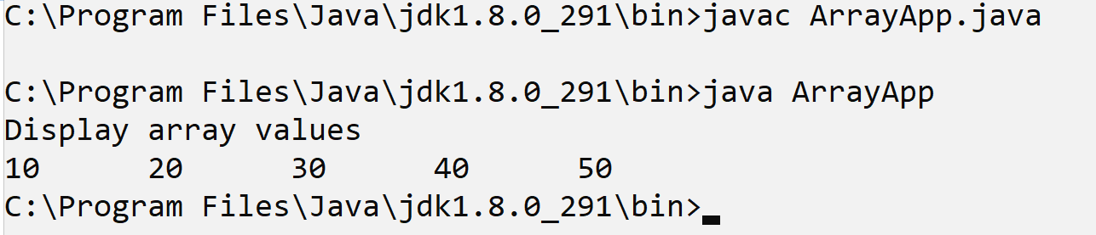
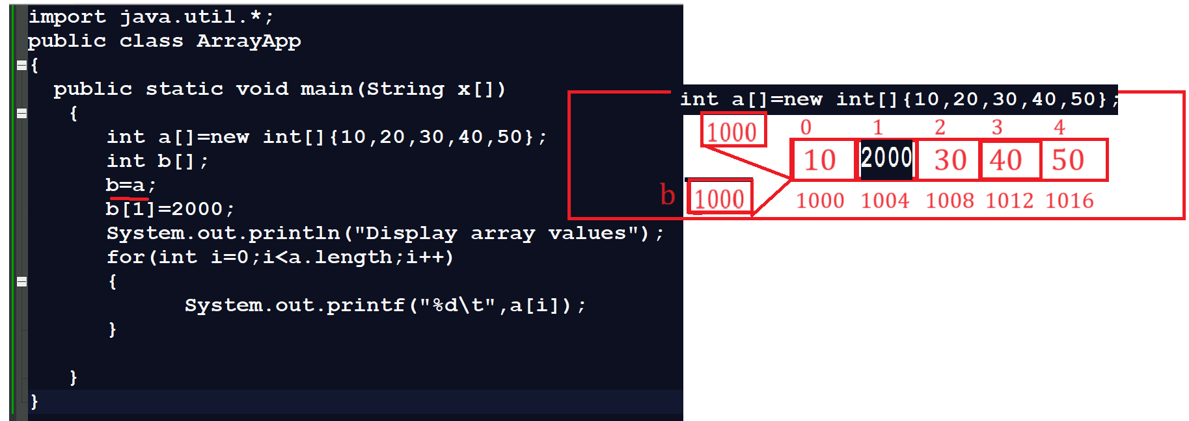
Assignments
________________________________________________________________________
Q1. WAP to create array of size 5 and find the max and min value from array?
Q2. WAP to create array of size 5 and input single value from keyboard and search value present in array or not?
Q3. WAP to create array of size 5 and reverse it means shift value of its index?
Q4. WAP to create array of size 5 and arrange all in ascending and descending order?
Q5. WAP to create array of size 5 and calculate sum of all values.

Example: 10 20 30 40 50 = 150

Array Declaration ways
_____________________________________________________________________________
Syntax: datatype variablename[]; : this syntax help us to declare specific variable as array.
or
datatype []variablename: this syntax help us to declare all variable as array in that particular statement.

Example:
int a[],b,c,d[]; here a and d are array variable and b,c is normal variable
Means when we want to declare specific variable as array then we can use this approach.
or
int []a,b,c,d; all four variables are array variable.
means when we want to declare more than one variable as array of same type then we can use this approach

Example:
public class ArrayApp
{
public static void main(String x[])
{
int []a={10,20,30,40,50};
System.out.println("display array");
for(int i=0;i<a.length;i++)
{
System.out.printf("%d\t",a[i]);
}
}
}

Two dimensional arrays in JAVA
_____________________________________________________________________________
Two dimensional array is used for create the matrix but it is not matrix internally it is sequential block of memory and every block has two digit index.

Syntax of declare two dimensional array
1. datatype variablename[][];
or
datatype[][] variablename;
or
datatype[] variablename[];

Example:
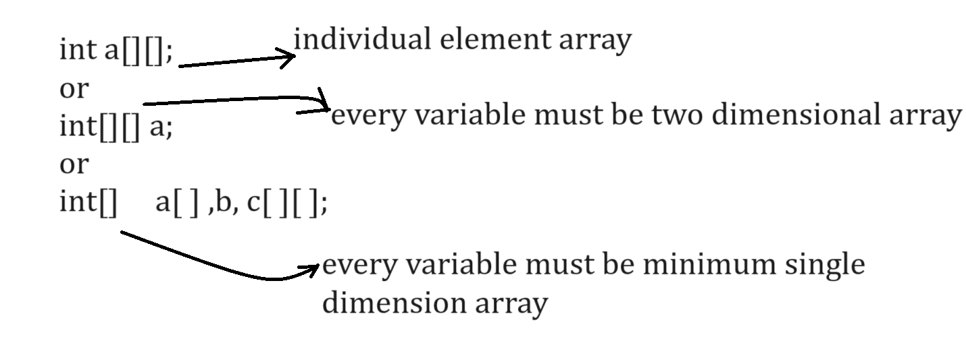

How two dimensional arrays stored in memory
_______________________________________________________________________
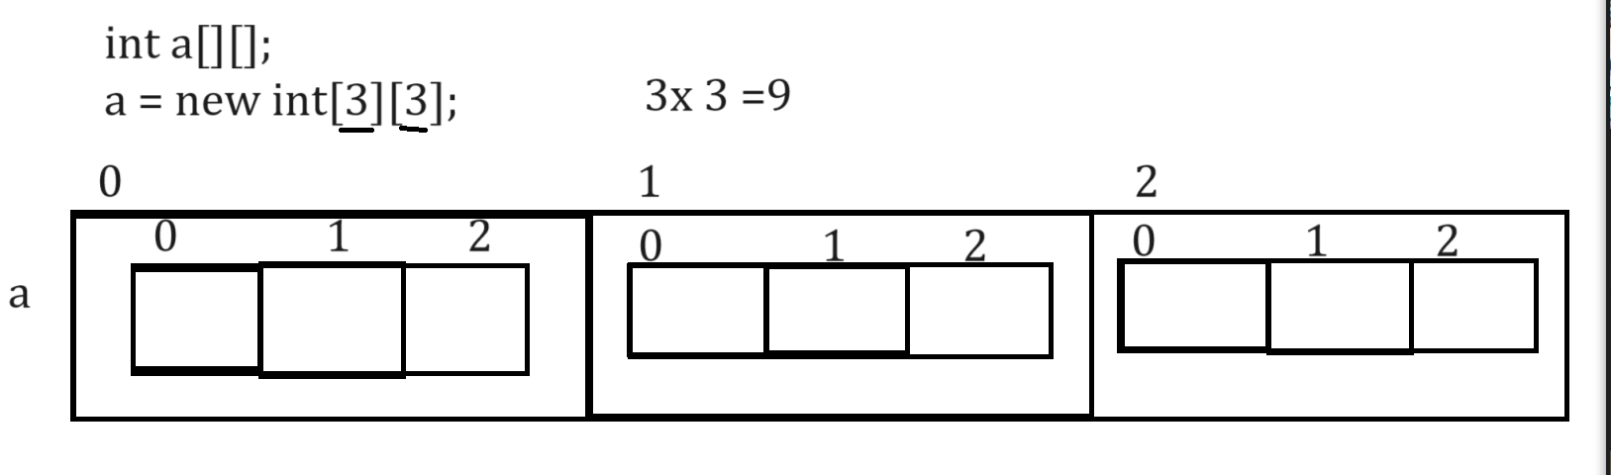
Example with source code
public class ArrayApp
{ public static void main(String []x)
{ int a[][]=new int[3][3];
System.out.println("Size of a[0] "+a[0].length);
System.out.println("Size of a[1] "+a[1].length);
System.out.println("Size of a[2] "+a[2].length);
System.out.println("total size of a "+(a[0].length+a[1].length+a[2].length));
}
}
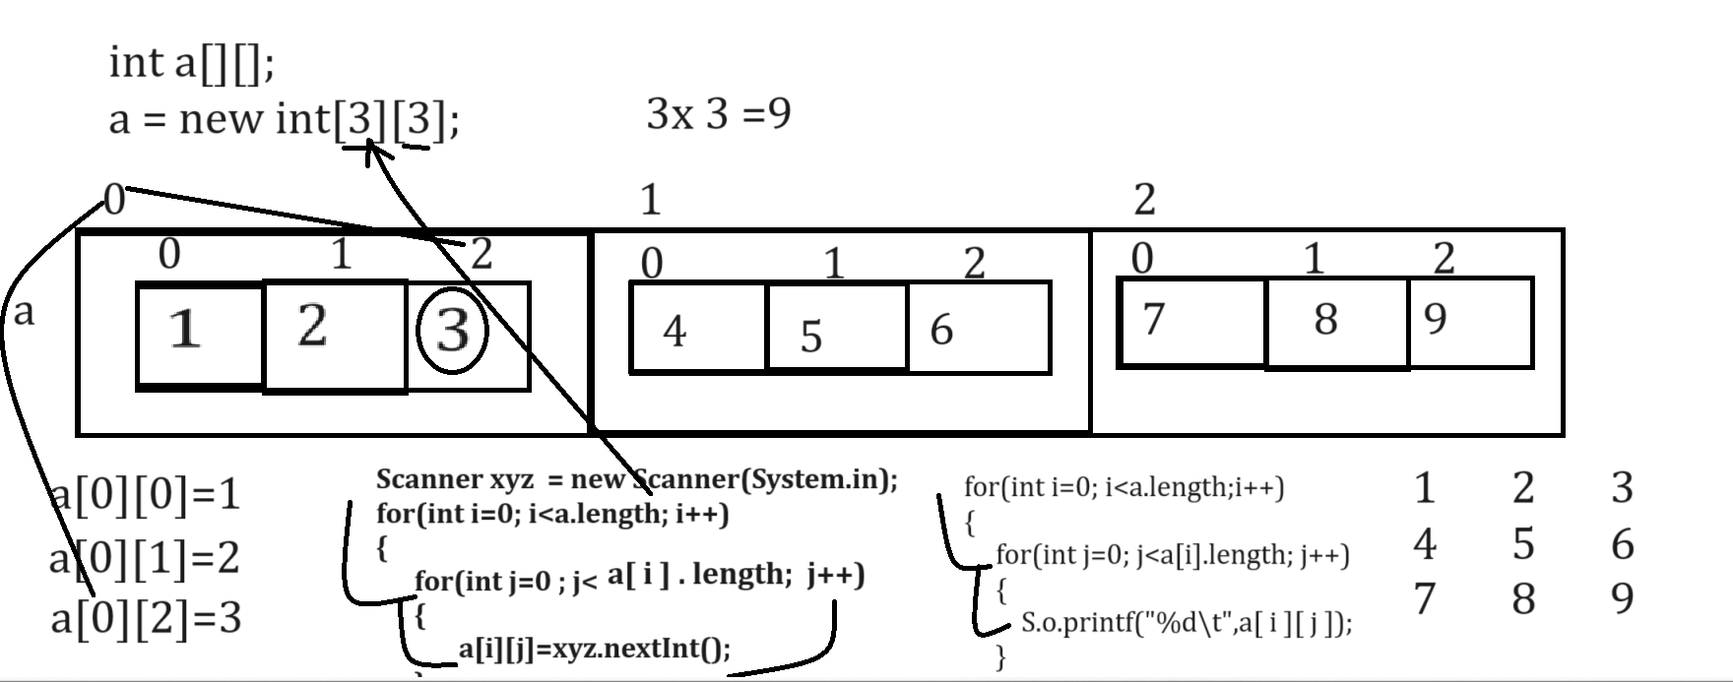
Example with source code
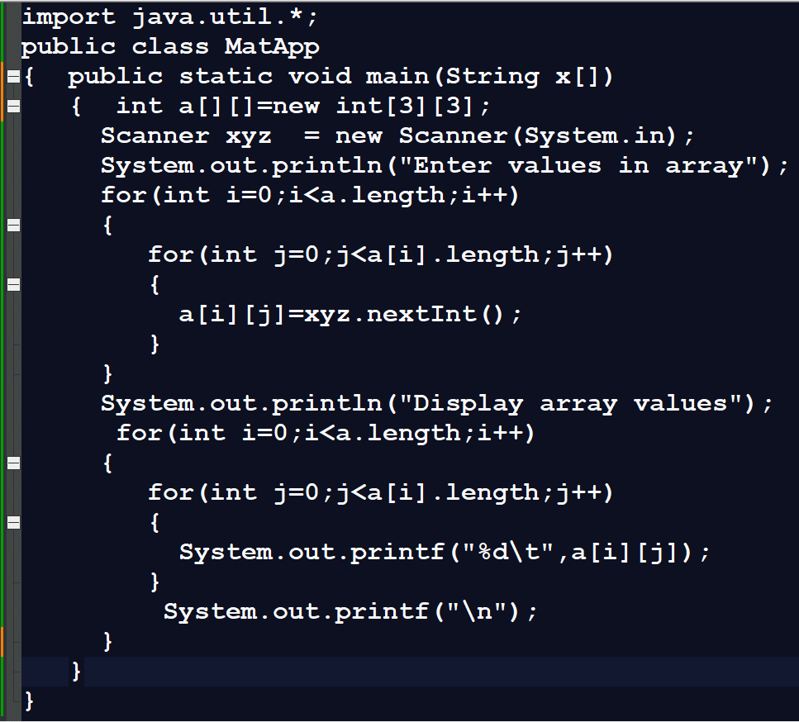
Output
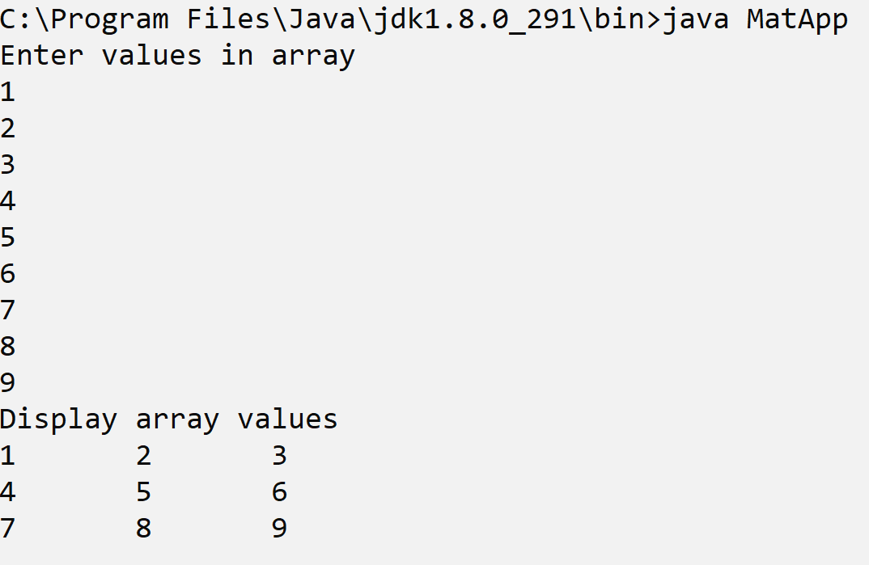
Jagged Array
____________________________________________________________________
Jagged Array is facility in Java where we can create matrix every row having different column list.

How to use Jagged Array Practically
_______________________________________________________________________
Syntax:
datatype variablename[][] = new datatype[row][];
a[rowindex]=new datatype[colsize];
Example: we want to create matrix like as
1 2 3
4 5 6 7
8 9
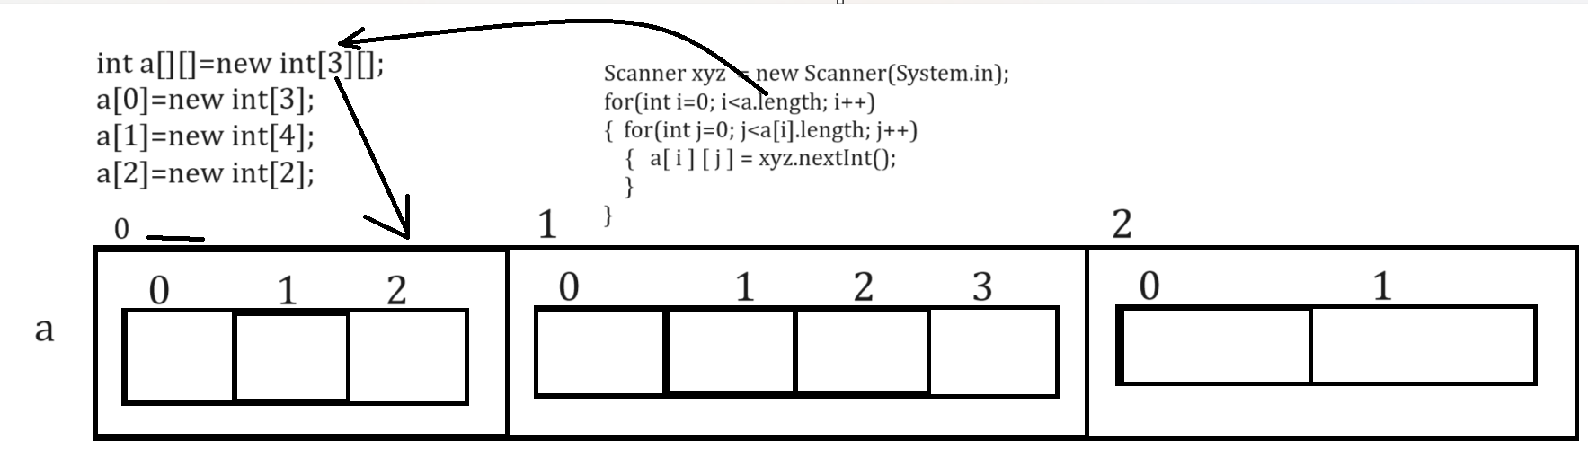

Example with source code
import java.util.*;
public class MatApp
{ public static void main(String x[])
{ int a[][]=new int[3][];
a[0]=new int[3];
a[1]=new int[4];
a[2]=new int[2];
Scanner xyz = new Scanner(System.in);
System.out.println("Enter values in array");
for(int i=0;i<a.length;i++)
{
for(int j=0;j<a[i].length;j++)
{
a[i][j]=xyz.nextInt();
}
}
System.out.println("Display array values");
for(int i=0;i<a.length;i++)
{
for(int j=0;j<a[i].length;j++)
{
System.out.printf("%d\t",a[i][j]);
}
System.out.printf("\n");
}
}
}
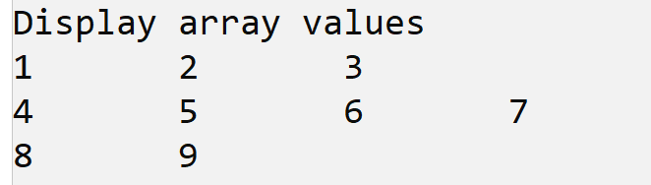

How to initialize two dimensional arrays in JAVA
___________________________________________________________________________
Initialization means to fix the values in array called as initialization
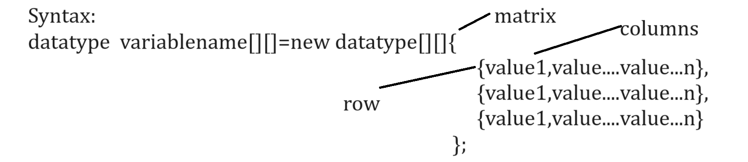

Example with source code
import java.util.*;
public class MatApp
{ public static void main(String x[])
{ int a[][]=new int[][]{
{1,2,3},
{4,5,6},
{7,8,9}
};
System.out.println("Display array values");
for(int i=0;i<a.length;i++)
{
for(int j=0;j<a[i].length;j++)
{
System.out.printf("%d\t",a[i][j]);
}
System.out.printf("\n");
}
}
}
Output
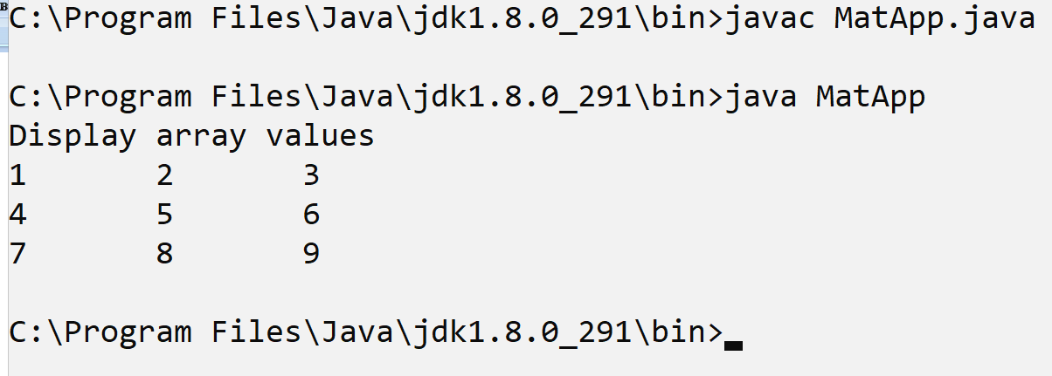
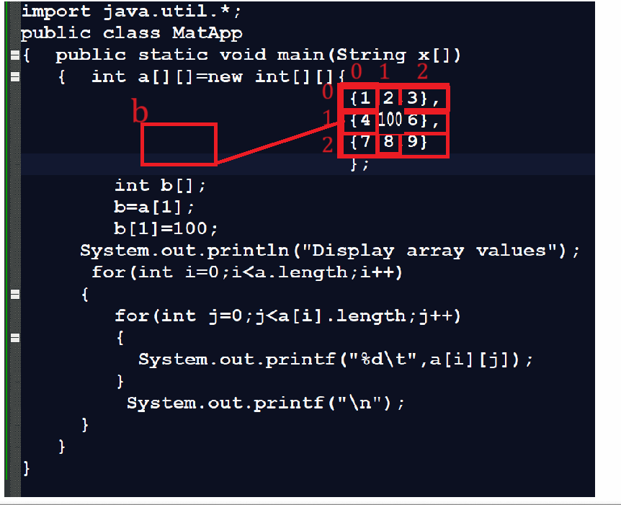

Example: WAP to input five values in array and arrange in ascending order.
______________________________________________________________________________
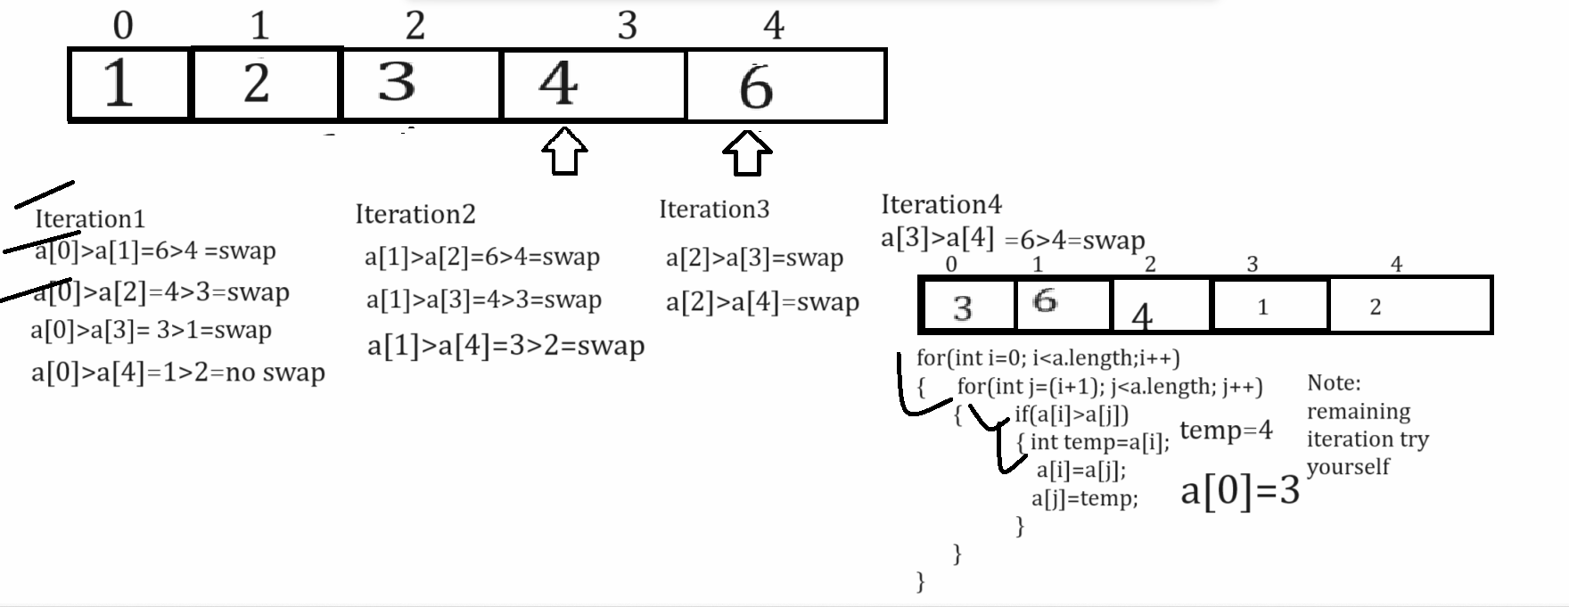

Example with source code
import java.util.*;
public class AscendingApp
{
public static void main(String x[])
{
Scanner xyz = new Scanner(System.in);
int a[]=new int[5];
System.out.println("Enter values in array");
for(int i=0;i<a.length;i++)
{ a[i]=xyz.nextInt();
}
System.out.println("Display array bevore sorting");
for(int i=0;i<a.length;i++)
{ System.out.printf("%d\t",a[i]);
}
//apply ascending order logics
for(int i=0;i<a.length;i++)
{ for(int j=(i+1);j<a.length;j++)
{
if(a[i]>a[j])
{ int temp=a[i];
a[i]=a[j];
a[j]=temp;
}
}
} System.out.printf("\n\n");
System.out.println("Display array values after sorting ");
for(int i=0;i<a.length;i++)
{ System.out.printf("%d\t",a[i]);
}
}
}
Output
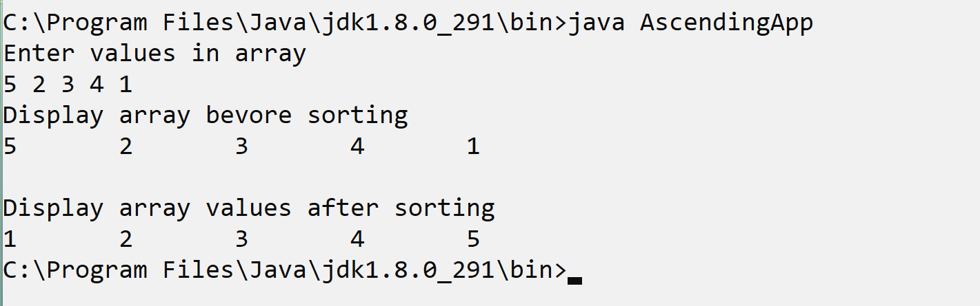

Example: WAP to create array and find second highest value with sorting and without using sorting
___________________________________________________________________________________
Finding second highest value using sorting technique
import java.util.*;
public class AscendingApp
{ public static void main(String x[])
{ Scanner xyz = new Scanner(System.in);
int a[]=new int[5];
System.out.println("Enter values in array");
for(int i=0;i<a.length;i++)
{ a[i]=xyz.nextInt();
}
System.out.println("Display array bevore sorting");
for(int i=0;i<a.length;i++)
{ System.out.printf("%d\t",a[i]);
}
//apply ascending order logics
for(int i=0;i<a.length;i++)
{ for(int j=(i+1);j<a.length;j++)
{ if(a[i]>a[j])
{ int temp=a[i];
a[i]=a[j];
a[j]=temp;
}
}
} System.out.printf("\n\n");
System.out.println("Display array values after sorting ");
for(int i=0;i<a.length;i++)
{ System.out.printf("%d\t",a[i]);
}
int count=0;
for(int i=0;i<a.length; i++)
{ if(a[a.length-1]==a[i])
{ ++count;
}
}
System.out.println("Second highest value of array is "+a[a.length-(count+1)]);
}
}
Finding second highest value without using sorting technique
_____________________________________________________________________________
Note: before finding second highest value first we want to find the highest from array without using sorting and after that we can work logic of second highest
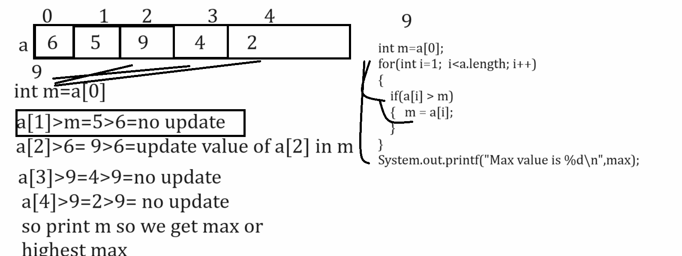

Example with source code
import java.util.*;
public class FindingMaxApp
{
public static void main(String []x)
{
Scanner xyz = new Scanner(System.in);
int a[]=new int[5];
System.out.println("Enter values in array");
for(int i=0;i<a.length;i++)
{
a[i]=xyz.nextInt();
}
int m=a[0];
for(int i=1; i<a.length; i++)
{
if(a[i]>m)
{ m=a[i];
}
}
System.out.printf("Max value is %d\n",m);
}
}

Example: WAP to find the missing elements from sorted array
__________________________________________________________________________________
1 5 9 12 15

Output: 2 3 4 6 7 8 10 11 13 14

import java.util.*;
public class FindMSL
{
public static void main(String x[])
{
int a[]=new int[5];
Scanner xyz = new Scanner(System.in);
System.out.println("Enter values in array");
for(int i=0; i<a.length;i++)
{ a[i]=xyz.nextInt();
}
System.out.println("Display original array");
for(int i=0; i<a.length;i++)
{ System.out.printf("%d\t",a[i]);
}
//find missing logics
/*for(int i=0;i<(a.length-1);i++)
{
int diff=a[i+1]-a[i];
if(diff>1)
{ int count=a[i];
while(count<(a[i+1]-1))
{ ++count;
System.out.printf("%d\t",count);
}
}
}*/
System.out.println("\nDissing elements of array\n");
for(int i=0; i<(a.length-1); i++)
{
for(int j=a[i];j<(a[i+1]-1);)
{
System.out.printf("%d\t",++j);
}
}
}
}
Example: WAP to create array of size and print Fibonacci series using array.

0 1 1 2 3 5 8
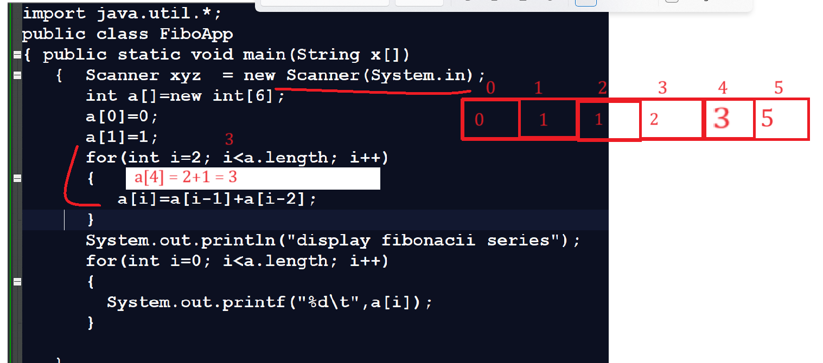

Example: WAP to create two array of size 5 and 5 and merge them in third array and third array size is 10
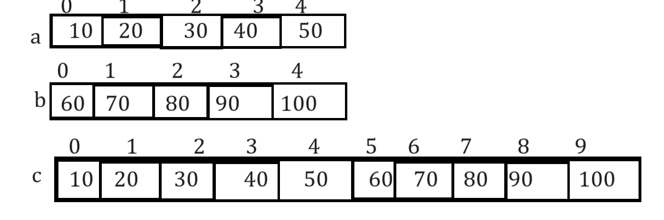

Example:
import java.util.*;
public class TestArr
{ public static void main(String x[])
{ int a[]=new int[5];
int b[]=new int[5];
int c[]=new int[10];
Scanner xyz = new Scanner(System.in);
System.out.println("Enter five values in array");
for(int i=0; i<a.length; i++)
{ a[i]=xyz.nextInt();
}
System.out.println("Enter five values in second array");
for(int i=0;i<a.length;i++)
{ b[i]=xyz.nextInt();
}
int k=0;
for(int i=0;i<a.length;i++,k++)
{ c[i]=a[i];
}
for(int j=0;j<b.length;j++)
{ c[k]=b[j];
k++;
}
System.out.println("Array after merging");
for(int i=0;i<c.length;i++)
{ System.out.printf("%d\t",c[i]);
}

}
}

Example: WAP to create 3 x 3 matrices and calculate the sum of row
import java.util.*;
public class TwoDArrayApp
{
public static void main(String x[])
{ Scanner xyz = new Scanner(System.in);
int a[][]=new int[3][3];
System.out.println("enter 3 x 3 matrix\n");
for(int i=0; i<a.length; i++)
{
for(int j=0; j<a[i].length; j++)
{
a[i][j]=xyz.nextInt();
}
}
System.out.println("display all values");
for(int i=0; i<a.length; i++)
{ int sum=0;
for(int j=0; j<a[i].length; j++)
{ System.out.printf("%d\t",a[i][j]);
sum = sum +a[i][j];
}
System.out.printf(" = %d\n",sum);
}
}
}
Output
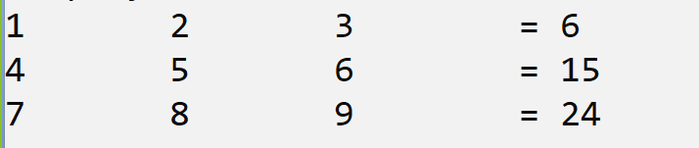

Example: WAP to create 3 x 3 matrixes and calculate the sum of left and right diagonal of element.
import java.util.*;
public class TwoDArrayApp
{
public static void main(String x[])
{ Scanner xyz = new Scanner(System.in);
int a[][]=new int[3][3];
int lsum=0,rsum=0;
System.out.println("enter 3 x 3 matrix\n");
for(int i=0; i<a.length; i++)
{
for(int j=0; j<a[i].length; j++)
{
a[i][j]=xyz.nextInt();
}
}
System.out.println("display all values");
for(int i=0; i<a.length; i++)
{
for(int j=0; j<a[i].length; j++)
{ System.out.printf("%d\t",a[i][j]);
if(i==j)
{ lsum=lsum+a[i][j];
}
if(j==2-i)
{ rsum=rsum+a[i][j];
}
}
System.out.printf("\n");

}
System.out.printf("Sum of left diagonal is %d\n",lsum);
System.out.printf("Sum of right diagonal is %d\n",rsum);
}
}

Time Complexity and Bit O notations
_______________________________________________________________________
Q. Why learn Time Complexity?
__________________________________________________________________
1. With the help of time complexity you can identify better code.
2. Now a days in interview generally people ask you what is the time complexity of this code or particular code.

Q. Prerequisite knowledge for learn Time Complexity?
_____________________________________________________________________
1. Basic coding knowledge
2. Basic mathematical function topic
3. Need to know how to design algorithm for code
4. Resource Utilizations

Q. What is algorithm?
___________________________________________________________________
Algorithm means step by step procedure for solve the program or problem statement called as algorithm.
In terms of coding if we write the some lines of code called as algorithm
When we work with any algorithm and if we want to implement any algorithm practically we need to write code for that algorithm
But when we run code on computer then computer utilize the some resources for execute that code.

Two types of resources
A) Processor
B) Memory
If we think of time complexity we need to know the process utilization
and if we want to identify processor utilization we need to know the processor operation.

Q. What is processer operation and How to calculate processor operation?
__________________________________________________________________________
For understanding processor operation we have simple example

Problem: suppose consider we have problem statement and we solve this problem statement by using two algorithms like as algo1 and algo2.
suppose you design algo1 and your friend design algo2 and suppose you have system name as system1 and your friend has system name as system2
So algo1 required 2 seconds for execute on system1 and algo2 required 5 second on system2
So if we want to compare the running time of these algorithm so using running time we can think algo1 is better than algo2 because it required less time
but if we think about approach the problem is if suppose consider your system1 is modern computer with high configuration and your system2 is old computer so the problem is if algo1 is not efficient but system is very powerful so definitely it execute fast as compare to algo2 so this is not good approach to compare these two codes or algorithm so if we want to solve this problem we have to use processor operation technique.

Q. what is processor operation?
_____________________________________________________________________-
Processor operation means we know find out the individual operation in that algorithm and find sum of all operations for finding the efficient algorithm

How to find out the processor operations
_______________________________________________________________________
1. Every assignment operator in application consider as 1 individual operation.
2. Every Arithmetic operation in application consider as 1 individual operation like as + ,-,*, / etc
3. Every comparison operator like as < > <= >= != == et consider as 1 individual operation
4. Return statement consider as 1 individual operation.

Note: the benefit of processor operation is it is system independent.
Now we will see the one example for calculate the processor operation

int getSumSquare(int x)
{ x=x+1;
return x*5;
}
if we think about above code we have x=x+1 here = is assignment operator so it is 1 processor operation as per our rule and we have one statement x+1 so here + required 1 processor operation x=x+1 requried total 2 processor operation and we have statement return x*5 here return required 1 process operation and x*5 required 1 processor operation so return x*5 required 2 processor operation x=x+1 = 2 processor operation and return x*5 =2 so total processor operation for execute all code required 4 operations.
= -- 1
+ - 1
* - 1
return 1=
total =1+1+1+1 = 4

Example:
int sum=0;
int n=1;
for(int i=1; i<=n; i++)
{ sum = sum+i;
}
Note: if we think about above code we have statement int sum=0 required 1 processor operation and n=1 required 1 processor operation means 1+1 = 2 means sum=0 and n=1 required total 2 processor operations
if we think about for loop then i=1 required 1 processor operation 1<=1 required 1 processor so condition is true then control enter in loop means no we have total 4 operations again in loop we have sum=sum+I this statement contain 2 processor operations means here we required total 6 operations again i++ get executed it required 1 processor process means 6+1 is 7 and again condition check so last our condition is 2<=1 means it is 1 processor operation and total processor operation is 8 and 2<=1 is false so loop not executed.

How to perform performance of code of two different algorithms by using processor operations.
___________________________________________________________________________________
Now we want to perform comparison between linear search and binary search by using processor operation

Linear Search: Linear search is technique to search element from array so if we think about linear search we search or we compare search value with every element in array and if value found then we return its index and if value not found then return -1

Binary Search:
Q. What is Time Complexity and How to calculate the time complexity of application?

