Collection
________________________________________________________________________________
Collection is a framework or API in JAVA which is used for following purpose

1. To Store different types of data or any type of data
2. To Grow size dynamically or shrink size dynamically.
3. Store unlimited size data.
4. To Provide inbuilt data structure algorithm or provide inbuilt data implementation

Now we want to work with Eclipse IDE
___________________________________________________________________________________
Steps to work with Eclipse IDE
________________________________________________________________________________
1. Download & Install Eclipse.
Eclipse Downloads | The Eclipse Foundation
2. Create Project using eclipse
If we want to create project using eclipse we have to use following steps.

File --- New --- Java Project ---- Give Project name ---- click on next ---- next and click on finish button.

3. Create Package under src folder
Right click on src --- new --- give package name i.e(org.techub) ---- click on finish button

4. Create Class under created package.
Right click on package ---- new --- class --- give class name (e.g ObjectArrApp) --- select main method check box and click on finish button.
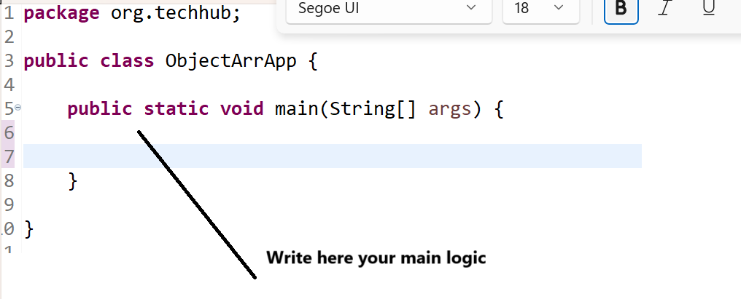

Note: if we think about java if we create array of Object class then we can store any kind of data in it
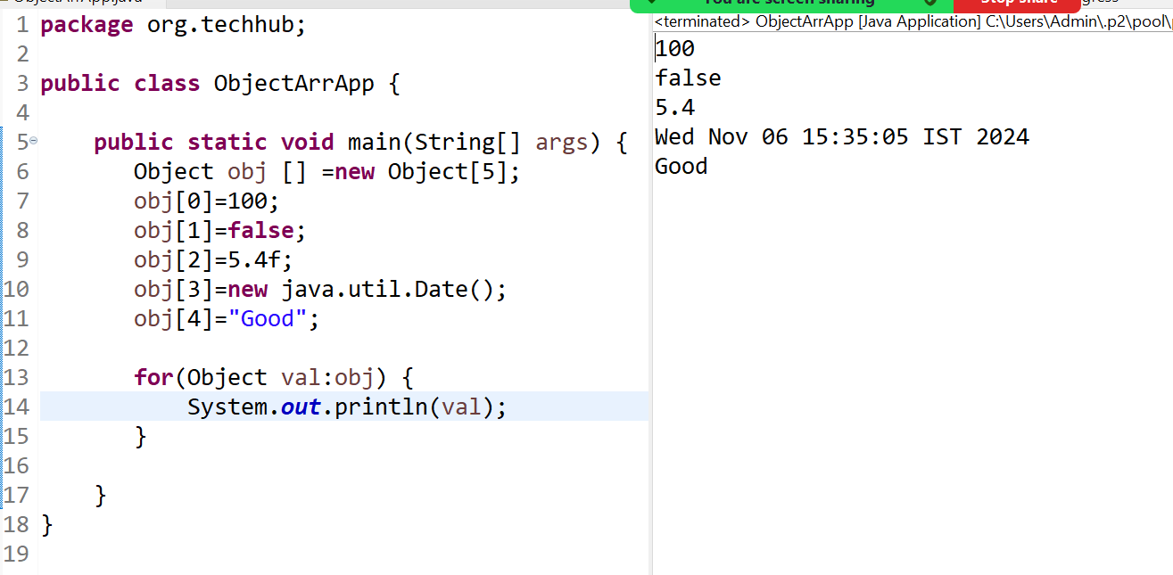
Note: means we can say in java we can create of different types of data.
If we think about above code there are two limitations
1. Cannot expand the size at program run time
2. Need to write manual logic for achieve data structure operation like as searching, sorting, etc

If we want to overcome these two problems java provide some interfaces and some classes with data structure implementation called as collection.
If we want to work with collection in java we need to know the following class hierarchy.
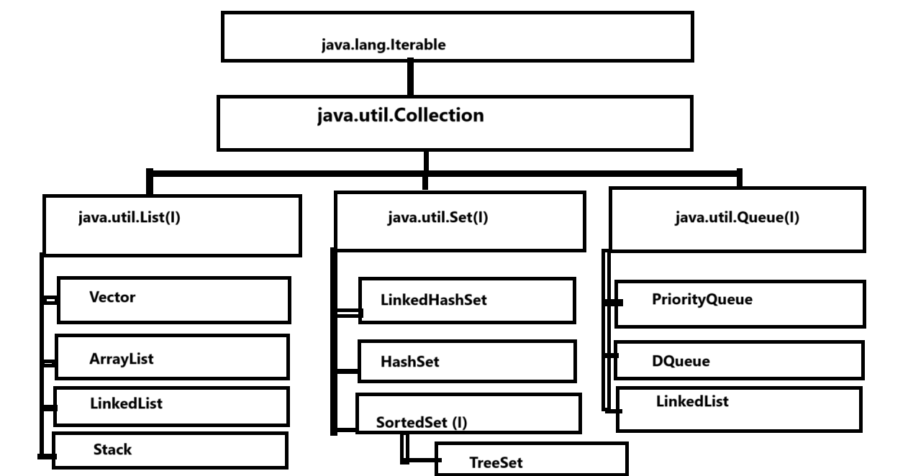

Now we want to discuss about java.lang.Iterable interface

Q. What is purpose of Iterable interface?
________________________________________________________________________________
Iterable is interface from java.lang package which is used for fetch data from collection or retrieve data from collection and display it.
Iterable interface contain iterator() method and this method return reference of Iterator interface.

Syntax: Iterator iterator(); this method return reference of Iterator interface.

Interanally structure of Iterable
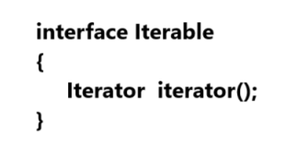

So when we call the iterator() method of Iterable using any collection implementer class then we get reference of Iterator
So Iterator is also interface from java.util package and this interface help us to fetch data from collection using some inbuilt methods.

Methods of Iterator interface
_________________________________________________________________________
boolean hasNext(): this method can fetch data from collection and move cursor on next element
Object next(): this method can fetch data from collection and move cursor on next element
void remove(): this method can remove data from collection at the time of data fetching
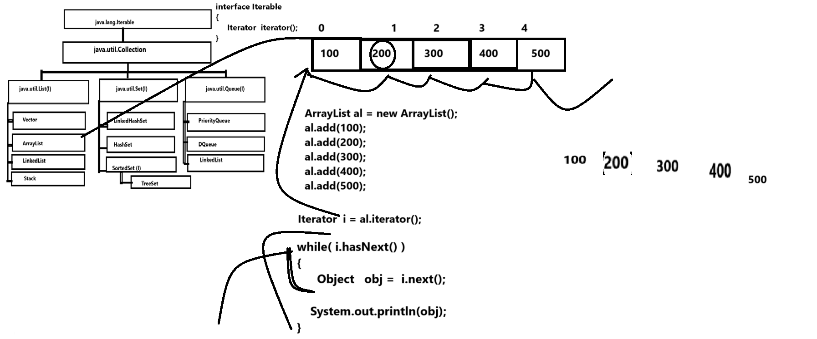
Note: Iterable support fetch data from all types of collection with the help of iterator() method

We have one more type of interface name as java.util.Collection
____________________________________________________________________
Collection interface contain some common regular methods which help us to perform operation on Collection like as adding element collection, count the element of collection, remove element from collection etc

Methods of Collection interface
________________________________________________________________________
public abstract int size(): this method is used for return size of collection or return total number of element present in collection.
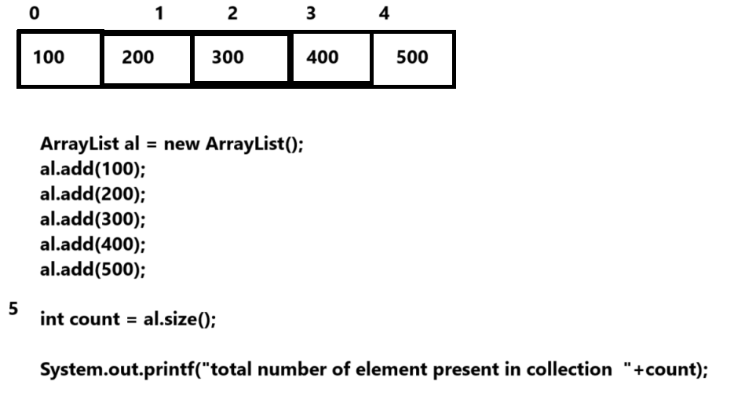
public abstract boolean isEmpty(): This method is used for check collection is empty or not if collection is empty return true otherwise return false.
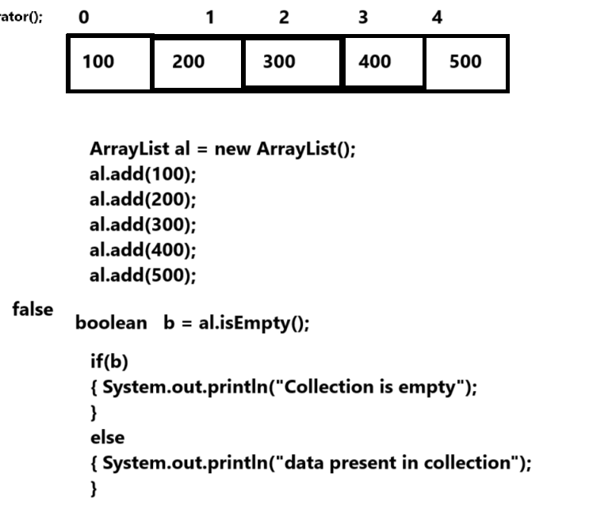

public abstract boolean contains(java.lang.Object): this method help us to search element present in collection or not if element present in collection return true otherwise return false Means we can say this method help us to search data from collection.
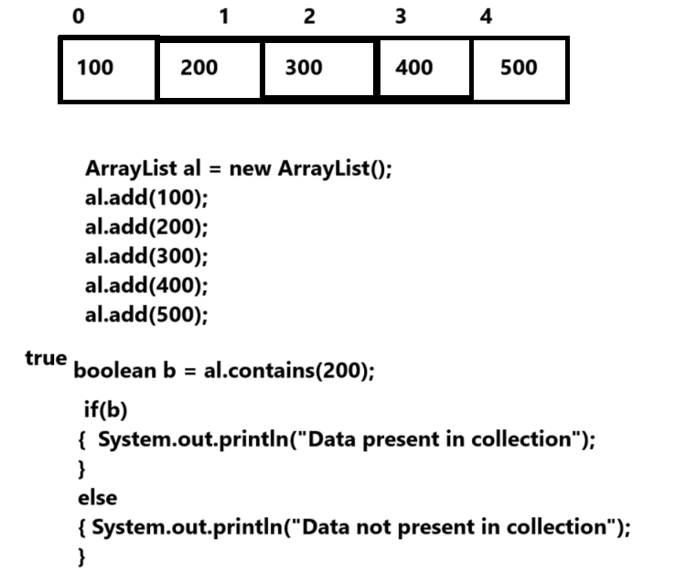
public abstract java.util.Iterator<E> iterator();: this method help us to fetch data from collection.
public abstract java.lang.Object[] toArray(): this method is used for convert your collection in to object class array.

public abstract boolean add(E): this method is used for add new element in collection if element added return true otherwise return false.
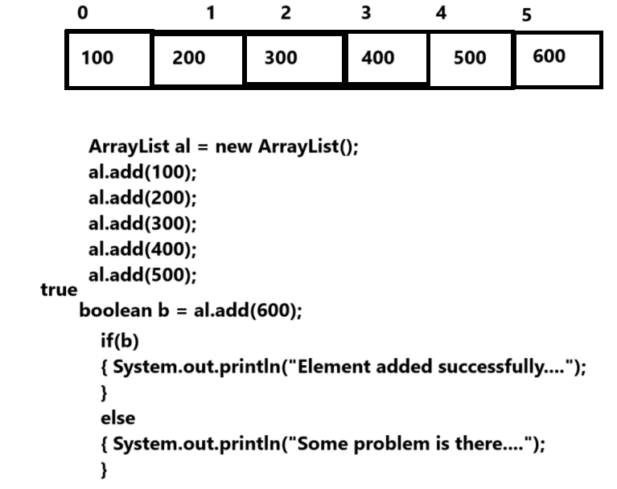

public abstract boolean remove(java.lang.Object): this method is used for remove element from collection and element remove return true otherwise return false.
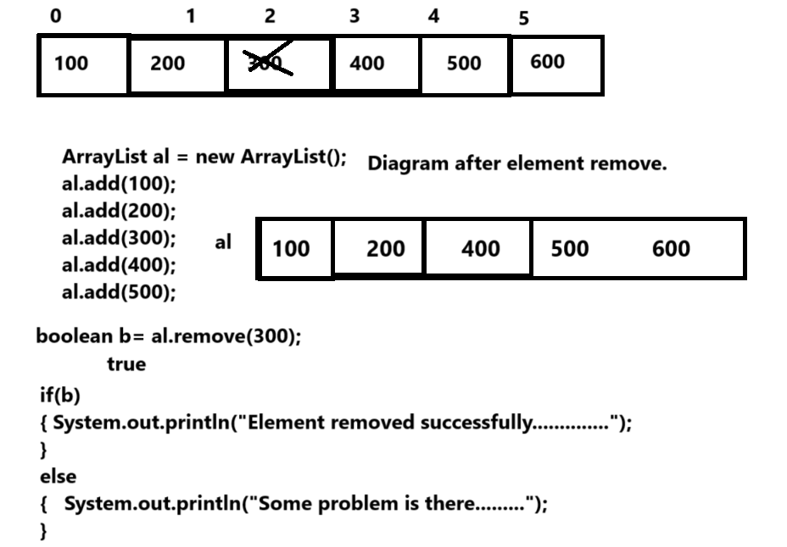

public abstract boolean containsAll(java.util.Collection<?>): this method help us search more than one value at time in collection if any value found return true otherwise return false.

public abstract boolean addAll(java.util.Collection<? extends E>): this method help us to add more than one value at time in collection.
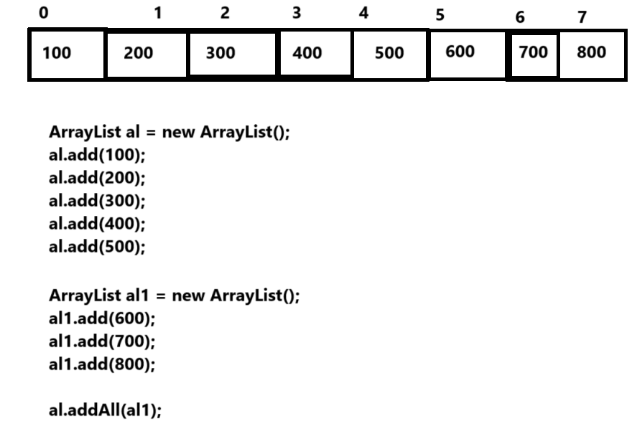
public abstract boolean removeAll(java.util.Collection<?>): we can remove more than one element at time from collection

public abstract void clear(): Delete the all data from collection.

We will discuss this method later in JDK 1.8 version of JAVA

public boolean removeIf(java.util.function.Predicate<? super E>);
public abstract boolean retainAll(java.util.Collection<?>);
public java.util.Spliterator<E> spliterator();
public java.util.stream.Stream<E> stream();
public java.util.stream.Stream<E> parallelStream();

Note: Collection interface has three child interfaces name as List, Set, and Queue

List: List Collection can store any type of data in it and store unlimited data but allow duplicated data and manage data by using its index.

Set: Set collection can store any type of data in it but allow unique means we cannot store duplicate data in collection and manage data by using its index.

Queue: Queue collection can store any type of data in unlimited size but allow duplicated data and manage data by using its index and manage data in first in first out format.

Now we want to discuss about List Collection
____________________________________________________________________________
Methods of List Collection
public abstract E get(int): this method is used for return data from collection using its index and data not present in collection then generate IndexOutOfBoundsException at run time.
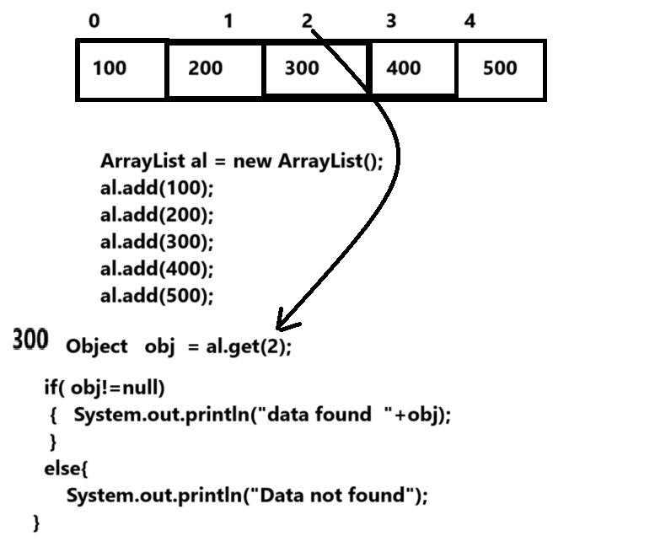
Note: we can use this method for two purpose
1. Fetch data from collection
2. Search data from collection

public abstract E set(int, E): this method is used for replace data in collection by using its index
means override new data on previous data using index of element and return previous element
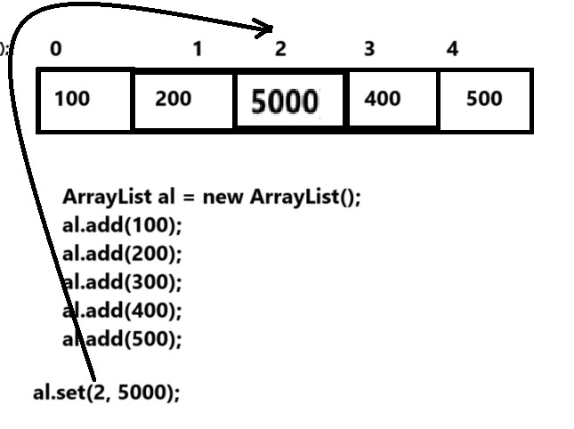
public abstract void add(int, E): this method can add new data in collection using its index and shift remaining data on new index by +1 it.
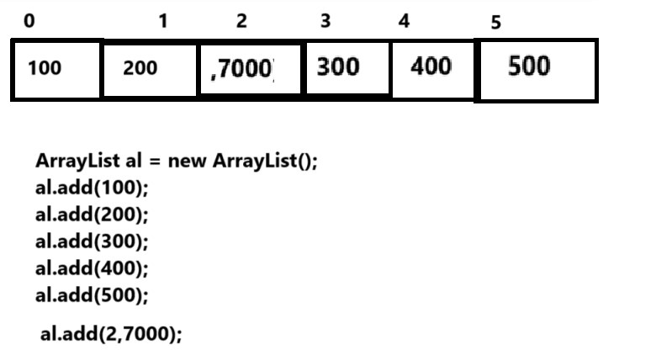

public abstract E remove(int): this method can remove data from collection using its index and return removed value from collection and index not found generate exception at run time

public abstract int indexOf(java.lang.Object): this method help us to return index of element from list collection if element not found return -1
Normally this method can use in following scenario
1. Searching element from collection: if we get -1 then we can show message element not found if get any positive index then we can say element found.
2. This method can use before replace or remove element from collection using index.
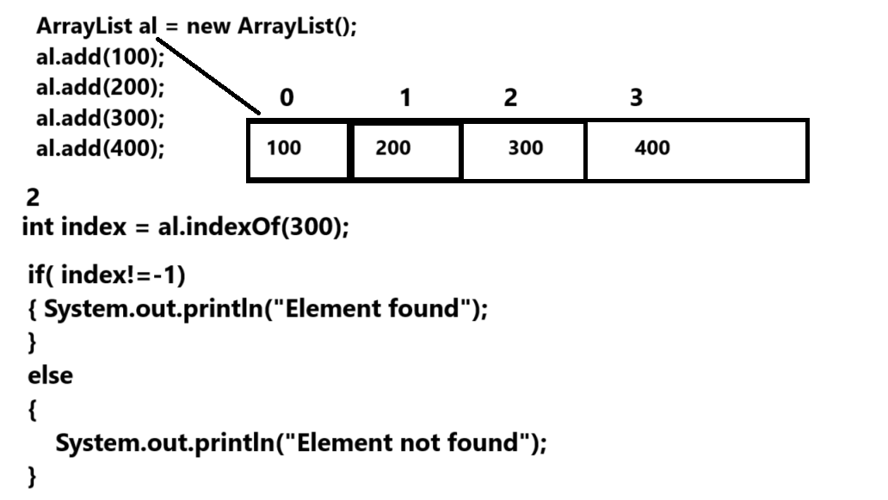

public abstract int lastIndexOf(java.lang.Object): this method return index of last occurred element in collection means if we have duplicated element in collection and if we want to find the last index of duplicated element then we can use lastIndexOf()
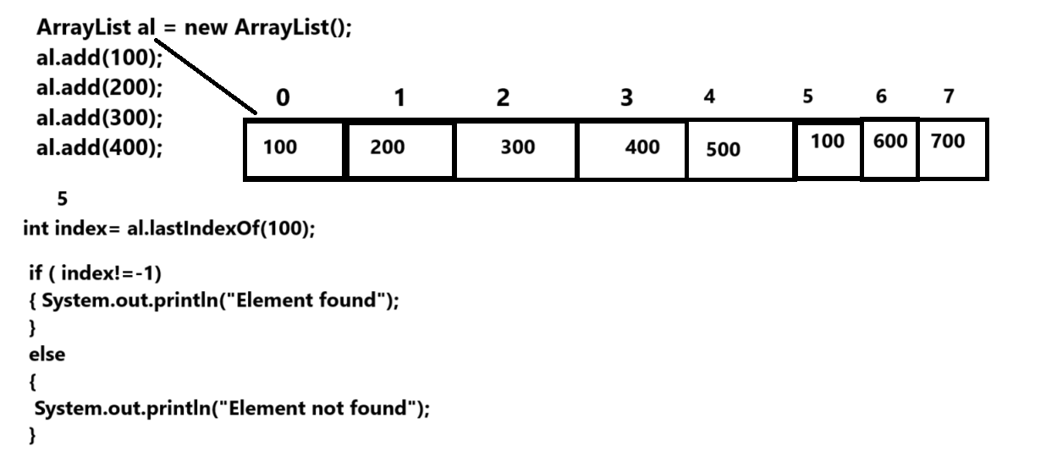

public abstract java.util.ListIterator<E> listIterator(int): this method help us to travel the collection in forward direction as well as in backward directions using specified index.

public abstract java.util.List<E> subList(int, int): this is used for fetch data between two specified index from collection.
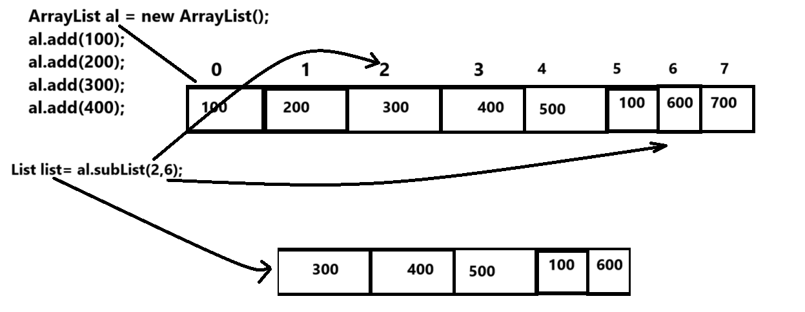

Vector
_____________________________________________________________________
Q. What is Vector?
___________________________________________________________________
Basically Vector is implementer class of List Collection and it is known as legacy collection in JAVA
Q. What is legacy collection?
________________________________________________________________________________
Legacy collection means those collection classes is not part of collection framework in older version and later they are added as part of collection called as legacy collection
Means in short we can say legacy collection classes already present in JDK before launching collection framework and later they modify and added as part of collection so it is legacy collection.
Before JDK 1.2 version of JAVA Vector known as dynamic array means vector grow its size at run time as well as shrink its size at run time.
Important points of vector
________________________________________________________________
1. Vector is legacy collection and implementer class of List Interface.
2. Vector is thread safe collection means all methods of vector are synchronized and cannot use vector simultaneously by multiple thread objects
3. The default capacity of vector is 10 means when we create object of Vector class then internally we get array of object class with size of 10 and collection framework can change its size at run time.
Shown in following diagram
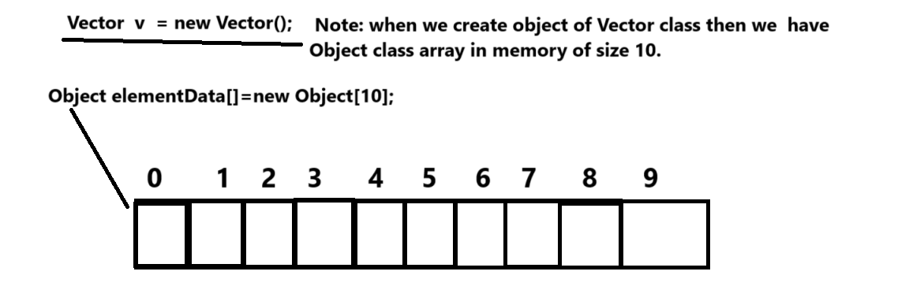

4. When Vector cross its initial capacity then Vector allocates double memory than its initial capacity
So this is main reason some people threshold value of vector is 1 or 100%

Q. What is threshold?
A threshold is an amount, level, or limit on a scale. When the threshold is reached, something else happens or changes.

The logic of capacity increment of vector is
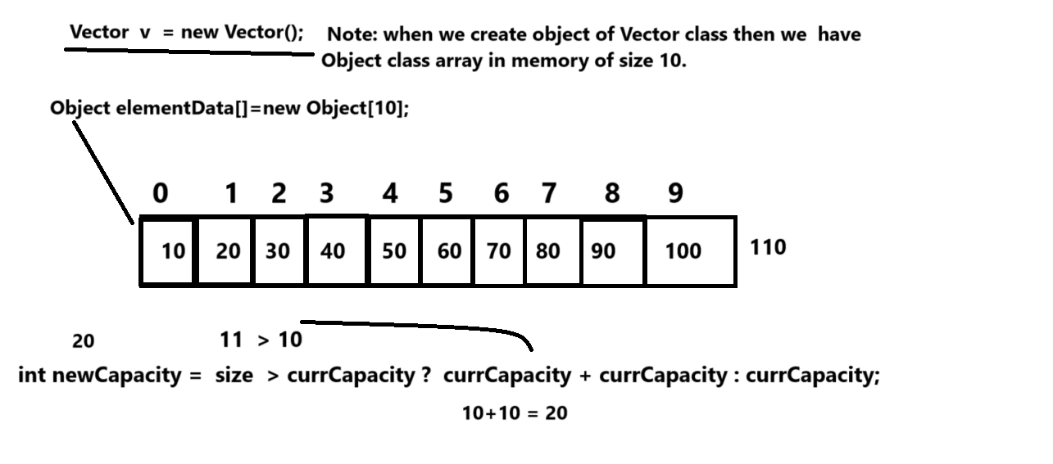

If we want to create object of Vector class we have four type of constructor

Vector(): this is the default constructor and create vector with initial capacity i.e 10
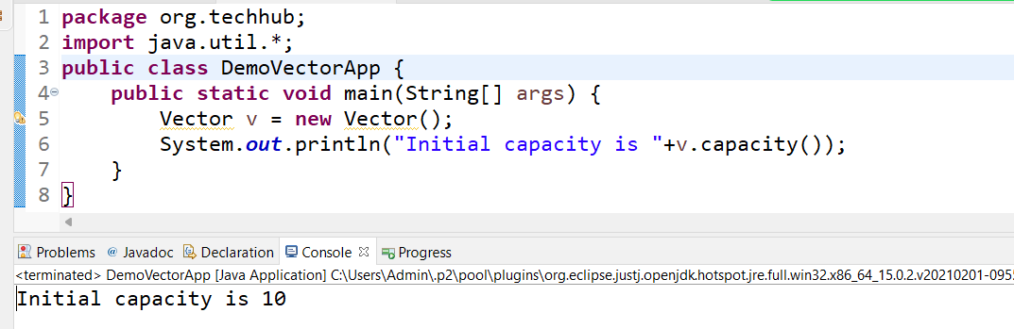
Vector(int intialCapacity): this constructor help developer to set the vector capacity according to his choice means we can customize the capacity of vector by passing parameter in vector constructor.
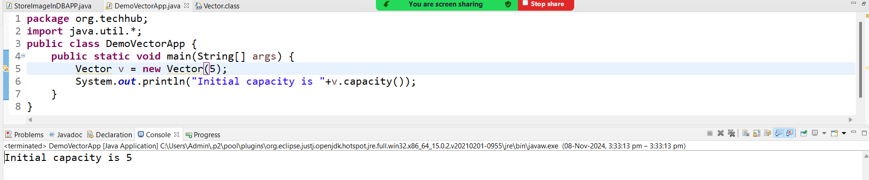

Note: If we use these two constructors and if vector capacity gets cross then vector occupy double memory than its current capacity shown in following code.

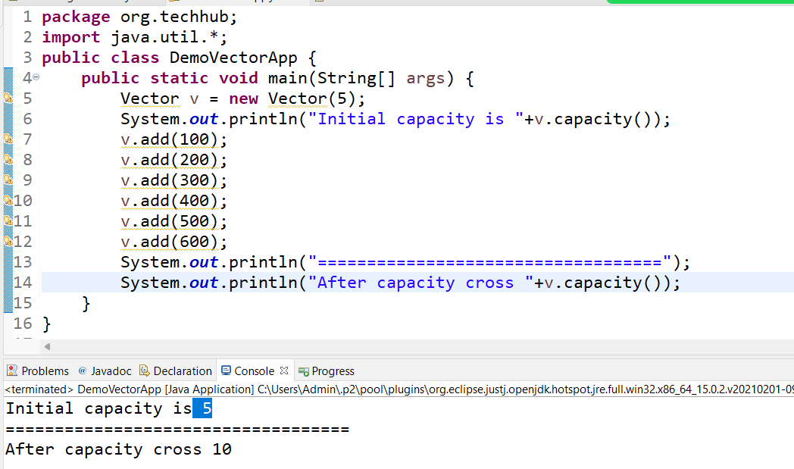

Note: by default vector increase its capacity double than its current capacity but if developer want to increase the capacity of vector according to his choice then we have third constructor given below.

Vector(int initialCapacity,int incrementalCapacity):

int initialCapacity: this parameter indicate set the initial capacity of vector
int incrementalCapacity: this parameter indicate set the incremental capacity of vector when cross the initial capacity value.
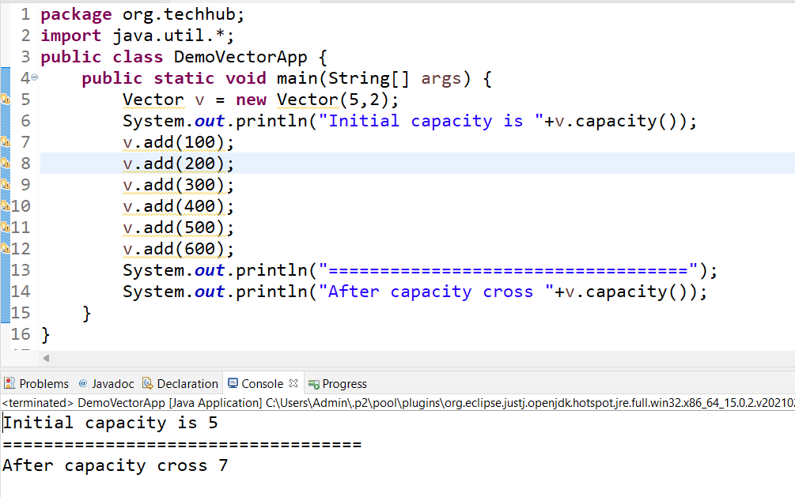
Vector(Collection): this constructor help us to copy data of another collection in vector.
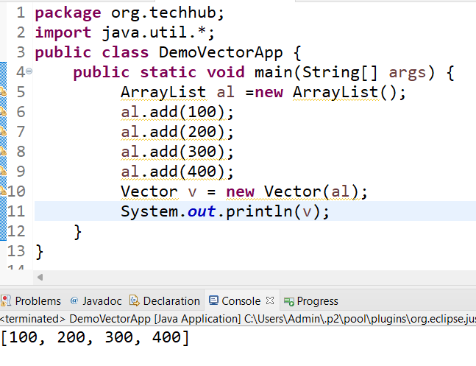

Example: we want to perform basic operation on vector for understanding the use of methods
Case 1: Add New Element
Case 2: View all elements
Case 3: Search element by contains method
Case 4: search element by indexOf() method
Case 5: search element by get() method
Case 6: remove data by using its index
Case 7: count the element using size()
Case 8: replace element using index.

Example with source code
package org.techhub;

import java.util.*;
public class DemoVectorApp {
public static void main(String[] args) {
Vector v = new Vector();
do {

System.out.println("1:Add New Element");
System.out.println("2:View All Elements");
System.out.println("3:Search Element By Contains method");
System.out.println("4:Search Element By Index Of methods");
System.out.println("5:Search element by get method");
System.out.println("6:Count element by using size");
System.out.println("7:replace element using index");
Scanner xyz = new Scanner(System.in);
System.out.println("Enter your choice");
int choice = xyz.nextInt();
switch (choice) {
case 1:
System.out.println("Enter value in vector");
int value=xyz.nextInt();
boolean b=v.add(value);
if(b) {
System.out.println("element added in vector");
}
else {
System.out.println("Some problem is there.........");
}
break;
case 2:
Iterator i=v.iterator();
while(i.hasNext()) {
Object obj = i.next();
System.out.println(obj);
}
break;
case 3:
System.out.println("Enter value for search");
value=xyz.nextInt();
b=v.contains(value);
if(b) {
System.out.println("Value found");
}
else {
System.out.println("Value not found");
}
break;
case 4:
System.out.println("Enter value for search");
value=xyz.nextInt();
int index=v.indexOf(value);
if(index!=-1) {
System.out.println("Value found");
}
else {
System.out.println("Value not found");
}
break;
case 5:
System.out.println("Enter value for search");
value=xyz.nextInt();
index=v.indexOf(value);
if(index!=-1) {
System.out.println("Value found "+v.get(index));
}
else {
System.out.println("Value not found");
}
break;
case 6:
System.out.println("Total element in vector is "+v.size());
break;
case 7:

System.out.println("Enter value which we want to replace");
int value1=xyz.nextInt();
System.out.println("Enter value for replace");
value=xyz.nextInt();
index=v.indexOf(value1);
if(index!=-1) {
v.set(index, value);
}
else {
System.out.println("Value not found for replacement");
}
break;

default:
System.out.println("Wrong choice");
}
} while (true);
}
}

Q1. What is Collection and why use it?
Q2. Explain hierarchy of Collection?
Q3. What is Iterable and why use it and explain with method?
Q4. What is Collection interface and explain its 10 method with example?
Q5. What is list set and queue interface?
Q6. What is difference between list and set?
Q7. What is Vector and explain with all constructors with example?
Q8. Explain important points of vector?
Q9. Explains 10 method of List interface which is not inherited by Collection?

How to fetch data from collection or retrieve data from collection
________________________________________________________________________
If we want to fetch data from collection or retrieve data from collection we have some cursors or Iterators provided by java.

1. Using for loop (just work with list/queue collection): when we want of fetch list collection using for loop we have to maintain the index value for fetching data from collection
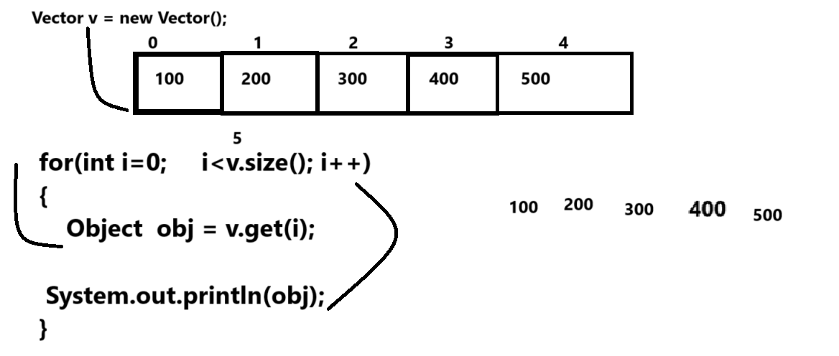

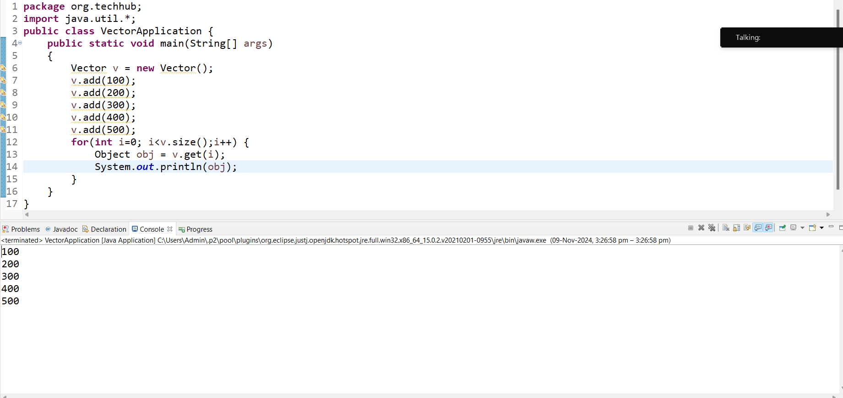
2. Using Enumeration: if we think about Enumeration it is interface from java.lang package and which is used for fetch data only from legacy collection and Enumeration is read only cursor using Enumeration we can only fetch data from collection and we cannot perform any other modification on collection by Enumeration reference at the time of data fetching.
If we want to create reference of Enumeration we have elements() method of Vector so this method can return reference of Enumeration interface to us

Syntax: Enumeration ref = collref.elements();

Methods of Enumeration interface
boolean hasMoreElements(): this method help us to check element present in collection or not if present return true otherwise return false.
Object nextElement(): this method can fetch data from collection and move cursor on next element
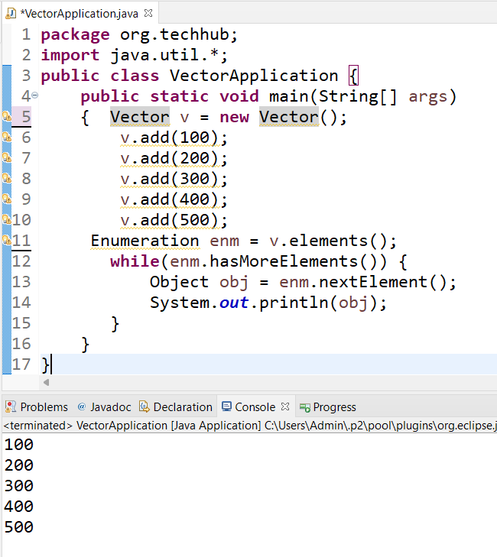

3. Using Iterator: Iterator is an interface from java.util package and it is universal cursor in java and which is fetch data from collection and Iterator can work with list , set, queue as well as can work with legacy and non legacy collections.
Iterator can remove the data from collection at the time of data fetching.
If we want to create reference of Iterator interface we have iterator() method of Iterable interface.

Syntax: Iterator ref = collref.iterator();

Methods of Iterator interface
____________________________________________________________________
boolean hasNext(): this method help us to check element present in collection or not if present return true otherwise return false.

Object next(): this method help us fetch data from collection and move cursor on next element in collection
void remove(): this method can remove the element from collection by using Iterator interface at the time of data fetching.
default void forEachRemaining(Consumer<? super E> action): we will discuss this method in JDK 1.8 versioon of JAVA

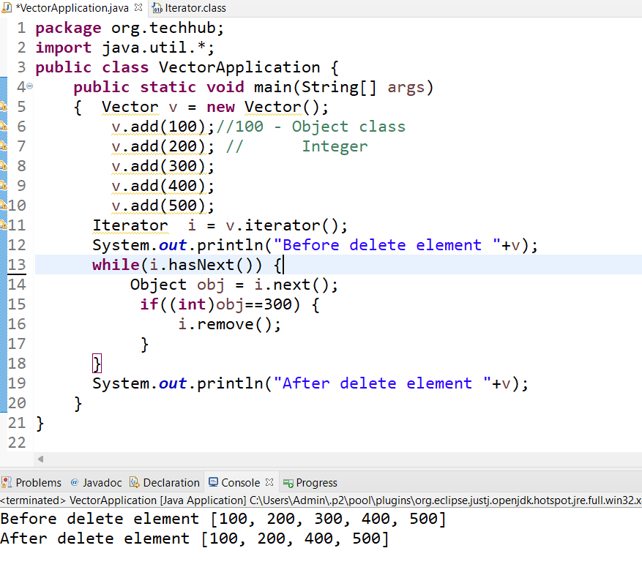

Q. What is difference between Iterator and Enumeration?
______________________________________________________________________________
a) Iterator can work with legacy as well as non legacy collection and Enumeration can work with legacy collection.
b) Iterator can remove data from collection at time of traversing but Enumeration cannot remove data from collection just can fetch
c) Enumeration contain methods boolean hasMoreElements() and Object nextElement() and Iterator contain methods boolean hasNext(),Object next() and void remove() and forEachRemaining() etc

4. Using ListIterator: ListIterator interface can fetch data in forward direction as well as in backward direction and ListIterator can work with only List Collection not other.
If we want to create reference of ListIterator we have listIterator() method and it is overloaded method which return reference of ListIterator

Syntax: ListIteator ref = listcollref.listIterator() : this method can create reference of ListIterator which by default point to 0th index of collection
or
ListIterator ref=listcollref.listIterator(int index): this method can decide from which index travel the collection it may in forward or may be in backward direction

Note: ListIterator interface is a child of Iterator interface means all methods of Iterator is present in ListIterator as well as ListIterator has own methods
Methods of ListIterator
boolean hasNext(): this method help us to check element present in collection or not if present return true otherwise return false.
Object next(): this method help us fetch data from collection and move cursor on next element in collection
void remove(): this method can remove the element from collection by using Iterator interface at the time of data fetching.
default void forEachRemaining(Consumer<? super E> action): we will discuss this method in JDK 1.8 versioon of JAVA
boolean hasPrevious(): this method can check element present in collection or not in backward direction or backward traveling
Object previous(): this method can fetch data from collection and move cursor in backward direction
void add(E): this method can add new element in collection at the time traveling
void set(E): this method can replace element in collection using ListIterator reference
int previousIndex(): return index of previous element in backward traveling
int nextIndex(): return index of next element when we traveling in forward direction

Example: we want to create linked list and travel it in backward direction
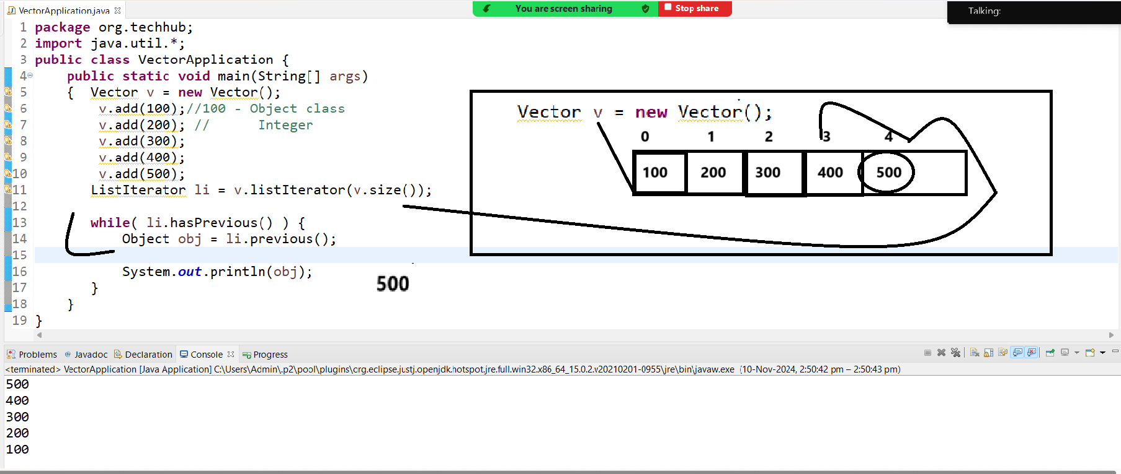

Q. What is difference between Iterator and ListIterator?
_______________________________________________________________________________
a. Iterator is universal cursor means can work with all types of collection and ListIterator can only work with list collection
b. Iterator can work with forward direction only and ListIterator can work with forward as well as backward direction
c. Iterator can only remove data from collection but ListIterator can remove, add, and replace etc operation on Collection at the time of traversing.

5. Using Enhance for loop
_______________________________________________________________________
Enhance for loop means we not required to provide initialization, condition and increment when we fetch data from collection.

Syntax: for(datatype value: array or coll)
{
}
Example
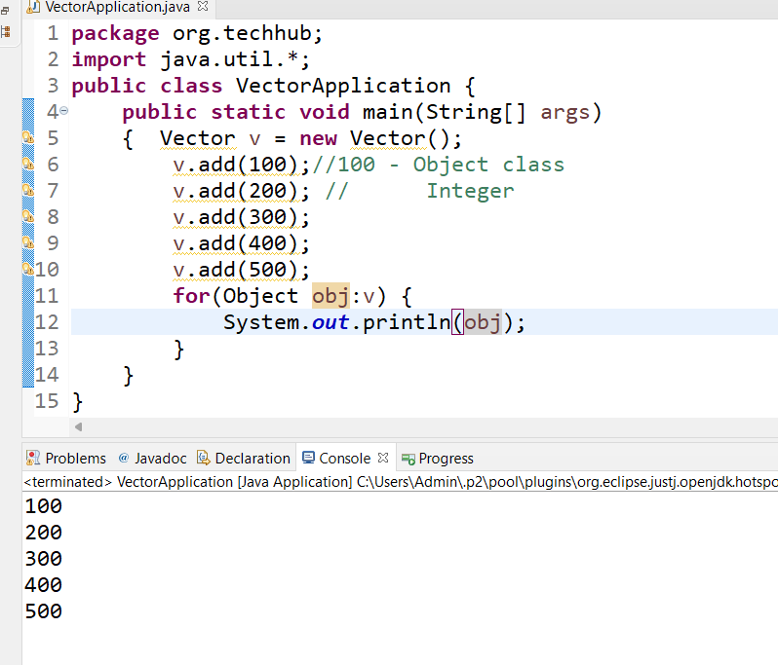

6. Using forEach() method from JDK 1.8 version of java
__________________________________________________________
Note: we will just see the sample code using forEach() we will discuss this method in JDK1.8 version of java In Depth

package org.techhub;
import java.util.*;
import java.util.function.*;
public class VectorApplication {
public static void main(String[] args)
{ Vector v = new Vector();
v.add(100);//100 - Object class
v.add(200); // Integer
v.add(300);
v.add(400);
v.add(500);
v.forEach((t)->System.out.println(t));
}
}

Interview Question:
Q. What is cursor and why use it ?
Q. Explain the Enumeration and Iterator with its difference?
Q. Explain ListIterator with its methods?

Note: we want to implement the some basic examples using Vector
___________________________________________________________________
We want to create Vector class with 5 values and calculate the sum of all values.
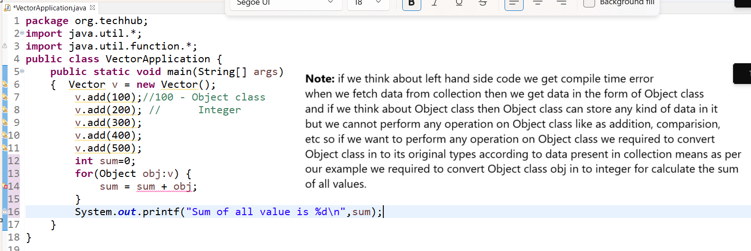
Example with conversion
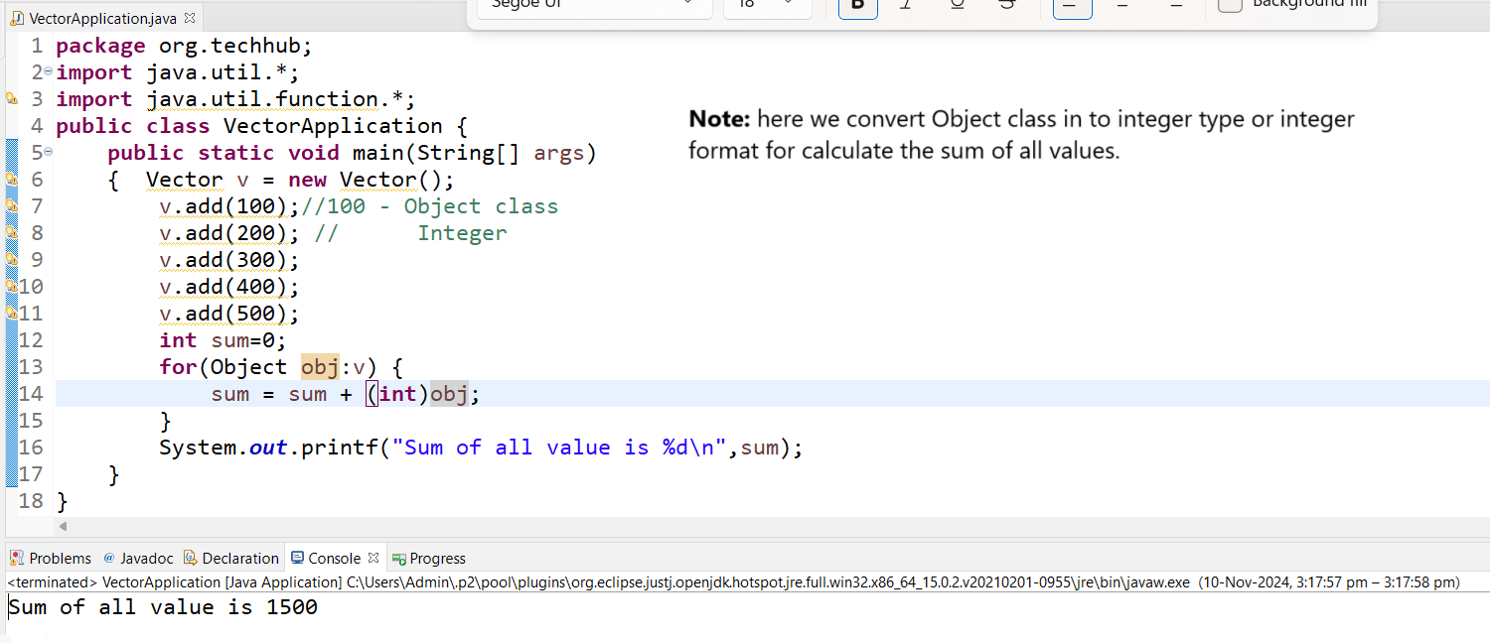

Example: WAP to create Vector and store 5 values in it and find the max value from collection.
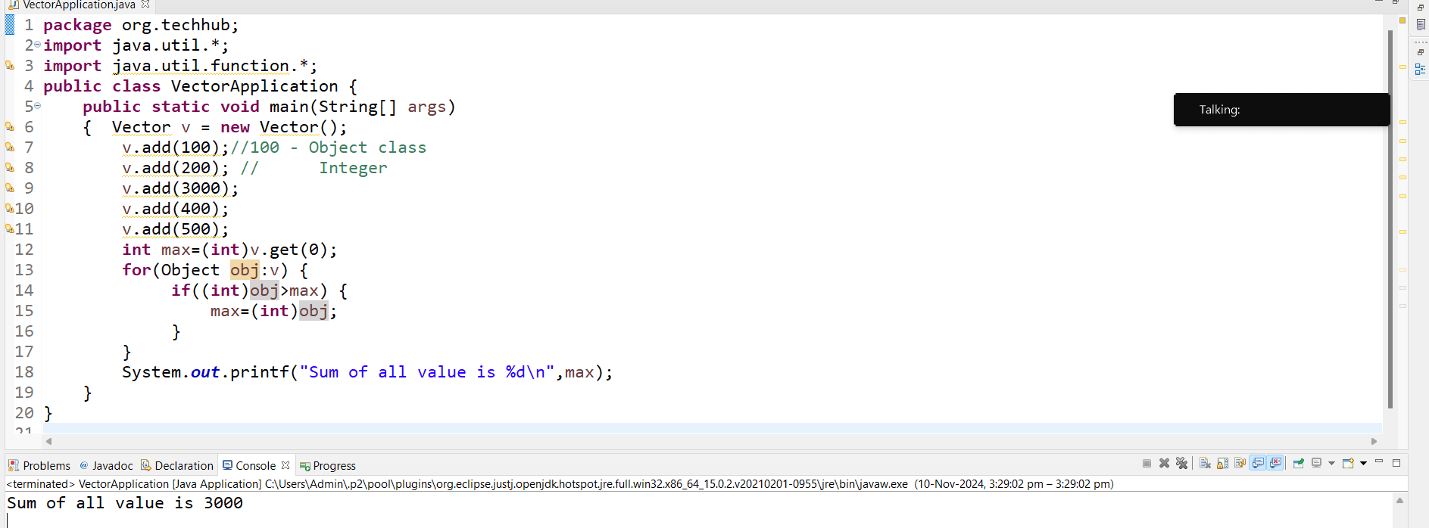

Example: WAP to create vector store 5 values in it and arrange in ascending order.
package org.techhub;
import java.util.*;
import java.util.function.*;
public class VectorApplication {
public static void main(String[] args)
{ Vector v = new Vector();
v.add(10);//100 - Object class
v.add(2); // Integer
v.add(30);
v.add(4);
v.add(5);
System.out.println("Before Sorting");
for(Object obj:v) {
System.out.print(obj+"\t");
}
for(int i=0; i<v.size();i++) {
for(int j=(i+1);j<v.size();j++) {
Object prev=v.get(i);
Object next=v.get(j);
if((int)prev>(int)next) {
v.set(i, next);
v.set(j, prev);
}
}
}
System.out.println("\nAfter Sorting");
for(Object obj:v) {
System.out.print(obj+"\t");
}
}
}

How to create user defined java objects in collection and retrieve it.
___________________________________________________________________________
If we want to store user defined java objects in collections then we have to create POJO class and Store All POJO objects in Collection and fetch it.
Just we need to convert Object class data in POJO type

Example: we want to create Employee class with field id, name and sal and Create POJO of Employee class and store 5 objects of Employee in Vector and display it.

Example with source code
package org.techhub;

public class Employee {

private int id;
private String name;
public int getId() {
return id;
}
public void setId(int id) {
this.id = id;
}
public String getName() {
return name;
}
public void setName(String name) {
this.name = name;
}
public int getSal() {
return sal;
}
public void setSal(int sal) {
this.sal = sal;
}
private int sal;

}
package org.techhub;
import java.util.*;
public class VectorWithUserApp {

public static void main(String[] args) {

Vector v = new Vector();

Employee emp1 = new Employee();
emp1.setId(1);
emp1.setName("ABC");
emp1.setSal(10000);

Employee emp2 = new Employee();
emp2.setId(2);
emp2.setName("MNO");
emp2.setSal(20000);

Employee emp3 = new Employee();
emp3.setId(3);
emp3.setName("XYZ");
emp3.setSal(30000);

Employee emp4 = new Employee();
emp4.setId(4);
emp4.setName("PQR");
emp4.setSal(50000);

v.add(emp1);
v.add(emp2);
v.add(emp3);
v.add(emp4);

for(Object obj:v) {
Employee emp=(Employee)obj;
System.out.println(emp.getId()+"\t"+emp.getName()+"\t"+emp.getSal());
}
}
}

Example to pass parameter in constructor
package org.techhub;

public class Employee {

private int id;
private String name;
public Employee() {

}
public Employee(String name,int id,int sal) {
this.name=name;
this.id=id;
this.sal=sal;
}
public int getId() {
return id;
}
public void setId(int id) {
this.id = id;
}
public String getName() {
return name;
}
public void setName(String name) {
this.name = name;
}
public int getSal() {
return sal;
}
public void setSal(int sal) {
this.sal = sal;
}
private int sal;

}
package org.techhub;
import java.util.*;
public class VectorWithUserApp {
public static void main(String[] args) {
Vector v = new Vector();
Employee emp1 = new Employee("ABC",1,1000);
Employee emp2 = new Employee("MNO",2,2000);
Employee emp3 = new Employee("XYZ",3,3000);
Employee emp4 = new Employee("PQR",4,50000);
v.add(emp1);
v.add(emp2);
v.add(emp3);
v.add(emp4);
for(Object obj:v) {
Employee emp=(Employee)obj;
System.out.println(emp.getId()+"\t"+emp.getName()+"\t"+emp.getSal());
}
}
}
or
package org.techhub;
public class Employee {
private int id;
private String name;
public Employee() {
}
public Employee(String name,int id,int sal) {
this.name=name;
this.id=id;
this.sal=sal;
}
public int getId() {
return id;
}
public void setId(int id) {
this.id = id;
}
public String getName() {
return name;
}
public void setName(String name) {
this.name = name;
}
public int getSal() {
return sal;
}
public void setSal(int sal) {
this.sal = sal;
}
private int sal;

}
package org.techhub;
import java.util.*;
public class VectorWithUserApp {
public static void main(String[] args) {
Vector v = new Vector();
v.add(new Employee("ABC",1,1000));
v.add(new Employee("MNO",2,2000));
v.add(new Employee("XYZ",3,3000));
v.add(new Employee("PQR",4,50000));
for(Object obj:v) {
Employee emp=(Employee)obj;
System.out.println(emp.getId()+"\t"+emp.getName()+"\t"+emp.getSal());
}
}
}
ArrayList
___________________________________________________________________
ArrayList is a same like as Vector class and it is also known as dynamic array and it is implementer class of list collection.

Q. What is difference between Vector and ArrayList?
______________________________________________________________________
1. Vector occupies the double memory than its current capacity when capacity cross and ArrayList occupy half memory than its current capacity when capacity cross.
So this is major reason we can say the threshold value of Vector is 1 and ArrayList 0.5

2. Vector is synchronized collection or thread safe collection because methods of vector are synchronized but ArrayList is asynchronized collection or not thread safe collection means methods of ArrayList are not synchronized.

3. Vector known as legacy collection and ArrayList is not legacy collection

4. The Vector capacity increment logics is
newcapacity= size>currCapacity?currCapacity+currCapacity:currCapacity; and logic of ArrayList capacity increment is
newcapacity=size>currCapacity?curCapacity+currCapacity>>1:currCapacity;

Constructor of ArrayList
_______________________________________________________________________________
ArrayList(): this constructor can create the ArrayList with default capacity 10.
ArrayList(int initialCapacity): this constructor can create the ArrayList with initial capacity according to use choice
ArrayList(Collection): this constructor create array and copy the data from another collection
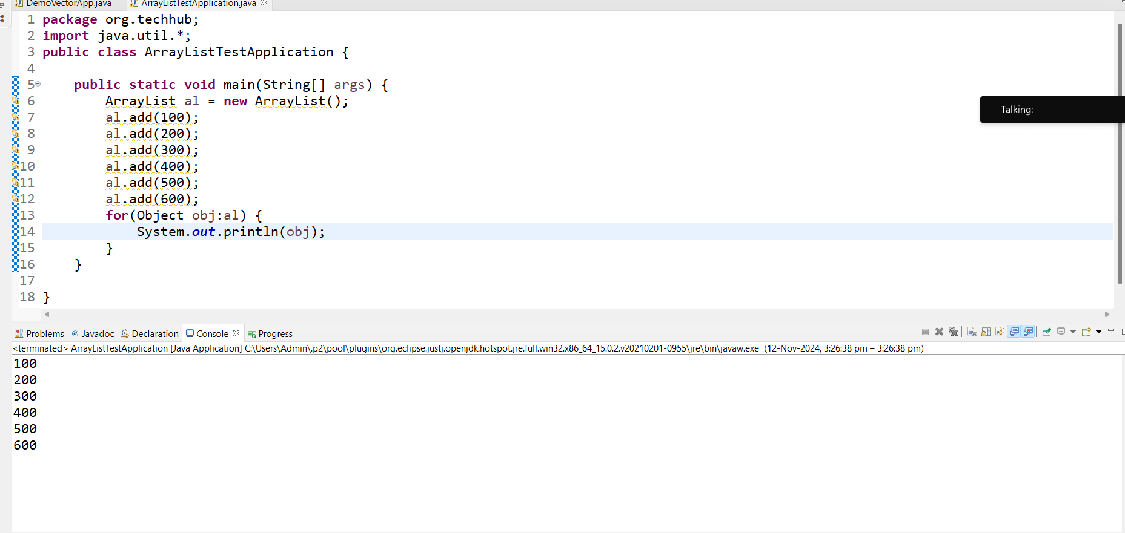
Example using POJO class and ArrayList
__________________________________________________________________________________
We want to create POJO class name as Product with field id, name and price and perform following operations on it.
Case 1: Add New Product
Case 2: View All Products
Case 3: Search Product by Id
Case 4: Delete Product by Id
Case 5: Update Product by Id

package org.techhub.prodcrud;

import java.util.*;

public class ProductCrudApplication {

public static void main(String[] args) {
ArrayList al = new ArrayList();
do {
Scanner xyz = new Scanner(System.in);
System.out.println("1:Add New Product");
System.out.println("2:View All Products");
System.out.println("3:Search Product By Id");
System.out.println("4:Delete Product By Id");
System.out.println("5:Update Product By Id");
System.out.println("Enter your choice");
int choice = xyz.nextInt();
switch (choice) {
case 1:
xyz.nextLine();
System.out.println("Enter name id and price of product");
String name = xyz.nextLine();
int id = xyz.nextInt();
int price = xyz.nextInt();
Product p1 = new Product(name, id, price);
boolean b = al.add(p1);
if (b) {
System.out.println("Product Added Successfully............");
} else {
System.out.println("Some problem is there...................");
}
break;
case 2:
for (Object obj : al) {
Product p = (Product) obj;
System.out.println(p.getId() + "\t" + p.getName() + "\t" + p.getPrice());
}
break;
case 3:
System.out.println("enter id for search product");
int userid = xyz.nextInt();
boolean flag = false;
for (Object obj : al) {
Product p = (Product) obj;
if (p.getId() == userid) {
flag = true;
break;
}
}
if (flag) {
System.out.println("Product found");
} else {
System.out.println("Product not found");
}
break;
case 4:
System.out.println("enter id for search product");
userid = xyz.nextInt();
flag = false;
for (Object obj : al) {
Product p = (Product) obj;
if (p.getId() == userid) {
int index = al.indexOf(p);
if (index != -1) {
al.remove(index);
flag = true;

}
}
}
if (flag) {
System.out.println("Product Deleted successfully");
} else {
System.out.println("Product not found");
}
break;
case 5:
System.out.println("enter id for search product");
userid = xyz.nextInt();
xyz.nextLine();

System.out.println("Enter new product details");
String newName = xyz.nextLine();
int newPrice = xyz.nextInt();
Product p2 = new Product(newName, userid, newPrice);
flag = false;
for (Object obj : al) {
Product p = (Product) obj;
if (p.getId() == userid) {
int index = al.indexOf(p);
if (index != -1) {
al.set(index, p2);
flag = true;

}
}
}
if (flag) {
System.out.println("Product Updated successfully");
} else {
System.out.println("Product not found");
}
break;
default:
System.out.println("Wrong choice");
}
} while (true);
}
}
LinkedList
_____________________________________________________________________________________
LinkedList is a by default double linked list in java and it is implementer class of List interface

Q. what is difference between ArrayList and LinkedList?
__________________________________________________________________________________
1. ArrayList is work as dynamic array and LinkedList work doubly linked list by default
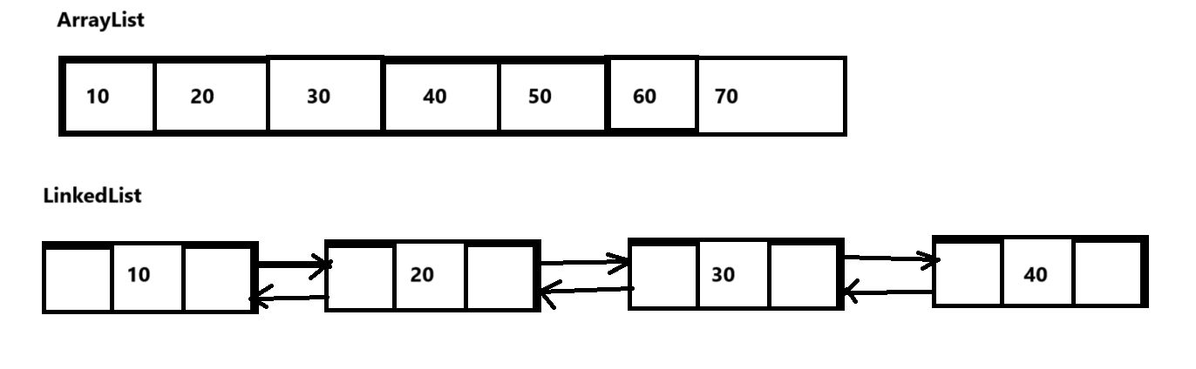
2. ArrayList use the O(n) for deletion and updation of element and LinkedList use the O(1) for deletion and updation purpose. Means when we delete or update element using ArrayList then we required to perform number of iterations and if we perform delete and update operation using LinkedList we not required to perform iterations means we can say deletion and updation operation can perform faster than using LinkedList than ArrayList.
3, In terms of searching and fetching data ArrayList is faster than LinkedList because ArrayList data is manage by using single sequence and by using index so we fetch data easily but if we think about LinkedList then LinkedList can store using random address so fetch address and extracting data is length or it may take some time so we can say fetching and searching operation can perform faster using ArrayList than LinkedList.
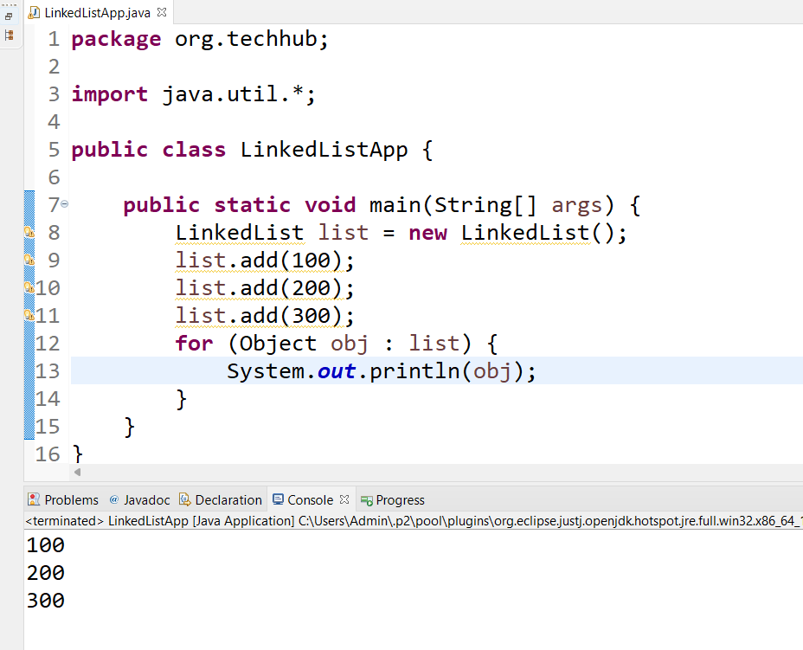

Stack
___________________________________________________________________________
Stack is collection and it is child of Vector class and this class helps us to manage data using last in first out format.
Stack has only one constructor i.e empty constructor
Stack(): this constructor help us to create stack or create empty stack.
Methods of Stack
______________________________________________________________________
public void push(E): this method can push data in stack and increase top by 1.
public Object pop(): this method remove data or remove top most data from stack and decrease top by 1
boolean isEmpty(): this method can return true when element not present in stack otherwise return false.
Object peek(): this method can peek data from or display on last inserted data but not remove.

Example: we want to implement stack practically
Case 1: Insert Data in Stack
Case 2: Delete Data from Stack
Case 3: Display data from Stack
Case 4: peek data from stack.

Example with source code
package org.techhub;

import java.util.*;

public class LinkedListApp {
public static void main(String[] args) {
Stack s = new Stack();
do {
Scanner xyz = new Scanner(System.in);
System.out.println("1:Insert");
System.out.println("2:Delete");
System.out.println("3:Display");
System.out.println("4:Peek");
System.out.println("Enter your choice");
int choice = xyz.nextInt();
switch (choice) {
case 1:
System.out.println("Enter value in stack");
int value = xyz.nextInt();
s.push(value);
System.out.println("Data Save In Stack Successfully.....");
break;
case 2:
boolean b = s.isEmpty();
if (b) {
System.out.println("Stack is empty");
} else {
System.out.println("Removed data is " + s.pop());
}
break;
case 3:
b = s.isEmpty();
if (b) {
System.out.println("there is no data for fetching");
} else {
ListIterator li = s.listIterator(s.size());
while (li.hasPrevious()) {
Object obj = li.previous();
System.out.println(obj);
}
}
break;
case 4:
b = s.isEmpty();
if (b) {
System.out.println("Stack is empty");
} else {
System.out.println("Removed data is " + s.peek());
}
break;

default:
System.out.println("Wrong choice");
}
} while (true);
}
}
Collections class
_______________________________________________________________________
Collection is a class from java.util package and it is utility class in JAVA means we can say we cannot create object of Collections class and it contains only static methods and Collections provide some operations to us which is commonly required to all Collection like as sorting element, searching element, reverse the collection, finding max element from collection, min element from collection etc
Methods of Collections class
____________________________________________________________________________
Example: WAP to create collection or ArrayList and store 5 values in it and find the max and min value from ArrayList.
package org.techhub.prodcrud;
import java.util.*;
public class SortArrayListApp {
public static void main(String[] args) {
ArrayList al = new ArrayList();
al.add(5);
al.add(1);
al.add(100);
al.add(4);
al.add(2);
al.add(3);
Object objMax=Collections.max(al);
Object objMin=Collections.min(al);
System.out.println("Max Value from Collection "+objMax);
System.out.println("Min Value from Collection "+objMin);

}
}
Example: WAP to create ArrayList and store 5 values in it and reverse the collection.
package org.techhub.prodcrud;
import java.util.*;
public class SortArrayListApp {
public static void main(String[] args) {
ArrayList al = new ArrayList();
al.add(5);
al.add(1);
al.add(4);
al.add(2);
al.add(3);
System.out.println("Before reverse");
for(Object obj:al) {
System.out.print(obj+"\t");
}
Collections.reverse(al);
System.out.println("\nAfter reverse ");
for(Object obj:al) {
System.out.print(obj+"\t");
}

}
}

Note: You can convert your non synchronized collection as synchronized collection using Collections class and for that we have method name as Collections.synchronizedNameOfMap() or synchronizedNameOfCollection() etc
package org.techhub.prodcrud;
import java.util.*;
public class SortArrayListApp {
public static void main(String[] args) {
ArrayList al = new ArrayList();
al.add(5);
al.add(1);
al.add(4);
al.add(2);
al.add(3);
List list1=Collections.synchronizedList(al);
System.out.println(list1);
}
}

Example: we want to create ArrayList and store 5 values in it and perform sorting on it.
package org.techhub.prodcrud;
import java.util.*;
public class SortArrayListApp {
public static void main(String[] args) {
ArrayList al = new ArrayList();
al.add(5);
al.add(1);
al.add(4);
al.add(2);
al.add(3);
System.out.println("Before Sorting");
for(Object obj:al) {
System.out.println(obj);
}
Collections.sort(al);
System.out.println("After Sorting");
for(Object obj:al) {
System.out.println(obj);
}
}
}
Example: we want to Employee class with field id, name and sal and store five employees’ data in ArrayList and perform sorting on it.
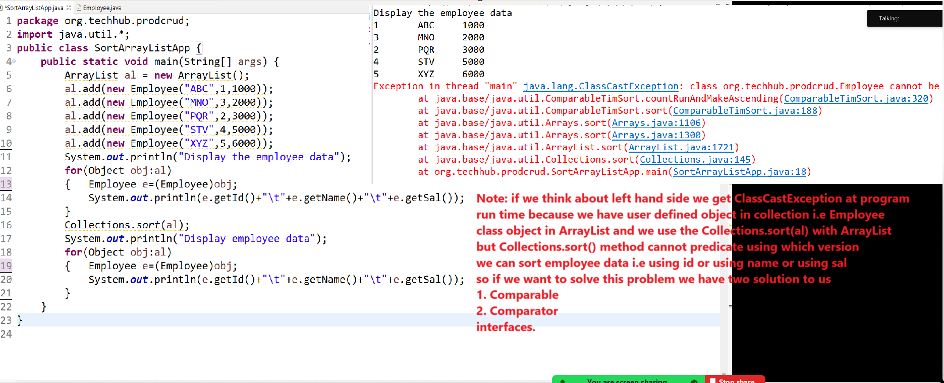

Now we want to discuss about the Comparable interface.
Q. What is Comparable interface?
_____________________________________________________________________
Comparable interface is used for perform sorting on user define objects with collection

How we can handle the Comparable interface in JAVA
__________________________________________________________________________
Steps to work with Comparable interface
1. Add java.lang package in application
Note: java.lang is a default package of java means we not need to import it.
2. Create class and implements Comparable interface in it.
package org.techhub.prodcrud;
public class Employee implements Comparable {
private int id;
public int getId() {
return id;
}
public void setId(int id) {
this.id = id;
}
public String getName() {
return name;
}
public void setName(String name) {
this.name = name;
}
public int getSal() {
return sal;
}
public void setSal(int sal) {
this.sal = sal;
}
private String name;
private int sal;
public Employee() {
}

public Employee(String name, int id, int sal) {
this.name = name;
this.id = id;
this.sal = sal;
}
}
Note: You can implement Comparable in class whose object we want to sort.
3. Override its compareTo() method and use the following logics for perform comparison
___________________________________________________________________________
public int compareTo(Object o) : if we think about this method and using this method we can perform comparison.

Rules of compareTo() method
______________________________________________________________________
1. If current object is greater than second object then return 1.
2. If current object is less than second object then return -1
3. If current object is equal with second then return 0

Example: sort the employee by using its id.
package org.techhub.prodcrud;
public class Employee implements Comparable {
private int id;
public int getId() {
return id;
}
public void setId(int id) {
this.id = id;
}
public String getName() {
return name;
}
public void setName(String name) {
this.name = name;
}
public int getSal() {
return sal;
}
public void setSal(int sal) {
this.sal = sal;
}
private String name;
private int sal;
public Employee() {
}

public Employee(String name, int id, int sal) {
this.name = name;
this.id = id;
this.sal = sal;
}
@Override
public int compareTo(Object o) {
Employee e=(Employee)o;

if(this.getId()>e.getId()) {
return 1;
}
else if(this.getId()<e.getId()) {
return -1;
}
else {
return 0;
}
}

}
package org.techhub.prodcrud;
import java.util.*;
public class SortArrayListApp {
public static void main(String[] args) {
ArrayList al = new ArrayList();
al.add(new Employee("ABC",1,1000));
al.add(new Employee("MNO",3,2000));
al.add(new Employee("PQR",2,3000));
al.add(new Employee("STV",4,5000));
al.add(new Employee("XYZ",5,6000));
System.out.println("Display the employee data");
for(Object obj:al)
{ Employee e=(Employee)obj;
System.out.println(e.getId()+"\t"+e.getName()+"\t"+e.getSal());
}
Collections.sort(al);
System.out.println("Display employee data");
for(Object obj:al)
{ Employee e=(Employee)obj;
System.out.println(e.getId()+"\t"+e.getName()+"\t"+e.getSal());
}
}
}

Example: WAP to create class name as id,name and run and sort player data by using run.
package org.techhub.prodcrud;

public class Player implements Comparable{
private int id;
private String name;

Player(){

}
Player(String name,int id,int run)
{
this.name=name;
this.id=id;
this.run=run;
}
public int getId() {
return id;
}

public void setId(int id) {
this.id = id;
}

public String getName() {
return name;
}

public void setName(String name) {
this.name = name;
}

public int getRun() {
return run;
}

public void setRun(int run) {
this.run = run;
}

private int run;

@Override
public int compareTo(Object o) {
Player p1=(Player)o;
if(this.run>p1.getRun()) {
return 1;
}
else if(this.run<p1.getRun()) {
return -1;
}
else {
return 0;
}
}

}
package org.techhub.prodcrud;
import java.util.*;
public class PlayerDataSortingApplication {

public static void main(String[] args) {
ArrayList al = new ArrayList();

al.add(new Player("ABC",1,10000));
al.add(new Player("MNO",3,22000));
al.add(new Player("PQR",2,3000));
al.add(new Player("STV",4,12000));
al.add(new Player("XYZ",5,45000));
System.out.println("Display Player record without sorting");
for(Object obj:al) {
Player p=(Player)obj;
System.out.println(p.getId()+"\t"+p.getName()+"\t"+p.getRun());
}
Collections.sort(al);
System.out.println("Display Player record with sorting");
for(Object obj:al) {
Player p=(Player)obj;
System.out.println(p.getId()+"\t"+p.getName()+"\t"+p.getRun());
}
}
}
Note: if we think about Comparable interface the limitation is we can sort user define object using single attribute or using field. So we want to sort the collection with user define objects we have Comparator interface.
Steps to work with Comparator
_________________________________________________________
1. Add java.util package in application
2. Create class and implement Comparator interface in it.
3. override its compare() method
4. use the Collections.sort() give syntax

