Constructor
___________________________________________________________________
Constructor is a function same name as class name but without return type.

Q. Why use constructor or what is benefit of constructor?
_________________________________________________________________
There are Major two benefits of constructor.
1. Initialize class member
___________________________________________________________
Normally constructor is used for initialize the variable declared within class at the time of object creations.
2. To call function when class object get created
________________________________________________________________________
Constructor calls automatically when we create object of class.

How to declare constructor in JAVA
If we want to declare constructor in JAVA then we have to use following syntax.
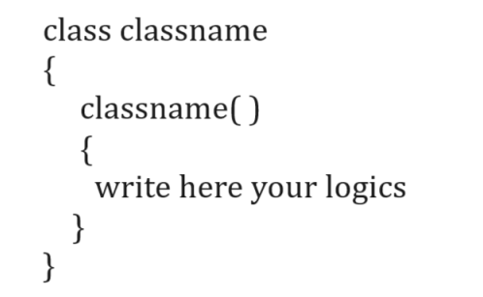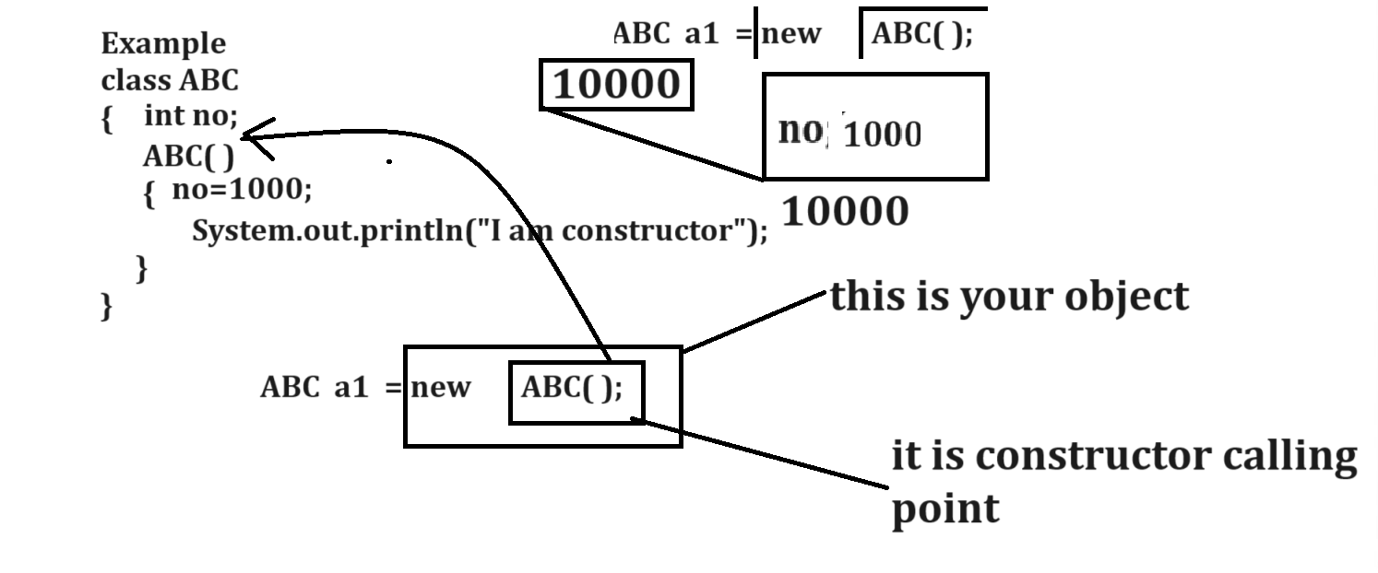
Note: if we think about above code we have constructor ABC and we initialize no=1000 in it and we initialize value in constructor and no is part of object so if we initialize number means we initialize object but constructor call at the time of creation.

Example with source code constructor
class ABC
{
ABC()
{ System.out.println("I am default constructor");
}
}
public class ABCAPP
{
public static void main(String x[])
{ ABC a1=new ABC();
}
}
If we want to work with constructor we have some types of constructor
1. Default Constructor: default constructor means a constructor cannot have any argument or without argument constructor called as default constructor.

Example of default constructor
class ABC
{
ABC() //default constructor
{ System.out.println("I am default constructor");
}
}
public class ABCAPP
{
public static void main(String x[])
{ ABC a1=new ABC();
}
}
Note: if we not declare any constructor within class then every class one default constructor knows as implicit constructor.
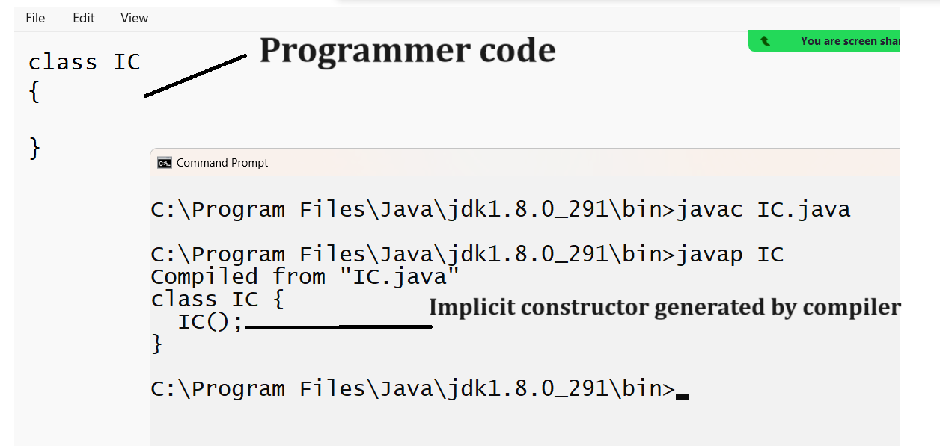
2. Parameterized constructor: Parameterized constructor means if we pass parameter or argument to the constructor called as parameterized constructor and when we pass parameter to constructor then we required passing parameter to object.
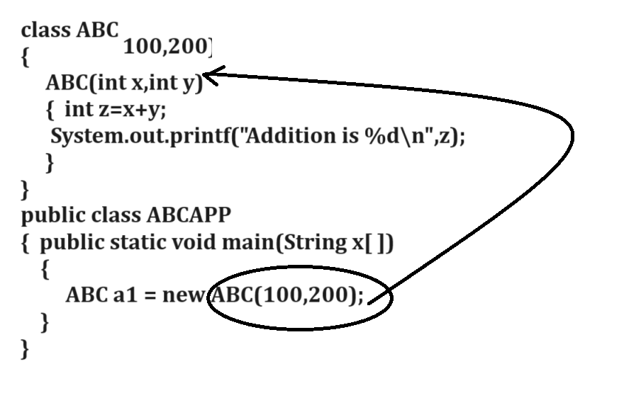
Example with source code
class ABC
{
ABC(int x,int y)
{ System.out.println("Addition is "+(x+y));
}
}
public class ABCAPP
{
public static void main(String x[])
{ ABC a1=new ABC(100,200);
}
}
Example: WAP to create class name as Power with parameterized constructor and one method
Power(int base,int index): accept the two value first as base and second as index.
int getPower(): this is used for calculate the power of number and return it.

Example with source code
import java.util.*;
class Power
{ int base,index,p=1;
Power(int base,int index)
{ this.base=base;
this.index=index;
}
int getPower()
{ for(int i=1; i<=index;i++)
{ p = p * base;
}
return p;
}
}
public class ParamConsApp
{ public static void main(String x[])
{ Scanner xyz =new Scanner(System.in);
int base,index;
System.out.println("Enter base and index");
base=xyz.nextInt();
index=xyz.nextInt();
Power p = new Power(base,index);
int result=p.getPower();
System.out.println("Power is "+result);
}
}
Example:WAP to create class name as Sum with one constructor and method
Sum(int a[]): accept integer array as parameter
int getSum(): this function can calculate sum of all array values and return it.

Example with source code
import java.util.*;
class Sum
{ int a[],s=0;
Sum(int a[])
{ this.a=a;
}
int getSum()
{ for(int i=0; i<a.length;i++)
{ s = s + a[i];
}
return s;
}
}
public class ArrSumApp
{
public static void main(String x[])
{ int m[]=new int[5];
Scanner xyz = new Scanner(System.in);
System.out.println("enter values in array");
for(int i=0;i<m.length;i++)
{ m[i]=xyz.nextInt();
}
Sum s = new Sum(m);
int result=s.getSum();
System.out.println("Sum of all value is "+result);
}
}

Example: WAP to create class with one parameterized constructor and one method
LenCount(char[]): this constructor accept character array as input
int getLength(): this method return length of character array.

3. Overloaded constructor
____________________________________________________________________________
Constructor overloading means if we define multiple constructors using same name with different parameter list with different parameter sequence as well as different data type called as constructor overloading.
Note: In the case of constructor overloading which constructor should execute is dependent on how much parameter in it, its sequence as well as its data type.

Example with source code
class Square
{
Square(int x)
{ System.out.println("Integer square is "+(x*x));
}
Square(float x)
{ System.out.println("Float square is "+(x*x));
}
}
public class SquareApp
{
public static void main(String x[])
{
Square s1 = new Square(5);//call integer constructor
Square s2 = new Square(5.5f);//call float constructor
}
}

Example: WAP to Create class ConvertToUpperOnEvenPosition with one constructor and method
ConvertToUpperOnEvenPosition(char[]): we have to pass character array as parameter
void convert(): this method can convert even position character in upper case
char [] getConvertedArray(): this method can return array after conversion.

Example: WAP to create class name as SubArrSum with constructor and one method
SubArrSum(int a[],int sumValue): this method can accept array as parameter and one single value as sum
void findSubArr(): this method can find the sum array whose sum is equal with sum value provide by user.
Example: 1 5 2 5 4 8
User provided value: 12
Index of sub array 1 and 3 and you sub array is 5 2 5

Example: WAP to create class name as FindNArmstrong with constructor and function
FindNArmstrong(int limit): you have to accept integer as parameter
void showAllNumbersBetweenLimt(): find the all Armstrong numbers between limit

Expected output is
Input Limit: 11
Output: 1 2 3 4 5 6 7 8 9
Input Limit: 200
Output: 1 2 3 4 5 6 7 8 9 153

4. this() constructor
_______________________________________________________________________________
this() constructor means we can call one constructor from another constructor within same class and if we call one constructor from another constructor known as constructor chaining.
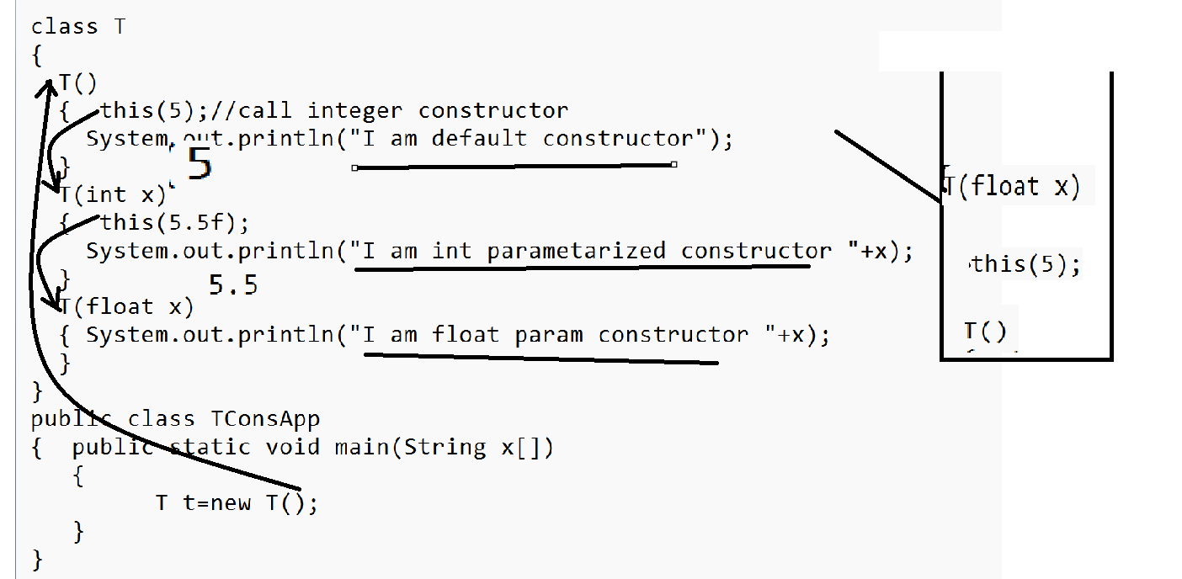

Q. What is constructor chaining and how we can achieve it?
____________________________________________________________________________
Constructor chaining means we can call one constructor from another constructor called as constructor chaining and we can achieve constructor chaining by using two ways.
1. Using this() constructor
2. Using super() constructor:
Note: super() constructor we will discuss in inheritance chapter.

If we want to work with constructor in java we should have to know some important points.
1. Constructor cannot have return type
Note: if we give return type to constructor in java then it is not consider as constructor it is consider as method. Means we can say in the case of java function name and class name may be same.
Example with source code.
class C
{ void C() //it is method not constructor
{ System.out.println("I am Method");
}
}
public class ConsRuleApp
{ public static void main(String x[])
{ C c1 = new C();
c1.C();//method need to call
}
}
2. Constructor cannot declare as static
Note: if we try to declare constructor as static then compiler will generate compile time error.
class C
{
static C()
{ System.out.println("I am constructor");
}
}
public class ConsRuleApp
{ public static void main(String x[])
{ C c1 = new C();
}
}
Output
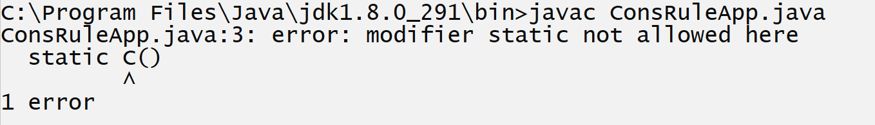
Q. Why constructors not declare as static?
because static can allocate memory before creating object of class and constructor can call after object creation means we can say the behavior of constructor and static opposite of each other.

3. Constructor cannot declare as final and abstract also
Note: we will discuss this concept in inheritance chapter.

4. Try to avoid declare constructor as private
___________________________________________________________________________
If we declare constructor as private then we cannot create object of that class outside of class
class C
{
private C()
{ System.out.println("I am constructor");
}
}
public class ConsRuleApp
{
public static void main(String x[])
{
C c1 = new C();

}
}
Output
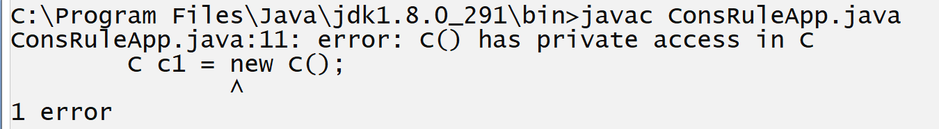
Note: if we create utility class or singleton class then your class constructor must be private.

Q. what is meaning of utility class?
______________________________________________________________________
Utility class means class cannot create its object but it contains static methods called as utility class.
Example: Collections class is utility class in java
Note: if we want create the utility class we required to declare class constructor as private.

class C
{private C() {
}
static void show()
{ System.out.println("I am show method");
}
static void display()
{ System.out.println("I am display method");
}
}
public class ConsRuleApp
{ public static void main(String x[]){
C.show();
C.display();
}
}
Q. What is singleton class?
_____________________________________________________________________________
Singleton class means class can create its only one object in whole application called as singleton class basically singleton is a design pattern.

Q. What is design pattern?
____________________________________________________________________________
Design patterns are reusable solutions to common problems in software design. They represent best practices used by experienced object-oriented software developers. Design patterns provide a standard terminology and are specific to particular scenarios.

There are three types of design pattern
1. Creational
2. Behavioral
3. Structural design pattern.

How to create singleton design pattern
_________________________________________________________________________________
If we want to create singleton design pattern or create singleton class using java we have some following steps.

1. Declare class with private constructor
__________________________________________________________________________
class DB
{ private DB()
{ System.out.println(“I am singleton class”);
}
}
2. Create static reference within same class with null value.
class DB
{ private static DB db=null;
private DB()
{ System.out.println("I am singleton class");
}
}
3. Create one static method and return same class reference from it.
_________________________________________________________________
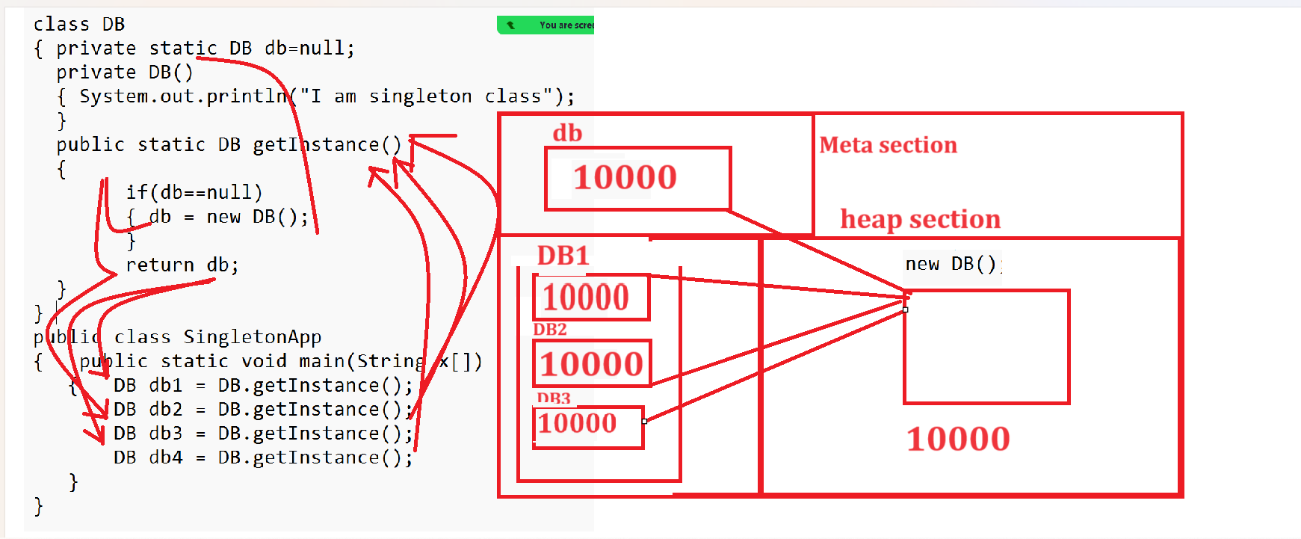
Example with source code
class DB
{ private static DB db=null;
private DB()
{ System.out.println("I am singleton class");
}
public static DB getInstance()
{
if(db==null)
{ db = new DB();
System.out.println("Hash code of object "+System.identityHashCode(db));

}
return db;
}
}
public class SingletonApp
{ public static void main(String x[])
{ DB db1 = DB.getInstance();
System.out.println("Hash code of object "+System.identityHashCode(db1));

DB db2 = DB.getInstance();
System.out.println("Hash code of object "+System.identityHashCode(db2));

DB db3 = DB.getInstance();
System.out.println("Hash code of object "+System.identityHashCode(db3));

DB db4 = DB.getInstance();
System.out.println("Hash code of object "+System.identityHashCode(db4));
}
}

Q. what is the difference between function and constructor?
Function | Constructor
Function must have return type and non necessary same with class name | Constructor does not have return type and must be same as class name
Function need to call by using reference of class or object of class manually by using dot operator | Constructor call automatically at the time object creation
Function can declare as static | Constructor cannot declare as static
Class cannot have default function or implicit function | But every class must have implicit constructor
Function can declare as final or abstract | Constructor cannot declare as final or abstract
Function can override | Constructor cannot override in child class
function can work with recursion or allow to perform recursion | Constructor cannot support to recursion

