JAVA
____________________________________________________________________________________

Q. What is JAVA?
__________________________________________________________________________________
Ans: JAVA is pure object oriented language

Q. What is Object oriented?
___________________________________________________________________________
Object oriented is a concept of programming based on four pillars and seven features.

Pillar of OOP
_______________________________________________________________
1. Polymorphism
2. Abstraction
3. Encapsulation
4. Inheritance

Feature of OOP
__________________________________________________________________________
1. Class 2. Object 3. Inheritance 4. Polymorphism 5. Data Abstraction and Encapsulation
6. Dynamic Binding 7.Message Passing.

If we want to work with JAVA we need to know how to create program in it and execute it.

Steps to work with JAVA Application
__________________________________________________________________________
1. Install JDK
Q. What is JDK?
________________________________________________________________________
JDK stands for Java Development Kit
Def: JDK is software cluster or it is group of software which provide environment to us to create and execute java application like as compiler , JVM etc
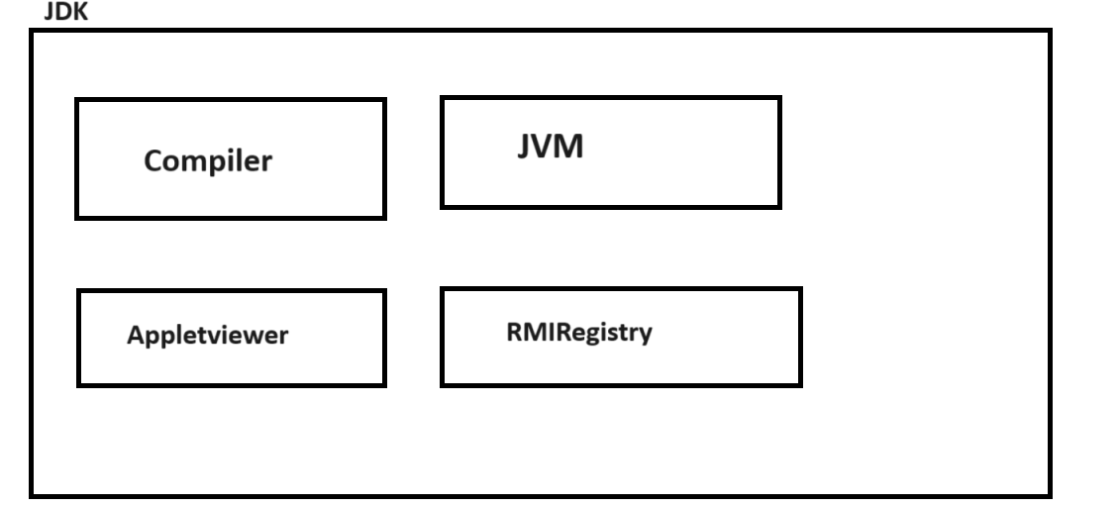

Q. What is compiler?
_________________________________________________________________
Compiler is application which is used for convert source to byte code in java

Q. What is byte code?
____________________________________________________________________________
Byte code is intermediate code which is converting in machine code with the help of JVM or Byte code is machine understandable code.

Q. What is JVM?
_____________________________________________________________________________
JVM Stands for Java Virtual Machine it is application which is used for convert your byte code in to machine code.

Note: if you want to download the JDK we have to use following links.
Java Downloads | Oracle India

2. Create Sample Application
______________________________________________________________________________
If we want to create program in java we have generalize syntax of Java Application.
Syntax:
access specifier class classname
{ public static void main(String x[])
{ write here your logics
}
}
Example with source code
public class TestFirst
{ public static void main(String x[])
{ System.out.println("good morning");
}
}

Description of above code
public class TestFirst: Here public is access specifier
Q. what is access specifier?
Access specifier is the some keywords which is responsible for apply restrictions on class and its member.

There are four types of access specifier in JAVA
a) public: public access specifier means member can access anywhere in application means within same package as well as outside of package.
b) private: private access specifier means member cannot access outside of class.
c) protected: protected access specifier means member can access only within child class.
d) default: default access specifier means member can access outside of class but within same package cannot access outside of package.
Note: we will discuss this access specifier in depth in classes and object chapter as well as in inheritance and package chapter.

class is keyword for class declaration purpose
TestFirst is class name and user can give any name to his class.

public static void main(String x[]): It is main function of java same like as main function in C or C++
Note: we will discuss main method in depth after 2 lectures.

System.out.println("good morning"): it is output statement of java like as printf() in c

Meaning of Above Statement
_________________________________________________________________________
System is class out is static reference of PrintStream class.
System and PrintStream maintain HAS-A relationship between them and println() is overloaded method which is used for display output on console or output window.
Note: we will discuss this meaning in inheritance chapter.

Note: you can use any text editor or different tools for develop java application.
Text Editor: notepad, notepad++ , sublimetext
Tools: VSCode , Eclipse, InteliJ IDE etc

Note: As a fresher for practice purpose we will use the notepad++ or notepad

3. Save Application: if we want to save program in java you can save in bin folder where JDK install and give class name and filename same with .java extension So as per our example our file name should TestFirst.java

4. Compile Application:
Q. What is compilation?
Compilation is process where we can convert source code in to byte code in JAVA.

How to compile JAVA program?
__________________________________________________________________________
If we want to compile your java program then we have some following steps.
a) Open Command prompt
Start menu ----- search ----- command prompt.
b) Go where Java File Save
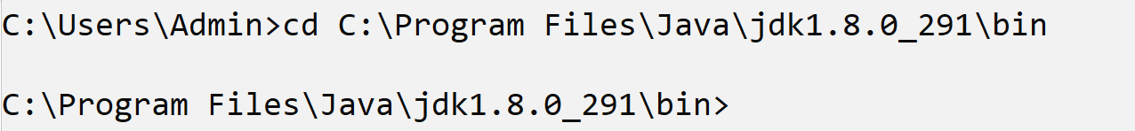
c) Type the command: javac filename.java
Example: javac TestFirst.java
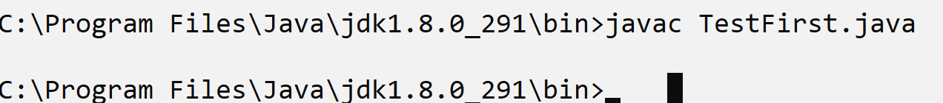
Note: if we think about above screen shot we have statement javac TestFirst.java means we compile java program successfully.
When your java program get compile successfully then java compiler create new file with extension .class and in this file contain your byte code.
Means after compilation of java code we have two files with extension .java and .class so .java file contain source code and .class file contain byte code.
As per our example.
TestFirst.java --- this file contain source code
TestFirst.class --- this file contain your byte code.
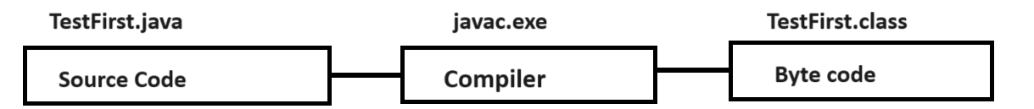

5. Run Application: if you want to run the program then we have to use following statement.
Sytax: java filename
Example: java TestFirst
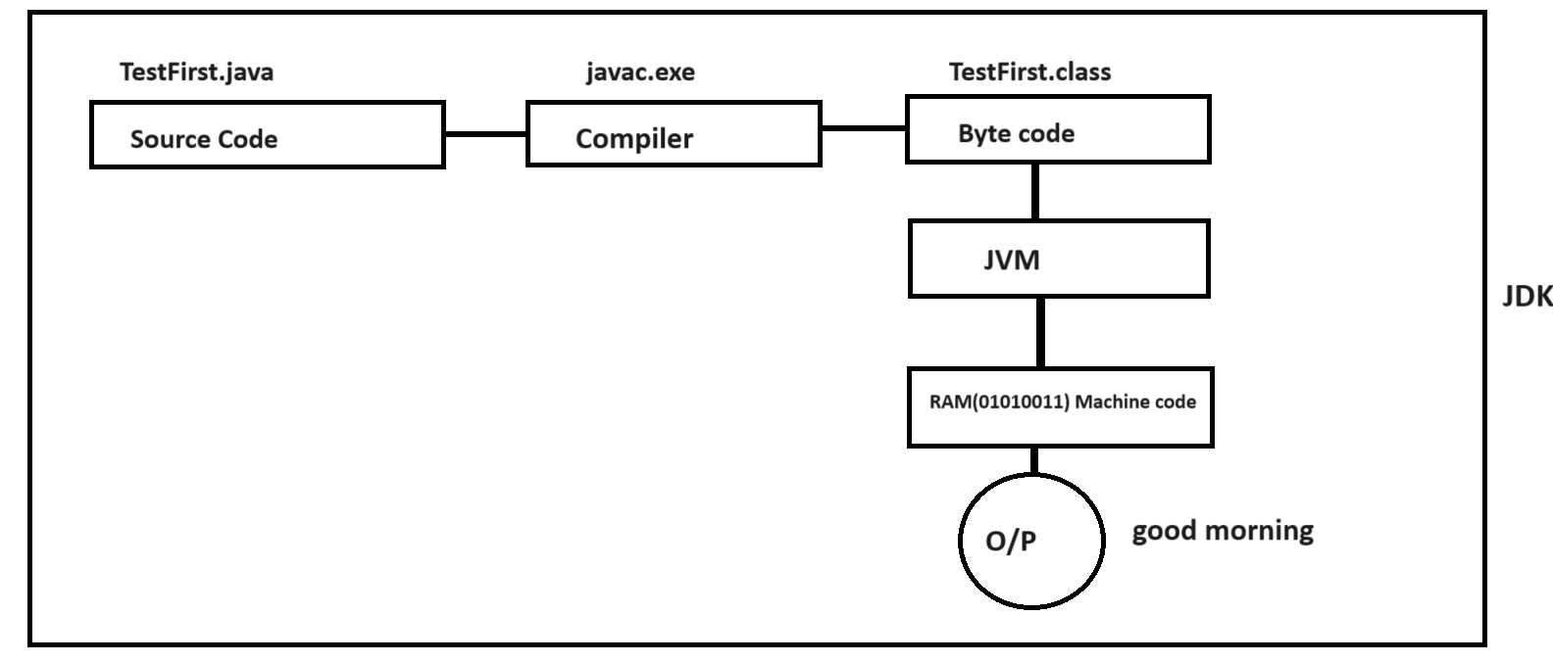

Example: WAP to declare two variables and calculate its addition.
public class FebMarchAddApp
{
public static void main(String x[])
{
int a,b,c;
a=10;
b=20;
c=a+b;
System.out.printf("Addition is %d\n",c);
}
}
If we think about above code we calculate addition of two fix values. We want to accept the
Input from keyboard and after that calculate its addition.

How to accept the input from keyboard at program run time
___________________________________________________________________________
If we want to accept the input from keyboard at program run time we have following ways.
1. Use Command Line Arguments
2. Use Scanner class.

Q. What are Command line arguments?
__________________________________________________________________________
Command line argument is parameter present in main function of string array type and it is infinite string array and it is used for accept the input at program run time using keyboard and the first input present at 0th position up to n-1

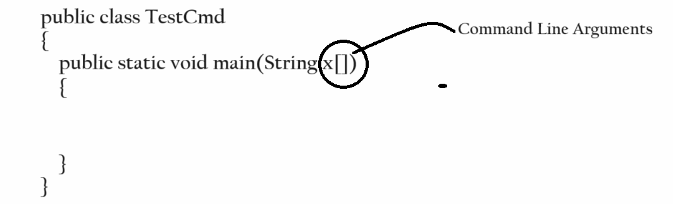

Example: we want to accept the two inputs from keyboard at program run time using command line arguments and calculate its addition

Example with source code
public class FebMarchAddApp
{ public static void main(String x[])
{
int a,b,c;
a=x[0]; //first input
b=x[1]; //second input
c=a+b;
System.out.printf("Addition is %d\n",c);
}
}
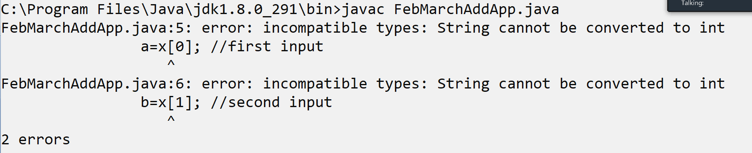
Note: if we think about above code we get 2 compile time errors and the error is incompatible types.

Q. Why Program Generate this type of error?
____________________________________________________________________________
Because we have string for input and we want to accept integer input from keyboard and String cannot store in integer directly so compiler will generate compile time error
If we want to solve this type of error in java we need to use type casting technique.

Q. What is type casting?
_________________________________________________________________________
Type casting means convert one type of data in to another type for single line of code called as type casting means as per our example we need to convert string value into integer value.

How to convert String value in to integer value?
________________________________________________________________________________
If we want to convert string value in to integer value we have to use following statement

Syntax: int variablename = Integer.parseInt(string);
Example: int a = Integer.parseInt(x[0]); //this statement can convert string value in to integer type.

Note: if we think about statement here Integer is class and parseInt() is function of Integer class which is used for convert string value in to integer type.

Important points
Q. How we can identify class in Java?
________________________________________________________________________
If we want to identify class in Java we then class name start with capital letter as per standard of java and if class name create by using multiple words then every word first letter must be capital.
Example: Scanner – it is class name so S is capital.
Integer: here I is capital
DataInputStream: this is class in java but form by using three different word Data Input Stream so D I and S is capital
Example EmployeeSalaryByDesignation

Q. How we can identify function/method in Java?
Java Function name writing style known as camel case means as per the standard of camel case if your function form by using single word then all letters should be small and if your function name form by using multiple word then first word first letter should be small and remaining every word first letter must be capital.

Example: read(): this is single word function so all letters small
readLine(): this function form by using two words so r is small and L is capital.
getEmployeeSalary(): this function by using three words so g is small E and S is capital.

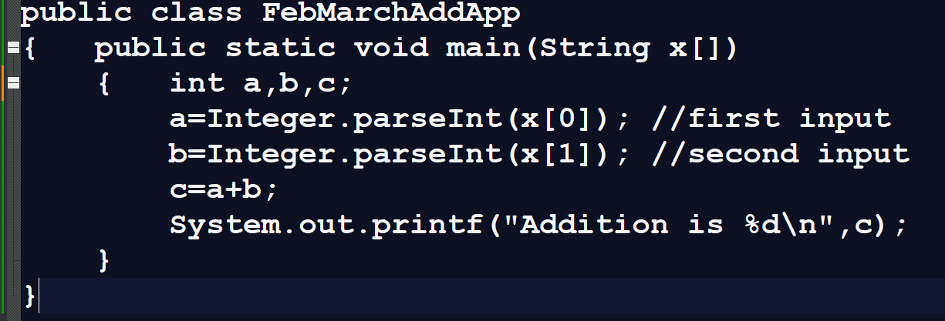
Output
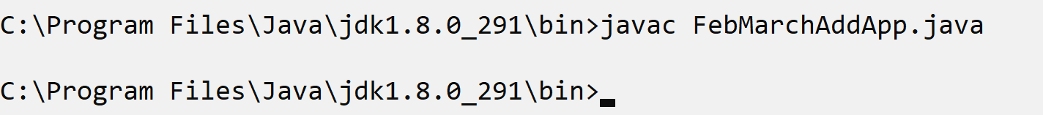
If we think about above screen shot there is no compile time error
Because Integer.parseInt(x[0]) and Integer.parseInt(x[1]) successfully convert string value in to integer value.
Now we want to run java program and accept input from keyboard.
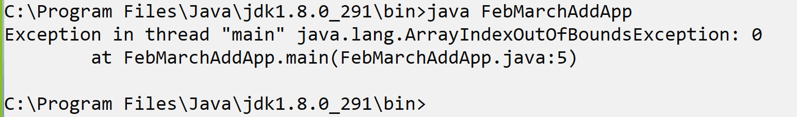
Note: if we think about above screen shot we get run time error ArrayIndexOutOfBoundsException : 0
Because if we think about command line argument then you must be accept input where you run java program or accept all input on same line where we run java program
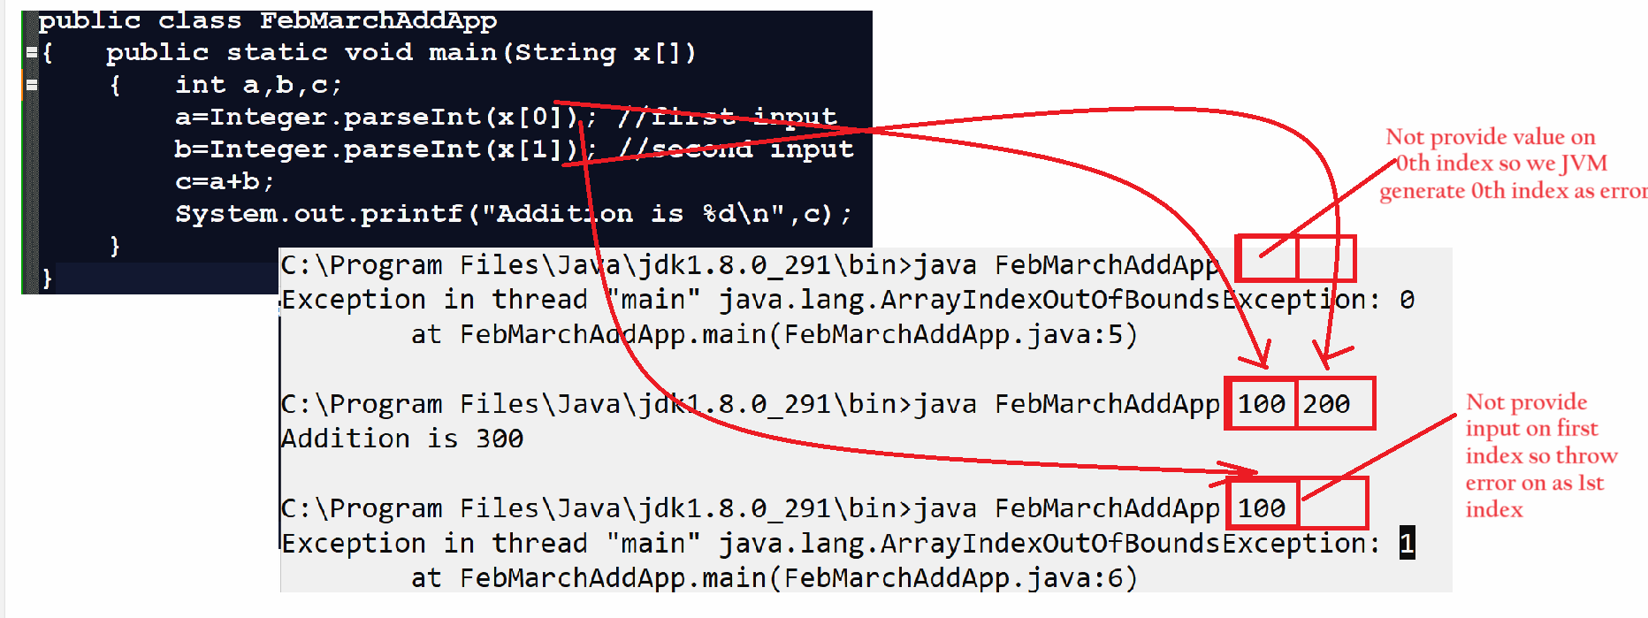
Note: means if we think command line argument input must be present on same line

Example: WAP to input number from keyboard using command line argument and print its table.
public class TableApp
{ public static void main(String x[])
{ int no=Integer.parseInt(x[0]);
for(int i=1; i<=10;i++)
{ System.out.printf("%d\n",no*i);
}
}
}
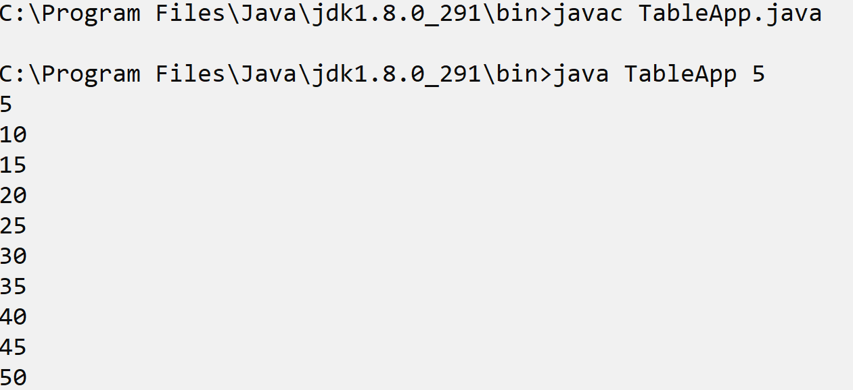

Example: WAP to input radius from keyboard and calculate area of circle.
public class CircleAreaApp
{
public static void main(String x[])
{
float radius,area,PI=3.14f;
radius=Float.parseFloat(x[0]);
area=radius*radius*PI;
System.out.printf("Area of circle is %f\n",area);
}
}
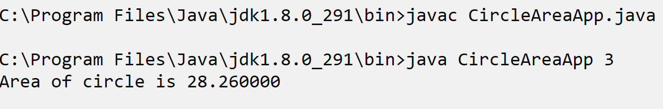
Example: WAP to Input two values from keyboard consider first value as base and second as index and calculate its power.

public class PowerApp
{ public static void main(String x[])
{ int base,index,p=1;
base=Integer.parseInt(x[0]);
index=Integer.parseInt(x[1]);
for(int i=1; i<=index;i++)
{ p = p * base;
}
System.out.printf("Power is %d\n",p);
}
}

Example: WAP to input number from keyboard and check number is even or odd

public class EvenOddApp
{ public static void main(String x[])
{ int no;
no=Integer.parseInt(x[0]);
if(no%2==0)
{ System.out.println("Number is even");
}
else
{ System.out.println("Number is Odd");
}
}
}

Output
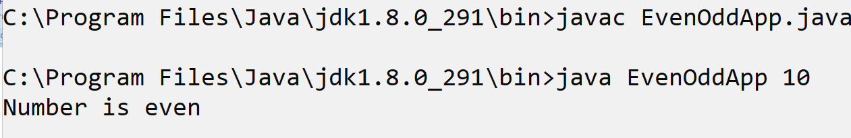

Note: The major limitation of command line argument is cannot accept the input on new line. We must be pass input value on same line where we run program.
If we want to accept the input on new line we have one more approach known as Scanner class.

What is Scanner class and why use it?
_______________________________________________________________________________
Scanner class is a member of java.util package which is used for accept the input from keyboard on new line like as scanf() in c language.

Steps to work with Scanner class
_____________________________________________________________________________
1. Add java.util package in application
_________________________________________________________________________
Q. What is package?
________________________________________________________________
Package is a collection of classes and interfaces in Java it is same like as header file in c language.
If we want to add package in your program we have import keyword.

Syntax: import packagename.*: here * indicate the wild card import means if we use the * then we can import all member from package in program there is not compulsory to use all.
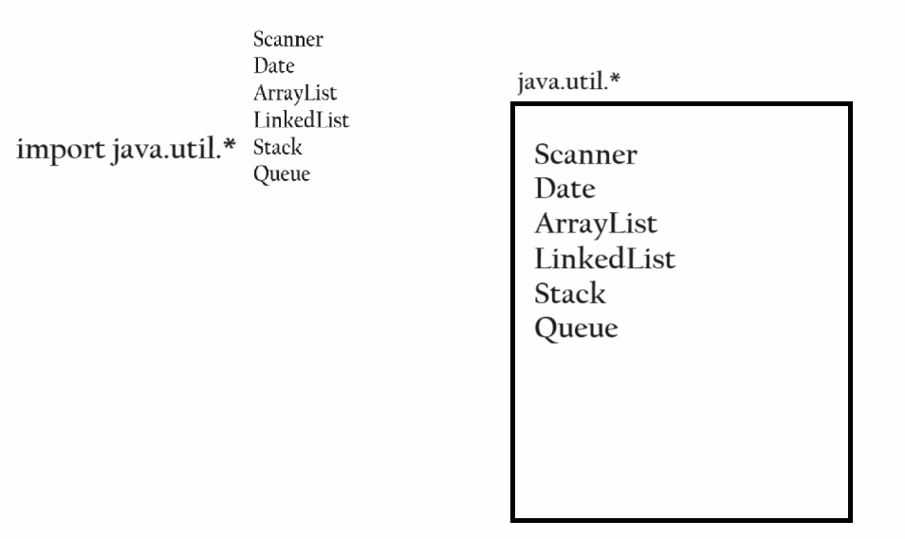
or
import packagename.membername: this syntax known as single type package import using this syntax we can import specific member from package in application.

Syntax: import packagename.classname;

Example: import java.util.*;
or
import java.util.Scanner;

2. Create Object of Scanner class
________________________________________________________________________
Syntax: Scanner ref = new Scanner(System.in);
Example: Scanner xyz = new Scanner(System.in);
Note: we will discuss about object in classes and object chapter after 15 days
3. Use its method/function to work with Scanner.
Scanner class provide n number of inbuilt method to us for accept input from keyboard.
int nextInt(): this function/method is used for accept input of type integer.
float nextFloat(): this function /method is used for accept input of type float
double nextDouble(): this function/method is used for accept input of type double
long nextLong(): this function/method is used for accept input of type long.
short nextShort(): this function /method is used for accept input of type short.
String nextLine(): this function/method is used for accept input of type string.
etc
Note: you can Scanner function using object.methodname or ref.methodname
Syntax: datatype variablenae =ref.methdoname();
Example :
Scanner xyz = new Scanner(System.in);
int no=xyz.nextInt();
Example with source code
import java.util.*;//step1 - import package
public class SquareApp
{ public static void main(String x[])
{ Scanner xyz = new Scanner(System.in);//step2
int no,sq;
System.out.println("Enter number from keyboard");
no=xyz.nextInt(); //step3
sq=no*no;
System.out.printf("Square is %d\n",sq);
}
}
Output
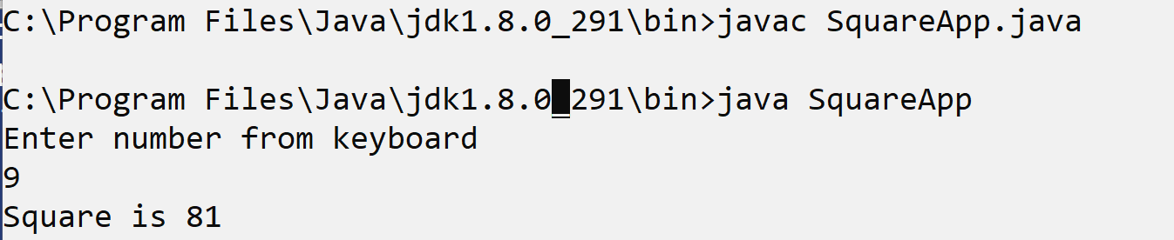

Example: WAP to Input basic salary of Employee and calculate its total salary using following terms
da=30%
hra=30%
total= bs+da+hra

Example with source code
import java.util.*;//step1
public class EmployeeSalaryApp
{ public static void main(String x[])
{ Scanner xyz = new Scanner(System.in);//step2
int bs,da,hra,total;
System.out.println("Enter basic salary of employee");
bs=xyz.nextInt();//step3
da=bs*30/100;
hra=bs*30/100;
total=bs+da+hra;
System.out.printf("total salary is %d\n",total);
}
}
Example: WAP to input number and reverse it.
import java.util.*;//step1
public class ReverseApp
{ public static void main(String x[])
{ Scanner xyz = new Scanner(System.in);//step2
int no,rev=0,rem;
System.out.println("Enter number");
no=xyz.nextInt();
while(no!=0)
{
rem = no % 10;
no = no /10;
rev = rev *10+rem;
}
System.out.printf("Reverse is %d\n",rev);
}
}
Output
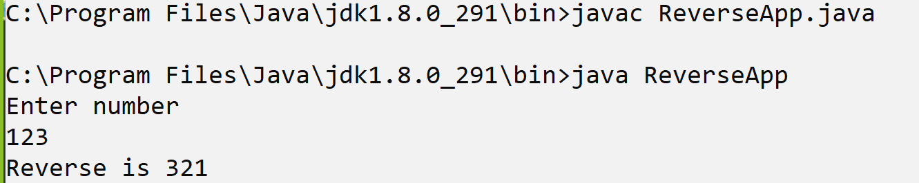
Example: WAP to input number and calculate its factorial using Scanner.

import java.util.*; //step1
public class FactApp
{ public static void main(String x[])
{ Scanner xyz = new Scanner(System.in); //step2
int no,f=1,i;
System.out.println("Enter number");
no=xyz.nextInt(); //step3
for(i=1;i<=no;i++)
{ f=f*i;
}
System.out.printf("Factorial is %d\n",f);
}
}

