Inheritance
____________________________________________________
Q. What is inheritance?
Inheritance means transfer the content/properties or data of one class to another class called as inheritance so property sender class known as parent class and property receiver class known as child class.
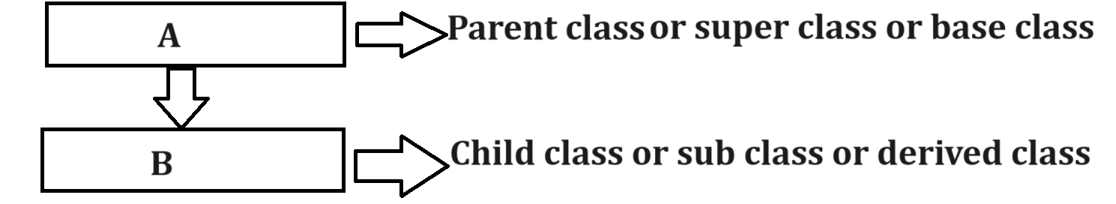
Q. Why use inheritance or what is benefit of inheritance?
________________________________________________________
1. Reuse the code of class without creating its object: means if we think about inheritance then parent class content present in child class means we if create object of child class then using child object we can access member of parent class so we not required to create manually object of parent means we can reuse parent class content using child object without creating its manual object by developer.
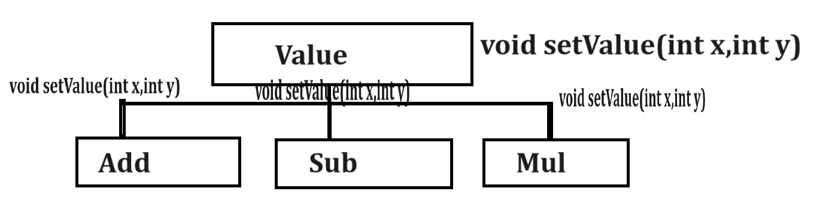
Note: if we think about above diagram we have parent class name as Value with setValue() function and we have three child classes name as Add, Sub and Mul means setValue() function available in Add class , Mul class and Sub class means we can use setValue() function by object of Add class , Mul class and Div class so we not required to create manually object of Value class for calling setValue() function means we can reuse Value class by creating object of Add , Sub and Mul so it is reusability of code.
2. Extensibility of code if required: extensibility means we can acquire the property from parent class and add additional property in child class as per the requirement of child class called as extensibility.
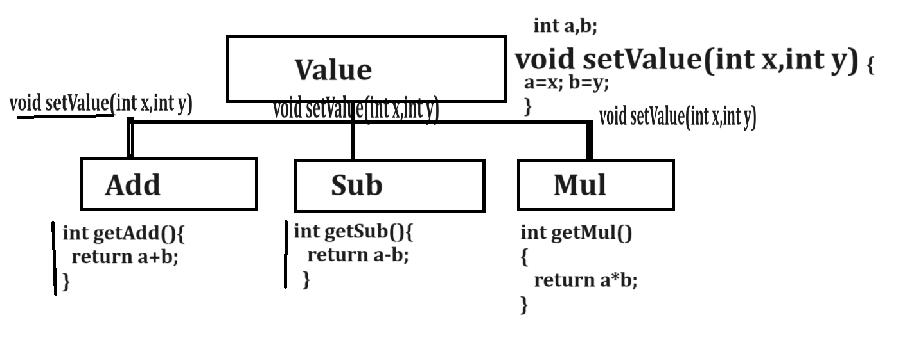
If we think about above diagram we have parent class name as Value with function void setValue(int x,int y) and this function present in all child classes name as Add, Sub and Mul and every class has own function like as int getAdd() in Add class , int getSub() in Sub class and int getMul() in Mul means every child class extend the logic of parent as per their required called as extensibility
Note: if we the inheritance then child class can modify the content of parent by using overriding technique.
Note: if we want to transfer the content of parent class in to child class then we have extends keyword.
Syntax:
class parentclassname{
}
class childclassname extends parentclassname{
}
Example
class A{
} class B extends A{
}
Note: if we think about above code we have class A is parent class and class B is child class.
Note: we cannot create any program in java without inheritance because every class has a default parent class provided by java known as Object class and Object class is member of java.lang package and java.lang package is a default package of so we not need to import it.
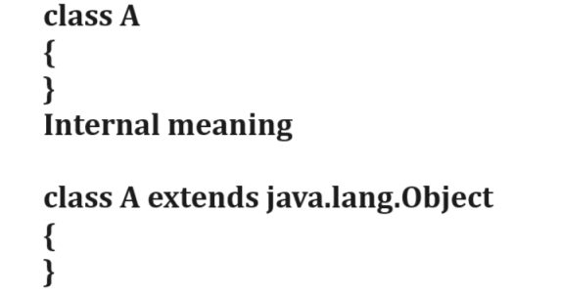
Q. Why Object class is parent of all classes in Java?
____________________________________________________
Object class contain some inbuilt methods which is required for perform daily operation or regular operation in every user define class so java store all required operation method in Object class and mark Object as default parent so all methods of parent present in every user define class or built classes and developer can override that if he/she required.
Methods of Object class
int hashCode(),boolean equals(), String toString(),void finalize(),Class getClass(),Object clone(), void wait(),void wait(int), void notify(),void notifyAll() ,static{ } etc
Example with source code
class Value
{ int a,b;
void setValue(int x,int y)
{ a=x;
b=y;
}
}
class Add extends Value
{
int getAdd(){
return a+b;
}
}
class Mul extends Value
{ int getMul()
{ return a*b;
}
}
public class CalcApp
{
public static void main(String x[])
{ Add ad = new Add();
ad.setValue(10,20);
int result=ad.getAdd();
System.out.println("Addition is "+result);
Mul m = new Mul();
m.setValue(10,20);
result=m.getMul();
System.out.println("Multiplication is "+result);

}
}

Types of inheritance
_____________________________________________
1. Single level inheritance: there single parent class and single child class called as single level inheritance.
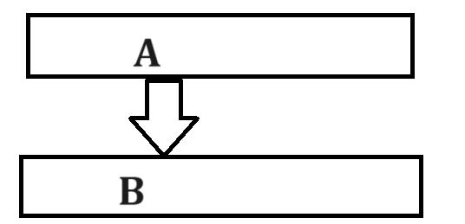
2. Multiple inheritances: there is more than one parent classes and single child class called as multiple inheritances.
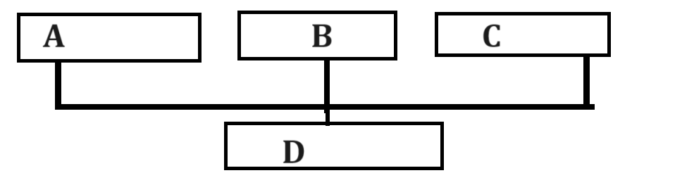
3. Multilevel inheritance: one class is parent of another and child of another and in multilevel inheritance there is main parent class and main child class.

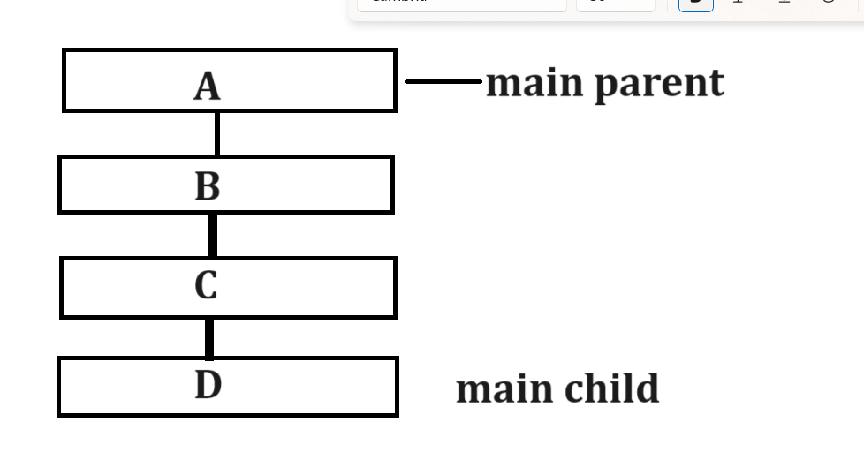
4. Hierarchical Inheritance: there is more than one child and single parent called as hierarchical inheritance.
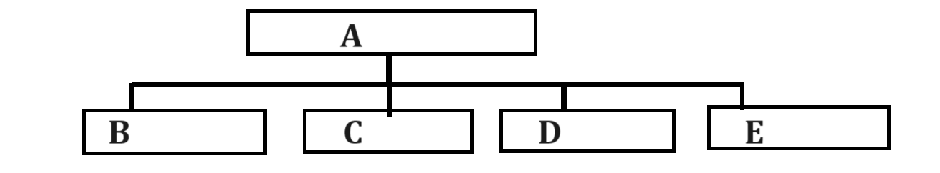
5. Hybrid inheritance: hybrid inheritance means it is combination of all types of inheritance called as hybrid inheritance.
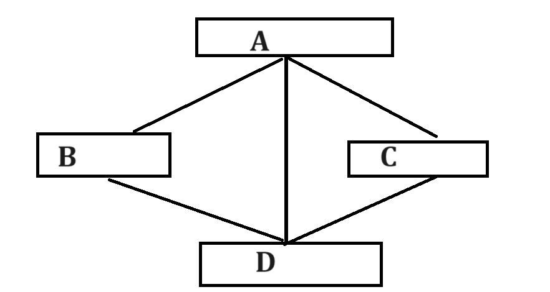
Note: java not support multiple inheritance and hybrid inheritance using classes. We will discuss this concept at the time of interface topic.

Constructor in inheritance
_________________________________________________________
If think about constructor in inheritance means when we have default constructor in parent class and default constructor in child class and if we create object of child class then parent constructor get executed before child class
Example with source code
class P
{
P()
{ System.out.println("I am parent constructor");
}
}
class C extends P
{ C()
{ System.out.println("I am child constructor");
}
}
public class PCAPP
{ public static void main(String x[])
{
C c1 = new C();
}
}
Output
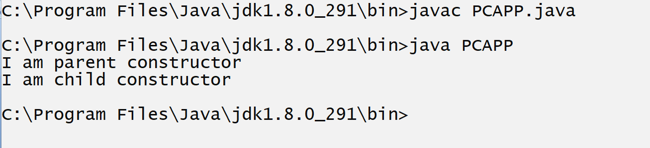
Note: when we have parameter present in parent class constructor and if we create object of child class then we required to call parent constructor from child class and for that we have super() constructor concept in JAVA
Means super() constructor is used for call parent class constructor from child class and pass parameter to parent constructor
Note: super() must be first line of code in child class constructor
class P
{
P(int x)
{ System.out.println("I am parent constructor "+x);
}
}
class C extends P
{ C()
{ System.out.println("I am child constructor");
}
}
public class PCAPP
{ public static void main(String x[])
{
C c1 = new C();
}
}
Note: if we think about above code we get compile time error because we have constructor in parent class with parameter and we not pass that parameter from child class so we get compile time error so if we want to resolve this problem we have to use super() constructor shown in following code.
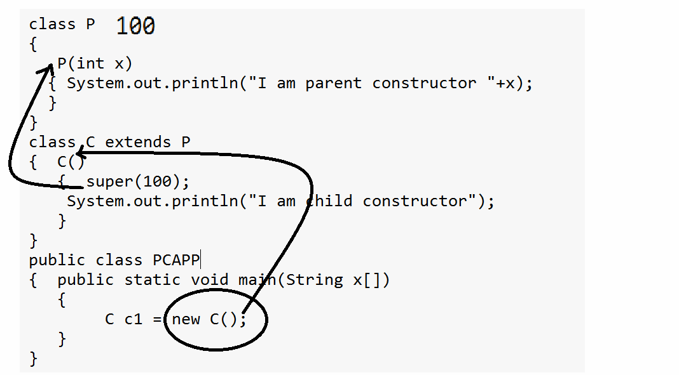
Note: super() must be first line of code and if we not use super() on first line then compiler will generate the compile time error to us shown in following code
class P
{
P(int x)
{ System.out.println("I am parent constructor "+x);
}
}
class C extends P
{ C()
{
System.out.println("I am child constructor");
super(100);
}
}
public class PCAPP
{ public static void main(String x[])
{
C c1 = new C();
}
}
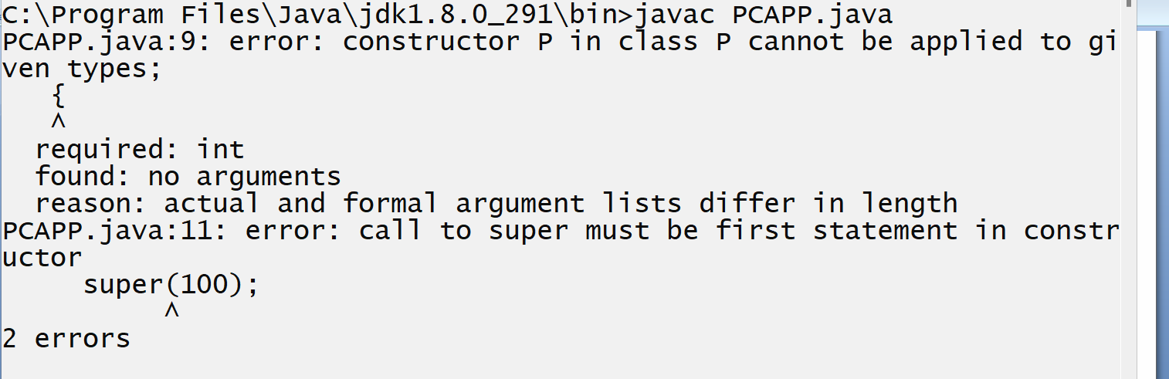

Q. What is constructor chaining and how we can perform constructor chaining in Java?
Constructor chaining means we can call one constructor from another constructor without creating object using new keyword called as constructor chaining
There are two ways to perform constructor chaining in JAVA
1. Using this() constructor concept: we can perform constructor chaining within same class using constructor overloading concept.
2. Using super() constructor concept: we can perform constructor chaining using inheritance means call parent constructor from child or pass parameter to parent constructor from child class

Q. If parent class contain default constructor then there is super() exist in child or not?
Note : when parent class contain default constructor then we not need to call super() constructor manually from child class because JVM call super() constructor automatically in this case shown in following code.
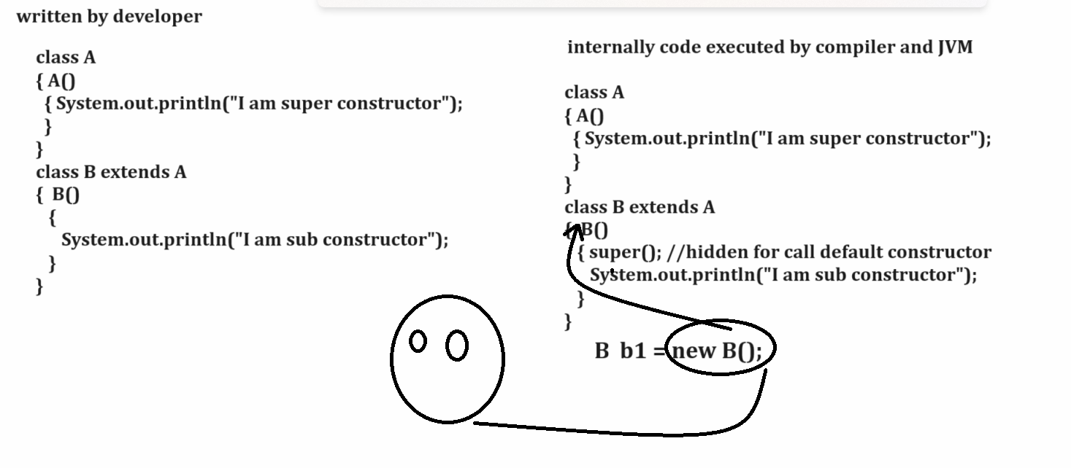
Q. Can we use this() and super() at same time?
No we cannot call super() and this() at same because this() constructor required first line of code and super() constructor must be required first line of code and we cannot write different code statement in single line so compiler will generate compile time error to us.
Example with source code
class P
{
P(int x)
{ System.out.println("I am parent constructor "+x);
}
}
class C extends P
{ C()
{ super(100);
this(200);
System.out.println("I am child constructor");
}
C(int x)
{
}
}
public class PCAPP
{ public static void main(String x[])
{
C c1 = new C();
}
}
Note: above code generate compile time error to us.

Q. Can super() call immediate class constructor or immediate parent with grand parent constructor?
super() can call only immediate constructor not grand parent
Example with source code
class D
{
D(int m)
{ System.out.println("I am D "+m);
}
}
class P extends D
{
P(int x)
{
System.out.println("I am parent constructor "+x);
}
}
class C extends P
{ C()
{ super(100);
System.out.println("I am child constructor");
}
}
public class PCAPP
{ public static void main(String x[])
{ C c1 = new C();
}
}
Note: if we think about above code we get compile time error because we have three classes name as D , P and C and D is main parent and it is immediate parent of P and P is immediate parent of C and D is grand parent of C and we call super(100) statement in C so class C call its immediate parent class constructor i.e constructor of class P but cannot call constructor of class D so D class constructor should from class P we not call D constructor in class P using super() so get error means the conclusion is super() can call immediate parent
so if we want to solve this error we required to write super() in class P shown in following code.
Example with source code
class D
{
D(int m)
{ System.out.println("I am D "+m);
}
}
class P extends D
{
P(int x)
{ super(200); //call D constructor
System.out.println("I am parent constructor "+x);
}
}
class C extends P
{ C()
{ super(100); //call P constructor
System.out.println("I am child constructor");
}
}
public class PCAPP
{ public static void main(String x[])
{
C c1 = new C();
}
}
Q. what is difference between this() constructor and super() constructor?
__________________________________________________
This constructor | Super constructor
This can perform constructor chaining within same class | Super() can perform constructor chaining using inheritance
This() can work with constructor overloading | Super() can work with parent class constructor not required to overloading
This() is not inbuilt constructor present in every class | Super() is inbuilt present when we declare constructor within child class

Abstract class and abstract methods in JAVA
_________________________________________________________
Q. What is abstract class?
___________________________________________________
abstract class means class cannot create its object and abstract method means method cannot have logics.

How to declare abstract class and abstract method in JAVA
___________________________________________________
If we want to declare abstract class and abstract method in Java we have abstract keyword.
Syntax:
abstract class classname{
abstract return type functionname(datatype variablename);
}
Example:
abstract class ABC
{ abstract void show();
}

Q. Why use abstract class and abstract methods?
______________________________________________________
The major goal of abstract class and abstract method is to
1. Achieve abstraction.
2. Achieve Dynamic Polymorphism.
Q. What is abstraction?
_______________________________________________________
Abstraction means to hide the implementation detail from end user at design level called as abstraction means in the case of abstract we provide template of method but not write its logic we can write logic of method in child class as per the requirement of child called as abstraction
Means in the case of abstract we know what to do but we don’t know how to do it is dependent on end user requirement or future requirement called as abstractions.

Example: Suppose consider we want to hire the employee for particular company and we know the employee required skill but we cannot predict which skill required to employee because it is dependent on requirement of position.

Example: Suppose consider we are doing software for particular Vehicle production company and every vehicle has engine but we cannot predicate its design every vehicle has different engine design it is also example of abstraction

Note: if abstract method cannot have logic then where we required writing logic of abstract method.
If we want to write logic of abstract method we need to inherit abstract class in some another class and override its method.
Note: before that we need to know
Q. what is method overriding?
_________________________________________________________
Method overriding means if we define method within parent class and redefine same method again in child class called as method overriding.
Example
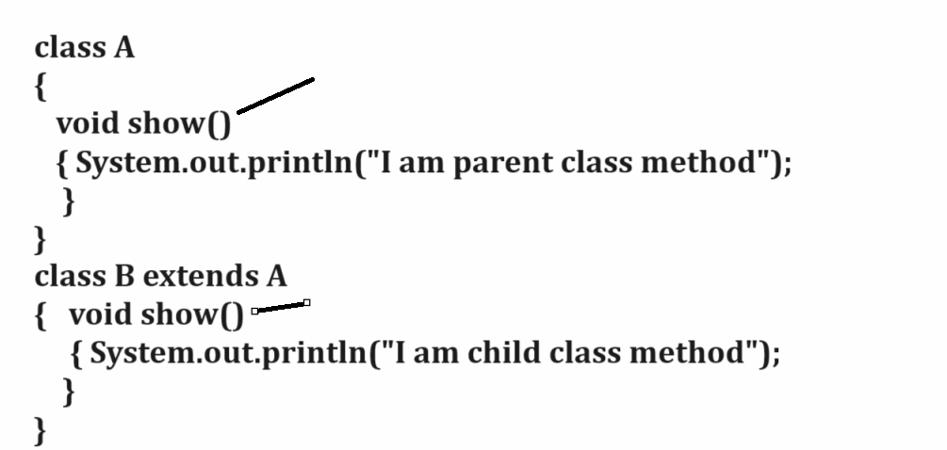
Note: if we think about method overriding if we create object of child class and try to call the overridden method then by default child logics get executed.

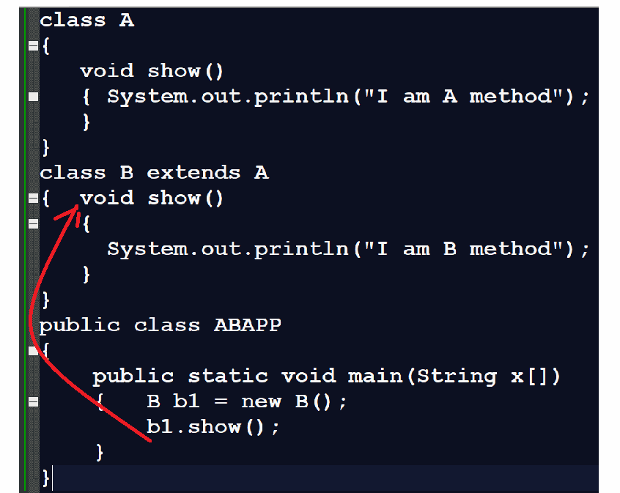
Q. What is benefit of method overriding?
______________________________________________________
There are two benefits of method overriding
1. Customize parent logic in child class as per the requirements of child
2. To Achieve dynamic polymorphism.

Example: suppose consider we want to design application marksheet generation and we have three classes name as Eight,Nine and Ten and we want to best five for Tenth class and best of six for Eight and Nine
you code like as

Example with source code
class Per
{ int p;
void calPer(int a[])
{ int agg=0;
for(int i=0; i<a.length;i++)
{ agg=agg+a[i];
}
p=agg/a.length;
}
}
class Eight extends Per
{
void showEightPer()
{ System.out.println("Eight percentage is "+p);
}
}
class Nine extends Per
{void showNinePer()
{ System.out.println("Nine percentage is "+p);
}
}
class Ten extends Per
{
void calPer(int a[])
{ int agg=0;
for(int i=0;i<a.length;i++)
{
for(int j=(i+1); j<a.length;j++)
{
if(a[i]<a[j])
{ int temp=a[i];
a[i]=a[j];
a[j]=temp;
}
}
}
for(int i=0;i<(a.length-1);i++)
{ agg=agg+a[i];
}
p=(agg/(a.length-1));
}
void showTenPer()
{ System.out.println("Ten percentage is "+p);
}
}
public class BestFiveApp
{
public static void main(String x[])
{ int arr[]=new int[]{60,70,80,90,80,70};
Eight e=new Eight();
e.calPer(arr);
e.showEightPer();

Nine n=new Nine();
n.calPer(arr);
n.showNinePer();

Ten t=new Ten();
t.calPer(arr);
t.showTenPer();

}
}
Q. is method overriding beneficial?
_____________________________________________________
It is dependent in situation some time it is beneficial and some time it has some limitation

If we want to work with method overriding we have some important points.

1. In the case of overriding signature/definition of method in parent and child method must be same.
Means return type of method, name of method and parameter type of method and number of parameter must be same.

Example with source code
class P
{
void setValue(int x)
{ System.out.println("I am P "+x);
}
}
class C extends P
{ void setValue(int x)
{ System.out.println("I am C "+x);
}
}
public class OverridingApp
{ public static void main(String x[])
{ C c1 = new C();
c1.setValue(10);
}
}

Note: if we think about given code then we get compile time error because we give different return type to function in parent class and in child class

Example with source code
class P
{
void setValue(int x)
{ System.out.println("I am P "+x);
}
}
class C extends P
{ int setValue(int x)
{ System.out.println("I am C "+x);
}
}
public class OverridingApp
{ public static void main(String x[])
{ C c1 = new C();
c1.setValue(10);
}
}

Note: if we give different type of parameter in overriding then it is not consider as overriding it is consider as overloading in inheritance shown in following code.

class P
{
void setValue(int x)
{ System.out.println("I am P "+x);
}
}
class C extends P
{ void setValue(float x)
{ System.out.println("I am C "+x);
}
}
public class OverridingApp
{ public static void main(String x[])
{ C c1 = new C();
c1.setValue(10);
c1.setValue(5.4f);
}
}
If we think about above code we have two classes name as P and C and P class contain setValue(int x) and setValue(float x) means here we two different classes with same method with a different data type so it is your method overloading using inheritance.

Access specifier rules in method overriding
1. If we define your parent class method as protected or default then you can override it as public in child class because public has higher access specifier than protected or default.

Example protected to public overriding
class P
{ protected void setValue(int x)
{ System.out.println("I am P "+x);
}
}
class C extends P
{ public void setValue(int x)
{ System.out.println("I am C "+x);
}
}
public class OverridingApp
{ public static void main(String x[])
{ C c1 = new C();
c1.setValue(10);
}
}
Example: default to public overriding.
class P
{
void setValue(int x)
{ System.out.println("I am P "+x);
}
}
class C extends P
{ public void setValue(int x)
{ System.out.println("I am C "+x);
}
}
public class OverridingApp
{ public static void main(String x[])
{ C c1 = new C();
c1.setValue(10);

}
}
Note: but if your parent class method is public and if we try to override it as protected or default then we get compile time error because default and protected has less priority than public so it is not possible.

Example : public to protected overriding with compile time error.
class P
{
public void setValue(int x)
{ System.out.println("I am P "+x);
}
}
class C extends P
{ protected void setValue(int x)
{ System.out.println("I am C "+x);
}
}
public class OverridingApp
{ public static void main(String x[])
{ C c1 = new C();
c1.setValue(10);

}
}
Output
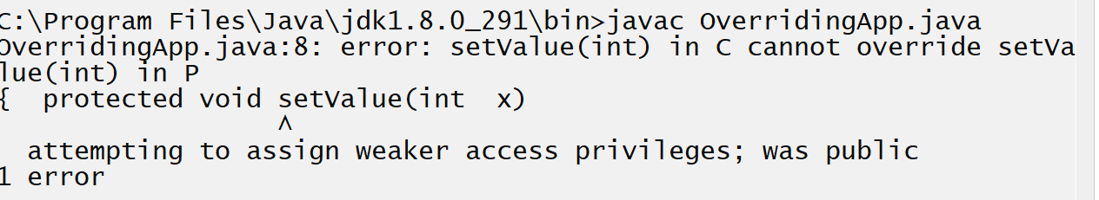

Example with source code
class P
{
public void setValue(int x)
{ System.out.println("I am P "+x);
}
}
class C extends P
{ void setValue(int x)
{ System.out.println("I am C "+x);
}
}
public class OverridingApp
{ public static void main(String x[])
{ C c1 = new C();
c1.setValue(10);

}
}
Note: if your method define as default in parent then we can override it as protected but not vice versa

Example : default to protected overriding
class P
{
void setValue(int x)
{ System.out.println("I am P "+x);
}
}
class C extends P
{ protected void setValue(int x)
{ System.out.println("I am C "+x);
}
}
public class OverridingApp
{ public static void main(String x[])
{ C c1 = new C();
c1.setValue(10);

}
}
Example: protected to default with compile time error.
class P
{
protected void setValue(int x)
{ System.out.println("I am P "+x);
}
}
class C extends P
{ void setValue(int x)
{ System.out.println("I am C "+x);
}
}
public class OverridingApp
{ public static void main(String x[])
{ C c1 = new C();
c1.setValue(10);

}
}
Note: private method cannot inherit or override
class A
{ private void show()
{ System.out.println("I am A show method");
}
}
class B extends A
{
}
public class TestPrivateApp
{ public static void main(String x[])
{
B b1 = new B();
b1.show();
}
}
Output
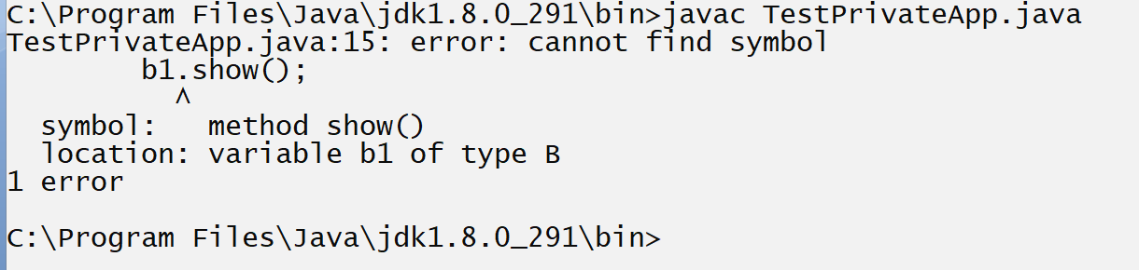
Note: if we think about above code we get compile time error because we declare class A method as private.

Example private with overriding
class A
{
private void show()
{ System.out.println("I am A show method");
}
}
class B extends A
{ void show()
{ System.out.println("I am B show method");
}

}
public class TestPrivateApp
{
public static void main(String x[])
{
B b1 = new B();
b1.show();
}
}
Output of above code
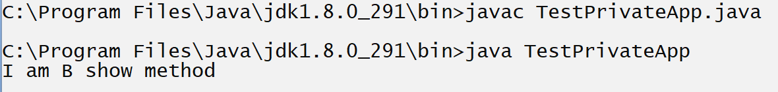
If we think about above code we call show() method using class B object but show () is not overridden method it is original method of class B and if we want to check or test show() is overridden or not then we can use super keyword.

Q. what is super keyword?
______________________________________________________
super is keyword of java which is used for call the parent member from child class in the case of overriding because if we think about overriding in overriding by default child logics get executed but if we want to parent logic in the case of overriding then we can use super keyword.
shown in following code.

Example method
class A
{
void show()
{ System.out.println("I am A show method");
}
}
class B extends A
{ void show()
{ super.show();//call parent logics
System.out.println("I am B show method");
}
}
public class TestPrivateApp
{ public static void main(String x[])
{
B b1 = new B();
b1.show();
}
}
Output
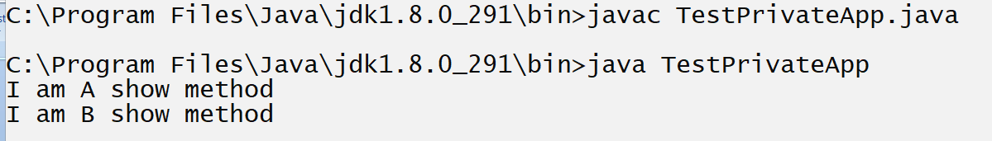
If we think about above code we use statement super.show() in class B so this statement call parent class method from child class

Example for private method with super keyword
class A
{
private void show()
{ System.out.println("I am A show method");
}
}
class B extends A
{ void show()
{ super.show();//call parent logics
System.out.println("I am B show method");
}
}
public class TestPrivateApp
{ public static void main(String x[])
{
B b1 = new B();
b1.show();
}
}
Output
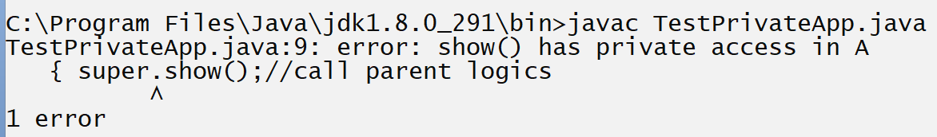
If we think about above code we try to call show() method from child class using super() but show() in parent declare as private so it is inherit in child class and if we not inherit the method means method cannot override because overriding cannot happen without inheritance.

Note: static method cannot override but static method can hide.
we will method hiding concept later.

Note: using method overriding we can achieve dynamic polymorphism

Q. what is dynamic polymorphism?
_______________________________________________________
Dynamic polymorphism means object bounded functionality at program run time called as dynamic polymorphism.
If we want to achieve dynamic polymorphism we should create reference of parent class and we can store object of child in parent reference at run time so the benefit is we can modify or we can change object at run time using parent reference it is called as dynamic polymorphism show in following code and diagram.
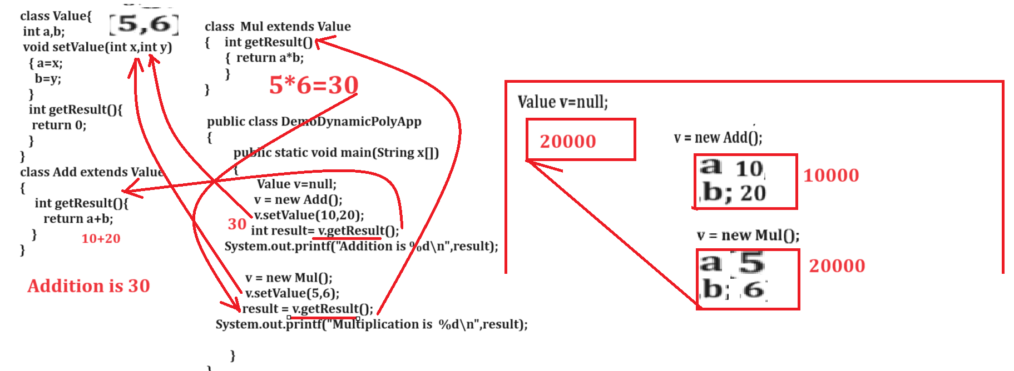

Example with source code
class Value
{ int a,b;
void setValue(int x,int y)
{ a=x;
b=y;
}
int getResult(){
return 0;
}
}
class Add extends Value
{ int getResult()
{ return a+b;
}
}
class Mul extends Value
{ int getResult(){
return a*b;
}
}
public class DynamicPolyApp
{
public static void main(String x[])
{ Value v=null;
v=new Add();
v.setValue(10,20);
int result=v.getResult();
System.out.printf("Addition is %d\n",result);
v=new Mul();
v.setValue(5,7);
result=v.getResult();
System.out.printf("Multiplication is %d\n",result);
}
}
If we think about above code we have parent class name as Value which contain two methods void setValue(int x,int y) and int getResult()
and we have two child classes name as Add and Mul and we override getResult() method in two different child classes and if we think about main method we have statement Value v=null; means we declare reference of parent class with null value and we have statement v=new Add() means we create object of child class whose address is 10000 in our example and we store 10000 address in reference variable v and we have statement v.setValue(10,20) means we call setValue() and pass two values as parameter name as 10 and 20 and store in object whose address is 10000 and we have one statement int result=v.getResult() here v points to object whose address is 10000 means point to Add object means we call getResult() from class Add because v point to Add object and we have statement v = new Mul() means we create object of class Mul whose object is 20000 and we store its address in reference variable v means our v reference release the previous object address and points to new object whose address is 20000 and we have statement v.setValue(5,7) means 20000.setValue(5,7) means we store 5 and 7 on address 20000 and we have statement int result = v.getResult() means 20000.getResult() so here we call getResult() function from Mul class
Means v work with two object at run time and call two version of getResult() two times at program run time it is called as dynamic polymorphism

final keyword
__________________________________________________
final keyword can use with variable , with function and with class also and final know as non access specifier in JAVA

There are 8 types of non access specifier in JAVA
___________________________________________________
1. static 2. final 3. abstract 4. volatile 5. strictfp 6. transient 7.assert 8.synchornized.

final variable: final variable means variable cannot modify its value once we initialize it means if we want to declare constant in java we can use final keyword.
public class ConstApp
{
public static void main(String x[])
{
final int a=10;
++a; //raise compile time error because we try to modify its value.
System.out.printf("A is %d\n",a);
}
}
Output
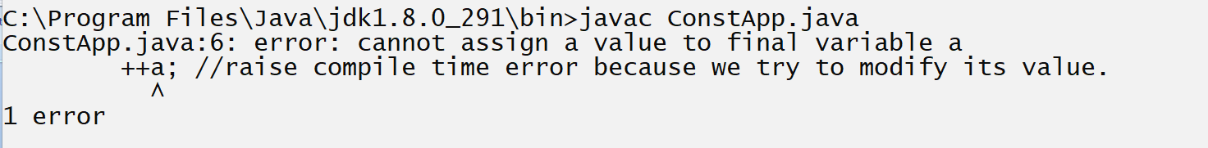

final method: final method means method cannot override in child class called as final method.
Not final method specially design for avoid method overriding purpose

class A
{
final void show()
{ System.out.println("I am A show method");
}
}
class B extends A
{ void show()
{
System.out.println("I am B show method");
}
}
public class TestPrivateApp
{ public static void main(String x[])
{
B b1 = new B();
b1.show();
}
}
Note: above code generate compile time error to us because we have show() method in class A and we declare it as final.
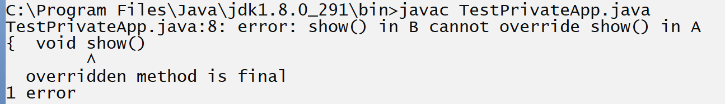

Q. How we can avoid method overriding in JAVA?
__________________________________________________
We can avoid method overriding in java by using final keyword.
Means we can say using final keyword we can restrict child class to modify parent logics.

final class: final class means class cannot inherit in child class.
Note: final class specially designs for create immutable classes in JAVA.

Example with source code
final class A
{
}
class B extends A
{
}
public class InheritApp
{
public static void main(String x[])
{
}
}
Output
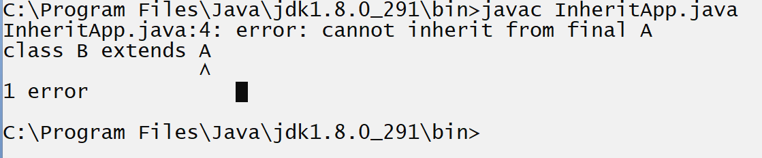
Above code generate compile time error to us because we try to inherit the final class A in class B and it is not possible.

Abstract class and Abstract methods in JAVA
__________________________________________________________

Q. What is abstract class?
Abstract class means class cannot create its object and abstract method means method cannot have logics

Q. What is purpose of abstract class and Abstract methods?
_________________________________________________________
The purpose of abstract class and abstract method is
1. To Achieve Abstraction
2. To Achieve dynamic polymorphism.

Q. What is abstraction?
________________________________________________________
Abstraction means to hide the implementation detail from end user at design level called as abstraction.
Means abstraction says just provide template or prototype of method and write its logic in future as per the requirement of child or client.
Means in the case of abstraction we know what to do but don’t know how to do.

How to declare the abstract class and abstract method in JAVA
_________________________________________________________
If we want to declare abstract method in java we have abstract keyword in java means we can use abstract keyword with class for declaring abstract class and abstract keyword with method for declaring abstract method.
Syntax:
abstract class classname
{ abstract return type functionname(datatype variablename);
}
Note: abstract method cannot have and if we write logic for abstract method we must be override abstract method in any another class and write its logic

Explain abstraction in detail with real time scenario or give example of abstraction?
________________________________________________________
Example: Suppose consider we are working for vehicle manufacturing company and if we think about abstraction in this application then we can say every Vehicle has engine but we cannot predict its design because design of engine vary as per the vehicle category.
Suppose consider if we want to implement this scenario we have to following type of code.
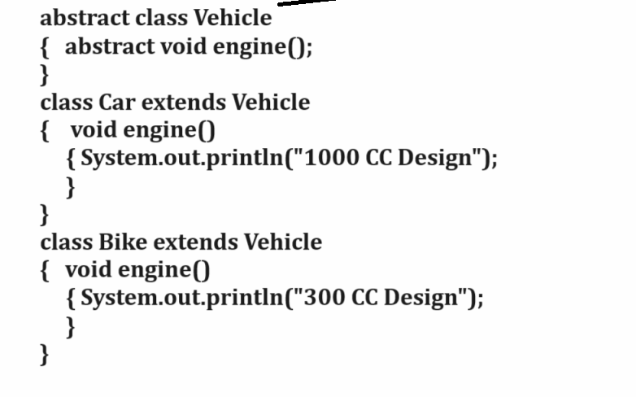

Note: if we think about above example we can say Vehicle is abstraction because we know Vehicle has engine but we don’t know engine design its vary from vehicle to vehicle means vary as per the child class

Example: Suppose consider we are working on banking application and we have one module name as AccountOpening Module so we can say if we think about customer then every customer has account in bank but we cannot predicate account type its vary from customer to customer or requirement of customer.
Means we can say Bank can create policy for account opening but policy change as per the account type means if we think about SavingAccount it has different Policy , if we think CurrentAccount it has different policy but both are category of Account

If we want to implement this scenario we have following code structure.

Example: Suppose consider we are working on EmployeeRecuriment Module for particular Third Party Employee Hiring Company and so every recruiter required skillful employee or required skill but we cannot predict skill because it is depend on position or role of employee.
Example: Suppose if company want to developer he need skill but according to development, If company want to hire employee as Manager he need skill but according to management etc
Example with source code
abstract class Employee
{ abstract void skill();
}
class Developer extends Employee
{ void skill()
{ System.out.println("Should good in coding");
}
}
class Manager extends Employee
{ void skill()
{System.out.println("Should good in management skills");
}
}
If we want to work with abstract class and abstract method we should to know the some important points.
1. Abstract class cannot create its object
_________________________________________________
Note: if we try to create object of abstract class then we get compile time error.
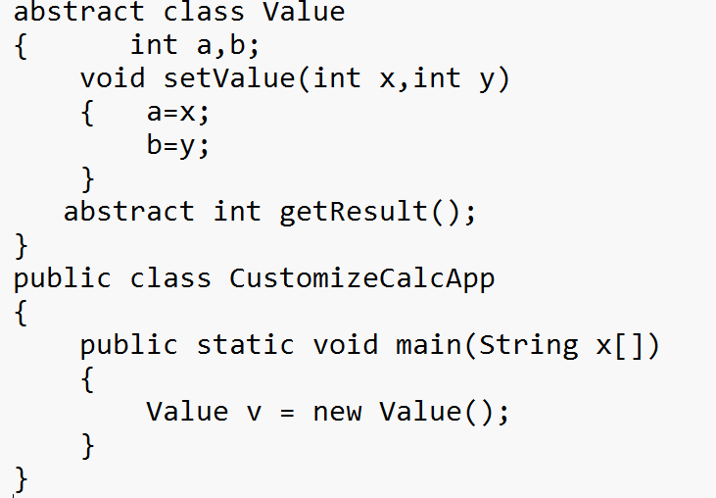
Note: above code generate compile time error to us because we try to create object of abstract class and it is not possible.
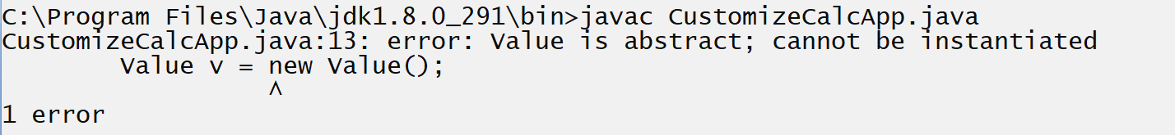

Q. Why abstract class cannot create its object or why OOP not allow for creating object of abstract class?
_________________________________________________________
If we think about abstract class then it contain abstract methods as well as non abstract methods and here abstract method cannot have definition and suppose consider if OOP allow us to create object of abstract class then using that object there is possibility developer can call abstract method but abstract method cannot have definition and without definition we cannot call any method so avoiding this problem OOP not allow us to create object of abstract class

2. Abstract method cannot have logics
_____________________________________________________
If we want to write logic of abstract method we must be override abstract method in child class and write its logic and create object of child class and call overridden method

Example
abstract class Value
{ int a,b;
void setValue(int x,int y)
{ a=x;
b=y;
}
abstract int getResult();
}
class Add extends Value{
int getResult(){
return a+b;
}
}
class Mul extends Value
{ int getResult()
{ return a*b;
}
}
public class CustomizeCalcApp
{
public static void main(String x[])
{ Add ad = new Add();
ad.setValue(10,20);
int result=ad.getResult();
System.out.println("Addition is "+result);
Mul m = new Mul();
m.setValue(5,4);

result=m.getResult();
System.out.println("Multiplication is "+result);
}
}

Note: if we think about abstract method then the benefit is we can write different logic for same method in different child classes as per their requirement and the benefit is we can achieve loose coupling and dynamic polymorphism using abstract class and method

3. For declaring abstract method class must be abstract
Means we cannot declare abstract method in non abstract class and if we try to declare abstract method in non abstract class then we get compile time error shown in following code.

Example with source code
class Value
{ int a,b;
void setValue(int x,int y) { a=x;
b=y;
}
abstract int getResult();
}
public class CustomizeCalcApp
{ public static void main(String x[]) {
}
}
Output
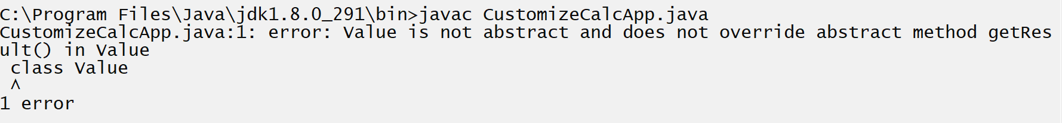

If we think about above code we have Value class and it is non abstract class and we try to declare getResult() abstract method in it so compiler will generate compile time error because we break the rule of abstract method.

Q. Can we define constructor in abstract class?
_______________________________________________________
yes because if we have data or variable in abstract class and if we initialize at the time of object creation of child then we can define constructor in parent or abstract class and initialize because if we think about inheritance when we create object of child class then parent constructor get executed before child object means abstract class constructor cannot call using abstract class object call internally by super() constructor from child class so this is major we cannot create object of abstract but can define constructor within abstract class.
Example with source code
abstract class Value
{ int a,b;
Value(int x,int y)
{ a=x;
b=y;
}
void setValue(int x,int y)
{ a=x;
b=y;
}
abstract int getResult();
}
public class CustomizeCalcApp
{
public static void main(String x[])
{
}
}
4. Abstract method cannot declare as static
__________________________________________________
If we declare abstract method as static then we get compile time error shown in following code
Example with source code
abstract class Value
{ int a,b;
void setValue(int x,int y)
{ a=x;
b=y;
}
static abstract int getResult();
}
public class CustomizeCalcApp
{ public static void main(String x[])
{
}
}
Output
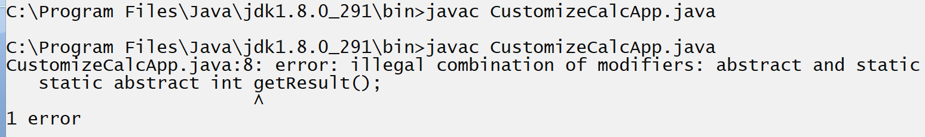

Q. Why we cannot declare abstract method as static?
a. static method can work with compile time polymorphism means static method must have definition or logic and abstract method can work with dynamic polymorphism means abstract method cannot have logic means behavior of static non access specifier and abstract completely opposite to each other so this is major cannot declare abstract method as static
b. static method can support to method hiding concept and abstract can support method overriding concept these are the some reasons we cannot declare abstract method as static or cannot use static with abstract methods.

5. Abstract method cannot declare as final
Note: if we try to declare abstract method as final then compiler will generate compile time error to us shown in following code.

Example with source code
abstract class Value
{ int a,b;

void setValue(int x,int y)
{ a=x;
b=y;
}
final abstract int getResult();
}
public class CustomizeCalcApp
{
public static void main(String x[])
{
}
}
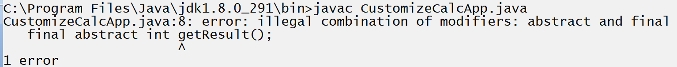

Q. Why abstract method cannot declare as final?
Because abstract method must override in child class and final is used for avoid method overriding so this is major reason we cannot declare abstract method as final.

6. Abstract keyword cannot work with variable
_______________________________________________________
Because abstraction cannot achieve by using variable because variable just use for store data not for write logic so this is major we cannot use abstract keyword with variable.

7. If abstract class contain more than one abstract method then all method must be override where abstract class get inherit

Note: if we think about abstract class and if abstract class contains more than one abstract method then all method must be override where abstract class get inherit and if we not override then compiler will generate compile time error to us.

Example with source code
abstract class A
{ abstract void show();
abstract void display();
}
class B extends A
{ void show()
{ System.out.println("I am show method from class A");
}
}
class C extends A
{ void display()
{ System.out.println("I am display method from class A");
}
}
public class AbsApp
{ public static void main(String x[])
{ B b1 = new B();
C c1 = new C();
b1.show();
c1.display();
}
}
Output
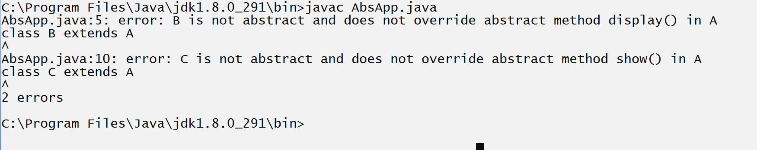
If we think about above code we get compile time error because we have abstract class name as A which contain two abstract methods name as void show() and void display() and we override show() method in class B and display() method in class C but we override all method of class A in class B and in class C so we get compile time error
Because we not satisfy rule of abstract class.
So this is the major abstract class and abstract method suppose consider if we have abstract class with 10 abstract method and if we have 10 child classes and we want to override single method of abstract class in every child so we required to 100 method compulsory because need 1 method as well as remaining 9 methods override as blank.
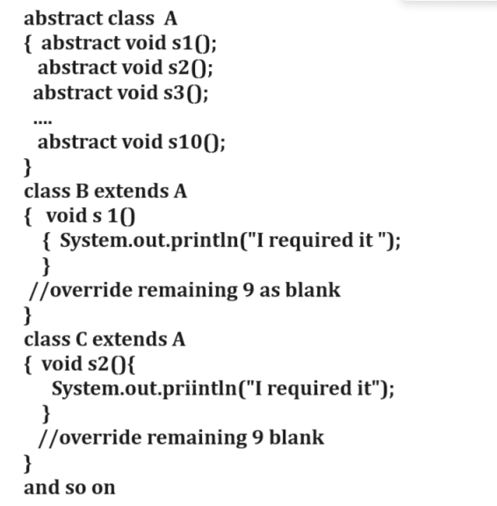

Note: if we want to solve this problem we can use adapter class concept.

Q. What is adapter class?
_____________________________________________________
Adapter class is intermediate class which contain blank methods of abstract class and which is able to provide specific method to its child class called as adapter class.
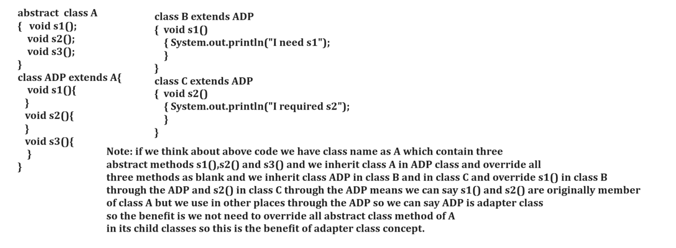

Example with source code
abstract class A
{ abstract void show();
abstract void display();
}
class ADP extends A{
void show()
{
}
void display()
{
}
}
class B extends ADP
{ void show()
{ System.out.println("I am show method from class A");
}
}
class C extends ADP
{
void display()
{ System.out.println("I am display method from class A");
}
}
public class AbsApp
{ public static void main(String x[])
{ B b1 = new B();
C c1 = new C();
b1.show();
c1.display();

}
}

8. Abstract class cannot create its object but can create its reference.
_________________________________________________________
If we want to create reference of abstract class need to create object of its child class.

Syntax: Abstractclassname ref = new childclassname();

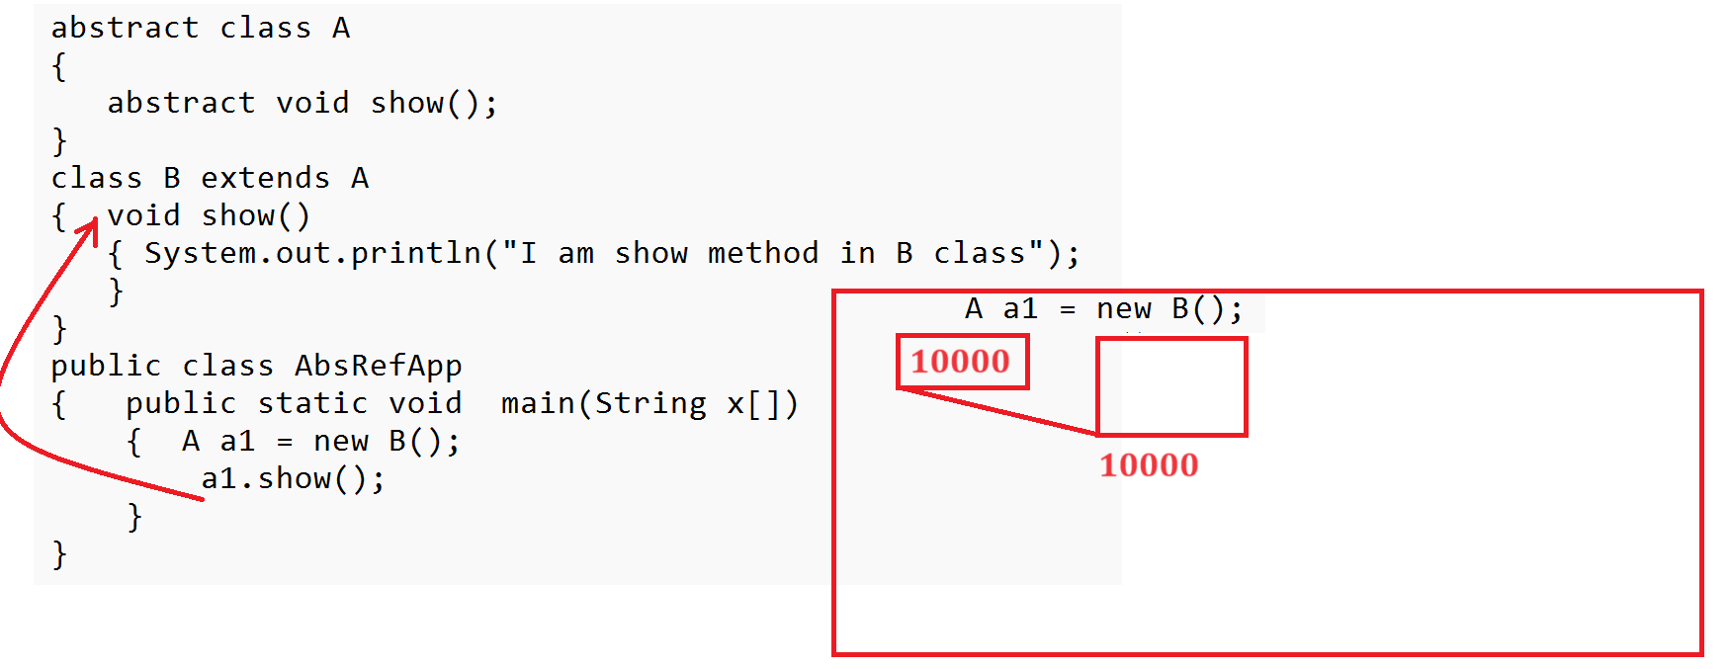
Note: if we think about above code we have statement in main method A a1=new B() here a1 is reference of class A and new B() is actual object
means we store object B address in reference variable which is reference of abstract class

Q. What is the benefit of abstract class reference or parent class reference?
___________________________________________________
There are two benefits of abstract class reference.

1. Using abstract class reference we can achieve dynamic polymorphism.
2. Using Abstract class reference we can achieve loose coupling.

Q. What is coupling?
__________________________________________________
Coupling means if one object is dependent on another class object called as coupling.

There are two types of coupling.
_________________________________________________________
a) Tight coupling: tight coupling means if one is 100% dependent on another object called as tight coupling.
b) Loose coupling: if one object is partially dependent on another object called as loose coupling.

Example of dynamic polymorphism
________________________________________________________
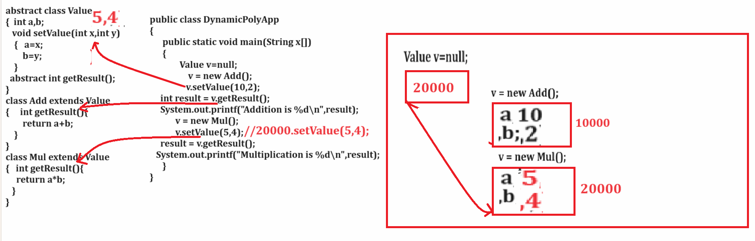

Note: if we think about above code we achieve dynamic
Polymorphism by using this code.
The major benefit of dynamic polymorphism is to achieve loose coupling and cover the limitation of method overloading or compile time polymorphism using loose coupling
Note: for identify the limitation of compile we will work with tight coupling example

Example of tight coupling?
________________________________________________________
Suppose consider we have scenario we want to design Calculator and we have following classes and we are going to implement this example without using abstraction technique.
In this example we have following classes
1. Add : With two methods void setValue(int x,int y) and int getResult()
2. Mul: With two methods void setValue(int x,int y) and int getResult()
3. Sub: with two methods void setValue(int x,int y) and int getResult()
4. Calculator : with one void performOperation(Add ad)
5. CalcApplication which contain main method.
Example with source code
class Add
{ int a,b;
void setValue(int x,int y)
{ a=x;
b=y;
}
int getResult(){
return a+b;
}
}
class Mul
{ int a,b;
void setValue(int x,int y)
{ a=x;
b=y;
}
int getResult(){
return a*b;
}

}
class Sub
{ int a,b;
void setValue(int x,int y)
{ a=x;
b=y;
}
int getResult(){
return a-b;
}

}
class Calculator
{
void performOperation(Add ad)
{ int result=ad.getResult();
System.out.printf("Result is %d\n",result);
}
}
public class CalcApplication
{ public static void main(String x[])
{
Calculator c = new Calculator();
Add ad = new Add();
ad.setValue(5,4);
c.performOperation(ad);

Mul m = new Mul();
m.setValue(5,4);
c.performOperation(m);//generate compile time error

}
}
Output
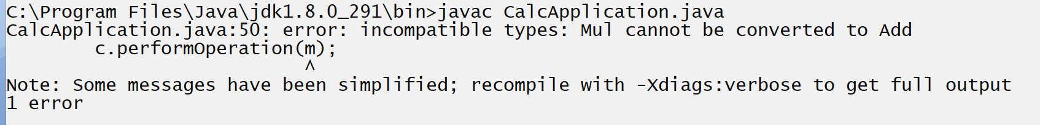
Note: If we think about above code we have compile time error because we have method in performOperation(Add ad) from Calculator class means this class can accept Add class reference as parameter but we try to pass reference of Mul class and it is not possible because we passing mismatch type parameter so we get compile time error
If we want to overcome this problem we have two solutions.
1. Use Compile time polymorphism i.e method overloading
if we think about compile time polymorphism we are going to use method overloading technique means as per our example we need to define multiple method with name void performOperation() and different parameter in it like as void performOperation(Add ad) or
void performOperation(Mul ad) or void performOperation(Sub ad)
So the benefit is if we have three different of performOperation then we can pass any class object in performOperation() and according parameter we get result shown in following code.

Example of tight coupling with source code
class Add
{ int a,b;
void setValue(int x,int y)
{ a=x;
b=y;
}
int getResult(){
return a+b;
}
}
class Mul
{ int a,b;
void setValue(int x,int y)
{ a=x;
b=y;
}
int getResult(){
return a*b;
}

}
class Sub
{ int a,b;
void setValue(int x,int y)
{ a=x;
b=y;
}
int getResult(){
return a-b;
}

}
class Calculator
{
void performOperation(Add ad)
{ int result=ad.getResult();
System.out.printf("Result is %d\n",result);
}
void performOperation(Mul m)
{ int result=m.getResult();
System.out.printf("Result is %d\n",result);
}

void performOperation(Sub s)
{ int result=s.getResult();
System.out.printf("Result is %d\n",result);
}

}
public class CalcApplication
{ public static void main(String x[])
{
Calculator c = new Calculator();
Add ad = new Add();
ad.setValue(5,4);
c.performOperation(ad); //call add logic
Mul m = new Mul();
m.setValue(5,4);
c.performOperation(m);//call Mul logic
}
}
Note: if we think about above code the limitation is we define 3 methods for three different operation in calculator and suppose consider if we want to perform 100 different operation in Calculator then we required to overload performOperation() 100 times and it is not possible in real time so better way we want to define only one performOperation() as our example which accept 100 or 1000 different types of parameter then your dynamic polymorphism and loose coupling comes in picture.

2. Use Runtime Polmorphism i.e method overriding or using abstract methods
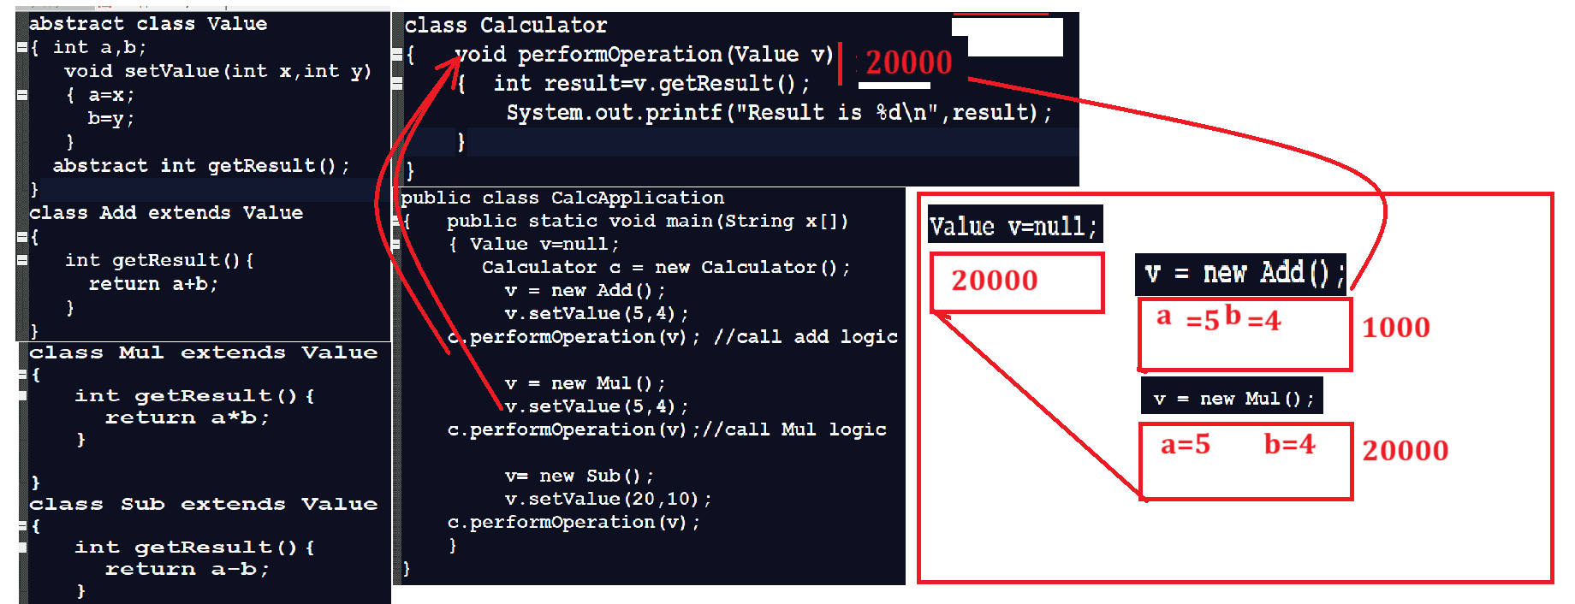

Example of Dynamic polymorphism
abstract class Number
{ int no;
void setNum(int no)
{this.no=no;
}
abstract int getNo();
}
class Rev extends Number
{
int getNo()
{
int r=0;
while(no!=0)
{ int rem = no % 10;
no = no /10;
r=r*10+rem;
}
return r;
}
}
class SumOfDigit extends Number
{
int getNo(){
int s=0;
while(no!=0)
{ int rem=no%10;
no = no /10;
s=s+rem;
}
return s;
}
}
class NumberOperation
{
void setNumberOperation(Number n)
{ int result=n.getNo();
System.out.println("Result is "+result);
}
}
public class LooseCouplingApp
{ public static void main(String x[])
{ Number numRef=null;
NumberOperation nopt = new NumberOperation();
numRef=new Rev();
numRef.setNum(123);
nopt.setNumberOperation(numRef);
numRef=new SumOfDigit();
numRef.setNum(5678);
nopt.setNumberOperation(numRef);

}
}

Interface
__________________________________________________
Q. What is interface?
__________________________________________________
Interface is same like as abstract class in JAVA.

Q. Why use interface if we have abstract class already?
__________________________________________________
There are three major uses of interface
____________________________________________________
1. To achieve multiple inheritance
_____________________________________________________
Q. Why java not uses classes for achieve multiple inheritances?
Because of diamond problem
Q. What is diamond problem?
In the case of multiple inheritances there is more than one parent class and single child class and if multiple parents contain same name method and if we create object of child class and try to call method whose name same in different parent then compiler may be get confused called as diamond problem.
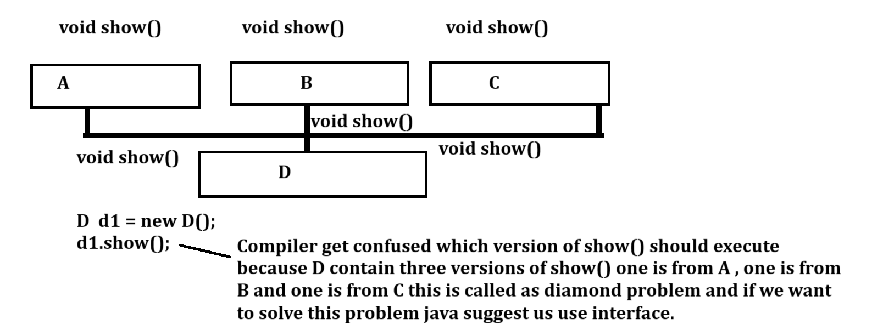
2. To Achieve 100% abstraction: if we think about interface every method of interface is by default abstract
3. To Achieve dynamic polymorphism.

If we want to declare interface we have to use interface keyword
Syntax
interface interfacename
{ return type functionname(arguments);
}
Example: interface Vehicle{
void engine();
}

If we want to work with interface in java we have some important points.

1. Interface methods cannot have logic
Because internally they are public and abstract and abstract method cannot have logics so interface method also cannot have logics.
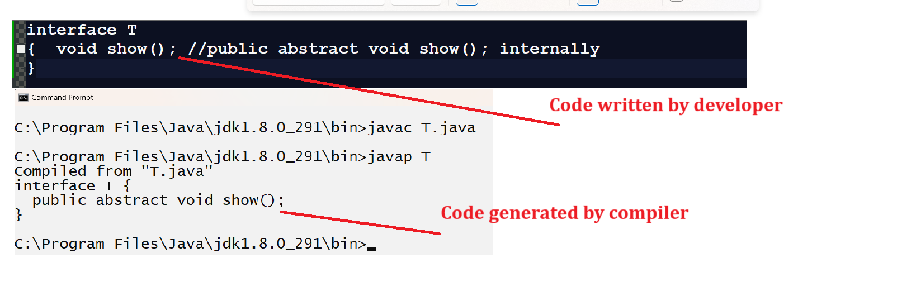
If we want to write logics of interface method we need to implement interface in any another class and override its method and write logic and if we want to implement interface in another class we have to use implements keyword and must be use public keyword when we override interface method.

Example with source code
interface T
{ void show(); //public abstract void show(); internally
}
class TA implements T
{
public void show()
{ System.out.println("I am show method of TA");
}
}
public class TAAPP
{
public static void main(String x[])
{
TA t = new TA();
t.show();
}
}

2. Interface variables are by default public static final
Means if we want to declare variable within interface we must be initialize some value in it otherwise compiler will generate error to us means when we declare variable within interface it act as constant

Shown in following code
interface T
{ float PI;
void show(); //public abstract void show(); internally
}
class TA implements T
{
public void show()
{ System.out.println("I am show method of TA");
}
}
public class TAAPP
{
public static void main(String x[])
{
TA t = new TA();
t.show();
}
}
Output
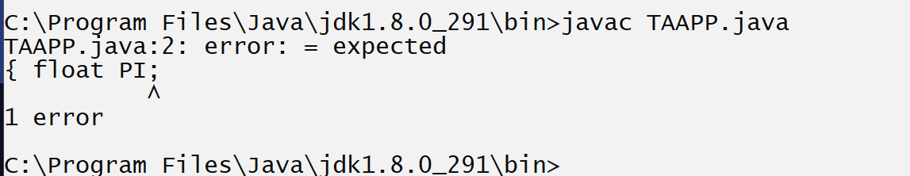
if we think about above code we get compile time error = expected because we declare variable within interface but not initialize value in it so if we want to resolve this problem we must be initialize value to interface variable because they are static and final.
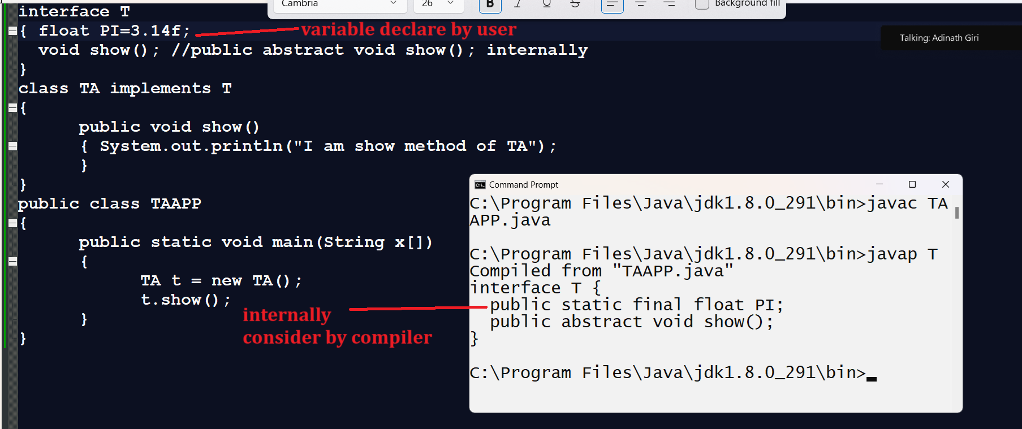

Q. Why interface variables are static and final?
_________________________________________________________
final because they cannot modify their values means if use want to set constant then internally it is final and static because user can use constant variable of interface without its object means user can use it by using interface name also like as class name
because static variable can use with the help of class name or interface name
Shown in following code.
interface T
{ float PI=3.14f;
void show(); //public abstract void show(); internally
}

public class TAAPP
{
public static void main(String x[])
{
System.out.println("PI is "+T.PI);
}
}
3. Interface cannot create its object
Because it is internally like as abstract class and abstract class cannot create its object so interface also not creates its object.

4. Interface method cannot declare as final
Because interface methods are by default abstract and abstract method must be override and final method cannot be override so interface method cannot declare as final and if we try to declare it as final then we get compile time error.
Example with source code
interface T
{ float PI=3.14f;
final void show(); //public abstract void show(); internally
}
public class TAAPP
{ public static void main(String x[])
{
System.out.println("PI is "+T.PI);
}
}
Output
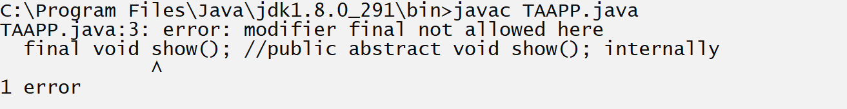

5. Interface method cannot declare as static
because interface methods are abstract and abstract method support to dynamic polymorphism and they cannot logic or definition and static method can work with compile time polymorphism means they can have logic or definition means static and abstract have opposite behavior so we cannot declare interface method as static and if we try to declare it as static then we get compile time error.

Example with source code
interface T
{ float PI=3.14f;
static void show(); //public abstract void show(); internally
}

public class TAAPP
{
public static void main(String x[])
{
System.out.println("PI is "+T.PI);
}
}
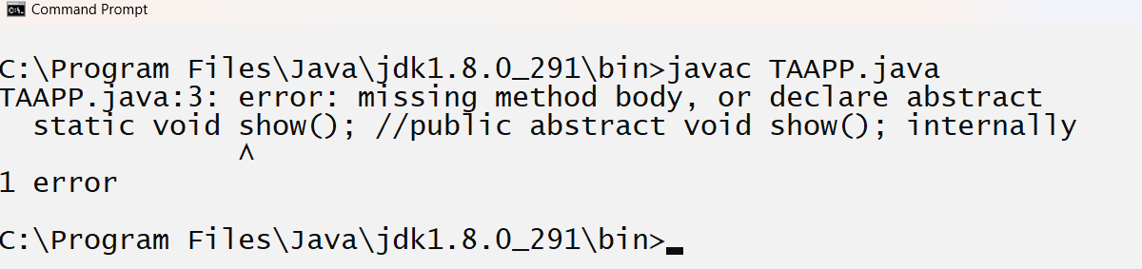

6. Interface method cannot declare as private
Because private method cannot support to override and interface method must be override so we cannot declare it as private and if we try to declare it as private then we get compile time error.

Example with source code
interface T
{ float PI=3.14f;
private void show(); //public abstract void show(); internally
}
public class TAAPP
{ public static void main(String x[])
{
System.out.println("PI is "+T.PI);
}
}
Output
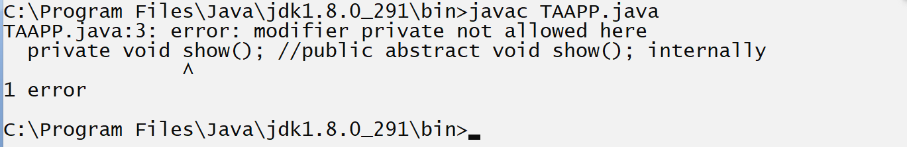
7. Interface method cannot declare as protected

Q. if we declare abstract method in class then we can declare it as protected and if interface method is abstract so why we cannot declare as protected?

Note: if we declare abstract method within abstract class then abstract method use default access specifier and if we declare it protected then protected can override on default so it is possible to declare abstract within abstract class as protected.

Example:
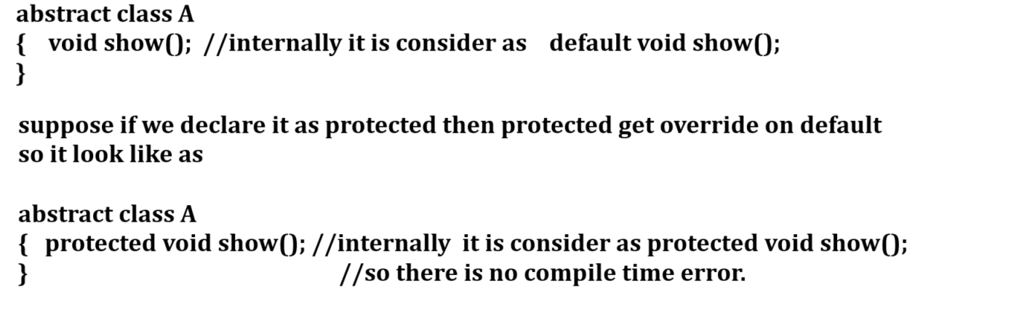
If we declare abstract within interface then by default use public access specifier and if we try to declare it as protected then protected cannot override on public so internally compiler consider it as protected public and in java there is not protected public access specifier so we get compile time
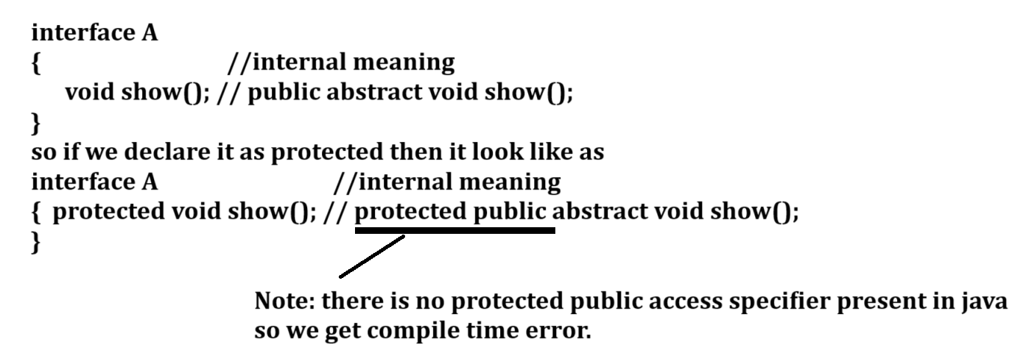

8. If interface contain more than one methods then all method must be override where interface get implemented
__________________________________________________________
If we want to solve this problem we can use adapter class concept.

Example with source code
interface A
{ void show();
void display();
}
class ADP implements A
{
public void show()
{
}
public void display()
{
}
}
class B extends ADP
{
public void show()
{ System.out.println("I am show from interface A");
}
}
public class InfApp
{ public static void main(String x[])
{
B b1= new B();
b1.show();
}
}

9. Interface cannot create its object but can create its reference
_________________________________________________________
If we want to create reference of interface we need to create object of its implementer class and the goal of interface reference is achieve dynamic polymorphism and loose coupling.

Example with source code
interface Value
{
void setValue(int x,int y);
int getResult();
}
class Add implements Value
{ int a,b;
public void setValue(int x,int y)
{ a=x;
b=y;
}
public int getResult(){
return a+b;
}
}
class Mul implements Value
{ int a,b;
public void setValue(int x,int y)
{ a=x;
b=y;
}
public int getResult(){
return a*b;
}

}
public class DynamicPolyInfApp
{
public static void main(String x[])
{ Value v=null;
v = new Add();
v.setValue(10,20);
int result=v.getResult();
System.out.printf("Addition is %d\n",result);
v = new Mul();
v.setValue(5,4);
result=v.getResult();
System.out.printf("Multiplication is %d\n",result);
}
}

10. Interface cannot have constructor
________________________________________________
Because not need to initialize interface member because when we declare variable within interface then it is by default final and final variable must have to initialize value so not need to declare constructor for initialize interface member and if we think about abstract class then variable or member within abstract class not final means they not need to initialize at the time of declaration so we required to constructor for initialize them so this is major reason interface cannot have constructor and abstract can have constructor.

11. interface to interface need to use extends keyword
_______________________________________________________
When we perform inheritance between one interface to another interface then we can use extends keyword

interface A
{ void show();
}
interface B extends A
{ void display();
}
class C implements B
{
public void show()
{ System.out.println("I am show method");
}
public void display()
{ System.out.println("I am display method");
}
}
public class InfApp
{ public static void main(String x[])
{ C c1 = new C();
c1.show();
c1.display();
}
}
12. We can declare interface within class or class within interface
_________________________________________________________
interface A
{ void show();
class B implements A
{
void display()
{ System.out.println("I am display");
}
public void show()
{ System.out.println("I am show method");
}
}
}
class C extends A.B
{
}
public class ClassWithinInfApp
{ public static void main(String x[])
{ C c1 = new C();
c1.show();
c1.display();
}
}
Interface within class
class A
{ void display()
{ System.out.println("I am display from class A");
}
interface B
{ void show();
}
}
class C extends A implements A.B
{
public void show()
{ System.out.println("I am show method from C");
}
}
public class ClassWithinInfApp
{ public static void main(String x[])
{ C c1 = new C();
c1.show();
c1.display();
}
}

How to achieve multiple inheritances using interface
_____________________________________________________
Multiple inheritance means more than one parents and single child called as multiple inheritances.
From Multiple parent there should be only one parent class and remaining all interfaces.
Means if we have 10 parents then there may be 1 class and 9 interfaces or 10 interfaces.

Example with source code
interface A
{ void show();
}
interface B
{ void show();
}
class C
{
void show()
{ System.out.println("I am show from C");
}
}
class D extends C implements A,B
{
public void show()
{ System.out.println("I am D method");
}
}
public class MultipleInheritance
{
public static void main(String x[])
{ D d1 = new D();
d1.show();
}
}
Q. what is difference between abstract class and interface?
______________________________________________________
Abstract class | Interface
Need to use abstract keyword for declaration | not need to use abstract keyword
Abstract class variables are not final by default | Interface variables are final default
Abstract class method are use default access specifier by default | Interface method use public access specifier by default
Abstract class can achieve partial abstraction | Interface can achieve 100% abstraction
Abstract class can use extends keyword for inheritance purpose | Interface can use implements keyword
Abstract class cannot support to multiple inheritance | Interface can support to multiple inheritance
Abstract method can declare as protected | Interface method cannot declare as protected
Abstract class contain constructor | Interface cannot use constructor or not allow constructor

