

**Tribhuvan University**

**Faculty of Humanities and Social Sciences**

**Saraswati Multiple Campus**

**Lekhanath marg, Kathmandu**

**MATLAB Report**

**Submitted by : Submitted to :**

**Name :Bikram Gyawali Name : ………….**

**Roll No : ………**

**Subject : Mathematics Signature :**

**Program : BCA(1st Semester)**

**Table of Content**

**Matlab**

**Introduction .............................................................. 3**

**Advantages of MATLAB ......................................... 3**

**Disadvanges of MATLAB ........................................ 4**

**Starting and Stopping ............................................... 4**

**Syntax of MATAB ..................................................... 5**

**Solving Problem by using MATLAB ....................... 8**

**MATLAB**

**Introduction**

Cleve money, the Chairman of the computer science deportment at the University of NEW MEXICO, Started damping MATLAB In the late 1970S.

MATLAB is a high-lever Software package with many but in function that make the learning of numerical methals much easier and more interesting. The name MATLAB Stands for matrix laboratory, because the system was designed to make matrix computations particularly easy. MATLAB is a powerful computing system for handling the Calculations involved in scientific and engineering problems. It is developed by Maths works. By using MATLAB as Simple Calculator (using numbers and boste operations) as well as a Complex calculator (using variables with complex functions), user can perform numerical calculations with matrix. The software can also be integrated with other programming languages such as Python, C/C++, and Java, making it a versatile platform for solving complex technical problems. MATLAB Combines a desktop environment tumed for iterative analysis and design process with a programming language that expresses matrix and array mathematics directly. It includes the live Editor for creating Scripts that combine code, butput and formatted text in an executable notebook. It allows to extends fis functions and developments of all kinds of discipline trough a set of characteristics called toolbox.

Primary MATLAB is a powerful and most popular mathematical Software which takes ~ 18 GB memory and inis software runs on both windows and Mac Operating system. The popularity of MATLAB is due to its ease of use, user-friendly interface, and support for rapid prototyping and development. This softuctive is useful in signal processing, Deep Learning, Image processing, machine learning, Structural Analysts, Electric Vehicles Design and so form used by Electrical, mechanical, civil, computer Engineers, other research and much more.

**Advantages of MATLAB**

MATLAB has many advantages compared with conventional Computer languages for technical problem solving some are describe below :

* + **User-friendly interface**: MATLAB has a user-friendly interface that makes it easy to perform numerical computations, visualize data, and develop algorithms.
  + **Wide range of mathematical functions**: MATLAB provides a large library of pre-written functions for tasks such as signal processing, optimization, and statistics, which makes it easier for users to perform complex calculations.
  + **Visualization tools**: MATLAB provides powerful visualization tools that enable users to visualize data in various formats such as 2D and 3D plots, contours, and histograms.
  + **Ease of Use**: MATLAB is an interpreted language, the ons te Versions of Basic. Like Basic, It is very easy i programs may be eastly written and modifled with the built-in interpated develop- ment environment, and olebugged when the MATLAB debugger.
  + **Platform Independence**: MATLAB is Supported on many. different Computer Systems (windows 2000/XP/Vista/linux/several version of Unix and Macintosh) providing. a large measure of platform Independence.
  + **Strong community**: MATLAB has a large and active user community, which provides a wealth of resources and support, including forums, blogs, and documentation.
  + **Others**: Toolbox, Introperability, Device independence, Widely used etc.

Overall, MATLAB's user-friendly interface, mathematical functions, visualization tools, interoperability, toolboxes, popularity, and strong community make it a powerful platform for numerical computing and algorithm development.

**Disadvantages of MATLAB**

While MATLAB is a powerful platform for numerical computing, it also has some disadvantages, including:

* **Cos**t: MATLAB is proprietary software, and its license can be expensive, making it inaccessible to some individuals and organizations. It is 5 to 10 times more expensive than conventional cor fortran compiler.
* **Performance limitations:** MATLAB is designed for numerical computations, but it can be slow for large-scale data processing and complex computations, making it less suitable for some applications.
* **Dependence on proprietary software:** MATLAB requires the use of proprietary software and hardware, which can limit its compatibility with other systems and increase the risk of vendor lock-in.
* **Limited open-source options:** MATLAB is a closed-source platform, which means that users do not have access to its source code, limiting opportunities for customization and collaboration.
* **Memory limitations:** MATLAB can require a large amount of memory to perform certain tasks, especially for large-scale data processing and visualization, making it less suitable for use on low-memory systems.

Overall, while MATLAB is a powerful platform for numerical computing, its cost, performance limitations, dependence on proprietary software, limited open-source options, steep learning curve, and memory limitations can make it less suitable for some applications.

**Starting and Stopping**

MATLAB Can be Started by clicking on the MATLAB Option in your startup free or possible on your windows desktop. The main window In MATLAB is the command window, positioned at the center, in which command can be typed after the MATLAB. Prompt “>>”

Command are entered with the 'retum key. •The Command is than executed by MATLAB. If MATLAB is ready, after possible outputs a new prompt appears.

Stopping MATLAB Can also be done in different ways:

• By means of the Command

» quit

• Via the menu File \ Exit MATLAB

Clicking on the Cross in the upper right of our window.

**Syntax of MATLAB**

The MATLAB application is built around the MATLAB programming language.

Common usage of the MATLAB application involves using the "Command Window"

as an interactive mathematical shell or executing text files containing MATLAB code.

In command window if we type

>> 2+2

Then MATLAB will display:

Ans=4

To be specific we are now going to use this sophisticated software for our laboratory assignments.

**Solving Problem by Using Mat Lab**

1. **solve x+5=9**

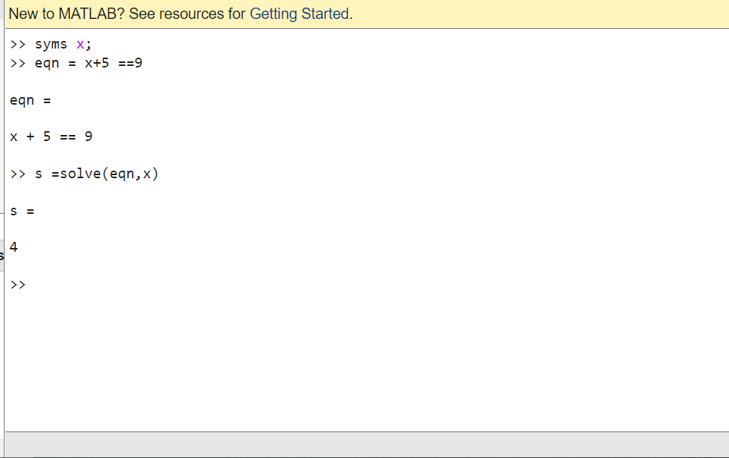

**2. solve x2=9**

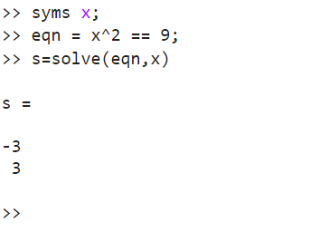

**3.Draw the graph of y=2x+1 using matlab**

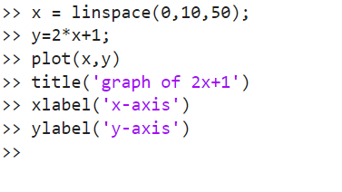

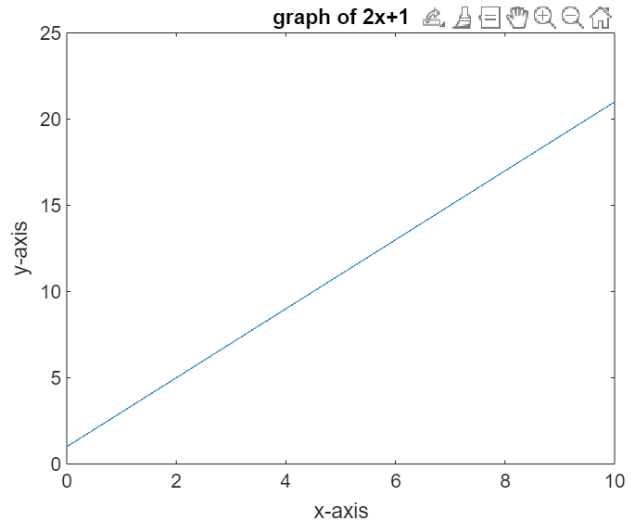

**4. Draw the graph of y=sinx**

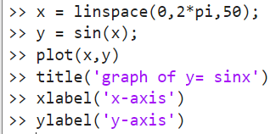

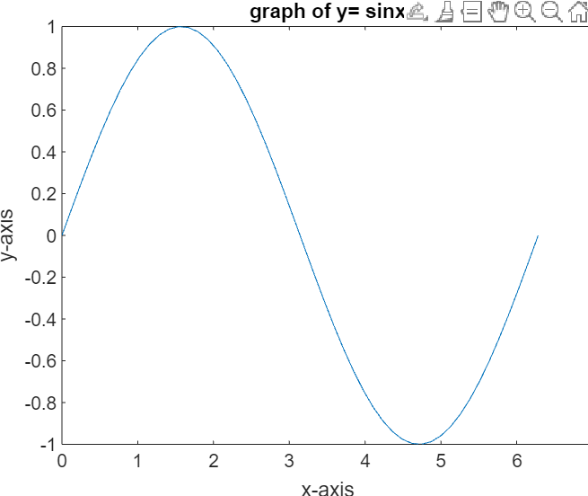

**5. Draw y=log10x**

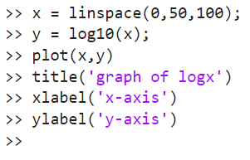

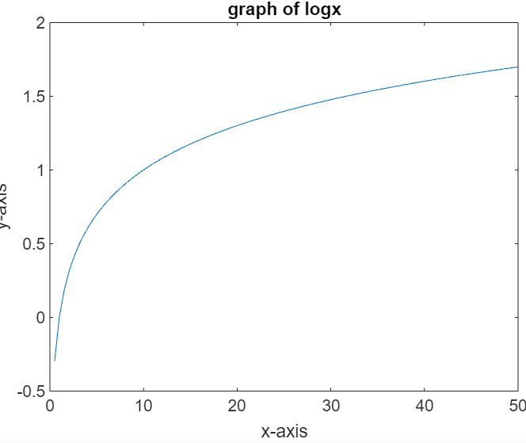

**6. Draw the graph of y= e^x in matlab**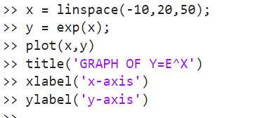

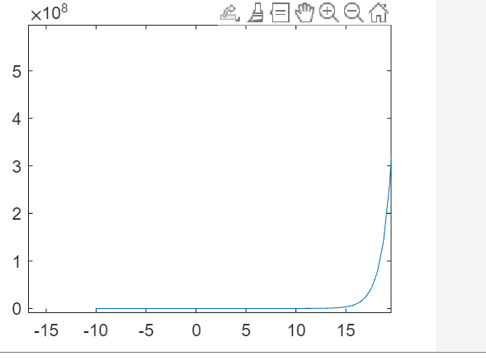

**7. Draw Y=tanx**

