

ToolStripMruList

14 October 2012

**Description**

Add recent file list to Windows Forms Application.

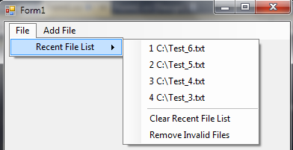

**Features**

* Customize number of files to remember.
* Auto truncate long file name to defined length.
* User define storage location for recent file list
* Clear Recent File List
* Remove Invalid Files

**Requirement**

* .NET Framework 3.5 and above.
* Applicable for Windows Forms Application only.
* Supported for C# and VB.NET.

**Contact**

* **Email:** [codearteng@gmail.com](mailto:codearteng@gmail.com)
* **Webpage:** [www.codearteng.blogspot.com](http://www.codearteng.blogspot.com)

**Step-by-step User Guide**

**Implementing MRU List**

* Add ToolstripMruList.dll to Windows Forms Application project.
* Add “MRU List” item from drop down in MenuStrip, ContextMenuStrip or ToolStrip.  
   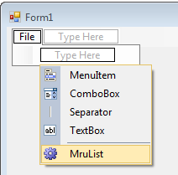
* With “MRU List” object selected, configure Text, MRU List Size and Max Path Length properties at your choice.
* Subscribe to “RecentFileClicked” event to get notify when user clicked on recent file.  
  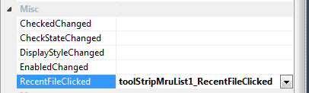

**Add File to MRU List**

* Call AddRecentFileToMruList(<FileName>) to add recent file entry when needed.

**Save MRU List**

* Retrieve MRU List from RecentFileList properties and store to file, registry or application settings when terminating application.  
  **Example:** Save to application settings

**[C#]**Properties.Settings.Default.MRUList = string.Join(";", MRUList.RecentFileList);  
Properties.Settings.Default.Save();

**[VB.NET]**

My.Settings.MRUList = String.Join(";", MRUList.RecentFileList)

My.Settings.Save()

**Load MRU List**

* Read file list from external file, registry or application settings and assign to RecentFileList when application loaded.  
  **Example:** Read recent file list form application settings.

**[C#]**MRUList.RecentFileList = Properties.Settings.Default.MRUList.Split(';');

**[VB.NET]**

MRUList.RecentFileList = My.Settings.MRUList.Split(';');

**Appendix**

MRU List Entry in Application settings used for saving / loading MRU file list.

