CodeArtEng.Diagnostics Migration Guide

1. Identify classes which is generic and platform specific (WinForm) - Visio
2. Create WPF project  
   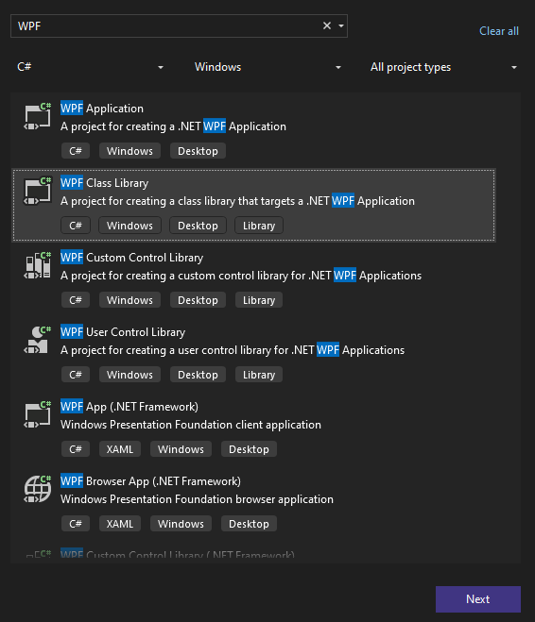
3. Delete auto generated class.  
   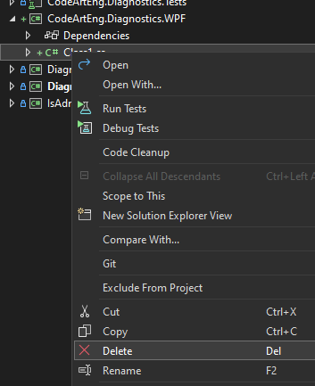
4. Include all generic classes, add as link. Alternatively, create separate shared library reference by both project. Not recommend to copy the code difficult to maintain.  
   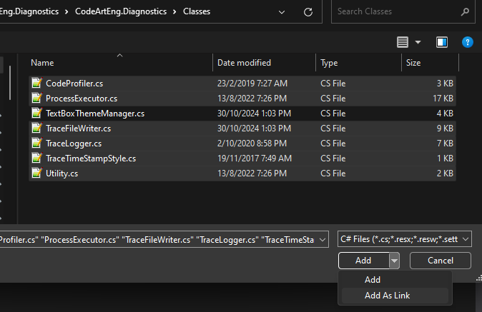
5. Remove nullable to maintain backward compatibility with WinForm code.  
   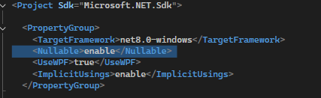
6. Add missing package, System.Management  
   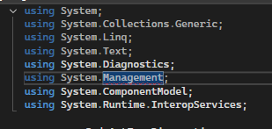  
     
   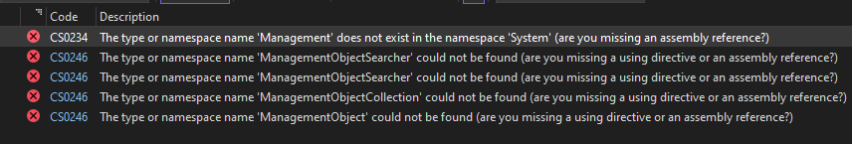
7. Compile and make sure no error.
8. Namespace  
   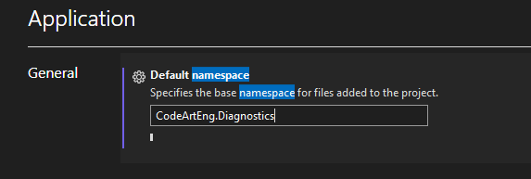
9. Create unit test project for WPF (Optional)  
   Include unit test cases (add by link) if backward compatible.
10. Next, the hardest part, migrate windows form to WPF.