|  |
| --- |
| **Practical 1:- Build a “Guess the Number Game” using JavaScript.** |

**Index.html**

|  |
| --- |
| <!DOCTYPE html>  <html lang="en">  <head>  <meta charset="UTF-8">  <meta name="viewport" content="width=device-width, initial-scale=1.0">  <title>Practical 1</title>  </head>  <style>  .table{  align-items: center;  text-align: center;  padding: auto;  }  </style>  <body>  <table border="1">  <tr>  <th colspan="3">  <h1>Guess the Number</h1>  </th>  </tr>  <form action="#">  <tr>  <td>  <input type="text" id="txt1" placeholder="Enter number">  </td>  <td>  <input type="submit" value="start Guess" id="btn1">  </td>  <td>  <input type="submit" onclick="reset()" value="Reset" id="btn2">  </td>  </tr>  </form>  <tr>  <div id="box">  <td>  <p>Previous Guesses: <span id="hh1"></span></p>  </td>  <td colspan="2">  <p>Remaining Count: <span id="hh2"></span></p>  </td>  </div>  </tr>  <tr>  <td colspan="3">  <p id="lowHigh"></p>  <p id="random"></p>  </td>  </tr>  </table>  <script src="jquery.js"></script>  <script src="app.js"></script>  </body>  </html>  **Game.js**  var randomNumber=parseInt((Math.random()*100)+1);  var userInput=document.getElementById('txt1');  var submitBtn=document.getElementById('btn1');  var guessNo=document.getElementById('hh1');  var remainingCount=document.getElementById('hh2');  var lowHigh=document.getElementById('lowHigh');  var parentDiv=document.getElementById('box');  var newResetButton=document.createElement('button');  var playGame=true;  var random = document.getElementById('random');  var previousGuesses=[];  var numberGuess=1;  var reset = document.getElementById('btn2');  $("#btn2").hide();  if(playGame)  {  submitBtn.addEventListener('click',function(e)  {  e.preventDefault();  var guess=parseInt(userInput.value);  validateGuess(guess);  });  reset.addEventListener('click',function(e){  e.preventDefault();  guessNo.innerHTML='';  remainingCount.innerHTML='';  random.innerHTML='';  lowHigh.innerHTML='';  parentDiv.removeChild(newResetButton);  previousGuesses = [];  });  }  function validateGuess(guess)  {  if(isNaN(guess)){  alert('please enter number ');  }  else if(guess<1 || guess>100){  alert('number must be in between 1 to 100');  }  else {  previousGuesses.push(guess);  if(numberGuess==5)  {  displayGuess(guess);  endGame();  }  else {  displayGuess(guess);  checkGuess(guess);  }  }  }  function displayGuess(guess)  {  $("#btn2").show();  guessNo.innerHTML+=' '+guess;  userInput.value='';  numberGuess++;  remainingCount.innerHTML=6-numberGuess;  }  function checkGuess(guess)  {  if(guess==randomNumber)  {  lowHigh.innerHTML='You guess correct number '+randomNumber;  }  else if(guess<randomNumber)  {  lowHigh.innerHTML='Too Low!Try again';  }  else if(guess>randomNumber)  {  lowHigh.innerHTML='Too High!Try again';  }  }  function endGame()  {  userInput.value='';  userInput.setAttribute('disabled','');  newResetButton.innerHTML='StartNewGame';  newResetButton.id="newGame";  parentDiv.appendChild(newResetButton);  random.innerHTML='Random Number: '+randomNumber;  $("#btn2").hide();  newGame();  }  function newGame()  {  document.getElementById('newGame').addEventListener('click',function()  {  numberGuess = 1;  randomNumber=parseInt((Math.random()*100)+1);  userInput.removeAttribute('disabled');  guessNo.innerHTML='';  remainingCount.innerHTML='';  random.innerHTML='';  lowHigh.innerHTML='';  parentDiv.removeChild(newResetButton);  });  } |

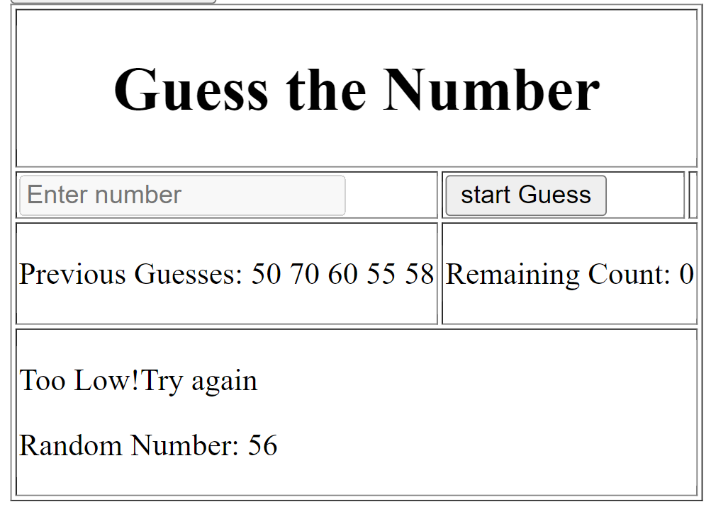**Output:-**