# **Practical- 1) Aim:** **Build a “Guess the Number Game” using JavaScript.** **Code:**

## Practical1.html

<!DOCTYPE html>

<html lang="en">

<head>

<meta charset="UTF-8">

<meta name="viewport" content="width=device-width, initial-scale=1.0">

<title>Number Guessing Game</title>

</head>

<body>

<div class="container" style="text-align: center">

<form>

<h2> Number Guessing Game </h2>

<input type="text" id="txt1">

<input type="submit" value="start Guess" id="btn1">

<input type="submit" value="Reset" id="btn2">

</form>

<div id="box">

<p>Previous Guesses: <span id="hh1"></span></p>

<p>Remaining Count: <span id="hh2"></span></p>

<p id="lowHigh"></p>

</div>

</div>

<script src="jquery.js"></script>

<script src="app1.js"></script>

</body>

</html>

# App.js

var randomNumber = parseInt((Math.random() * 100) + 1);

var userInput = document.getElementById('txt1');

var submitBtn=

document.getElementById('btn1');

var resetBtn = document.getElementById('btn2');

var guessNo = document.getElementById('hh1');

var remainingCount = document.getElementById('hh2');

var lowHigh = document.getElementById('lowHigh');

var parentDiv = document.getElementById('box');

var newResetButton =

document.createElement('button');

var playGame = true; var previousGuesses = [];

var numberGuess = 1; $("#btn2").hide();

if (playGame) {

submitBtn.addEventListener('click', function (e)

{

e.preventDefault();

var guess = parseInt(userInput.value);

validateGuess(guess);

}); }

function validateGuess(guess) {

if (isNaN(guess))

{ alert('please enter number ');

}

else if (guess < 1 || guess > 100) {

alert('number must be in between 1 to

100');

} else {

previousGuesses.push(guess);

if (numberGuess == 5) {

displayGuess(guess);

endGame();

} else {

displayGuess(guess);

checkGuess(guess);

}

} }

function displayGuess(guess) {

$("#btn2").show();

guessNo.innerHTML += ' ' + guess; userInput.value =''; numberGuess++;

remainingCount.innerHTML = 6 - numberGuess;

} function checkGuess(guess) {

if (guess

== randomNumber) {

lowHigh.innerHTML = 'You guess correct number';

}

else if (guess < randomNumber) { lowHigh.innerHTML = 'Too

Low!Try again'; } else if (guess > randomNumber) { lowHigh.innerHTML = 'Too High!Try again';

} }

function endGame() { userInput.value = ''; userInput.setAttribute('disabled', ''); newResetButton.innerHTML = 'StartNewGame'; newResetButton.id = "newGame"; parentDiv.appendChild(newResetButton); $("#btn2").hide(); newGame();

}

function newGame() { document.getElementById('newGame').addEventListener('click', function ()

{ randomNumber =

parseInt((Math.random() * 100) + 1); userInput.removeAttribute('disabled'); guessNo.innerHTML = ''; remainingCount.innerHTML = ''; lowHigh.innerHTML = ''; parentDiv.removeChild(newResetButton); numberGuess = 1;

});

}

**Output: -**

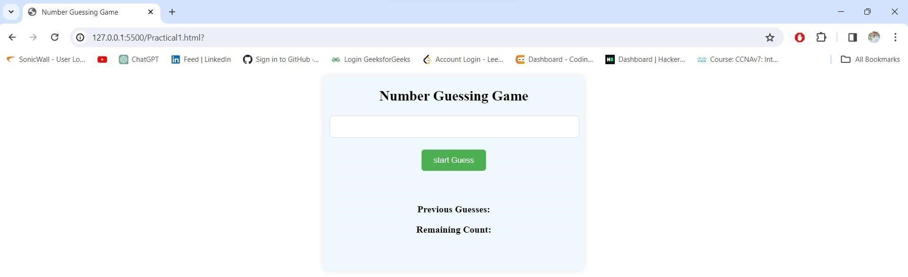



**Practical- 2) Aim:** **Develop a Scientific Calculator using JavaScript.**

## **Code: -** html

<!DOCTYPE html>

<html lang="en">

<head>

<meta charset="UTF-8">

<meta name="viewport" content="width=device-width, initial-scale=1.0">

<title>Scientific Calculator</title>

</head>

<body>

<div class="container">

<h3>Scientific Calculator</h3>

<input type="text" id="screen" placeholder="0"><br><br>

<button onclick="backspace()">CE</button>

<button onclick="factorial()">X!</button>

<button class="btn">(</button>

<button class="btn">)</button>

<button class="btn">%</button>

<button onclick="screen.value=''">CLR</button> <br><br>

<button onclick="sin()">sin</button>

<button onclick="pi()">&#8508;</button>

<button class="btn">7</button>

<button class="btn">8</button>

<button class="btn">9</button> <button class="btn">/</button> <br> <br>

<button onclick="cos()">cos</button>

<button onclick="log()">log</button>

<button class="btn">4</button>

<button class="btn">5</button>

<button class="btn">6</button>

<button class="btn">*</button> <br><br>

<button onclick="tan()">tan</button>

<button onclick="sqrt()">&#8730;</button>

<button class="btn">1</button>

<button class="btn">2</button>

<button class="btn">3</button>

<button class="btn">-</button> <br><br>

<button onclick="f1()">e</button>

<button onclick="pow()">x <sup>2</sup></button>

<button class="btn">0</button>

<button class="btn">.</button>

<button onclick="screen.value=eval(screen.value);">=</button> <button class="btn">+</button> <br><br>

<button onclick="radian()">Rad</button>

<button onclick="degree()">Deg</button> </div>

<script src="Practical2.js"></script>

</body>

</html>

# Calculator.js

//For Scientific calculator

var screen=document.getElementById('screen');

var btn=document.getElementsByClassName('btn'); for(item of btn)

{

item.addEventListener('click',function(e)

{

btnText=e.target.innerHTML; screen.value+=btnText;

}); }

function backspace()

{

screen.value=screen.value.substr(0,screen.value.length-1);

} function factorial()

{ var fact=1; var ans=screen.value; for(i=1;i<=screen.value;i++)

{ fact=fact*ans; ans--; }

screen.value=fact; } function sin() { screen.value=Math.sin(screen.value);

} function pi() { screen.value+=3.14;

} function cos()

{

screen.value=Math.cos(screen.value);

} function log() { screen.value=Math.log(screen.value);

} function tan() { screen.value=Math.tan(screen.value);

} function sqrt() { screen.value=Math.sqrt(screen.value);

} function f1()

{

screen.value+=2.71828182;

} function pow() { screen.value=Math.pow(screen.value,2);

} function radian() {

var radian=screen.value; var ans=(radian*180)/3.14; screen.value=ans; } function degree() {

var degree=screen.value; var ans=degree*180/3.14; screen.value=ans;

}

**Output: -**

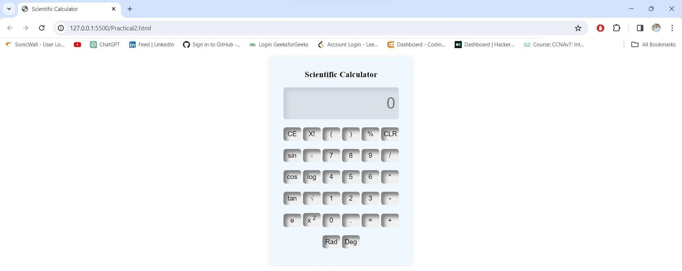



**Practical- 3) Aim:** **Create a Todo App using ReactJS. Code:**

# Index.html

<!DOCTYPE html>

<html lang="en">

<head>

<meta charset="utf-8" />

<link rel="icon" href="%PUBLIC_URL%/favicon.ico" />

<meta name="viewport" content="width=device-width, initial-scale=1" />

<meta name="theme-color" content="#000000" />

<meta name="description" content="Web site created using create-react-app" />

<link rel="apple-touch-icon" href="%PUBLIC_URL%/logo192.png" />

<link rel="manifest" href="%PUBLIC_URL%/manifest.json" />

<title>React App</title>

</head>

<body>

<noscript>You need to enable JavaScript to run this app.</noscript>

<div id="root"></div>

</body>

</html>

# Index.js

import React from 'react'; import ReactDOM from 'react-dom/client'; import

'./index.css'; import App from './App'; import reportWebVitals from './reportWebVitals';

const root = ReactDOM.createRoot(document.getElementById('root')); root.render(

<React.StrictMode>

<App />

</React.StrictMode>

); reportWebVitals();

## App.js

import './App.css'; import TodoList from './TodoList'; function App() { return (

<div className="App">

<TodoList/>

</div>

); }

export default App;

TodoList.js

import { useState } from "react"; import TodoItem

from "./TodoItem"; function TodoList() { const tasks

= [

{ id: 1, title: "Learn React", completed: false },

{ id: 2, title: "Speaking English", completed: true },

{ id: 3, title: "C Programming", completed: true },

{ id: 4, title: "Python Programming", completed: false }

];

const [todo, setTodo] = useState(tasks); const [inputValue, setInputValue] = useState(''); const deleteTodo = (keyId) => { const newTodo = todo.filter((val) => val.id != keyId); setTodo(newTodo);

}

const markAsComplete = (keyId) => { const updatedTodo = todo.map(val => { if (val.id == keyId) {

return { ...val, completed: !val.completed };

} return val;

});

setTodo(updatedTodo);

} const addTodo = () => { const x = { id: Date.now(), title: inputValue, completed:

false }

setTodo([...todo, x]); setInputValue('');

} return (

<div className="TodoList">

<div className="inputContainer">

<input type="text" value={inputValue} class="todoInput" onChange={(e) => setInputValue(e.target.value)} />

<input type="submit" class="addTodoButton" onClick={addTodo} /> </div>

{todo.map(row => (

<TodoItem task={row} onDelete={() => deleteTodo(row.id)} onComplete={() => markAsComplete(row.id)}

/>

))}

</div>

); }

export default TodoList;

## TodoItem.js

function TodoItem(props)

{

const itemClass=`TodoItem ${props.task.completed?"Completed":""}`; return(

<div className={itemClass}>

<h2>{props.task.title}</h2>

<p>Completed {props.task.completed?"Yes":"No"}</p>

<button onClick={props.onDelete}>Delete</button>

<button onClick={props.onComplete}>Complete</button>

</div>

); }

export default TodoItem;

Output: -

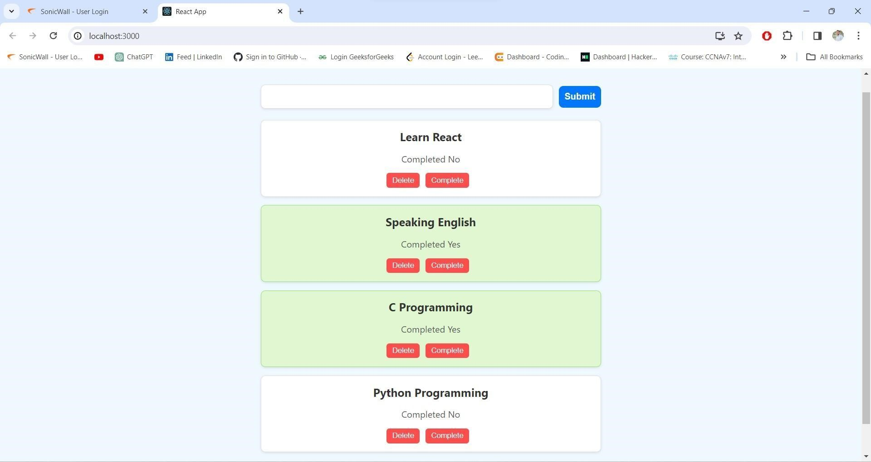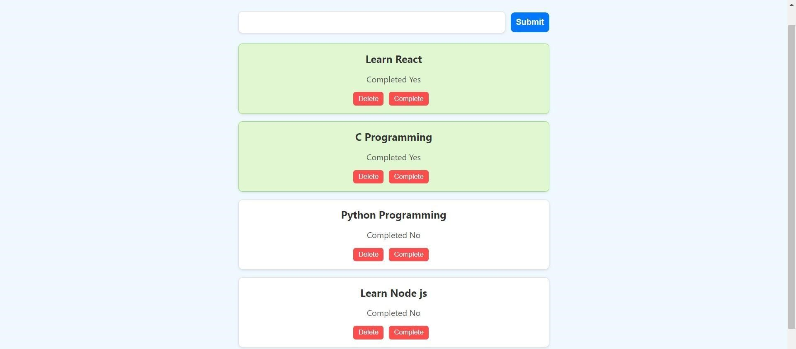

**Practical- 4) Aim:** **Simple Login Form using ReactJS.**

**Code: -**  App.js

import logo from './logo.svg'; import './App.css';

import LoginSignup from './Componetns/LoginSignupform/LoginSignup'; function App() { return ( <div>

<LoginSignup/>

</div>

);

}

export default App;

### LoginSignUp.jsx

import React, { useState } from 'react'; import

'./LoginSignup.css'; import user_icon from '../Assets/person.png' import email_icon from

'../Assets/email.png' import password_icon from

'../Assets/password.png'

const LoginSignup =()=> {

const[action,setAction] = useState("Login"); return(

<div className='Container'>

<div className="header">

<div className="text">{action}</div>

<div className="underline"></div>

</div>

<div className="inputs">

{action=="Login"?<div></div>:<div className="input">

<img src={user_icon} alt="" />

<input type="text" placeholder="Enter Name" />

</div>}

<div className="input">

<img src={email_icon} alt="" />

<input type="text" placeholder='Enter Email Id' />

</div>

<div className="input">

<img src={password_icon} alt="" />

<input type="text" placeholder='Enter Password' />

</div>

</div>

{action==="Sign Up"?<div></div>:<div className="forgotpassword">Lost

Password? <span>Click Here!</span></div>} <div className="submit-container">

<div className={action==="Login"?"submit gray":"submit"}onClick={()=>{setAction("Sign

Up")}}>Sign Up</div> <div className={action==="Sign Up"?"submit gray":"submit"}onClick={()=>{setAction("Login")}}>Login </div>

</div>

</div> ); } export default LoginSignup;

Output: -

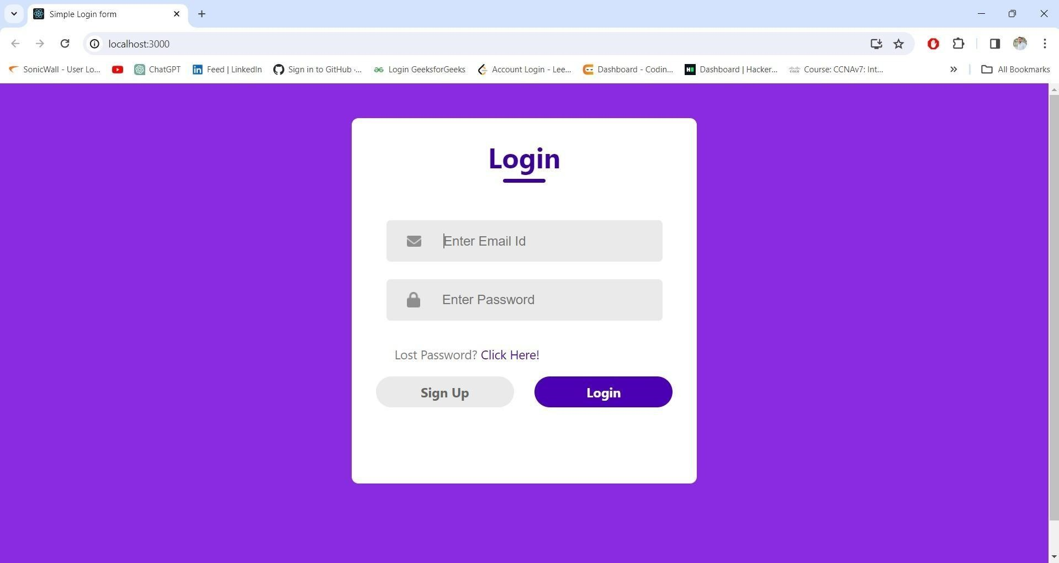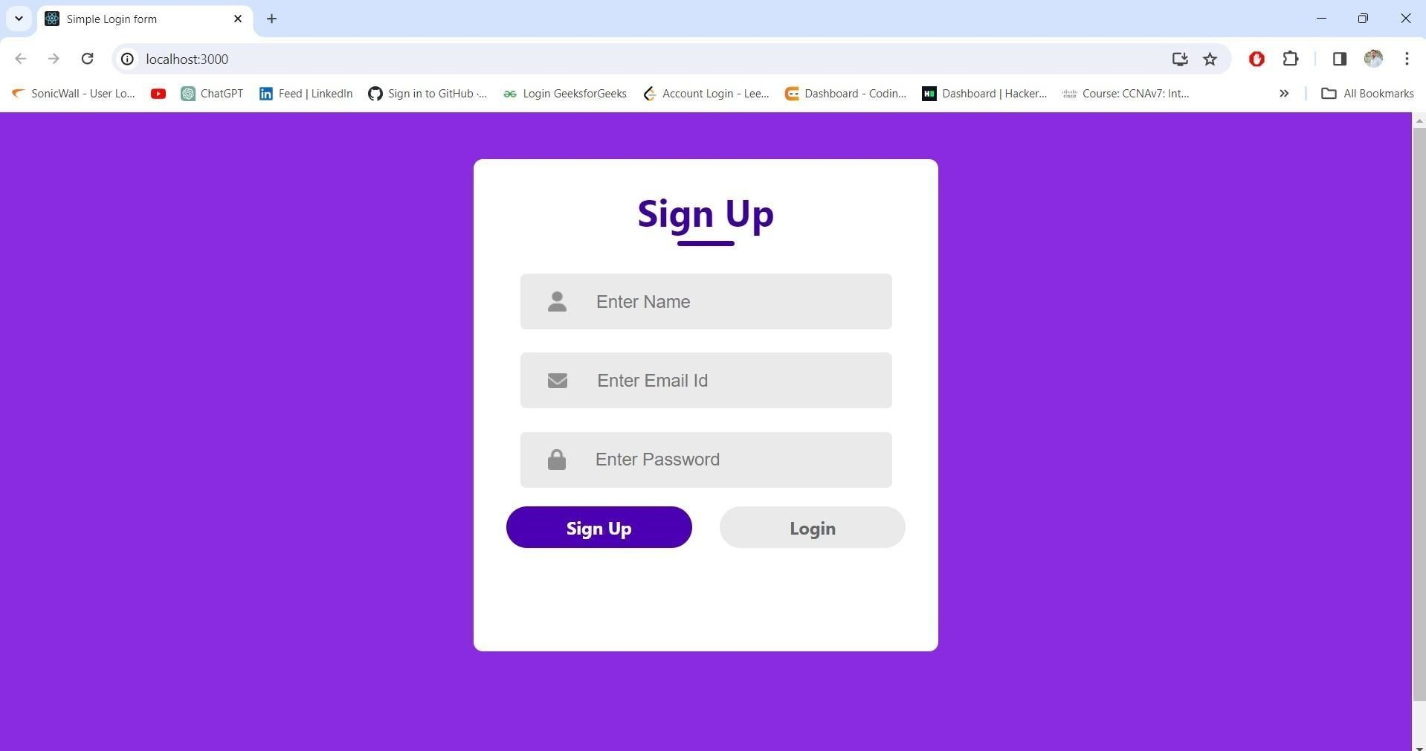

**Practical- 5) Aim:** **Fetch Data from Open API using fetch() in ReactJS.**

**Code:**

#### Index.html

<!DOCTYPE html>

<html lang="en">

<head>

<meta charset="utf-8" />

<link rel="icon" href="%PUBLIC_URL%/favicon.ico" />

<meta name="viewport" content="width=device-width, initial-scale=1" />

<meta name="theme-color" content="#000000" />

<meta

name="description"

content="Web site created using create-react-app"

/>

<link rel="apple-touch-icon" href="%PUBLIC_URL%/logo192.png" />

<link rel="stylesheet"

href="https://cdn.jsdelivr.net/npm/bootstrap@5.2.2/dist/css/bootstrap.min.css">

<script src=

https://cdn.jsdelivr.net/npm/bootstrap@5.2.2/dist/js/bootstrap.min.js></script>

<link rel="manifest" href="%PUBLIC_URL%/manifest.json" />

<title>React App</title>

</head>

<body>

<noscript>You need to enable JavaScript to run this app.</noscript>

<div id="root"></div>

</body>

</html>

#### App.jsx

import { useState } from 'react'; import

'./App.css'; function App()

{

const [location,setLocation]=useState(''); const

[weather,setWeather]=useState({}); const

[photo,setPhoto]=useState([]); const handleSubmit=()=>

{

fetch(`https://api.openweathermap.org/data/2.5/weather?q=${location}&appid=${'9 00bfc805aaa1c81c28ad6fb9cb70a89'}`). then(res=> { if(res.ok)

{

return res.json();

}

else if(res.status===404)

{

return alert('opps!data not found');

} else

{ return console.log('Server

Error');

} }).

then(data=> { console.log(data); setWeather(data);

}). catch(error=>console.log(error));

fetch(`https://api.unsplash.com/search/photos?query=${location}&client_id=${'fW yTRZpj4RxPfqh6luyJgj6VzI-

hgM39VkLsRydC3tY'}`). then(res=> {

return res.json(); }). then(data=>

{ console.log(data); setPhoto(data?.results[0]?.urls?.small); }). catch(error=>console.log(error));

}

return(

<div className='container'>

<div className='row my-4'>

<div className='col-2 offset-4'>

<input type='text' className='form-control border border-danger' onChange={(e)=>setLocation(e.target.value)}/>

</div>

<div className='col-1'>

<input type='button' onClick={handleSubmit} className="btn btnwarning" value="Search Location"></input>

</div>

</div>

<div className='row'>

<div className='offset-5 col-1'>

<p>{weather?.main?.temp}</p>

</div>

</div>

<img src={photo} className='d-block w-50 m-auto'/> </div>

) }

export default App;

### Output: -

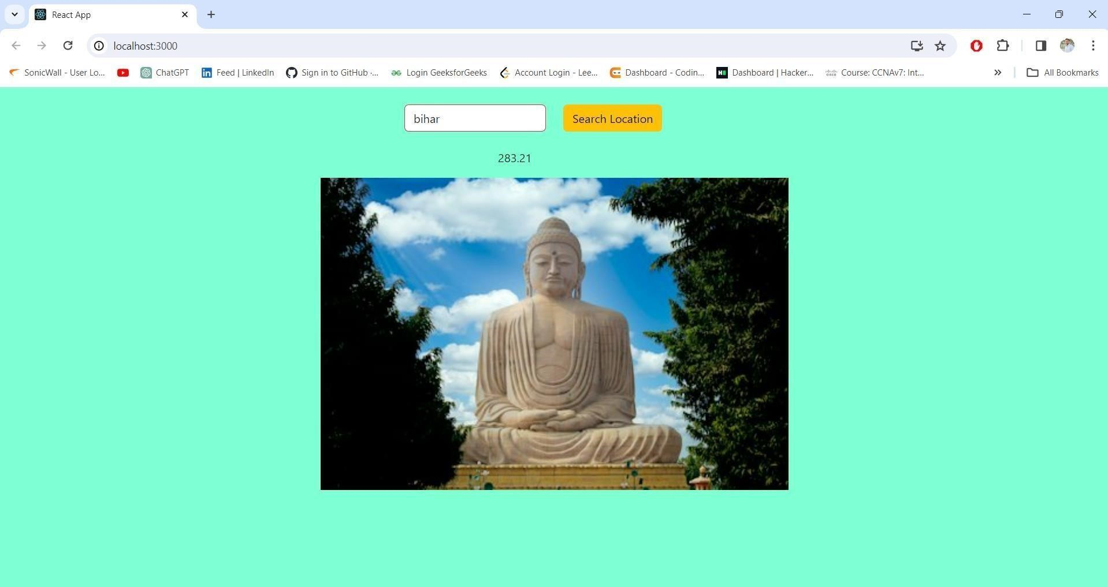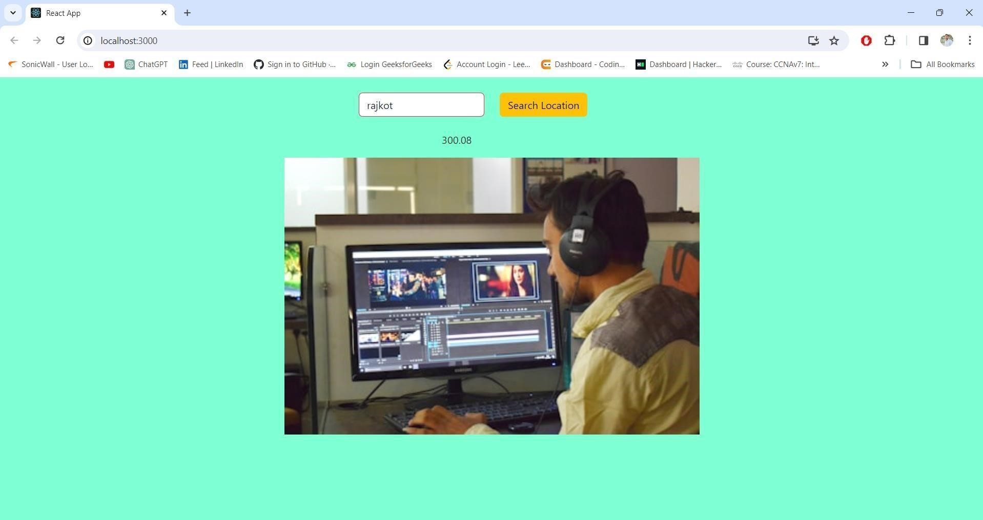

**Practical- 6) Create the following Webpages and make Page Navigation using React Router for the Laptop Shopping Cart. Home About Contact**

# index.html

<!DOCTYPE html>

<html lang="en">

<head>

<meta charset="utf-8" />

<link rel="icon" href="%PUBLIC_URL%/favicon.ico" /> <meta name="viewport" content="width=device-width, initial-scale=1" /> <meta name="theme-color" content="#000000" />

<meta name="description" content="Web site created using create-react- app"

/>

<link rel="apple-touch-icon" href="%PUBLIC_URL%/logo192.png" />

<link

href="https://cdn.jsdelivr.net/npm/bootstrap@5.3.2/dist/css/bootstrap.min.css" rel="stylesheet" integrity="sha384-

T3c6CoIi6uLrA9TneNEoa7RxnatzjcDSCmG1MXxSR1GAsXEV/Dwwykc2MPK8M2HN" crossorigin="anonymous"

/>

<link rel="manifest" href="%PUBLIC_URL%/manifest.json" />

<link

rel="stylesheet"

href="https://cdn.jsdelivr.net/npm/bootstrap@5.3.2/dist/css/bootstrap.min.css" /> <title>React App</title>

</head>

<body>

<noscript>You need to enable JavaScript to run this app.</noscript> <div id="root"></div>

<script src="https://cdn.jsdelivr.net/npm/bootstrap@5.3.2/dist/js/bootstrap.bundle.min.

js"></script> </body> </html>

index.js import React from 'react'; import

ReactDOM from 'react-dom/client'; import

'./index.css'; import App from

'./App'; import reportWebVitals from './reportWebVitals'; import

{ BrowserRouter } from 'react-router-dom'; import { BrowserRouter as Router, Route, Switch } from

'react-router-dom';

import Cookies from 'universal-cookie';

const root = ReactDOM.createRoot(document.getElementById('root')); root.render( <React.StrictMode> <BrowserRouter>

<App />

</BrowserRouter>

</React.StrictMode>

);

reportWebVitals();

## App.js

import { Route,Routes } from 'react-router-dom'; import './App.css'; import Header from './components/Header'; import

Home from './components/Home'; import AboutUs from

'./components/AboutUs'; import

ContactUs from './components/ContactUs'; import

Login from './components/Login'; import MyCart from

'./components/MyCart'; function App() { return (

<div className="App">

<Header/>

<Routes>

<Route path="/" element={<Home/>}></Route>

<Route path="/aboutus" element={<AboutUs/>}></Route>

<Route path="/contactus" element={<ContactUs/>}></Route>

<Route path="/login" element={<Login/>}></Route>

<Route path="/mycart" element={<MyCart/>}></Route>

</Routes>

</div>

); }

export default App;

## Home.js

import data from './Data.json'; import { useNavigate } from

'react-router-dom'; import Cookies from 'universalcookie'; function Home() { //props.purchasedItems const x=useNavigate();//return one function

const handleSubmit=(index)=>

{

const product=data[index];//store product object const

productName=product.title;

alert(`${productName} has been added to cart`); let cookies=new Cookies(); let existingProductInCart=cookies.get("cart_products"); if(existingProductInCart === null||existingProductInCart === undefined) { cookies.set("cart_products",[product]); } else

{ cookies.set("cart_products",[...existingProductInCart,product]);

}

if(window.confirm('Want to buy this product? '))

{

x('/myCart');

} } return (

<div className="container-fluid">

<div className='row'>

{data.map((row,index)=>

{ return(

<div className='col-sm-3 mt-4 text-center' key={index}>

<img src={row.url} style={{width:"200px"}} alt={'images'} className='card-img m-auto'/> <p className='card-title'>{row.title}<br/>{"MRP Rs.

"+row.price}</p>

<input type="button" onClick={()=>handleSubmit(index)} value="Add To Cart" className='btn btn-warning m-3'/>

</div>

)

})}

</div>

</div> ); } export default Home;

## Header.js

import {Link} from 'react-router-dom'; import logo from

'../components/logo.png'; import './header.css'; function Header() { return (

<nav className="navbar navbar-expand-lg bg-body-tertiary">

<div className="container-fluid">

<Link className="navbar-brand" to="/">

<img id='img1-' src={logo} height="50px" width="60px" alt='logo' className='rounded-circle'/> </Link>

<button className="navbar-toggler" type="button" databstoggle="collapse" data-

bstarget="#navbarNav" aria-controls="navbarNav" ariaexpanded="false" aria-label="Toggle navigation"> <span className="navbar-toggler-icon"></span>

</button>

<div className="collapse navbar-collapse" id="navbarNav">

<ul className="navbar-nav">

<li className="nav-item">

<Link className="nav-link" aria-current="page" to="/">Home</Link> </li> <li className="nav-item">

<Link className="nav-link" to="/contactus">Contact Us</Link>

</li>

<li className="nav-item">

<Link className="nav-link" to="/aboutus">About Us</Link>

</li>

</ul>

<ul className="navbar-nav ms-auto">

<li className="nav-item">

<Link className="nav-link" aria-current="page" to="/login">Login</Link>

</li>

<li className="nav-item">

<Link className="nav-link" to="/myCart">My Cart</Link>

</li>

</ul>

</div>

</div>

</nav>

); }

export default Header;

## About.js

function AboutUs() {

return (

<div className="AboutUs container p-5">

<h2 className="m-5">AboutUs page</h2>

<div className="accordion" id="accordionExample">

<div className="accordion-item">

<h2 className="accordion-header">

<button className="accordion-button" type="button" databstoggle="collapse" databstarget="#collapseOne" aria-expanded="true" ariacontrols="collapseOne"> <strong>Indroduction</strong>

</button>

</h2>

<div id="collapseOne" className="accordion-collapse collapse show" databsparent="#accordionExample"> <div className="accordion-body">

<strong>Good morning/afternoon.</strong> Thank you for the opportunity to introduce myself. My name is <strong>Sadab Hussain</strong> , and I bring a diverse background in Two years to contribute to the team's success. I am a proactive and adaptable professional who excels in problem-solving and delivering high-quality results..

</div>

</div>

</div>

<div className="accordion-item">

<h2 className="accordion-header">

<button className="accordion-button collapsed" type="button" databstoggle="collapse" databstarget="#collapseTwo" aria-expanded="false" ariacontrols="collapseTwo"> <strong>Education</strong>

</button>

</h2>

<div id="collapseTwo" className="accordion-collapse collapse" databsparent="#accordionExample"> <div className="accordion-body">

<strong> Education is about learning skills and knowledge.</strong>It also means helping people to learn how to do things and support them to think about what they learn. It is also important for educators to teach ways to find and use information. Education needs research to find out how to make it better. </div> </div>

</div>

<div className="accordion-item">

<h2 className="accordion-header">

<button className="accordion-button collapsed" type="button" databstoggle="collapse" databstarget="#collapseThree" aria-expanded="false" ariacontrols="collapseThree"> <strong>web developer</strong>

</button>

</h2>

<div id="collapseThree" className="accordion-collapse collapse" databsparent="#accordionExample"> <div className="accordion-body">

<strong>What do web developers do ?</strong> In short, they build and maintain websites. Web developers often work for clients who are trying to get their product or service onto the web. The work is typically very project focused and involves collaborating with a team that helps to coordinate the client's needs into the end product.

</div>

</div>

</div>

</div>

</div>

); } export default AboutUs;

## ContactUs.js

function ContactUs() {

return (

<section className="mb-4">

<h1 className="h1-responsive font-weight-bold text-center my- 4">Contact us</h1>

<p className="text-center w-responsive mx-auto mb-5">Do you have any questions? Please do not hesitate to contact us directly. Our team will come back to you within

a matter of hours to help you.</p>

<div className="row">

<div className="col-md-9 mb-md-0 mb-5 ">

<form id="contact-form" name="contact-form" action="mail.php" method="POST">

<div className="row">

<div className="col-md-6">

<div className="md-form mb-0 "> <input

type="text" id="name" className="formcontrol m-3" placeholder="your name" name="name"

/>

</div>

</div>

<div className="col-md-6">

<div className="md-form mb-0">

<input type="text" id="email" className="form-control m-3" placeholder="your email" name="email"

/>

</div>

</div>

</div>

<div className="row">

<div className="col-md-12">

<div className="md-form mb-0">

<input type="text" id="subject" className="form-control m-3" style={{height:'50px'}} placeholder="your subject"

name="subject" />

</div>

</div>

</div>

<div className="row">

<div className="col-md-12">

<div className="md-form">

<textarea type="text" id="message" placeholder="Your Messages"

style={{height:'150px'}} name="message" rows="2" className="form-control m-3 mt-2"></textarea>

</div>

</div>

</div>

</form>

<div className="text-center text-md-left">

<a className="btn btn-danger mt-5" href="www.gmail.com">Send</a>

</div>

<div className="status"></div>

</div>

<div className="col-md-3 text-center">

<ul className="list-unstyled mb-0">

<li><i className="fas fa-map-marker-alt fa-2x"></i>

<p>marwadi university morbi road rajkot , gujarat 360003</p>

</li>

<li><i className="fas fa-phone mt-4 fa-2x"></i> <p>7091733441</p>

</li>

<li><i className="fas fa-envelope mt-4 fa-2x"></i>

<p>sadabhussain.118160@marwadiuniversity.ac.in</p>

</li>

</ul>

</div>

</div>

</section>

); } export default ContactUs;

### Output:- Homepage

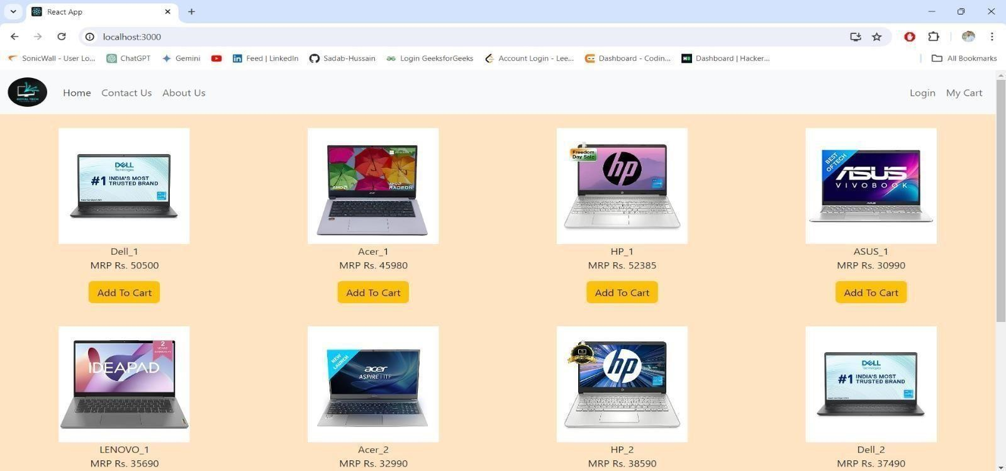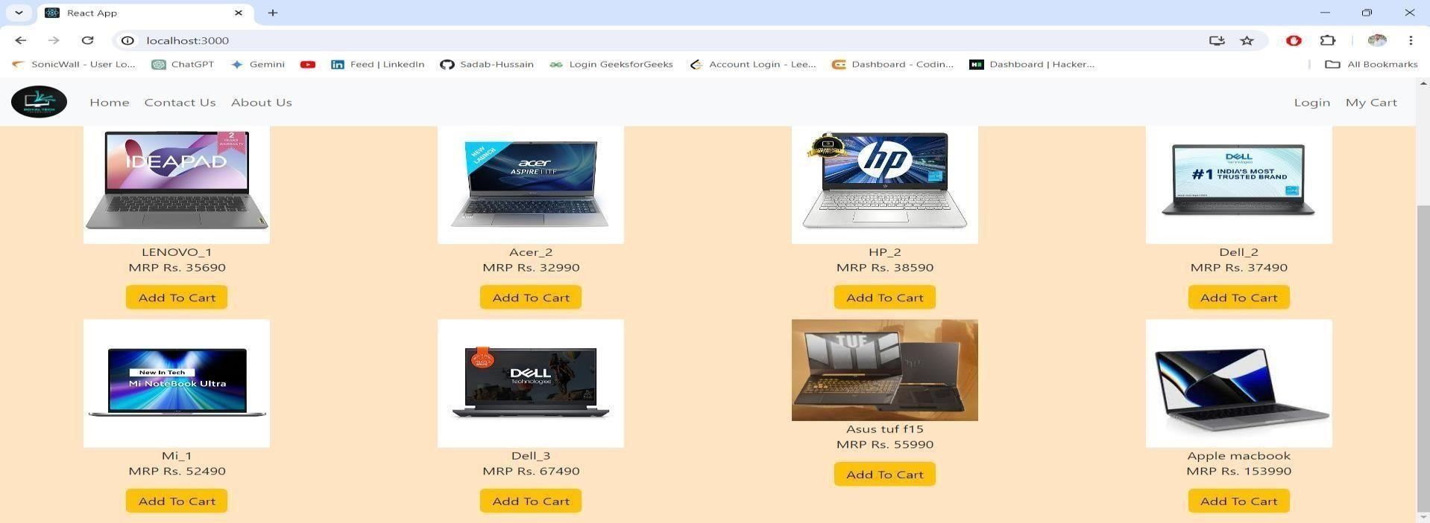

### About page

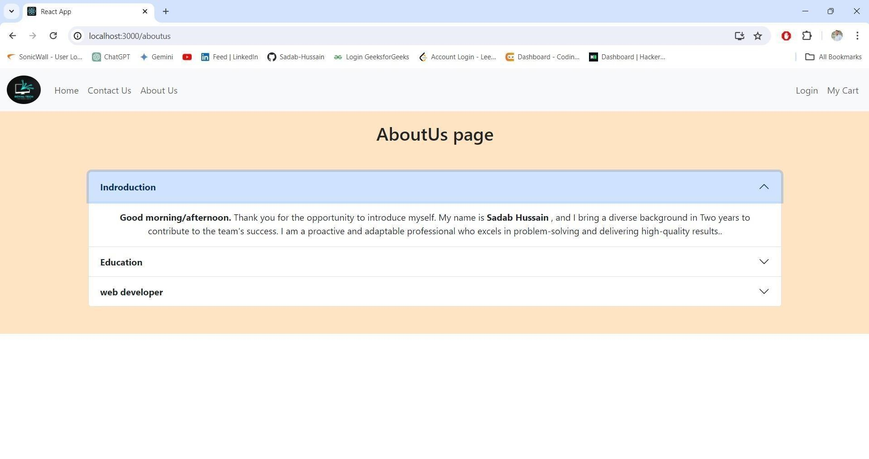

### Contactus

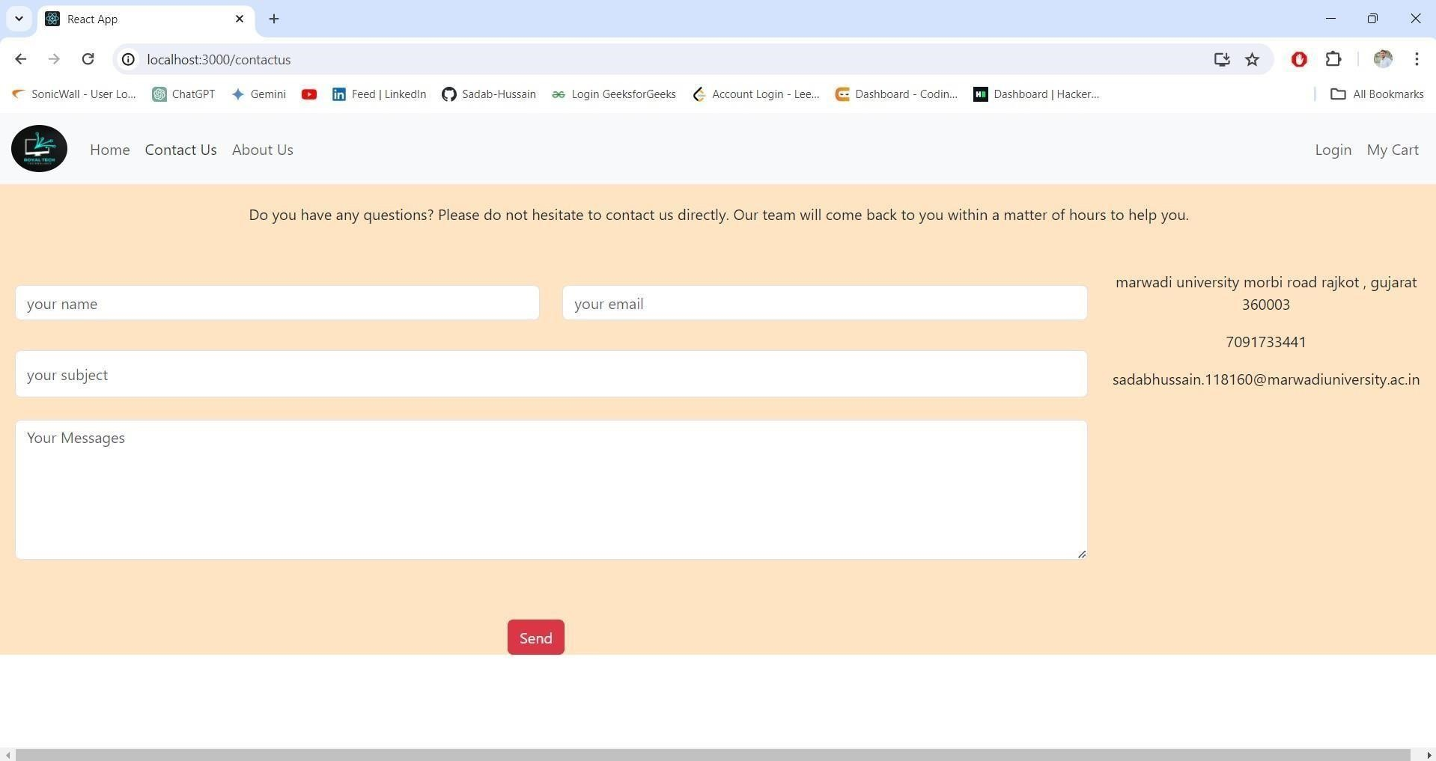

### Practical- 7) Add two more Web Pages to the above practical and make Page Navigation using React Router for the Laptop Shopping Cart. My Cart Login/Signup index.html <!DOCTYPE html>

<html lang="en">

<head>

<meta charset="utf-8" />

<link rel="icon" href="%PUBLIC_URL%/favicon.ico" /> <meta name="viewport" content="width=device-width, initial-scale=1" /> <meta name="theme-color" content="#000000" />

<meta name="description" content="Web site created using create-react- app"

/>

<link rel="apple-touch-icon" href="%PUBLIC_URL%/logo192.png" />

<link

href="https://cdn.jsdelivr.net/npm/bootstrap@5.3.2/dist/css/bootstrap.min.css" rel="stylesheet" integrity="sha384-

T3c6CoIi6uLrA9TneNEoa7RxnatzjcDSCmG1MXxSR1GAsXEV/Dwwykc2MPK8M2HN" crossorigin="anonymous"

/>

<link rel="manifest" href="%PUBLIC_URL%/manifest.json" />

<link

rel="stylesheet"

href="https://cdn.jsdelivr.net/npm/bootstrap@5.3.2/dist/css/bootstrap.min.css" /> <title>React App</title>

</head>

<body>

<noscript>You need to enable JavaScript to run this app.</noscript> <div id="root"></div>

<script src="https://cdn.jsdelivr.net/npm/bootstrap@5.3.2/dist/js/bootstrap.bundle.min.

js"></script>

</body>

</html>

**index.js**

import React from 'react'; import

ReactDOM from 'react-dom/client'; import './index.css'; import App from

'./App'; import reportWebVitals from './reportWebVitals'; import

{ BrowserRouter } from 'react-router-dom';

import { BrowserRouter as Router, Route, Switch } from 'react-router-dom'; import Cookies from 'universal-cookie';

const root = ReactDOM.createRoot(document.getElementById('root')); root.render( <React.StrictMode> <BrowserRouter>

<App />

</BrowserRouter>

</React.StrictMode>

);

reportWebVitals();

#### App.js

import { Route,Routes } from 'react-router-dom'; import './App.css'; import Header from './components/Header'; import

Home from './components/Home'; import AboutUs from

'./components/AboutUs'; import

ContactUs from './components/ContactUs'; import

Login from './components/Login'; import MyCart from

'./components/MyCart'; function App() { return (

<div className="App">

<Header/>

<Routes>

<Route path="/" element={<Home/>}></Route>

<Route path="/aboutus" element={<AboutUs/>}></Route>

<Route path="/contactus" element={<ContactUs/>}></Route>

<Route path="/login" element={<Login/>}></Route>

<Route path="/mycart" element={<MyCart/>}></Route>

</Routes>

</div>

); }

export default App;

#### Home.js

import data from './Data.json'; import { useNavigate } from

'react-router-dom'; import Cookies from 'universalcookie'; function Home() { //props.purchasedItems const x=useNavigate();//return one function

const handleSubmit=(index)=>

{

const product=data[index];//store product object const

productName=product.title;

alert(`${productName} has been added to cart`); let cookies=new Cookies(); let existingProductInCart=cookies.get("cart_products"); if(existingProductInCart === null||existingProductInCart === undefined)

{ cookies.set("cart_products",[product]); } else

{ cookies.set("cart_products",[...existingProductInCart,product]);

}

if(window.confirm('Want to buy this product? '))

{

x('/myCart');

} } return (

<div className="container-fluid">

<div className='row'>

{data.map((row,index)=>

{ return(

<div className='col-sm-3 mt-4 text-center' key={index}>

<img src={row.url} style={{width:"200px"}} alt={'images'} className='card-img m-auto'/> <p className='card-title'>{row.title}<br/>{"MRP Rs.

"+row.price}</p>

<input type="button" onClick={()=>handleSubmit(index)} value="Add To Cart" className='btn btn-warning m-3'/>

</div>

)

})}

</div>

</div> ); }

export default Home;

#### Header.js

import {Link} from 'react-router-dom'; import logo from

'../components/logo.png'; import './header.css'; function Header() { return (

<nav className="navbar navbar-expand-lg bg-body-tertiary">

<div className="container-fluid">

<Link className="navbar-brand" to="/">

<img id='img1-' src={logo} height="50px" width="60px" alt='logo' className='rounded-circle'/> </Link>

<button className="navbar-toggler" type="button" databstoggle="collapse" data-

bstarget="#navbarNav" aria-controls="navbarNav" ariaexpanded="false" aria-label="Toggle navigation"> <span className="navbar-toggler-icon"></span>

</button>

<div className="collapse navbar-collapse" id="navbarNav">

<ul className="navbar-nav">

<li className="nav-item">

<Link className="nav-link" aria-current="page" to="/">Home</Link> </li> <li className="nav-item">

<Link className="nav-link" to="/contactus">Contact Us</Link> </li> <li className="nav-item">

<Link className="nav-link" to="/aboutus">About Us</Link>

</li>

</ul>

<ul className="navbar-nav ms-auto">

<li className="nav-item">

<Link className="nav-link" aria-current="page" to="/login">Login</Link>

</li>

<li className="nav-item">

<Link className="nav-link" to="/myCart">My Cart</Link>

</li>

</ul>

</div>

</div>

</nav>

); }

export default Header;

## MyCart.js

import { useEffect, useState } from "react";

import Cookies from "universal-cookie"; function MyCart() {

const [price,setPrice]=useState(0); const [cartItems,setCartItems]=useState([]); const

[qtyMap,setQtyMap]=useState(new Map());

const [productMap,setProductMap]=useState(new Map()); useEffect(()=>

{

let cookies=new Cookies(); let

existingProductInCart=cookies.get("cart_products"); setCartItems(existingProductInCart);

},[]); useEffect(()=>

{

var x=new Map(); var

y=new Map();

for(var i=0;i<cartItems.length;i++)

{

var product=cartItems[i]; var

productQty=x.get(product.title); if(productQty==null)

{

x.set(product.title,1); } else

{

x.set(product.title,productQty+1); }

y.set(product.title,product); } setQtyMap(x);

setProductMap(y); var sum=0;

for(var i=0;i<cartItems.length;i++)

{

sum+=cartItems[i].price;

} setPrice(sum); },[cartItems]); const productTlt=(productTitle1)=>

{

let newProductArray=[]; for(var i=0;i<cartItems.length;i++)

{

if(productTitle1!=cartItems[i].title)

{

newProductArray.push(cartItems[i]);

} }

setCartItems(newProductArray); let cookies=new Cookies();

cookies.set("cart_products",newProductArray);

} return(

<div className="container my-4">

<div className="row">

<div className="col-7">

{Array.from(productMap.entries()).map((entry,title)=>

{

let [prodTitle,data]=entry; return(

<div className="card">

<img src={data.url} style={{width:"250px"}} className="mauto"/>

<h3 className="card-title">{data.title}</h3>

<h4>Quantity {qtyMap.get(data.title)}</h4>

<h5>Price

{data.price}*{qtyMap.get(data.title)}={data.price*qtyMap.get(data.title)}</h5> <input type="button" onClick={()=>productTlt(data.title)} className="btn btnwarning w-25 m-auto mb-3" value="Delete"/>

</div>

); })}

</div>

<div className="col-5">

<div className="card">

<table>

<tr>

<th>Product NAme</th>

<th>Price</th>

</tr>

{Array.from(productMap.entries()).map((row,t1)=>

{ let [prodTitle1,obj1]=row; return(

<tr><td>{obj1.title}</td><td>{obj1.price}</td></tr>

); })}

<tr>

<td>SubTotal</td>

<td>{price}</td>

</tr>

</table>

</div>

</div>

</div>

</div> ) } export default MyCart;

## Login/SignUp.js

import { useState } from "react"; function Login() { const

[isSubmit, setIsSubmit] = useState(false); const [userName, setUserName] = useState(''); const [password, setPassword] = useState(''); const

[userNameError, setUserNameError] = useState(''); const [passwordError, setPasswordError] = useState(''); const database = [ { username: 'vivek', password: '3084'

} ]; const handleSubmit = (e) => {

e.preventDefault(); setUserNameError(''); setPasswordError('');

const userData = database.find((val) => val.username === userName); if

(userData) {

if (userData.password !== password) { setPasswordError('password not valid');

} else {

setIsSubmit(true);

}

} else { setUserNameError('UserName not valid'); } } const renderForm =

(

<form onSubmit={handleSubmit} style={{ marginTop: "15px" }}>

<label for="txt"><b>UserName : </b></label>

<input type='text' className="mt-5" id='txt' onChange={(e) => setUserName(e.target.value)} /> <span>{userNameError}</span>

<br /><br />

<label for="txt"><b>password : </b></label>

<input type='password' className="mt-3" id='txt' onChange={(e) => setPassword(e.target.value)} />

<span>{passwordError}</span><br /><br />

<input type='submit' id='btn' className="btn btn-warning m-5" /> </form> ) return ( <div className='container m-3'>

<div className='App'>

<h1>Login form</h1>

{isSubmit ? "Successfully Logged In" : renderForm}

</div>

</div>

); }

export default Login;

### Output:- Homepage

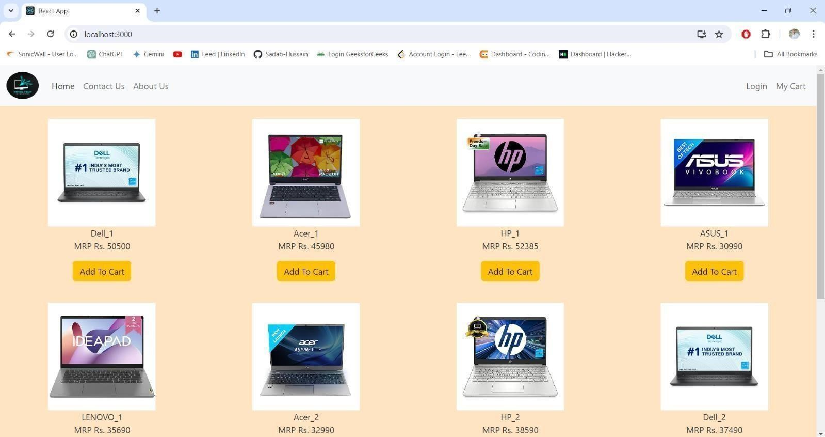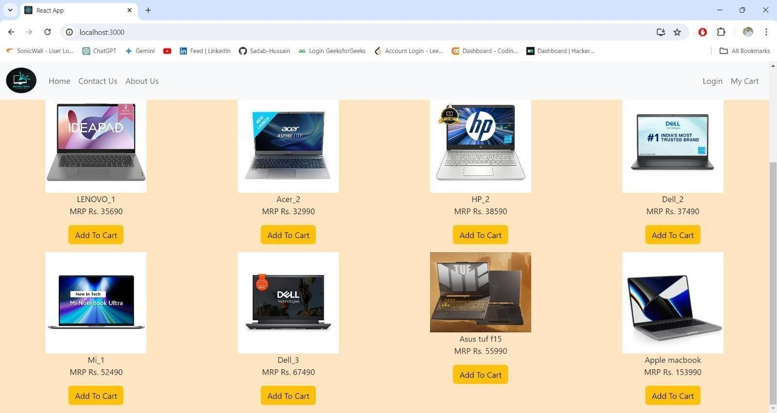

### MyCartpage

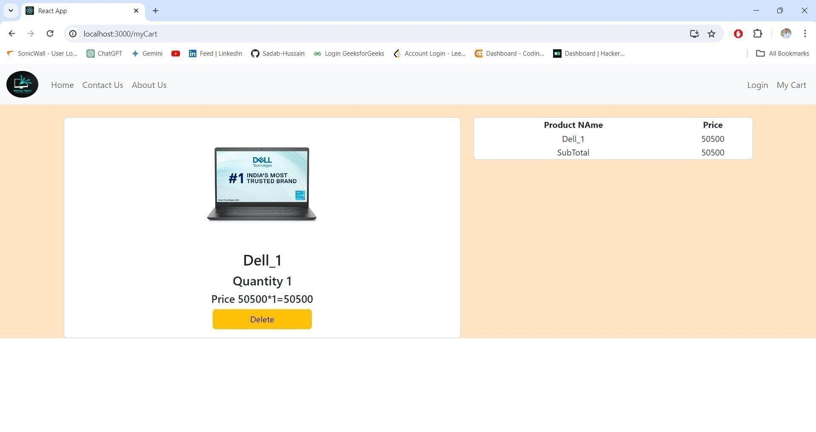

### Login/Signup page

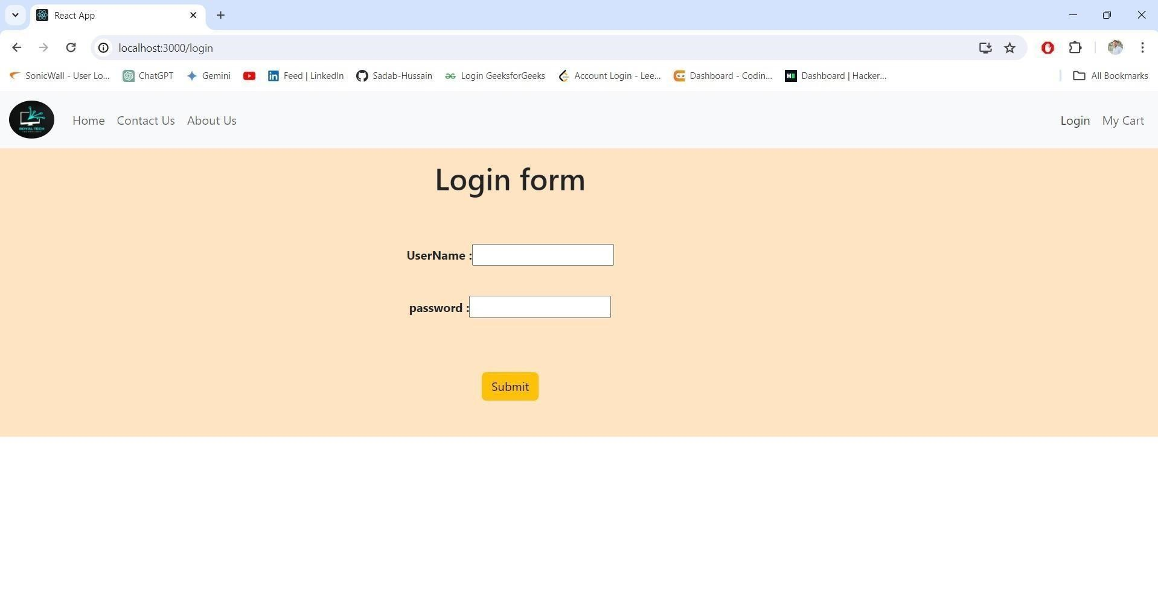

**Practical- 8) Develop REST API using CRUD operations to create the product information (Laptop)**  **for Shopping Cart using ExpressJS.**

**Code:**

## connection.js

const {MongoClient}=require('mongodb'); const url ="mongodb://127.0.0.1:27017"; const conn = new MongoClient(url); async function dbConnection(){

let data=await conn.connect(); let result = data.db('ec2stude'); return result.collection('praducts');

}

### module.exports=dbConnection;

**Create/insert.js**

const x =require('./connection'); const main=async()=>{ let data = await x();

//let result =await data.insertOne({name:"9pro",company:"realme",price:18000}); let result=await data.insertMany([{name:"9pro",company:"realme", price:18000},

{name:"nothing 2",company:"nothing",price:22000},

{name:"nord ce 2 lite",company:"onePlus",price:18000}]); if(result.acknowledged){ console.log('success');

} } main();

### Output:-

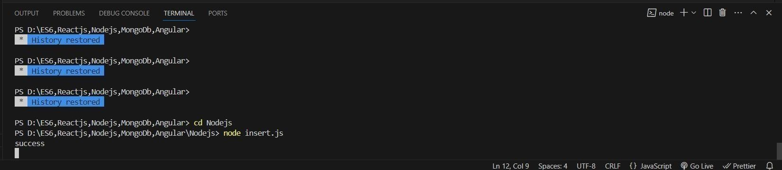

**MongoDB Output:-**

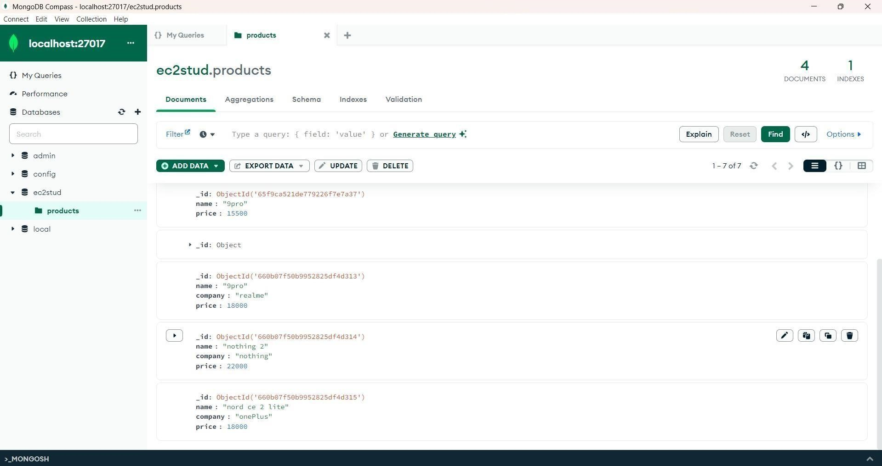

**Practical-9) Develop REST API using CRUD operations to read and update the product information (Laptop) for Shopping Cart using ExpressJS.**

# **Code: -** connection.js

# const {MongoClient}=require('mongodb'); const url

="mongodb://127.0.0.1:27017"; const conn = new MongoClient(url); async function dbConnection(){

let data=await conn.connect(); let result = data.db('ec2stude'); return result.collection('praducts');

}

## module.exports=dbConnection;

**Read/index.js**

const x=require('./connection'); const main=async()=>{ let data

= await x(); console.log(await data.find().toArray()); } main();

## **Output:-**

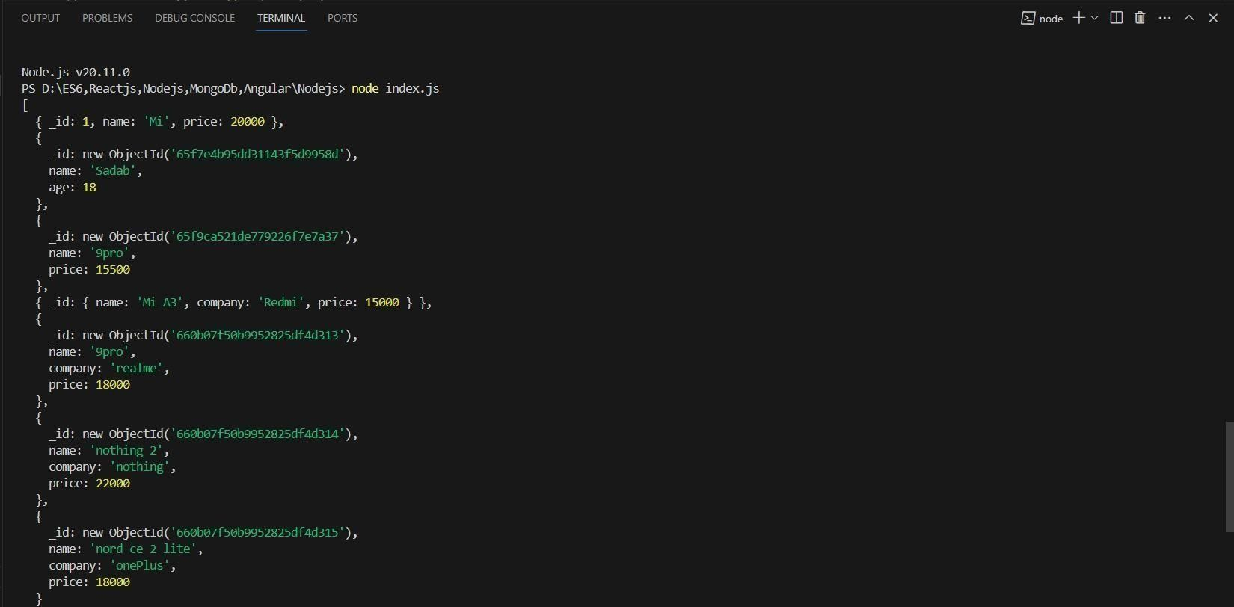

## Update.js

const x =require('./connection');

const main=async()=>{

let data = await x();

// let result = await data.updateOne({name:"9pro"},{$set:{price:15000}}); let result = await data.updateMany({name:"9pro"},{$set:{price:20000}}); if(result.modifiedCount >=1){ console.log('update success fully'); } } main();

**Output:-**

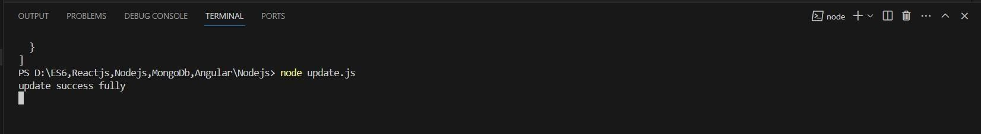

### MongoDB output:-

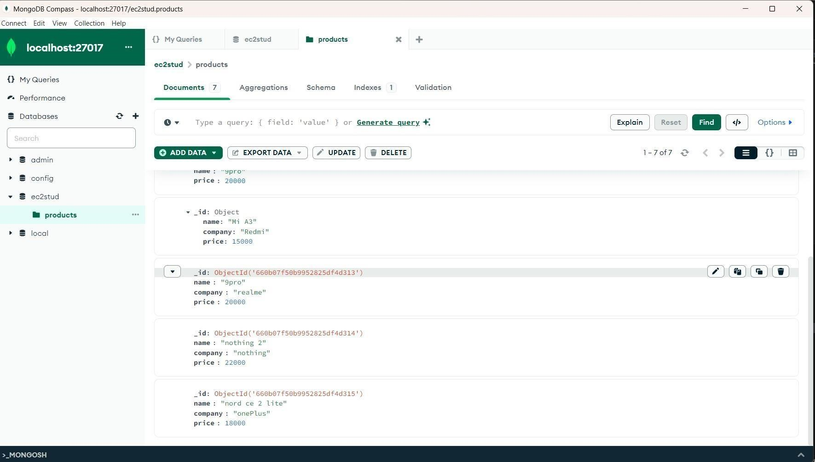

### Practical-10) Develop REST API using CRUD operations to delete the product information (Laptop) for Shopping Cart using ExpressJS.

Code: - connection.js

const {MongoClient}=require('mongodb');

const url ="mongodb://127.0.0.1:27017";

const conn = new MongoClient(url);

async function dbConnection(){

let data=await conn.connect(); let result = data.db('ec2stude'); return result.collection('praducts'); }

#### module.exports=dbConnection;

Delete.js

const x =require('./connection'); const main=async()=>{ let data = await x(); let result = await data.deleteMany({name:"nord ce 2 lite"});

if(result.deletedCount >=1){ console.log('success deleted'); } } main();

### Output:-

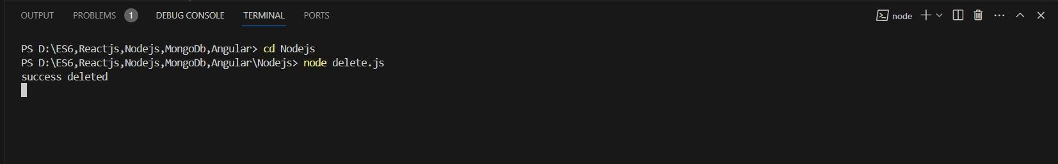

### MongoDB output:-

